Online Supplementary Materials for
“Taiwanese Public Opinion on the Chinese and US Military Presence in the Taiwan Strait”

Content
Table A.1: Balance Table 1
Table A.2: Operationalization of Variables 2
Table A.3: Results Using the 5-Point Unification-Independence Measurement 3
Table A.4: Standardized Coefficients 4
Table A.5: Affinity Variables as Moderators 5
Table A.5: Continued 6
Table A.6: Multinomial Logit Model 7
Figure A.1: Support for Taiwan Independence, by Experimental Group 8
Figure A.2: Sensitivity Analysis 9

Table A.1: Balance Table
Variable | Control | The US | China
Age (Mean) | 37.260 | 37.521 | 37.871
Female (%) | 56.000 | 51.000 | 56.200
College and Above (%) | 83.249 | 84.375 | 85.567
Support for KMT (%) | 9.000 | 6.771 | 11.340
Support for DPP (%) | 11.000 | 16.667 | 13.918
Support for Other Parties (%) | 22.500 | 14.583 | 20.103
Non-Partisan (%) | 57.500 | 61.979 | 54.639
Taiwan-US Affinity (Mean) | 5.935 | 6.109 | 6.052
Taiwan-China Affinity (Mean) | 2.975 | 2.656 | 2.835
Perceived Likelihood of China's Attack (Mean) | 4.503 | 4.646 | 4.588
Perceived Likelihood of US Defense (Mean) | 3.495 | 3.807 | 3.747
Support for Independence (%) | 32.500 | 42.188 | 37.113
Support for Independence (Mean) | 3.508 | 3.708 | 3.634

Table A.2: Operationalization of Variables
Variables | Coding
Perceived Likelihood of China’s Attack on Taiwan | “If Taiwan declares independence no matter the circumstance, do you think that China will attack Taiwan?” 1: Very Unlikely, 2: Unlikely; 3: Somewhat unlikely; 4: Somewhat likely; 5: Likely; 6: Very likely.
Perceived Likelihood of US Military Assistance to Taiwan | “If a Taiwanese declaration of independence will lead to attacks from Mainland China, do you think the United States will deploy troops to help Taiwan?” 1: Very Unlikely, 2: Unlikely; 3: Somewhat unlikely; 4: Somewhat likely; 5: Likely; 6: Very likely.
Support for Taiwan’s Independence | “Which of the following statements comes closest to your point of view about Taiwan’s relationship with China?”  Coded as 1 if a respondent’s answer is “independence as soon as possible” or “maintain status quo now, move towards independence later.”  Coded as 0 if a respondent’s answer is “unification as soon as possible,” “maintain status quo now, move towards unification later,” “maintain status quo now, decide between unification or independence later,” or “maintain status quo indefinitely.”
Age | Age in years.
Female | 1: female, and 0 Male
College | 1: With collage degree, and 0 otherwise.
KMT | 1: Supporter of the KMT, and 0 otherwise (Omitted)
DPP | 1: Supporter of the DPP, and 0 otherwise.
Other Parties | 1: Supporter of other Parties, and 0 otherwise.
Non-Partisan | 1: Without any party identification, and 0 otherwise.
Taiwan-China Affinity | (On a 0-10 scale) 0: the Taiwan-China relationship is very antagonistic, 10: the US-China relationship is very peaceful.
Taiwan-US Affinity | (On a 0-10 scale) 0: the Taiwan-US relationship is very antagonistic, 10: the Taiwan-US relationship is very peaceful.

Table A.3: Results Using the 5-Point Unification-Independence Measurement
 | Model 1
US Group | 0.186*
 | [0.108]
China Group | 0.134
 | [0.104]
Age | -0.026***
 | [0.004]
Female | 0.126
 | [0.088]
College | -0.026
 | [0.130]
DPP | 0.931***
 | [0.186]
Other Parties | 0.360**
 | [0.180]
Non-Partisan | 0.213
 | [0.160]
Taiwan-US Affinity | 0.024
 | [0.026]
Taiwan-China Affinity | 0.006
 | [0.022]
Constant | 3.964***
 | [0.344]
R-squared | 0.151
No. of Observations | 560
Note: Robust standard error in brackets.

* p < 0.1, ** p < 0.05, *** p < 0.01.

Table A.4: Affinity Variables as Moderators
 | Model 1 | Model 2 | Model 3 | Model 4 | Model 5 | Model 6
 | China | US | Support |  | Support
 | Attack | Defense | Independence (0/1) |  | Independence (1-5)
US Group | 0.232 | 0.521 | 0.191 | 0.255 | 0.163 | 0.125
 | [0.231] | [0.476] | [0.354] | [0.734] | [0.166] | [0.359]
China Group | -0.173 | 0.608 | 0.175 | -0.178 | 0.171 | 0.139
 | [0.241] | [0.451] | [0.359] | [0.782] | [0.167] | [0.352]
Age | 0.012** | -0.020*** | -0.052*** | -0.051*** | -0.026*** | -0.026***
 | [0.006] | [0.005] | [0.010] | [0.010] | [0.004] | [0.004]
Female | 0.007 | 0.087 | 0.178 | 0.192 | 0.122 | 0.128
 | [0.117] | [0.107] | [0.194] | [0.194] | [0.088] | [0.088]
College | 0.427** | -0.038 | -0.027 | -0.030 | -0.025 | -0.026
 | [0.175] | [0.154] | [0.285] | [0.286] | [0.130] | [0.130]
DPP | -0.535** | 0.307 | 1.826*** | 1.777*** | 0.940*** | 0.927***
 | [0.230] | [0.229] | [0.428] | [0.428] | [0.186] | [0.187]
Others | -0.595*** | 0.036 | 0.740* | 0.727* | 0.357** | 0.360**
 | [0.226] | [0.224] | [0.395] | [0.393] | [0.180] | [0.180]
Non-Partisan | -0.511*** | -0.117 | 0.177 | 0.156 | 0.214 | 0.213
 | [0.183] | [0.200] | [0.368] | [0.369] | [0.160] | [0.160]
Taiwan-US Affinity | -0.014 | 0.092 | 0.045 | 0.018 | 0.024 | 0.021
 | [0.038] | [0.057] | [0.057] | [0.085] | [0.026] | [0.038]
Taiwan-China Affinity | -0.065 | 0.023 | -0.015 | 0.012 | 0.007 | 0.006
 | [0.045] | [0.025] | [0.069] | [0.047] | [0.032] | [0.022]
US Group X | -0.046 |  | 0.080 |  | 0.009
Taiwan-China Affinity | [0.060] |  | [0.098] |  | [0.048]
China Group X | 0.073 |  | 0.001 |  | -0.013
Taiwan-China Affinity | [0.061] |  | [0.096] |  | [0.044]
US Group X |  | -0.034 |  | 0.027 |  | 0.010
Taiwan-US Affinity |  | [0.079] |  | [0.115] |  | [0.055]
China Group X |  | -0.059 |  | 0.060 |  | -0.001
Taiwan-US Affinity |  | [0.073] |  | [0.123] |  | [0.056]
Constant | 4.484*** | 3.611*** | 0.365 | 0.437 | 3.966*** | 3.979***
 | [0.485] | [0.521] | [0.799] | [0.855] | [0.350] | [0.373]
(Continued overleaf)

Table A.4: Continued
 | Model 1 | Model 2 | Model 3 | Model 4 | Model 5 | Model 6
 | China | US | Support |  | Support
 | Attack | Defense | Independence (0/1) |  | Independence (1-5)
Log pseudolikelihood | N.A. | N.A. | -343.557 | -343.893 | N.A. | N.A.
R-squared | 0.050 | 0.063 | N.A. | N.A. | 0.152 | 0.152
No. of Observations | 583 | 583 | 583 | 583 | 560 | 560
Note: Models 1 and 2 estimated OLS regression models with perceived likelihood of China’s attack on Taiwan and US defense of Taiwan as the dependent variables, respectively. Models 3 and 4 estimated logit regression models with support for Taiwan’s independence as the dependent variable. Models and 6 estimated OLS regression models with the 5-point measurement of support for Taiwan’s The omitted category of respondents’ party identification is the KMT. Robust standard error in brackets. * p<0.1, ** p<0.05, *** p<0.01. All tests are two-tailed.

Table A.5: Standardized Coefficients
 | Model 1 |  |  | Model 2 |  |  | Model 3
 | China’s Attack |  |  | US Defense |  |  | Support Independence
 | beta | t | p value | beta | t | p value | beta | t | p value
US Group | 0.037 | 0.792 | 0.428 | 0.118 | 2.481 | 0.013 | 0.097 | 1.815 | 0.069
China Group | 0.012 | 0.248 | 0.804 | 0.096 | 2.049 | 0.041 | 0.043 | 0.816 | 0.414
Age | 0.089 | 1.910 | 0.057 | -0.167 | -3.589 | 0.000 | -0.280 | -5.289 | 0.000
Female | -0.005 | -0.121 | 0.904 | 0.035 | 0.824 | 0.41 | 0.048 | 0.994 | 0.320
College | 0.116 | 2.503 | 0.013 | -0.01 | -0.223 | 0.824 | -0.006 | -0.111 | 0.911
DPP | -0.123 | -2.181 | 0.030 | 0.083 | 1.355 | 0.176 | 0.307 | 4.191 | 0.000
Other Parties | -0.174 | -2.712 | 0.007 | 0.010 | 0.15 | 0.881 | 0.142 | 1.862 | 0.063
Non-Partisan | -0.182 | -2.802 | 0.005 | -0.046 | -0.594 | 0.553 | 0.040 | 0.438 | 0.662
Taiwan-US Affinity | -0.021 | -0.401 | 0.688 | 0.093 | 1.681 | 0.093 | 0.043 | 0.811 | 0.417
Taiwan-China Affinity | -0.098 | -2.004 | 0.045 | 0.044 | 0.922 | 0.357 | 0.014 | 0.251 | 0.801
Note: The beta coefficients reported in the shaded areas are the regression coefficients estimated via standardizing all variables to have a mean of 0 and a standard deviation of 1.

Table A.6: Multinomial Logit Model
 | Model 1
 | Unification vs. S.Q. | Independence vs. S.Q.
US Group | 0.029 | 0.441*
 | [0.383] | [0.238]
China Group | -0.444 | 0.129
 | [0.389] | [0.235]
Age | 0.065*** | -0.042***
 | [0.015] | [0.010]
Female | -0.091 | 0.228
 | [0.313] | [0.201]
College | 0.170 | -0.184
 | [0.426] | [0.299]
DPP | -1.489* | 1.598***
 | [0.770] | [0.443]
Others | -0.045 | 0.788*
 | [0.451] | [0.416]
Non-Partisan | -1.233*** | -0.007
 | [0.424] | [0.379]
Taiwan-US Affinity | -0.046 | 0.029
 | [0.108] | [0.059]
Taiwan-China Affinity | 0.062 | 0.010
 | [0.073] | [0.048]
Constant | -3.456*** | 0.484
 | [1.229] | [0.820]
Log pseudolikelihood | -464
No. of Observations | 560
Note: Models 1 estimated a multinomial logit regression model with support for Taiwan’s unification with China, the status quo (S.Q.), and de jure independence as the dependent variable, with the S.Q. as the baseline category. The omitted category of respondents’ party identification is the KMT. Robust standard error in brackets. * p<0.1, ** p<0.05, *** p<0.01. All tests are two-tailed.

Figure A.1: Support for Taiwan Independence, by Experimental Group
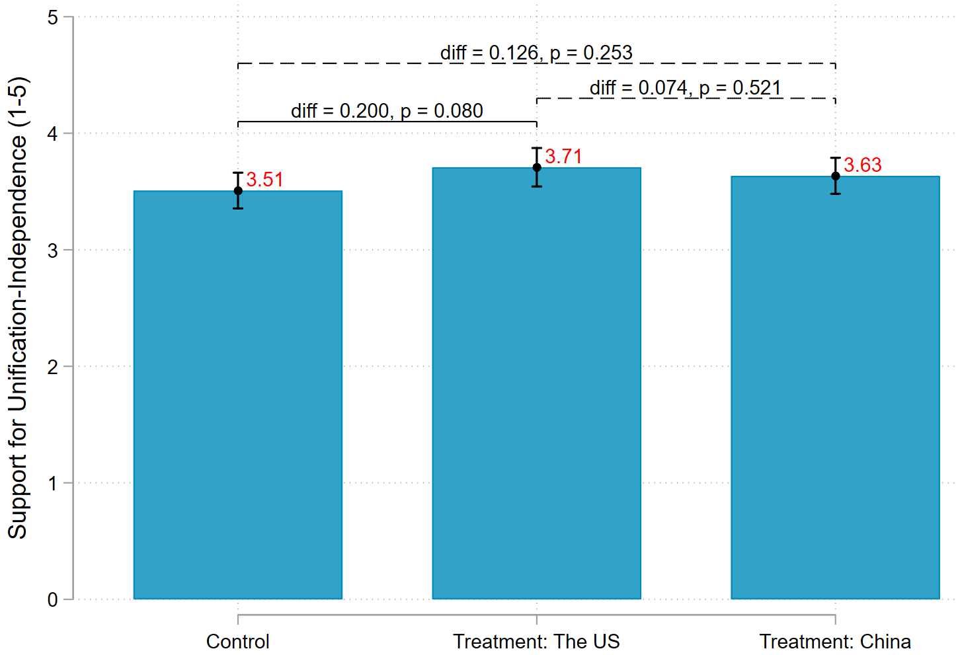
Note: The y-axis indicates respondents’ support for unification or independence on a 1-5 scale based on their responses to the following question: “Concerning the relationship between Taiwan and mainland China, which of the following six positions do you agree with? (1) Immediate unification; (2) Immediate independence; (3) Maintain the status quo and move toward unification in the future; (4) Maintain the status quo and move toward independence in the future; (5) Maintain the status quo and decide either unification or independence in the future; (6) Maintain the status quo forever.” We recoded their responses into a 5-point scale by merging (4) and (5) into a middle point (i.e., 3) and immediate unification and immediate independence at the two end points (i.e., 1 and 5), respectively. A dashed horizontal line indicates the difference is statistically insinificant between two groups (p > 0.1), whereas a solid horizontal line indicates a statistically significant difference (p < 0.1).

Figure A.2: Sensitivity Analysis
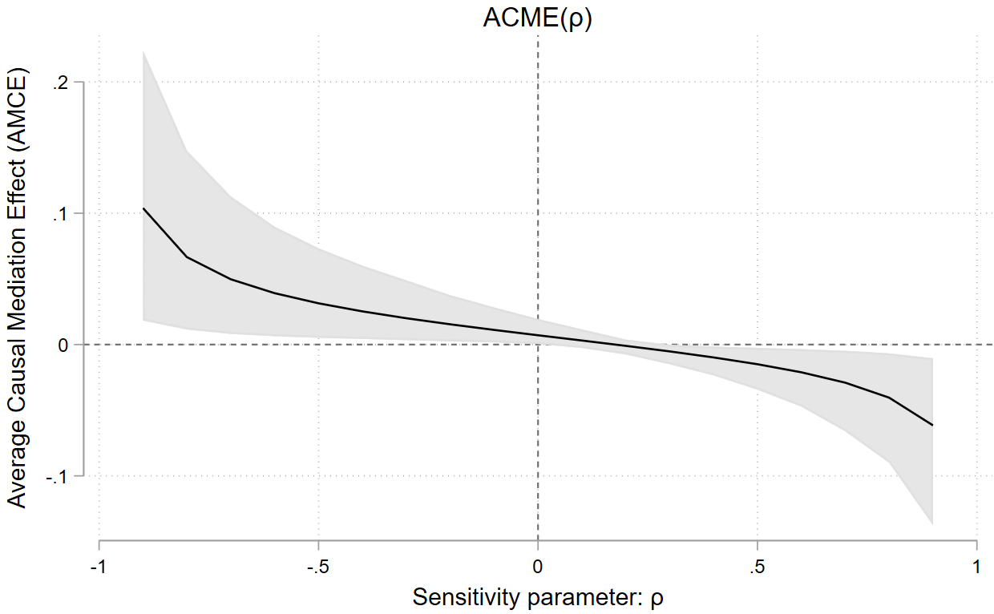
Note: Figures A.2 illustrates the results of sensitivity analysis for Model 1 of Table 2 in the main text. The shaded areas indicate 90% confidence intervals. In the figure, the ACME is 0 when ρ equals 0.115.

One key assumption of mediation analysis is sequential ignorability (Imai et al. 2011), which The assumes that, conditional on covariates, there are no unmeasured confounding relationships among the treatment, mediator, and outcome variables. As this assumption is non-testable with observational data, Imai et al. (2011) propose a sensitivity analysis to specify the conditions under which the average mediation effect is 0 (i.e., no mediation effect). We follow this advice and conduct a sensitivity analysis for Model 1 of Table in the main text. We find that for the estimated ACME to be 0, the correlation between two error terms in Model R.1 resulting from the presence of confounding variables (ρ) has to be greater than 0.115.

