**Appendix A**

*Pseudoword lexicon used in the experiment (adapted from Monaghan and Mattock, 2012).*

The six bisyllabic content words used as nouns were: *barget, limeber, jeelow, goorshell, nellby, bimdah.* The fourbisyllabic content words used as verbs were *dingep, fisslin, rakken, makkot*. The two monosyllabic words used as grammatical role markers (subject/object) were *tha* and *noo*.

**Appendix B**

*Animal characters used in training and testing blocks.*

Animal characters occurred across the experiment with equal frequency.

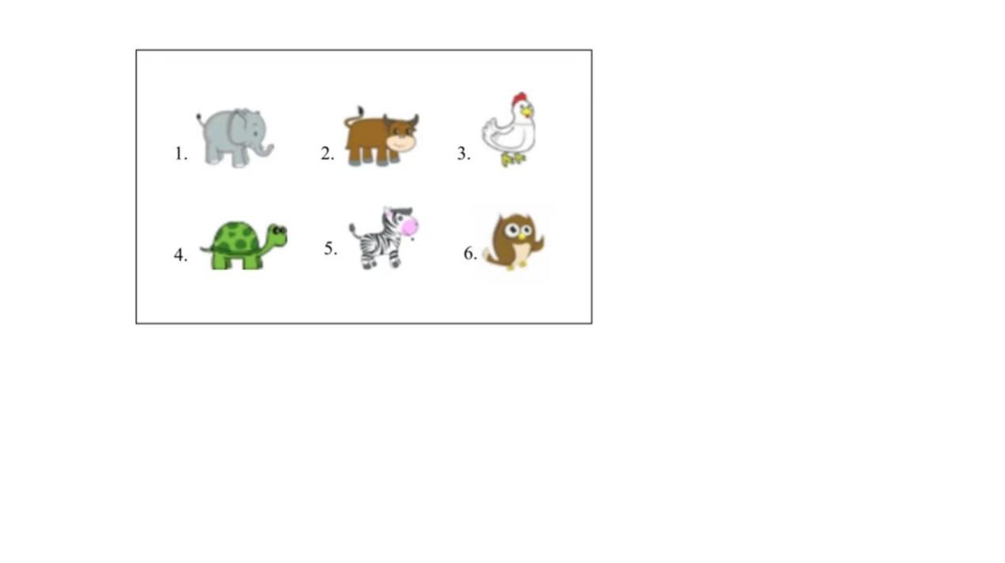

**Appendix C Supplementary Tables**

**Table S1**

*Mixed-effects model results for noun test trials. Null model contains only a random intercept for item. Model 1 includes block as a fixed effect. Model 2 includes day as a fixed effect.*

|  |  |  |  |  |  |
| --- | --- | --- | --- | --- | --- |
|  | Predictor | Estimate | *SD* Error | *Z* | *p* |
| null model | Intercept | 0.059 | 0.103 | 0.572 | 0.567 |
| model 1 | Intercept | 0.034 | 0.327 | 0.103 | 0.918 |
|  | block | 0.006 | 0.069 | 0.082 | 0.934 |
| model 2 | Intercept | 0.237 | 0.325 | 0.728 | 0.467 |
|  | day | -0.118 | 0.206 | -0.576 | 0.565 |

Best-fitting model specification (null model): Number of observations: 480, Item, 24. AIC = 668.3, BIC = 676.7, log-likelihood = -332.2. R syntax: glmer(accuracy ~ 1 + (1 | item), data = noun_test_data, family = "binomial").

**Table S2**

*Mixed-effects model results for verb test trials. Null model contains only a random intercept for participant. Model 1 includes block as a fixed effect. Model 2 includes day as a fixed effect.*

|  |  |  |  |  |  |
| --- | --- | --- | --- | --- | --- |
|  | Predictor | Estimate | *SD* Error | *Z* | *p* |
| null model | Intercept | 0.170 | 0.147 | 1.151 | 0.25 |
| model 1 | Intercept | 0.288 | 0.374 | 0.769 | 0.442 |
|  | block | -0.026 | 0.076 | -0.344 | 0.731 |
| model 2 | Intercept | 0.130 | 0.374 | 0.348 | 0.728 |
|  | day | 0.026 | 0.229 | 0.115 | 0.909 |

Best-fitting model specification (null model): Number of observations: 320, Participants: 20. AIC = 442.6, BIC = 450.2, log-likelihood = -219.3. R syntax: glmer(accuracy ~ 1 + (1 | participant), data = verb_test_data, family = "binomial").

**Table S3**

*Mixed-effects model results for marker test trials. Null model contains only random intercepts for participant and item. Model 1 includes block as a fixed effect. Model 2 includes day as a fixed effect.*

|  |  |  |  |  |  |
| --- | --- | --- | --- | --- | --- |
|  | Predictor | Estimate | *SD* Error | *Z* | *p* |
| null model | Intercept | 0.078 | 0.150 | 0.521 | 0.602 |
| model 1 | Intercept | -0.155 | 0.464 | -0.335 | 0.738 |
|  | block | 0.052 | 0.098 | 0.530 | 0.596 |
| model 2 | Intercept | 0.154 | 0.468 | 0.330 | 0.741 |
|  | day | -0.051 | 0.296 | -0.172 | 0.863 |

Best-fitting model specification (null model): Number of observations: 320, Participants: 20, Item: 16. AIC = 446.7, BIC = 458.0, log-likelihood = -220.3. R syntax: glmer(accuracy ~ 1 + (1 | participant) + (1 | item), data = marker_test_data, family = "binomial").

**Appendix D Analysis Omitting the Two Urdu Speakers**

**Table S4**

*Descriptive statistics for training trials in CSL task in the six blocks on two days. Showing t-test values compared against chance performance.*

|  |  |  |  |  |  |  |  |  |  |  |  |  |  |  |  |  |  |  |  |  |  |  |  |  |  |
| --- | --- | --- | --- | --- | --- | --- | --- | --- | --- | --- | --- | --- | --- | --- | --- | --- | --- | --- | --- | --- | --- | --- | --- | --- | --- |
| Block | | | | | | | | | | | | | | | | | | | | | | | | | |
|  | | Day 1 | | | | | | | | | | | | Day 2 | | | | | | | | | | | |
|  | 1 | | 2 | | 3 | | 4 | | 5 | | 6 | | 1 | | 2 | | 3 | | 4 | | 5 | | 6 | |
| M | | 0.57 | | 0.52 | | 0.56 | | 0.56 | | 0.59 | | 0.58 | | 0.50 | | 0.56 | | 0.52 | | 0.44 | | 0.56 | | 0.53 | |
| SD | | 0.14 | | 0.14 | | 0.13 | | 0.11 | | 0.16 | | 0.14 | | 0.17 | | 0.15 | | 0.19 | | 0.21 | | 0.18 | | 0.16 | |
| *t* | | 1.90 | | 0.72 | | 1.84 | | 2.22 | | 2.37 | | 2.46 | | -0.12 | | 1.76 | | 0.51 | | -1.13 | | 1.30 | | 0.75 | |
| *p* | | 0.074 | | 0.482 | | 0.083 | | 0.040 | | 0.030 | | 0.025 | | 0.907 | | 0.097 | | 0.618 | | 0.274 | | 0.211 | | 0.462 | |
| *d* | | 0.45 | | 0.17 | | 0.43 | | 0.52 | | 0.56 | | 0.58 | | -0.03 | | 0.41 | | 0.12 | | -0.27 | | 0.31 | | 0.18 | |

**Table S5**

*Descriptive statistics for vocabulary test trials in CSL task in block 3 and 6 on days 1 and 2. Showing t-test values compared against chance performance.*

|  |  |  |  |  |  |
| --- | --- | --- | --- | --- | --- |
|  |  | Blocks | | | |
|  |  | Day 1 | | Day 2 | |
|  |  | 3 | 6 | 3 | 6 |
| *Nouns* | *M* | 0.57 | 0.51 | 0.47 | 0.52 |
|  | *SD* | 0.20 | 0.22 | 0.22 | 0.23 |
|  | *t* | 1.57 | 0.18 | -0.53 | 0.34 |
|  | *p* | 0.134 | 0.859 | 0.604 | 0.734 |
|  | *d* | 0.37 | 0.04 | -0.12 | 0.08 |
| *Verbs* | *M* | 0.53 | 0.54 | 0.57 | 0.56 |
|  | *SD* | 0.32 | 0.26 | 0.27 | 0.25 |
|  | *t* | 0.37 | 0.68 | 1.10 | 0.94 |
|  | *p* | 0.717 | 0.507 | 0.288 | 0.361 |
|  | *d* | 0.09 | 0.16 | 0.26 | 0.22 |
| *Markers* | *M* | 0.50 | 0.56 | 0.46 | 0.54 |
|  | *SD* | 0.24 | 0.29 | 0.25 | 0.27 |
|  | *t* | 0.00 | 0.81 | -0.72 | 0.64 |
|  | *p* | 1.000 | 0.430 | 0.483 | 0.528 |
|  | *d* | 0.00 | 0.19 | -0.17 | 0.15 |

**Table S6**

*Descriptive statistics for syntax test trials in CSL task on days 1 and 2. Showing t-test values compared against chance performance.*

|  |  |  |
| --- | --- | --- |
|  | Day 1 | Day 2 |
| M | 0.58 | 0.63 |
| SD | 0.16 | 0.22 |
| *t* | 2.19 | 2.46 |
| *p* | 0.043 | 0.025 |
| *d* | 0.52 | 0.58 |