Supplementary Materials

The Role of Age of Arrival and Language Environment Factors in Arabic Heritage Language Development: A Longitudinal Study

Figure S1. Correlation matrix for predictor and outcome variables for Arabic entered in regression models.

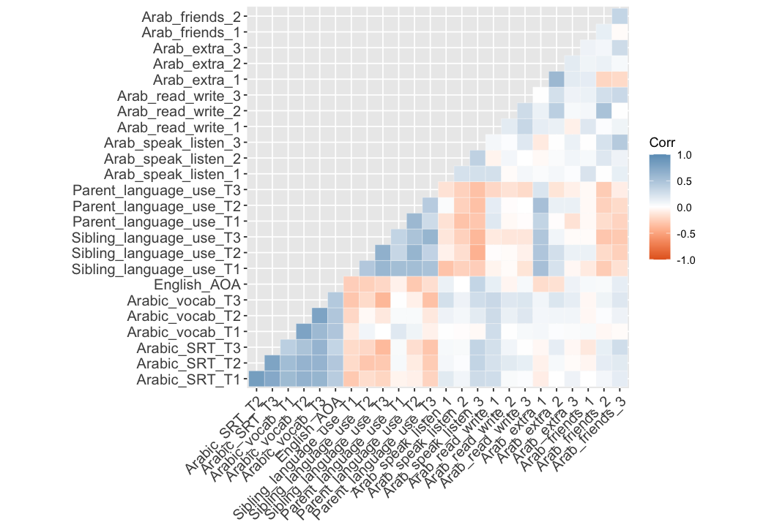

Figure S2. Correlation matrix for predictor and outcome variables for English entered into regression models.

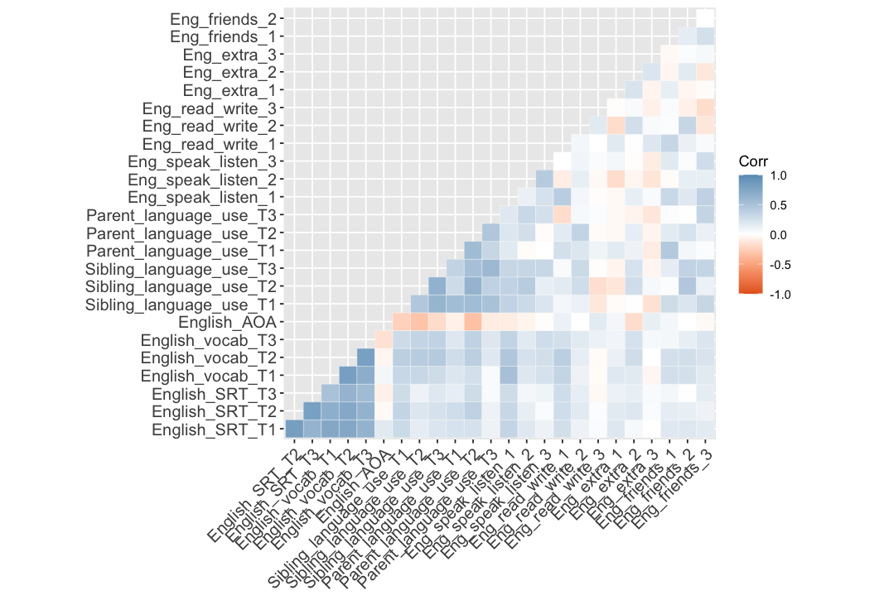

Appendix SA: Output of Binomial Model Predicting Verbatim Responses on SRT

Table A1. Coefficient table of binomial model predicting verbatim responses on SRT including a triple interaction between Time (T1, T2, T3), Language (Arabic, English), and AOA (Young, Old) as fixed effects.
 | Estimate | Std. Error | z value | Pr(>|z|)
(Intercept) | 1.490 | 0.262 | 5.669 | <.001 ***
Time_T2 | 0.714 | 0.115 | 6.185 | <.001 ***
Time_T3 | -0.682 | 0.140 | -4.866 | <.001 ***
Language_English | -2.755 | 0.347 | -7.929 | <.001 ***
AOA_Young | -0.687 | 0.222 | -3.084 | .002 **
Time_T2:Language_English | 0.241 | 0.136 | 1.761 | .078 †
Time_T3:Language_English | 2.711 | 0.137 | 19.813 | <.001 ***
Time_T2:AOA_Young | -0.394 | 0.147 | -2.688 | .007 **
Time_T3:AOA_Young | -0.072 | 0.176 | -0.412 | .680
Language_English:AOA_Young | 0.243 | 0.196 | 1.240 | .215
Time_T2:Language_English:AOA_Young | 0.894 | 0.187 | 4.765 | <.001 ***
Time_T3:Language_English:AOA_Young | 0.689 | 0.189 | 3.640 | <.001 ***
Note. *** = p < .001; ** = p < .01; † = p < .10.

Table A2. Random effects of A1 model. Random effects included two intercepts, by Item and Participant (nested within Family), and two by-Participant slopes, Time and Language.
Groups | Name | Variance | Std.Dev. | Corr
Participant:Family | (Intercept) | 1.037 | 1.018
 | Time_T2 | 0.065 | 0.256 | 0.09
 | Time_T3 | 0.259 | 0.509 | -0.45 | 0.57
 | Language_English | 0.250 | 0.500 | 0.03 | 0.01 | -0.19
Family | (Intercept) | 0.494 | 0.703
 | Time_T2 | 0.087 | 0.294 | 0.20
 | Time_T3 | 0.277 | 0.526 | -0.29 | 0.71
 | Language_English | 1.977 | 1.406 | -0.52 | -0.63 | -0.59
Item | (Intercept) | 1.171 | 1.082
Note. Model run on 21213 observations.

Table A3. Pairwise comparisons of A1 model per Language for each level of AOA and Time.
AOA Group: Old, Time = T1
Contrast | Estimate | SE | z.ratio | p.value
Arabic-English | 2.755 | 0.347 | 7.929 | <.001 ***

AOA Group: Young, Time = T1
Contrast | Estimate | SE | z.ratio | p.value
Arabic-English | 2.512 | 0.347 | 7.228 | <.001 ***

AOA Group: Old, Time = T2
Contrast | Estimate | SE | z.ratio | p.value
Arabic-English | 2.515 | 0.348 | 7.219 | <.001 ***
AOA Group: Young, Time = T2
Contrast | Estimate | SE | z.ratio | p.value
Arabic-English | 1.378 | 0.343 | 4.008 | <.001 ***

AOA Group: Old, Time = T3
Contrast | Estimate | SE | z.ratio | p.value
Arabic-English | 0.044 | 0.347 | 0.127 | .899

AOA Group: Young, Time = T3
Contrast | Estimate | SE | z.ratio | p.value
Arabic-English | -0.889 | 0.344 | -2.581 | .010 *
Note. *** = p < .001; * = p < .05.

Table A4. Pairwise comparisons of A1 model per AOA group for each Language and Time.
Language = Arabic, Time = T1
Contrast | Estimate | SE | z.ratio | p.value
Old - Young | 0.687 | 0.222 | 3.084 | .002 **

Language = English, Time = T1
Contrast | Estimate | SE | z.ratio | p.value
Old - Young | 0.443 | 0.259 | 1.710 | .087 †

Language = Arabic, Time = T2
Contrast | Estimate | SE | z.ratio | p.value
Old - Young | 1.081 | 0.237 | 4.566 | <.001 ***

Language = English, Time = T2
Contrast | Estimate | SE | z.ratio | p.value
Old - Young | -0.056 | 0.255 | -0.220 | .825

Language = Arabic, Time = T3
Contrast | Estimate | SE | z.ratio | p.value
Old - Young | 0.759 | 0.203 | 3.732 | <.001 ***

Language = English, Time = T3
Contrast | Estimate | SE | z.ratio | p.value
Old - Young | -0.171 | 0.218 | -0.797 | .425
Note. *** = p < .001; ** = p < .01; * = p < .05; † = p < .10.

Table A5. Pairwise comparisons of A1 model per Time for each Language and AOA group.
Language = Arabic, AOA = Old AOA
Contrast | Estimate | SE | z.ratio | p.value
T1 – T2 | -0.714 | 0.115 | -6.185 | <.001 ***
T1 – T3 | 0.682 | 0.140 | 4.866 | <.001 ***
T2 – T3 | 1.396 | 0.131 | 10.661 | <.001 ***

Language = Arabic, AOA = Young AOA
Contrast | Estimate | SE | z.ratio | p.value
T1 – T2 | -0.320 | 0.104 | -3.071 | .006 **
T1 – T3 | 0.754 | 0.133 | 5.660 | <.001 ***
T2 – T3 | 1.074 | 0.119 | 9.011 | <.001 ***

Language = English, AOA = Old AOA
Contrast | Estimate | SE | z.ratio | p.value
T1 – T2 | -0.954 | 0.108 | -8.831 | <.001 ***
T1 – T3 | -2.029 | 0.143 | -14.225 | <.001 ***
T2 – T3 | -1.075 | 0.122 | -8.834 | <.001 ***

Language = English, AOA = Young AOA
Contrast | Estimate | SE | z.ratio | p.value
T1 – T2 | -1.454 | 0.112 | -12.965 | <.001 ***
T1 – T3 | -2.646 | 0.143 | -18.452 | <.001 ***
T2 – T3 | -1.192 | 0.118 | -10.145 | <.001 ***
Note. *** = p < .001; ** = p < .01.

Appendix SB: Output of Logistic Models Predicting Vocabulary Scores
Table B1. Coefficient table of logistic model predicting Arabic vocabulary scores, including Time (T1, T2, T3) and AOA (Young, Old) as predictors.
 | Estimate | Std. Error | t value | Pr(>|t|)
(Intercept) | 1.298 | 0.222 | 5.846 | <.001 ***
Time_T2 | 0.316 | 0.074 | 4.262 | <.001 ***
Time_T3 | 0.275 | 0.096 | 2.883 | .004 **
AOA_Young | -0.931 | 0.133 | -6.984 | <.001 ***
Note. *** = p < .001; ** = p < .01.

Table B2. Random effects of B1 model. Random effects included two intercepts, by Item and Participant (nested within Family), and one by-Participant slope, Time.
Groups | Name | Variance | Std.Dev. | Corr
Participant:Family | (Intercept) | 0.493 | 0.702
 | Time_T2 | 0.180 | 0.424 | -0.49
 | Time_T3 | 0.464 | 0.681 | -0.51 | 0.59
Family | (Intercept) | 0.251 | 0.501
 | Time_T2 | 0.141 | 0.376 | 0.28
 | Time_T3 | 0.196 | 0.443 | 0.19 | 0.57
Item | (Intercept) | 2.640 | 1.625
Note. Model run on 25649 observations.

Table B3. Pairwise comparisons of B1 model per Time, with results averaged over AOA groups.
Contrast | Estimate | SE | t.ratio | p.value
T1 - T2 | -0.316 | 0.074 | -4.262 | < .001***
T1 - T3 | -0.275 | 0.095 | -2.883 | .011*
T2 - T3 | 0.041 | 0.084 | 0.482 | .880
Note. *** = p < .001; * = p < .05.

Table B4. Coefficient table of logistic model predicting English vocabulary scores, including Time (T1, T2, T3), AOA group (Young, Old), and the interaction between Time and AOA Group as predictors.
 | Estimate | Std. Error | t value | Pr(>|t|)
(Intercept) | -0.535 | 0.301 | -1.777 | .076 †
Time_T2 | 0.874 | 0.113 | 7.738 | <.001 ***
Time_T3 | 1.784 | 0.152 | 11.744 | <.001 ***
AOA_Young | -0.450 | 0.195 | -2.304 | .021 *
Time_T2:AOA_Young | 0.465 | 0.125 | 3.725 | <.001 ***
Time_T3:AOA_Young | 0.443 | 0.164 | 2.697 | .007 **
Note. *** = p < .001; ** = p < .01; * = p < .05; † = p < .10.

Table B5. Random effects of B4 model. Random effects included two intercepts, by Item and Participant (nested within Family), and one by-Participant slope, Time.
Groups | Name | Variance | Std.Dev. | Corr
Participant:Family | (Intercept) | 0.686 | 0.828
 | Time_T2 | 0.164 | 0.405 | -0.41
 | Time_T3 | 0.357 | 0.598 | -0.48 | 0.96
Family | (Intercept) | 1.553 | 1.246
 | Time_T2 | 0.395 | 0.629 | -0.79
 | Time_T3 | 0.736 | 0.858 | -0.78 | 0.87
Item | (Intercept) | 11.000 | 3.317
Note. Model run on 43874 observations.

Table B6. Pairwise comparisons per Time for each level of AOA for the English vocabulary model.
AOA Group: Young
Contrast | Estimate | SE | t.ratio | p.value
T1 - T2 | -1.339 | 0.112 | -11.986 | <.001***
T1 - T3 | -2.227 | 0.148 | -15.021 | <.001***
T2 - T3 | -0.888 | 0.088 | -10.135 | <.001***

AOA Group: Old
Contrast | Estimate | SE | t.ratio | p.value
T1 - T2 | -0.874 | 0.113 | -7.738 | <.001***
T1 - T3 | -1.784 | 0.152 | -11.744 | <.001***
T2 - T3 | -0.910 | 0.093 | -9.830 | <.001***
Note. *** = p < .001.

Table B7. Pairwise comparisons per AOA for each level of Time for the English vocabulary model.
Time = T1
Contrast | Estimate | SE | t.ratio | p.value
Old-Young | -0.450 | 0.195 | 2.304 | .021*

Time = T2
Contrast | Estimate | SE | t.ratio | p.value
Old-Young | -0.015 | 0.171 | -0.090 | .928

Time = T3
Contrast | Estimate | SE | t.ratio | p.value
Old-Young | 0.007 | 0.175 | 0.040 | .968
Note. * = p < .05.

Appendix SC: Output of Ordinal Model Predicting Language Use between Participants and Parents
Table C1. Coefficient table of ordinal model predicting language use between participants and parents, including Time (T1, T2, T3), AOA (Young, Old), the interaction between Time and AOA, and Interaction type (Child input from parents, Child output to parents) as fixed effects.
 | Estimate | Std. Error | z value | Pr(>|z|)
Time_T2 | 0.612 | 0.485 | 1.262 | .207
Time_T3 | 1.067 | 0.497 | 2.147 | .032*
AOA_Young | -0.356 | 0.668 | -0.534 | .593
Interaction type_Child output to parents | 2.302 | 0.314 | 7.321 | <.001***
Time_T2:AOA_Young | 1.531 | 0.694 | 2.207 | .027*
Time_T3:AOA_Young | 1.140 | 0.701 | 1.627 | .104
Note. *** = p < .001; ** = p < .01; † = p < .10.

Table C2. Random effects for model C1. Random effects included an intercept by Participant.
Groups | Name | Variance | Std.Dev.
Participant | (Intercept) | 3.285 | 1.813
Note. Model run on 732 observations.

Table C3. Threshold coefficients for model C1.
 | Estimate | Std. Error | z value
1|1.5 | 5.052 | 0.603 | 8.375
1.5|2 | 5.675 | 0.626 | 9.059
2|2.5 | 6.879 | 0.679 | 10.132
2.5|3 | 7.162 | 0.693 | 10.334
3|3.5 | 7.952 | 0.739 | 10.763
3.5|4 | 8.040 | 0.745 | 10.798
4|5 | 9.378 | 0.879 | 10.668

Table C4. Pairwise comparisons per Time for each level of AOA, averaged over Interaction type.
AOA Group: Young
Contrast | Estimate | SE | z.ratio | p.value
T1 - T2 | -2.143 | 0.502 | -4.265 | .001**
T1 - T3 | -2.207 | 0.510 | -4.329 | <.001***
T2 - T3 | -0.064 | 0.356 | -0.181 | .982

AOA Group: Old
Contrast | Estimate | SE | z.ratio | p.value
T1 - T2 | -0.612 | 0.485 | -1.262 | .417
T1 - T3 | -1.067 | 0.497 | -2.147 | .081†
T2 - T3 | -0.455 | 0.463 | -0.984 | .587
Note. *** = p < .001; ** = p < .01; † = p < .10.

Table C5. Pairwise comparisons per AOA group for each Time, averaged over Interaction type.
Time: Time 1
Contrast | Estimate | SE | z.ratio | p.value
Old - Young | 0.356 | 0.668 | 0.534 | .593

Time: Time 2
Contrast | Estimate | SE | z.ratio | p.value
Old - Young | -1.175 | 0.553 | -2.125 | .034*

Time: Time 3
Contrast | Estimate | SE | z.ratio | p.value
Old - Young | -0.784 | 0.550 | -1.426 | .154
Note. * = p < .05.

Appendix SD: Output of Ordinal Model Predicting Language Use between Participants and Siblings
Table D1. Coefficient table of ordinal model predicting language use between participants and siblings, including Time (T1, T2, T3), AOA (Young, Old), and Interaction type (Child input from siblings, Child output to siblings) as fixed effects.
 | Estimate | Std. Error | z value | Pr(>|z|)
Time_T2 | 0.920 | 0.226 | 4.069 | <.001***
Time_T3 | 2.907 | 0.244 | 11.902 | <.001***
AOA_Young | 0.789 | 0.587 | 1.344 | .179
Interaction type_Child output to siblings | 0.058 | 0.167 | 0.345 | .730
Note. *** = p < .001.

Table D2. Random effects for model D1. Random effects included an intercept by Participant.
Groups | Name | Variance | Std.Dev.
Participant | (Intercept) | 9.427 | 3.070
Note. Model run on 732 observations.

Table D3. Threshold coefficients for model D1.
 | Estimate | Std. Error | z value
1|1.5 | 2.049 | 0.463 | 4.427
1.5|2 | 2.476 | 0.468 | 5.293
2|2.5 | 3.780 | 0.489 | 7.724
2.5|3 | 4.186 | 0.497 | 8.425
3|3.5 | 5.725 | 0.528 | 10.839
3.5|4 | 6.083 | 0.536 | 11.355
4|4.5 | 7.813 | 0.591 | 13.223
4.5|5 | 8.329 | 0.610 | 13.650

Table D4. Pairwise comparisons per Time, averaged over the different AOA groups and Interaction type.
Contrast | Estimate | SE | z.ratio | p.value
T1 - T2 | -0.920 | 0.226 | -4.069 | .001**
T1 - T3 | -2.910 | 0.244 | -11.902 | <.001***
T2 - T3 | -1.990 | 0.222 | -8.948 | <.001***

Appendix SE: Output of Ordinal Model Predicting Frequency of Reading/Writing Activities

Table E1. Coefficient table of ordinal model predicting frequency of reading/writing activities, including Time (T1, T2, T3), Language (Arabic, English), AOA (Young, Old), and the interaction between Time and Language as fixed effects.
 | Estimate | Std. Error | z value | Pr(>|z|)
Time_T2 | 0.530 | 0.268 | 1.975 | .048*
Time_T3 | -0.077 | 0.285 | -0.269 | .788
Language_English | 1.640 | 0.254 | 6.450 | <.001***
AOA_Young | -0.427 | 0.193 | -2.214 | .027*
Time_T2:Language_English | -0.064 | 0.352 | -0.182 | .855
Time_T3:Language_English | 1.199 | 0.374 | 3.208 | .001**

Table E2. Random effects for model E1. Random effects included an intercept by Participant.
Groups | Name | Variance | Std.Dev.
Participant | (Intercept) | 0.497 | 0.705
Note. Model run on 732 observations.

Table E3. Threshold coefficients for model E1.
 | Estimate | Std. Error | z value
1|2 | 0.508 | 0.224 | 2.269
2|3 | 2.583 | 0.249 | 10.389
3|4 | 3.938 | 0.278 | 14.187
4|5 | 5.421 | 0.353 | 15.376

Table E4. Pairwise comparisons per Time for each Language, averaged over AOA.
Language: Arabic
 | Contrast | SE | z.ratio | Pr(>|z|)
T1 – T2 | -0.530 | 0.268 | -1.975 | .119
T1– T3 | 0.077 | 0.285 | 0.269 | .961
T2 – T3 | 0.606 | 0.282 | 2.147 | .081†

Language: English
 | Contrast | SE | z.ratio | Pr(>|z|)
T1 – T2 | -0.465 | 0.232 | -2.009 | .110
T1 – T3 | -1.123 | 0.243 | -4.619 | <.001***
T2 – T3 | -0.657 | 0.243 | -2.700 | .019 *
Note. *** = p < .001; * = p < .05; † = p < .10.

Table E5. Pairwise comparisons per Language for each Time, averaged over AOA.
Time: T1
 | Contrast | SE | z.ratio | Pr(>|z|)
Arabic – English | -1.640 | 0.254 | -6.450 | <.001***

Time: T2
 | Contrast | SE | z.ratio | Pr(>|z|)
Arabic – English | -1.580 | 0.256 | -6.163 | <.001***

Time: T3
 | Contrast | SE | z.ratio | Pr(>|z|)
Arabic – English | -2.840 | 0.291 | -9.757 | <.001***

Appendix SF: Output of Ordinal Model Predicting Frequency of Speaking/Listening Activities

Table F1. Coefficient table of ordinal model predicting frequency of speaking/listening activities, including Time (T1, T2, T3), Language (Arabic, English), AOA (Young, Old), and the interaction between Time and Language as fixed effects.
 | Estimate | Std. Error | z value | Pr(>|z|)
Time_T2 | -0.772 | 0.223 | -3.461 | <.001***
Time_T3 | -0.688 | 0.233 | -2.948 | .003**
Language_English | -0.477 | 0.219 | -2.184 | .029*
AOA_Young | -0.098 | 0.134 | -0.731 | .465
Time_T2:Language_English | 1.376 | 0.317 | 4.345 | <.001***
Time_T3:Language_English | 2.670 | 0.343 | 7.783 | <.001***
Note. *** = p < .001; ** = p <. 001; * = p < .05.

Table F2. Random effects for model F1. Random effects included an intercept by Participant.
Groups | Name | Variance | Std.Dev.
Participant | (Intercept) | 0.005 | 0.071
Note. Model run on 732 observations.

Table F3. Threshold coefficients for model F1.
 | Estimate | Std. Error | z value
1|2 | -2.146 | 0.195 | -10.993
2|3 | -0.809 | 0.172 | -4.712
3|4 | 0.463 | 0.171 | 2.711
4|5 | 1.586 | 0.187 | 8.473

Table F4. Pairwise comparisons per Time for each Language, averaged over AOA.
Language: Arabic
 | Contrast | SE | z.ratio | Pr(>|z|)
T1 – T2 | 0.772 | 0.223 | 3.461 | .002**
T1 – T3 | 0.688 | 0.233 | 2.948 | .009**
T2 – T3 | -0.083 | 0.239 | -0.350 | .935

Language: English
 | Contrast | SE | z.ratio | Pr(>|z|)
T1 – T2 | -0.604 | 0.223 | -2.709 | .018*
T1 – T3 | -1.982 | 0.247 | -8.029 | <.001***
T2 – T3 | -1.378 | 0.244 | -5.651 | <.001***
Note. *** = p < .001; ** = p < .01; * = p < .05.

Table F5. Pairwise comparisons per Language for each Time, averaged over AOA.
Time: T1
 | Contrast | SE | z.ratio | Pr(>|z|)
Arabic – English | 0.477 | 0.219 | 2.184 | .029*

Time: T2
 | Contrast | SE | z.ratio | Pr(>|z|)
Arabic – English | -0.899 | 0.227 | -3.954 | <.001***

Time: T3
 | Contrast | SE | z.ratio | Pr(>|z|)
Arabic – English | -2.193 | 0.261 | -8.389 | <.001***
Note. *** = p < .001; * = p < .05.

Appendix SG: Output of Ordinal Model Predicting Frequency of Language Use with Friends

Table G1. Coefficient table of ordinal model predicting frequency of language use with friends, including Time (T1, T2, T3), Language (Arabic, English), AOA (Young, Old), and the interaction between Time and Language as fixed effects.
 | Estimate | Std. Error | z value | Pr(>|z|)
Time_T2 | 0.049 | 0.227 | 0.218 | .827
Time_T3 | -1.105 | 0.240 | -4.596 | <.001***
Language_English | -0.626 | 0.225 | -2.789 | .005**
AOA_Young | -0.273 | 0.151 | -1.802 | .072†
Time_T2:Language_English | 1.393 | 0.326 | 4.272 | <.001***
Time_T3:Language_English | 2.364 | 0.347 | 6.802 | <.001***
Note. *** = p < .001; ** = p <. 01; † = p < .10.

Table G2. Random effects for model G1. Random effects included an intercept by Participant.
Groups | Name | Variance | Std.Dev.
Participant | (Intercept) | 0.138 | 0.372
Note. Model run on 732 observations.

Table G3. Threshold coefficients for model G1.
 | Estimate | Std. Error | z value
1|2 | -1.287 | 0.189 | -6.810
2|3 | 0.261 | 0.180 | 1.447
3|4 | 1.810 | 0.198 | 9.131
4|5 | 2.821 | 0.232 | 12.152

Table G4. Pairwise comparisons per Time for each Language, averaged over AOA.
Language: Arabic
 | Contrast | SE | z.ratio | Pr(>|z|)
T1 – T2 | -0.049 | 0.227 | -0.218 | .974
T1 – T3 | 1.105 | 0.240 | 4.596 | <.001***
T2 – T3 | 1.155 | 0.246 | 4.685 | <.001***

Language: English
 | Contrast | SE | z.ratio | Pr(>|z|)
T1 – T2 | -1.442 | 0.235 | -6.133 | <.001***
T1 – T3 | -1.258 | 0.244 | -5.160 | <.001***
T2 – T3 | 0.184 | 0.242 | 0.761 | .727
Note. *** = p < .001.

Table G5. Pairwise comparisons per Language for each Time, averaged over AOA.
Time: T1
 | Contrast | SE | z.ratio | Pr(>|z|)
Arabic – English | 0.626 | 0.225 | 2.789 | .005**

Time: T2
 | Contrast | SE | z.ratio | Pr(>|z|)
Arabic – English | -0.767 | 0.233 | -3.283 | .001**

Time: T3
 | Contrast | SE | z.ratio | Pr(>|z|)
Arabic – English | -1.737 | 0.259 | -6.707 | <.001***
Note. *** = p < .001; ** = p <. 001.

Appendix SH: Output of Ordinal Model Predicting Frequency of Extracurricular Activities

Table H1. Coefficient table of ordinal model predicting frequency of extracurricular activities, including Time (T1, T2, T3), Language (Arabic, English), AOA (Young, Old), and the interaction between Time and Language as fixed effects.
 | Estimate | Std. Error | z value | Pr(>|z|)
Time_T2 | -0.477 | 0.250 | -1.908 | .056†
Time_T3 | -0.088 | 0.251 | -0.350 | .726
Language_English | -0.728 | 0.248 | -2.931 | .003**
AOA_Young | -0.314 | 0.231 | -1.355 | .175
Time_T2:Language_English | 0.974 | 0.356 | 2.739 | .006**
Time_T3:Language_English | -2.137 | 0.455 | -4.693 | <.001***
Note. *** = p < .001; ** = p <. 01; † = p < .10.

Table H2. Random effects for model H1. Random effects included an intercept by Participant.
Groups | Name | Variance | Std.Dev.
Participant | (Intercept) | 0.928 | 0.963
Note. Model run on 729 observations.

Table H3. Threshold coefficients for model H1.
 | Estimate | Std. Error | z value
1|2 | -0.559 | 0.223 | -2.505
2|3 | 1.299 | 0.229 | 5.660
3|4 | 2.718 | 0.270 | 10.052
4|5 | 3.627 | 0.332 | 10.935

Table H4. Pairwise comparisons per Time for each Language, averaged over AOA.
Language: Arabic
 | Contrast | SE | z.ratio | Pr(>|z|)
T1 – T2 | 0.477 | 0.250 | 1.908 | .136
T1 – T3 | 0.088 | 0.251 | 0.350 | .935
T2 – T3 | -0.389 | 0.264 | -1.474 | .304

Language: English
 | Contrast | SE | z.ratio | Pr(>|z|)
T1 – T2 | -0.497 | 0.254 | -1.960 | .122
T1 – T3 | 2.225 | 0.382 | 5.821 | <.001***
T2 – T3 | 2.722 | 0.381 | 7.149 | <.001***
Note. *** = p < .001.

Table H5. Pairwise comparisons per Language for each Time, averaged over AOA.
Time: T1
 | Contrast | SE | z.ratio | Pr(>|z|)
Arabic – English | 0.728 | 0.248 | 2.931 | .003**

Time: T2
 | Contrast | SE | z.ratio | Pr(>|z|)
Arabic – English | -0.247 | 0.255 | -0.970 | .332

Time: T3
 | Contrast | SE | z.ratio | Pr(>|z|)
Arabic – English | 2.865 | 0.389 | 7.373 | <.001***
Note. *** = p < .001; ** = p <. 01.

Appendix SI: Output of Logistic Models Predicting Accuracy in the Arabic SRT

Table I1. Coefficient table of logistic model predicting the accuracy in SRT at T3 with concurrent T3 predictors, including Language use with siblings, Length of Arabic schooling, Hours of speaking/listening activities in Arabic, Hours spent interacting with friends in Arabic, and Hours of Arabic extracurricular activities as fixed effects.
 | Estimate | Std. Error | z value | Pr(>|z|)
(Intercept) | 0.451 | 0.237 | 1.907 | .057†
Language use with siblings | -0.306 | 0.140 | -2.191 | .028*
Length of Arabic schooling | 0.367 | 0.125 | 2.931 | .003**
Hours of speaking/listening activities in Arabic | 0.260 | 0.142 | 1.826 | .068†
Hours spent interacting with friends in Arabic | 0.354 | 0.145 | 2.444 | .015*
Hours of Arabic extracurricular activities | -0.315 | 0.136 | -2.312 | .021*
Note. ** = p <. 01; * = p < .05; † = p < .10.

Table I2. Random effects of I1 model. Random effects included an intercept by Item and one by Participant nested within Family.
Groups | Name | Variance | Std.Dev.
Participant:Family | (Intercept) | 1.001 | 1.001
Family | (Intercept) | 0.276 | 0.525
Item | (Intercept) | 1.219 | 1.104
Note. Model run on 3198 observations.

Table I3. Coefficient table of logistic model predicting the accuracy in SRT at T3 with T2 predictors, including Language use with siblings at T2, Hours of Arabic extracurricular activities at T2, and Length of Arabic schooling as fixed effects.
 | Estimate | Std. Error | z value | Pr(>|z|)
(Intercept) | 0.426 | 0.246 | 1.735 | .083†
Language use with siblings – T2 | -0.355 | 0.144 | -2.459 | .014*
Hours of Arabic extracurricular activities – T2 | 0.230 | 0.139 | 1.655 | .098†
Length of Arabic schooling | 0.369 | 0.134 | 2.764 | .006**
Note. ** = p <. 01; * = p < .05; † = p < .10.

Table I4. Random effects of I3 model. Random effects included an intercept by Item and one by Participant nested within Family.
Groups | Name | Variance | Std.Dev.
Participant:Family | (Intercept) | 1.097 | 1.047
Family | (Intercept) | 0.453 | 0.673
Item | (Intercept) | 1.214 | 1.102
Note. Model run on 3112 observations.

Appendix SJ: Output of Logistic Models Predicting Accuracy in the Arabic Vocabulary Task

Table J1. Coefficient table of logistic model predicting the accuracy in vocabulary task at T3 with concurrent T3 predictors, including Language use with siblings and Length of Arabic schooling as fixed effects.
 | Estimate | Std. Error | t value | Pr(>|t|)
(Intercept) | 1.034 | 0.207 | 5.008 | <.001***
Language use with siblings | -0.350 | 0.098 | -3.561 | <.001***
Length of Arabic schooling | 0.434 | 0.090 | 4.792 | <.001***
Note. *** = p <. 001.

Table J2. Random effects of model J1. Random effects included an intercept by Item and one by Participant nested within Family.
Groups | Name | Variance | Std.Dev.
Participant:Family | (Intercept) | 0.472 | 0.687
Family | (Intercept) | 0.290 | 0.539
Item | (Intercept) | 2.365 | 1.538
Note. Model run on 7947 observations.

Table J3. Coefficient table of logistic model predicting the accuracy in vocabulary task at T3 with T2 predictors, including Language use with siblings at T2, Hours of Arabic extracurricular activities at T2, and Length of Arabic schooling as fixed effects.
 | Estimate | Std. Error | z value | Pr(>|z|)
(Intercept) | 1.027 | 0.208 | 4.934 | <.001***
Language use with siblings – T2 | -0.310 | 0.102 | -3.032 | .002**
Hours of Arabic extracurricular activities – T2 | 0.237 | 0.099 | 2.395 | .017*
Length of Arabic schooling | 0.434 | 0.093 | 4.659 | <.001***
Note. *** = p <. 001; ** = p < .01; * = p < .05.

Table J4. Random effects of J3 model. Random effects included an intercept by Item and one by Participant nested within Family.
Groups | Name | Variance | Std.Dev.
Participant:Family | (Intercept) | 0.458 | 0.677
Family | (Intercept) | 0.340 | 0.583
Item | (Intercept) | 2.347 | 1.532
Note. Model run on 7818 observations.

