Supplementary materials
Table A
Variable name | Coding | Additional notes
Child’s sex | 1=Male  2=Female
Child’s age in months | Numeric
Language | 1=Afrikaans  2=SA English
Area | 1=Rural  2=Urban
Mother primary caregiver | 1=Yes  0=No | Score of 1 if the mother is declared to be the only primary caregiver
Creche attendance | 1=Yes  0=No
Total number of adults in household | Numeric
Father presence | 1=Yes  0=No
Grandparent presence | 1=Yes  0=No
Other family members presence | 1=Yes  0=No
Nuclear family | 1=Yes  0=No | Score of 1 if only the parents and their children are present in the household. No other people or family members present
Older children in household | Numeric
Total number of people in household | Total number of adults in household + Total number of children in household
Rooms for sleeping | Numeric
People by bedroom | Total number of people in household/Rooms for sleeping
Mother's age at birth | 1=20 years old or younger  2=21 to 25 years old  3=26 to 30 years old  4=31 to 35 years old  5=36 to 39 years old  6=40+ years old  na=Don't know
First born | 1=Yes  0=No
Mother's level of education | 0=No formal education  1=Primary school incomplete  2=Completed primary school  3=High school incomplete  4=Completed high school  5=Studied beyond high school  na=Don't know
Mother employment | 1=Not working  2=Employed  3=Self-employed (without employees)  4=Self-employed (with employees)  na=Don't know
Father employment | 1=Not working  2=Employed  3=Self-employed (without employees)  4=Self-employed (with employees)  na=Don't know
Household income | 0=no income  1=R1 – R600  2=R601 – R1 200  3=R1 201 – R2 400  4=R2 401 – R5 000  5=R5 001 – R10 000  6=R10 001 – R20 000  7=R20 001 – R40 000  8=R40 001 – R80 000  9=R80 001 – R150 000  10=R150 001 – R300 000  11=R300 001 or more  na=Don't know
Grocery expenditure | 0=none  1=R1 – R600  2=R601 – R1 200  3=R1 201 – R2 000  4=R2 001 – R3 000  5=R3 001 – R5 000  6=R5 001 – R8 000  7=R8 001 – R12 000  8=R12 001 or more  na=Don't know
Total grammar | 0-181 | Afrikaans CDI Toddler form
Total grammar | 0-188 | SA English CDI Toddler form
Word combinations | 0=Not yet  1=Sometimes  2=Often | CDI Toddler form
Complex phrases | 0-96 | Afrikaans CDI Toddler form
Complex phrases | 0-74 | SA English CDI Toddler form

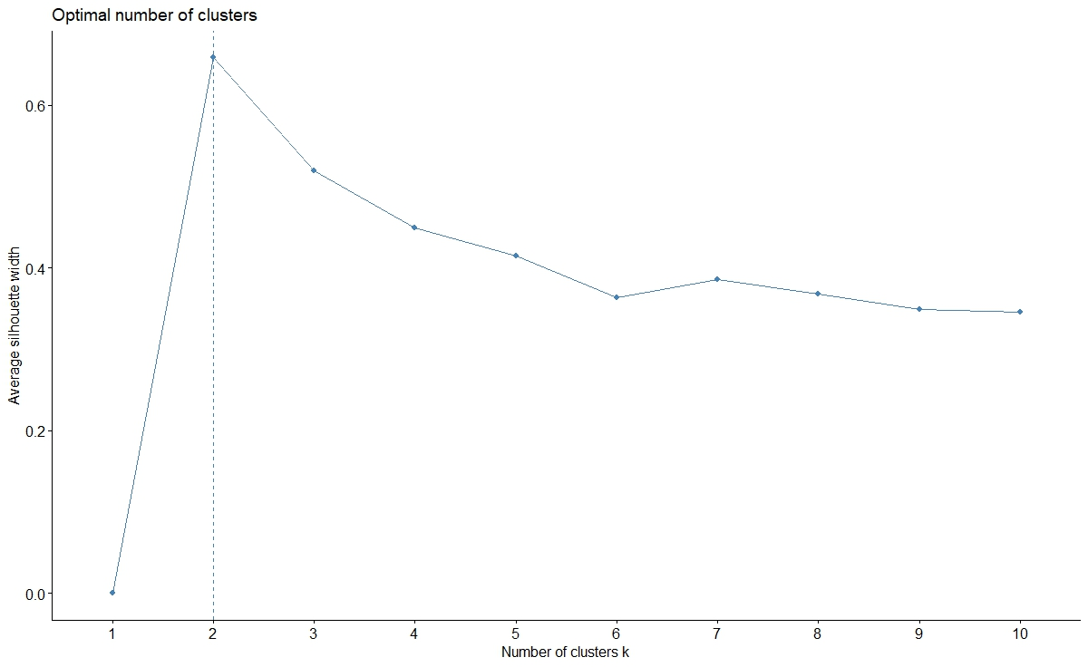
Figure A. Optimal number of clusters.

