Supporting Information
Table S1
Acoustic measurements with formant values in Bark scale and F0 values in Hz.
Token | Onset Vowel (ms) | Syllable Duration (ms) | F1 (Bark) | F2 (Bark) | F3 (Bark) | F0 initial (min-max) (in Hz) | F0 middle (min-max) (in Hz) | F0 final (min-max) (in Hz)
sԑ33 1  (Standard) | 98 | 583 | 6.44 | 10.14 | 14.44 | 203  (195-218) | 192  (188-195) | 192  (188-196)
sԑ33_2  (Standard) | 100 | 584 | 6.55 | 10.57 | 14.94 | 211  (202-222) | 196  (191-202) | 188  (186-192)
si33_1  (Vowel Deviant) | 101 | 584 | 3.54 | 12.14 | 15.45 | 217  (207-227) | 193  (188-208) | 187  (183-190)
si33_2  (Vowel Deviant) | 97 | 578 | 3.77 | 11.95 | 15.32 | 202  (194-215) | 192  (188-198) | 190  (187-197)
sԑ25_1  (Tone Deviant) | 101 | 586 | 6.72 | 9.72 | 14.46 | 208  (199-220) | 196  (193-199) | 230  (199-266)
sԑ25_2  (Tone Deviant) | 99 | 579 | 6.73 | 9.70 | 14.44 | 211  (200-222) | 197  (194-202) | 237  (201-268)
Note. To be able to compare the JND between Standards and Vowel-quality Deviants and Standards and Lexical-tone Deviants we compared the JND in units. For the Vowel-quality Deviant, we transformed the Hz formant values into Bark scale by using the formula: B = (26.81F/ (1960 + F)) – 0.53. We then calculated the Euclidean distance between Standards and Vowel-quality Deviants, which results in a value of 3.39 bark. To obtain the JND units, this value was divided by 0.3 bark, the JND for formant frequencies (Kewley-Port, 2001). The Vowel-quality Deviant spans 11.3 JND units. For the Lexical-tone Deviant, we assumed, according to Jongman et al. (2017), that the JND for rising tones for non-tone listeners is around 6.7 Hz. This results in 10.90 JND at the endpoint of the rising tone. Hence the difference between the Vowel-quality Deviant and Lexical-tone Deviant is about 0.4 JND units suggesting that vowel quality may be more salient than tones. We are aware that the overall (psycho-) acoustic comparison between tones and vowels might not be as simple as we assumed in this calculation.

Figure S1
Oscillogram and spectrogram of the standard
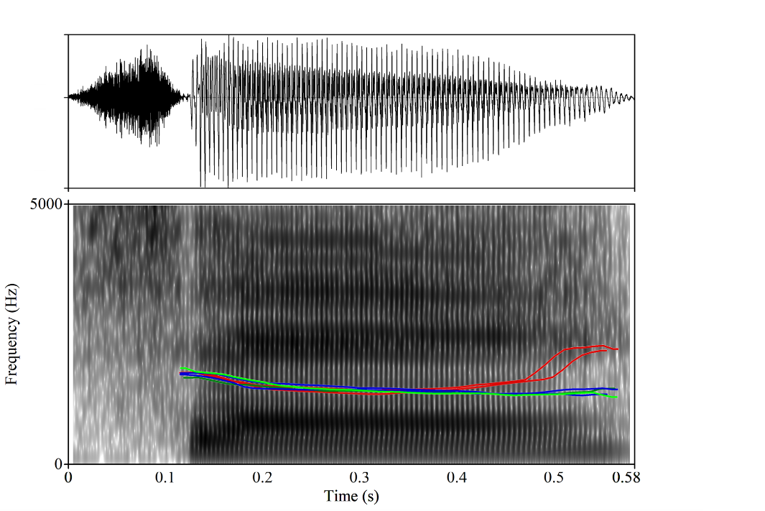
Note. Oscillogram and spectrogram of /sԑ33/ and the F0 contours of the two different tokens of the syllables /sԑ25/ (red), /si33/ (blue), and /sԑ33/ (green).

Experiment 1
Table S2.
Results from the fitted MMN model with the fixed and random effects.
Fixed effects | Estimate (SE) | df | t-value | Pr(>|t|)
Intercept | -1.026 (0.233) | 24.01 | -4.412 | <0.001
Deviant type | 0.276 (0.057) | 696.00 | 4.874 | <0.001
Region | -0.169 (0.057) | 696.00 | 2.993 | <0.01
Deviant type × Region | 0.067 (0.057) | 696.00 | 1.192 | 0.234
Random effects | Variance | Std. Dev. | Correlation
Subject (Intercept) | 1.242 | 1.115
Deviant type | 0.615 | 0.785 | 0.38
Note. Significant effects are given in bold.

Table S3.
Results from the fitted LDN model with the fixed and random effects.
Fixed effects | Estimate (SE) | df | t-value | Pr(>|t|)
Intercept | -1.378 (0.268) | 24.00 | -5.141 | <0.001
Deviant type | 0.274 (0.190) | 24.02 | 4.874 | 0.1621
Region | -0.305 (0.056) | 672.00 | -5.441 | <0.001
Deviant type × Region | -0.113 (0.056) | 672.00 | -2.019 | 0.044
Random effects | Variance | Std. Dev. | Correlation
Subject (Intercept) | 1.650 | 1.285
Deviant type | 0.793 | 0.890 | 0.26
Note. Significant effects are given in bold.

Experiment 2
Table S4
Early analysis time-window
Lexical tone deviant
 | 6-month-olds |  |  | 9-month-olds
Region | Estimate (SE) | t-value | p-value | Estimate (SE) | t-value | p-value
Frontocentral | 0.312 (0.447) | 0.698 | 1 | 0.890 (0.321) | 2.775 | 0.03
Posterior | 0.875 (0.440) | 1.987 | 0.23 | -0.039 (0.413) | -0.094 | 1
Vowel-quality deviant
 | 6-month-olds |  |  | 9-month-olds
Region | Estimate (SE) | t-value | p-value | Estimate (SE) | t-value | p-value
Frontocentral | 2.349 (0.447) | 5.261 | < 0.001 | 0.268 (0.321) | 0.837 | 1
Posterior | -0.041 (0.440) | -0.094 | 1 | -0.825 (0.417) | -1.978 | 0.21
Note. Early analysis time-window: Comparison of the ERP difference waves against zero at frontocentral and posterior regions for both sound contrasts and age groups. Significant MMRs are given in bold.

Table S5.
Results from the fitted early MMR model with the fixed and random effects
Fixed effects | Estimate (SE) | df | t-value | Pr(>|t|)
Intercept | 0.474 (0.193) | 50 | 2.457 | 0.018
Deviant type | 0.036 (0.207) | 50 | 0.172 | 0.864
Age | -0.400 (0.193) | 50 | -2.075 | 0.043
Region | 0.481 (0.105) | 1300 | 4.600 | <0.001
Deviant type × Age | 0.316 (0.207) | 50 | 1.525 | 0.134
Deviant type × Region | -0.390 (0.105) | 1300 | -3.726 | <0.001
Age × Region | 0.024 (0.105) | 1300 | 0.232 | 0.816
Deviant type × Age × Region | 0.349 (0.105) | 1300 | 3.333 | <0.001
Random effects | Variance | Std. Dev. | Correlation
Subject (Intercept) | 1.310 | 1.145
Deviant type | 1.601 | 1.265 | 0.03
Note. Significant effects are given in bold.
Table S6
Late analysis time-window.
Lexical-tone deviant
 | 6-month-olds |  |  |  |  | 9-month-olds
Region | Estimate (SE) |  | t-value | p-value | Estimate (SE) |  | t-value |  | p-value
Frontocentral |  | 3.408 (0.520) | 6.551 | <0.001 | 2.497 (0.312) |  | 7.997 | <0.001
Posterior |  | -0.876 (0.534) | -1.625 | 0.452 | -1.669 (0.444) |  | -3.758 | 0.001
Vowel-quality deviant
 |  | 6-month-olds |  |  |  | 9-month-olds
Region |  | Estimate (SE) | t-value | p-value | Estimate (SE) |  | t-value | p-value
Frontocentral |  | 0.518 (0.520) | 0.989 | 1 | -1.415 (0.312) |  | -3.798 | 0.001
Posterior |  | -1.511 (0.534) | -2.804 | 0.03 | -2.076 (0.444) |  | -4.675 | <0.001
Note. Late analysis time-window: Comparison of the ERP difference waves against zero at frontocentral and posterior regions for both sound contrasts and age groups. Significant MMRs are given in bold.

Table S7.
Results from the fitted late MMR model with the fixed and random effects.
Fixed effects | Estimate (SE) | df | t-value | Pr(>|t|)
Intercept | -0.218 (0.225) | 50 | -0.967 | 0.338
Deviant type | 0.904 (0.198) | 50 | 4.569 | <0.001
Age | -0.601 (0.225) | 50 | -2.673 | 0.010
Region | 1.469 (0.112) | 1300 | 13.081 | <0.001
Deviant type × Age | 0.022 (0.198) | 50 | 0.111 | 0.912
Deviant type × Region | 0.797 (0.112) | 1300 | 7.099 | <0.001
Age × Region | -0.108 (0.112) | 1300 | -0.964 | 0.335
Deviant type × Age × Region | 0.233 (0.112) | 1300 | 2.072 | 0.039
Random effects | Variance | Std. Dev. | correlation
Subject (Intercept) | 1.904 | 1.380
Deviant type | 1.327 | 1.152 | -0.10
Note. Significant effects are given in bold.

References
Kewley-Port, D. (2001). Vowel formant discrimination II: Effects of stimulus uncertainty, consonantal context, and training. The Journal of the Acoustical Society of America, 110(4), 2141–2155.
Jongman, A., Qin, Z., Zhang, J., & Sereno, J. A. (2017). Just noticeable differences for pitch direction, height, and slope for Mandarin and English listeners. The Journal of the Acoustical Society of America, 142(2), EL163–EL169. https://doi.org/10.1121/1.4995526

