To what extent do children's expressions of time actually refer to time? An investigation into the temporal and discursive usages of temporal adverbs in family interaction

Supplementary Materials

Table 5. Estimated coefficients, standard errors, z-values, and p-values for the generalized mixed model fitted to the occurrence of the adverb JO in adult vs child utterances.

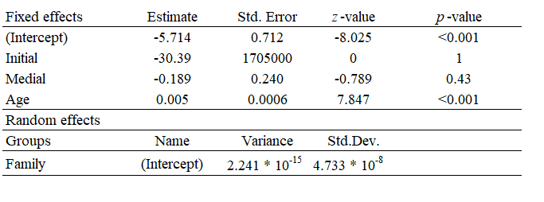

Table 13. Estimated coefficients, standard errors, z-values, and p-values for the generalized mixed model for JO. The temporal/discursive distinction is dummy coded as 0 and 1, functioning as the dependent variable. The variables Age, Speaker (child vs parent), and Location (Initial, Medial, Final) are utilized as independent variables, including terms for their interaction.

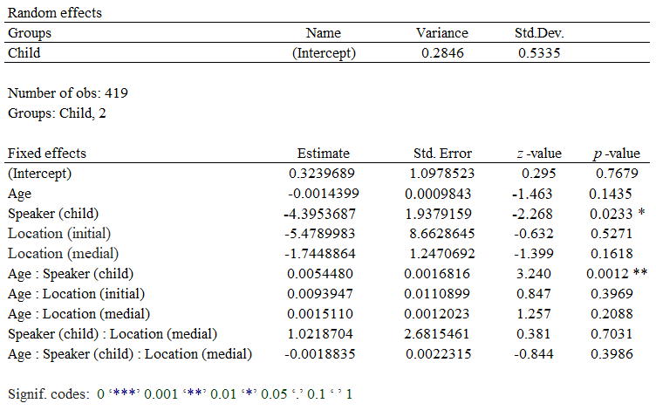

Table 14. Estimated coefficients, standard errors, z-values, and p-values for the generalized mixed model for KOHTA. The temporal/discursive distinction is dummy coded as 0 and 1, functioning as the dependent variable. The variables Age, Speaker (child vs parent), and Location (Initial, Medial, Final) are utilized as independent variables, including terms for their interaction.

