Appendix A
Table 1
The Mean (SD) numbers and percentages of the total number of trials included for the three maternal employment subgroups
 | At home group |  | Part time group |  | Full time group
Trial Type | M(SD) | Percentage | M(SD) | Percentage | M(SD) | Percentage
Recognition  (N = 8) | 6.53(1.67) | 81.6% | 6.59 (1.47) | 82.4% | 5.90(1.45) | 73.8%
Retention  (N = 8) | 5.58(1.80) | 69.8% | 5.55(1.92) | 69.3% | 4.48(1.81) | 56.0%
Training  (N = 12) | 9.81(2.40) | 81.8% | 9.41(1.92) | 78.4% | 8.45(2.44) | 70.5%

Appendix B
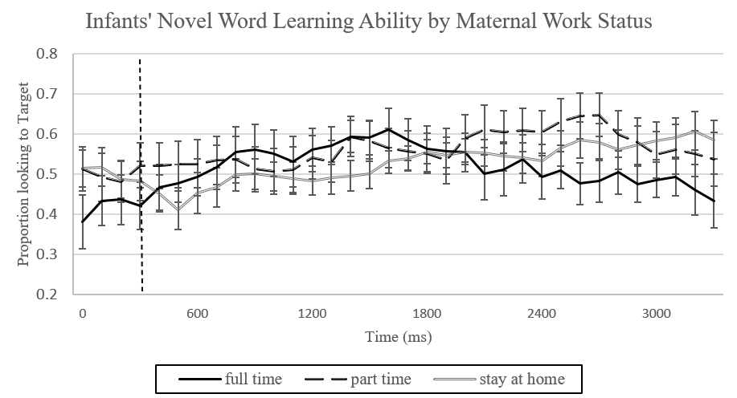
Figure 1. Performance of novel word learning ability by maternal work status. Overall accuracy of responses on retention trials by children whose mothers are at home, part time working, and full time working. Curves show the mean proportion of trials on which children were fixating at the target picture at each 33-ms interval as the stimulus sentence unfolded, measured from the acoustic onset of the noun. The vertical dashed line indicates 300-ms after noun onset. Error bars indicate standard errors from the means.

