Supplemental S2

Figure 1: The distribution of number of sessions words were retrieved and produced correctly at the beginning of the session. This represents 216 words (24 children x 9 words each).
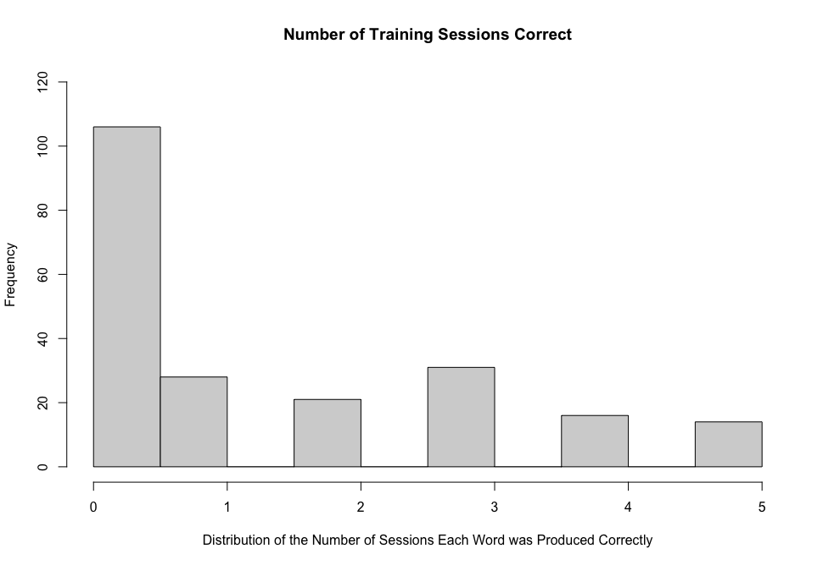

Figure 2: The distribution of the responses after the one-month delay based on phonological precision. Here responses are represented as the percentage of target phonetic features produced.

