Supplementary materials
S1. Questionnaire

- Where do you live?
- Drenthe
- Flevoland
- Friesland
- Gelderland
- Groningen
- Limburg
- Noord-Brabant
- Noord-Holland
- Overijssel
- Utrecht
- Zeeland
- Zuid-Holland
- Not in the Netherlands
- Prefer not to say
- How many of your children currently live in your household?
  - 1
  - 2
  - 3
  - 4
  - More than 4

For each child:
- How old is the child living in your household?
Please answer in years.
- Which language(s) do you usually speak to you child?
More than 1 option can be selected.
  - Dutch
  - Arabic
  - Berber
  - English
  - French
  - Frisian
  - German
  - Hindi
  - Papiamento
  - Polish
  - Russian
  - Spanish
  - Tigrinya
  - Turkish
  - Other (please specify):
- Which language(s) does your child usually speak to you?
More than 1 option can be selected.
  - Dutch
  - Arabic
  - Berber
  - English
  - French
  - Frisian
  - German
  - Hindi
  - Papiamento
  - Polish
  - Russian
  - Spanish
  - Tigrinya
  - Turkish
  - Other (please specify):
- Are you the only (step)parent or guardian in your household?
  - Yes
  - No
- Which other adults (besides yourself) live in your household?
More than 1 option can be selected
  - Other (step)parent
  - Grandparent 1
  - Grandparent 2
  - Adult child
  - Other (please specify):
- Which language(s) does Other (step)parent usually speak to your child?
More than 1 option can be selected.
  - Dutch
  - Arabic
  - Berber
  - English
  - French
  - Frisian
  - German
  - Hindi
  - Papiamento
  - Polish
  - Russian
  - Spanish
  - Tigrinya
  - Turkish
  - Other (please specify):
- Which language(s) does your child usually speak to the Other (step)parent?
More than 1 option can be selected.
  - Dutch
  - Arabic
  - Berber
  - English
  - French
  - Frisian
  - German
  - Hindi
  - Papiamento
  - Polish
  - Russian
  - Spanish
  - Tigrinya
  - Turkish
  - Other (please specify):

[Questions 8 and 9 were repeated for each adult living in the household.]
From now on, we will refer to the language(s) you use in your family in addition to or instead of Dutch as the other language(s).
- Please indicate how well you speak and understand Dutch.
 | not at all | not very well | quite well | very well
I speak Dutch...
I understand Dutch...

[Question 10 was repeated for each adult living in the household.]

We are now going to ask you about what happened in your family when the schools and childcare were closed.

- In normal circumstances, which kind of education or childcare does your child attend?
  - Childcare (daycare, childminder, preschool)
  - Primary school
  - Secondary school
  - None
  - Other (please specify):
- Which language or languages are used at school or childcare?
  - Dutch (regular school or childcare)
  - English (international school or childcare)
  - Dutch and English (bilingual school or childcare)
  - Other (please specify):
- How was your child educated or cared for when the schools and childcare centres were (completely) closed? More than 1 option can be selected.
  - Family members supervised homeschooling
  - My child followed online classes
  - My child had online meetings but these were mostly for fun
  - My child went to school or childcare centre (noodopvang)
  - My child was cared for by family members
  - Other (please specify):
- Who was involved in homeschooling your child? More than 1 option possible.
  - Me
  - Siblings (under 18)
  - Other (step)parent
  - Grandparent 1
  - Grandparent 2
  - Adult child
  - Other (please specify):
- Which language(s) were used during homeschooling?
  - Mostly Dutch
  - Dutch and other language(s)
  - Mostly other language(s)

- Did your family make a conscious decision about which language(s) to use during homeschooling?
  - Yes
  - No

- Please tell us more about the decision about which language(s) to use during homeschooling (if you wish).
We are now going to ask you about how you think school closures, social distancing measures, and other restrictions relating to the lockdown(s) more generally have affected your family's language use. We will refer to this as the impact of the pandemic.

- In normal circumstances, does your child attend a heritage language school (also known as Saturday school, mother tongue school)?
  - Yes
  - No

- What has happened to this programme during the pandemic?
  - It has continued in more or less the same way
  - It has continued online
  - It has stopped
  - Other (please specify):

- Please indicate whether and where you have mostly been working during the pandemic.
  - Working from home
  - Working outside the home
  - Not working
[Question 20 was repeated for each adult living in the household.]

- How, if at all, has the pandemic changed your language use when speaking to your child compared to before?
 | a lot more Dutch and a lot less of the other language(s) | a little more Dutch and a little less of the other language(s) | No change | a little less Dutch and a little more of the other language(s) | a lot less Dutch and a lot more of the other language(s)
I speak...

- How, if at all, has the pandemic changed your child's language use when speaking to you compared to before?
 | a lot more Dutch and a lot less of the other language(s) | a little more Dutch and a little less of the other language(s) | No change | a little less Dutch and a little more of the other language(s) | a lot less Dutch and a lot more of the other language(s)
My child speaks...

[Questions 21 and 22 were repeated for each adult living in the household.]

- How, if at all, has the pandemic changed how much your family mix languages when speaking to each other?
  - No change (we almost never mix)
  - No change (we mix as much as before)
  - We mix a lot more than before
  - We mix a little more than before
  - We mix a little less than before
  - We mix a lot less than before

- How, if at all, has the pandemic changed your child's proficiency in Dutch?
  - It has got a lot worse
  - It has got a little worse
  - No change
  - It has improved a little
  - It has improved a lot

- How, if at all, has the pandemic changed your proficiency in Dutch?
  - It has got a lot worse
  - It has got a little worse
  - No change
  - It has improved a little
  - It has improved a lot

[Question 25 was repeated for each adult living in the household.]

- How, if at all, has the pandemic changed your child's proficiency in the other language(s)?
  - It has got a lot worse
  - It has got a little worse
  - No change
  - It has improved a little
  - It has improved a lot
- Please tell us more about any changes in language use and/or proficiency in your family during the pandemic (if you wish).
- How often, if at all, has your child spoken the other language(s) with family and friends over the internet during the lockdown? For example, using WhatsApp, Skype, FaceTime, Zoom.
  - (Almost) never
  - Once or twice a month
  - Once or twice a week
  - Several times a week
  - Every day

- How concerned, if at all, are you about the impact of the pandemic on your child's Dutch?
  - Very concerned
  - Somewhat concerned
  - Slightly concerned
  - Not at all concerned

- Please tell us more about any concerns about the impact of the pandemic on your child's Dutch (if you wish).

- How concerned, if at all, are you about the impact of the pandemic on your child's other language(s)?
  - Very concerned
  - Somewhat concerned
  - Slightly concerned
  - Not at all concerned

- Please tell us more about any concerns about the impact of the pandemic on your child's other language(s) (if you wish).
- How, if at all, has the pandemic changed your attitude towards the importance of...

 | a lot less important | a little less important | No change | a little more important | a lot more important
Dutch?
The other language(s)?

- How, if at all, has the pandemic changed your child’s attitude towards the importance of...

 | a lot less important | a little less important | No change | a little more important | a lot more important
Dutch?
The other language(s)?

- How, if at all, has the pandemic changed the attitude of your child's teacher(s) towards the importance of the other language(s)?
  - A lot less important
  - A little less important
  - No change
  - A little more important
  - A lot more important
  - Don't know
- Please tell us about any changes in attitude towards the importance of Dutch and the other language(s) (if you wish).
- How, if at all, has the pandemic affected your relationship with your child?
  - Worsened it a lot
  - Worsened it a little
  - No change
  - Improved it a little
  - Improved it a lot

[Question 37 was repeated for each adult living in the household.]

- Please tell us about any effect of the pandemic on your child(ren)'s relationships (if you wish).

We will now finish by asking you some more general questions about your beliefs about multilingualism.

- To what extent, if at all, is being multilingual an important part of your family's identity?
  - Very important
  - Somewhat important
  - Slightly important
  - Not at all important

- How important, if at all, is it that your child is fluent in Dutch?
  - Very important
  - Somewhat important
  - Slightly important
  - Not at all important

- How important, if at all, is it that your child is fluent in the other language(s)?
  - Very important
  - Somewhat important
  - Slightly important
  - Not at all important

- Is being multilingual beneficial or harmful to how your child functions at school?
  - Very beneficial
  - Slightly beneficial
  - Neither beneficial nor harmful
  - Slightly harmful
  - Very harmful

Almost there! Just a couple more questions.

- What is the highest level of education you have completed?
  - Primary school
  - Secondary school or equivalent
  - Post-secondary school, but not a university degree
  - University degree or equivalent

- What is the highest level of education your child's other main caregiver has completed?
  - Primary school
  - Secondary school or equivalent
  - Post-secondary school, but not a university degree
  - University degree or equivalent
- If there is anything else you would like to share with us concerning your family's experiences of the pandemic, or about this survey, please tell us about this here.

S2. Additional background information

Table 1. Number of families per language

Afrikaans | 2
Albanian | 1
American Sign Language | 1
Arabic | 4
Bengali | 2
Berber | 1
Bildts | 1
Bulgarian | 1
Catalan | 1
Cebuano | 1
Chinese | 7
Croatian | 2
Czech | 2
Danish | 1
Dutch Sign Language | 2
English | 234
Estonian | 1
Farsi | 2
Finnish | 1
French | 25
Frisian | 46
German | 156
Greek | 22
Hebrew | 4
Hindi | 5
Hungarian | 10
Ibibio | 1
Icelandic | 1
Igbo | 2
Indonesian | 3
Italian | 36
Japanese | 5

Kannada | 4
Korean | 1
Latvian | 5
Limburgian | 2
Lithuanian | 1
Low Saxon | 1
Macedonian | 1
Malayalam | 2
Marathi | 1
Montenegrin | 2
Norwegian | 2
Papiemento | 1
Polish | 60
Portuguese | 14
Romanian | 4
Russian | 13
Sankethi | 1
Sanskrit | 1
Serbian | 4
Serbo-Croatian | 1
Spanish | 60
Swedish | 5
Tagalog | 1
Tamil | 4
Telugu | 6
Thai | 1
Turkish | 27
Twi | 1
Urdu | 1
Vietnamese | 2

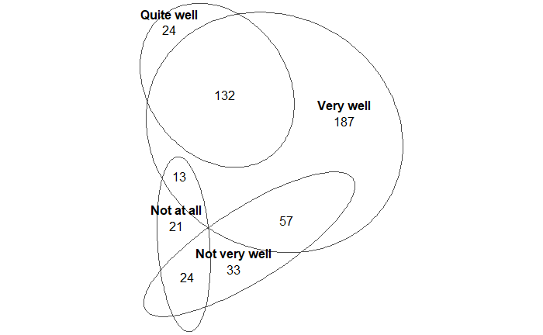
Figure 1. Number of families with different combinations of parental proficiency in speaking Dutch (two-parent households only). The following combinations are missing: not at all and quite well (8 families) and not very well and quite well (36 families).

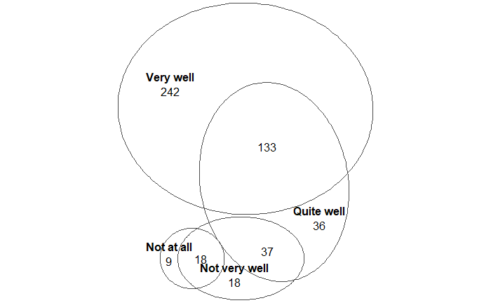
Figure 2. Number of families with different combinations of parental proficiency in understanding Dutch (two-parent households only). The following combinations are missing: not at all and quite well (5 families), not at all and very well (4 families), and not very well and very well (33 families).

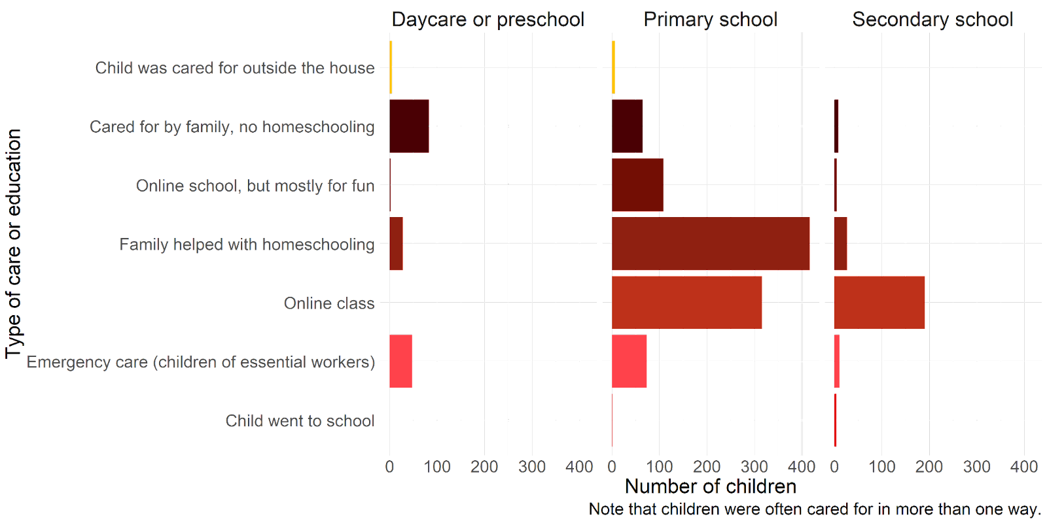
Figure 3. How children were cared for and educated during childcare and school closures.

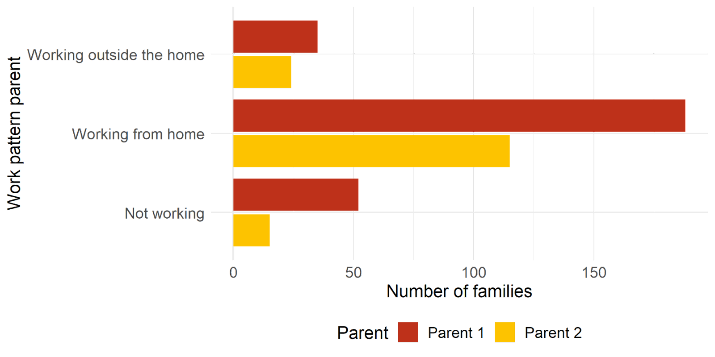
Figure 4. Working patterns for parents involved in homeschooling. Number of parents working from home, working outside the home or not working.

S3. Final models

Table 1a. Summary of optimal Ordinal Logistic Regression model for children's language use.

Coefficients
 | b (SE) | t | p | Odds ratio | 95% CI
Age: Preschool | -0.43 (0.15) | -2.83 | .005 | 0.65 | 0.48, 0.88
Age: Secondary school | 0.02 (0.17) | 0.09 | .924 | 1.02 | 0.73, 1.42
LangParentAtHome: Both | 0.31 (0.25) | 1.27 | .203 | 1.37 | 0.84, 2.21
LangParentAtHome: Dutch only | -0.20 (0.25) | -0.81 | .415 | 0.81 | 0.50, 1.33
Intercepts
 | b (SE) | t | p
More HL | No change | -1.48 (0.24) | -6.13 | <.001
No change | More Dutch | 1.87 (0.24) | 7.64 | <.001
Model fit
Residual deviance = 2077.1; AIC = 2089.1
Dataset: Children attending Dutch-language education, at least one parent at home
Model equation: LangChangeChild ~ Age + LangParentAtHome
Key: Age – reference level = primary school; LangParentAtHome – reference level = Dutch only

Table 1b. Summary of optimal Ordinal Logistic Regression model for children's language use (as Table 1a but with HL only as reference level for LangParentAtHome).
Coefficients
 | b (SE) | t | p | Odds ratio | 95% CI
Age: Preschool | -0.43 (0.15) | -2.83 | .005 | 0.65 | 0.48, 0.88
Age: Secondary school | 0.02 (0.17) | 0.09 | .924 | 1.02 | 0.73, 1.42
LangParentAtHome: Both | 0.52 (0.13) | 3.99 | <.001 | 1.68 | 1.30, 2.17
LangParentAtHome: Dutch only | -0.20 (0.25) | -0.81 | .415 | 1.23 | 0.75, 2.01
Intercepts
 | b (SE) | t | p
More HL | No change | -1.27 (0.11) | -11.12 | <.001
No change | More Dutch | 2.07 (0.13) | 16.20 | <.001
Model fit
Residual deviance = 2077.1; AIC = 2089.1
Dataset: Children attending Dutch-language education, at least one parent at home
Model equation: LangChangeChild ~ Age + LangParentAtHome
Key: Age – reference level = primary school; LangParentAtHome – reference level = HL only

Table 1b. Summary of optimal Ordinal Logistic Regression model for children's language use (as Table 1a but with HL only as reference level for LangParentAtHome and Preschool as reference level for Age).
Coefficients
 | b (SE) | t | p | Odds ratio | 95% CI
Age: Primary school | -0.43 (0.15) | -2.83 | .005 | 1.54 | 1.14, 2.09
Age: Secondary school | 0.45 (0.21) | 2.19 | 0.029 | 1.57 | 1.05, 2.35
LangParentAtHome: Both | 0.52 (0.13) | 3.99 | <.001 | 1.68 | 1.30, 2.17
LangParentAtHome: Dutch only | 0.20 (0.25) | 0.81 | .415 | 1.23 | 0.75, 2.01
Intercepts
 | b (SE) | t | p
More HL | No change | -1.27 (0.11) | -5.58 | <.001
No change | More Dutch | 2.07 (0.13) | 14.70 | <.001
Model fit
Residual deviance = 2077.1; AIC = 2089.1
Dataset: Children attending Dutch-language education, at least one parent at home
Model equation: LangChangeChild ~ Age + LangParentAtHome
Key: Age – reference level = preschool; LangParentAtHome – reference level = HL only

Table 2a. Summary of optimal Ordinal Logistic Regression model for children's language use (homeschooled primary school children only).
Coefficients
 | b (SE) | t | p | Odds ratio | 95% CI
SiblingPresent: Yes | -0.51 (0.23) | -2.25 | .024 | 0.60 | 0.38, 0.93
HomeschoolLang: Both | 0.22 (0.28) | 0.81 | 0.417 | 1.25 | 0.73, 2.14
HomeschoolLang: Dutch only | 1.01 (0.29) | 3.49 | <.001 | 2.76 | 1.56, 4.88
Intercepts
 | b (SE) | t | p
More HL | No change | -1.49 (0.32) | -4.72 | <.001
No change | More Dutch | 1.91 (0.32) | 5.91 | <.001
Model fit
Residual deviance = 921.83; AIC = 931.83
Dataset: Children attending Dutch-language primary school, homeschooled children only
Model equation: LangChangeChild ~ SiblingPresent + HomeschoolLang
Key: SiblingPresent – reference level = No; HomeschoolLang – reference level = HL only

Table 2b. Summary of optimal Ordinal Logistic Regression model for children's language use (homeschooled primary school children only; as Table 2a but with Dutch only as reference level for HomeschoolLang).
Coefficients
 | b (SE) | t | p | Odds ratio | 95% CI
SiblingPresent: Yes | -0.51 (0.23) | -2.25 | .024 | 0.60 | 0.38, 0.93
HomeschoolLang: Both | -0.79 (0.20) | -3.96 | <.001 | 0.45 | 0.31, 0.67
HomeschoolLang: HL only | -1.01 (0.29) | -3.49 | <.001 | 0.36 | 0.20, 0.64
Intercepts
 | b (SE) | t | p
More HL | No change | -2.50 (0.26) | -9.74 | <.001
No change | More Dutch | 0.89 (0.23) | 3.95 | <.001
Model fit
Residual deviance = 921.83; AIC = 931.83
Dataset: Children attending Dutch-language primary school, homeschooled children only
Model equation: LangChangeChild ~ SiblingPresent + HomeschoolLang
Key: SiblingPresent – reference level = No; HomeschoolLang – reference level = Dutch only

Table 3a. Summary of optimal Ordinal Logistic Regression model for sibling’s language use.
Coefficients
 | b (SE) | t | p | Odds ratio | 95% CI
LangSiblings: Both | -1.01 (0.40) | -2.53 | .011 | 0.37 | 0.16, 0.79
LangSiblings: Dutch only | 0.27 (0.40) | 0.67 | .503 | 1.31 | 0.59, 2.92
Intercepts
 | b (SE) | t | p
More HL | No change | -1.75 (0.31) | -5.56 | <.001
No change | More Dutch | 2.56 (0.37 | 6.91 | <.001
Model fit
Residual deviance = 293.98; AIC = 301.98
Dataset: Families with more than 1 child, only parents whose children do not differ in language use patterns
Model equation: LangChangeSiblings ~ LangSiblings
Key: LangSiblings – reference level = HL only

Table 3b. Summary of optimal Ordinal Logistic Regression model for sibling’s language use (as Table 3a but with Dutch only as reference level for LangSiblings).
Coefficients
 | b (SE) | t | p | Odds ratio | 95% CI
LangSiblings: Both | -1.28 (0.39) | -3.27 | .001 | 0.28 | 0.13, 0.59
LangSiblings: HL only | -0.27 (0.40) | -0.67 | .503 | 0.76 | 0.34, 1.68
Intercepts
 | b (SE) | t | p
More HL | No change | -1.75 (0.31) | -6.55 | <.001
No change | More Dutch | 2.56 (0.37 | 6.95 | <.001
Model fit
Residual deviance = 293.98; AIC = 301.98
Dataset: Families with more than 1 child, only parents whose children do not differ in language use patterns
Model equation: LangChangeSiblings ~ LangSiblings
Key: LangSiblings – reference level = Dutch only

Table 4a. Summary of optimal Ordinal Logistic Regression model for children’s language proficiency in Dutch.
Coefficients
 | b (SE) | t | p | Odds ratio | 95% CI
LangParentAtHome: Both | -0.01 (0.34) | -0.04 | 0.969 | 0.99 | 0.51, 1.91
LangParentAtHome: HL only | -1.11 (0.35) | -3.20 | .001 | 0.33 | 0.17, 0.65
Intercepts
 | b (SE) | t | p
Worse | No change | -1.90 (0.33) | -5.77 | <.001
No change | Better | 1.55 (0.33) | 4.78 | <.001
Model fit
Residual deviance = 1175.29; AIC = 1183.29
Dataset: Children attending Dutch-language education, at least one parent at home
Model equation: ChangeNLChild ~ LangParentAtHome
Key: LangParentAtHome – reference level = Dutch only

Table 4b. Summary of optimal Ordinal Logistic Regression model for children’s language proficiency in Dutch (as Table 4a but with HL only as reference level for LangParentAtHome).
Coefficients
 | b (SE) | t | p | Odds ratio | 95% CI
LangParentAtHome: Both | 1.10 (0.17) | 6.33 | <.001 | 2.99 | 2.14, 4.21
LangParentAtHome: Dutch only | 1.11 (0.35) | 3.20 | .001 | 3.03 | 1.54, 5.99
Intercepts
 | b (SE) | t | p
Worse | No change | -0.79 (0.12) | -6.36 | <.001
No change | Better | 2.66 (0.17) | 15.65 | <.001
Model fit
Residual deviance = 1175.29; AIC = 1183.29
Dataset: Children attending Dutch-language education, at least one parent at home
Model equation: ChangeNLChild ~ LangParentAtHome
Key: LangParentAtHome – reference level = HL only

Table 5a. Summary of optimal Ordinal Logistic Regression model for children’s language proficiency in HL(s).
Coefficients
 | b (SE) | t | p | Odds ratio | 95% CI
Age: Preschool | 0.67 (0.19) | 3.60 | <.001 | 1.96 | 1.36, 2.83
Age: Secondary school | -0.16 (0.20) | -0.80 | 0.422 | 0.85 | 0.57, 1.26
Intercepts
 | b (SE) | t | p
Worse | No change | -1.71 (0.12) | -14.22 | <.001
No change | Better | 0.81 (0.10) | 8.19 | <.001
Model fit
Residual deviance =1357.39; AIC = 1365.39
Dataset: Children attending Dutch-language education
Model equation: ChangeHLChild ~ Age
Key: Age – reference level = Primary school

Table 5b. Summary of optimal Ordinal Logistic Regression model for children’s language proficiency in HL(s) (as Table 5a but with preschool as reference level for Age).
Coefficients
 | b (SE) | t | p | Odds ratio | 95% CI
LangParentAtHome: Both | -0.67 (0.19) | -3.60 | <.001 | 0.51 | 0.35, 0.73
LangParentAtHome: Dutch only | -0.84 (0.24) | -3.42 | <.001 | 0.43 | 0.27, 0.70
Intercepts
 | b (SE) | t | p
Worse | No change | -2.38 (0.19) | -12.56 | <.001
No change | Better | 0.14 (0.16) | 0.86 | 0.388
Model fit
Residual deviance =1357.39; AIC = 1365.39
Dataset: Children attending Dutch-language education
Model equation: ChangeNLChild ~ LangParentAtHome
Key: Age – reference level = Preschool

Table 6a. Summary of optimal Ordinal Logistic Regression model for children’s language proficiency in HL(s) (homeschooled primary school children only).
Coefficients
 | b (SE) | t | p | Odds ratio | 95% CI
HomeschoolLang: Both | -0.50 (0.37) | -1.37 | .170 | 0.60 | 0.29, 1.24
HomeschoolLang: Dutch only | -1.37 (0.39) | -3.55 | <.001 | 0.25 | 0.12, 0.54
Intercepts
 | b (SE) | t | p
Worse | No change | -2.32 (0.36 | -6.41 | <.001
No change | Better | 0.00 (0.33) | -0.01 | 0.992
Model fit
Residual deviance =567.83; AIC = 575.83
Dataset: Children attending Dutch-language primary school, homeschooled children only
Model equation: ChangeHLChild ~ HomeschoolLang
Key: HomeschoolLang – reference level = HL only

Table 6b. Summary of optimal Ordinal Logistic Regression model for children’s language proficiency in HL(s) (homeschooled primary school children only; as Table 6a but with Dutch only as reference level for HomeschoolLang).

Coefficients
 | b (SE) | t | p | Odds ratio | 95% CI
HomeschoolLang: Both | 0.86 (0.25) | 3.48 | <.001 | 2.37 | 1.46, 3.87
HomeschoolLang: HL only | 1.37 (0.39) | 3.55 | <.001 | 3.92 | 1.86, 8.45
Intercepts
 | b (SE) | t | p
Worse | No change | -0.96 (0.20) | -4.85 | <.001
No change | Better | 1.36 (0.21) | 6.54 | <.001
Model fit
Residual deviance =567.83; AIC = 575.83
Dataset: Children attending Dutch-language primary school, homeschooled children only
Model equation: ChangeHLChild ~ HomeschoolLang
Key: HomeschoolLang – reference level = Dutch only

Table 7a. Summary of optimal Ordinal Logistic Regression model for families’ well-being.
Coefficients
 | b (SE) | t | p | Odds ratio | 95% CI
Age: Combination | -0.33 (0.21) | -1.58 | 0.114 | 0.72 | 0.48, 1.08
Age: Primary/secondary | -0.57 (0.17) | -3.33 | 0.001 | 0.56 | 0.40, 0.79
Intercepts
 | b (SE) | t | p
Worse | No change | -2.59 (0.18) | -14.40 | <.001
No change | Better | 0.05 (0.16) | 0.35 | 0.728
Model fit
Residual deviance =2094.23; AIC = 2102.23
Dataset: All families except those with post-secondary school-aged children only
Model equation: RelationshipParent ~ Age
Key: Age – reference level = Preschool

Table 7b. Summary of optimal Ordinal Logistic Regression model for families’ well-being (as Table 7a but with Primary/secondary as reference level for Age).
Coefficients
 | b (SE) | t | p | Odds ratio | 95% CI
Age: Combination | 0.24 (0.15) | 1.57 | 0.117 | 1.27 | 0.94, 1.73
Age: Preschool | 0.57 (0.17) | 3.33 | <.001 | 1.77 | 1.27, 2.49
Intercepts
 | b (SE) | t | p
Worse | No change | -2.01 (0.10) | -19.57 | <.001
No change | Better | 0.63 (0.07) | 8.40 | <.001
Model fit
Residual deviance =2094.23; AIC = 2102.23
Dataset: All families except those with post-secondary school-aged children only
Model equation: RelationshipParent ~ Age
Key: Age – reference level = Primary/secondary

Table 7c. Summary of optimal Ordinal Logistic Regression model for families’ well-being (as Table 7a but with Preschool as reference level for Age).
Coefficients
 | b (SE) | t | p | Odds ratio | 95% CI
Age: Combination | -0.19 (0.23) | -0.82 | 0.412 | 0.83 | 0.52, 1.30
Age: Primary/Secondary | -0.44 (0.19) | -2.31 | 0.021 | 0.64 | 0.44, 0.93
Intercepts
 | b (SE) | t | p
Worse | No change | -2.51 (0.20) | -12.49 | <.001
No change | Better | 0.25 (0.17) | 1.45 | 0.148
Model fit
Residual deviance =567.83; AIC = 575.83
Dataset: Families with children who attend Dutch-language education, no families with only post-secondary school-aged children
Model equation: RelationshipParent ~ Age
Key: Age – reference level = Preschool

Table 8. Summary of optimal Ordinal Logistic Regression model for families’ well-being (primary school children only).
Coefficients
 | b (SE) | t | p | Odds ratio | 95% CI
Homeschooler: Yes | 0.65 (0.21) | 3.15 | 0.002 | 1.92 | 1.28, 2.89
Intercepts
 | b (SE) | t | p
Worse | No change | -1.82 (0.20) | -13.79 | <.001
No change | Better | 1.18 (0.17) | 5.58 | <.001
Model fit
Residual deviance =727.55; AIC = 733.55
Dataset: Families with only primary school-aged children attending Dutch-language education
Model equation: RelationshipParent ~ Homeschooler
Key: Homeschooler – reference level = No

S4. Examples of parents’ comments in response to open questions.

On language choice during homeschooling:

“The school told us to do what we can in French and they will do more Dutch after at school”
Parent of a child at primary school, French and English at home, Dutch at school.

“School is in Dutch so courses are in Dutch, no choice .”
Parent of a child at primary school, Dutch, German and English at home, Dutch at school

“My husband and I just kept homeschooling in our own languages”
Parent of a child at primary school, French and Dutch at home, Dutch at school

“I wouldn't ever attempt to teach my child in a language other than my own, because I know I would do her and the language a great disservice”
Parent of a child at primary school, English at home, Dutch at school

“As I don t speak Dutch, I had no choice than to use my mother tongue. And google translate...”
Parent of a child at primary school, Italian and Czech at home, Dutch at school

“My husband cannot speak Dutch, so he would do maths and I would do language exercises”
Parent of a child at primary school, German and English at home, Dutch at school

“Verlengde instructie, toelichting en extra uitleg in het Pools, naast Nederlands”
[“Extended instruction, explanations and additional explanations in Polish, in addition to Dutch”]
Parent of children at primary school, Dutch and Polish at home, Dutch at school

“Ik spreek met het kind mijn eigen taal. Wanneer het om opdrachten enz. gaat dan gebruik ik soms Nederlands. Nederlands is de taal van het onderwijs, en ik wil voorkomen dat er verwarring ontstaat.”
[“I speak my own language to the child. When it comes to assignments etc., then I sometimes use Dutch. Dutch is the language of education, and I want to avoid my child becoming confused.”]
Parent of a child at primary school, German and Dutch at home, Dutch at school

“We hebben moeite Nederlands te spreken en uit te leggen. Het is niet natuurlijk. Natuurlijk hebben wij bij Nederlands in Nederlands geholpen maar rekenen bijvoorbeeld zal ik in mijn eigen taal uitleggen.”
[“We struggle to speak and to explain in Dutch. It’not natural. Of course for the subject Dutch we helped in Dutch but for maths, for example, I explain in my own language.”]
Parent of children at primary school, German and Hindi at home, Dutch at school

“Math was explained in the mother tongue and then repeated in Dutch, symbols were mixed into the mother tongue if vocabulary was only present in Dutch in the child’s vocabulary. Explanations were given in Hungarian, fill in exercises were completed in Dutch.”
Parent of a child at primary school, Hungarian at home, Dutch at school

“Ik vond dat het voor rekenen niet uit maakte welke taal we gebruikten dus legde ik dat in het Duits uit. Maar ook bij taal stelde ik de vragen vaak in het Duits.”
[“I felt that for maths it didn't matter which language we used so I explained it in German. But also for the subject ‘language’ [= Dutch, ed.], I often asked the questions in German.”]
Parent of children at primary school, German at home, Dutch at school
On changes in family well-being:

Positive changes

"Broer en zus zijn heel close geworden en konden goed samen spelen (en ook ruziën )"
[“Brother and sister became very close and could play (and also argue) well together ”]
Parent of 2 children, Dutch and Greek at home

“The kids have been very resilient. They are usually good friends with each but they really stuck together and supported each other during the lockdown. It was actually very cool to watch :)”
Parent of 2 children, Dutch and English at home

“Between the children at home, they learned to help each other more when I am busy with work”
Parent of 2 children, English and Malayalam at home

“De twee kinderen moesten ondanks het leeftijdsverschil (1 en 4) vaak met elkaar spelen omdat er geen andere opties waren. Dat heeft hen wel dichter tot elkaar gebracht.”
[“Despite the age difference (1 and 4), the two children often had to play with each other because there were no other options. That did bring them closer together.”
Parent of 2 children, Frisian at home

“We hadden het thuis erg goed en gezellig. Omdat we op elkaar aangewezen waren, moesten we ons samen vermaken. Dat is goed gelukt.”
[“We had a very good and cosy time at home. Because we were dependent on each other, we had to enjoy ourselves together. That worked out well.”]
Parent of 2 children, Frisian at home

“We spent so much time together, which created a strong bond. I followed his developments as closely as never before.”
Parent of 1 child, German and French at home

“Because of homeschooling, I got involved in his school activities, books and so forth. I have a much better picture of what he is learning. What is his level and what does he like more and less.”
Parent of 1 child, Dutch, German and Spanish at home

“Their togetherness became more strong. Since they were missing their usual schoolmates, they had sometimes only each other to play. I have the feeling that they bonded more, found common ground in their very different interests and managed to play more together.”
Parent of 2 children, Greek and Spanish at home

“Door verbetering van de talige communicatie en het meer thuis zijn van mijn man, is de relatie met onze dochter nog hechter geworden.”
[“With improved linguistic communication and my husband being home more, the relationship with our daughter has become even closer.”]
Parent of 2 children, English, Portuguese and Dutch at home

Negative changes

“Meer dan gebruikelijk op elkaars lip zitten leidt tot meer confrontaties en ruzies ergo verslechterd de relatie iets. Plus de veranderde werkinrichting en - beleving van de ouder die tot stress en dus een kort lontje leidt.”
[“Being on each other's lips more than usual leads to more confrontations and arguments ergo the relationship deteriorates slightly. Plus changes in how the parents work and their experience has lead to stress and thus a short fuse."]
Parent of 2 children, German and Dutch at home

“I don't want to be a teacher for my child but I had to, so this led us to arguments. I feel bad for those arguments.”
Parent of 1 child, Turkish and Dutch at home

“Mijn zoon vind dat zijn moeder een bazige juf is.”
[“My son thinks his mother is a bossy teacher."]
Parent of 1 child, Greek and Dutch at home

“Well, we got all tired sitting in one place, and the most pressure for learning was from me, hence it got a little worse I suppose. We were all tired.”
Parent of 3 children, Russian and Dutch at home

“We were stressed, used screen time a lot more, and lost patience with the kids, for example yelling more than we used to.”
Parent of 2 children, English and Hungarian at home

Bit of both

“We hebben veel meer tijd met de kinderen en onderling doorgebracht. Soms was dat pittig, maar over het algemeen was het erg waardevol.”
[“We spent a lot more time with the children and among ourselves. Sometimes that was tough, but overall it was very valuable.”]
Parent of 3 children, Frisian at home

“We are forced to spend a lot of time together. This is a double-edged sword, of course. Because we're around each other so much, there are ample opportunities for communication, but we also experience plenty of moments of cabin fever. There's only so much togetherness one can take.”
Parent of 1 child, English and Dutch at home

“I feel that I was very stressed having the kids home 24/7 while also trying to work and run the house. I feel this affected my relationship with them as I was very tired all the time and was more irritable because of this. My husband on the other hand has bonded more with the kids since he now spends more time with them.”
Parent of 2 children, English and Dutch at home

“Jullie vragen gaan over de pandemie, maar ik merk een verschil tussen de eerste lockdown en de tweede lockdown. Tijdens de eerste lockdown, bijvoorbeeld, waren de kinderen echt gehecht aan elkaar, ze zochten elkaar veel en ze speelden heel fijn samen. Ze spraken niet af met andere kinderen. Tijdens de tweede lockdown, was de moed veel minder in thuisonderwijs, ze ergerden veel vaker aan elkaar, de irritaties liepen veel sneller op, ze speelden veel vaker met andere vriendjes. Dus het antwoord aan deze vraag is niet zo simpel.”
[“Your questions are about the pandemic, but I notice a difference between the first lockdown and the second lockdown. During the first lockdown, for example, the children were really attached to each other, they looked for each other a lot and they played very nicely together. They did not meet up with other children. During the second lockdown, motivation for homeschooling wasn’t as high, they annoyed each other much more often, they got irritated with each other much faster, they played with other friends much more often. So the answer to this question is not so simple."”
Parent of 2 children, Italian and Dutch at home

“There's good days, there's bad days, but they average each other in the end.”
Parent of 2 children, Portuguese at home

