Supplemental Materials

Deviations from the Pre-registration
The current study was conducted as a component study under a larger project which aimed to collect longitudinal monthly data from 100 French–English bilingual infants during 16 to 30 months (https://osf.io/a9f4d/). The larger project was initiated with the intention of being able to investigate a variety of research questions that would only be possible from a dense, longitudinal dataset of vocabulary measured in both languages. Conceptualization and data analysis plan of the current study was pre-registered and conducted after the data collection for the larger project had already begun but before data collection was completed, as it was the basis of an undergraduate honours thesis, thus the current sample represents a subset of the larger project’s target sample. In this document, we detailed deviations from the pre-registration for the current study (https://osf.io/6fk8r/).
First of all, while the pre-registered data collection plan followed the larger study and stated that a final language exposure questionnaire would be collected at 30 months, none of the participating infants in the current study reached 30 months of age when this study concluded, thus our analyses used the last available language exposure questionnaire for each infant.
Next, we also slightly modified the cognate list as mentioned in the section “Identification of Translation Equivalents and Cognates”. The pre-registration stated that there were 132 cognates in the cognate list; but it was in fact missing a few onomatopoeias and nouns. Those were then added back to the cognate list, leading to a total of 138 cognates and 473 non-cognates in the current study. Therefore, the number of items subsequently described in the section “Identification of Translation Equivalents and Cognates” also slightly deviated from the pre-registration accordingly.
Finally, with regards to the data analysis strategy, we deviated from the pre-registered plan by using proportion of words as the dependent variable instead of the raw number of words. Proportion was used as opposed to raw number of words to provide a more comparable description of production of cognates versus non-cognates, since the number of cognate words and non-cognate words differed especially in the complete list. We note that the use of proportions should not change the pattern of statistical significance. Since the dependent variables were now proportion data, logistic regression models were used rather than linear regression models as pre-registered. Moreover, in addition to analyzing the number of translation equivalent pairs as pre-registered, the main paper included an additional exploratory analysis that looked at the interval between infants producing a word and producing its translation equivalent, as a function of whether the pairs were cognates or non-cognates.

Analyses Using the More Stringent 25%–75% Language Exposure Criterion
Using the more stringent 25%–75% language exposure criterion, we further eliminated a total of 9 bilingual infants who had a wider language exposure range. This left us with data from 41 participants (23 girls; mean starting age = 18.00 months, $SD$ = 1.17, range = 16.20 – 20.40; mean ending age = 21.84 months, $SD$ = 3.43, range = 16.30 – 27.14), with 180 English CDI administrations and 176 French CDI administration. As in the main pre-registered analysis, we retained only those administrations where both the English and French were completed at the same time point; this gave us 172 completed administrations from 38 infants. Among the 38 infants, 5 infants contributed data at only one time point, and 33 infants contributed data at more than one time point, with participants contributing an average of 4.53 measurements for each language ($SD$ = 2.63, range = 1 – 10).
On average, this group of 38 infants were exposed to English 50.90% of the time ($SD$ = 10.70, range = 26 – 74), to French 48.50% of the time ($SD$ = 11.20, range = 26 – 74), and to a third language 0.60% of the time ($SD$ = 1.50, range = 0 – 5). 22 of the bilingual infants were English-dominant ($M$ = 57.30% English exposure, $SD$ = 7.70, range = 49 – 74), 15 were French-dominant ($M$ = 59.40% French exposure, $SD$ = 6.10, range = 51 – 74), and 1 reported equal exposure to both English and French. The average maternal education level was 17.32 years ($SD$ = 2.00, range = 12 – 23), and 92.11% of the mothers had completed a university degree or higher.
Descriptive Measures of Number of Words Produced
Out of the complete list, bilingual infants on average produced a total of 164 words ($SD$ = 170.16), with a range of 0 – 709 words, which constituted 15.28% of the words on the complete list. Moreover, they produced an average of 44 complete translation equivalent pairs where both the English and French words were produced ($SD$ = 54.52, range = 0 – 243), which constituted 8.27% of the translation equivalent pairs on the complete list.
As for the matched list, bilingual infants produced an average of 53 words ($SD$ = 64.23, range = 0 – 248), which constituted 16.49% of the words on the matched list. On average, bilingual infants produced a total of 14 complete translation equivalent pairs ($SD$ = 22.52, range = 0 – 92), which constituted 8.79% of translation equivalent pairs on the matched list.

Dependent Variable 1: Cognate Words Versus Non-Cognate Words
Following the procedure in the main analysis, we first looked at the total proportion of words infants produced on the relevant list. Our predictor variables were age (in days) and cognate status. Age was continuous and was centered at the mean age of 548.3 days (approximately 18 months) for ease of interpretation. Cognate status was categorical with two levels (cognates versus non-cognates) with non-cognates as the reference level. We ran separate logistic regression models for the complete and matched lists. The initial model specification included a random slope of age and cognate status by participants, which was pruned to a random intercept to achieve model convergence. The final model was:
proportion_word ~ age * cognate_status + (1|participant)
Complete List. Out of the complete list which contained 262 cognate words (i.e., adding the 131 English cognate words and 131 French cognate words) and 812 non-cognate words (i.e., adding the 406 English non-cognate words and 406 French non-cognate words), bilingual infants produced an average of 56 cognate words ($SD$ = 48.84, range = 0 – 204) and 108 non-cognate words ($SD$ = 121.96, range = 0 – 505). The proportion of cognate words produced was 0.21 ($SD$ = 0.19, range = 0 – 0.78), whereas the proportion of non-cognate words produced was 0.13 ($SD$ = 0.15, range = 0 – 0.62). Table S1 shows the coefficient estimates for the model and Figure S1 Panel A visualizes the model. Similar to the results reported in the main analysis, we observed significant main effects of age and cognate status, as well as a significant interaction. Overall, the pattern of results was the same as that of the main analysis.
Matched List. Out of the 162 cognate (i.e., adding the 81 English cognate words and 81 French cognate words) and 162 non-cognate words (i.e., adding the 81 English non-cognate words and 81 French non-cognate words) on the matched list, bilingual infants produced an average of 29 cognate words ($SD$ = 33.82, range = 0 – 135) and 25 non-cognate words ($SD$ = 30.62, range = 0 – 113). The overall mean proportion of cognate words produced was 0.18 of words ($SD$ = 0.21, range = 0 – 0.83), whereas the proportion of non-cognate words produced was 0.15 ($SD$ = 0.19, range = 0 – 0.70). Table S1 also shows the coefficient estimates for the matched list model and Figure S1 Panel B visualizes the model. There were significant effects of age and cognate status, once again showing that infants produced a greater proportion of cognates than non-cognates on the matched list; there was no interaction between cognate status and age. Again, we observed the same patterns as those reported in the main analysis.

Table S1. Coefficient estimates from the logistic mixed-effects models predicting proportion of words produced.
 | Complete list |  |  |  |  | Matched list
 | Estimate | $$SE$$ | $$z$$ | $$p$$ |  | Estimate | $$SE$$ | $$z$$ | $$p$$
Intercept | -2.58 | 0.17 | -15.10 | <.001 |  | -2.81 | 0.25 | -11.44 | <.001
cognate_status | 0.76 | 0.02 | 44.28 | <.001 |  | 0.24 | 0.03 | 7.77 | <.001
age_days | 0.01 | 0.00 | 75.69 | <.001 |  | 0.01 | 0.00 | 40.64 | <.001
cognate_status * age_days | 0.00 | 0.00 | -5.76 | <.001 |  | 0.00 | 0.00 | 0.57 | 0.572
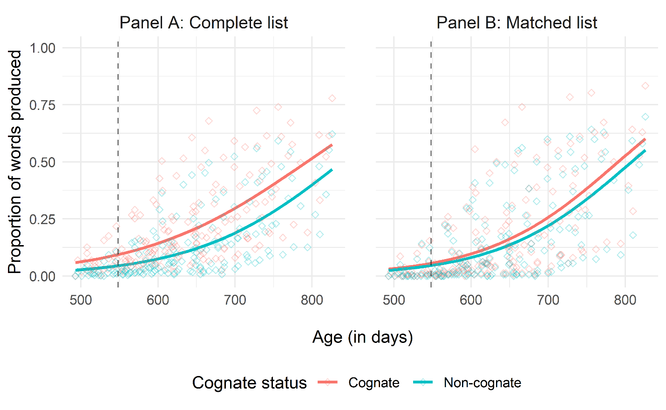
Figure S1. Proportion of words produced by age and cognate status, with Panel A representing the complete list and Panel B representing the matched list. Note that the black dashed line represents the mean age of 548.3 days which serves as the reference level for age in our models.

Dependent Variable 2: Cognate Pairs Versus Non-Cognate Pairs
Again, following the procedure reported in the main analysis, the proportion of translation equivalent pairs produced was entered as the dependent variable in the following analysis. Age and cognate status were entered as our predictor variables, with non-cognates set as the reference level, and we ran separate logistic models for the complete and matched lists. The initial model specification, which included a random effect of age and cognate status by participants, had to be reduced for model convergence; therefore, the final model was:
proportion_pair ~ age * cognate_status + (1|participant)
Complete List. Out of the complete list which contained 537 translation equivalent pairs (131 cognates and 406 non-cognates), bilingual infants produced an average of 19 cognate pairs ($SD$ = 19.39, range = 0 – 82) and 26 non-cognate pairs ($SD$ = 35.57, range = 0 – 167). The proportion of cognate pairs produced was 0.14 ($SD$ = 0.15, range = 0 – 0.63) whereas the proportion of non-cognate pairs produced was 0.06 ($SD$ = 0.09, range = 0 – 0.41). Table S2 shows the coefficient estimates for the model and Figure S2 Panel A visualizes the model. Again, similar to the pattern reported in the main analysis, there were significant effects of age and cognate status and a significant interaction between age and cognate status. Therefore, we observed the same findings as in the main analysis, where overall infants produced a greater proportion of cognates than non-cognates and there is a slightly steeper learning curve for non-cognates than cognates.
Matched List. Out of the 162 translation equivalent pairs, bilingual infants produced an average of 9 cognate pairs ($SD$ = 13.18, range = 0 – 58) and 6 non-cognate pairs ($SD$ = 9.64, range = 0 – 42). The proportion of cognate pairs produced was 0.11 ($SD$ = 0.16, range = 0 – 0.72) and the proportion of non-cognate pairs produced was 0.07 ($SD$ = 0.12, range = 0 – 0.52). The coefficient estimates for the matched list model is shown in Table S2, and Figure S2 Panel B visualizes the model. Again, we observed similar pattern of results as those reported in the main analysis, with significant effects of age and cognate status but no significant interaction between age and cognate status.

Table S2. Coefficient estimates from the logistic mixed-effects models predicting proportion of translation equivalent pairs produced.
 | Complete list |  |  |  |  | Matched list
 | Estimate | $$SE$$ | $$z$$ | $$p$$ |  | Estimate | $$SE$$ | $$z$$ | $$p$$
Intercept | -3.58 | 0.17 | -20.64 | <.001 |  | -4.18 | 0.28 | -14.78 | <.001
cognate_status | 1.17 | 0.03 | 36.96 | <.001 |  | 0.64 | 0.07 | 9.88 | <.001
age_days | 0.01 | 0.00 | 43.62 | <.001 |  | 0.01 | 0.00 | 24.27 | <.001
cognate_status * age_days | 0.00 | 0.00 | -5.58 | <.001 |  | 0.00 | 0.00 | -0.79 | 0.430

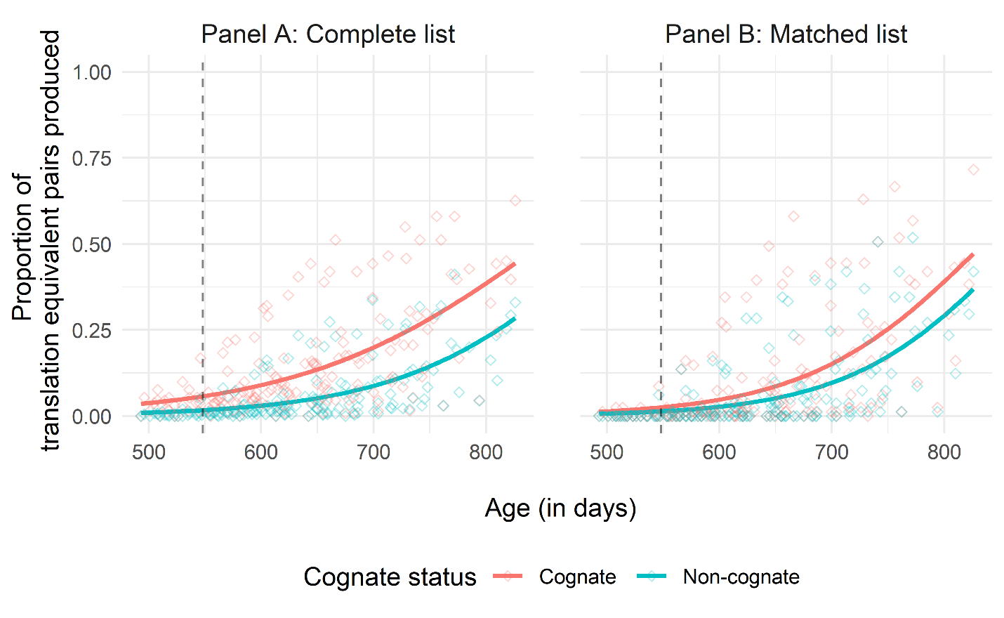
Figure S2. Proportion of translation equivalent pairs produced by age and cognate status, with Panel A representing the complete list and Panel B representing the matched list. Note that the black dashed line represents the mean age of 548.3 days which serves as the reference level for age in our models.

Exploratory Analysis: Interval between Producing Translation Equivalents
Similar to the main analysis, we also ran an exploratory analysis exploring whether the interval between producing a word and its translation equivalent would be shorter for cognates than for non-cognates. Following the procedure in the main paper, the analyses were limited to translation equivalent pairs that an infant learned to produce both words during the course of their participation in the current study. To fulfill such criteria, it left us with a total of 380 translation equivalent pairs (112 cognate and 268 non-cognate pairs) on the complete list and 137 translation equivalent pairs (73 cognate and 64 non-cognate pairs) on the matched list. On average, each infant produced 18 cognate pairs ($SD$ = 19.25, range = 1 – 81) and 32 non-cognate pairs ($SD$ = 39.40, range = 1 – 133) on the complete list, and 12 cognate pairs ($SD$ = 14.53, range = 1 – 58) and 12 non-cognate pairs ($SD$ = 11.51, range = 1 – 34) on the matched list.
A linear mixed-effects model was then run on the number of days in between when the first word of a pair was reported to have been produced and when its translation equivalent was reported to have been produced. Cognate status was entered as fixed effects (with non-cognates as the reference level), and participants and word pairs were entered as random intercepts:
interval_days ~ cognate_status + (1|participant) + (1|word_pair)
Complete List. After having produced a word, on average, bilingual infants took 41.24 days ($SD$ = 28.35, range = 0 – 182) to produce its translation equivalent when it was a cognate and 54.48 days ($SD$ = 32.34, range = 0 – 221) to produce it when it was a non-cognate. Figure S3 Panel A visualizes this model. The effect of cognate status was statistically significant, $estimate$ = -10.28, $SE$ = 3.20, $t$ = -3.21, $p$ < .01. Therefore, the same result was observed as the one reported in the main analysis, where the interval between learning to produce a word and its translation equivalent was shorter for cognate pairs than for non-cognate pairs.
Matched List. After having produced a word, on average, bilingual infants took 45.24 days ($SD$ = 29.21, range = 0 – 182) to produce its translation equivalent when it was a cognate and 57.43 days ($SD$ = 33.75, range = 0 – 221) to produce it when it was a non-cognate. Figure S3 Panel B visualizes this model. Once again, similar to the results for the complete list, we observed the same pattern as in the main analysis with a significant main effect of cognate status, $estimate$ = -13.10, $SE$ = 4.82, $t$ = -2.72, $p$ < .01.
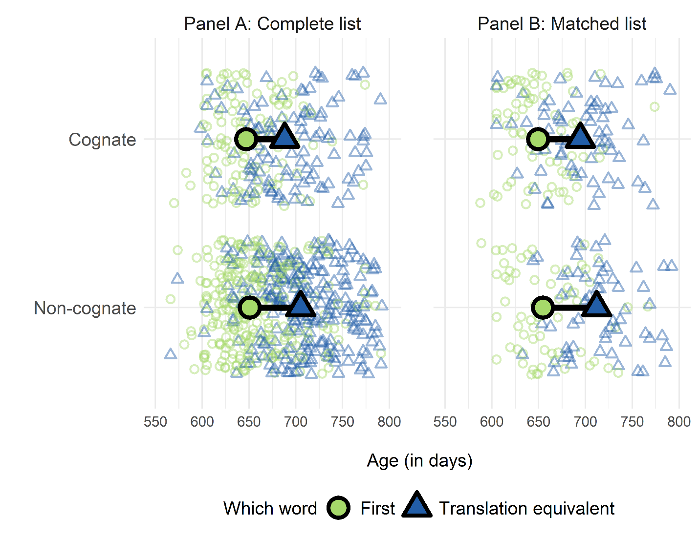
Figure S3. Average intervals between production of the first words (light green circles) and their translation equivalent (dark blue triangles), by cognate status and age. Panel A represents the complete list and Panel B represents the matched list. Smaller individual circles and triangles plot data of the first words and translation equivalent words, respectively, from each word pair.
Summary of Analyses
Overall, the result patterns observed here with the more stringent language exposure criterion were consistent with those reported in the main analysis. This suggests that the cognate effect we observed in our pre-registered analysis was robust across different language exposure inclusion criteria.

