Appendix 2: Sample pictures

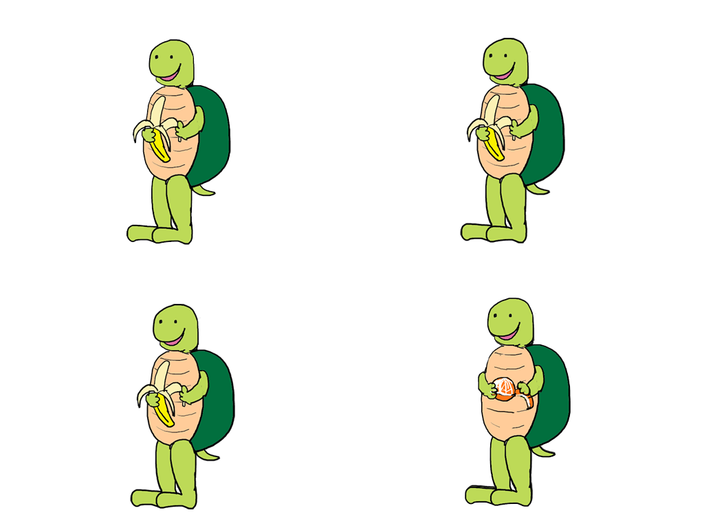
Sample picture for Filler 1 (“Every turtle is peeling a banana.”)

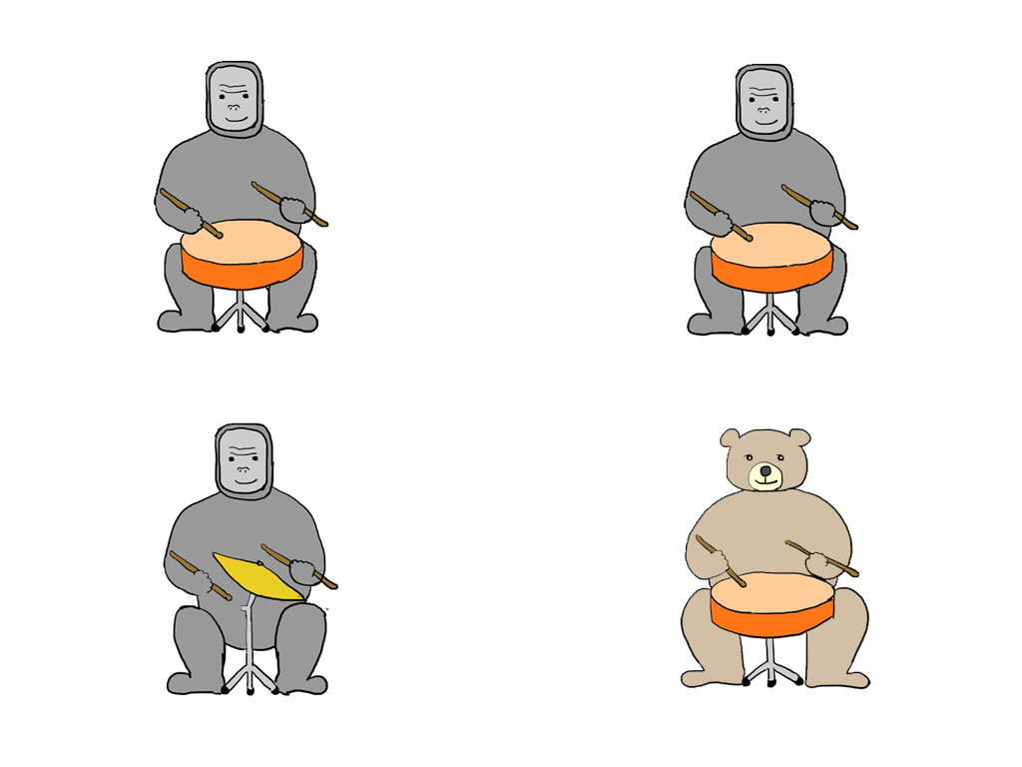
Sample picture for Filler 2 (“Every gorilla is hitting a drum.”)

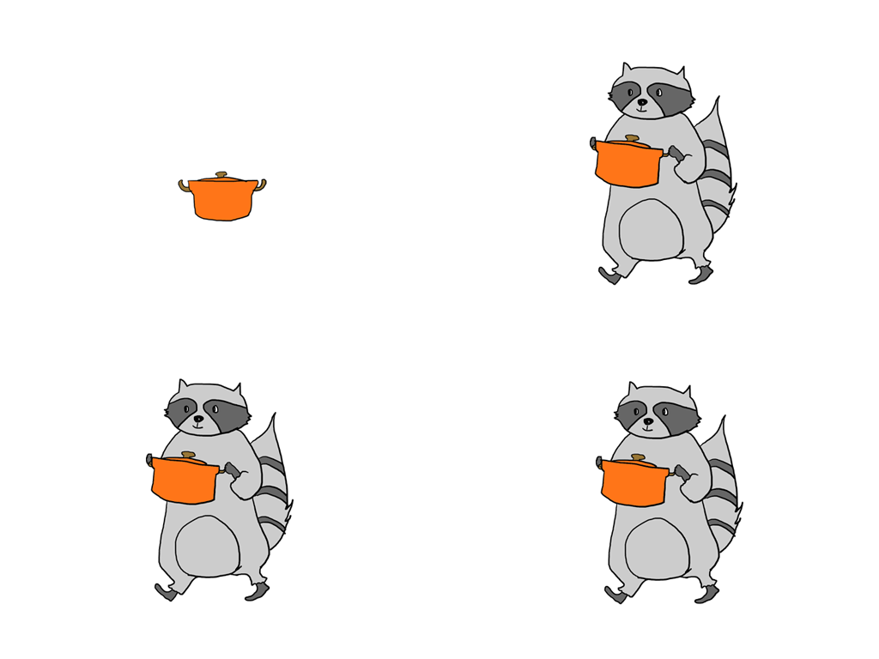
Sample picture for Filler 3 (“Three raccoons are carrying a pot.”)

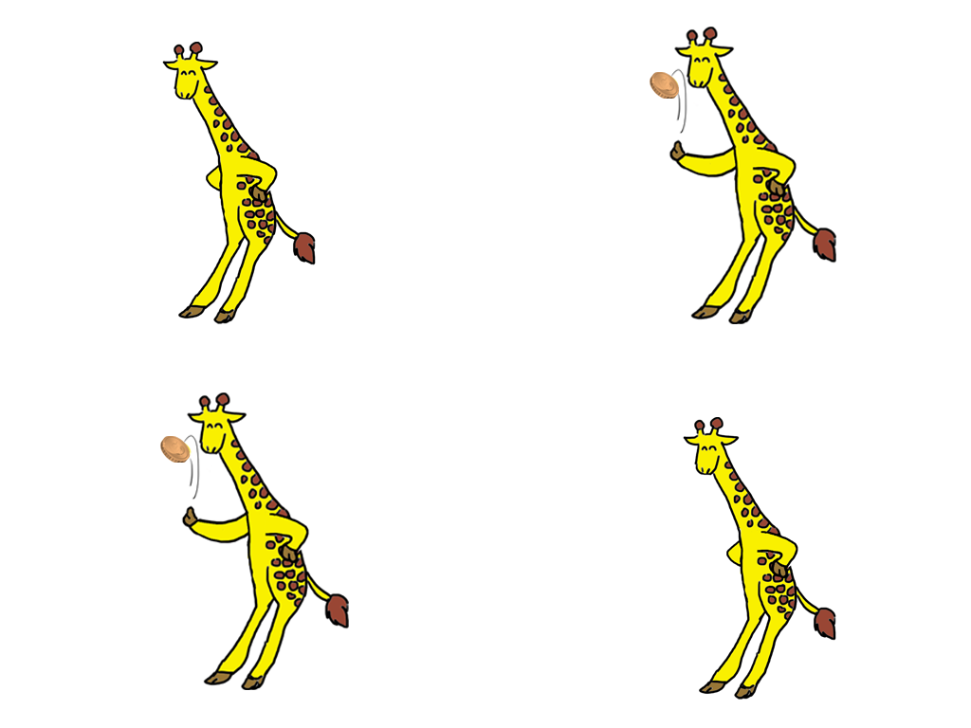
Sample picture of Filler 4 (“Three giraffes are tossing a coin.”)

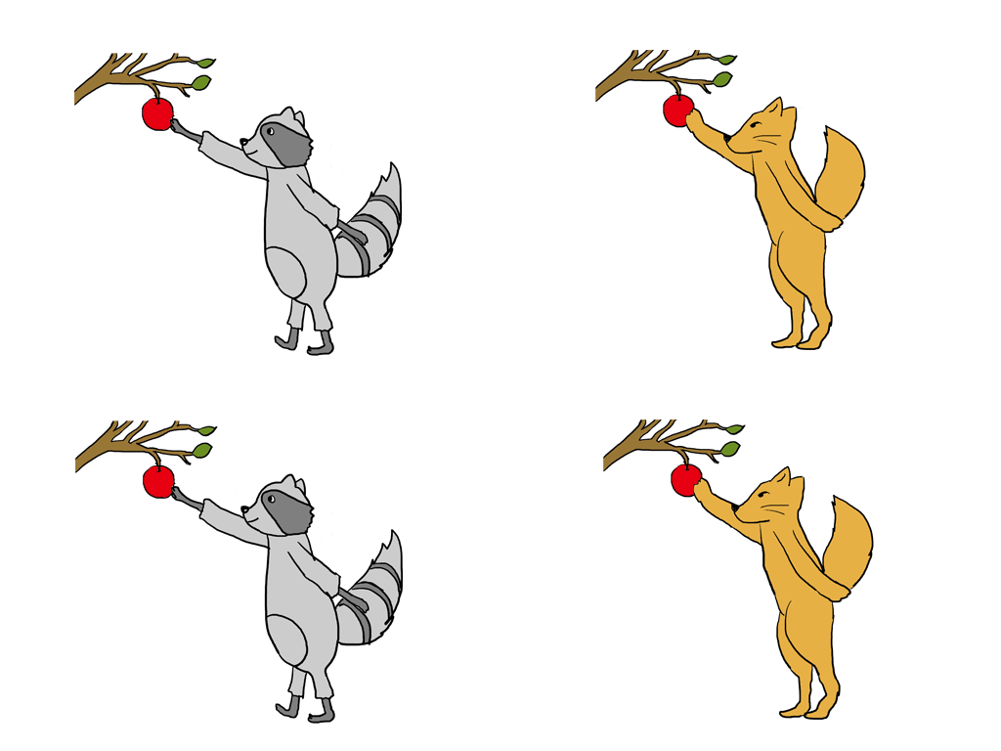
Sample picture for Filler 5 (“Three fixes are picking an apple.”)

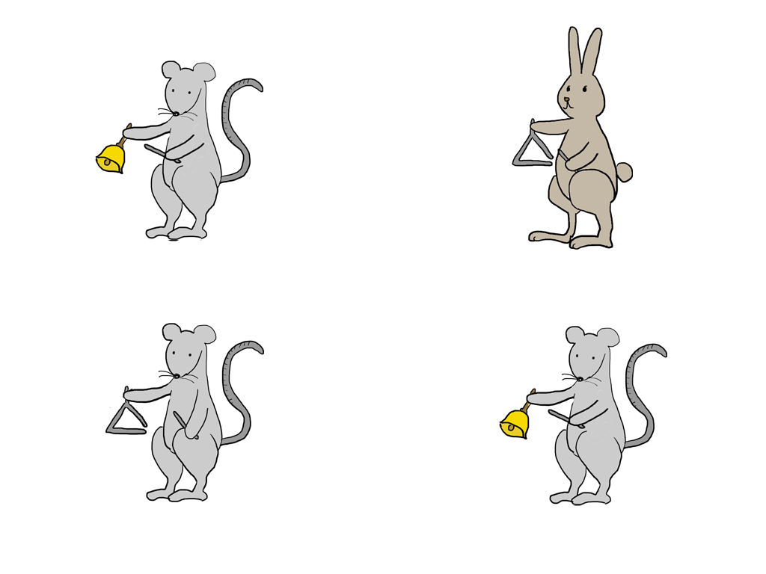
Sample picture for Filler 6 (“Three mice are hitting a bell.”)

