Online appendix
for the paper “All spending is not equal: European Union public spending, policy feedback, and citizens’ support for the EU”

Table of contents

Appendix A. Tables
Table A1. Operationalization | 2
Table A2. Summary statistics | 5
Table A3. Correlation matrix | 6
Table A4. Budgetary items in spending categories | 7

Appendix B. Robustness checks
Table B1. Robustness check for Environment spending using Waste | 10
Table B2. Replication of Table 1 including Identity | 11
Table B3. Replication of Table 2 using Identity | 12
Table B4. Replication of Table 1 including Count | 13
Table B5. Replication of Table 2 including Count | 14
Table B6. Replication of Table 2 including interactions with Count | 15
Table B7. Replication of Table 1 with National unemployment | 16
Table B8. Replication of Table 1 with National fiscal transfers | 17
Table B9. Replication of Table 1 with National GDP | 18
Table B10: Replication of Table 2 with National unemployment | 19
Table B11: Replication of Table 2 with National fiscal transfers | 20
Table B12: Replication of Table 2 with National GDP | 21
Figure B1. Public support and European spending across EU member states and over time | 23
Figure B2. European spending across issue areas | 24
Figure B3. Marginal effect of Agriculture spending on Support at different levels of Utilized agricultural area | 25
Figure B4. Marginal effect of Energy spending on Support at different levels of Population density | 26
Figure B5. Marginal effect of Environment spending on Support at different levels of Waste | 27
Figure B6. Marginal effect of Human capital spending on Support at different levels of High-Skilled Labor, by Identity | 28
Figure B7. Marginal effect of Infrastructure spending on Support at different levels of Motorways, by Identity | 29
Figure B8. Marginal effect of Environment spending on Support at different levels of Rurality, by Identity | 30
Figure B9. Marginal effect of Agriculture spending on Support at different levels of Count | 31
Figure B10. Marginal effect of Human capital spending on Support at different levels of High-skilled labor, by Knowledge | 32
Figure B11. Marginal effect of Infrastructure spending on Support at different levels of Motorways, by Knowledge | 33
Figure B12. Marginal effect of Environment spending on Support at different levels of Rurality, by Knowledge | 34

Appendix A. Tables

Table A1. Operationalization
Variable | Measurement |  | Source | Year
Support | Individual-level measure based on the question: Generally speaking, do you think that (our country’s) membership of the European Union is: 0 (a bad thing), 1 (neither good nor bad), or 2 (a good thing)? | Eurobarometer 56.1, 60.1, 61.0, 62.0, 63.4, 64.2, 65.2, 66.1, 68.1, 69.2, 70.1, 71.3, 72.4, 73.4, 74.2, 75.3 |  | 2001, 2003, 2004, 2005, 2006, 2007, 2008, 2009, 2010, 2011
Human capital | Regional-level measure of the sum of ESIF in a region in 1000 Euro per capita, total sum. Categories: Human capital, physical capital, and innovation, see Table A4 | European Commission DG Regio Datawarehouse C3. |  | 2000-2006, 2007-2013
Infrastructure | Regional-level measure of the sum of Structural Funds investment in a region in 1000 Euro per capita, total sum. Categories: Transport and infrastructure, see Table A4 | European Commission DG Regio Datawarehouse C3. |  | 2000-2006, 2007-2013
Agriculture | Regional-level measure of the sum of Structural Funds investment in a region in 1000 Euro per capita, total sum. Categories: Agriculture, forest, tourism, and fishery, see Table A4 | European Commission DG Regio Datawarehouse C3. |  | 2000-2006, 2007-2013
Energy | Regional-level measure of the sum of Structural Funds investment in a region in 1000 Euro per capita, total sum. Categories: Energy, see Table A4 | European Commission DG Regio Datawarehouse C3. |  | 2000-2006, 2007-2013
Environment | Regional-level measure of the sum of Structural Funds investment in a region in 1000 Euro per capita, total sum. Categories: Environment, see Table A4 | European Commission DG Regio Datawarehouse C3. |  | 2000-2006, 2007-2013
Population | Population on the first of January | Eurostat |  | 2001, 2003, 2004, 2005, 2006, 2007, 2008, 2009, 2010, 2011
High-skilled employment | Persons with tertiary education (ISCED) and/or employed in science and technology, in % of the total population | Eurostat |  | 2001, 2003, 2004, 2005, 2006, 2007, 2008, 2009, 2010, 2011
Motorways | Extension of road networks in kilometers per thousand square kilometers | Eurostat |  | 2001, 2003, 2004, 2005, 2006, 2007, 2008, 2009, 2010, 2011
Utilized agricultural area | Utilized agricultural area in 1,000 ha | Eurostat |  | 2001, 2003, 2004, 2005, 2006, 2007, 2008, 2009, 2010, 2011
Population density (log) | The ratio between the annual average population and geographical size of region in square kilometers | Eurostat |  | 2001, 2003, 2004, 2005, 2006, 2007, 2008, 2009, 2010, 2011
Rurality | Geographical size in square kilometers | Eurostat |  | 2001, 2003, 2004, 2005, 2006, 2007, 2008, 2009, 2010, 2011
Manual worker | Individual-level measure based on the question: What is your current occupation? 1 if employed position (service job), supervisor, skilled manual worker or unskilled manual worker, 0 otherwise | Eurobarometer 56.1, 60.1, 61.0, 62.0, 63.4, 64.2, 65.2, 66.1, 68.1, 69.2, 70.1, 71.3, 72.4, 73.4, 74.2, 75.3 |  | 2001, 2003, 2004, 2005, 2006, 2007, 2008, 2009, 2010, 2011
GDP | Regional-level GDP in purchasing power standards per inhabitant | Eurostat |  | 2001, 2002, 2003, 2004, 2005, 2006, 2007, 2008, 2009, 2010, 2011
Trust in govern-ment | Individual-level measure based on the question: I would like to ask you a question about how much trust you have in certain institutions. For each of the following institutions, please tell me if you tend to trust it or tend not to trust it. The (NATIONALITY) government: 1 (tend to trust), 0 (tend not to trust) | Eurobarometer 56.1, 60.1, 61.0, 62.0, 63.4, 64.2, 65.2, 66.1, 68.1, 69.2, 70.1, 71.3, 72.4, 73.4, 74.2, 75.3 |  | 2001, 2003, 2004, 2005, 2006, 2007, 2008, 2009, 2010, 2011
Knowledge | Dichotomous, individual-level measure based on the following question: Have you heard of the European Commission? 1 (Yes); 0 (No) | Eurobarometer 56.1, 60.1, 61.0, 62.0, 63.4, 64.2, 65.2, 66.1, 68.1, 69.2, 70.1, 71.3, 72.4, 73.4, 74.2, 75.3 |  | 2001, 2003, 2004, 2005, 2006, 2007, 2008, 2009, 2010, 2011
Education | 9-point indicator measuring at what age a respondent has finished formal education. It is coded: 1 (up to 14 years), 2 (15), 3 (16), 4 (17), 5 (18), 6 (19), 7 (20), 8 (21), 9 (22 years and older) | Eurobarometer 56.1, 60.1, 61.0, 62.0, 63.4, 64.2, 65.2, 66.1, 68.1, 69.2, 70.1, 71.3, 72.4, 73.4, 74.2, 75.3 |  | 2001, 2003, 2004, 2005, 2006, 2007, 2008, 2009, 2010, 2011
Age | Continuous individual-level measure based on the question: How old are you? | Eurobarometer 56.1, 60.1, 61.0, 62.0, 63.4, 64.2, 65.2, 66.1, 68.1, 69.2, 70.1, 71.3, 72.4, 73.4, 74.2, 75.3 |  | 2001, 2003, 2004, 2005, 2006, 2007, 2008, 2009, 2010, 2011
Gender | Dichotomous, individual-level measure that is 1 for females and 0 for males | Eurobarometer 56.1, 60.1, 61.0, 62.0, 63.4, 64.2, 65.2, 66.1, 68.1, 69.2, 70.1, 71.3, 72.4, 73.4, 74.2, 75.3 |  | 2001, 2003, 2004, 2005, 2006, 2007, 2008, 2009, 2010, 2011
Crisis | Dichotomous measure that is 1 for the years 2007 and 2008 and 0 otherwise. |  |  | 2001, 2003, 2004, 2005, 2006, 2007, 2008, 2009, 2010, 2011
Waste | Waste in thousand tonnes |  |  | 2001, 2003, 2004, 2005, 2006, 2007, 2008, 2009, 2010, 2011
European identity | The wording of the two questions used for this indicator is as follows. 1. Please tell me how attached you feel to the European Union. 0 (Not at all attached), 1 (Not very attached), 2 (Fairly attached), 3 (Very attached). 2. For each of the following statements, please tell me to what extent it corresponds to your own opinion. ’You feel you are a citizen of the EU’. 0 (No, definitely not), 1 (No, not really), 2 (Yes, to some extent) to 3 (Yes, definitely). The second variable is used from 2010, the former until 2010. | Eurobarometer 60.1, 62.0, 63.4, 65.2, 68.1, 73.4 |  | 2003, 2004, 2005, 2006, 2007, 2010
National unemployment | Unemployment rate by sex and age – annual average | Eurostat |  | 2001, 2002, 2003, 2004, 2005, 2006, 2007, 2008, 2009, 2010, 2011
National fiscal transfers | Fiscal Transfers as % of GNI | Eurostat |  | 2001, 2002, 2003, 2004, 2005, 2006, 2007, 2008, 2009, 2010, 2011
National GDP | Country-level GDP in purchasing power standards per inhabitant | Eurostat |  | 2001, 2002, 2003, 2004, 2005, 2006, 2007, 2008, 2009, 2010, 2011
Notes: ª Available at http://ec.europa.eu/eurostat and http://www.gesis.org/eurobarometer-data-service/search-data-access, last access 2017-02-20.

Table A2. Summary statistics
Variable | Min | Mean | Max | Std. Dev. | N
Support | –1.000 | 0.4020 | 1.0000 | 0.7100 | 506912
Human capital | 0.0818 | 0.6180 | 3.3710 | 0.6450 | 238838
Infrastructure | 0.0004 | 0.2270 | 2.2050 | 0.3970 | 238838
Agriculture | 0.0000 | 0.0328 | 0.5130 | 0.0516 | 238838
Energy | 0.0048 | 0.1670 | 1.3000 | 0.2270 | 238838
Environment | 0.0003 | 0.0137 | 0.1300 | 0.0211 | 238838
Manual worker | 0.0000 | 0.1820 | 1.0000 | 0.3860 | 564089
GDP | 12600.0000 | 26669.0000 | 56200.0000 | 7897.0000 | 179046
Trust in government | 0.0000 | 0.3950 | 1.0000 | 0.4890 | 423149
Knowledge | 0.0000 | 0.8390 | 1.0000 | 0.3680 | 522805
Education | 1.0000 | 5.1220 | 9.0000 | 2.8710 | 518228
Age | 15.0000 | 46.8700 | 99.0000 | 18.2300 | 564020
Gender | 0.0000 | 0.5430 | 1.0000 | 0.4980 | 564085
Crisis | 0.0000 | 0.3300 | 1.0000 | 0.4700 | 262309
High-skilled labor | 5.9000 | 27.6300 | 50.6000 | 7.5370 | 236637
Motorways | 0.0000 | 31.5500 | 225.0000 | 28.8900 | 204347
Utilized agricultural area | 0.2000 | 1077.0000 | 43033.0000 | 1266.0000 | 189634
Population density (log) | 1.1220 | 5.1960 | 8.8620 | 1.2620 | 231079
Rurality | 161.0000 | 23511.0000 | 211143.0000 | 21340.0000 | 231079
Waste | 111.3000 | 1620.0000 | 9165.0000 | 1629.0000 | 74528
European identity | 0.0000 | 1.6350 | 3.0000 | 0.8620 | 90501
Count | 0.0000 | 2.7600 | 6.0000 | 1.8300 | 564089
National unemployment | 3.6730 | 8.1820 | 14.9200 | 2.7180 | 443777
National fiscal transfers | –0.3950 | 1.7410 | 29.9600 | 5.7060 | 443777
National GDP | 9045.0000 | 23634.0000 | 58927.0000 | 9058.0000 | 443777

Table A3. Correlation matrix
 | 1. | 2. | 3. | 4. | 5. | 6. | 7. | 8. | 9. | 10. | 11. | 12.
1. Human capital | 1.0000
2. Infrastructure | 0.8350 | 1.0000
3. Agriculture | 0.6790 | 0.5370 | 1.0000
4. Energy | 0.8680 | 0.8420 | 0.6590 | 1.0000
5. Environment | 0.5840 | 0.2690 | 0.5100 | 0.5000 | 1.0000
6. Manual worker | 0.0098 | –0.0055 | 0.0070 | 0.0015 | 0.0170 | 1.0000
7. GDP | –0.5560 | –0.4000 | –0.4330 | –0.4760 | –0.4430 | –0.0366 | 1.0000
8. Trust in government | 0.0011 | –0.0034 | 0.0093 | –0.0089 | 0.0024 | –0.0432 | 0.0597 | 1.0000
9. Knowledge | –0.0275 | –0.0091 | –0.0117 | –0.0377 | –0.0402 | –0.0198 | 0.0637 | 0.0400 | 1.0000
10. Education | –0.1460 | –0.1330 | –0.1250 | –0.1740 | –0.1180 | –0.0476 | 0.1620 | 0.0850 | 0.1700 | 1.0000
11. Age | 0.0075 | –0.0256 | –0.0064 | –0.0172 | 0.0339 | –0.2320 | –0.0398 | 0.0450 | 0.0146 | –0.2850 | 1.0000
12. Gender | 0.0089 | 0.0103 | 0.0080 | 0.0124 | 0.0068 | –0.0626 | –0.0123 | –0.0204 | –0.1010 | –0.0175 | –0.0067 | 1.0000
13. Crisis | –0.0872 | –0.1170 | –0.0554 | –0.1620 | –0.0326 | 0.0187 | 0.1230 | 0.0536 | 0.0125 | 0.1350 | –0.0037 | –0.0091
14. High–skilled labor | –0.5210 | –0.4390 | –0.5410 | –0.5350 | –0.4430 | –0.0468 | 0.7000 | 0.0127 | 0.0210 | 0.2130 | 0.0454 | –0.0140
15. Motorways | –0.1900 | –0.1300 | –0.2080 | –0.0246 | –0.1720 | 0.0030 | 0.2140 | 0.00180 | 0.0166 | 0.0214 | –0.0189 | –0.0112
16. Utilized agricultural area | 0.0224 | 0.1760 | 0.0057 | 0.1190 | –0.1280 | –0.0062 | –0.0773 | –0.0799 | –0.0181 | –0.1260 | –0.0202 | 0.0271
17. Population density (log) | –0.2780 | –0.2250 | –0.2730 | –0.1400 | –0.2490 | –0.0220 | 0.4670 | –0.0418 | –0.0473 | –0.0022 | –0.0439 | –0.0056
18. Rurality | 0.1770 | 0.1210 | 0.0536 | 0.0988 | 0.0971 | –0.0032 | –0.1610 | 0.0040 | 0.0281 | 0.0128 | 0.0570 | 0.0026
19. Count | –0.0050 | 0.0624 | –0.0124 | 0.0722 | –0.0203 | –0.0766 | 0.0137 | –0.0434 | –0.0048 | –0.0624 | –0.0207 | 0.0170
20. National unemployment | 0.1710 | 0.2550 | –0.0132 | 0.3570 | –0.0187 | –0.0090 | –0.2070 | –0.0578 | 0.0114 | 0.0209 | 0.0064 | 0.0045
21. National fiscal transfers | 0.4260 | 0.5540 | 0.3460 | 0.5690 | 0.1050 | 0.0015 | –0.0541 | –0.0232 | 0.0375 | –0.1710 | –0.0726 | 0.0143
22. National GDP | –0.4030 | –0.2290 | –0.2940 | –0.5270 | –0.3930 | –0.0058 | 0.4600 | 0.0479 | 0.0679 | 0.1200 | –0.0218 | –0.0055
 | 13. | 14. | 15. | 16. | 17. | 18. | 19. | 20. | 21. | 22.
13. Crisis | 1.0000
14. High-skilled labor | 0.1510 | 1.0000
15. Motorways | –0.0305 | 0.1410 | 1.0000
16. Utilized agricultural area | –0.1720 | –0.0935 | –0.4080 | 1.0000
17. Population density (log) | –0.0938 | 0.3870 | 0.6690 | –0.3560 | 1.0000
18. Rurality | 0.0271 | –0.0815 | –0.4550 | 0.5820 | –0.6680 | 1.0000
19. Count | –0.6450 | –0.0726 | 0.0119 | 0.1260 | 0.0697 | –0.0381 | 1.0000
20. National unemployment | –0.2220 | –0.0729 | 0.0598 | 0.2010 | –0.1160 | 0.2830 | 0.1670 | 1.0000
21. National fiscal transfers | –0.1250 | –0.3800 | 0.0215 | 0.3520 | –0.1570 | 0.1370 | 0.0878 | 0.2180 | 1.0000
22. National GDP | 0.2380 | 0.3430 | –0.3510 | 0.2080 | –0.2040 | 0.0981 | –0.1120 | –0.4840 | –0.1040 | 1.0000
Notes: N = 68084. Table does not include Waste and European identity because this would have significantly reduced number of observations.

Table A4. Budgetary items in spending categories
Human capital | Infrastructure | Agriculture | Energy | Environment
Actions by professionals (including vocational training) | Airports | Adjustment of the fishing effort | Collection, storage, treatment and distribution of drinking water | Air quality
Advanced support services for firms and groups of firms | Basic services for the rural economy and population | Agricultural water resources management | Electricity | Energy efficiency, co-generation, energy management
Assistance to R&TD, particularly in SMEs (including access to R&TD services in research centers) | Cycle tracks | Agriculture-specific vocational training | Electricity, gas, petrol, solid fuel | Environment-friendly technologies, clean and economical energy technologies
Assistance to SMEs for the promotion of environmentally-friendly products and production processes | Information and communication technologies | Aquaculture | Energy infrastructures | Environmental infrastructure
Assisting large business organizations | Information and communication technologies | Development and improvement of infrastructure connected with the development of agriculture | Natural gas | Improving and maintaining ecological stability of protected woodlands
Childcare infrastructure | Inland waterways (regional and local) | Development of cultural infrastructure | Noise | Integrated prevention and pollution control
Design and dissemination of innovative and more productive ways of organizing work | Intelligent transport systems | Diversification of agricultural activities and activities | Petroleum products | Management and distribution of water (drink and waste water)
Design, introduction and implementing of reforms in education | Investment in physical capital (plant and equipment) | Encouragement for craft activities | Upgrading and rehabilitation of industrial and military sites | Management of household and industrial waste
Developing educational and vocational training (persons, firms) | Mobile rail assets | Encouragement for tourist activities |  | Preservation of the environment and biodiversity in connection with land, forestry, and agriculture
Developing human potential in the field of research and innovation, in particular through post-graduate studies and training of researchers, and networking activities between universities, research centers and businesses | Motorways | Equipment of the fishing ports and protection of the coast |  | Promotion of clean urban transport
Development of life-long learning systems and strategies in firms | Multimodal Transport | Establishment of associations of forest holders |  | Promotion of natural assets
Development of specific services for employment, training and support in connection with restructuring of sectors and firms, and development of systems for anticipating economic changes and future requirements in terms of jobs and skills | National roads | Fisheries |  | Protection and development of natural heritage
Education infrastructure | Ports | Forestry |  | Rehabilitation of industrial sites and contaminated land
Forestry-specific vocational training | Railways | Improving harvesting, processing and marketing of forestry |  | Renewable energy: biomass, solar, wind, solar power, wind power, hydro-electricity, biomass, hydroelectric, geothermal and other
Health infrastructure | Regional/local roads | Improving processing and marketing of agricultural product |  | Restoring agricultural and forestry production potential damaged by natural disasters and introducing appropriate prevention instruments
Implementing active and preventive measures on the labor market | Renovation and development of villages and protection and conservation of the rural heritage | Land improvement |  | Risk prevention
Innovation and technology transfers, establishment of networks and partnerships between business and/or research institutes | Social infrastructure and public health | Marketing of quality agricultural products |  | Urban and industrial waste (including hospital and dangerous waste)
Integrated projects for urban and rural regeneration | Technology transfer and improvement of cooperation networks | Meeting standards: use of farm advisory services
Investment in firms directly linked to research and innovation | Telecommunications infrastructure and information society | Non-physical investments (development and provision of tourist services, sporting, cultural and leisure activities, heritage)
LEADER+ | Telephone infrastructures (including broadband networks) | Physical investment (information centers, tourist accommodation, catering, facilities)
Measures encouraging active ageing and prolonging working lives | Urban transport | Planting of non-farm land
Measures for improving access to and efficient use of ICTs by SMEs |  | Processing, marketing and promoting of fisheries products
Modernization and strengthening labor market institutions |  | Promoting new outlets for the use and marketing of forestry products
Other measures to stimulate research and innovation and entrepreneurship in SMEs |  | Promoting the adaptation and the development of rural areas
Pathways to integration and re-entry into employment for disadvantaged people and women |  | Protection and preservation of the cultural heritage
Research projects based in universities and research institutes |  | Renewal and modernization of the fishing fleet
Research, technological development and innovation (RTDI) |  | Reparcelling
Social inclusion |  | Setting up of farm relief and farm management services
Support for self-employment and business start-up |  | Setting up young farmers
Training for researchers |  | Tourism

Source: Description of spending categories by the European Commission. Source: DG Regio Datawarehouse C3.

Appendix B. Robustness Checks

Table B1. Robustness check for Environment spending using Waste
 | (1)
Interaction term
Environment * Waste | 0.99***
 | (0.00)
EU investment
Environment | 1.00***
 | (0.00)
Waste | 1.00***
 | (0.00)
Alternative explanations
Manual worker | 0.81***
 | (0.02)
GDP | 1.00**
 | (0.00)
Trust in government | 2.47***
 | (0.06)
Knowledge | 1.38***
 | (0.04)
Education | 1.09***
 | (0.00)
Age | 0.99***
 | (0.00)
Gender | 0.84***
 | (0.02)
Crisis | 1.05*
 | (0.03)
N | 34113
BIC | 65364.68
Notes: Odds ratios with robust standard errors in parentheses. Based on ordered logit regression models using weighted data. Dependent variable: Support. Significance levels: * p<.05, ** p<.01, *** p<.001.

Table B2. Replication of Table 1 including Identity
 | (1) | (2) | (3) | (4) | (5)
EU investment
Human capital | 1.27***
 | (0.05)
Infrastructure |  | 1.51***
 |  | (0.08)
Agriculture |  |  | 5.38**
 |  |  | (3.16)
Energy |  |  |  | 1.53***
 |  |  |  | (0.16)
Environment |  |  |  |  | 0.07*
 |  |  |  |  | (0.07)
Alternative explanations
Manual worker | 0.81 | 0.82 | 0.82 | 0.83 | 0.81
 | (0.09) | (0.10) | (0.10) | (0.10) | (0.09)
GDP | 1.00* | 1.00 | 1.00 | 1.00 | 1.00
 | (0.00) | (0.00) | (0.00) | (0.00) | (0.00)
Manual worker * GDP | 1.00 | 1.00 | 1.00 | 1.00 | 1.00
 | (0.00) | (0.00) | (0.00) | (0.00) | (0.00)
Trust in government | 2.25*** | 2.23*** | 2.21*** | 2.23*** | 2.22***
 | (0.06) | (0.05) | (0.05) | (0.05) | (0.05)
Knowledge | 1.27*** | 1.26*** | 1.26*** | 1.27*** | 1.26***
 | (0.05) | (0.05) | (0.05) | (0.05) | (0.05)
Education | 1.07*** | 1.07*** | 1.07*** | 1.07*** | 1.07***
 | (0.00) | (0.00) | (0.00) | (0.00) | (0.00)
Age | 1.00*** | 1.00*** | 1.00*** | 1.00*** | 1.00***
 | (0.00) | (0.00) | (0.00) | (0.00) | (0.00)
Gender | 0.84*** | 0.84*** | 0.84*** | 0.84*** | 0.84***
 | (0.02) | (0.02) | (0.02) | (0.02) | (0.02)
Identity | 0.92*** | 0.91*** | 0.89*** | 0.90*** | 0.90***
 | (0.02) | (0.02) | (0.02) | (0.02) | (0.01)
N | 30642 | 30642 | 30642 | 30642 | 30642
BIC | 56810.79 | 56807.06 | 56805.82 | 56804.39 | 56822.15
Notes: Odds ratios with robust standard errors in parentheses. Based on ordered logit regression models using weighted data. Dependent variable: Support. Significance levels: * p<.05, ** p<.01, *** p<.001.
Table B3. Replication of Table 2 including Identity
 | (6) | (7) | (8) | (9) | (10)
Interaction terms
Human * High-skilled | 0.97***
 | (0.00)
Infra. * Motorways |  | 0.96***
 |  | (0.01)
Agri. * Utilized area |  |  | 1.00
 |  |  | (0.00)
Energy * Populat. dens. |  |  |  | 1.00
 |  |  |  | (0.06)
Environment * Rurality |  |  |  |  | 1.00**
 |  |  |  |  | (0.00)
EU investment
Human capital | 1.55***
 | (0.12)
Infrastructure |  | 3.61***
 |  | (0.31)
Agriculture |  |  | 1.61
 |  |  | (1.43)
Energy |  |  |  | 1.49
 |  |  |  | (0.46)
Environment |  |  |  |  | 0.00***
 |  |  |  |  | (0.00)
High-skilled employment | 0.99***
 | (0.00)
Motorways |  | 1.00***
 |  | (0.00)
Utilized agricultural area |  |  | 1.00
 |  |  | (0.00)
Population density (log) |  |  |  | 1.00
 |  |  |  | (0.06)
Rurality |  |  |  |  | 1.00
 |  |  |  |  | (0.00)
Alternative explanations
Manual worker | 0.87*** | 0.86*** | 0.86*** | 0.86*** | 0.85***
 | (0.03) | (0.03) | (0.03) | (0.03) | (0.03)
GDP | 1.00*** | 1.00 | 1.00* | 1.00 | 1.00
 | (0.00) | (0.00) | (0.00) | (0.00) | (0.00)
Trust in government | 2.18*** | 2.11*** | 2.17*** | 2.22*** | 2.20***
 | (0.06) | (0.06) | (0.06) | (0.05) | (0.05)
Knowledge | 1.28*** | 1.28*** | 1.27*** | 1.25*** | 1.24***
 | (0.05) | (0.05) | (0.06) | (0.05) | (0.05)
Education | 1.07*** | 1.07*** | 1.07*** | 1.07*** | 1.07***
 | (0.01) | (0.01) | (0.01) | (0.00) | (0.00)
Age | 1.00*** | 1.00*** | 1.00*** | 1.00*** | 1.00***
 | (0.00) | (0.00) | (0.00) | (0.00) | (0.00)
Gender | 0.85*** | 0.86*** | 0.88*** | 0.85*** | 0.85***
 | (0.02) | (0.02) | (0.02) | (0.02) | (0.02)
Identity | 0.91*** | 0.90*** | 0.95* | 0.90*** | 0.87***
 | (0.02) | (0.02) | (0.02) | (0.02) | (0.02)
N | 30226 | 25429 | 22315 | 30143 | 30143
BIC | 55921.63 | 47305.68 | 41592.91 | 56009.32 | 56051.74
Notes: Odds ratios with robust standard errors in parentheses. Based on ordered logit regression models using weighted data. Dependent variable: Support. Significance levels: * p<.05, ** p<.01, *** p<.001.

Table B4. Replication of Table 1 including Count
 | (1) | (2) | (3) | (4) | (5)
EU investment
Human capital | 1.16***
 | (0.02)
Infrastructure |  | 1.74***
 |  | (0.04)
Agriculture |  |  | 2.25***
 |  |  | (0.43)
Energy |  |  |  | 2.46***
 |  |  |  | (0.10)
Environment |  |  |  |  | 0.05***
 |  |  |  |  | (0.03)
Count | 1.01 | 1.01 | 1.00 | 1.00 | 1.01
 | (0.01) | (0.01) | (0.01) | (0.01) | (0.01)
Alternative explanations
Manual worker | 0.83*** | 0.84** | 0.84** | 0.84** | 0.84**
 | (0.05) | (0.05) | (0.05) | (0.05) | (0.05)
GDP | 1.00*** | 1.00*** | 1.00 | 1.00*** | 1.00***
 | (0.00) | (0.00) | (0.00) | (0.00) | (0.00)
Manual worker * GDP | 1.00 | 1.00 | 1.00 | 1.00 | 1.00
 | (0.00) | (0.00) | (0.00) | (0.00) | (0.00)
Trust in government | 2.62*** | 2.60*** | 2.61*** | 2.59*** | 2.61***
 | (0.03) | (0.03) | (0.03) | (0.03) | (0.03)
Knowledge | 1.34*** | 1.33*** | 1.35*** | 1.33*** | 1.35***
 | (0.02) | (0.02) | (0.02) | (0.02) | (0.02)
Education | 1.10*** | 1.10*** | 1.10*** | 1.10*** | 1.10***
 | (0.00) | (0.00) | (0.00) | (0.00) | (0.00)
Age | 0.99*** | 0.99*** | 0.99*** | 0.99*** | 0.99***
 | (0.00) | (0.00) | (0.00) | (0.00) | (0.00)
Gender | 0.83*** | 0.83*** | 0.83*** | 0.83*** | 0.83***
 | (0.01) | (0.01) | (0.01) | (0.01) | (0.01)
Crisis | 1.03 | 1.04* | 1.02 | 1.01 | 1.04
 | (0.02) | (0.02) | (0.02) | (0.02) | (0.02)
N | 106823 | 106823 | 106823 | 106823 | 106823
BIC | 196832.63 | 196876.01 | 196825.54 | 196878.53 | 196812.84
Notes: Odds ratios with robust standard errors in parentheses. Based on ordered logit regression models using weighted data. Dependent variable: Support. Significance levels: * p<.05, ** p<.01, *** p<.001.
Table B5. Replication of Table 2 including Count
 |  | (6) |  | (7) |  | (8) |  | (9) |  | (10)
Interaction terms
Human capital * High-skilled |  | 0.98*
 |  | (0.01)
Infrastructure * Motorways |  |  |  | 1.00**
 |  |  |  | (0.00)
Agriculture * Utilized area |  |  |  |  |  | 1.00
 |  |  |  |  |  | (0.00)
Energy * Population density (log) |  |  |  |  |  |  |  | 0.99
 |  |  |  |  |  |  |  | (0.03)
Environment * Rurality |  |  |  |  |  |  |  |  |  | 1.00***
 |  |  |  |  |  |  |  |  |  | (0.00)
EU investment
Human capital |  | 1.28***
 |  | (0.04)
Infrastructure |  |  |  | 1.80***
 |  |  |  | (0.11)
Agriculture |  |  |  |  |  | 0.46
 |  |  |  |  |  | (0.19)
Energy |  |  |  |  |  |  |  | 3.63***
 |  |  |  |  |  |  |  | (0.59)
Environment |  |  |  |  |  |  |  |  |  | 1566.70***
 |  |  |  |  |  |  |  |  |  | (2263.95)
High-skilled employment |  | 0.97***
 |  | (0.00)
Motorways |  |  |  | 1.00***
 |  |  |  | (0.00)
Utilized agricultural area |  |  |  |  |  | 1.00***
 |  |  |  |  |  | (0.00)
Population density (log) |  |  |  |  |  |  |  | 1.05***
 |  |  |  |  |  |  |  | (0.01)
Rurality |  |  |  |  |  |  |  |  |  | 1.00***
 |  |  |  |  |  |  |  |  |  | (0.00)
Alternative explanations
Manual worker |  | 0.82*** |  | 0.81*** |  | 0.82*** |  | 0.81*** |  | 0.81***
 |  | (0.01) |  | (0.01) |  | (0.01) |  | (0.01) |  | (0.01)
GDP |  | 1.00*** |  | 1.00*** |  | 1.00*** |  | 1.00*** |  | 1.00***
 |  | (0.00) |  | (0.00) |  | (0.00) |  | (0.00) |  | (0.00)
Trust in government |  | 2.57*** |  | 2.49*** |  | 2.55*** |  | 2.59*** |  | 2.61***
 |  | (0.03) |  | (0.04) |  | (0.04) |  | (0.04) |  | (0.04)
Knowledge |  | 1.34*** |  | 1.35*** |  | 1.34*** |  | 1.35*** |  | 1.34***
 |  | (0.03) |  | (0.03) |  | (0.03) |  | (0.03) |  | (0.03)
Education |  | 1.10*** |  | 1.11*** |  | 1.09*** |  | 1.09*** |  | 1.10***
 |  | (0.00) |  | (0.00) |  | (0.00) |  | (0.00) |  | (0.00)
Age |  | 0.99*** |  | 0.99*** |  | 0.99*** |  | 0.99*** |  | 0.99***
 |  | (0.00) |  | (0.00) |  | (0.00) |  | (0.00) |  | (0.00)
Gender |  | 0.83*** |  | 0.83*** |  | 0.85*** |  | 0.84*** |  | 0.84***
 |  | (0.01) |  | (0.01) |  | (0.01) |  | (0.01) |  | (0.01)
Count |  | 1.00 |  | 1.00 |  | 1.00 |  | 1.00 |  | 1.00
 |  | (0.00) |  | (0.00) |  | (0.00) |  | (0.00) |  | (0.00)
N |  | 106137 |  | 88941 |  | 78991 |  | 103676 |  | 103676
BIC |  | 195284.31 |  | 163441.54 |  | 146125.35 |  | 190907.42 |  | 190844.38
Notes: Odds ratios with robust standard errors in parentheses. Based on ordered logit regression models using weighted data. Dependent variable: Support. Significance levels: * p<.05, ** p<.01, *** p<.001.

Table B6. Replication of Table 1 including interactions with Count
 | (1) | (2) | (3) | (4) | (5)
EU investment
Human capital | 1.19***
 | (0.03)
Infrastructure |  | 1.71***
 |  | (0.07)
Agriculture |  |  | 16.05***
 |  |  | (5.43)
Energy |  |  |  | 1.99***
 |  |  |  | (0.14)
Environment |  |  |  |  | 3.09
 |  |  |  |  | (2.50)
Count | 1.01 | 1.00 | 1.01* | 1.01 | 1.01
 | (0.01) | (0.01) | (0.01) | (0.01) | (0.01)
Count * Human capital | 1.00
 | (0.01)
Count * Infrastructure |  | 1.01
 |  | (0.01)
Count * Agriculture |  |  | 0.81*
 |  |  | (0.07)
Count * Energy |  |  |  | 1.02
 |  |  |  | (0.02)
Count * Environment |  |  |  |  | 0.69
 |  |  |  |  | (0.13)
Alternative explanations
Manual worker | 0.83*** | 0.83*** | 0.81*** | 0.83*** | 0.82***
 | (0.05) | (0.05) | (0.01) | (0.05) | (0.05)
GDP | 1.00 | 1.00 | 1.00*** | 1.00*** | 1.00***
 | (0.00) | (0.00) | (0.00) | (0.00) | (0.00)
Manual worker * GDP | 1.00 | 1.00 |  | 1.00 | 1.00
 | (0.00) | (0.00) |  | (0.00) | (0.00)
Trust in government | 2.61*** | 2.59*** | 2.61*** | 2.59*** | 2.59***
 | (0.03) | (0.03) | (0.04) | (0.04) | (0.03)
Knowledge | 1.34*** | 1.35*** | 1.34*** | 1.35*** | 1.34***
 | (0.03) | (0.03) | (0.03) | (0.03) | (0.03)
Education | 1.10*** | 1.10*** | 1.10*** | 1.10*** | 1.10***
 | (0.00) | (0.00) | (0.00) | (0.00) | (0.00)
Age | 0.99*** | 0.99*** | 0.99*** | 0.99*** | 0.99***
 | (0.00) | (0.00) | (0.00) | (0.00) | (0.00)
Gender | 0.83*** | 0.83*** | 0.83*** | 0.83*** | 0.83***
 | (0.02) | (0.02) | (0.01) | (0.01) | (0.01)
Crisis | 1.03 | 1.03 | 1.04* | 1.05** | 1.03
 | (0.02) | (0.02) | (0.02) | (0.02) | (0.02)
N | 106910 | 106910 | 106910 | 106910 | 106910
BIC | 197041.30 | 197030.24 | 197028.28 | 197086.30 | 197022.08
Notes: Odds ratios with robust standard errors in parentheses. Based on ordered logit regression models using weighted data. Dependent variable: Support. Significance levels: * p<.05, ** p<.01, *** p<.001. Model 3 does not converge when including the interaction term between Manual worker and GDP. The result for the count interaction is robust when replicating model 3 by including the interaction term between Manual worker and GDP using unweighted data.

Table B7. Replication of Table 1 with National unemployment
 | (1) | (2) | (3) | (4) | (5)
EU investment
Human capital | 1.35***
 | (-0.03)
Infrastructure |  | 1.16***
 |  | (-0.03)
Agriculture |  |  | 2.75**
 |  |  | (-0.51)
Energy |  |  |  | 1.06
 |  |  |  | (-0.05)
Environment |  |  |  |  | 1.21
 |  |  |  |  | (-0.58)
Alternative explanations
National unemployment | 1.19** | 1.10** | 1.10** | 1.11** | 1.16**
 | (-0.01) | (0.00) | (0.00) | (0.00) | (0.00)
Manual worker | 0.84** | 0.84** | 0.84** | 0.83** | 0.83*
 | (-0.05) | (-0.05) | (-0.05) | (-0.05) | (-0.05)
GDP | 1.00** | 1.00 | 1.00* | 1.00 | 1.00*
 | (0.00) | (0.00) | (0.00) | (0.00) | (0.00)
Manual worker * GDP | 1.00 | 1.00 | 1.00 | 1.00 | 1.00
 | (0.00) | (0.00) | (0.00) | (0.00) | (0.00)
Trust in government | 2.60** | 2.59** | 2.59** | 2.60** | 2.59**
 | (-0.03) | (-0.03) | (-0.03) | (-0.03) | (-0.03)
Knowledge | 1.34** | 1.35** | 1.34** | 1.35** | 1.34**
 | (0.03) | (0.03) | (0.03) | (0.03) | (0.03)
Education | 1.10** | 1.10** | 1.10** | 1.10** | 1.10**
 | (0.00) | (0.00) | (0.00) | (0.00) | (0.00)
Age | 0.99** | 0.99** | 0.99** | 0.99** | 0.99**
 | (0.00) | (0.00) | (0.00) | (0.00) | (0.00)
Gender | 0.83** | 0.83** | 0.83** | 0.83** | 0.83**
 | (-0.01) | (-0.01) | (-0.01) | (-0.01) | (-0.01)
Crisis | 1.00 | 1.01 | 1.01 | 1.02 | 1.02
 | (-0.01) | (-0.01) | (-0.01) | (-0.01) | (-0.01)
N | 106910 | 106910 | 106910 | 106910 | 106910
BIC | 197081.5 | 197001.2 | 197005.84 | 196997.85 | 196996.93
Notes: Odds ratios with robust standard errors in parentheses. Significance levels: * p<.05, ** p<.01

Table B8. Replication of Table 1 with National fiscal transfers
 | (1) | (2) | (3) | (4) | (5)
EU investment
Human capital | 1.11***
 | (-0.02)
Infrastructure |  | 1.21***
 |  | (-0.05)
Agriculture |  |  | 3.71***
 |  |  | (-0.97)
Energy |  |  |  | 2.60***
 |  |  |  | (-0.13)
Environment |  |  |  |  | 0.06***
 |  |  |  |  | (-0.04)
Alternative Explanations
National fiscal transfers | 0.99*** | 0.99*** | 1.00*** | 1.05*** | 0.97***
 | (0.00) | (0.00) | (0.00) | (0.00) | (0.00)
Manual worker | 0.83*** | 0.83** | 0.84** | 0.83** | 0.83***
 | (-0.05) | (-0.05) | (-0.05) | (-0.05) | (-0.05)
GDP | 1.00*** | 1.00 | 1.00 | 1.00*** | 1.00***
 | (0.00) | (0.00) | (0.00) | (0.00) | (0.00)
Manual worker * GDP | 1.00 | 1.00 | 1.00 | 1.00 | 1.00
 | (0.00) | (0.00) | (0.00) | (0.00) | (0.00)
Trust in government | 2.60*** | 2.61*** | 2.58*** | 2.60*** | 2.60***
 | (-0.04) | (-0.03) | (-0.03) | (-0.03) | (-0.03)
Knowledge | 1.34** | 1.35** | 1.34** | 1.35** | 1.34**
 | (0.03) | (0.03) | (0.03) | (0.03) | (0.03)
Education | 1.10*** | 1.10*** | 1.10*** | 1.10*** | 1.10***
 | (0.00) | (0.00) | (0.00) | (0.00) | (0.00)
Age | 0.99*** | 0.99*** | 0.99*** | 0.99*** | 0.99***
 | (0.00) | (0.00) | (0.00) | (0.00) | (0.00)
Gender | 0.83*** | 0.83*** | 0.83*** | 0.83*** | 0.83***
 | (-0.01) | (-0.01) | (-0.01) | (-0.01) | (-0.01)
Crisis | 1.02 | 1.02 | 1.01 | 1.02 | 1.01
 | (-0.01) | (-0.01) | (-0.01) | (-0.01) | (-0.01)
N | 106910 | 106910 | 106910 | 106910 | 106910
BIC | 197058.46 | 197022.34 | 197042.55 | 197083.89 | 197018.58
Notes: Odds ratios with robust standard errors in parentheses. Significance levels: * p<.05, ** p<.01, *** p<.001

Table B9. Replication of Table 1 with National GDP
 | (1) | (2) | (3) | (4) | (5)
EU investment
Human capital | 1.06**
 | (-0.02)
Infrastructure |  | 1.71***
 |  | (-0.04)
Agriculture |  |  | 5.12***
 |  |  | (-0.91)
Energy |  |  |  | 2.98***
 |  |  |  | (-0.15)
Environment |  |  |  |  | 0.00***
 |  |  |  |  | (0.00)
Alternative Explanations
National GDP | 1.00 | 1.00*** | 1.00*** | 1.00*** | 1.00***
 | (0.00) | (0.00) | (0.00) | (0.00) | (0.00)
Manual worker | 0.85** | 0.84** | 0.83*** | 0.83*** | 0.84**
 | (-0.05) | (-0.05) | (-0.05) | (-0.05) | (-0.05)
GDP | 1.00 | 1.00** | 1.00*** | 1.00*** | 1.00
 | (0.00) | (0.00) | (0.00) | (0.00) | (0.00)
Manual worker * GDP | 1.00 | 1.00 | 1.00 | 1.00 | 1.00
 | (0.00) | (0.00) | (0.00) | (0.00) | (0.00)
Trust in government | 2.60*** | 2.60*** | 2.59*** | 2.59*** | 2.60***
 | (-0.03) | (-0.03) | (-0.03) | (-0.03) | (-0.03)
Knowledge | 1.34** | 1.35** | 1.34** | 1.35** | 1.34**
 | (0.03) | (0.03) | (0.03) | (0.03) | (0.03)
Education | 1.10*** | 1.10*** | 1.09*** | 1.10*** | 1.10***
 | (0.00) | (0.00) | (0.00) | (0.00) | (0.00)
Age | 0.99*** | 0.99*** | 0.99*** | 0.99*** | 0.99***
 | (0.00) | (0.00) | (0.00) | (0.00) | (0.00)
Gender | 0.83*** | 0.83*** | 0.83*** | 0.83*** | 0.83***
 | (-0.01) | (-0.01) | (-0.01) | (-0.01) | (-0.01)
Crisis | 1.01 | 1.01 | 1.00 | 1.00 | 1.01
 | (-0.01) | (-0.01) | (-0.01) | (-0.01) | (-0.01)
N | 106910 | 106910 | 106910 | 106910 | 106910
BIC | 197037.37 | 197022.08 | 197160.53 | 197067.1 | 197076.73
Notes: Odds ratios with robust standard errors in parentheses. Significance levels: * p<.05, ** p<.01, *** p<.001

Table B10: Replication of Table 2 with National unemployment
 | (1) | (2) | (3) | (4) | (5)
Interaction terms
Human capital * High-skilled | 0.98***
 | (0.00)
Infrastructure * Motorways |  | 0.98***
 |  | (0.00)
Agriculture * Utilized area |  |  | 1.00***
 |  |  | (0.00)
Energy * Population density (log) |  |  |  | 0.74***
 |  |  |  | (0.03)
Environment * Rurality |  |  |  |  | 1.00***
 |  |  |  |  | (0.00)
EU Investment
Human capital | 1.43***
 | (0.05)
Infrastructure |  | 2.23***
 |  | (0.11)
Agriculture |  |  | 0.76
 |  |  | (0.26)
Energy |  |  |  | 2.68***
 |  |  |  | (0.46)
Environment |  |  |  |  | 11110.35***
 |  |  |  |  | (8985.93)
High-skilled employment | 0.98***
 | (0.00)
Motorways |  | 1.00***
 |  | (0.00)
Utilized agricultural area |  |  | 1.00***
 |  |  | (0.00)
Population density (log) |  |  |  | 1.07***
 |  |  |  | (0.01)
Rurality |  |  |  |  | 1.00
 |  |  |  |  | (0.00)
Alternative Explanations
National unemployment | 1.07*** | 1.13*** | 1.10*** | 1.04*** | 1.02***
 | (0.01) | (0.00) | (0.01) | (0.00) | (0.00)
Manual worker | 0.81*** | 0.81*** | 0.82*** | 0.81*** | 0.81***
 | (0.01) | (0.01) | (0.01) | (0.01) | (0.01)
GDP | 1.00*** | 1.00*** | 1.00** | 1.00 | 1.00***
 | (0.00) | (0.00) | (0.00) | (0.00) | (0.00)
Trust in government | 2.57*** | 2.47*** | 2.56*** | 2.60*** | 2.60***
 | (0.03) | (0.04) | (0.04) | (0.04) | (0.04)
Knowledge | 1.34** | 1.35** | 1.34** | 1.35** | 1.34**
 | (0.03) | (0.03) | (0.03) | (0.03) | (0.03)
Education | 1.10*** | 1.10*** | 1.09*** | 1.10*** | 1.09***
 | (0.00) | (0.00) | (0.00) | (0.00) | (0.00)
Age | 0.99*** | 0.99*** | 0.99*** | 0.99*** | 0.99***
 | (0.00) | (0.00) | (0.00) | (0.00) | (0.00)
Gender | 0.83*** | 0.84*** | 0.85*** | 0.84*** | 0.84***
 | (0.01) | (0.01) | (0.01) | (0.01) | (0.01)
Crisis | 1.03 | 1.01 | 1.02 | 1.02 | 1.02*
 | (0.01) | (0.02) | (0.02) | (0.01) | (0.01)
N | 106137 | 88941 | 78991 | 103676 | 103676
BIC | 195297.05 | 163550.69 | 146081.36 | 190882.48 | 190899.52
Notes: Odds ratios with robust standard errors in parentheses. Significance levels:
* p<.05, ** p<.01, *** p<.001
Table B11: Replication of Table 2 with National fiscal transfers
 | (1) | (2) | (3) | (4) | (5)
Interaction terms
Human capital * High-skilled | 0.98***
 | (0.00)
Infrastructure * Motorways |  | 0.99***
 |  | (0.00)
Agriculture * Utilized area |  |  | 1.00**
 |  |  | (0.00)
Energy * Population density (log) |  |  |  | 0.94*
 |  |  |  | (0.03)
Environment * Rurality |  |  |  |  | 1.00***
 |  |  |  |  | (0.00)
EU Investment
Human capital | 1.08*
 | (0.04)
Infrastructure |  | 1.21***
 |  | (0.07)
Agriculture |  |  | 0.87
 |  |  | (0.32)
Energy |  |  |  | 2.94***
 |  |  |  | (0.37)
Environment |  |  |  |  | 55458.95***
 |  |  |  |  | (84357.07)
High-skilled employment | 0.98***
 | (0.00)
Motorways |  | 1.00***
 |  | (0.00)
Utilized agricultural area |  |  | 1.00***
 |  |  | (0.00)
Population density (log) |  |  |  | 1.05***
 |  |  |  | (0.01)
Rurality |  |  |  |  | 1.00***
 |  |  |  |  | (0.00)
Alternative Explanations
National fiscal transfers | 0.98*** | 2.45*** | 0.95*** | 1.01*** | 1.00
 | (0.00) | (0.06) | (0.00) | (0.00) | (0.00)
Manual worker | 0.81*** | 0.81*** | 0.82*** | 0.81*** | 0.81***
 | (0.01) | (0.01) | (0.01) | (0.01) | (0.01)
GDP | 1.00 | 1.00*** | 1.00 | 1.00* | 1.00
 | (0.00) | (0.00) | (0.00) | (0.00) | (0.00)
Trust in government | 2.57*** | 2.48*** | 2.56*** | 2.62*** | 2.60***
 | (0.03) | (0.04) | (0.04) | (0.04) | (0.04)
Knowledge | 1.34** | 1.35** | 1.34** | 1.35** | 1.34**
 | (0.03) | (0.03) | (0.03) | (0.03) | (0.03)
Education | 1.10*** | 1.11*** | 1.10*** | 1.09*** | 1.10***
 | (0.00) | (0.00) | (0.00) | (0.00) | (0.00)
Age | 0.99*** | 0.99*** | 0.99*** | 0.99*** | 0.99***
 | (0.00) | (0.00) | (0.00) | (0.00) | (0.00)
Gender | 0.83*** | 0.84*** | 0.85*** | 0.84*** | 0.84***
 | (0.01) | (0.01) | (0.01) | (0.01) | (0.01)
Crisis | 1.04** | 1.02 | 1.03 | 1.01 | 1.02
 | (0.01) | (0.02) | (0.02) | (0.01) | (0.02)
N | 106137 | 88941 | 78991 | 103676 | 103676
BIC | 195389.96 | 163430.45 | 146118.62 | 190915.43 | 190870.56
Notes: Odds ratios with robust standard errors in parentheses. Significance levels:
* p<.05, ** p<.01, *** p<.001

Table B12: Replication of Table 2 with National GDP
 | (1) | (2) | (3) | (4) | (5)
Interaction terms
Human capital * High-skilled | 0.98***
 | (0.00)
Infrastructure * Motorways |  | 0.98***
 |  | (0.00)
Agriculture * Utilized area |  |  | 1.00
 |  |  | (0.00)
Energy * Population density (log) |  |  |  | 1.12***
 |  |  |  | (0.04)
Environment * Rurality |  |  |  |  | 1.00***
 |  |  |  |  | (0.00)
EU Investment
Human capital | 1.51***
 | (0.05)
Infrastructure |  | 2.32***
 |  | (0.13)
Agriculture |  |  | 6.78***
 |  |  | (2.40)
Energy |  |  |  | 0.41***
 |  |  |  | (0.06)
Environment |  |  |  |  | 268.21***
 |  |  |  |  | (249.66)
High-skilled employment | 0.99***
 | (0.00)
Motorways |  | 1.00*
 |  | (0.00)
Utilized agricultural area |  |  | 1.00***
 |  |  | (0.00)
Population density (log) |  |  |  | 0.88***
 |  |  |  | (0.01)
Rurality |  |  |  |  | 1.00
 |  |  |  |  | (0.00)
Alternative Explanations
National GDP | 1.00 | 1.00*** | 1.00 | 1.00*** | 1.00
 | (0.00) | (0.00) | (0.00) | (0.00) | (0.00)
Manual worker | 0.81*** | 0.81*** | 0.82*** | 0.81*** | 0.81***
 | (0.01) | (0.01) | (0.01) | (0.01) | (0.01)
GDP | 1.00*** | 1.00 | 1.00 | 1.00 | 1.00***
 | (0.00) | (0.00) | (0.00) | (0.00) | (0.00)
Trust in government | 2.58*** | 2.45*** | 2.56*** | 2.62*** | 2.61***
 | (0.03) | (0.04) | (0.04) | (0.04) | (0.04)
Knowledge | 1.34** | 1.35** | 1.34** | 1.35** | 1.34**
 | (0.03) | (0.03) | (0.03) | (0.03) | (0.03)
Education | 1.10*** | 1.10*** | 1.09*** | 1.10*** | 1.10***
 | (0.00) | (0.00) | (0.00) | (0.00) | (0.00)
Age | 0.99*** | 0.99*** | 0.99*** | 0.99*** | 0.99***
 | (0.00) | (0.00) | (0.00) | (0.00) | (0.00)
Gender | 0.83*** | 0.83*** | 0.85*** | 0.84*** | 0.84***
 | (0.01) | (0.01) | (0.01) | (0.01) | (0.01)
Crisis | 1.03* | 1.02 | 1.04* | 1.02 | 1.02
 | (0.01) | (0.02) | (0.02) | (0.01) | (0.01)
N | 106137 | 88941 | 78991 | 103676 | 103676
BIC | 195274.47 | 163510.70 | 146116.25 | 190880.68 | 190843.88
Notes: Odds ratios with robust standard errors in parentheses. Significance levels:
* p<.05, ** p<.01, *** p<.001

Figure B1: Public support and European spending across EU member states and over time
(a)

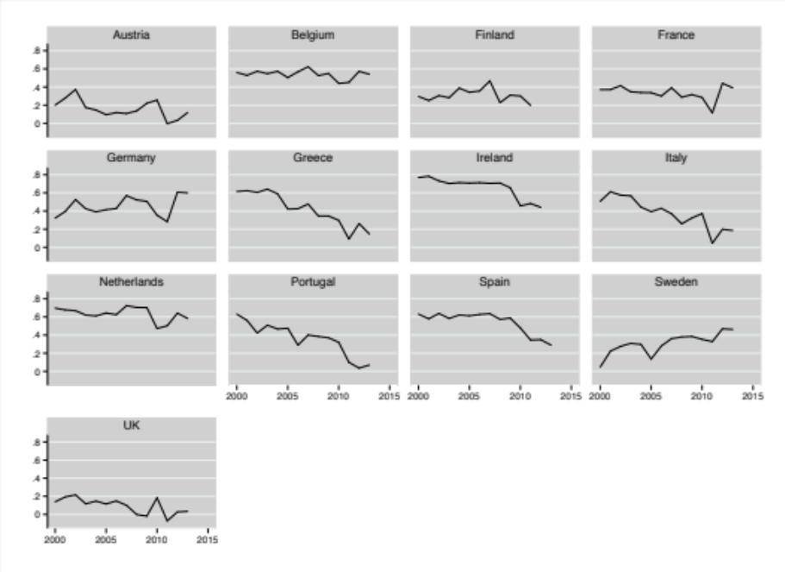
(b)

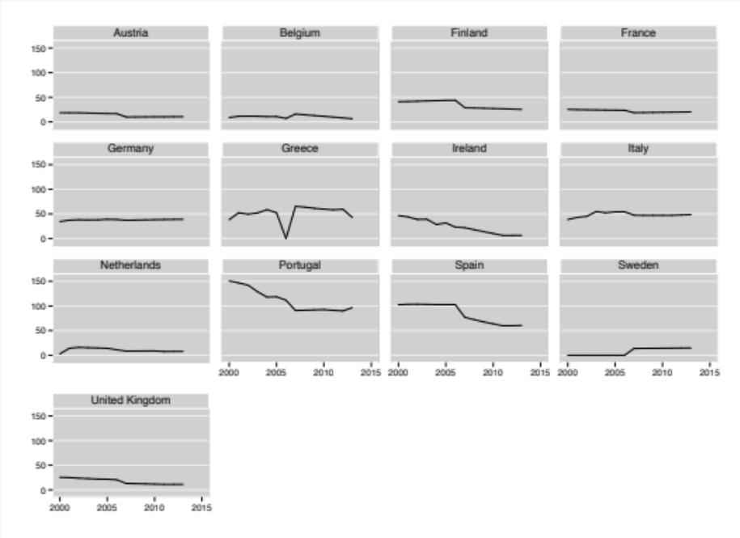
Notes: (a) Source: EB surveys: 56.1 (2001); 60.1 (2003); 61.0 (2004); 62.0 (2004); 63.4 (2004); 64.2 (2005); 65.2 (2006); 66.1 (2006); 68.1 (2007); 69.2 (2008); 701. (2008); 71.1 (2009; 71.3 (2009); 72.4 (2009); 73.4 (2010); 74.2 (2010); 75.3 (2011). Weighted data. (b) Source: European spending through the ESIF in Euro per capita. Source: DG Regio Datawarehouse C3.

Figure B2. European spending across issue areas
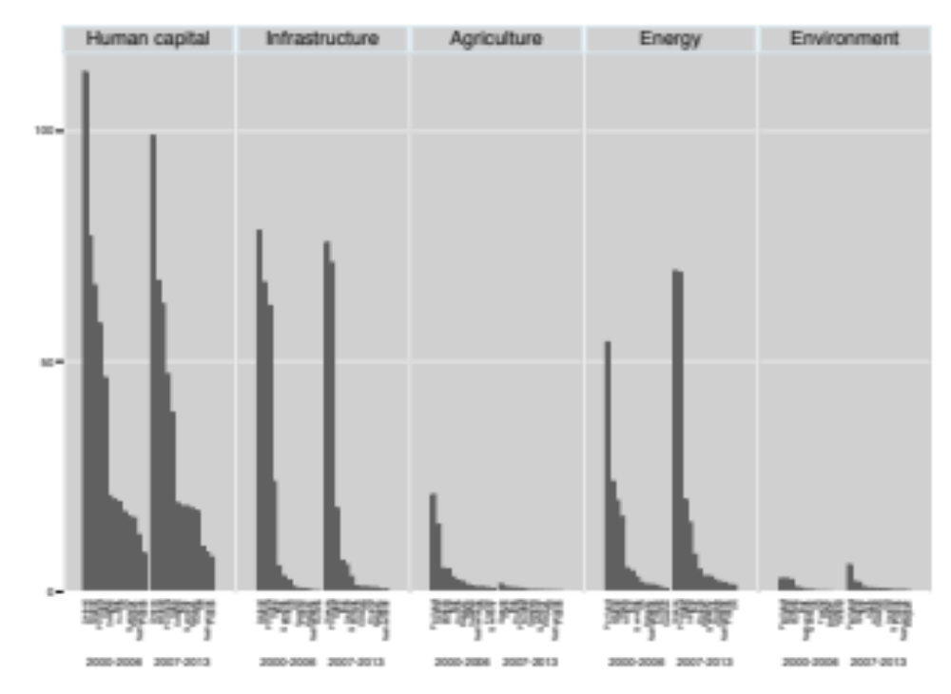
Notes: European spending through the ESIF in Euro per capita. Data from DG Regio Datawarehouse C3 for the two previous funding periods, 2000-2006 and 2007-2013. Population figures used to calculate the per capita measures are population from the 1st of January 2000 and 2007, respectively, taken from Eurostat (2016). No yearly payment data made in Greece in 2006 according to the data archive.

Figure B3. Marginal effect of Agriculture spending on Support at different levels of Utilized agricultural area

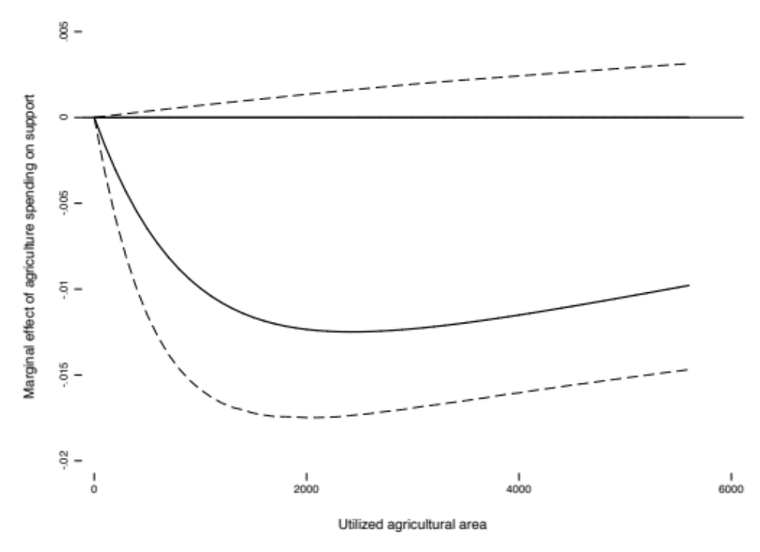

Notes: Based on estimations in model 8 in Table 2 in the paper. Solid line depicts the marginal effect on the latent dependent variable. Dashed lines depict the 95% confidence intervals of the marginal effect.

Figure B4. Marginal effect of Energy spending on Support at different levels of Population density (log)
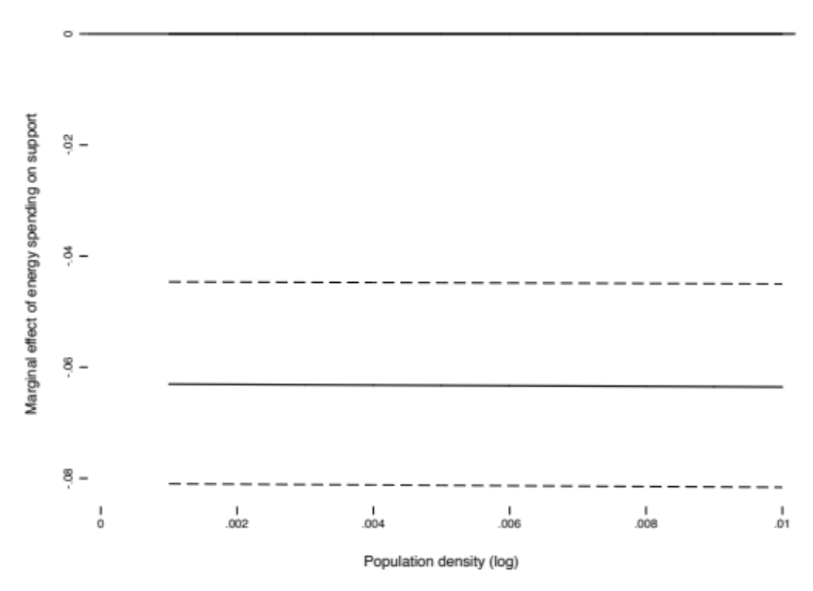
Notes: Based on estimations in model 9 in Table 2 in the paper. Solid line depicts the marginal effect on the latent dependent variable. Dashed lines depict the 95% confidence intervals of the marginal effect.

Figure B5. Marginal effect of Environment spending on Support at different levels of Waste

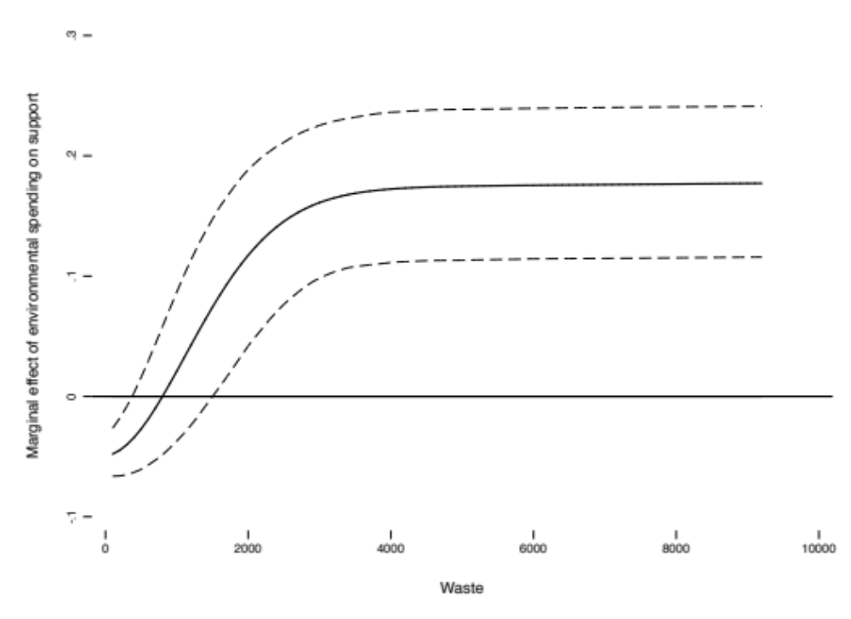
Notes: Based on estimations from model 1 in Table B1 in this appendix. Solid line depicts the marginal effect on the latent dependent variable. Dashed lines depict the 95% confidence intervals of the marginal effect.

Figure B6. Marginal effect of Human capital spending on Support at different levels of High-Skilled Labor, by Identity

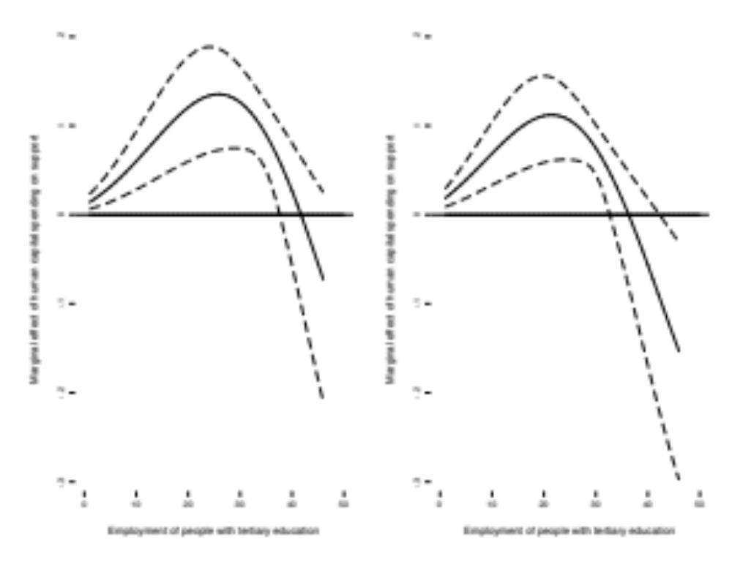
Notes: Based on estimations in model 6 in Table B3 in this appendix. Solid line depicts the marginal effect on the latent dependent variable. Dashed lines depict the 95% confidence intervals of the marginal effect. Left-hand panel: for people who have an exclusive national identity (Identity=0); right-hand panel for people who have a European identity (Identity=3).

Figure B7. Marginal effect of Infrastructure spending on Support at different levels of Motorways, by Identity

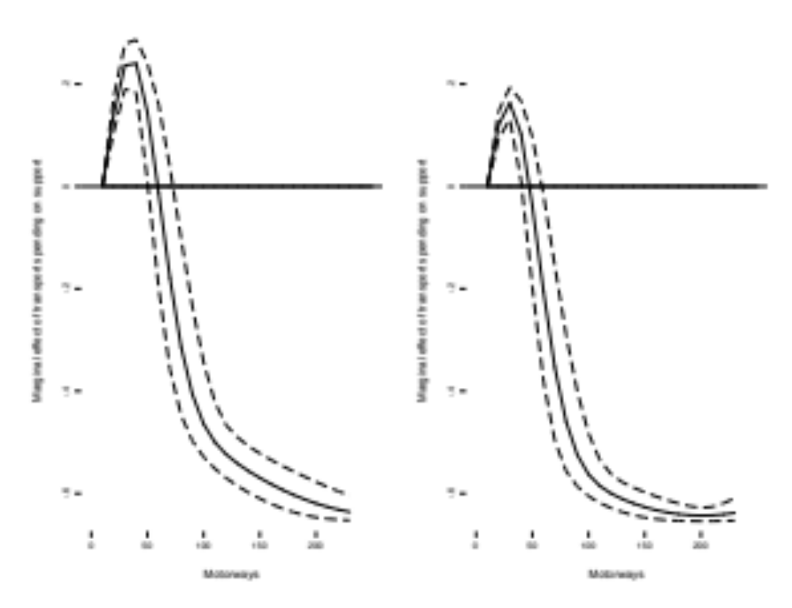
Notes: Based on estimations in model 7 in Table B3 in this appendix. Solid line depicts the marginal effect on the latent dependent variable. Dashed lines depict the 95% confidence intervals of the marginal effect. Left-hand panel: for people who have an exclusive national identity (Identity=0); right-hand panel for people who have a European identity (Identity=3).

Figure B8. Marginal effect of Environment spending on Support at different levels of Rurality, by Identity
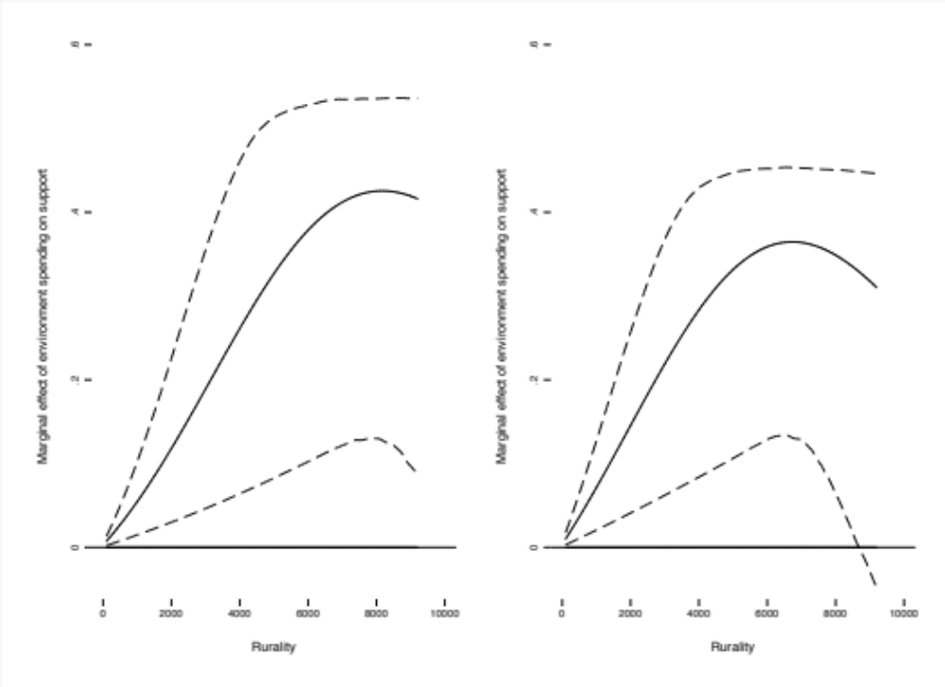
Notes: Based on estimations in model 10 in Table B3 in this appendix. Solid line depicts the marginal effect on the latent dependent variable. Dashed lines depict the 95% confidence intervals of the marginal effect. Left-hand panel: for people who have an exclusive national identity (Identity=0); right-hand panel for people who have a European identity (Identity=3).

Figure B9. Marginal effect of Agriculture spending on Support at different levels of Count
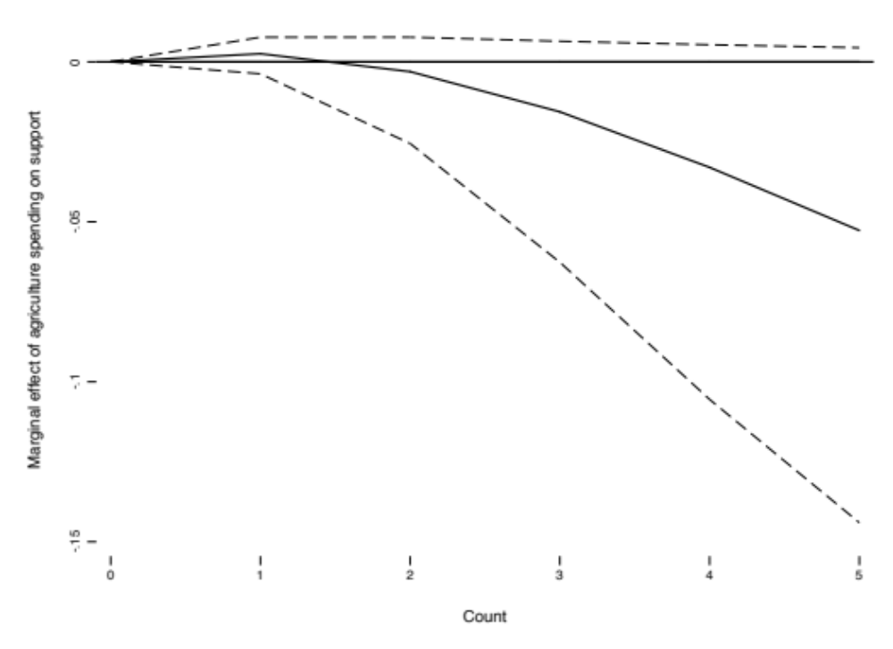
Notes: Based on estimations in model 3 in Table B6 in this appendix. Solid line depicts the marginal effect on the latent dependent variable. Dashed lines depict the 95% confidence intervals of the marginal effect.

Figure B10. Marginal effect of Human capital spending on Support at different levels of High-skilled labor, by Knowledge
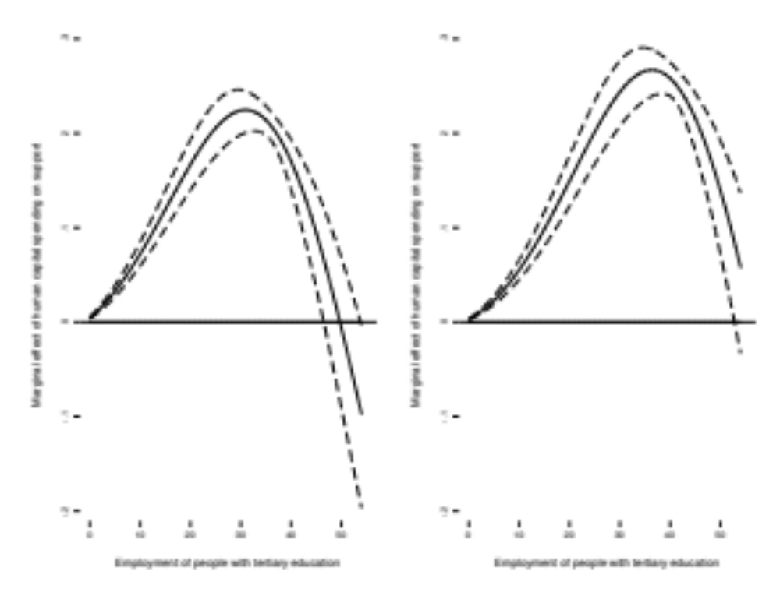
Notes: Based on estimations in model 6 in Table 2 in the paper. Solid line depicts the marginal effect on the latent dependent variable. Dashed lines depict the 95% confidence intervals of the marginal effect. Left-hand panel: for people who do not know about the EU Commission (Knowledge =0); for people who know about the EU Commission (Knowledge =1).

Figure B11. Marginal effect of Infrastructure spending on Support at different levels of Motorways, by Knowledge
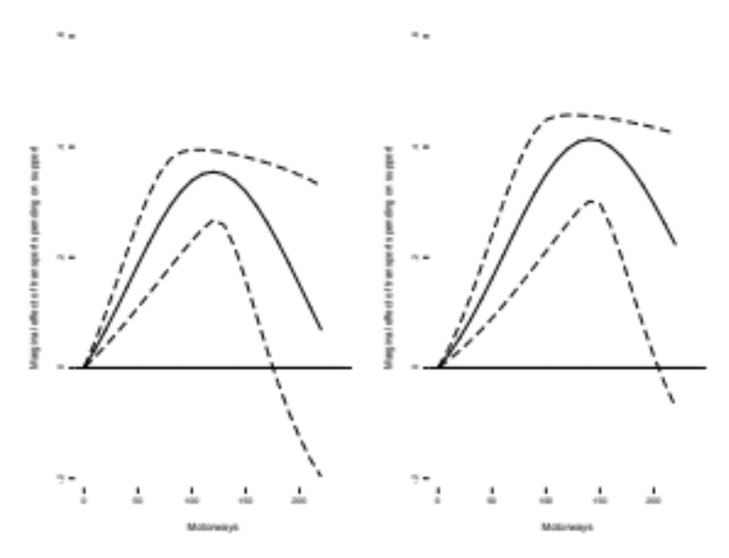
Notes: Based on estimations in model 7 in Table 2 in the paper. Solid line depicts the marginal effect on the latent dependent variable. Dashed lines depict the 95% confidence intervals of the marginal effect. Left-hand panel: for people who do not know about the EU Commission (Knowledge =0); for people who know about the EU Commission (Knowledge =1).

Figure B12. Marginal effect of Environment spending on Support at different levels of Rurality, by Knowledge
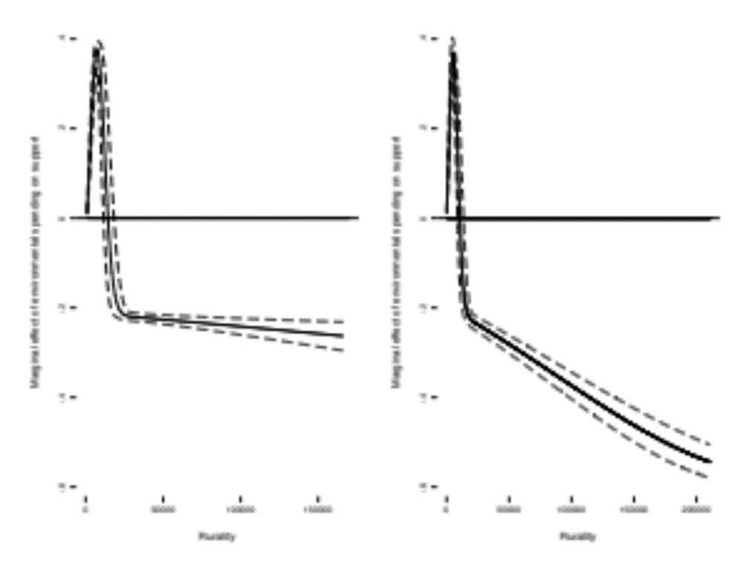
Notes: Based on estimations in model 10 in Table 2 in the paper. Solid line depicts the marginal effect on the latent dependent variable. Dashed lines depict the 95% confidence intervals of the marginal effect. Left-hand panel: for people who do not know about the EU Commission (Knowledge =0); for people who know about the EU Commission (Knowledge =1).

