APPENDIX

ESS/CHES Survey Models

Data Sources, Summary Statistics and Data Construction

Data Sources and Data Construction
All individual-level variables for the main models are taken from Edition 2.0 of the 7th wave of the European Social Survey. Due to missingness for country level variables, four countries (Switzerland, Estonia, Israel, and Norway) are removed. The robustness checks for party and platform polarization use waves 1 to 4 of the European Social Survey.

Internal Efficacy consists of an index (Cronbach α = 0.84) of three survey items, rescaled to follow the original variables 0 to 10 scale.
- How confident are you in your own ability to participate in politics?
- How easy do you personally find it to take part in politics?
- How able do you think you are to take an active role in a group involved with political issues?

Level 2 controls
- Gini Coefficient: Eurostat
- Post-Communism: Constructed by the authors
- Effective Number of Parties: Armingeon, Klaus, Christian Isler, Laura Knöpfel, David Weisstanner and Sarah Engler. 2016.Comparative Political Data Set 1960-2014. Bern: Institute of Political Science, University of Berne.

Level 2 Party System Control construction:
Anti-Elite Vote Share and Maximum Anti-Elite Salience in parliament are calculated using the 2014 version of the Chapel Hill Expert Survey. Anti-Elite salience is measured on a 0 to 10 scale (mean = 4.588, sd=2.654) and is based on expert surveys. Vote and seat shares used for the calculation were also taken directly from the Chapel Hill Dataset
- Anti-Elite vote share is the combined vote share of all parties that were placed in the top 25% of Anti-Elite sentiment (6.925). We also consider different cut-off points in this appendix.
- Maximum Anti-Elite salience in parliament is the highest Anti-Elite sentiment score

Party System Polarization was adapted from Dalton (2008) and updated using newly available data from the Comparative Study of Electoral Systems Survey (Waves 1 to 4). This polarization index uses public perceptions of party-left right placements to calculate a 0 to 10 index where 0 indicates that all parties occupy the same position and 10 indicates a split between the extreme ends of the scale. Unfortunately data availability for most of the CSES is limited to 2013 and earlier.

Party Platform Polarization was adapted from Finseraas and Vernby (2011) with updated data from the Comparative Manifesto Project. Instead of a focus on welfare polarization, we use their technique to focus on overall left-right statements in the manifesto. Specifically, using the CMP, we assign a left-right score to all parties in parliament, where a higher score indicates more favorable mentions on issues such as regulation, redistribution, and a more expansive role of the state in the economy. We then use the CMP party classifications to place parties either in the left or in the non-left block. Finally, we take a seat-weighted average of the left-right score for both blocks, and calculate the difference between the two. The larger the difference between the two blocks, the higher the difference in party platforms and therefore the degree of polarization. We rescale this index to fit between 0 and 10 to make results more easily comparable to the party system polarization index.

Summary Statistics
Table 1: Individual Summary Statistics - Nominal Variables
Statistic | N | Mean | St. Dev. | Min | Median | Max
Internal Efficacy | 25,792 | 3.766 | 2.426 | 0.000 | 3.667 | 10.000
Age | 25,792 | 50.427 | 17.934 | 14 | 51 | 102
Years of Education | 25,792 | 13.433 | 6.505 | 0 | 13 | 88

Table 2: Individual Summary Statistics - Categorical Variables
Variable | Category | Freq. | %
Gender | Male | 12333 | 47.8%
 | Female | 13459 | 52.2 %
Income | Low | 7820 | 30.3%
 | Middle | 7820 | 42.3%
 | High | 7037 | 27.3 %
Main Activity | Paid Work | 13263 | 51.4%
 | Education | 1628 | 6.3%
 | Unemployed –Looking | 1066 | 4.1%
 | Unemployed – Not looking | 425 | 1.6%
 | Permanently sick or disabled | 697 | 2.7%
 | Retired | 6998 | 27.1%
 | Community or Military Service | 7 | 0.02%
 | Housework, looking after children | 1708 | 6.7%

Country Variable Summary
Table 3: Country Level Summary Statistics
Country | Post-Communist | Effective Number of Parties | Gini | Anti-Elite Vote Share | Number of Lvl. 1 Observations
AT | 0 | 5.16 | 27.6 | 26.2 | 1273
BE | 0 | 9.7 | 25.9 | 7.4 | 1561
CZ | 1 | 7.62 | 25.1 | 28.1 | 1462
DE | 0 | 4.82 | 30.7 | 6.3 | 2603
DK | 0 | 5.72 | 27.7 | 0 | 1252
ES | 0 | 3.45 | 34.7 | 0 | 1444
FI | 0 | 6.45 | 25.6 | 19.1 | 1879
FR | 0 | 5.29 | 29.2 | 14.53 | 1750
GB | 0 | 3.73 | 31.6 | 5.8 | 1810
HU | 1 | 3.22 | 28.6 | 25.5 | 1116
IE | 0 | 4.79 | 30.8 | 12.1 | 1765
LT | 1 | 7.63 | 35 | 15.3 | 1590
NL | 0 | 5.97 | 26.2 | 10.1 | 1671
PL | 1 | 3.74 | 30.8 | 31 | 1115
PT | 0 | 3.67 | 34.5 | 14 | 1026
SE | 0 | 5.41 | 25.4 | 16.4 | 1559
SI | 1 | 5.44 | 25 | 13.2 | 916

 | Internal Efficacy | Effective Number of Parties | Gini | Anti-Elite Salience | GDP  /Capita | GDP Growth | Pop Risk of Excl. | Leg. Frag. | Macro-  Turnout | Unempl. | Social Spending  Per Inhab
Internal Efficacy | 1.00 | 0.14 | -0.28 | -0.48 | 0.86 | -0.32 | -0.56 | 0.41 | 0.72 | -0.27 | 0.89
Effective Number of Parties | 0.14 | 1.00 | -0.45 | -0.02 | 0.17 | -0.16 | -0.50 | 0.83 | 0.32 | -0.29 | 0.19
Gini | -0.28 | -0.45 | 1.00 | -0.25 | -0.36 | 0.18 | 0.75 | -0.50 | -0.37 | 0.57 | -0.41
Anti-Elite Salience | -0.48 | -0.02 | -0.25 | 1.00 | -0.47 | 0.08 | -0.05 | -0.07 | -0.48 | -0.33 | -0.46
GDP/Capita | 0.86 | 0.17 | -0.36 | -0.47 | 1.00 | -0.11 | -0.51 | 0.42 | 0.80 | -0.29 | 0.96
GDP Growth | -0.32 | -0.16 | 0.18 | 0.08 | -0.11 | 1.00 | 0.46 | -0.23 | -0.16 | -0.02 | -0.34
Population at Risk of Exclusion | -0.56 | -0.50 | 0.75 | -0.05 | -0.51 | 0.46 | 1.00 | -0.70 | -0.35 | 0.53 | -0.60
Legislative Fragmentation | 0.41 | 0.83 | -0.50 | -0.07 | 0.42 | -0.23 | -0.70 | 1.00 | 0.43 | -0.32 | 0.42
Macro-Turnout | 0.72 | 0.32 | -0.37 | -0.48 | 0.80 | -0.16 | -0.35 | 0.43 | 1.00 | -0.18 | 0.79
Unemployment | -0.27 | -0.29 | 0.57 | -0.33 | -0.29 | -0.02 | 0.53 | -0.32 | -0.18 | 1.00 | -0.31
Social Spending  per Inhabitant | 0.89 | 0.19 | -0.41 | -0.46 | 0.96 | -0.34 | -0.60 | 0.42 | 0.79 | -0.31 | 1.00
Table 4: Correlations between macro-variables

Alternate Specifications

Variations on Main Model
Table 5: Empty Model
 | Empty Model
(Intercept) | 3.66***
 | (0.21)
AIC | 116009.03
BIC | 116033.51
Log Likelihood | -58001.52
Num. obs. | 25792
Num. groups: country | 17
Var: country(Intercept) | 0.75
Var: Residual | 5.24
***p < 0.001, **p < 0.01, *p < 0.05, ·p < 0.1

Table 6: Non-Standardized Results
 | Individual Level | Country Characteristics | Cross-Level Interactions
Household Income - Ref: Medium
Low | -0.51 (0.03)*** | -0.51 (0.03)*** | -0.62 (0.06)***
High | 0.54 (0.03)*** | 0.54 (0.03)*** | 0.66 (0.06)***
Cross-Level Interactions
Anti-Elite Vote Share |  | -0.02 (0.02) | -0.02 (0.02)
Anti-Elite Vote Share x Low Income |  |  | 0.01 (0.00)*
Anti-Elite Vote Share x High Income |  |  | -0.01 (0.00)*
Main Activity - Ref: Paid Employment
Education | 0.23 (0.06)*** | 0.23 (0.06)*** | 0.23 (0.06)***
Unemployed | -0.09 (0.07) | -0.09 (0.07) | -0.09 (0.07)
Inactive | -0.31 (0.11)** | -0.31 (0.11)** | -0.31 (0.11)**
Sick or Disabled | -0.45 (0.09)*** | -0.45 (0.09)*** | -0.45 (0.09)***
Retired | -0.34 (0.05)*** | -0.34 (0.05)*** | -0.34 (0.05)***
Military Service | -0.43 (0.82) | -0.43 (0.82) | -0.44 (0.82)
Housework | -0.38 (0.06)*** | -0.38 (0.06)*** | -0.38 (0.06)***
Socio-Economic Controls
Age | -0.01 (0.00)*** | -0.01 (0.00)*** | -0.01 (0.00)***
Female | -0.57 (0.03)*** | -0.57 (0.03)*** | -0.58 (0.03)***
Years of Education | 0.05 (0.00)*** | 0.05 (0.00)*** | 0.05 (0.00)***
Country Characteristics
Post-Communist |  | -1.09 (0.38)** | -1.08 (0.37)**
Multiparty System |  | -0.00 (0.09) | -0.01 (0.09)
Gini |  | -0.07 (0.05) | -0.07 (0.05)
AIC | 113113.26 | 113119.86 | 113127.87
BIC | 113235.63 | 113274.86 | 113299.19
Log Likelihood | -56541.63 | -56540.93 | -56542.94
Num. obs. | 25792 | 25792 | 25792
Num. groups: cntry | 17 | 17 | 17
Var: cntry (Intercept) | 0.63 | 0.31 | 0.30
Var: Residual | 4.67 | 4.67 | 4.67
***p < 0.001, **p < 0.01, *p < 0.05, ○ p < 0.1

Table 7: Additional Covariates
Household Income - Ref: Medium
Low | -0.50 (0.03)*** | -0.50 (0.03)*** | -0.50 (0.03)***
High | 0.54 (0.03)*** | 0.54 (0.03)*** | 0.54 (0.03)***
Cross-Level Interactions
Anti-Elite Vote Share |  | -0.27 (0.34) | -0.26 (0.34)
Anti-Elite Vote Share x Low Income |  |  | 0.12 (0.07)○
Anti-Elite Vote Share x High Income |  |  | -0.16 (0.07)*
Main Activity - Ref: Paid Employment
Education | 0.27 (0.06)*** | 0.27 (0.06)*** | 0.28 (0.06)***
Unemployed | -0.08 (0.07) | -0.08 (0.07) | -0.08 (0.07)
Inactive | -0.30 (0.11)** | -0.30 (0.11)** | -0.30 (0.11)**
Sick or Disabled | -0.47 (0.09)*** | -0.47 (0.09)*** | -0.46 (0.09)***
Retired | -0.36 (0.05)*** | -0.36 (0.05)*** | -0.36 (0.05)***
Military Service | -0.55 (0.81) | -0.55 (0.81) | -0.56 (0.81)
Housework | -0.37 (0.06)*** | -0.37 (0.06)*** | -0.36 (0.06)***
Socio-Economic Controls
Age | -0.35 (0.05)*** | -0.35 (0.05)*** | -0.35 (0.05)***
Female | -0.56 (0.03)*** | -0.56 (0.03)*** | -0.56 (0.03)***
Years of Education | 0.79 (0.04)*** | 0.79 (0.04)*** | 0.79 (0.04)***
Political Extreme | 0.33 (0.03)*** | 0.33 (0.03)*** | 0.33 (0.03)***
Trade Union - Ref: No
Yes, currently | 0.24 (0.04)*** | 0.24 (0.04)*** | 0.24 (0.04)***
Yes, previously | 0.30 (0.04)*** | 0.31 (0.04)*** | 0.30 (0.04)***
Religious | 0.17 (0.03)*** | 0.17 (0.03)*** | 0.17 (0.03)***
Country Characteristics
Post-Communist |  | -1.11 (0.35)** | -1.10 (0.35)**
Effective Number of Parties |  | -0.00 (0.28) | -0.01 (0.28)
Gini |  | -0.47 (0.32) | -0.47 (0.32)
AIC | 112338.59 | 112332.52 | 112330.03
BIC | 112493.49 | 112520.04 | 112533.86
Log Likelihood | -56150.29 | -56143.26 | -56140.02
Num. obs. | 25667 | 25667 | 25667
Num. groups: cntry | 17 | 17 | 17
Var: cntry (Intercept) | 0.61 | 0.27 | 0.27
Var: Residual | 4.63 | 4.63 | 4.63
***p < 0.001, **p < 0.01, *p < 0.05, ○ p < 0.1

Income
Table 8: Income as Continuous Variable
Income | 0.13 (0.01)*** | 0.13 (0.01)*** | 0.15 (0.01)***
Cross-Level Interactions
Anti-Elite Vote Share |  | -0.02 (0.02) | -0.01 (0.02)
Anti-Elite Vote Share x Income |  |  | -0.00 (0.00)**
Main Activity - Ref: Paid Employment
Education | 0.19 (0.06)** | 0.19 (0.06)** | 0.20 (0.06)**
Unemployed | -0.16 (0.07)* | -0.16 (0.07)* | -0.16 (0.07)*
Inactive | -0.39 (0.11)*** | -0.39 (0.11)*** | -0.39 (0.11)***
Sick or Disabled | -0.53 (0.09)*** | -0.53 (0.09)*** | -0.52 (0.09)***
Retired | -0.38 (0.05)*** | -0.38 (0.05)*** | -0.38 (0.05)***
Military Service | -0.35 (0.82) | -0.35 (0.82) | -0.37 (0.82)
Housework | -0.40 (0.06)*** | -0.40 (0.06)*** | -0.40 (0.06)***
Socio-Economic Controls
Age | -0.01 (0.00)*** | -0.01 (0.00)*** | -0.01 (0.00)***
Female | -0.59 (0.03)*** | -0.59 (0.03)*** | -0.59 (0.03)***
Years of Education | 0.05 (0.00)*** | 0.05 (0.00)*** | 0.05 (0.00)***
Country Characteristics
Post-Communist |  | -1.09 (0.37)** | -1.08 (0.37)**
Multiparty System |  | -0.00 (0.09) | -0.00 (0.09)
Gini |  | -0.07 (0.05) | -0.07 (0.05)
AIC | 113241.38 | 113247.99 | 113255.60
BIC | 113355.59 | 113394.84 | 113410.60
Log Likelihood | -56606.69 | -56606.00 | -56608.80
Num. obs. | 25792 | 25792 | 25792
Num. groups: cntry | 17 | 17 | 17
Var: cntry (Intercept) | 0.63 | 0.30 | 0.30
Var: Residual | 4.69 | 4.69 | 4.69
***p < 0.001, **p < 0.01, *p < 0.05, ○ p < 0.1

Table 9: Full Income Deciles
Household Income Decile- Ref: 5th
1st | -0.64 (0.06)*** | -0.64 (0.06)*** | -0.65 (0.06)***
2nd | -0.50 (0.06)*** | -0.50 (0.06)*** | -0.50 (0.06)***
3rd | -0.34 (0.06)*** | -0.34 (0.06)*** | -0.34 (0.06)***
4th | -0.16 (0.06)** | -0.16 (0.06)** | -0.16 (0.06)**
6th | 0.11 (0.06)○ | 0.11 (0.06)○ | 0.10 (0.06)○
7th | 0.23 (0.06)*** | 0.23 (0.06)*** | 0.23 (0.06)***
8th | 0.36 (0.06)*** | 0.36 (0.06)*** | 0.36 (0.06)***
9th | 0.56 (0.06)*** | 0.56 (0.06)*** | 0.55 (0.06)***
10th | 0.93 (0.06)*** | 0.93 (0.06)*** | 0.91 (0.06)***
Anti-Elite Vote Share Interaction
Anti-Elite Vote Share |  | -0.26 (0.35) | -0.38 (0.36)
1st |  |  | 0.31 (0.13)*
2nd |  |  | 0.18 (0.12)
3rd |  |  | 0.24 (0.12)*
4th |  |  | 0.05 (0.12)
6th |  |  | 0.27 (0.12)*
7th |  |  | 0.09 (0.12)
8th |  |  | -0.03 (0.12)
9th |  |  | 0.05 (0.13)
10th |  |  | -0.07 (0.13)
Main Activity - Ref: Paid Employment
Education | 0.28 (0.06)*** | 0.28 (0.06)*** | 0.28 (0.06)***
Unemployed | -0.02 (0.07) | -0.02 (0.07) | -0.02 (0.07)
Inactive | -0.23 (0.11)* | -0.24 (0.11)* | -0.23 (0.11)*
Sick or Disabled | -0.39 (0.09)*** | -0.39 (0.09)*** | -0.38 (0.09)***
Retired | -0.30 (0.05)*** | -0.30 (0.05)*** | -0.30 (0.05)***
Military Service | -0.44 (0.82) | -0.44 (0.82) | -0.45 (0.82)
Housework | -0.35 (0.06)*** | -0.36 (0.06)*** | -0.35 (0.06)***
Socio-Economic Controls
Age | -0.23 (0.04)*** | -0.23 (0.04)*** | -0.23 (0.04)***
Female | -0.56 (0.03)*** | -0.56 (0.03)*** | -0.56 (0.03)***
Years of Education | 0.77 (0.04)*** | 0.77 (0.04)*** | 0.77 (0.04)***
Country Characteristics
Post-Communist |  | -1.10 (0.37)** | -1.10 (0.37)**
Multiparty System |  | -0.00 (0.30) | -0.01 (0.29)
Gini |  | -0.49 (0.34) | -0.50 (0.34)
AIC | 112989.27 | 112983.78 | 113007.25
BIC | 113168.74 | 113195.88 | 113292.77
Log Likelihood | -56472.64 | -56465.89 | -56468.62
Num. obs. | 25792 | 25792 | 25792
Num. groups: cntry | 17 | 17 | 17
Var: cntry (Intercept) | 0.63 | 0.30 | 0.30
Var: Residual | 4.64 | 4.64 | 4.64
***p < 0.001, **p < 0.01, *p < 0.05, ○ p < 0.1

Anti-Elite Salience
Table 10: Lower Bound Anti-Elite Salience Cut-Off (Anti-Elite Salience = 6)
Household Income - Ref: Medium
Low | -0.51 (0.03)*** | -0.52 (0.03)***
High | 0.54 (0.03)*** | 0.54 (0.03)***
Cross-Level Interactions
Anti-Elite Vote Share | -0.35 (0.36) | -0.40 (0.36)
Anti-Elite Vote Share x Low Income |  | 0.13 (0.07)*
Anti-Elite Vote Share x High Income |  | 0.07 (0.07)
Main Activity - Ref: Paid Employment
Education | 0.23 (0.06)*** | 0.23 (0.06)***
Unemployed | -0.09 (0.07) | -0.09 (0.07)
Inactive | -0.31 (0.11)** | -0.31 (0.11)**
Sick or Disabled | -0.45 (0.09)*** | -0.45 (0.09)***
Retired | -0.34 (0.05)*** | -0.34 (0.05)***
Military Service | -0.43 (0.82) | -0.44 (0.82)
Housework | -0.38 (0.06)*** | -0.38 (0.06)***
Socio-Economic Controls
Age | -0.24 (0.05)*** | -0.24 (0.05)***
Female | -0.57 (0.03)*** | -0.57 (0.03)***
Years of Education | 0.80 (0.04)*** | 0.80 (0.04)***
Country Characteristics
Post-Communist | -1.15 (0.32)*** | -1.15 (0.32)***
Multiparty System | 0.14 (0.31) | 0.14 (0.31)
Gini | -0.49 (0.32) | -0.49 (0.32)
AIC | 113094.67 | 113101.79
BIC | 113249.67 | 113273.10
Log Likelihood | -56528.34 | -56529.89
Num. obs. | 25792 | 25792
Num. groups: cntry | 17 | 17
Var: cntry (Intercept) | 0.30 | 0.30
Var: Residual | 4.67 | 4.67
***p < 0.001, **p < 0.01, *p < 0.05, ○ p < 0.1

Table 11: Max Anti-Elite Salience in Parliament
Household Income - Ref: Medium
Low | -0.51 (0.03)*** | -0.52 (0.03)***
High | 0.54 (0.03)*** | 0.54 (0.03)***
Cross-Level Interactions
Max Anti-Elite | -0.59 (0.39) | -0.64 (0.39)
Max Anti-Elite x Low Income |  | 0.17 (0.08)*
Max Anti-Elite x High Income |  | 0.02 (0.07)
Main Activity - Ref: Paid Employment
Education | 0.23 (0.06)*** | 0.23 (0.06)***
Unemployed | -0.09 (0.07) | -0.09 (0.07)
Inactive | -0.31 (0.11)** | -0.31 (0.11)**
Sick or Disabled | -0.45 (0.09)*** | -0.46 (0.09)***
Retired | -0.34 (0.05)*** | -0.34 (0.05)***
Military Service | -0.43 (0.82) | -0.43 (0.82)
Housework | -0.38 (0.06)*** | -0.38 (0.06)***
Socio-Economic Controls
Age | -0.24 (0.05)*** | -0.24 (0.05)***
Female | -0.57 (0.03)*** | -0.57 (0.03)***
Years of Education | 0.80 (0.04)*** | 0.80 (0.04)***
Country Characteristics
Post-Communist | -1.16 (0.29)*** | -1.16 (0.29)***
Multiparty System | 0.19 (0.29) | 0.19 (0.29)
Gini | -0.52 (0.31)○ | -0.53 (0.31)○
AIC | 113093.21 | 113098.50
BIC | 113248.21 | 113269.81
Log Likelihood | -56527.61 | -56528.25
Num. obs. | 25792 | 25792
Num. groups: cntry | 17 | 17
Var: cntry (Intercept) | 0.27 | 0.27
Var: Residual | 4.67 | 4.67
***p < 0.001, **p < 0.01, *p < 0.05, ○ p < 0.1

Polarization
Unfortunately, limited data availability for 2014 (ESS Wave 7) for the polarization measures did not allow for a direct comparison between anti-elite salience and polarization measures. However, using ESS Waves 1 to 4 do include measures of internal efficacy. The following two models therefore use ESS waves 1 to 4 instead of wave 7.

Table 12: Party System Polarization
Household Income - Ref: Medium
High | 0.38 (0.02)*** | 0.37 (0.02)***
Low | -0.41 (0.02)*** | -0.39 (0.02)***
Cross-Level Interactions
Party System Polarization | 0.13 (0.05)* | 0.11 (0.05)○
Party System Polarization x High Income |  | -0.08 (0.05)○
Party System Polarization x Low Income |  | 0.12 (0.04)**
Main Activity - Ref: Paid Employment
Education | 0.15 (0.04)*** | 0.15 (0.04)***
Unemployed | -0.00 (0.05) | 0.00 (0.05)
Inactive | -0.12 (0.07)○ | -0.11 (0.07)○
Sick or Disabled | -0.17 (0.05)*** | -0.17 (0.05)***
Retired | -0.21 (0.03)*** | -0.21 (0.03)***
Military Service | -0.15 (0.21) | -0.15 (0.21)
Housework | -0.29 (0.03)*** | -0.29 (0.03)***
Other | -0.01 (0.08) | -0.01 (0.08)
Socio-Economic Controls
Age | 0.31 (0.02)*** | 0.31 (0.02)***
Female | -0.90 (0.02)*** | -0.90 (0.02)***
Other Education | -1.04 (0.06)*** | -1.04 (0.06)***
ISCED Education - Ref: IIIa - Upper Tier, Upper Secondary
I-Less than lower secondary | -1.51 (0.04)*** | -1.52 (0.04)***
II-Lower Secondary | -0.93 (0.03)*** | -0.94 (0.03)***
IIIb-Lower Tier Upper Secondary | -0.49 (0.03)*** | -0.49 (0.03)***
IV-Advanced Vocational | 0.07 (0.04)○ | 0.07 (0.04)○
V1-Lower Tertiary | 0.41 (0.04)*** | 0.41 (0.04)***
V2-Higher Tertiary | 0.78 (0.04)*** | 0.79 (0.04)***
Country Characteristics
Post-Communist | -0.45 (0.29) | -0.48 (0.29)
Effective Number of Parties | 0.10 (0.06) | 0.08 (0.06)
Gini | 0.01 (0.06) | 0.02 (0.06)
AIC | 313088.14 | 313086.19
BIC | 313327.16 | 313343.59
Log Likelihood | -156518.07 | -156515.10
Num. obs. | 72617 | 72617
Num. groups: cntry | 16 | 16
Var: cntry (Intercept) | 0.21 | 0.21
Var: Residual | 4.35 | 4.35
***p < 0.001, **p < 0.01, *p < 0.05, ○ p < 0.1
Table 13: Manifesto Polarization
Household Income - Ref: Medium
High | 0.34 (0.04)*** | 0.33 (0.04)***
Low | -0.61 (0.04)*** | -0.62 (0.04)***
Cross-Level Interactions
Manifesto Polarization | 0.30 (0.11)** | 0.19 (0.12)
Manifesto Polarization x High Income |  | -0.18 (0.11)
Manifesto Polarization x Low Income |  | 0.39 (0.11)***
Main Activity - Ref: Paid Employment
Education | 0.04 (0.07) | 0.07 (0.07)
Unemployed | 0.08 (0.10) | 0.08 (0.10)
Inactive | 0.15 (0.14) | 0.16 (0.14)
Sick or Disabled | -0.08 (0.11) | -0.07 (0.11)
Retired | -0.25 (0.06)*** | -0.24 (0.06)***
Military Service | -0.01 (0.49) | 0.00 (0.49)
Housework | -0.35 (0.06)*** | -0.36 (0.06)***
Other | -0.07 (0.14) | -0.05 (0.14)
Socio-Economic Controls
Age | 0.16 (0.05)** | 0.16 (0.05)**
Female | -0.90 (0.03)*** | -0.90 (0.03)***
Other Education | -0.66 (0.13)*** | -0.68 (0.13)***
ISCED Education - Ref: IIIa - Upper Tier, Upper Secondary
I-Less than lower secondary | -1.33 (0.08)*** | -1.35 (0.08)***
II-Lower Secondary | -0.91 (0.07)*** | -0.92 (0.07)***
IIIb-Lower Tier Upper Secondary | -0.49 (0.07)*** | -0.50 (0.07)***
IV-Advanced Vocational | 0.10 (0.10) | 0.12 (0.10)
V1-Lower Tertiary | 0.47 (0.08)*** | 0.47 (0.08)***
V2-Higher Tertiary | 0.81 (0.09)*** | 0.81 (0.09)***
Country Characteristics
Post-Communist | -0.05 (0.38) | 0.01 (0.40)
Effective Parties | 0.08 (0.14) | 0.02 (0.15)
Gini | -0.04 (0.15) | 0.04 (0.15)
AIC | 77046.53 | 77035.42
BIC | 77248.81 | 77253.26
Log Likelihood | -38497.26 | -38489.71
Num. obs. | 17680 | 17680
Num. groups: cntry | 13 | 13
Var: cntry (Intercept) | 0.12 | 0.14
Var: Residual | 4.54 | 4.53
***p < 0.001, **p < 0.01, *p < 0.05, ○ p < 0.1

Alternative Macro controls
Table 14: GDP/Capita
 | Internal Efficacy | Voting | Participation
Household Income - Ref: Medium
Low | -0.51 (0.03)*** | -0.26 (0.02)*** | -0.11 (0.01)***
High | 0.54 (0.03)*** | 0.28 (0.03)*** | 0.15 (0.01)***
Cross-Level Interactions
Anti-Elite Vote Share | -0.09 (0.28) | -0.22 (0.14) | -0.05 (0.09)
Anti-Elite Vote Share x Low  Income | 0.13 (0.06)* | 0.01 (0.04) | 0.10 (0.03)***
Anti-Elite Vote Share x High  Income | -0.15 (0.07)* | 0.09 (0.05) | -0.03 (0.03)
Main Activity - Ref: Paid Employment
Education | 0.24 (0.06)*** | -0.03 (0.05) | 0.07 (0.03)*
Unemployed | -0.09 (0.07) | -0.17 (0.05)*** | 0.05 (0.03)
Inactive | -0.31 (0.11)** | -0.32 (0.07)*** | -0.01 (0.05)
Sick or Disabled | -0.44 (0.09)*** | -0.26 (0.05)*** | 0.07 (0.04)*
Retired | -0.33 (0.05)*** | -0.06 (0.03) | -0.11 (0.02)***
Military Service | -0.43 (0.82) | -0.95 (0.50) | -0.11 (0.36)
Housework | -0.37 (0.06)*** | -0.14 (0.04)*** | -0.09 (0.02)***
Socio-Economic Controls
Age | -0.23 (0.04)*** | 0.65 (0.03)*** | 0.01 (0.02)
Female | -0.57 (0.03)*** | -0.00 (0.02) | -0.01 (0.01)
Years of Education | 0.65 (0.03)*** | 0.24 (0.03)*** | 0.23 (0.01)***
Country Characteristics
Post-Communist | 0.11 (0.53) | -0.17 (0.25) | -0.31 (0.17)
Effective Number of Parties | -0.06 (0.24) | -0.06 (0.12) | -0.09 (0.08)
Gini | 0.10 (0.32) | -0.25 (0.17) | -0.01 (0.11)
GDP / Capita | 1.36 (0.49)** | 0.27 (0.25) | 0.09 (0.16)
AIC | 113011.55 | 24081.00 | 73039.11
BIC | 113191.01 | 24251.80 | 73219.39
Log Likelihood | -56483.77 | -12019.50 | -36497.56
Num. obs. | 25782 | 25170 | 26754
Num. groups: cntry | 17 | 17 | 17
Var: cntry (Intercept) | 0.19 | 0.04 | 0.02
Var: Residual | 4.66 |  | 0.89
***p < 0.001, **p < 0.01, *p < 0.05

Table 15:GDP Growth
 | Internal Efficacy | Voting | Participation
Household Income - Ref: Medium
Low | -0.51 (0.03)*** | -0.26 (0.02)*** | -0.11 (0.01)***
High | 0.54 (0.03)*** | 0.28 (0.03)*** | 0.15 (0.01)***
Cross-Level Interactions
Anti-Elite Vote Share | -0.27 (0.36) | -0.25 (0.14) | -0.07 (0.09)
Anti-Elite Vote Share x Low  Income | 0.13 (0.06)* | 0.01 (0.04) | 0.10 (0.03)***
Anti-Elite Vote Share x High  Income | -0.15 (0.07)* | 0.09 (0.05) | -0.03 (0.03)
Main Activity - Ref: Paid Employment
Education | 0.24 (0.06)*** | -0.03 (0.05) | 0.07 (0.03)*
Unemployed | -0.09 (0.07) | -0.17 (0.05)*** | 0.05 (0.03)
Inactive | -0.31 (0.11)** | -0.32 (0.07)*** | -0.01 (0.05)
Sick or Disabled | -0.44 (0.09)*** | -0.26 (0.05)*** | 0.07 (0.04)*
Retired | -0.33 (0.05)*** | -0.06 (0.03) | -0.11 (0.02)***
Military Service | -0.43 (0.82) | -0.95 (0.50) | -0.11 (0.36)
Housework | -0.37 (0.06)*** | -0.15 (0.04)*** | -0.09 (0.02)***
Socio-Economic Controls
Age | -0.23 (0.04)*** | 0.65 (0.03)*** | 0.01 (0.02)
Female | -0.57 (0.03)*** | -0.00 (0.02) | -0.01 (0.01)
Years of Education | 0.65 (0.03)*** | 0.24 (0.03)*** | 0.23 (0.01)***
Country Characteristics
Post-Communist | -1.06 (0.41)* | -0.42 (0.16)** | -0.39 (0.10)***
Effective Number of Parties | -0.03 (0.32) | -0.04 (0.12) | -0.08 (0.08)
Gini | -0.46 (0.33) | -0.37 (0.13)** | -0.06 (0.09)
GDP Growth | -0.06 (0.32) | 0.06 (0.12) | 0.00 (0.08)
AIC | 113018.69 | 24081.85 | 73040.94
BIC | 113198.16 | 24252.65 | 73221.21
Log Likelihood | -56487.35 | -12019.92 | -36498.47
Num. obs. | 25782 | 25170 | 26754
Num. groups: cntry | 17 | 17 | 17
Var: cntry (Intercept) | 0.33 | 0.05 | 0.02
Var: Residual | 4.66 |  | 0.89
***p < 0.001, **p < 0.01, *p < 0.05

 | Internal Efficacy | Voting | Participation
Household Income - Ref: Medium
Low | -0.51 (0.03)*** | -0.26 (0.02)*** | -0.11 (0.01)***
High | 0.54 (0.03)*** | 0.28 (0.03)*** | 0.15 (0.01)***
Cross-Level Interactions
Anti-Elite Vote Share | -0.39 (0.33) | -0.25 (0.15) | -0.04 (0.09)
Anti-Elite Vote Share x Low Income | 0.13 (0.06)* | 0.01 (0.04) | 0.10 (0.03)***
Anti-Elite Vote Share x High Income | -0.15 (0.07)* | 0.09 (0.05) | -0.03 (0.03)
Main Activity - Ref: Paid Employment
Education | 0.24 (0.06)*** | -0.03 (0.05) | 0.07 (0.03)*
Unemployed | -0.09 (0.07) | -0.17 (0.05)*** | 0.05 (0.03)
Inactive | -0.31 (0.11)** | -0.32 (0.07)*** | -0.01 (0.05)
Sick or Disabled | -0.44 (0.09)*** | -0.26 (0.05)*** | 0.07 (0.04)*
Retired | -0.33 (0.05)*** | -0.06 (0.03) | -0.11 (0.02)***
Military Service | -0.43 (0.82) | -0.95 (0.50) | -0.11 (0.36)
Housework | -0.37 (0.06)*** | -0.14 (0.04)*** | -0.09 (0.02)***
Socio-Economic Controls
Age | -0.23 (0.04)*** | 0.65 (0.03)*** | 0.01 (0.02)
Female | -0.57 (0.03)*** | -0.00 (0.02) | -0.01 (0.01)
Years of Education | 0.65 (0.03)*** | 0.24 (0.03)*** | 0.23 (0.01)***
Country Characteristics
Post-Communist | -1.04 (0.35)** | -0.39 (0.15)** | -0.40 (0.09)***
Effective Number of Parties | -0.07 (0.29) | -0.05 (0.12) | -0.08 (0.07)
Gini | -0.23 (0.33) | -0.38 (0.15)* | -0.11 (0.09)
Unemployment | -0.51 (0.31) | 0.03 (0.13) | 0.11 (0.08)
AIC | 113016.16 | 24082.07 | 73039.06
BIC | 113195.62 | 24252.87 | 73219.33
Log Likelihood | -56486.08 | -12020.03 | -36497.53
Num. obs. | 25782 | 25170 | 26754
Num. groups: cntry | 17 | 17 | 17
Var: cntry (Intercept) | 0.27 | 0.05 | 0.02
Var: Residual | 4.66 |  | 0.89
***p < 0.001, **p < 0.01, *p < 0.05
Table 16: National Unemployment

Table 17: Legislative Fragmentation
 | Internal Efficacy | Voting | Participation
Household Income - Ref: Medium
Low | -0.51 (0.03)*** | -0.26 (0.02)*** | -0.11 (0.01)***
High | 0.54 (0.03)*** | 0.28 (0.03)*** | 0.15 (0.01)***
Cross-Level Interactions
Anti-Elite Vote Share | -0.28 (0.31) | -0.26 (0.14) | -0.07 (0.09)
Anti-Elite Vote Share x Low Income | 0.13 (0.06)* | 0.01 (0.04) | 0.10 (0.03)***
Anti-Elite Vote Share x High Income | -0.15 (0.07)* | 0.09 (0.05) | -0.03 (0.03)
Main Activity - Ref: Paid Employment
Education | 0.24 (0.06)*** | -0.03 (0.05) | 0.07 (0.03)*
Unemployed | -0.09 (0.07) | -0.17 (0.05)*** | 0.05 (0.03)
Inactive | -0.31 (0.11)** | -0.32 (0.07)*** | -0.01 (0.05)
Sick or Disabled | -0.44 (0.09)*** | -0.26 (0.05)*** | 0.07 (0.04)*
Retired | -0.33 (0.05)*** | -0.06 (0.03) | -0.11 (0.02)***
Military Service | -0.43 (0.82) | -0.95 (0.50) | -0.11 (0.36)
Housework | -0.37 (0.06)*** | -0.14 (0.04)*** | -0.09 (0.02)***
Socio-Economic Controls
Age | -0.23 (0.04)*** | 0.65 (0.03)*** | 0.01 (0.02)
Female | -0.57 (0.03)*** | -0.00 (0.02) | -0.01 (0.01)
Years of Education | 0.65 (0.03)*** | 0.24 (0.03)*** | 0.23 (0.01)***
Country Characteristics
Post-Communist | -0.90 (0.35)* | -0.36 (0.15)* | -0.38 (0.10)***
Effective Number of Parties | -0.71 (0.45) | -0.18 (0.19) | -0.13 (0.13)
Gini | -0.33 (0.29) | -0.34 (0.14)* | -0.05 (0.09)
Legislative Fragmentation | 0.88 (0.46) | 0.17 (0.20) | 0.05 (0.13)
AIC | 113014.55 | 24081.40 | 73039.76
BIC | 113194.01 | 24252.20 | 73220.04
Log Likelihood | -56485.27 | -12019.70 | -36497.88
Num. obs. | 25782 | 25170 | 26754
Num. groups: cntry | 17 | 17 | 17
Var: cntry (Intercept) | 0.25 | 0.05 | 0.02
Var: Residual | 4.66 |  | 0.89
***p < 0.001, **p < 0.01, *p < 0.05

Table 18: Macroturnout
 | Internal Efficacy | Voting | Participation
Household Income - Ref: Medium
Low | -0.51 (0.03)*** | -0.26 (0.02)*** | -0.11 (0.01)***
High | 0.54 (0.03)*** | 0.28 (0.03)*** | 0.15 (0.01)***
Cross-Level Interactions
Anti-Elite Vote Share | -0.19 (0.37) | -0.10 (0.09) | -0.09 (0.10)
Anti-Elite Vote Share x Low Income | 0.13 (0.06)* | 0.02 (0.04) | 0.10 (0.03)***
Anti-Elite Vote Share x High Income | -0.15 (0.07)* | 0.09 (0.05) | -0.03 (0.03)
Main Activity - Ref: Paid Employment
Education | 0.24 (0.06)*** | -0.03 (0.05) | 0.07 (0.03)*
Unemployed | -0.09 (0.07) | -0.17 (0.05)*** | 0.05 (0.03)
Inactive | -0.31 (0.11)** | -0.32 (0.07)*** | -0.01 (0.05)
Sick or Disabled | -0.44 (0.09)*** | -0.26 (0.05)*** | 0.07 (0.04)*
Retired | -0.33 (0.05)*** | -0.06 (0.03) | -0.11 (0.02)***
Military Service | -0.43 (0.82) | -0.96 (0.50) | -0.11 (0.36)
Housework | -0.37 (0.06)*** | -0.14 (0.04)*** | -0.09 (0.02)***
Socio-Economic Controls
Age | -0.23 (0.04)*** | 0.65 (0.03)*** | 0.01 (0.02)
Female | -0.57 (0.03)*** | -0.00 (0.02) | -0.01 (0.01)
Years of Education | 0.65 (0.03)*** | 0.24 (0.03)*** | 0.23 (0.01)***
Country Characteristics
Post-Communist | -0.89 (0.48) | -0.01 (0.10) | -0.44 (0.12)***
Effective Number of Parties | -0.08 (0.32) | -0.16 (0.07)* | -0.07 (0.08)
Gini | -0.35 (0.36) | -0.11 (0.09) | -0.08 (0.10)
Macro-Turnout | 0.31 (0.46) | 0.59 (0.10)*** | -0.07 (0.11)
AIC | 113017.54 | 24062.06 | 73039.82
BIC | 113197.00 | 24232.86 | 73220.09
Log Likelihood | -56486.77 | -12010.03 | -36497.91
Num. obs. | 25782 | 25170 | 26754
Num. groups: cntry | 17 | 17 | 17
Var: cntry (Intercept) | 0.32 | 0.01 | 0.02
Var: Residual | 4.66 |  | 0.89
***p < 0.001, **p < 0.01, *p < 0.05

Table 19: Population at Risk of Exclusion
 | Internal Efficacy | Voting | Participation
Household Income - Ref: Medium
Low | -0.51 (0.03)*** | -0.26 (0.02)*** | -0.11 (0.01)***
High | 0.54 (0.03)*** | 0.28 (0.03)*** | 0.15 (0.01)***
Cross-Level Interactions
Anti-Elite Vote Share | -0.33 (0.31) | -0.23 (0.14) | -0.08 (0.09)
Anti-Elite Vote Share x Low Income | 0.13 (0.06)* | 0.01 (0.04) | 0.10 (0.03)***
Anti-Elite Vote Share x High Income | -0.15 (0.07)* | 0.09 (0.05) | -0.03 (0.03)
Main Activity - Ref: Paid Employment
Education | 0.24 (0.06)*** | -0.03 (0.05) | 0.07 (0.03)*
Unemployed | -0.09 (0.07) | -0.17 (0.05)*** | 0.05 (0.03)
Inactive | -0.31 (0.11)** | -0.32 (0.07)*** | -0.01 (0.05)
Sick or Disabled | -0.44 (0.09)*** | -0.26 (0.05)*** | 0.07 (0.04)*
Retired | -0.33 (0.05)*** | -0.06 (0.03) | -0.11 (0.02)***
Military Service | -0.43 (0.82) | -0.95 (0.50) | -0.11 (0.36)
Housework | -0.37 (0.06)*** | -0.15 (0.04)*** | -0.09 (0.02)***
Socio-Economic Controls
Age | -0.23 (0.04)*** | 0.65 (0.03)*** | 0.01 (0.02)
Female | -0.57 (0.03)*** | -0.00 (0.02) | -0.01 (0.01)
Years of Education | 0.65 (0.03)*** | 0.24 (0.03)*** | 0.23 (0.01)***
Country Characteristics
Post-Communist | -0.81 (0.36)* | -0.48 (0.15)** | -0.34 (0.10)***
Effective Number of Parties | -0.21 (0.29) | 0.01 (0.12) | -0.12 (0.08)
Gini | 0.04 (0.38) | -0.54 (0.17)** | 0.05 (0.11)
Population at Risk of Exclusion | -0.80 (0.40)* | 0.26 (0.17) | -0.15 (0.11)
AIC | 113014.57 | 24080.00 | 73038.35
BIC | 113194.03 | 24250.80 | 73218.63
Log Likelihood | -56485.28 | -12019.00 | -36497.18
Num. obs. | 25782 | 25170 | 26754
Num. groups: cntry | 17 | 17 | 17
Var: cntry (Intercept) | 0.24 | 0.04 | 0.02
Var: Residual | 4.66 |  | 0.89
***p < 0.001, **p < 0.01, *p < 0.05

Table 20: Social Spending per Inhabitant
 | Internal Efficacy | Voting | Participation
Household Income - Ref: Medium
Low | -0.51 (0.03)*** | -0.26 (0.02)*** | -0.11 (0.01)***
High | 0.54 (0.03)*** | 0.28 (0.03)*** | 0.15 (0.01)***
Cross-Level Interactions
Anti-Elite Vote Share | -0.01 (0.24) | -0.22 (0.14) | -0.06 (0.10)
Anti-Elite Vote Share x Low Income | 0.13 (0.06)* | 0.01 (0.04) | 0.10 (0.03)***
Anti-Elite Vote Share x High Income | -0.15 (0.07)* | 0.09 (0.05) | -0.03 (0.03)
Main Activity - Ref: Paid Employment
Education | 0.24 (0.06)*** | -0.03 (0.05) | 0.07 (0.03)*
Unemployed | -0.09 (0.07) | -0.17 (0.05)*** | 0.05 (0.03)
Inactive | -0.31 (0.11)** | -0.32 (0.07)*** | -0.01 (0.05)
Sick or Disabled | -0.44 (0.09)*** | -0.26 (0.05)*** | 0.07 (0.04)*
Retired | -0.33 (0.05)*** | -0.06 (0.03) | -0.11 (0.02)***
Military Service | -0.44 (0.82) | -0.95 (0.50) | -0.11 (0.36)
Housework | -0.37 (0.06)*** | -0.14 (0.04)*** | -0.09 (0.02)***
Socio-Economic Controls
Age | -0.23 (0.04)*** | 0.65 (0.03)*** | 0.01 (0.02)
Female | -0.57 (0.03)*** | -0.00 (0.02) | -0.01 (0.01)
Years of Education | 0.65 (0.03)*** | 0.24 (0.03)*** | 0.23 (0.01)***
Country Characteristics
Post-Communist | 0.53 (0.49) | -0.16 (0.28) | -0.33 (0.18)
Effective Number of Parties | -0.06 (0.21) | -0.05 (0.12) | -0.09 (0.08)
Gini | 0.40 (0.31) | -0.23 (0.19) | -0.02 (0.13)
Social Spending per Inhabitant | 1.85 (0.48)*** | 0.28 (0.29) | 0.07 (0.19)
AIC | 113007.54 | 24081.20 | 73039.02
BIC | 113187.01 | 24252.00 | 73219.30
Log Likelihood | -56481.77 | -12019.60 | -36497.51
Num. obs. | 25782 | 25170 | 26754
Num. groups: cntry | 17 | 17 | 17
Var: cntry (Intercept) | 0.14 | 0.04 | 0.02
Var: Residual | 4.66 |  | 0.89
***p < 0.001, **p < 0.01, *p < 0.05

Outliers
Figure 1: Cook's Distance Plot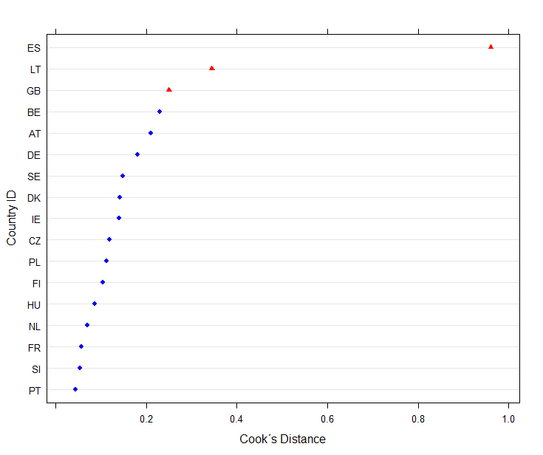

Since hierarchical models are particularly vulnerable to outliers at the group level, the following models replicate the main mode, excluding the three countries with the highest Cook’s distance. In general, this does not change the results, though significance levels do drop when either Spain or Great Britain are removed from the models.
Table 21: Exclude Country Outliers
 | Remove Spain | Remove Lithuania | Remove Great Britain
Household Income - Ref: Medium
Low | -0.49 (0.03)*** | -0.51 (0.03)*** | -0.50 (0.03)***
High | 0.53 (0.03)*** | 0.52 (0.04)*** | 0.54 (0.04)***
Cross-Level Interactions
Anti-Elite Vote Share | -0.36 (0.34) | -0.28 (0.32) | -0.25 (0.36)
Anti-Elite Vote Share x Low Income | 0.12 (0.07)○ | 0.14 (0.07)* | 0.12 (0.07)○
Anti-Elite Vote Share x High Income | -0.17 (0.07)* | -0.16 (0.07)* | -0.17 (0.07)*
Main Activity - Ref: Paid Employment
Education | 0.24 (0.06)*** | 0.30 (0.06)*** | 0.22 (0.06)***
Unemployed | -0.12 (0.07) | -0.06 (0.07) | -0.10 (0.07)
Inactive | -0.42 (0.11)*** | -0.22 (0.11)* | -0.26 (0.11)*
Sick or Disabled | -0.44 (0.09)*** | -0.43 (0.09)*** | -0.40 (0.09)***
Retired | -0.35 (0.05)*** | -0.30 (0.05)*** | -0.37 (0.05)***
Military Service | -0.43 (0.81) | -0.42 (0.81) | -0.97 (1.24)
Housework | -0.38 (0.06)*** | -0.34 (0.06)*** | -0.41 (0.06)***
Socio-Economic Controls
Age | -0.20 (0.04)*** | -0.22 (0.04)*** | -0.26 (0.04)***
Female | -0.58 (0.03)*** | -0.59 (0.03)*** | -0.57 (0.03)***
Years of Education | 0.70 (0.03)*** | 0.65 (0.03)*** | 0.62 (0.03)***
Country Characteristics
Post-Communist | -1.05 (0.37)** | -1.42 (0.39)*** | -1.08 (0.39)**
Multiparty System | -0.08 (0.30) | -0.53 (0.39) | -0.00 (0.32)
Gini | -0.37 (0.30) | -0.97 (0.40)* | -0.48 (0.33)
AIC | 106407.49 | 105897.31 | 104823.43
BIC | 106577.59 | 106067.29 | 104993.21
Log Likelihood | -53182.74 | -52927.65 | -52390.71
Num. obs. | 24348 | 24202 | 23982
Num. groups: cntry | 16 | 16 | 16
Var: cntry (Intercept) | 0.30 | 0.25 | 0.33
Var: Residual | 4.60 | 4.62 | 4.60
***p < 0.001, **p < 0.01, *p < 0.05, ○ p < 0.1

Experimental Study

Randomization Check
Table 22 : Randomization Check
 | Model 1
Intercept | 0.27 (0.85)
Male | 0.16 (0.15)
Age | -0.00 (0.01)
State - Ref: Schleswig Holstein
Hamburg | 0.85 (0.53)
Niedersachsen | 0.05 (0.42)
Bremen | -1.09 (1.22)
Nordrhein-Westfalen | 0.01 (0.37)
Hessen | 0.07 (0.43)
Rheinland-Pfalz | -0.39 (0.46)
Wuerttemberg | 0.27 (0.39)
Bayern | -0.28 (0.38)
Saarland | -0.18 (0.84)
Berlin | -0.41 (0.47)
Brandenburg | -0.45 (0.50)
Mecklenburg-Vorpommern | 0.23 (0.57)
Sachsen | 0.28 (0.46)
Sachsen-Anhalt | 0.36 (0.56)
Thuerringen | 0.13 (0.52)
Education Level-Ref: Still Schooling
Hauptschule | -0.16 (0.77)
Realschule | -0.13 (0.76)
Abitur | 0.09 (0.75)
No Degree | 0.25 (1.16)
No Answer | 0.32 (0.27)
Income Level-Ref: 0-500 Euro
500-1000 | 0.09 (0.27)
1000-1500 | -0.33 (0.29)
1500-2000 | -0.19 (0.30)
2000-2500 | 0.05 (0.37)
2500-3000 | -0.24 (0.47)
3000-3500 | 0.29 (0.53)
3500-4000 | 0.69 (0.58)
4000-4500 | -0.38 (0.69)
4500-5000 | 0.35 (0.62)
5000-10000 | 0.98 (1.28)
10000 and more | -0.25 (0.52)
No Personal Income | 0.52 (0.63)
No Income Information | -0.14 (0.25)
Employment Type
Part time Work (8-25 Hours) | 0.00 (0.75)
Part time (less than 8 hours) | -0.18 (0.18)
Not employed | 14.13 (378.45)
No Employment Information | -0.04 (0.03)
AIC | 1283.79
BIC | 1475.80
Log Likelihood | -601.90
Deviance | 1203.79
Num. obs. | 898
***p < 0.001, **p < 0.01, *p < 0.05
Statistical models

Figure 2: Distribution of Agreement with Anti-Elite Statements
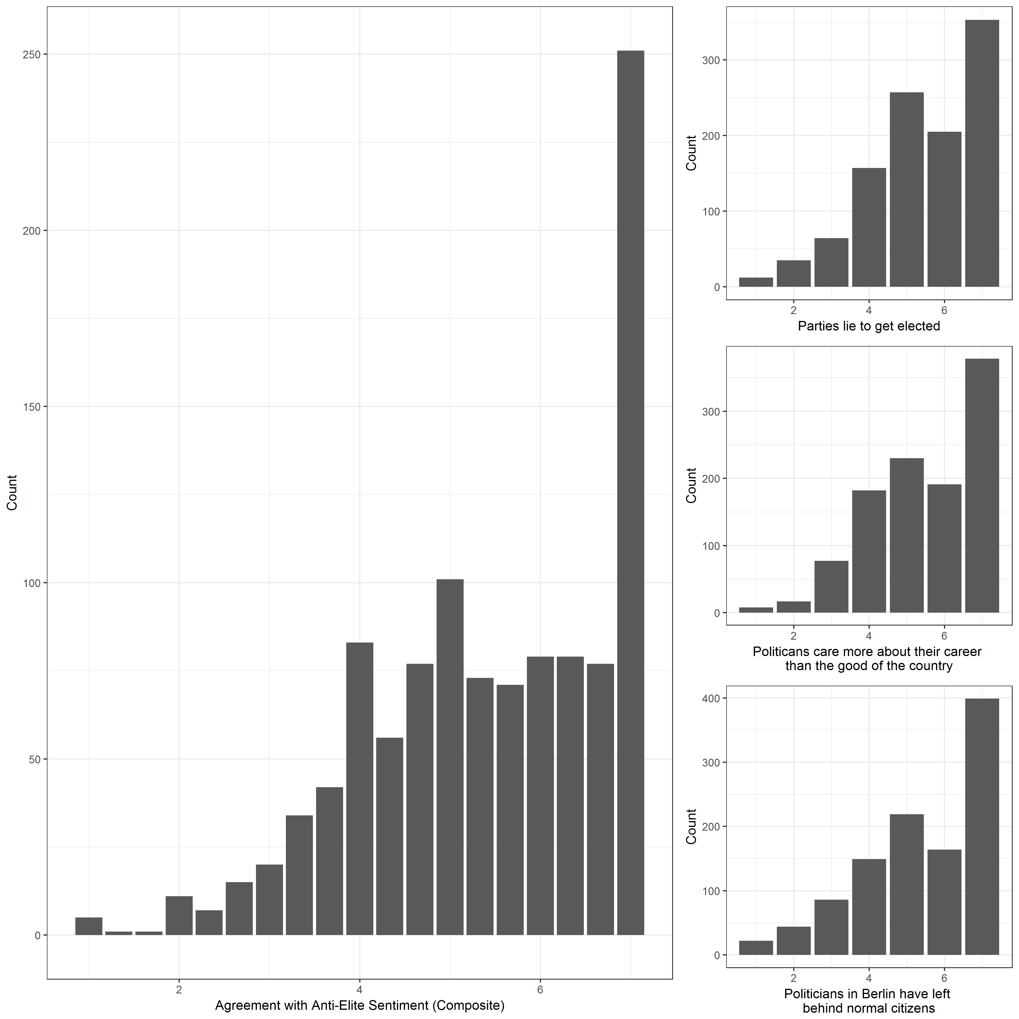

Figure 3: Distribution of Agreement with Anti-Elite Statement in ESS 7 (2014, Germany only)
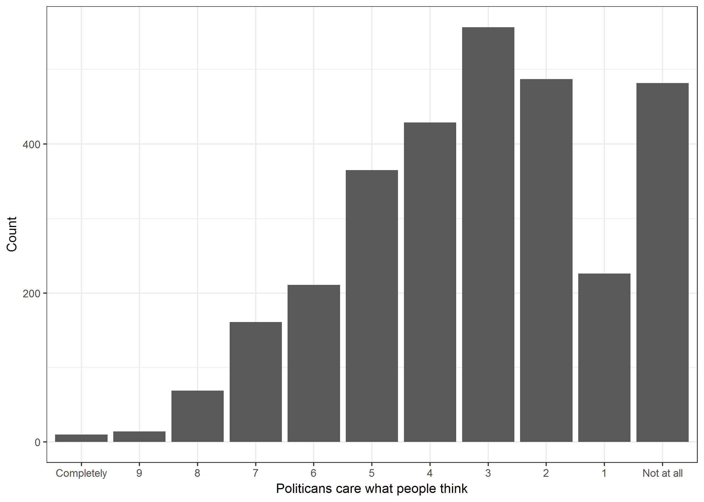
Figure 3: Distribution of Agreement with Anti-Elite Statements by Income
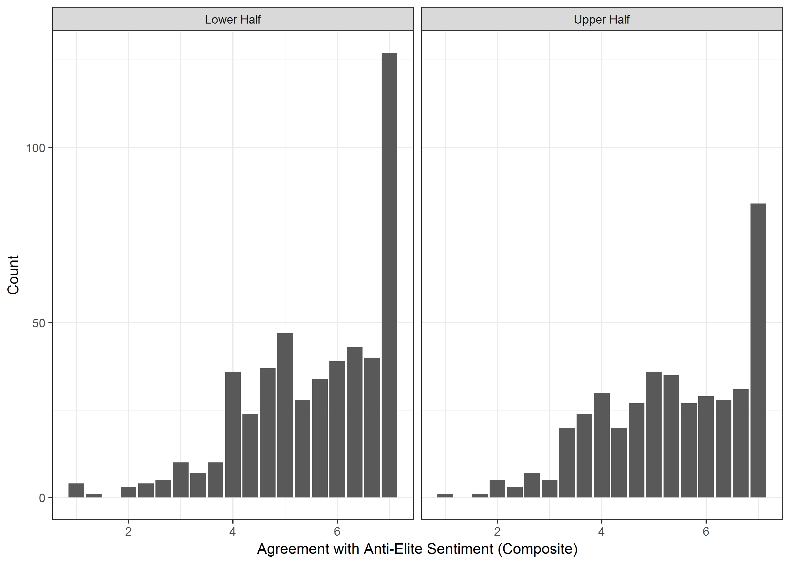
Figure 4: Relationship between Agreement with Anti-Elite Statements and Internal Efficacy by Experimental Group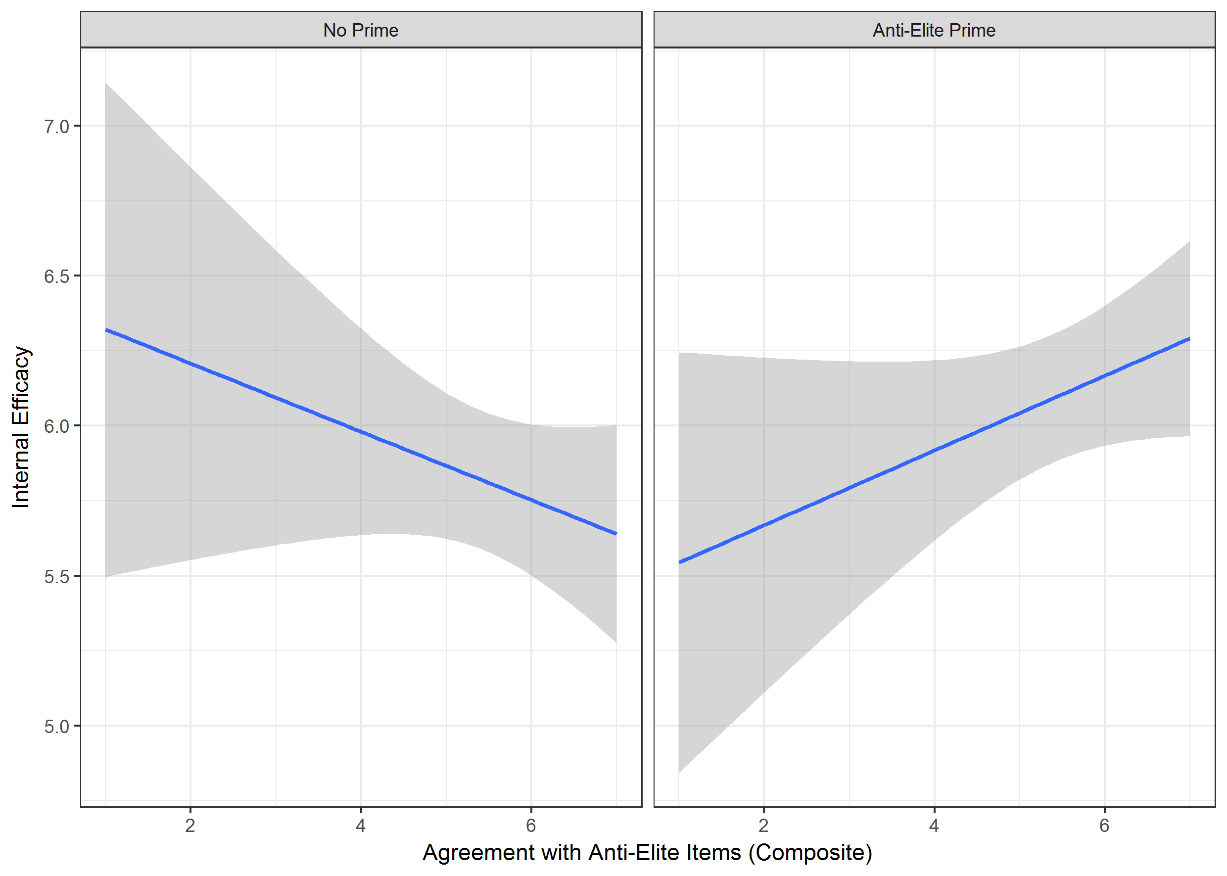

Figure 5: Distribution of Internal Efficacy by Income and Experimental Prime
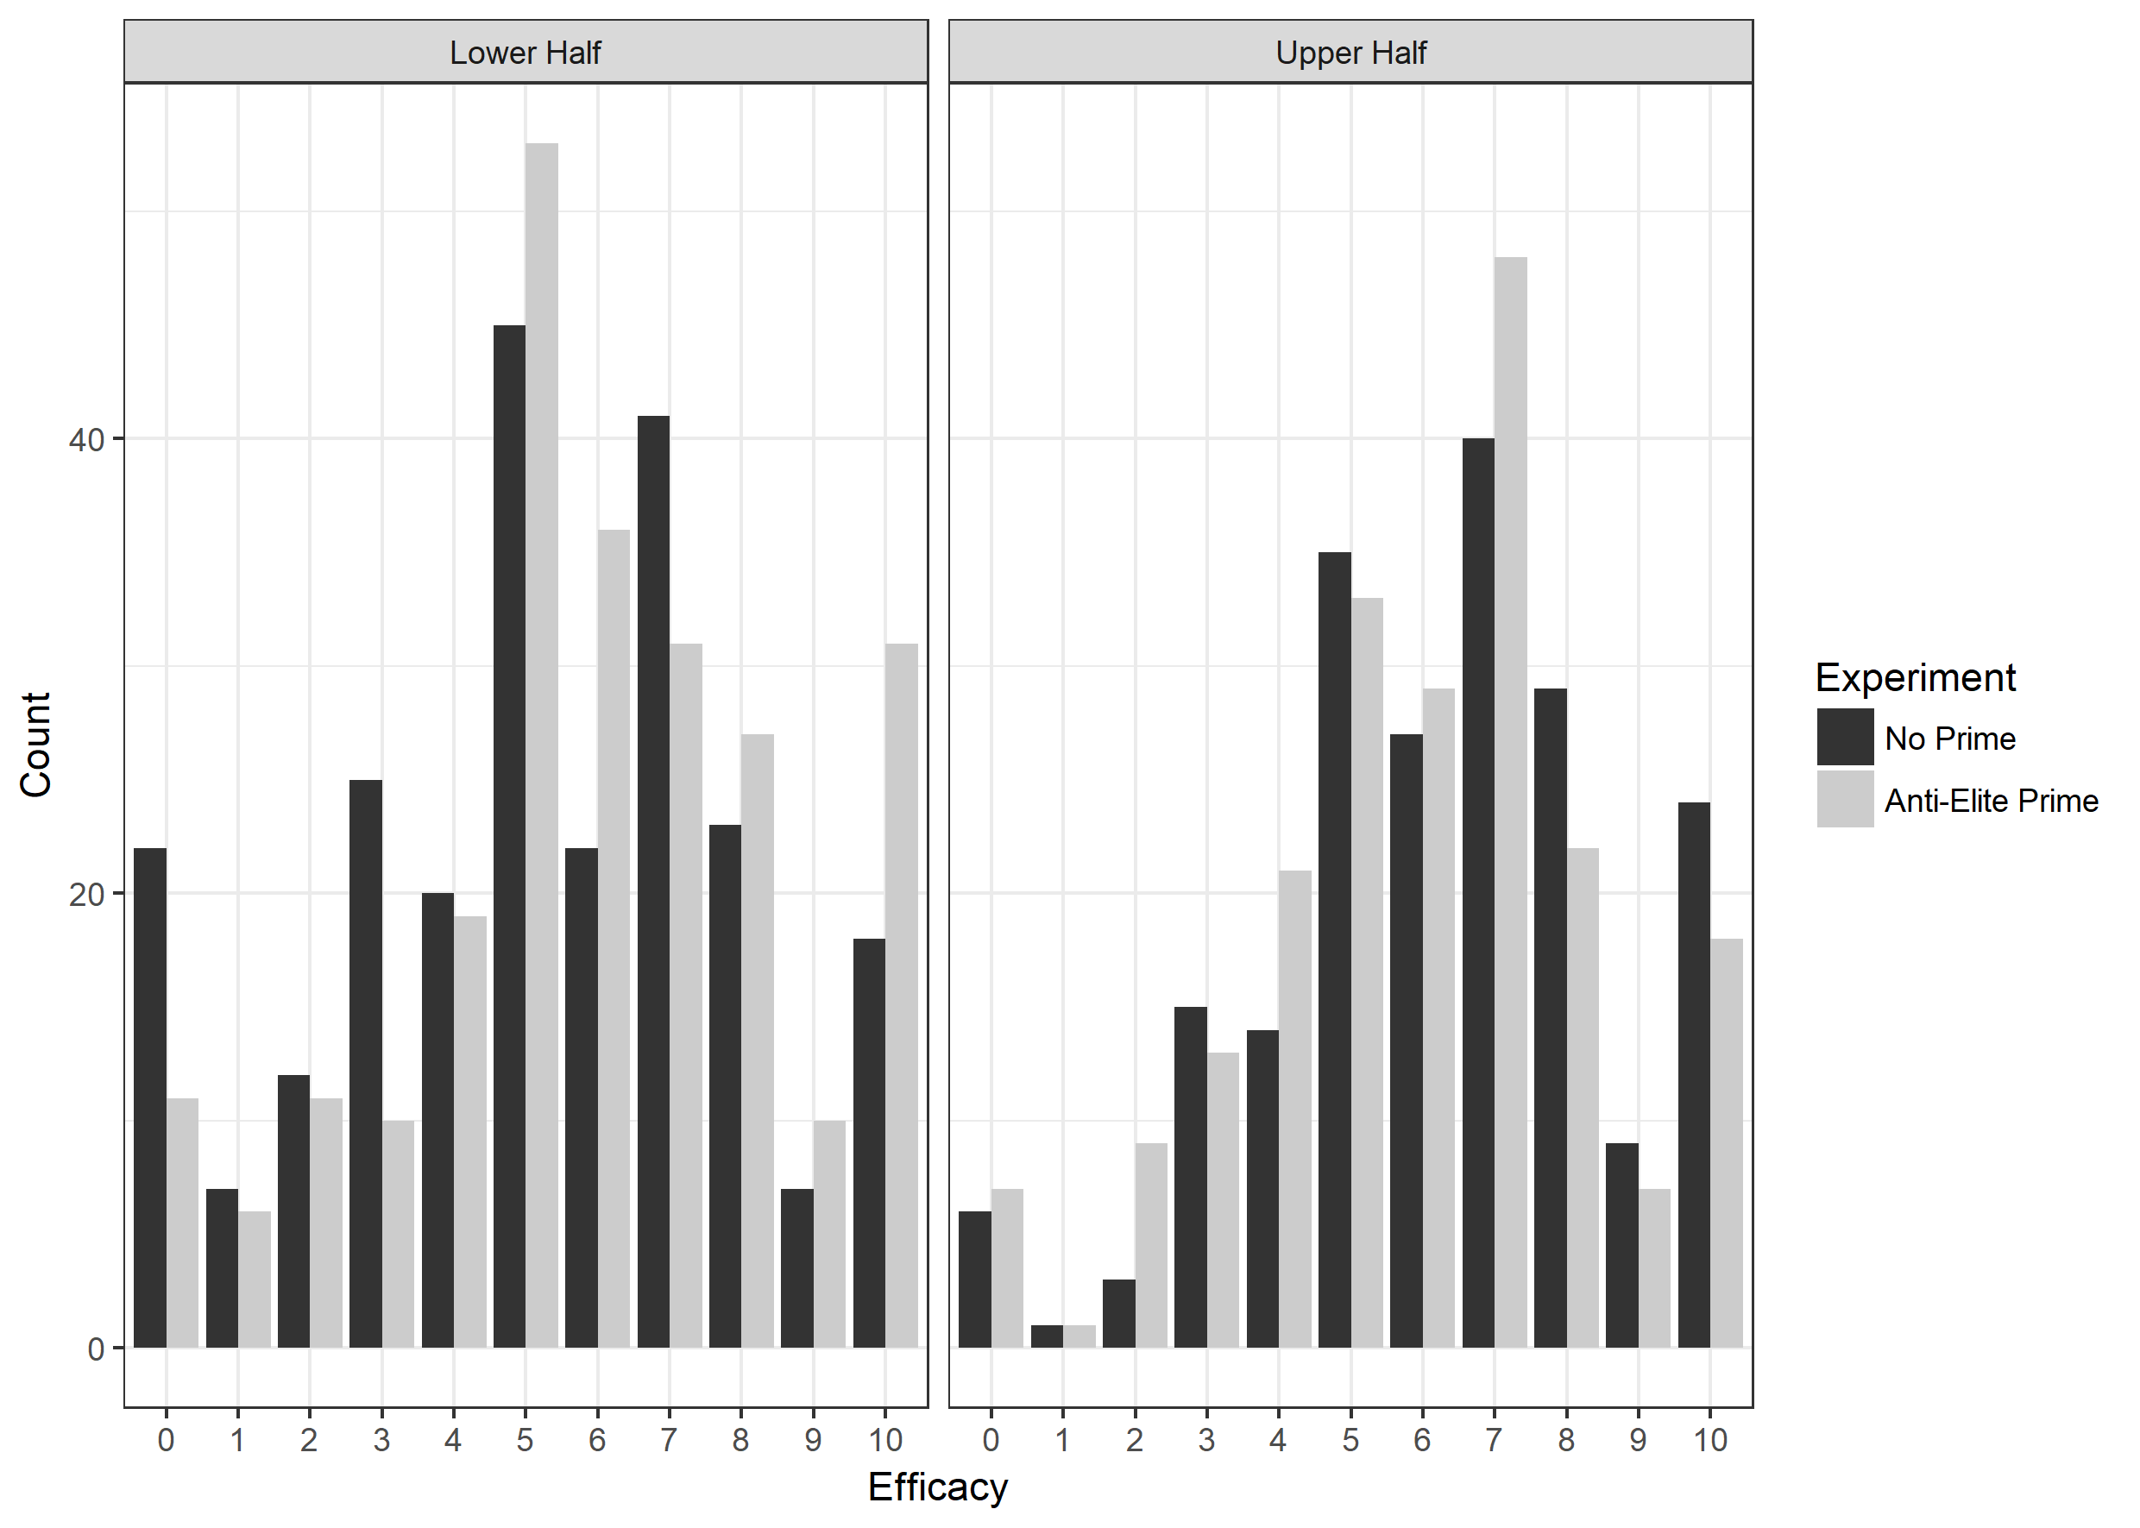
Figure 6: Distribution of Internal Efficacy by Income Worries and Experimental Prime (Question Wording: “How frequently do you worry about things that have to do with money?”)
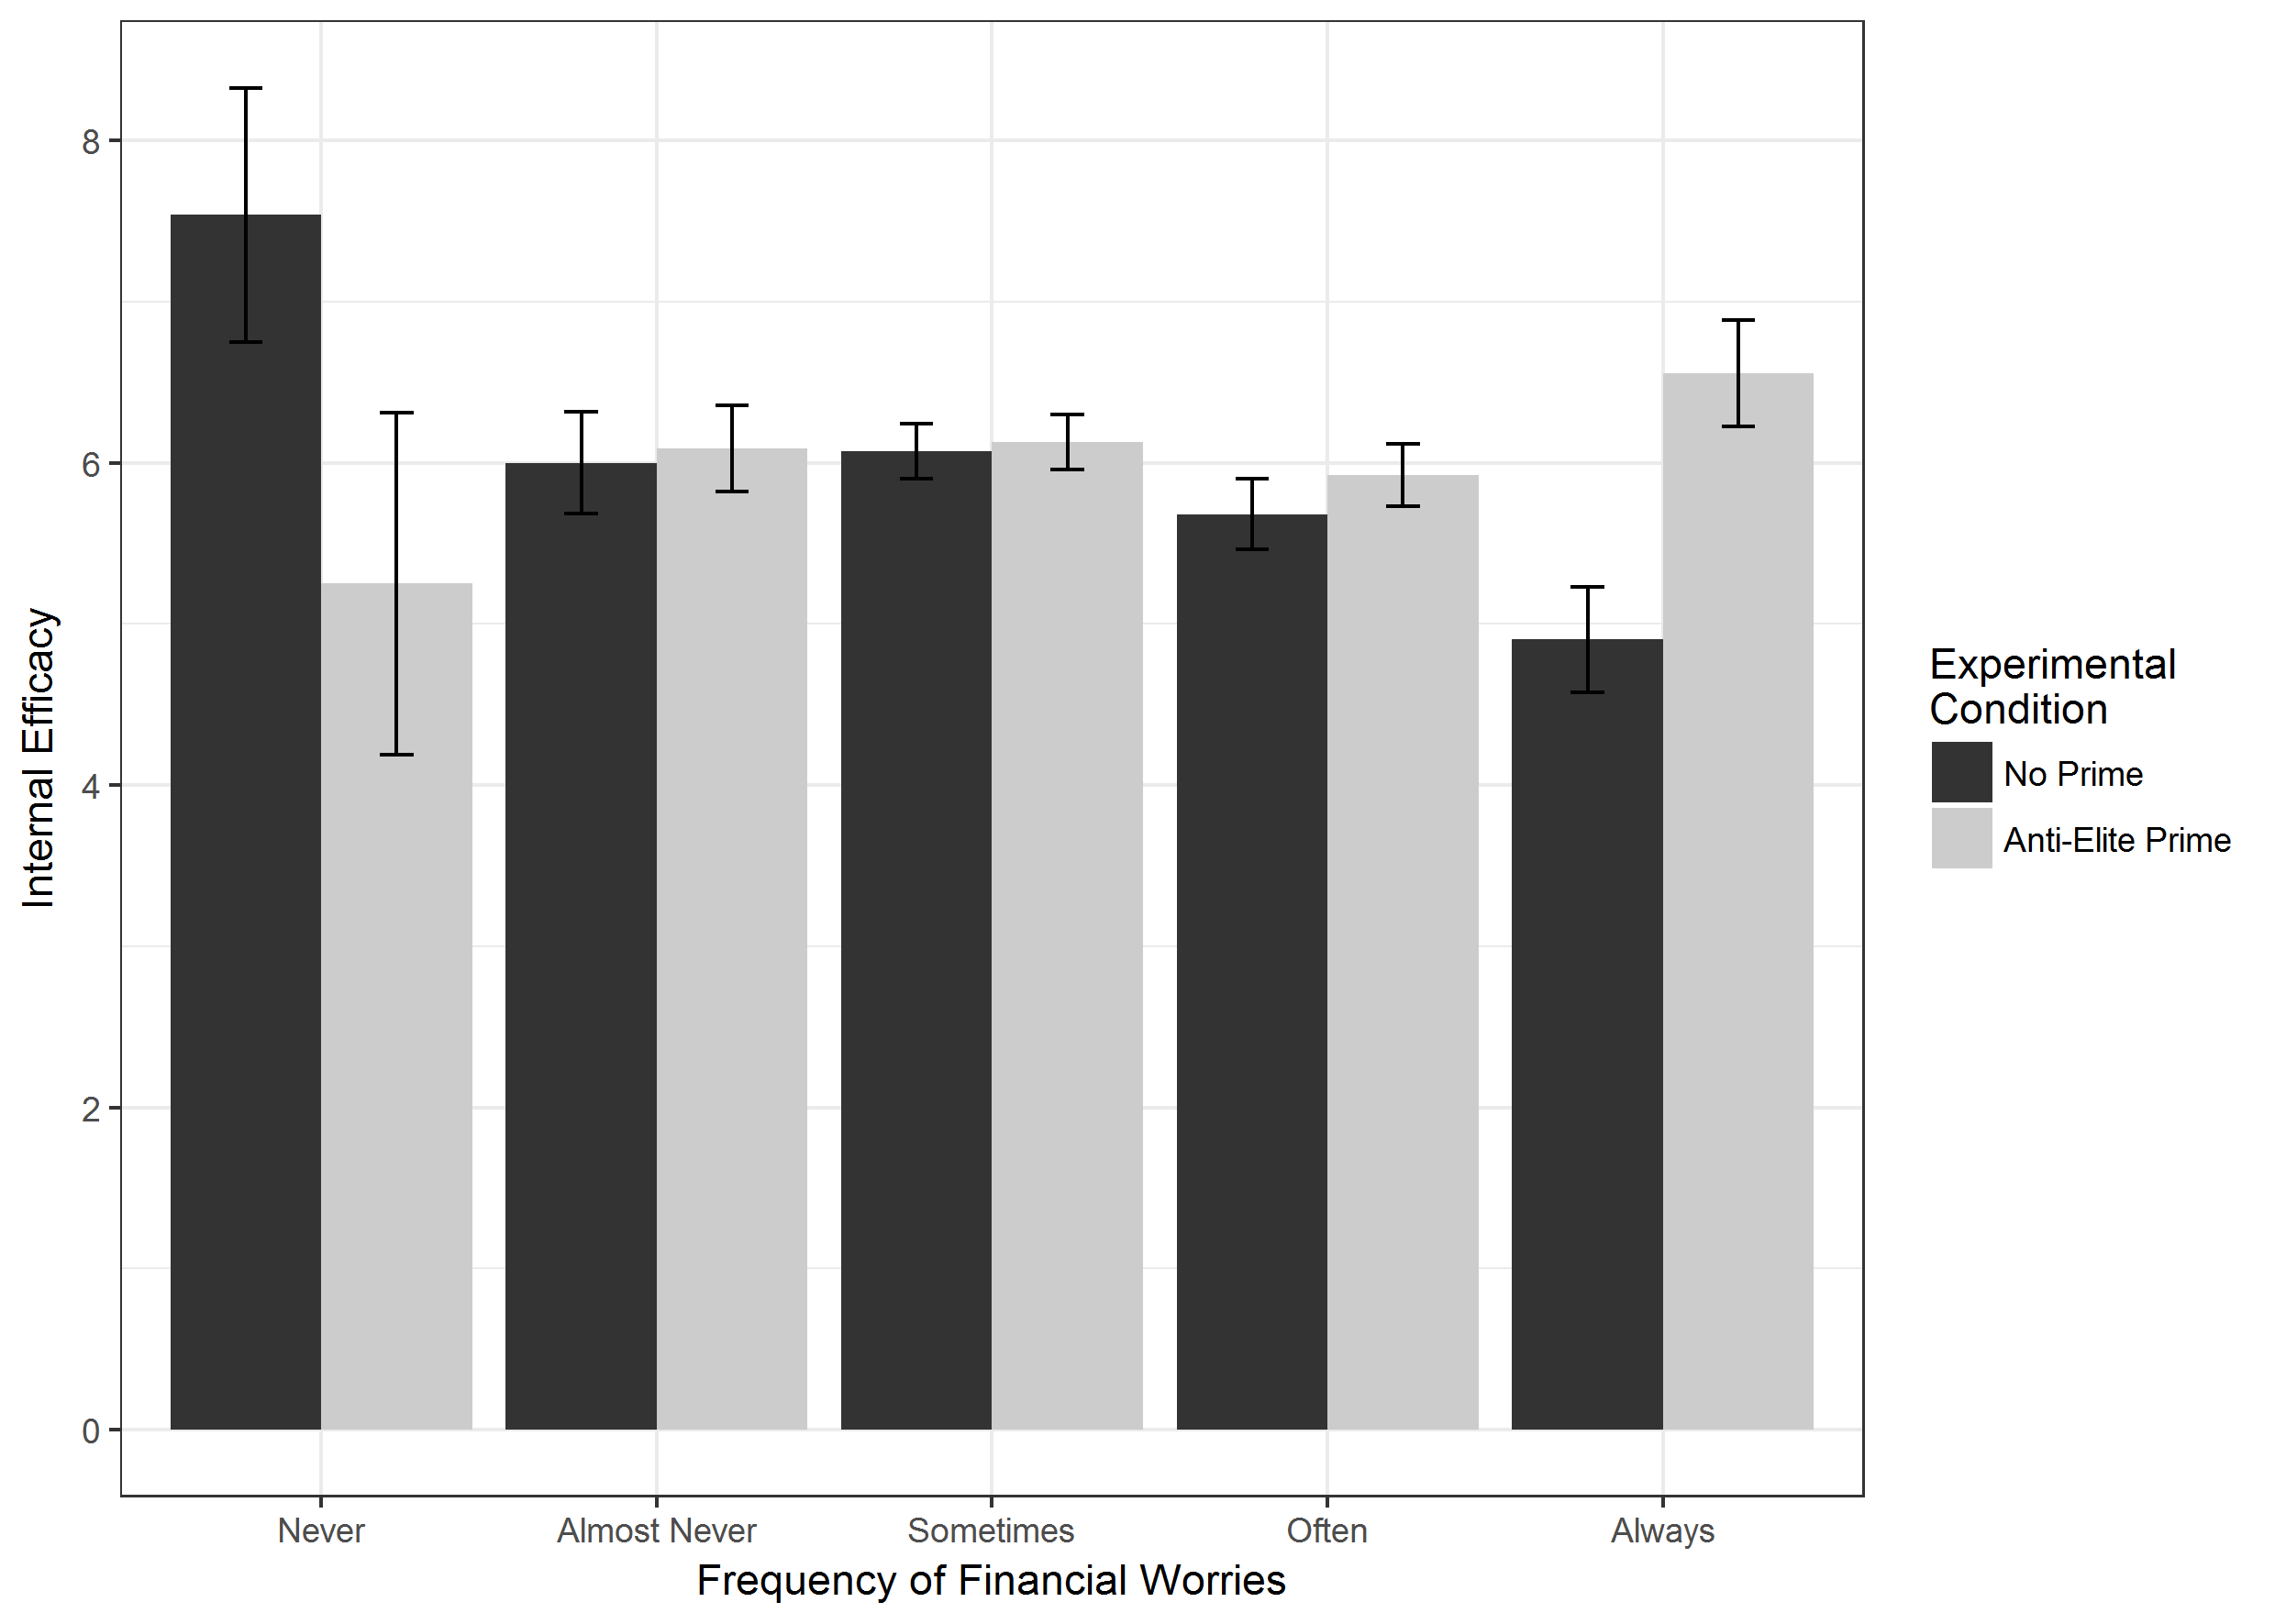

Political Participation Models
Table 23: Income, Anti-Elite Salience and Political Involvement
 | Probability of Voting | Other Political Participation
Household Income - Ref: Medium
Low | -0.26*** | -0.11***
 | (0.02) | (0.01)
High | 0.28*** | 0.15***
 | (0.03) | (0.01)
Cross-Level Interactions
Anti-Elite Vote Share | -0.26 | -0.07
 | (0.14) | (0.09)
Anti-Elite Vote Share x Low  Income | 0.01 | 0.10***
 | (0.04) | (0.03)
Anti-Elite Vote Share x High  Income | 0.09 | -0.03
 | (0.05) | (0.03)
Main Activity - Ref: Paid Employment
Education | -0.03 | 0.07*
 | (0.05) | (0.03)
Unemployed | -0.17*** | 0.05
 | (0.05) | (0.03)
Inactive | -0.32*** | -0.02
 | (0.07) | (0.05)
Sick or Disabled | -0.26*** | 0.07
 | (0.05) | (0.04)
Retired | -0.06 | -0.11***
 | (0.03) | (0.02)
Military Service | -0.95 | -0.11
 | (0.50) | (0.36)
Housework | -0.14*** | -0.09***
 | (0.04) | (0.02)
Socio-Economic Controls
Age | 0.65*** | 0.01
 | (0.03) | (0.02)
Female | -0.00 | -0.01
 | (0.02) | (0.01)
Years of Education | 0.25*** | 0.22***
 | (0.03) | (0.01)
Country Characteristics
Post-Communist | -0.39** | -0.39***
 | (0.15) | (0.09)
Effective Number of Parties | -0.05 | -0.08
 | (0.12) | (0.07)
Gini | -0.36** | -0.06
 | (0.14) | (0.08)
Intercept | 0.85*** | 0.66***
 | (0.06) | (0.04)
AIC | 24080.60 | 73083.90
BIC | 24243.28 | 73255.99
Log Likelihood | -12020.30 | -36520.95
Num. obs. | 25181 | 26766
Num. groups: cntry | 17 | 17
Var: cntry (Intercept) | 0.05 | 0.02
Var: Residual |  | 0.89
***p < 0.001, **p < 0.01, *p < 0.05

Table 24: Comparison of self-reported and officially recorded electoral turnout
Country | Vote –  ESS Self Report | VAP Turnout
AT | 77,19% | 65.87%
BE | 90,40% | 87.21%
CZ | 58,88% | 60.03%
DE | 83,54% | 66.07%
DK | 92,55% | 80.34%
EE | 69,73% | 60.87%
ES | 80,83% | 56.82%
FI | 82,89% | 73.14%
FR | 68,95% | 46.08%
GB | 71,50% | 60.45%
HU | 73,53% | 63.36%
IE | 76,21% | 58.04%
LT | 57,51% | 55.86%
NL | 79,32% | 71.02%
PL | 69,49% | 49.40%
PT | 71,44% | 61.75%
SE | 91,70% | 82.61%
SI | 67,69% | 54.09%

