Appendix
Table A: Countries in the Dataset
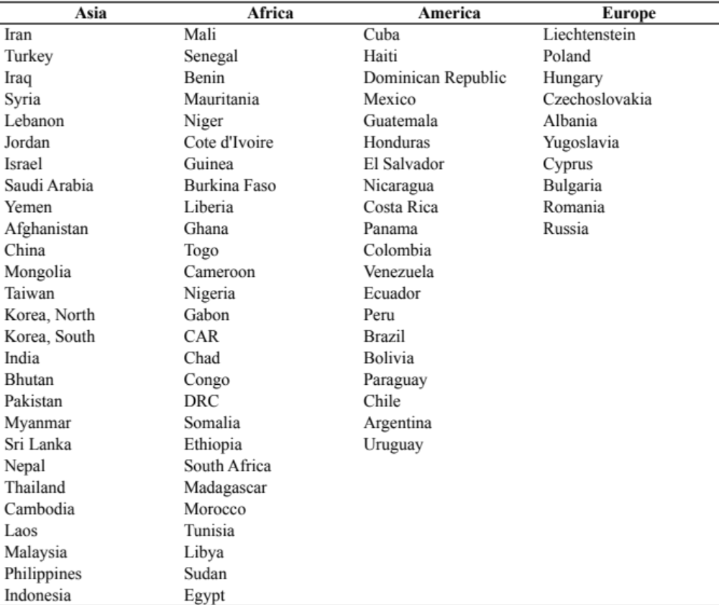

Table B: Summary Statistics
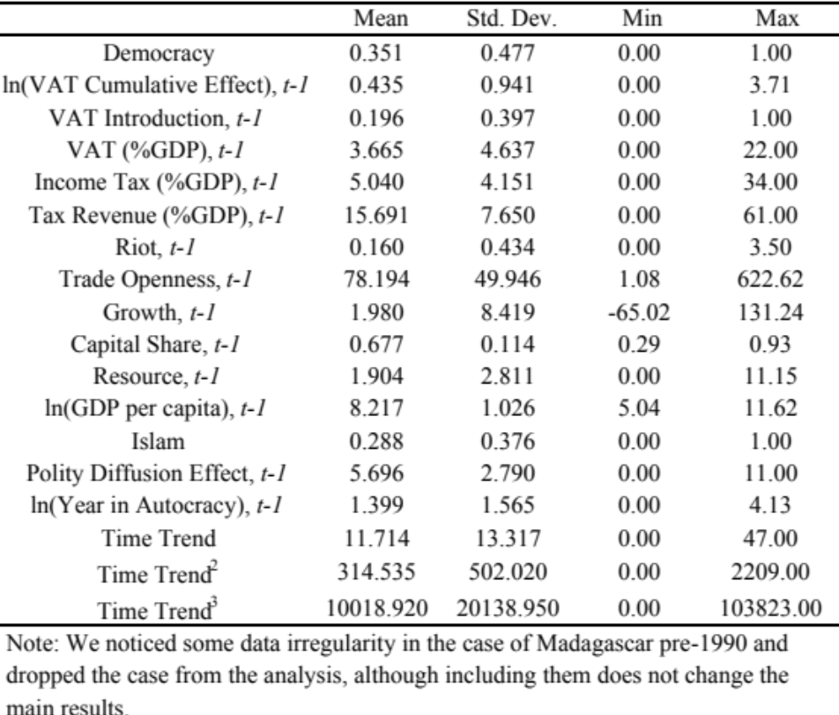

Table C: Baseline Analyses without Controls
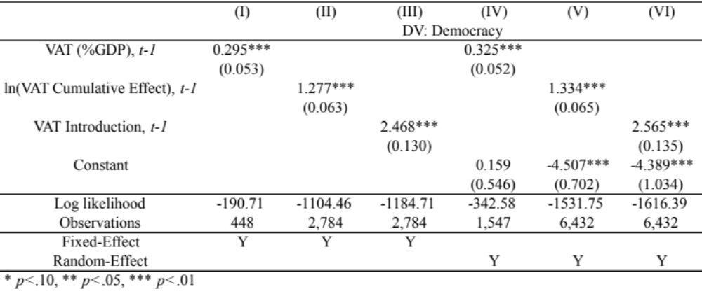

Table D: Analyses with Polity Scores
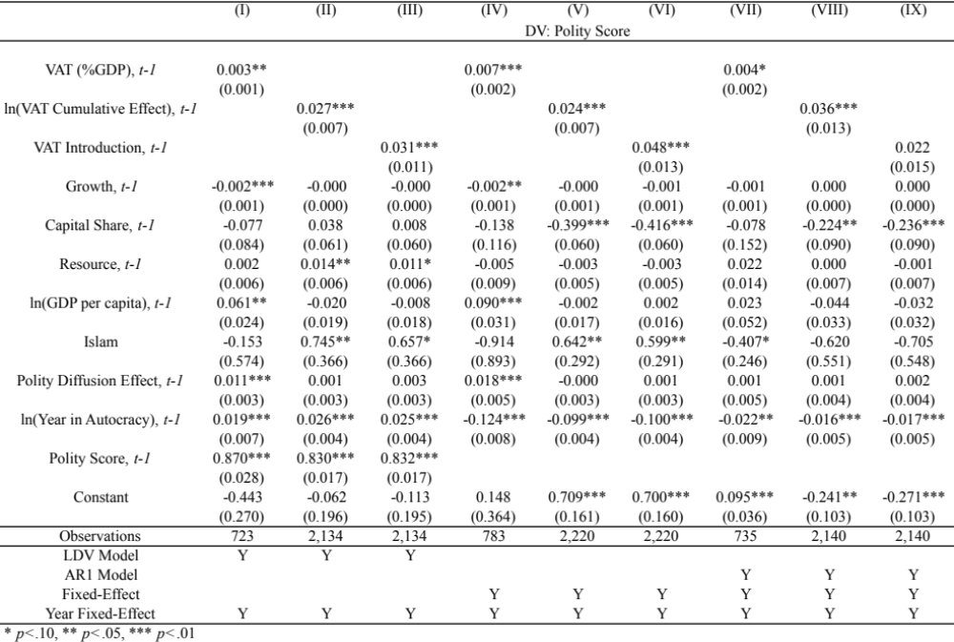Note: Some researchers are skeptical about the polity aggregate index. Thus, we also construct three additional measures based on component variables: competitiveness of executive recruitment (XRCOMP), constraints on the chief executive (XCONST), and competitiveness of political participation (PARCOMP). The results (not reported) are primarily similar to those with the component variables.
Table E: Baseline Analyses with Polity
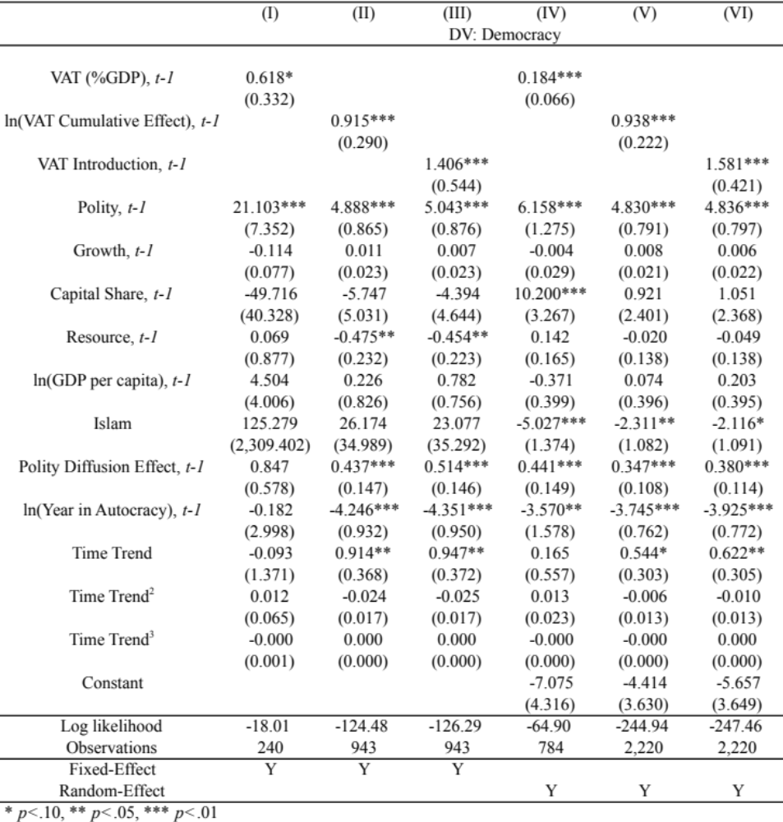

Table F: Analyses with Other Tax Variables
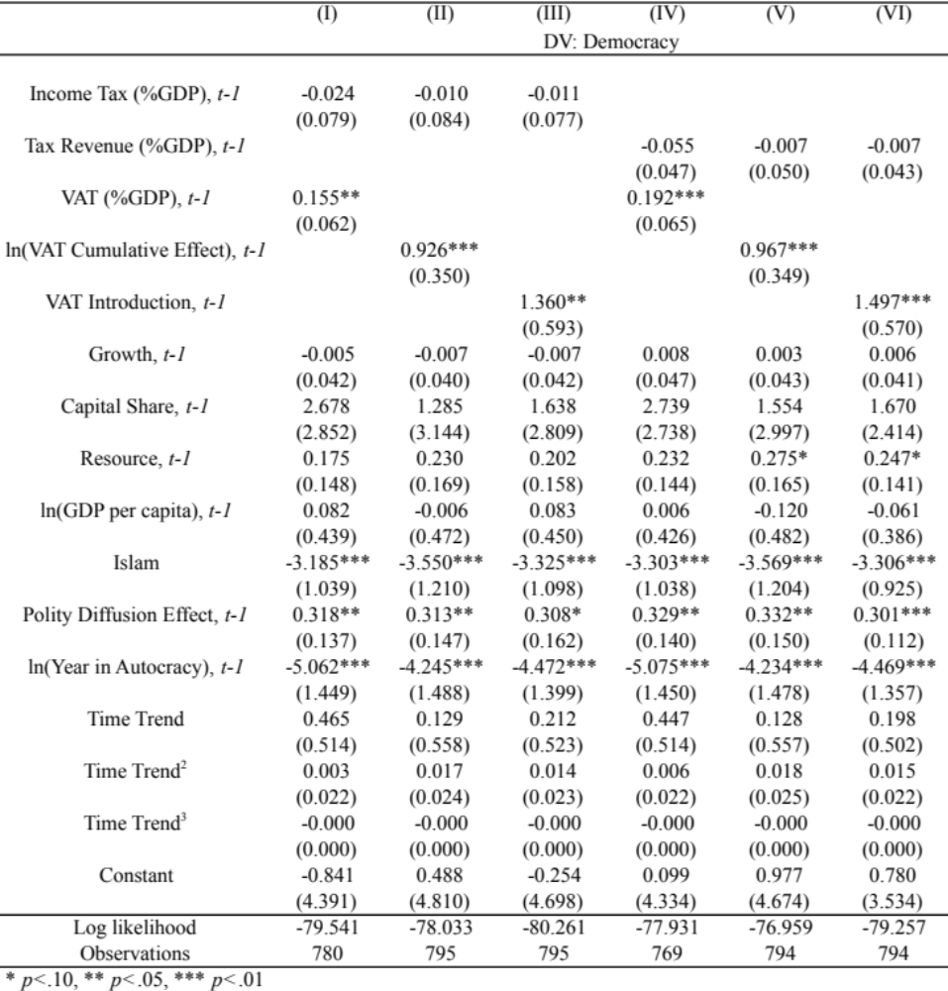

Table G: Analyses without Former Communist Countries
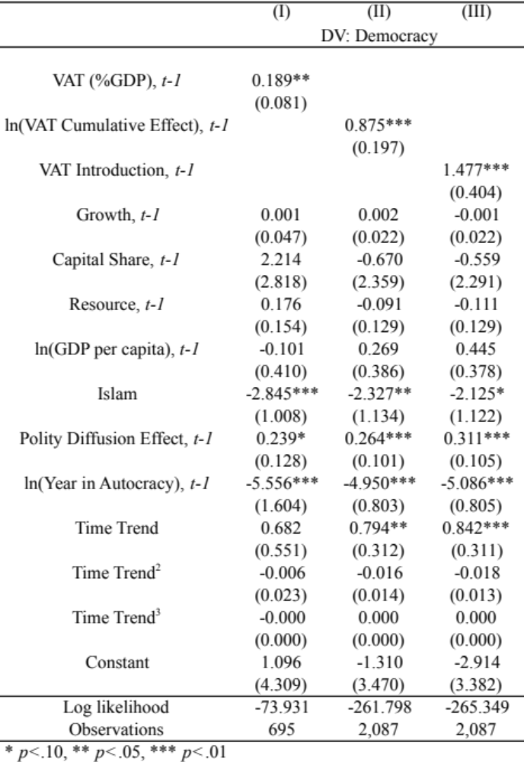

Table H: Analyses with the Trade Openness Variable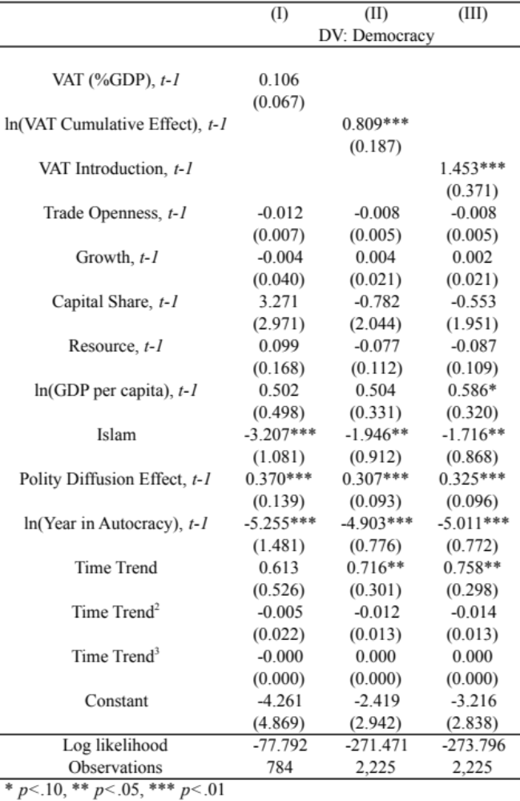

Table I: Analyses with the Interaction with GDP per capita 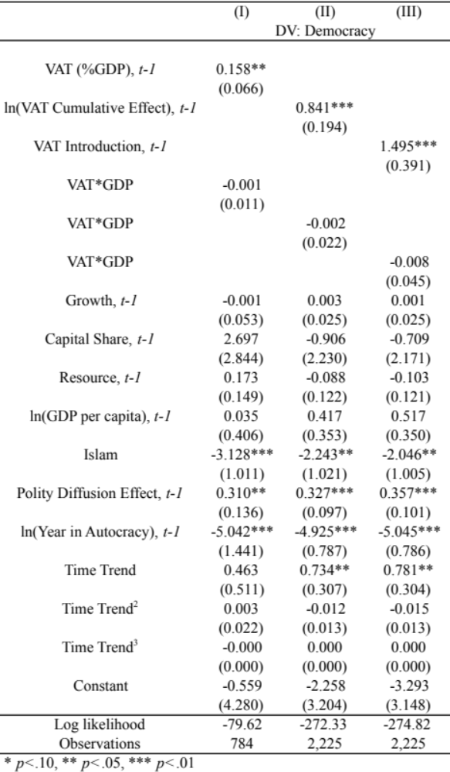
Table J: Analyses with Entropy Balancing, Including the Trade Openness Variable
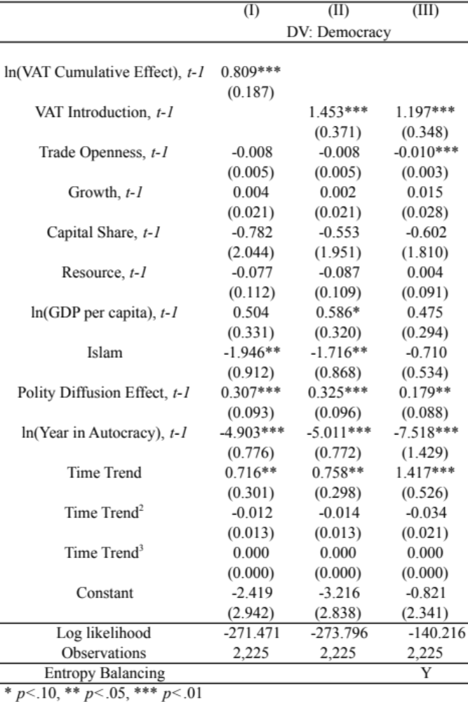

Table K: Analyses with Change in Democracy Variable
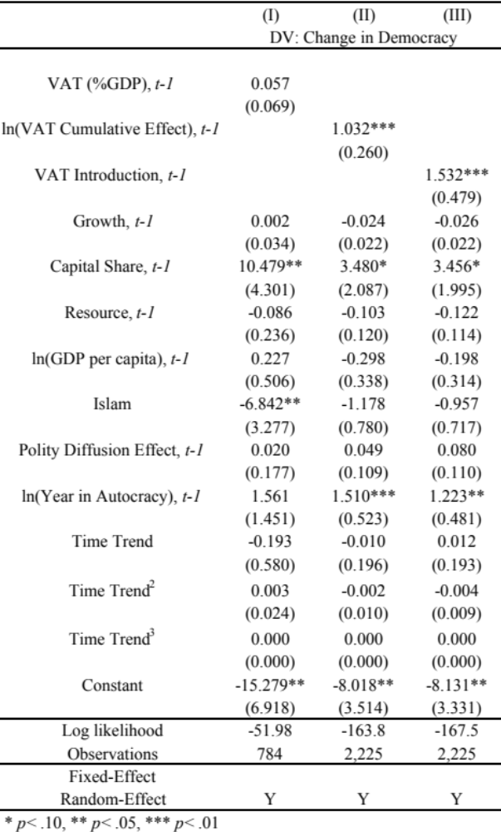

Table L: Dynamic Probit Analyses
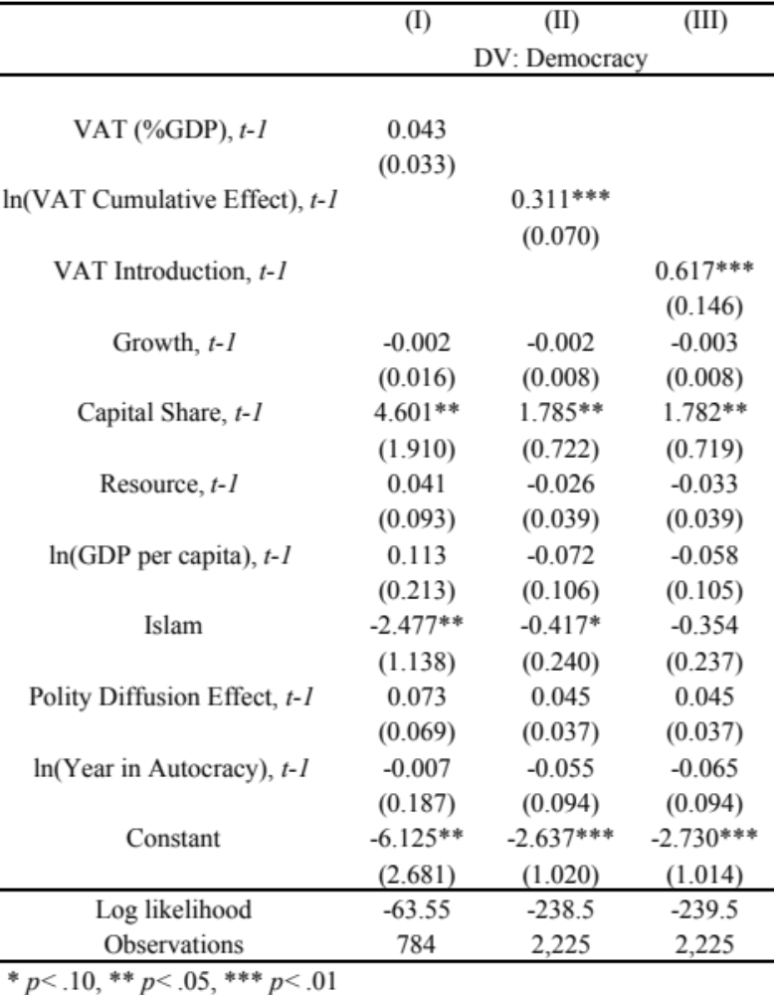
Note: We report only the results that are relevant for transition to democracy, not away from democracy.
Figure A: Entropy Balancing
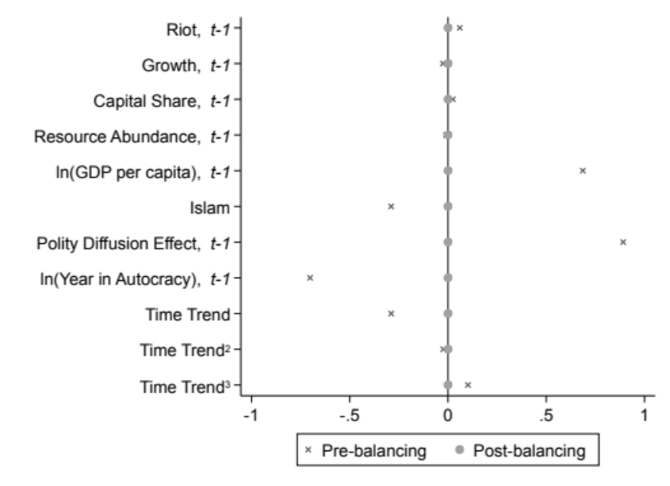
Note: The figure provides the standardized differences in the means before and after the entropy balancing. The figure shows that all the covariates are balanced between treated and control samples after the entropy balancing.

