ONLINE APPENDICES
ONLINE APPENDIX A: The relationship and congruence between public opinion and public policy
We use two distinct conceptions and measures of policy representation: a) The relationship between public opinion and policy, i.e. the degree to which a change in public support for a policy is correlated with a change in the likelihood of the policy being in place, and b) congruence between the majority of the public and the policy status quo. We can have different levels of congruence for the same relationship between opinion and policy. Similarly, the relationship between opinion and policy might vary between issues with the same level of congruence. Figure A1 illustrates this with five different scenarios represented in five panels.
The two scenarios represented on the top row of Figure A1 have the same basic relationship between opinion and policy, represented by β, which is the regression coefficient for public support in a logistic regression of the presence of the policy on public support. But congruence differs: in scenario A it is 51%, while in scenario B it is 89%. Note that α is the regression coefficient for the intercept in the same logistic regression of policy on public support. The locations of the observations are indicated as ‘rugs’ at the top and bottom of each plot.
The three scenarios depicted at the bottom row of Figure A1 have the same level of congruence (88%), but different relationships between opinion and policy. In scenario C, the regression coefficient β is 8, while in scenarios D and E it is 13. Furthermore, scenarios D and E have the same level of congruence and the same β, but differ in the estimates of the intercept, α.

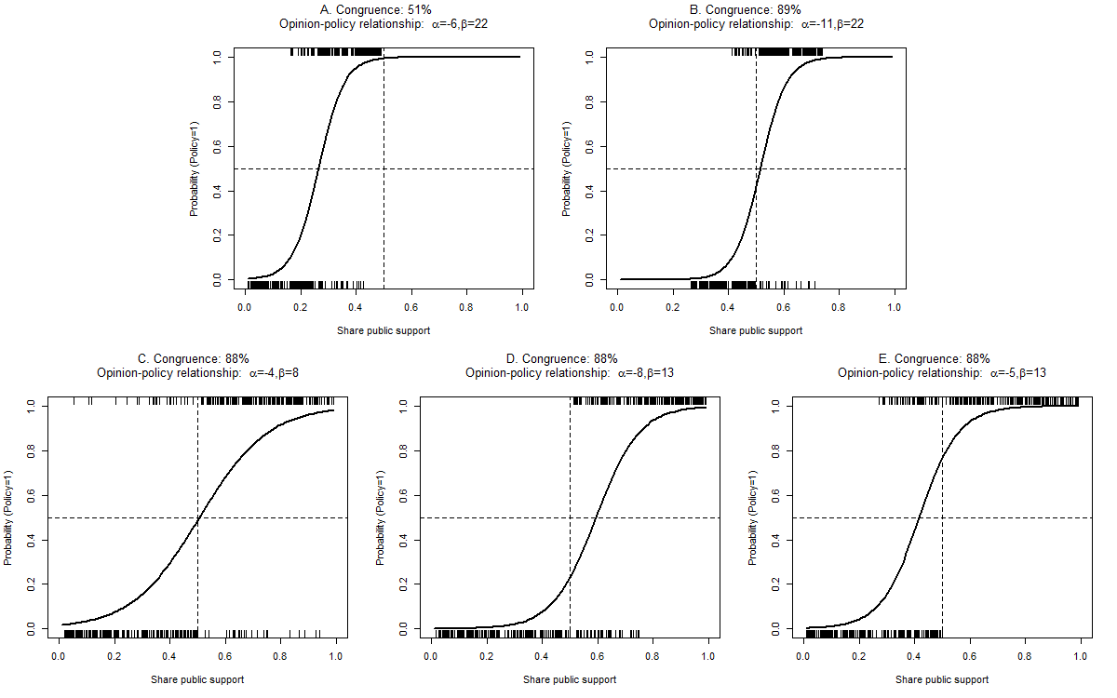
Figure A1. Congruence and relationship between public opinion and policy under five different scenarios.
Notes: Simulated data (N=400 for each panel). Observations represented by ‘rugs’ at the top and bottom of each panel. α and β are the intercept and public support coefficients, respectively, of logistic regressions of the presence of policy on public opinion support, estimated from the data for each panel.

ONLINE APPENDIX B: Policy scales
Issue | Original scale | Three-point scale | Binary scale
Warnings on alcoholic drink bottles | 0=no warnings  1=warnings | 0=no warnings  1= -  2=warnings | 0=no warnings  1=warnings
Experiments on animals like monkeys and dogs | 0=ban on experiments on monkeys and dogs  1=ban on experiments on great apes and gibbons  2=ban on experiments with great apes  3=no ban | 0= ban on experiments on any monkeys and dogs or great apes and gibbons  1= ban on experiments with great apes  2=no ban | 0=ban on experiments on any monkeys and dogs  1=no ban
Smoking bans in bars and pubs | 0=no ban  1=partial ban with many exceptions or not enforced  2=partial ban with some exceptions  3=ban, but separate smoking rooms (no exceptions for small premises)  4=complete ban | 0=no ban  1=partial ban with many exceptions or not enforced, or with some exceptions, or no exceptions but separate smoking rooms  2=complete ban | 0=no ban or partial ban with many exceptions or not enforced  1=partial ban with some exceptions or no exceptions but separate smoking rooms or complete ban
Banning of tobacco sale through vending machines | 0=no ban  1=restrictions  2=ban | 0=no ban  1=restrictions  2=ban | 0=no ban or restrictions  1=ban
Embryonic stem cell research | 0=no ban  1=no ban but restrictive  2=ban but allowed with imported cells  3=absolute ban | 0=no ban  1=no ban but restrictive  2=ban but allowed with imported cells or absolute ban | 0=no ban or no ban but restrictive  1=ban but allowed with imported cells or absolute ban
Nuclear power | 0=no nuclear energy with no plans to build or phase-out plan  1=no nuclear energy with no explicit policy  2=nuclear energy and plan to continue or none but explicit plans to build | 0=no nuclear energy with no plans to build or phase-out plan  1=no nuclear energy with no explicit policy  2=nuclear energy and plan to continue or none but explicit plans to build | 0=no nuclear energy with no plans to build or phase-out plan or no nuclear energy with no explicit policy  1=nuclear energy and plan to continue or none but explicit plans to build
Nation-wide minimum wage | 0=no minimum wage  1=industry-wide  2=national or industry-wide with coverage >90% | 0=no minimum wage  1=industry-wide  2=national or industry-wide with coverage >90% | 0=no minimum wage or industry-wide  1=national or industry-wide with coverage >90%
State support to care for dependent persons | 0=no support  1=support | 0=no support  1 = -  2=support | 0=no support  1=support
Detaining terrorist suspects indefinitely | 0=very short detention limit (<=3 days)  1=short detention limit (4-10 days)  2=long detention limit (>10 days)  3=no detention limit | 0=very short or short detention limit (<= 10 days)  1=long detention limit (>10 days)  2=no detention limit | 0=detention limit  2=no detention limit
Same-sex marriage | 0=marriage legalized  1=registered partnership  2=not legalized  3=prohibited | 0=marriage legalized  1=registered partnership  2=not legalized or prohibited | 0=marriage legalized  1=registered partnership or not legalized or prohibited
Adoption of children by same-sex couples | 0=not allowed  1=only internal adoption  2=internal and external | 0=not allowed  1=only internal adoption  2=internal and external | 0=not allowed or only internal adoption  1=internal and external
Abortion | 0=banned  1=only if threat to life of mother  2=only if threat to health of mother  3=for social and economic reasons  4=on request | 0=banned  1=only if threat to health of mother or for social and economic reasons  2=on request | 0=banned or only if threat to life or health of mother or for social and economic reasons  1=on request
Ius soli (citizenship on the basis of birth in a territory) | 0=only foundlings  1=only stateless children  2=only facilitated naturalization  3=double ius soli  4=weak ius soli  5=strong ius soli  6=unconditional ius soli at birth | 0=only foundlings or stateless children or facilitated naturalization  1=double or weak ius soli  2=strong or unconditional ius soli at birth | 0=only foundlings or stateless children or facilitated naturalization  1=double, weak or strong or unconditional ius soli at birth
Progressive income tax | 0=regressive tax  1=flat tax  2=progressive tax | 0=regressive tax  1=flat tax  2=progressive tax | 0=regressive or flat tax  1=progressive tax
The right to earn while receiving a pension | 0=not allowed to earn  1=limit on earnings/penalty  2=unlimited earnings | 0=not allowed to earn  1=limit on earnings/penalty  2=unlimited earnings | 0=not allowed to earn or limit on earnings/penalty  21=unlimited earnings
Asylum seekers’ right to work | 0=not allowed  1=allowed under certain conditions  2=allowed | 0=not allowed  1=allowed under certain conditions  2=allowed | 0=not allowed or only under strong conditions  1=allowed under (weak) conditions or allowed
On-line voting | 0=no  1=yes | 0=no  1= -  2=yes | 0=no  1=yes
Military involvement in Afghanistan | 0=no  1=yes | 0=no  1= -  2=yes | 0=no  1=yes
Mandatory retirement age | 0=none  1=none, with few exceptions (e.g. military)  2=for public servants and/or a considerable no. of professions based on collective agreements and/or employers may set one  3=yes | 0=none or none with few exceptions (e.g. military)  1=for public servants and/or a considerable no. of professions based on collective agreements and/or employers may set one  3=yes | 0=none or none with few exceptions (e.g. military)  1=for public servants and/or a considerable no. of professions based on collective agreements and/or employers may set one or yes
Banning the disposal of plastic waste in landfills | 0=no  1=yes | 0=no  1= -  2=yes | 0=no  1=yes

ONLINE APPENDIX C: Descriptive information on public opinion, policy, and congruence

Table C1. Descriptive information on public opinion, policy, and congruence
Country | Values | Empirical range | Mean (std. dev.)
Public opinion | 0-1 | .05-.98 | .63 (.22)
Policy | 0, 1, 2 | 0-2 | 1.00 (.89)
Congruence | 0, 1 | 0-1 | .63 (.48)

Table C2. Descriptive information on public opinion, policy, and congruence by country
 |  | Mean (standard error)
Country | No. of issues | Public opinion |  | Policy |  | Congruence
Austria | 19 | .59 | (.06) | .89 | (.23) | .74 | (.10)
Belgium | 17 | .62 | (.04) | .88 | (.22) | .53 | (.12)
Bulgaria | 15 | .73 | (.05) | 1.00 | (.26) | .60 | (.13)
Croatia | 7 | .56 | (.11) | .86 | (.34) | .57 | (.20)
Cyprus | 14 | .63 | (.08) | 1.00 | (.23) | .64 | (.13)
Czech Republic | 17 | .66 | (.04) | 1.00 | (.21) | .47 | (.12)
Denmark | 19 | .59 | (.05) | .79 | (.20) | .63 | (.11)
Estonia | 13 | .68 | (.06) | 1.08 | (.26) | .77 | (.12)
Finland | 19 | .60 | (.05) | 1.05 | (.19) | .63 | (.11)
France | 20 | .60 | (.04) | 1.25 | (.20) | .75 | (.10)
Germany | 20 | .63 | (.05) | 1.15 | (.18) | .60 | (.11)
Greece | 17 | .57 | (.07) | .94 | (.23) | .71 | (.11)
Hungary | 17 | .67 | (.05) | .88 | (.24) | .71 | (.11)
Iceland | 4 | .63 | (.15) | 1.25 | (.48) | 1.00 | (.00)
Ireland | 19 | .65 | (.05) | .79 | (.20) | .47 | (.12)
Italy | 17 | .61 | (.05) | .94 | (.22) | .41 | (.12)
Latvia | 16 | .67 | (.06) | .81 | (.23) | .56 | (.13)
Lithuania | 13 | .69 | (.07) | 1.23 | (.28) | .62 | (.14)
Luxembourg | 17 | .59 | (.05) | 1.06 | (.20) | .59 | (.12)
Malta | 13 | .60 | (.08) | 1.00 | (.23) | .69 | (.13)
Norway | 11 | .63 | (.06) | .91 | (.28) | .54 | (.16)
Poland | 17 | .68 | (.05) | 1.00 | (.24) | .41 | (.12)
Portugal | 20 | .62 | (.05) | .95 | (.20) | .85 | (.08)
Romania | 13 | .65 | (.06) | 1.23 | (.26) | .77 | (.12)
Slovakia | 15 | .69 | (.05) | 1.13 | (.26) | .67 | (.13)
Slovenia | 17 | .63 | (.05) | 1.00 | (.23) | .53 | (.12)
Spain | 20 | .62 | (.05) | .80 | (.17) | .60 | (.11)
Sweden | 20 | .64 | (.05) | .95 | (.21) | .75 | (.10)
Switzerland | 6 | .58 | (.09) | .50 | (.34) | .50 | (.22)
Netherlands | 19 | .64 | (.05) | 1.11 | (.20) | .68 | (.11)
UK | 20 | .68 | (.05) | 1.35 | (.20) | .55 | (.11)
Total | 20 | .63 | (.01) | 1.00 | (.04) | .63 | (.02)

Table C3. Descriptive information on public opinion, policy, and congruence by issue
 |  | Mean (standard error)
Issue | No. of  countries | Public opinion |  | Policy |  | Congruence
Warnings on alcoholic drink bottles | 27 | .80 | (.02) | .15 | (.10) | .07 | (.05)
Experiments on animals like monkeys and dogs | 31 | .56 | (.02) | 1.68 | (.12) | .52 | (.09)
Smoking bans in bars and pubs | 28 | .68 | (.02) | .96 | (.10) | .68 | (.09)
Banning tobacco sale through vending machines | 27 | .61 | (.02) | 1.48 | (.10) | .74 | (.09)
Embryonic stem cell research | 31 | .44 | (.02) | .58 | (.14) | .81 | (.07)
Nuclear power | 27 | .46 | (.04) | 1.33 | (.16) | .81 | (.08)
Nation-wide minimum wage | 27 | .69 | (.01) | 1.85 | (.09) | .89 | (.06)
State support to care for dependent persons | 28 | .92 | (.01) | 1.71 | (.13) | .86 | (.07)
Detaining terrorist suspects indefinitely | 18 | .49 | (.02) | .11 | (.08) | .56 | (.12)
Same-sex marriage | 27 | .48 | (.05) | 1.44 | (.14) | .63 | (.09)
Adoption of children by same-sex couples | 31 | .33 | (.04) | .52 | (.15) | .77 | (.08)
Abortion | 27 | .86 | (.02) | 1.67 | (.11) | .74 | (.09)
Ius soli (citizenship on the basis of birth in a territory) | 20 | .82 | (.02) | .60 | (.18) | .40 | (.11)
Progressive income tax | 16 | .81 | (.02) | 1.88 | (.13) | .94 | (.06)
The right to earn while receiving a pension | 16 | .65 | (.03) | 1.00 | (.26) | .56 | (.13)
Asylum seekers’ right to work | 21 | .76 | (.02) | .76 | (.15) | .38 | (.11)
On-line voting | 16 | .48 | (.03) | .00 | (.00) | .44 | (.13)
Military involvement in Afghanistan | 15 | .38 | (.05) | .67 | (.25) | 1.00 | (.00)
Mandatory retirement age | 30 | .65 | (.04) | .50 | (.10) | .53 | (.09)
Banning disposal of plastic waste in landfills | 28 | .83 | (.02) | .50 | (.17) | .21 | (.08)
Total | 31 | .63 | (.01) | 1.00 | (.04) | .63 | (.02)

ONLINE APPENDIX D: Values on institutional variables by country

Table D1. Country values on institutional variables
 | Effective number of parliamentary parties (ENPP)_{a} | Regime type_{b} | Legislature’s influence over the executive | Bicameralism_{b} | Federalism_{b}
Values | 1.99 – 9.05 (observed values) | 0=parliamentary,  1=semi-presidential, 2=presidential | 0 (least powerful) – 9 (most powerful) | 0=no bicameralism, 1=bicameralism | 0=unitary, 1=hybrid, 2=federal
Source | Bormann and Golder (2013) | Cheibub, Gandhi and Vreeland (2010) | Fish and Kroenig (2009) | Johnson and Wallack (2006) | Norris (2009)
Austria | 3.74 | 1 | 5 | 1 | 2
Belgium | 8.22 | 0 | 8 | 1 | 2
Bulgaria | 3.94 | 1 | 7 | 0 | 0
Croatia | 3.14 | 1 | 7 | 1 | 0
Cyprus | 3.83 | 2 | 1 | 0 | 0
Czech Republic | 3.49 | 0 | 8 | 1 | 0
Denmark | 5.15 | 0 | 8 | 0 | 0
Estonia | 4.31 | 0 | 8 | 0 | 0
Finland | 5.19 | 1 | 6 | 0 | 0
France | 2.66 | 1 | 3 | 1 | 0
Germany | 4.07 | 0 | 8 | 1 | 2
Greece | 2.49 | 0 | 8 | 0 | 0
Hungary | 2.44 | 0 | 8 | 0 | 0
Iceland | 3.96 | 1 | - | 0 | 0
Ireland | 3.17 | 1 | 8 | 1 | 0
Italy | 4.08 | 0 | 8 | 1 | 1
Latvia | 5.59 | 0 | 7 | 0 | 0
Lithuania | 5.70 | 1 | 6 | 0 | 0
Luxembourg | 3.87 | 0 | - | 0 | 0
Malta | 2.00 | 0 | - | 0 | 0
Norway | 4.52 | 0 | 7 | 0 | 0
Poland | 3.03 | 1 | 7 | 1 | 0
Portugal | 2.72 | 1 | 6 | 0 | 1
Romania | 3.55 | 1 | 6 | 1 | 0
Slovakia | 4.73 | 1 | 6 | 0 | 0
Slovenia | 4.58 | 0 | 7 | 1 | 0
Spain | 2.45 | 0 | 8 | 1 | 2
Sweden | 4.29 | 0 | 7 | 0 | 0
Switzerland | 5.03 | 2 | 6 | 1 | 2
Netherlands | 5.49 | 0 | 7 | 1 | 1
UK | 2.38 | 0 | 8 | 1 | 1
_{a} The values indicate the average ENPP value across all observations for a country. The measure used is ‘enpp1’ in Bormann and Golder’s dataset, which ‘corrects’ for the influence of independents and ‘other parties’ (cf. the codebook at http://mattgolder.com/elections).
_{b} The data is taken from the Quality of Government project (http://qog.pol.gu.se/data).

REFERENCES
Bormann, Nils-Christian, and Matt Golder (2013). Democratic Electoral Systems around the World, 1946–2011. Electoral Studies 32: 360–369.
Cheibub, José A., Jennifer Gandhi, and James R. Vreeland (2010). Democracy and Dictatorship Revisited. Public Choice 143(2-1): 67-101.
Fish, M. Steven, and Matthew Kroenig (2009). The Handbook of National Legislatures: A Global Survey. New York: Cambridge University Press.
Johnson, Joel W. and Jessica S. Wallack (2006). Electoral Systems and the Personal Vote. San Diego: University of California.
Norris, Pippa. (2009). Democracy Time-Series Dataset. http://www.pippanorris.com.

ONLINE APPENDIX E: Estimations with alternative electoral system measures

Table E1. Effects on the relationship between public opinion and policy
 | PR/majoritarian system dummy | Gallagher Index | Average district magnitude
Public opinion (PO) | 5.45 (2.67)* | 5.85 (2.73)* | 5.52 (2.66)*
Electoral system measure | .90 (.38)* | .05 (.03) | -.00 (.00)
PO * Electoral system measure | .50 (2.04) | -.08 (.17) | .01 (.02)
Regime type (reference=parliamentary)
Semi-presidential | .12 (.24) | .19 (.24) | .26 (.23)
Presidential | -.15 (.55) | -.08 (.56) | -.08 (.55)
PO * semi-presidential | -1.16 (1.23) | -1.06 (1.22) | -1.11 (1.20)
PO * presidential | -2.25 (2.35) | -2.47 (2.37) | -2.31 (2.35)
Bicameralism | -.12 (.27) | -.05 (.27) | .10 (.26)
PO * bicameralism | -.43 (1.42) | -.23 (1.41) | -.53 (1.35)
Federalism (reference=unitary)
Hybrid | .36 (.33) | .34 (.33) | .42 (.35)
Federal | .16 (.37) | .09 (.36) | -.08 (.35)
PO * hybrid | 1.62 (1.63) | 1.85 (1.63) | 1.56 (1.73)
PO * federal | 2.65 (1.87) | 2.45 (1.86) | 2.80 (1.83)
EU member | -.02 (.43) | .10 (.43) | .13 (.43)
PO * EU member | .69 (2.13) | .60 (2.11) | .56 (2.11)
Salience | .43 (.22)* | .43 (.22)* | .43 (.22)*
PO * salience | 1.48 (.91) | 1.52 (.92) | 1.55 (.92)
Year | .12 (.10) | .12 (.10) | .11 (.10)
PO * year | -1.13 (.48)* | -1.17 (.49)* | -1.14 (.48)*
Issue intercept variance | 2.40 (1.03) | 2.39 (1.02) | 2.38 (1.02)
Issue PO slope variance | 31.13 (18.13) | 31.37 (18.27) | 31.43 (18.33)
Intercept-slope covariance | 3.59 (3.33) | 3.23 (3.34) | 3.45 (3.34)
Deviance | 742 | 745 | 747
N level 1 (level 2) | 491 (20) | 490 (20) | 491 (20)
* p<.05, ** p<.01, *** p<.0005.

The models in Tables 1 and 3 include the Effective Number of Parliamentary Parties (ENPP) in the last election prior to the year in which public opinion and policy are measured as the measure of electoral system proportionality. Here, the measure is replaced with three alternative measures in order to test the robustness of the results: (1) a dummy indicating whether the main system used for lower house elections in a country is based on plurality or PR rules (Keefer 2015); (2) the Gallagher Index or Least Squares Index (Gallagher 2014), indicating the degree of vote-seat disproportionality of an election, at the last legislative election; and (3) a measure of the average district magnitude at the first tier at the last legislative election (Bormann and Golder 2013). In Table D1, Model 3 (Table 1) is replicated with these three measures. Table E2 replicates Model 7 (Table 3). The estimates show that neither the relationship between public opinion and policy nor opinion-policy congruence are affected by variation in the electoral system.

Table E2. Effects on public opinion-policy congruence
 | PR/majoritarian system dummy | Gallagher Index | Average district magnitude
Opinion majority | 3.48 (1.07)** | 3.47 (1.07)** | 3.47 (1.07)**
Electoral system measure | .42 (.36) | -.00 (.03) | .00 (.00)
Regime type (reference=parliamentary)
Semi-presidential | .30 (.24) | .37 (.24) | .37 (.24)
Presidential | -.12 (.56) | -.13 (.56) | -.10 (.56)
Bicameralism | -.79 (.27)** | -.68 (.27)* | -.69 (.26)**
Federalism (reference=unitary)
Hybrid | .33 (.33) | .36 (.34) | .33 (.35)
Federal | .63 (.36) | .51 (.36) | .53 (.35)
EU member | .50 (.41) | .56 (.41) | .56 (.41)
Salience | .49 (.14)** | .48 (.14)** | .48 (.14)**
Year | -.09 (.07) | -.09 (.07) | -.09 (.07)
Intercept | .34 (.46) | .29 (.47) | .28 (.46)
Issue intercept variance | .94 (.41) | .93 (.41) | .94 (.41)
Deviance | 547 | 549 | 549
N level 1 (level 2) | 491 (20) | 490 (20) | 491 (20)
* p<.05, ** p<.01, *** p<.0005.

REFERENCES
Bormann, Nils-Christian, and Matt Golder (2013). Democratic Electoral Systems around the World, 1946–2011. Electoral Studies 32: 360–369.
Gallagher, Michael (2014). Election indices dataset. Retrieved from http://www.tcd.ie/Political_ Science/staff/michael_gallagher/ElSystems/index.php on 11/05/2017.
Keefer, Philip E. (2015). Database of Political Institutions 2015. Retrieved from http://go. worldbank.org/2EAGGLRZ40 on 11/05/2017.

ONLINE APPENDIX F: Salience measure based on the ‘most important problem’ item
It is common in political science to use responses to the ‘most important problem’ (MIP) survey question as an indicator of the salience of an issue. We chose to use an indicator of the media salience of the policy issues in our sample instead, since we hypothesize that representation should function better if the public has more information about the issue at stake and about political elites’ positions and if policy-makers are, in turn, better informed about the preferences of the public. The media plays an important role in the transmission of this information. We nevertheless construct an alternative indicator using the MIP item.
Obtaining data on the ‘most important problems’ of the publics from all countries included in our study over the time period covered (1998-2013) is problematic. The first option is to use data from the Eurobarometer, which started to regularly include the MIP item in 2002. In this case, we would need to use data on salience in 2002 for the issues where policy and public opinion were measured between 1998 and 2001 (4 issues). But the more serious problem is that the item in the Eurobarometer (EB) is closed-ended and includes a very limited range of broad policy categories EB 57.2, conducted in 2002, contains the following issue categories: (1) crime, (2) public transport, (3) economic situation, (4) rising prices/inflation, (5) taxation, (6) unemployment, (7) terrorism, (8) defense/foreign affairs, (9) housing, (10) immigration, (11) health care system, (12) educational system, (13) pensions, and (14) protecting the environment. These categories change slightly over time. It is apparent that issues such as ‘online voting’ or ‘adoption of children by single-sex couples’ do not easily fit into any of these categories.
The other option is to use surveys that include open-ended items, where the response categories that were matched to the responses and are included in the dataset are generally more detailed. We chose this option and used the data from the European Election Studies (EES) from 1999, 2004, and 2009. We matched each policy issue in our sample with a response category in the last survey that was conducted before the respective policy and public support for it were measured. We then calculated the percentage of survey respondents in each country who mentioned the issue category among all respondents who gave a valid answer to the MIP question, which becomes the MIP salience measure. The policy issues and the response categories matched to them are listed in Table F1.

Table F1. List of policy issues and the issue categories matched to them that summarize responses to the ‘most important issue’ question in the European Election Studies (EES)
Policy issue | Year of public opinion and policy | Year of EES | MIP issue category
Warnings on alcoholic drink bottles directed at pregnant women and drivers | 2009 | 2009 | Health care
Experiments on animals like monkeys and dogs | 2010 | 2009 | Animals
Smoking bans in bars and pubs | 2008 | 2004 | Health care
Banning of tobacco sale through vending machines | 2012 | 2009 | Health care
Embryonic stem cell research | 2010 | 2009 | Health care
Nuclear power | 2008 | 2004 | Energy
Nation-wide minimum wage | 2010 | 2009 | Wages and earnings
State support for those who leave work to care for dependent persons | 2007 | 2004 | Welfare policy
Detaining terrorist suspects indefinitely without charging them | 2005-2008 | 2004 | Terrorism
Same-sex marriage | 2009 | 2009 | Civil rights, civil liberties, rights in general; homosexuals
Adoption of children by same-sex couples | 2008-2009 | 2004 | Politics of minorities
Abortion | 2009 | 2009 | Abortion
Ius soli (citizenship on the basis of birth in a territory) | 2003-2005 | 1999 | Politics of minorities/integration
Progressive income tax | 1998-2001 | 1999 | Taxes
The right to earn an unlimited income while receiving a pension | 2001 | 1999 | Pensions, retirement policy, retirement options
Asylum seekers’ right to work while waiting for the decision | 2002-2003 | 1999 | Immigration
On-line voting | 1999 | 1999 | Other election-related issues
Military involvement in Afghanistan | 2001 | 1999 | Defense and national security; foreign affairs
Mandatory retirement age | 2011 | 2009 | Pensions; national employment policies
Banning the disposal of plastic waste in landfills | 2013 | 2009 | Environment
It is clear that the categories are still much broader than the policy issues in most cases, whereas in some they fit very well (in particular for the issue of abortion). It is therefore not surprising that the MIP salience variable is uncorrelated with the media salience variable (Pearson’s r=.02, p=.65), which measures the salience of the specific policy issues rather than the broader policy areas. The media salience measure is arguably not equally valid for all countries, since the Financial Times covers, and is read in, some countries more than in others. On these grounds, it should have a particularly high degree of validity for the UK. Yet, even here, it is entirely uncorrelated with the MIP salience measure. This suggests that the

Table F2. The effects of media and MIP salience on the relationship between opinion and policy
 |  | Model
 |  | 1 |  | 2 |  | 3 |  | 4
Public opinion (PO) | 6.29 (1.71)*** |  | 5.99 (1.83)** |  | 5.32 (3.39) |  | 4.15 (3.55)
ENPP | -.05 (.09) |  | -.04 (.09) |  | -.02 (.09) |  | -.02 (.09)
PO * ENPP | .60 (.48) |  | .63 (.49) |  | .75 (.49) |  | .80 (.50)
Regime type (reference=parliamentary)
Semi-presidential | .35 (.26) |  | .36 (.26)
Presidential | -.37 (.82) |  | -.25 (.84)
PO * semi-presidential | -1.38 (1.32) |  | -1.69 (1.34)
PO * presidential | -2.32 (4.98) |  | -3.69 (5.24)
Legislature’s influence |  |  |  |  | -.14 (.08) |  | -.15 (.09)
PO * legislature’s influence |  |  |  |  | .13 (.44) |  | .22 (.45)
Bicameralism | .02 (.28) |  | .04 (.28) |  | .17 (.29) |  | .18 (.29)
PO * bicameralism | -.12 (1.46) |  | -.06 (1.49) |  | -.27 (1.50) |  | -.26 (1.53)
Federalism (reference=unitary)
Hybrid | .01 (.35) |  | -.06 (.36) |  | .07 (.35) |  | .02 (.36)
Federal | -.00 (.38) |  | .02 (.39) |  | -.04 (.38) |  | -.01 (.38)
PO * hybrid | 1.34 (1.67) |  | 1.79 (1.72) |  | 1.29 (1.67) |  | 1.73 (1.71)
PO * federal | .68 (1.99) |  | .70 (2.01) |  | .66 (1.98) |  | .81 (2.00)
Media salience | .39 (.22) |  |  |  | .42 (.22)
PO * media salience | 1.17 (.83) |  |  |  | .82 (.80)
MIP salience |  |  | .06 (.03)* |  |  |  | .05 (.03)
PO * MIP salience |  |  | -.17 (.15) |  |  |  | -.10 (.15)
Year | .04 (.10) |  | .04 (.11) |  | .04 (.10) |  | .04 (.11)
PO * year | -1.09 (.44)* |  | -1.10 (.48)* |  | -1.15 (.44)** |  | -1.12 (.48)*
Issue intercept variance | 2.45 (1.10) |  | 3.45 (1.53) |  | 2.46 (1.10) |  | 3.37 (1.48)
Issue PO slope variance | 19.53 (15.07) |  | 27.60 (20.32) |  | 16.35 (15.04) |  | 24.12 (19.50)
Intercept-slope covariance | 4.28 (3.18) |  | 6.46 (4.42) |  | 4.80 (3.08) |  | 6.62 (4.19)
Deviance | 620 |  | 618 |  | 577 |  | 578
N level 1 (level 2) | 397 (20) |  | 397 (20) |  | 375 (20) |  | 375 (20)
* p<.05, ** p<.01, *** p<.0005.
MIP salience measure is not a good indicator of the salience of the policy issues in the public debate – and especially in the media.
In Tables F2 and F3, we re-estimate the models from Tables 1 and 3 that estimate the effects of salience on the opinion-policy relationship and congruence, respectively, substituting the MIP salience measure for the media salience measure. We also report the results of the models using the media salience measure on the same sample, since the sample decreases from 491 to 397 cases when using the MIP salience measure because the EES do not include all countries (most importantly, it only includes EU member states, which is why the EU dummy is excluded from the models). We find that neither the media salience nor the MIP measure moderate the relationship between opinion and policy in the reduced sample, no matter whether the model includes the regime type dummies (Models 1 and 2, Table F2) or the indicator of the legislature’s influence (Models 3 and 4).

Table F3. The effects of media and MIP salience on public opinion-policy congruence
 | Model
 | 5 | 6 | 7 | 8
Opinion majority | 3.24 (1.17)** | 3.08 (1.21)* | 3.63 (1.23)** | 3.43 (1.26)**
ENPP | -.03 (.08) | -.03 (.08) | -.05 (.09) | -.05 (.09)
Regime type (reference=parliamentary)
Semi-presidential | .25 (.26) | .24 (.26)
Presidential | -.86 (.78) | -.81 (.78)
Legislature’s influence |  |  | -.05 (.08) | -.05 (.08)
Bicameralism | -.79 (.29)** | -.78 (.29)** | -.81 (.30)** | -.80 (.30)**
Federalism (reference=unitary)
Hybrid | .35 (.37) | .32 (.37) | .30 (.36) | .27 (.36)
Federal | .41 (.38) | .41 (.39) | .39 (.38) | .39 (.38)
Media salience | .43 (.14)** |  | .43 (.15)**
MIP salience |  | .04 (.04) |  | .04 (.04)
Year | -.12 (.07) | -.13 (.08) | -.12 (.07) | -.12 (.08)
Intercept | 1.01 (.31)** | 1.00 (.35)** | 1.15 (.31)*** | 1.14 (.35)**
Issue intercept variance | .84 (.40) | 1.40 (.63) | .95 (.45) | 1.48 (.66)
Deviance | 449 | 455 | 419 | 425
N level 1 (level 2) | 397 (20) | 397 (20) | 375 (20) | 375 (20)
* p<.05, ** p<.01, *** p<.0005.

In Table F3, we find that media salience maintains its significant positive effect on congruence in the reduced sample (Models 5 and 7). MIP salience, on the other hand, does not influence the relationship. Since the positive effect of issue salience on the strength of the opinion-policy link has been shown in a range of studies using different data and focusing on different periods and countries (e.g. Lax and Phillips 2012; Page and Shapiro 1983), this finding can be considered support for the claim that the media salience indicator is a more valid measure of our concept than the MIP salience variable.

REFERENCES
Lax, Jeffrey R., and Justin H. Phillips (2012). The Democratic Deficit in the States. American Journal of Political Science 56(1): 148-166.
Page, Benjamin I. and Robert Y. Shapiro (1983). Effects of Public Opinion on Policy. American Political Science Review 77(1): 175-190.

ONLINE APPENDIX G: Marginal effects plots of interactions

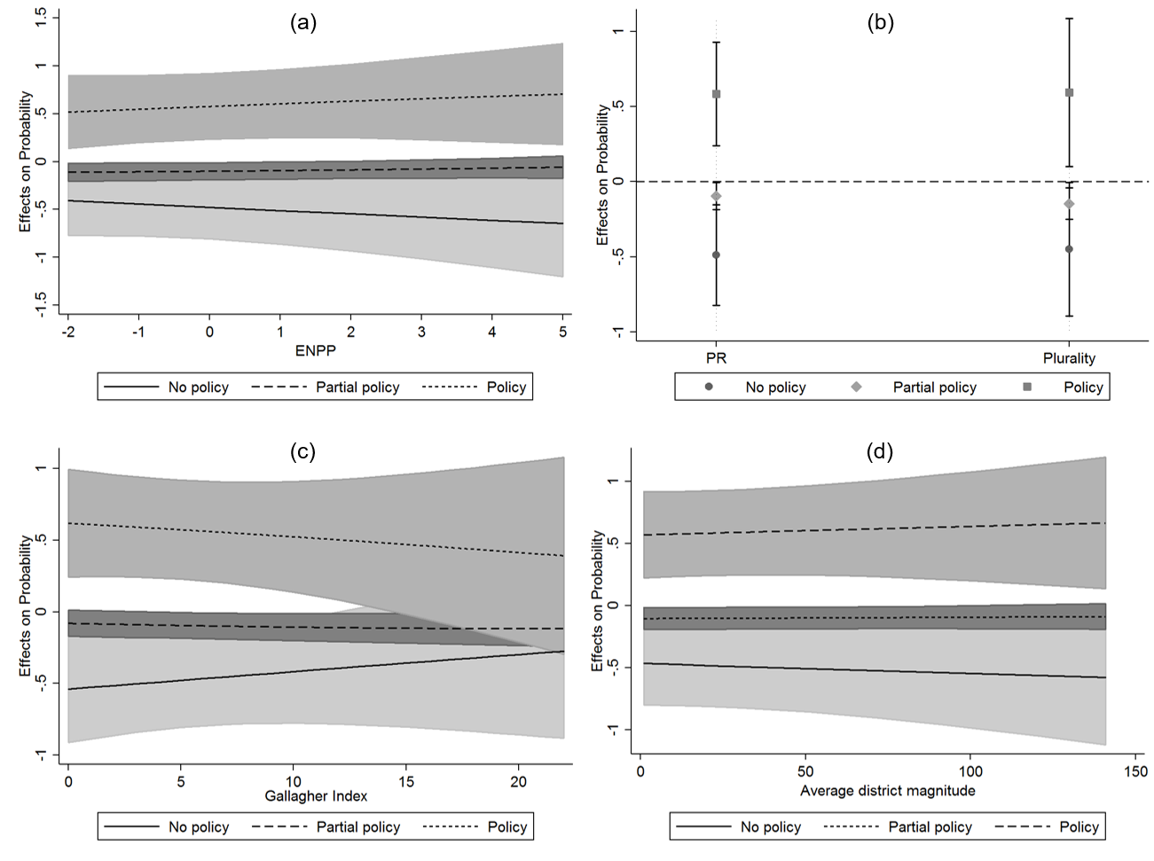
Figure G1. Marginal effects of public opinion on the probabilities of no policy, partial policy, and policy in different electoral systems
Notes: Average marginal effects with covariates at their observed values and 95% confidence intervals. (a) is based on Model 3 (Table 1); (b), (c), and (d) on equivalent models with ENPP replaced by the respective measure. ENPP is grand mean-centered.

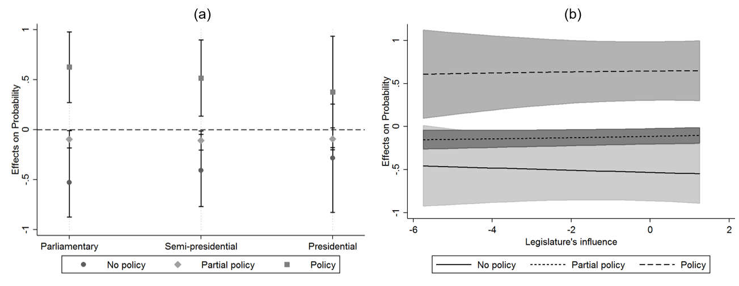
Figure G2. Marginal effects of public opinion on the probabilities of no policy, partial policy, and policy in different regime types
Notes: Average marginal effects with covariates at their observed values and 95% confidence intervals. (a) is based on Model 3, (b) on Model 4 (Table 1). Legislature’s influence is grand mean-centered.

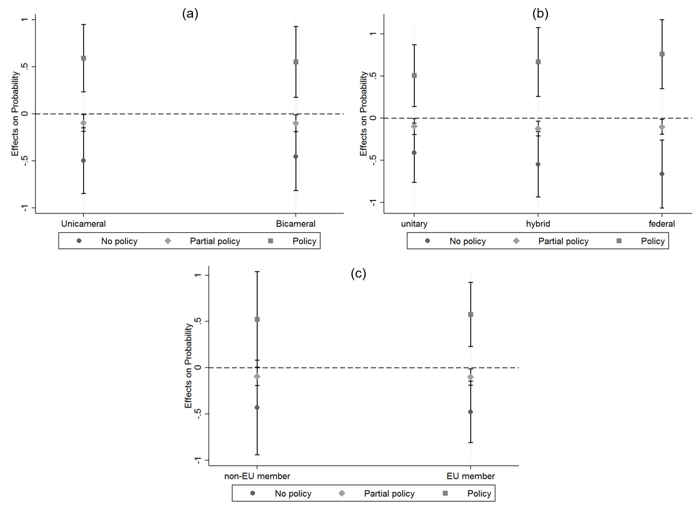
Figure G3. Marginal effects of public opinion on the probabilities of no policy, partial policy, and policy along variation in bicameralism, federalism, and EU membership status
Notes: Average marginal effects based on Model 3 (Table 1) with covariates at their observed values and 95% confidence intervals.
ONLINE APPENDIX H: Specifications with country fixed effects

Table H1. Ordinal logit regression with country fixed effects and robust standard errors (equivalent to Models 3 and 4 in Table 1)
 | Model
 | 3 | 4
Public opinion (PO) | 4.25 (2.10)* | 3.34 (2.22)
PO * ENPP | .13 (.37) | .06 (.41)
Regime type (reference=parliamentary)
PO * semi-presidential | -.16 (.99)
PO * presidential | -.83 (2.03)
PO * legislature’s influence |  | .00 (.31)
PO * bicameralism | .24 (1.11) | .16 (1.17)
Federalism (reference=unitary)
PO * hybrid | .13 (1.34) | -.03 (1.36)
PO * federal | .18 (1.54) | .07 (1.53)
PO * EU member | 1.10 (2.04) | 2.29 (2.27)
Salience | .35 (.06)*** | .36 (.06)***
PO * salience | .65 (.27)* | .63 (.31)*
Year | .11 (.04)** | .12 (.04)**
PO * year | -1.24 (.21)*** | -1.31 (.21)***
Deviance | 892 | 817
N | 491 | 457
* p<.05, ** p<.01, *** p<.0005
Notes: Models include country fixed effects and robust standard errors.

Table H2. Logistic regression with country fixed effects and robust standard errors (equivalent to Models 7 and 8 in Table 3, excluding variables with no within-country variation)
Opinion majority | 2.06 (.80)*
ENPP | -.11 (.22)
EU member | 1.24 (.58)*
Salience | .39 (.06)***
Year | -.07 (.03)*
Intercept | -.05 (.82)
Deviance | 568
N | 487
* p<.05, ** p<.01, *** p<.0005.
Notes: Models include country fixed effects and robust standard errors. Iceland is excluded because its observations are predicted perfectly.

ONLINE APPENDIX J: Congruence models excluding opinion majority

Table J1. Effects on public opinion-policy congruence without the opinion majority measure (equivalent to Models 7 and 8 in Table 3 and models in Table E2)
 | ENPP |  | PR/majoritarian system dummy | Gallagher Index | Average district magnitude
Electoral system measure | -.10 (.08) | -.11 (.08) | .42 (.36) | -.01 (.03) | .00 (.00)
Regime type (reference=parliamentary)
Semi-presidential | .35 (.24) |  | .31 (.24) | .39 (.24) | .38 (.23)
Presidential | -.06 (.56) |  | -.07 (.56) | -.09 (.56) | -.04 (.56)
Legislature’s influence |  | -.13 (.08)
Bicameralism | -.79 (.26)** | -.73 (.27)** | -.84 (.27)** | -.72 (.27)** | -.74 (.26)**
Federalism (reference=unitary)
Hybrid | .35 (.34) | .29 (.33) | .32 (.33) | .36 (.34) | .31 (.35)
Federal | .55 (.35) | .49 (.35) | .56 (.35) | .43 (.36) | .46 (.34)
EU member | .51 (.40) | .79 (.42) | .48 (.40) | .54 (.40) | .53 (.40)
Salience | .41 (.13)** | .40 (.14)** | .41 (.13)** | .41 (.13)** | .41 (.13)**
Year | -.08 (.06) | -.08 (.06) | -.08 (.06) | -.08 (.06) | -.08 (.06)
Intercept | .35 (.45) | .22 (.46) | .36 (.45) | .32 (.46) | .29 (.45)
Issue intercept variance | .83 (.37) | .92 (.41) | .82 (.37) | .81 (.37) | .82 (.37)
Deviance | 559 | 518 | 559 | 560 | 560
N level 1 (level 2) | 491 (20) | 457 (20) | 491 (20) | 490 (20) | 491 (20)
* p<.05, ** p<.01, *** p<.0005.

