Supplementary Information:
Institutional Reform and Public Attitudes
Toward EU Decision Making

Contents
- Descriptive statistics 2
- Additional analyses 3
- Sample representativeness 6
- Weighting analysis 9
- Diagnostic check of assumptions 10
  - Profile order 10
  - Carry over 11
  - Randomization effects 12
- Robustness 13
  - Respondent attentiveness 13
  - Alternative dependent variable 16
- Experimental design 17
- Survey questions 20

Descriptive statistics
Table A1: Descriptive information on variables

Variable | Min | Median | Mean | Max | Respondents
Personal benefit | 1 | 3 | 3.04 | 5 | 15370
National benefit | 1 | 3 | 2.65 | 5 | 15370
National attachment | 1 | 5 | 4.32 | 5 | 15367
Satisfaction with government performance | 1 | 4 | 4.37 | 11 | 15335
Knowledge about EU procedures | 1 | 5 | 5.05 | 10 | 15343
Political knowledge about EU | 0 | 3 | 2.38 | 4 | 15343
Pro-EU party support | -1 | 0 | -0.08 | 1 | 15328
Left-right self-placement | 1 | 6 | 6.04 | 11 | 15335
Education (in years) | 0 | 21 | 21.35 | 40 | 15317
Female | 0 | 0 | 0.47 | 1 | 15373
Age | 18 | 46 | 46.41 | 89 | 15373

Additional analyses

Table A2: Response patterns

Country | % Categorical rejecters | % Conditional supporters | % Categorical accepters
Austria | 0.03 | 0.93 | 0.04
Czech Rep. | 0.01 | 0.94 | 0.05
Denmark | 0.05 | 0.92 | 0.03
France | 0.02 | 0.86 | 0.11
Germany | 0.02 | 0.93 | 0.05
Greece | 0.01 | 0.90 | 0.08
Hungary | 0.00 | 0.93 | 0.06
Ireland | 0.01 | 0.89 | 0.10
Italy | 0.01 | 0.86 | 0.13
Netherlands | 0.03 | 0.90 | 0.07
Poland | 0.01 | 0.92 | 0.07
Spain | 0.01 | 0.86 | 0.13
Sweden | 0.04 | 0.89 | 0.07
Pooled | 0.02 | 0.90 | 0.08

Categorical rejecters (accepters) are defined by evaluating each profile they encounter unfavorably (favorably). As Table A2 illustrates, the vast majority show responsiveness to the variation of options presented to them.

Figure A1: Computing Average Component Interaction Effects (ACIEs) for first-order interaction effects among the four dimension.

Each panel represents one dimension being interacted with the other three. For each attribute, respectively, the first horizontal line represents the constitutive term (interpreted as the attribute’s effect when the moderator is zero). Interaction effects with each level of the moderator are displayed in matching colors. Overall, we see that as the interaction effects define dense clusters: None of the moderators substantially alters the predictions for the other three dimensions. Replicating these ACIEs with the AMIE approach proposed by Egami and Imai (2018) leads to similar conclusions. Estimates are available upon request.

Figure A2: Subgroup-specific difference in conditional AMCEs

Subgroup-specific differences in conditional AMCEs for subgroups: We divide our respondents according to whether or not they perceive high national benefit from European integration, indicate high knowledge about EU procedures, and high satisfaction with the performance of the current national government. Also, we distinguish respondents according to their level of education and their self-placement on the left-right scale.

- Sample representativeness

Table A3: Official demographic statistics from Eurostat (2018), compared to the sample distribution.

6
 | Austria |  | Czech Republic |  | Denmark |  | France |  | Germany |  | Greece |  | Hungary
 | Target | Sample | Target | Sample | Target | Sample | Target | Sample | Target | Sample | Target | Sample | Target | Sample
Age
18-29 | 15.80% | 16.80% | 14.80% | 16.30% | 17.00% | 16.30% | 15.30% | 16.70% | 14.10% | 13.60% | 13.20% | 16.30% | 15.60% | 15.10%
30-39 | 16.30% | 17.10% | 19.10% | 20.40% | 15.10% | 9.00% | 16.00% | 21.50% | 15.20% | 16.40% | 17.50% | 28.40% | 19.10% | 22.00%
40-49 | 18.60% | 19.60% | 19.00% | 19.00% | 18.20% | 14.50% | 17.50% | 21.20% | 16.80% | 22.00% | 18.60% | 29.90% | 18.50% | 19.00%
50-59 | 19.00% | 19.50% | 15.60% | 18.50% | 17.30% | 21.00% | 17.20% | 16.80% | 19.90% | 19.60% | 16.70% | 18.70% | 15.30% | 18.20%
60+ | 30.30% | 27.00% | 31.40% | 25.80% | 32.30% | 39.20% | 33.80% | 23.90% | 34.00% | 28.40% | 33.70% | 6.60% | 31.40% | 25.70%
Sum | 100.00% | 100.00% | 99.90% | 100.00% | 100.00% | 100.00% | 100.00% | 100.00% | 100.00% | 100.00% | 100.00% | 100.00% | 100.00% | 100.00%
Gender
Male | 48.70% | 54.40% | 51.40% | 48.40% | 52.20% | 58.90% | 52.10% | 53.10% | 51.30% | 53.70% | 51.80% | 52.60% | 53.30% | 48.90%
Female | 51.30% | 45.60% | 48.60% | 51.60% | 47.80% | 41.10% | 47.90% | 46.90% | 48.70% | 46.30% | 48.20% | 47.40% | 46.70% | 51.10%
Sum | 100.00% | 100.00% | 100.00% | 100.00% | 100.00% | 100.00% | 100.00% | 100.00% | 100.00% | 100.00% | 100.00% | 100.00% | 100.00% | 100.00%

 | Ireland |  | Italy |  | Netherlands |  | Poland |  | Spain |  | Sweden
 | Target | Sample | Target | Sample | Target | Sample | Target | Sample | Target | Sample | Target | Sample
Age
18-29 | 15.70% | 17.00% | 12.30% | 17.60% | 15.60% | 20.20% | 16.90% | 25.70% | 12.40% | 17.10% | 17.70% | 19.20%
30-39 | 21.50% | 17.90% | 14.60% | 20.80% | 15.20% | 11.50% | 20.80% | 20.40% | 17.90% | 25.50% | 16.00% | 14.90%
40-49 | 20.30% | 19.10% | 19.30% | 21.50% | 18.10% | 19.70% | 16.30% | 16.20% | 20.80% | 19.70% | 17.30% | 14.90%
50-59 | 16.70% | 18.40% | 18.30% | 16.10% | 19.00% | 19.40% | 16.80% | 17.70% | 18.20% | 17.60% | 15.80% | 16.80%
60+ | 25.80% | 27.50% | 35.50% | 24.00% | 32.10% | 29.30% | 29.20% | 20.10% | 30.70% | 20.20% | 33.10% | 34.20%
Sum | 100.00% | 100.00% | 100.00% | 100.00% | 100.00% | 100.00% | 100.00% | 100.00% | 100.00% | 100.00% | 100.00% | 100.00%
Gender
Male | 50.70% | 57.60% | 52.00% | 52.60% | 50.80% | 52.20% | 52.40% | 50.00% | 51.50% | 51.90% | 50.40% | 52.60%
male | 49.30% | 42.40% | 48.00% | 47.40% | 49.20% | 47.80% | 47.60% | 50.00% | 48.50% | 48.10% | 49.60% | 47.40%
Sum | 100.00% | 100.00% | 100.00% | 100.00% | 100.00% | 100.00% | 100.00% | 100.00% | 100.00% | 100.00% | 100.00% | 100.00%

Figure A3: Country representativeness by dimension

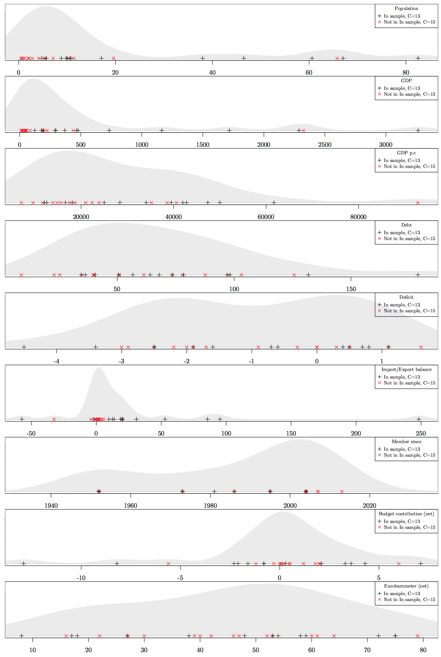

To assess the representativeness of the 13 countries selected for the overall EU, we compare all EU member states along nine dimensions which we compiled from Eurostat and the Eurobarometer: Budget contribution, debt, deficit, EU-support (share of respondents who think that membership in the EU is “a good thing” minus the share of respondents who think it is “a bad thing”), GDP, GDP per capita, import-export-balance, population size, and the year of accession to the EU. While this list is certainly not exhaustive, these nine dimensions provide meaningful comparisons among the EU member states.
For each dimension, we determine the distribution of the 13 countries in our sample: Austria, Czech Republic, Denmark, France, Germany, Greece, Hungary, Ireland, Italy, Netherlands, Poland, Spain and Sweden. Since we see a risk of extrapolating from our sample to countries that are incomparable, we propose to evaluate the 15 remaining member states of the EU with respect to where they fall on each dimension compared to the countries that we did sample. Figure A3 shows the density curves of all 28 EU member states on each dimension, and distinguishes our sampled countries (black cross) from not-sampled countries (red crosses). We want the non-sampled countries to be as close as possible to the sampled countries, indicating that the countries in our sample cover a ground representative of the EU overall on each dimension.
As Figure A3 suggests, the 13 countries we sampled cover a reasonable range of the overall density for the EU28 on each of the nine dimensions considered. Importantly, we see that the non-sampled countries (red crosses) never fall too far away from the countries in our sample. While we observe some clustering of non-sampled countries, for example with respect to countries with very small populations, our sample of 13 countries never seems drastically non-representative of the overall EU28 distribution. We conclude that by and large, our sample of 13 countries represents the EU28 reasonably well.

- Weighting analysis

Figure A4: Before and after entropy balancing.

Criteria for balancing: Age, gender and education. We use Hainmueller’s ebalance package to create survey weights. The weights target the age and gender distribution in the respective country, as well as the share of highly educated people in three different age groups (18 to 24, 25 to 54, 55 or older).

Diagnostic check of assumptions

Profile order

Figure A5: AMCEs estimated separately for two cases: whether a profile is shown first (on the left) or second (on the right).

Carry over

Figure A6: Analysis split by successive rounds

We separate the four contests the respondents get to see, each contest with two alternatives to compare. Results should not systematically differ across these four rounds, which would be a sign of survey fatigue.

  - Randomization effects

Table A4: Balance tests using (multinomial) logit models to regress shown attributes on respondent characteristics.

 | Proposal |  |  | Adoption |  |  | Voting | Sanctioning
 | COM, EP  or Council | EP | Council | COM | EP | Council | Unanimity | National courts | EU-representatives  & member states
Education | -0.0001 | -0.0002 | -0.0016 | -0.0014 | 0.00061 | 0.00093 | 0.00112 | -0.0011 | -0.0001
 | (0.001) | (0.001) | (0.001) | (0.001) | (0.001) | (0.001) | (0.001) | (0.001) | (0.001)
Age | -0.0007 | -0.0008 | -0.0007 | -0.0003 | -0.0007 | -0.0003 | -9.3079 | 0.00017 | 0.00086
 | (0.000) | (0.000) | (0.000) | (0.000) | (0.000) | (0.000) | (0.000) | (0.000) | (0.000)
Female | 0.01233 | 0.00615 | 0.00683 | 0.00065 | -0.0080 | 0.01648 | 0.02544∗ | -0.0002 | 0.02174
 | (0.016) | (0.016) | (0.016) | (0.016) | (0.016) | (0.016) | (0.011) | (0.014) | (0.014)
(Intercept) | 0.03109 | 0.05185 | 0.07305 | 0.04166 | 0.02142 | -0.0065 | -0.0380 | 0.01519 | -0.0528
 | (0.042) | (0.042) | (0.042) | (0.042) | (0.042) | (0.042) | (0.029) | (0.036) | (0.036)
Note: ∗ p < .05

Most coefficients are insignificant, indicating that demographic characteristics are unrelated to which conjoint attributes respondents get to see. Only one coefficient is statistically significant (female, for the voting dimension). Looking into the substantive significance, to balance gender on the voting dimension, we would have to move about 38 men and 13 women from one category to the other. Given more than 15,000 respondents in our sample, these 51 people do not strike us as evidence of imbalance. We conclude that our randomized treatment works.
12

Robustness

Respondent attentiveness

Figure A7: By consistency of answer patterns

We separate respondents who answer the conjoint tasks consistently, i.e., picking the alternative they evaluate highly. We define respondents to fail by this standard if they indicate to pick the alternative they like less on at least one occasion. By this definition, we detect 1574 respondents who provide at least one inconsistent answer. On average, each of these respondents delivers 1.3 inconsistent answers. The overall sample average lies at .13 inconsistent answers per respondent.

Figure A8: By reading check

We apply a test question that only people can correctly answer who read the question carefully. 5140 respondents fail that test, 10233 respondents pass successfully.

Figure A9: By response speed

To ensure data quality, we already had removed speeders, defined as respondents taking less than 48% percent of the median time to answer our questionnaire. Next, for the remaining sample, we assess whether our estimates depend on the amount of time the respondents took for completing the survey. We estimate the AMCEs successively after dropping the fastest 20% of the respondents, next the fastest 40%, and so on.

Alternative dependent variable

Figure A10: Alternative dependent variable I: Binary coding of rating scale

Using the rating scales for the two alternatives as an alternative dependent variable. We distinguish whether an alternative is evaluated positively (1) or not (0), where positive means to responses above the midpoint.

Figure A11: Alternative dependent variable II: Ordinal coding of rating scale

Using the rating scales for the two alternatives as an alternative dependent variable, ranging from whether an alternative is evaluated very negatively (1) to very positively (5), rescaled onto 0 to 1 interval (Hainmueller, Hopkins and Yamamoto 2014).

Experimental design

Before the experiment started, we presented the respondents with the following background information and instruction.

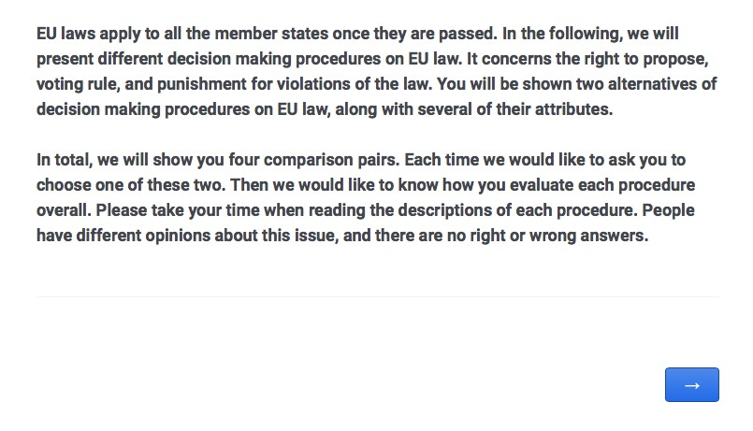

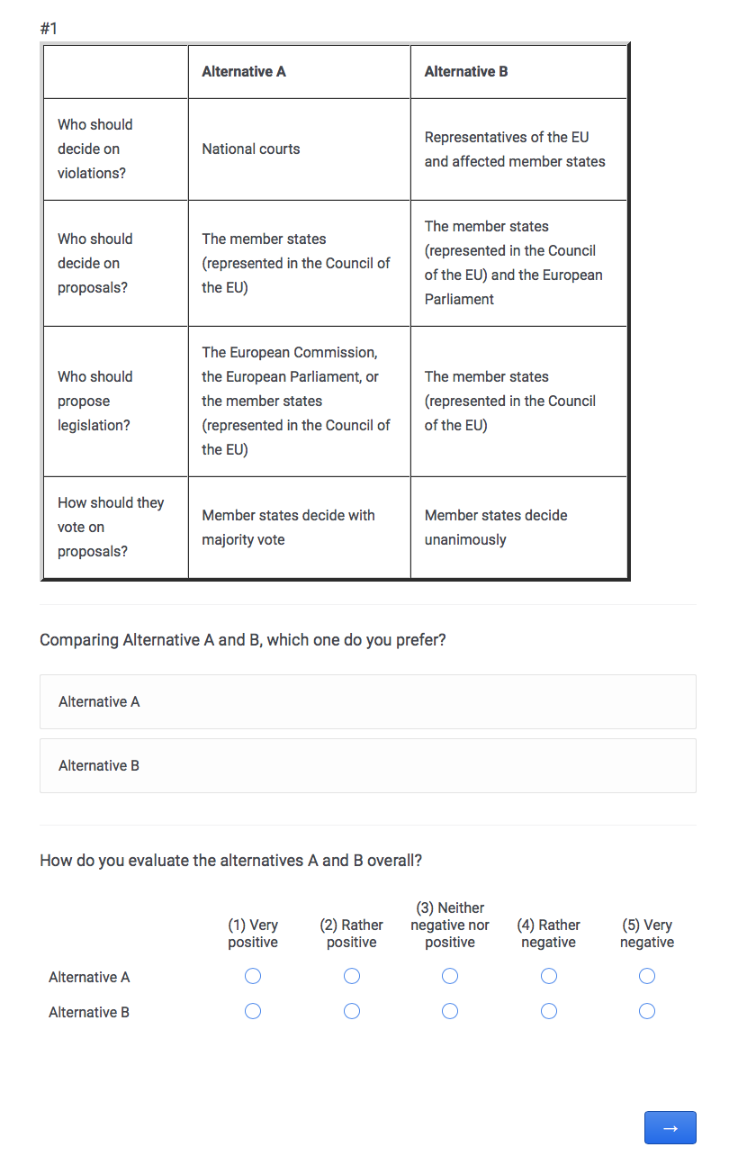

Survey questions

Personal benefit: In your opinion, how does the EU affect your general personal situation?

- Very negative (1)
- Somewhat negative (2)
- Neither negative nor positive (3)
- Somewhat positive (4)
- Very positive (5)
- Don’t know (6)

National benefit: Taking everything into consideration, would you say that [Country] has on balance benefited or not from being a member of the European Union?

- Benefited (1)
- (2)
- (3)
- (4)
- Not benefited at all (5)
- Don’t know (6)

National attachment: Please tell me how attached you feel to [Country]

- Very attached (1)
- Fairly attached (2)
- Moderately attached (3)
- Not very attached (4)
- Not at all attached (5)

Satisfaction with government performance: How dissatisfied or satisfied are you with the performance of the current national government?

- Very dissatisfied (1)
- (2)
- (3)
- (4)
- (5)
- (6)
- (7)
- (8)
- (9)
- (10)
- Very satisfied (11)

Knowledge about EU procedures: How good do you think is your knowledge about the decision making procedures in the European Union?

- Very good (1)
- (2)
- (3)
- (4)
- (5)
- (6)
- (7)
- (8)
- (9)
- Not good at all (10)

EU knowledge: For each of the following statements about the EU, could you please tell me whether you think it is true or false. If you don’t know, just say so and we will skip to the next.

- Switzerland is a member of the EU
- Each Member State elects the same number of representatives to the European Parliament
- The members of the European Parliament are directly elected by the citizens of each Member State
- At the EU level, European laws (directives and regulations) have to be agreed jointly by the European Parliament and the Member States

Left-right self-placement: In politics, people often talk about “left” and “right.” When you use this scale from 1 to 11, where would you locate yourself, where 1 means “left” and 11 means “right?”

- Left (1)
- (2)
- (3)
- (4)
- (5)
- (6)
- (7)
- (8)
- (9)
- (10)
- Right (11)
- Don’t know (12)

Pro-EU party support: If there were a European Parliament election tomorrow, which party would you be most likely to vote for?

Gender: Please indicate your gender.

Age: How old are you?

Education: How old were you when you stopped full-time education?

References
Bechtel, Michael M and Kenneth F Scheve. 2013. “Mass support for global climate agreements depends on institutional design.” Proceedings of the National Academy of Sciences 110(34):13763–13768.
Egami, Naoki and Kosuke Imai. 2018. “Causal Interaction in Factorial Experiments: Application to Conjoint Analysis.” Journal of the American Statistical Association pp. 1–34.
Eurostat. 2018. “Population data.”.http://ec.europa.eu/eurostat/web/population-demography-migration-projections/population-data, accessed: 2018-01-30.

