Appendix

Descriptive statistics

The descriptive statistics shown in Table A1 are for the full sample of respondents included in the regression analysis (Table 1, Model 2; N= 9529). The variables are unweighted und unstandardized.

Table A1: Descriptive statistics

Continuous variables
 | mean | sd | min | max
variables of interest
Conspiratorial thinking | 2.91 | 0.68 | 1 | 4
Conspiratorial thinking: alt. measure | 2.36 | 1.01 | 1 | 4
Cosmopolitanism: globalisation measure | 4.70 | 2.43 | 0 | 10
Sociodemographic
Education | 3.70 | 0.89 | 1 | 5
Age | 49.33 | 14.79 | 19 | 91
Religiosity | 3.01 | 1.60 | 1 | 8
Attitudinal
Satisfaction with democracy | 2.30 | 0.89 | 1 | 4
Political/ideological
Activism | 0.23 | 0.56 | 0 | 3
Efficacy | 1.96 | 0.87 | 1 | 4
News consumption | 5.35 | 2.18 | 1 | 9
Left-right ideology | 5.02 | 1.93 | 0 | 10

Categorical variables
 |  | share in percent
Political tolerance | [Least liked group] should be banned from electing representatives in parliament.
 | strongly agree | 41.17 | 1=low tolerance
 | somewhat agree | 19.32
 | somewhat disagree | 21.67
 | strongly disagree | 17.84 | 4=high tolerance
variables of interest
Cosmopolitanism | exclusive national identity | 19.09
 | inclusive national identity | 80.91
Sociodemographic
Female | male | 52.71
 | female | 47.29
Socialization | partial socialization under Communism | 7.68
 | socialization under Communism | 3.36
Occupation | Manual worker | 2.95
Location | Urban | 75.46
 | Rural | 24.54
Attitudinal
Interpersonal distrust | trust | 39.87
 | no trust | 60.13

Table A2: Robustness checks with various alternative model specifications

 | (1) | (2) | (3) | (4)
VARIABLES | Alternative measures for Cosmopolitanism and Conspiratorial thinking | Populism | Clustered standard errors | Country fixed effects
Variables of interest
Conspiratorial thinking (alternative measure) | -0.185***
 | (0.044)
Cosmopolitanism (alternative measure) | 0.107*
 | (0.043)
Conspiratorial thinking |  | -0.268*** | -0.223*** | -0.273***
 |  | (0.045) | (0.057) | (0.045)
Cosmopolitanism |  | 0.211*** | 0.137** | 0.220***
 |  | (0.053) | (0.052) | (0.053)
Sociodemographic
Education | 0.155*** | 0.137** | 0.179* | 0.136**
 | (0.042) | (0.042) | (0.074) | (0.042)
Age | -0.149** | -0.145** | -0.247** | -0.134**
 | (0.046) | (0.046) | (0.088) | (0.046)
Female | 0.039 | 0.044 | 0.026 | 0.045
 | (0.039) | (0.039) | (0.059) | (0.039)
Some education under thawed Communist period | 0.048 | 0.033 | 0.478*** | -0.016
 | (0.096) | (0.095) | (0.080) | (0.095)
No education under free or thawed Communist period | -0.155 | -0.170 | 0.323** | -0.226
 | (0.131) | (0.131) | (0.112) | (0.131)
Manual worker | -0.128 | -0.128 | -0.133 | -0.131
 | (0.102) | (0.102) | (0.128) | (0.102)
Urban | 0.034 | 0.029 | 0.044 | 0.027
 | (0.045) | (0.045) | (0.049) | (0.045)
Religiosity | 0.101* | 0.087* | 0.072 | 0.088*
 | (0.041) | (0.041) | (0.058) | (0.041)
Attitudinal
Interpersonal distrust | -0.160*** | -0.150*** | -0.180*** | -0.149***
 | (0.042) | (0.042) | (0.054) | (0.042)
Satisfaction with Democracy | 0.104* | 0.068 | 0.125 | 0.066
 | (0.043) | (0.044) | (0.067) | (0.044)
Political/ideological
Activism | -0.041 | -0.046 | -0.056 | -0.046
 | (0.039) | (0.039) | (0.033) | (0.039)
Political efficacy | 0.152*** | 0.101* | 0.114** | 0.101*
 | (0.041) | (0.042) | (0.043) | (0.042)
News consumption | 0.033 | 0.029 | 0.014 | 0.030
 | (0.040) | (0.040) | (0.041) | (0.041)
Populist |  | -0.030
 |  | (0.047)
Left-right | 0.004 | 0.004 | 0.012 | 0.001
 | (0.041) | (0.041) | (0.066) | (0.041)
Left-right^2 | -0.239*** | -0.225*** | -0.270*** | -0.226***
 | (0.053) | (0.053) | (0.069) | (0.053)
Cut 1 | -0.425*** | -0.429*** | -0.426*** | -0.835***
 | (0.079) | (0.084) | (0.059) | (0.069)
Cut 2 | 0.390*** | 0.389*** | 0.382*** | -0.017
 | (0.078) | (0.084) | (0.071) | (0.069)
Cut 3 | 1.521*** | 1.521*** | 1.503*** | 1.116***
 | (0.080) | (0.085) | (0.064) | (0.070)
Observations | 9,524 | 9,529 | 9,529 | 9,529
Number of groups | 10 | 10
Country random intercepts | YES | YES | NO | NO
AIC | 24849.39 | 24835.19 | 24905.52 | 24810.01
BIC | 24999.78 | 24992.76 | 24969.98 | 25017.71
Note: Note: Coefficients show log-odds. Standard errors in parentheses; *** p<0.001, ** p<0.01, * p<0.05. Reference categories: exclusive national identity, male, fully or partially educated under democracy, non-manual worker, rural, interpersonal trust, not populist. Standardized independent variables. All least liked groups included.

Table A3: Robustness checks with additional analysis of cohort effects

 | (1) | (2) | (3) | (4)
 | Least liked group
VARIABLES | All groups | Neo-Nazis/  Fascists | Muslims | All except Neo-Nazis/Fascists
Variables of interest

Conspiratorial thinking | -0.266*** | -0.235*** | -0.308* | -0.387***
 | (0.045) | (0.057) | (0.124) | (0.073)
Cosmopolitanism | 0.212*** | 0.217** | 0.375** | 0.306***
 | (0.053) | (0.078) | (0.116) | (0.073)
Sociodemographic
Education | 0.142*** | 0.137* | 0.132 | 0.233***
 | (0.042) | (0.054) | (0.110) | (0.066)
Age | -0.135** | -0.162** | -0.371** | -0.013
 | (0.046) | (0.058) | (0.129) | (0.076)
Female | 0.044 | 0.113* | -0.021 | 0.019
 | (0.039) | (0.050) | (0.103) | (0.063)
Youngest cohort in CZ and Poland | 0.505*** | 0.603*** | -0.099 | 0.304
 | (0.142) | (0.177) | (0.282) | (0.162)
Some education under thawed Communist period | 0.492*** | 0.581** | 0.054 | 0.251
 | (0.145) | (0.181) | (0.295) | (0.170)
No education under free or thawed Communist period | 0.282 | 0.182 | 0.592 | 0.160
 | (0.168) | (0.214) | (0.353) | (0.214)
Manual worker | -0.134 | -0.223 | -0.206 | -0.091
 | (0.102) | (0.146) | (0.219) | (0.145)
Urban | 0.030 | -0.033 | 0.145 | 0.092
 | (0.045) | (0.057) | (0.121) | (0.074)
Religiosity | 0.086* | 0.046 | -0.022 | 0.072
 | (0.041) | (0.054) | (0.111) | (0.064)
Attitudinal
Interpersonal  distrust | -0.155*** | -0.148** | -0.308* | -0.339***
 | (0.042) | (0.053) | (0.129) | (0.072)
Satisfaction with  Democracy | 0.071 | 0.042 | 0.467*** | 0.192**
 | (0.043) | (0.057) | (0.115) | (0.069)
Political/ideological
Activism | -0.046 | 0.012 | -0.322** | -0.178**
 | (0.039) | (0.052) | (0.108) | (0.060)
Political efficacy | 0.105* | 0.097 | 0.308** | 0.203**
 | (0.042) | (0.054) | (0.115) | (0.069)
News consumption | 0.028 | -0.047 | 0.103 | 0.157*
 | (0.040) | (0.053) | (0.106) | (0.064)
Left-right | 0.001 | 0.095 | -0.467*** | -0.409***
 | (0.041) | (0.060) | (0.122) | (0.071)
Left-right^2 | -0.230*** | -0.035 | -0.327* | -0.243**
 | (0.053) | (0.080) | (0.138) | (0.084)
cut1 | -0.428*** | -0.211** | -0.697*** | -0.899***
 | (0.056) | (0.068) | (0.122) | (0.069)
cut2 | 0.390*** | 0.572*** | 0.299* | 0.022
 | (0.056) | (0.069) | (0.121) | (0.067)
cut3 | 1.521*** | 1.706*** | 1.410*** | 1.194***
 | (0.059) | (0.072) | (0.129) | (0.071)
Observations | 9529 | 5841 | 1446 | 3688
Number of groups | 10 | 10 | 10 | 10
Country random intercepts | YES | YES | YES | YES
AIC | 24827.11 | 14935.14 | 3540.457 | 9693.634
BIC | 24984.67 | 15081.94 | 3656.541 | 9830.316
Note: Coefficients show log-odds. Standard errors in parentheses; *** p<0.001, ** p<0.01, * p<0.05. Reference categories: exclusive national identity, male, Western European respondents, non-manual worker, rural, interpersonal trust, not populist. Standardized independent variables. All least liked groups included.

Questionnaire and variable coding

Dependent variable

Which of the groups listed below do you like the least, or is there some other group you like even less?
1 Fascists | 8 Blacks
2 Neonazis | 9 Roma
3 Communists | 10 Other (Please Specify)
4 Homosexuals | 97 I prefer not to say which group I like least
5 Jews | 98 I like all groups equally
6 Anti-globalisation activists | 99 I don't like all groups equally
7 Muslims | 100 Don't know

Please indicate to what extent you agree or disagree with the following statements.
[Least liked group] should be banned from electing representatives in parliament.
Response categories: Strongly agree, Somewhat agree, Somewhat disagree, Strongly disagree.
We recoded the variable so higher values indicate more tolerance.

Independent variables

Conspiratorial thinking

To what extent do you agree or disagree with each of the following statements?
- Actually, it is not the government that runs the country: we don’t know who pulls the strings.
- The people think they govern themselves, but they really don't.
- I often feel that the really important matters are decided behind the scenes, by people we never even hear about.

Response categories: Strongly agree (4), Somewhat agree (3), Somewhat disagree (2), Strongly disagree (1). Higher values indicate more conspiratorial thinking.

Alternative measure for conspiratorial thinking:

To what extent do you agree or disagree with each of the following statements?
- A secretive power elite with a globalist agenda is conspiring to eventually rule the world through an authoritarian world government, or New World Order.

Response categories: Strongly agree (4), Somewhat agree (3), Somewhat disagree (2), Strongly disagree (1). Higher values indicate more conspiratorial thinking.

Cosmopolitanism

Do you consider yourself...
- [Nationality] and not European
- More [Nationality] than European
- Equally [Nationality] and European
- More European than [Nationality]
- European and not [Nationality]
We created a dummy variable such that those individuals who selected “[Nationality] and not European” were coded as having an exclusive national identity (0) while all others were coded as having a cosmopolitan identity (1).

Education

What is the highest degree or level of education that you have completed?
Responses: “Elementary (primary) school or below” = 1, “Some high (secondary) school education” = 2, “Graduation from high (secondary) school” = 3, “Graduation from college, university or other third-level institute” = 4, “Post-graduate degree (Masters, PHD) beyond your initial college degree” = 5.

Age: in years (measured via year of birth)

Female
Male = 0, Female= 1

Cohorts to identify socialization under Communism following Marquart-Pyatt & Paxton (2007)

The reference group: respondents in Western European countries and those in Poland and the Czech Republic “who had at least 1 year of education during the democratic period” (Marquart-Pyatt & Paxton, 2007: 97) (this refers to respondents born after 1971).
Some education under thawed Communist period: “individuals who had at least 1 year of education during the ‘‘thawed’’ period of Soviet history” (Marquart-Pyatt & Paxton, 2007: 97) (this refers to respondents born before 1971 but after 1950).
No education under free or thawed Communist period: “those with no years of education under a thawed or free period” (Marquart-Pyatt & Paxton, 2007: 97) (this refers to respondents born before 1950).
In the regression in Appendix Table A3, we include an additional dummy variable for all respondents in Poland and the Czech Republic who were born after 1971 (which turns all respondents in Western Europe into the reference group in the models in Table A3).

Manual worker

As far as your current occupation is concerned, would you say you are self- employed, an employee, a manual worker or would you say that you are without a professional activity?
1 Self-employed
2 Employee
3 Manual worker
4 Without a professional activity
97 Other (SPECIFY)
99 Prefer not to say

Urban/rural

In which type of locality do you live in?
Metropolitan zone (coded as urban)
Other town/urban centre (coded as urban)
Rural zone

Religiosity

Apart from special occasions such as weddings and funerals, roughly how often do you attend religious services? Response categories:
1 Every day | 6 Not very often
2 More than once a week | 7 Never
3 Once a week | 8 No religion, not a believer, agnostic
4 At least once a month | 98 Prefer not to say
5 Only on special holidays

Recoded so that higher values refer to greater religiosity

Interpersonal distrust

Generally speaking, would you say that most people can be trusted, or that you can't be too careful in dealing with others?
Response categories: “You can’t be too careful” = 1, “Most people can be trusted” = 0.

Satisfaction with democracy

On the whole, how satisfied are you with how democracy works in (OUR COUNTRY)?

Very satisfied, somewhat satisfied, somewhat dissatisfied, very dissatisfied, don’t know. Recoded so that higher values refer to more satisfaction.

Activism

Do you actively participate in any of the following...? We sum responses: respondents get a score of 0 if they are part of no association and a score of 3 if they are part of all of all the options that were presented to them (a trade union, a political party, a citizens' committee).

Political Efficacy

You find below a list of some opinions on politics that people sometimes express.
- People like me have no influence on what the government does.

Response categories: Strongly agree, Somewhat agree, Somewhat disagree, Strongly disagree. Recoded: higher values indicate a higher sense of political efficacy.

Interest in politics via proxy news consumption

Roughly how many times a week do you normally do the following activities?
- Reading about politics and society in a newspaper
- Listening to or watching the news about politics and society on TV
- Listening to or watching the news about politics and society on social media (Facebook, Twitter, etc)

Response categories for each item:
1 Never | 6 4 times a week
2 Less than once a week | 7 5 times a week
3 Once a week | 8 6 times a week
4 2 times a week | 9 Every day
5 3 times a week | 98 Don't know

We average responses across the three items and exclude don’t know responses.

Left-right ideology

In politics, people sometimes talk of left and right. Where would you place yourself on a scale from 0 to 10, where '0' means the extreme left and '10' means the extreme right?

Additional variables used in robustness checks:

Cosmopolitanism: globalisation measure

Do you think that, overall, globalisation has a positive or negative effect on [Nationality] citizens?
(10) Globalisation has a positive effect on [Nationality] citizens
(0) Globalisation has a negative effect on [Nationality] citizens
Don't know

We recode this variable so higher values indicate more cosmopolitanism.

Immigrant threat

Can you please indicate to what extent you agree or disagree with the following statements about the general impact of immigration on [COUNTRY] and [NATIONALITY] people?
Immigrants increase the likelihood of a terrorist attack in (OUR COUNTRY) -

Answer options:
Strongly agree, Somewhat agree, Somewhat disagree, Strongly disagree, Don't know.

Populism

If the General Election was tomorrow, which party would you be most likely to vote for?

For respondents who did not provide a vote choice:

Which party do you feel closest to?

The dummy variable for populism is 1 if respondents would vote for or feel close to a party that is categorized as a populist party in the following data set:

Rooduijn, M., Van Kessel, S., Froio, C., Pirro, A., De Lange, S., Halikiopoulou, D., Lewis, P., Mudde, C. & Taggart, P. (2019). The PopuList: An Overview of Populist, Far Right, Far Left and Eurosceptic Parties in Europe. www.popu-list.org.
Additional information on the collection of the survey data

The EUENGAGE data set was collected as part of a Horizon2020 funded EU project. The data collection was conducted by the University of Siena in partnership with Kantar Public. The fieldwork for the mass survey used in this analysis took place between June and October 2017. The universe of respondents were adults (age 18 and older) who live in the ten EU member states in which the survey took place. Kantar Public managed the sampling of respondents from their standing online panel. Respondents sign up voluntarily for these panels. Respondents are then drawn randomly from it. In order to ensure that inferences to the population at large can be made, Kantar Public used a solid sampling frame and an effective weighting strategy to limit potential biases resulting from self-selection. Quotas were used with regard to gender, age cohort (18-24; 25-39; 40-54; 55-64; 65 or older) and region (NUTS2), which ensures that inferences can be made from the sample to a country’s adult population with internet access. Weights are based on gender, age, region, education and internet use. A RIM weighting was used for each country (as opposed to an interlocked weighting), which is a procedure that limits the number of weighting cells and which avoids extreme weights. In order to ensure a high-quality survey data set, Kantar Public cleaned the data. This involved that observations were discarded for instance in case of straight-lining (respondents give identical answer across all questions) and in case of speeders (very short interviews).

The EUENGAGE mass survey data set has become a more widely used resource recently, with publications in various international journals which draw on these data, for instance:

Basile, L., & Olmastroni, F. (2020). Sharing the burden in a free riders’ land: The EU migration and asylum policy in the views of public opinion and politicians. European Journal of Political Research, 59(3), 669-691.
Basile, L., Borri, R., & Verzichelli, L. (2020). ‘For whom the sovereignist Bell Tolls?’Individual determinants of support for sovereignism in ten European countries. European Politics and Society, 21(2), 235-257.
Conti, N., Di Mauro, D., & Memoli, V. (2019). Citizens, immigration and the EU as a shield. European Union Politics, 20(3), 492-510.
Conti, N., Di Mauro, D., & Memoli, V. (2020). Immigration, security and the economy: who should bear the burden of global crises? Burden-sharing and citizens’ support for EU integration in Italy. Contemporary Italian Politics, 12(1), 77-97.

Appendix Figures

Figure A1: Distribution of cosmopolitanism by country (weighted data)

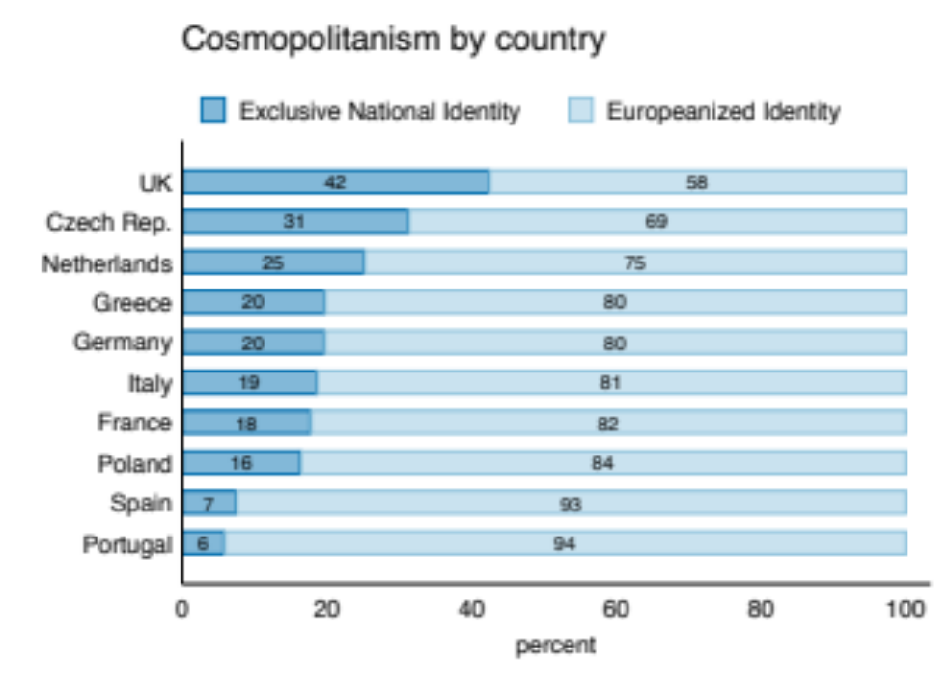
Figure A2: Distribution of most disliked groups by ideology (weighted data). Respondents were asked: “In politics, people sometimes talk of left and right - Where would you place yourself on a scale from 0 to 10, where '0' means the extreme left and '10' means the extreme right?” For easier exposition, we collapsed the categories to create five groups. Responses 0 and 1 were coded as “Extreme Left,” responses 2, 3 or 4 were coded as “Left”, response 5 was coded as “Centre”, responses 6, 7, or 8 were coded as “Right” and responses 9 and 10 were coded as “Extreme Right.”
