How the coronavirus crisis affects citizen trust in institutions and in unknown others – Evidence from “the Swedish experiment”

Supplementary information

The supplementary information is organized as follows. The first section (Supplementary Main) describes more extensively the survey waves (t-1, t0 and t1) and their relation to crisis phases of the Swedish corona pandemic 2020. In Supplementary Methods, we present further details about the analyzed survey waves. Supplementary Results presents additional statistical analysis of the relationship between institutional and interpersonal trust. Supplementary Discussion displays an overview over data indicating rally-effects from 37 countries around the world.

The Swedish Ethical Review Authority (protocol no.2019–04339/2020-01501) approved data collection procedures. Informed consent was received directly from each participant before their participation in each survey wave.

Supplementary Main
The study comprises one pre-survey and two survey waves that were conducted before and in parallel with the outbreak and development of the covid-19 in Sweden. The spread of the virus, number of infected and dead people changed dramatically between the turn of the year and by the time the second survey wave was closed on April 14th 2020. As did the media attention that was given to the covid-19 epidemic, and information seeking activities among the Swedish public.

Below follows a detailed description of how the pre-survey and survey waves coincided in time with the course of the pandemic.

The beginning, development and ending of crises is often described using stage- or phase-models. In our study we define a pre-crisis phase, an initial phase and an acute phase. The pre-survey, collected to a subsample between December 10th 2018 and January 8th 2019 was conducted in the pre-crisis stage, a year before the covid-19 was detected in China and consequently still was unknown to the Swedish public.

The first survey wave was launched during the initial phase of the epidemic in Sweden. The first infected case was confirmed on January 31th 2020, and on February 2nd the government classified covid-19 as a dangerous disease to society and the following cases were mostly detected among persons who had been abroad. The Public Health Agency (PHA) judged the risk of more COVID-19 cases to be high, but the risk of a general spreading to be moderate. Thus, during February and the beginning of March, Swedish authorities focused on tracing infected persons and their contacts, and closely monitoring the development of the virus in other countries. A week into March, Sweden passed a hundred new infected cases in one day and a few days later, on March 10th, the PHA judged the risk of general spreading to be very high, and declared the epidemic to enter a new phase of community spread. Survey wave 1 was fielded between February 24th and March 10th, covering the last 17 days of the initial phase of the epidemic. During this period there were no deaths due to the virus in Sweden. The epidemic was closely followed by the news media (see Figure 1 in the main text), but only as one of several other timely issues.

Figure S1: Google searches in Sweden for ‘corona’, January 4th – April 3rd 2020, relative search volume (number of searches).

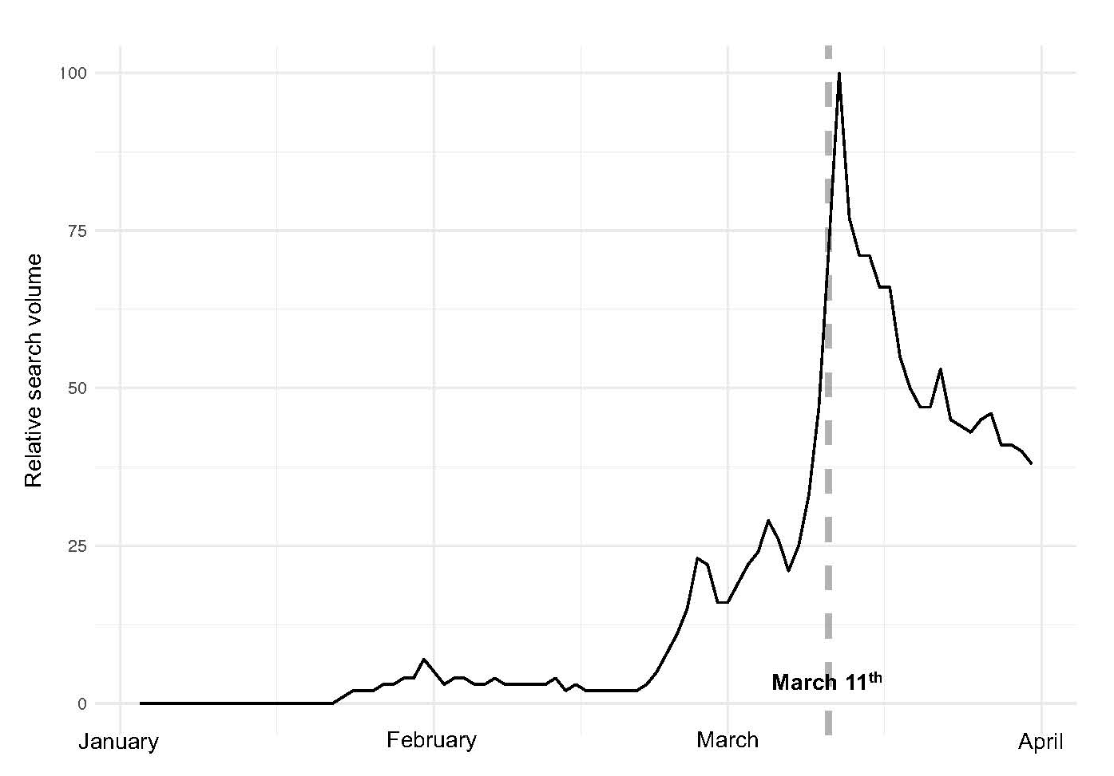

Figure S2: Articles on Swedish Wikipedia (sv.wikipedia.org) searching for items ‘corona’, ‘pandemic’, ‘epidemic, ‘respiratory infection’ and ‘virus’, January 1st – April 4th 2020 (numbers of articles).

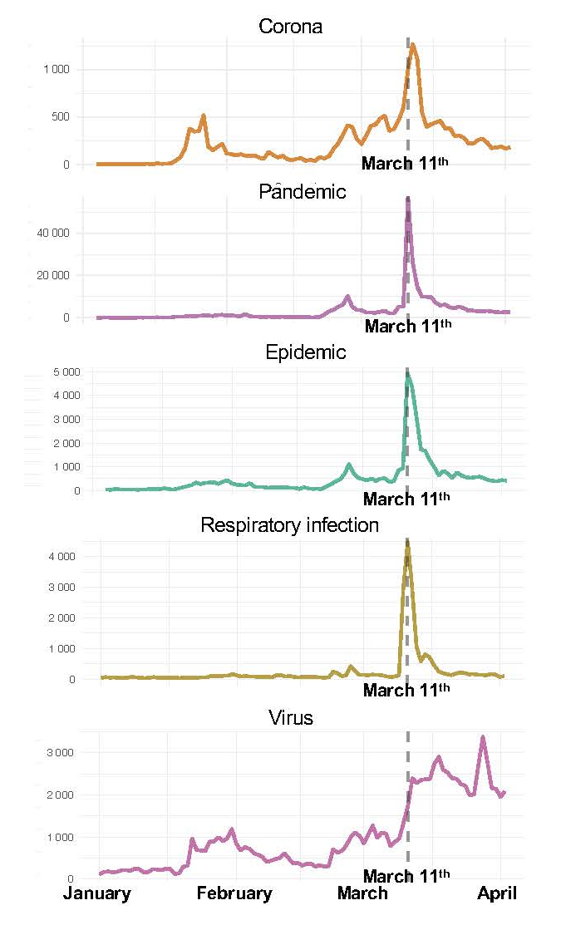

However, on March 11th several circumstances occurred that transformed the Swedish situation into an acute phase, which was also reflected in the immediately intensified media reporting (see Figure 1 in Result section) and in the public’s search patterns in social media (Supplementary figures 1 and 2). The WHO assessed covid-19 to have reached pandemic proportions, and Sweden registered its first death caused by the virus. The PHA urged everyone with symptoms of respiratory infection, even mild ones, to stay at home, and all others to keep a social distance, both at work and in private life. The same day the Government decided to abolish the qualifying day of sickness and an additional amending budget was proposed. Also, public gatherings were limited to 500 participants. From this point on, the numbers of infected and dead people raised dramatically.

Over the coming weeks, several new regulations were implemented, such as remote learning to upper secondary schools, adult education and universities, limitation of gatherings to 50 participants, stop all un-necessary travels abroad, specific regulations for food serving establishments, and a national ban of visiting retirement homes. The strategy of Swedish government authorities aimed to keep the spread of the infection within limits of health care capacities. Worth noting is, that contrary to other countries, the majority of implemented measures were based on recommendations and on people’s voluntary adaptation.

The second survey wave was carried out between March 31st and April 14th, while the death toll was still rising alarmingly and estimates of the epidemic's duration were extremely uncertain. Further, voices comparing the Swedish strategy with other countries' more comprehensive and compelling measures were heard. On the day that the survey was distributed the number of covid-19 deaths were 180. When it closed – on April 14th – the number of deaths had raised to 1,033.

Below we list a sample of publicly available texts that discussed the “Swedish Experiment” during our field periods:

What Sweden Has Done Right on Coronavirus. Retrieved from https://www.aier.org/article/what-sweden-has-done-right-on-coronavirus/amp/?__twitter_impression=true&fbclid=IwAR0qlJ_T4m7nlqnQSb1LIkwzleHl0gQFqu4ibF6Q2MEtn0zNSyPePOhsukc

Has Sweden Found the Right Solution to the Coronavirus? Retrieved from https://www.nationalreview.com/2020/04/coronavirus-response-sweden-avoids-isolation-economic-ruin/amp/?__twitter_impression=true&fbclid=IwAR1yIA0sHQoJwWkF8o2TYH9JFkFdQpyKc4HgRySy0zUkfhHvngr_e0cJqVE

Sweden challenges Trump -- and scientific mainstream -- by refusing to lock down. Retrieved from https://edition.cnn.com/2020/04/10/europe/sweden-lockdown-turmp-intl/index.html?fbclid=IwAR32AWEomQrIbWtYVFyYcHoRAKQFu6iC78CPIMIWr_P7Bt-YMtkKRZTzy-I

Why do the Nordic countries react differently to the covid-19 crisis? Retrieved from https://nordics.info/show/artikel/the-nordic-countries-react-differently-to-the-covid-19-crisis/?fbclid=IwAR382GJQy-3krMGyDxVLDKVxgqX5yG9d3riaw5CF2UKejJjXLchJLMbc414

Figure S3: Mobility at transit stations, workplaces, and retail and recreation spaces in 4 Nordic countries.
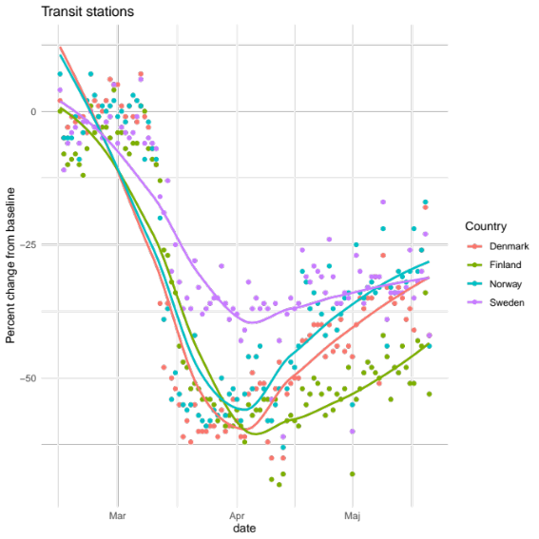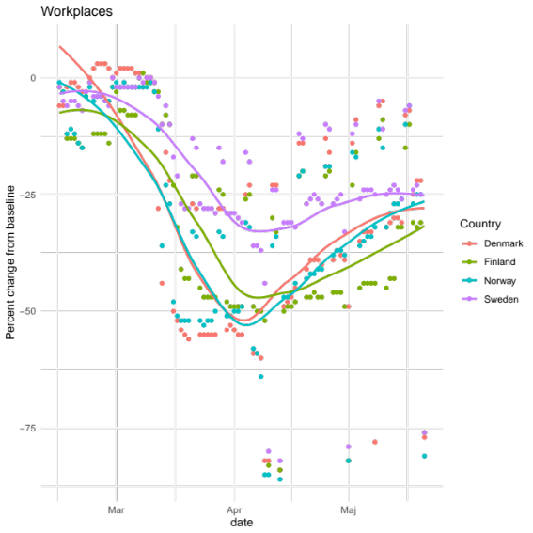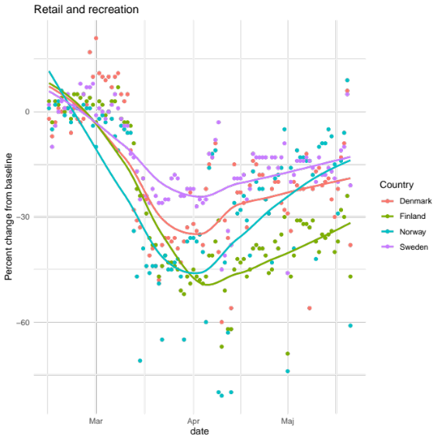
Notes: The figure is based on data from Google’s Community Mobility Reports https://www.google.com/covid19/mobility/.
Analysis compiled by Anders Sundell at University of Gothenburg.

Table S1: Restrictions imposed and advices given by the Swedish government

Date | Form of restriction or advice from Swedish authorities
March 10 | Advice against all non-essential travels to Italy  https://www.krisinformation.se/en/news/2020/march/advice-against-all-non-essential-travel-to-italy
March 11 | Limitations of public gatherings to 500 persons.  https://www.krisinformation.se/en/news/2020/march/the-government-has-decided-to-limit-public-gatherings-and-events-in-sweden
March 11 | Advice against travels till Tyrol, Austria.  https://www.krisinformation.se/en/news/2020/march/advice-against-non-essential-travel-to-tyrol-austria/
March 17 | Implementation of remote learning in all upper secondary schools, adult education schools and universities https://www.krisinformation.se/en/news/2020/march/remote-learning/
March 17 | People over the age of 70 are advised to avoid unnecessary social contacts.  https://www.krisinformation.se/en/news/2020/march/the-public-health-agency-of-sweden-persons-over-the-age-of-70-should-limit-their-social-contacts/
March 17 | Authorities encourage employees to work from home when possible  https://www.krisinformation.se/en/news/2020/march/the-public-health-agency-is-calling-for-working-remotely/
March 17 | Authorities advice persons older than 70 years to limit social contacts  https://www.krisinformation.se/en/news/2020/march/the-public-health-agency-of-sweden-persons-over-the-age-of-70-should-limit-their-social-contacts/
March 18 | Stop of all non-essential travels to Sweden from countries outside of Europe.  https://www.government.se/press-releases/2020/03/temporary-ban-on-travel-to-sweden-due-to-covid-19/
March 18 | Temporary ban on travel to the EU via Sweden due to COVID-19  https://www.government.se/press-releases/2020/03/temporary-ban-on-travel-to-sweden-due-to-covid-19/
March 25 | Ban on crowding in restaurants, cafés and bars  https://www.krisinformation.se/en/news/2020/march/public-health-agency-of-sweden-ban-on-crowding-in-restaurants-cafes-and-bars/
March 27 | Limitations of public gatherings to only 50 persons  https://www.dn.se/nyheter/sverige/1330-presskonferens-med-statsminister-stefan-lofven/
March 31 | National ban on visiting retirement homes  https://www.krisinformation.se/en/news/2020/march/national-ban-on-visiting-retirement-homes
April 1 | Restrictions on withdrawal of prescription drugs to counteract potential hoarding.  https://www.regeringen.se/pressmeddelanden/2020/04/begransat-uttag-av-lakemedel/
April 8 | The Public Health Agency makes use of mobile data to track the movement pattern of people in Sweden  https://www.folkhalsomyndigheten.se/nyheter-och-press/nyhetsarkiv/2020/april/folkhalsomyndigheten-tar-hjalp-av-mobildata/
April 16 | Extension of temporary entry ban to the EU via Sweden due to COVID-19. https://www.government.se/press-releases/2020/04/extension-of-temporary-entry-ban-to-the-eu-via-sweden-due-to-covid-19/
May 13 | Advice against travel from Sweden to all other countries extended  https://www.government.se/press-releases/2020/05/travel-abroad--advice-against-travel-to-all-countries-extended/
May 14 | Extension of temporary entry ban to the EU via Sweden until June 15  https://www.government.se/press-releases/2020/05/extension-of-temporary-entry-ban-to-the-eu-via-sweden-due-to-covid-19/

Supplementary Methods

Table S2: Participation dates, t-1.

Date started | Freq. | Percent | Cum.
2018-12-10 | 805 | 32.21 | 32.21
2018-12-11 | 480 | 19.21 | 51.42
2018-12-12 | 108 | 4.32 | 55.74
2018-12-13 | 58 | 2.32 | 58.06
2018-12-14 | 27 | 1.08 | 59.14
2018-12-15 | 17 | 0.68 | 59.82
2018-12-16 | 27 | 1.08 | 60.90
2018-12-17 | 22 | 0.88 | 61.78
2018-12-18 | 16 | 0.64 | 62.42
2018-12-19 | 209 | 8.36 | 70.79
2018-12-20 | 56 | 2.24 | 73.03
2018-12-21 | 19 | 0.76 | 73.79
2018-12-22 | 12 | 0.48 | 74.27
2018-12-23 | 11 | 0.44 | 74.71
2018-12-24 | 6 | 0.24 | 74.95
2018-12-25 | 8 | 0.32 | 75.27
2018-12-26 | 7 | 0.28 | 75.55
2018-12-27 | 6 | 0.24 | 75.79
2018-12-28 | 6 | 0.24 | 76.03
2018-12-29 | 4 | 0.16 | 76.19
2018-12-30 | 6 | 0.24 | 76.43
2018-12-31 | 4 | 0.16 | 76.59
2019-01-01 | 4 | 0.16 | 76.75
2019-01-02 | 3 | 0.12 | 76.87
2019-01-03 | 458 | 18.33 | 95.20
2019-01-04 | 56 | 2.24 | 97.44
2019-01-05 | 25 | 1.00 | 98.44
2019-01-06 | 22 | 0.88 | 99.32
2019-01-07 | 16 | 0.64 | 99.96
2019-01-08 | 1 | 0.04 | 100.00
Total | 2,499 | 100.00

Table S3: Participation dates, t0.

Date started | Freq. | Percent | Cum.
2020-02-24 | 5,627 | 43.68 | 43.68
2020-02-25 | 3,047 | 23.65 | 67.34
2020-02-26 | 722 | 5.61 | 72.94
2020-02-27 | 354 | 2.75 | 75.69
2020-02-28 | 188 | 1.46 | 77.15
2020-02-29 | 142 | 1.10 | 78.25
2020-03-01 | 119 | 0.92 | 79.18
2020-03-02 | 126 | 0.98 | 80.16
2020-03-03 | 1,128 | 8.76 | 88.91
2020-03-04 | 392 | 3.04 | 91.96
2020-03-05 | 119 | 0.92 | 92.88
2020-03-06 | 74 | 0.57 | 93.46
2020-03-07 | 52 | 0.40 | 93.86
2020-03-08 | 55 | 0.43 | 94.29
2020-03-09 | 52 | 0.40 | 94.69
2020-03-10 | 31 | 0.24 | 94.93
2020-03-11 | 390 | 3.03 | 97.96
2020-03-12 | 130 | 1.01 | 98.97
2020-03-13 | 39 | 0.30 | 99.27
2020-03-14 | 22 | 0.17 | 99.44
2020-03-15 | 19 | 0.15 | 99.59
2020-03-16 | 21 | 0.16 | 99.75
2020-03-17 | 13 | 0.10 | 99.85
2020-03-18 | 16 | 0.12 | 99.98
2020-03-19 | 3 | 0.02 | 100.00
Total | 12,881 | 100.00
Note: Responses from individuals who participated between March 11 and March 19 are not included in the analysis of the dynamics of institutional and interpersonal trust.

Table S4: Participation dates, t1.

Date started | Freq. | Percent | Cum.
2020-03-31 | 275 | 2.41 | 2.41
2020-04-01 | 7,529 | 66.01 | 68.42
2020-04-02 | 1,092 | 9.57 | 77.99
2020-04-03 | 345 | 3.02 | 81.02
2020-04-04 | 193 | 1.69 | 82.71
2020-04-05 | 141 | 1.24 | 83.95
2020-04-06 | 1,200 | 10.52 | 94.47
2020-04-07 | 322 | 2.82 | 97.29
2020-04-08 | 121 | 1.06 | 98.35
2020-04-09 | 65 | 0.57 | 98.92
2020-04-10 | 34 | 0.30 | 99.22
2020-04-11 | 20 | 0.18 | 99.40
2020-04-12 | 24 | 0.21 | 99.61
2020-04-13 | 35 | 0.31 | 99.91
2020-04-14 | 10 | 0.09 | 100.00
Total | 11,406 | 100.00

Table S5: Questions, response options, coding and variable names on institutional and interpersonal trust.
Variable | Variable name in wide format | Question | Response options | Original coding | Recode | Reverse recode
Institutional trust, t-1 | it_01_tpre | Generally speaking, how much trust do you have in Swedish government authorities? | Very high trust  Rather high trust  Neither high nor low trust  Rather low trust  Very low trust | 1  2  3  4  5 | 1  0.75  0.5  0.25  0 | Yes
Institutional trust, t0 | it_01_t0 | Generally speaking, how much trust do you have in Swedish government authorities? | Very high trust  Rather high trust  Neither high nor low trust  Rather low trust  Very low trust | 1  2  3  4  5 | 1  0.75  0.5  0.25  0 | Yes
Institutional trust, t1 | it_01_t1 | Generally speaking, how much trust do you have in Swedish government authorities? | Very high trust  Rather high trust  Neither high nor low trust  Rather low trust  Very low trust | 1  2  3  4  5 | 1  0.75  0.5  0.25  0 | Yes
Interpersonal trust, t-1 | st_01_tpre | In your opinion, to what extent is it generally possible to trust people? | 1 People cannot generally be trusted  2  3  4  5 People can generally be trusted | 1  2  3  4  5 | 0  0.25  0.5  0.75  1 | No
Interpersonal trust, t0 | st_01_t0 | In your opinion, to what extent is it generally possible to trust people? | 1 People cannot generally be trusted  2  3  4  5 People can generally be trusted | 1  2  3  4  5 | 0  0.25  0.5  0.75  1 | No
Interpersonal trust, t1 | st_01_t1 | In your opinion, to what extent is it generally possible to trust people? | 1 People cannot generally be trusted  2  3  4  5 People can generally be trusted | 1  2  3  4  5 | 0  0.25  0.5  0.75  1 | No

Table S6: Respondent characteristics at t-1, t0 and t1.

 | t-1 |  |  | t0 |  |  | t1
 | Freq. | Percent | Cum. | Freq. | Percent | Cum. | Freq. | Percent | Cum.
Sex
Female | 768 | 46.21 | 46.21 | 4,292 | 33.38 | 33.38 | 3,739 | 32.83 | 32.83
Male | 894 | 53.79 | 100.00 | 8,567 | 66.62 | 100.00 | 7,650 | 67.17 | 100.00
Total | 1,662 | 100.00 |  | 12,859 | 100.00 |  | 11,389 | 100.00
Age
< 30 | 102 | 6.14 | 6.14 | 356 | 2.76 | 2.76 | 277 | 2.43 | 2.43
30-39 | 247 | 14.86 | 21.00 | 854 | 6.63 | 9.39 | 712 | 6.24 | 8.67
40-49 | 325 | 19.55 | 40.55 | 1,269 | 9.85 | 19.25 | 1,052 | 9.22 | 17.89
50-59 | 387 | 23.29 | 63.84 | 3,779 | 29.34 | 48.58 | 3,258 | 28.56 | 46.46
60-69 | 369 | 22.20 | 86.04 | 3,330 | 25.85 | 74.44 | 3,022 | 26.49 | 72.95
≥ 70 | 232 | 13.96 | 100.00 | 3,293 | 25.56 | 100.00 | 3,085 | 27.05 | 100.00
Total | 1,662 | 100.00 |  | 12,881 | 100.00 |  | 11,406 | 100.00
Highest level of education
Not completed elementary school | 1 | 0.06 | 0.06 | 12 | 0.09 | 0.09 | 10 | 0.09 | 0.09
Completed elementary school | 47 | 2.87 | 2.93 | 389 | 3.06 | 3.16 | 347 | 3.07 | 3.15
High school, < 3 years | 190 | 11.61 | 14.54 | 902 | 7.10 | 10.26 | 807 | 7.13 | 10.28
High school, ≥ 3 years | 245 | 14.97 | 29.51 | 1,107 | 8.72 | 18.98 | 966 | 8.54 | 18.82
Post-secondary education, < 3 years | 215 | 13.13 | 42.64 | 1,030 | 8.11 | 27.09 | 914 | 8.08 | 26.90
Post-secondary education, ≥ 3 years | 77 | 4.70 | 47.34 | 407 | 3.21 | 30.30 | 365 | 3.22 | 30.12
College/University, < 3 years | 297 | 18.14 | 65.49 | 1,409 | 11.10 | 41.39 | 1,268 | 11.20 | 41.32
College/University, ≥ 3 years | 523 | 31.95 | 97.43 | 6,715 | 52.88 | 94.27 | 5,985 | 52.88 | 94.20
Doctoral degree | 42 | 2.57 | 100.00 | 727 | 5.73 | 100.00 | 656 | 5.80 | 100.00
Total | 1,637 | 100.00 |  | 12,698 | 100.00 |  | 11,318 | 100.00
Income (individual) in SEK
< 4,000 | 13 | 0.82 | 0.82 | 90 | 0.73 | 0.73 | 76 | 0.69 | 0.69
4,000 - 8,999 | 25 | 1.57 | 2.39 | 108 | 0.88 | 1.61 | 91 | 0.83 | 1.52
9,000 - 12,999 | 89 | 5.59 | 7.98 | 391 | 3.17 | 4.78 | 344 | 3.13 | 4.65
13,000 - 15,999 | 87 | 5.46 | 13.44 | 558 | 4.53 | 9.31 | 499 | 4.54 | 9.19
16,000 - 18,999 | 66 | 4.15 | 17.59 | 557 | 4.52 | 13.83 | 514 | 4.68 | 13.87
19,000 - 22,999 | 97 | 6.09 | 23.68 | 766 | 6.22 | 20.05 | 691 | 6.29 | 20.16
23,000 - 25,999 | 101 | 6.34 | 30.03 | 722 | 5.86 | 25.91 | 648 | 5.90 | 26.06
26,000 - 29,999 | 153 | 9.61 | 39.64 | 940 | 7.63 | 33.54 | 841 | 7.65 | 33.71
30,000 - 36,999 | 288 | 18.09 | 57.73 | 1,981 | 16.08 | 49.62 | 1,754 | 15.96 | 49.68
37,000 - 44,999 | 256 | 16.08 | 73.81 | 2,107 | 17.10 | 66.73 | 1,870 | 17.02 | 66.70
45,000 - 54,999 | 183 | 11.49 | 85.30 | 1,611 | 13.08 | 79.80 | 1,439 | 13.10 | 79.79
55,000 - 64,999 | 80 | 5.03 | 90.33 | 920 | 7.47 | 87.27 | 825 | 7.51 | 87.30
≥ 65,000 | 101 | 6.34 | 96.67 | 1,158 | 9.40 | 96.67 | 1,026 | 9.34 | 96.64
Don't know/Refusal | 52 | 3.27 | 99.94 | 389 | 3.16 | 99.83 | 350 | 3.19 | 99.83
Other | 1 | 0.06 | 100.00 | 21 | 0.17 | 100.00 | 19 | 0.17 | 100.00
Total | 1,592 | 100.00 |  | 12,319 | 100.00 |  | 10,987 | 100.00
Location
Large city (central) | 292 | 17.89 | 17.89 | 2,253 | 17.79 | 17.79 | 2,024 | 17.92 | 17.92
Large city (suburb) | 385 | 23.59 | 41.48 | 2,993 | 23.63 | 41.42 | 2,634 | 23.32 | 41.24
City (central) | 230 | 14.09 | 55.58 | 1,827 | 14.42 | 55.84 | 1,639 | 14.51 | 55.76
City (outskirts) | 209 | 12.81 | 68.38 | 1,650 | 13.03 | 68.87 | 1,495 | 13.24 | 68.99
Town | 70 | 4.29 | 72.67 | 595 | 4.70 | 73.57 | 526 | 4.66 | 73.65
Small town | 238 | 14.58 | 87.25 | 1,810 | 14.29 | 87.86 | 1,624 | 14.38 | 88.03
Countryside | 208 | 12.75 | 100.00 | 1,538 | 12.14 | 100.00 | 1,352 | 11.97 | 100.00
Total | 1,632 | 100.00 |  | 12,666 | 100.00 |  | 11,294 | 100.00

Table S7: Descriptive statistics of institutional and interpersonal trust.

Variable | N | Mean | S.D. | Min | Max
Institutional trust, t-1 | 2,482 | 0.625 | 0.255 | 0 | 1
Institutional trust, t0 | 12,159 | 0.639 | 0.252 | 0 | 1
Institutional trust, t1 | 11,281 | 0.737 | 0.245 | 0 | 1
Interpersonal trust, t-1 | 2,469 | 0.692 | 0.249 | 0 | 1
Interpersonal trust, t0 | 12,143 | 0.734 | 0.234 | 0 | 1
Interpersonal trust, t1 | 11,254 | 0.746 | 0.242 | 0 | 1

Table S8: Correlation matrix of institutional and interpersonal trust.

 | (1) | (2) | (3) | (4) | (5) | (6)
(1) Institutional trust, t-1 | 1
 | 2482
(2) Institutional trust, t0 | 0.734 | 1
 | 1587 | 12159
(3) Institutional trust, t1 | 0.709 | 0.711 | 1
 | 1454 | 10840 | 11281
(4) Interpersonal trust, t-1 | 0.439 | 0.437 | 0.428 | 1
 | 2468 | 1582 | 1449 | 2469
(5) Interpersonal trust, t0 | 0.420 | 0.421 | 0.385 | 0.692 | 1
 | 1587 | 12139 | 10831 | 1582 | 12143
(6) Interpersonal trust, t1 | 0.420 | 0.427 | 0.408 | 0.699 | 0.723 | 1
 | 1448 | 10817 | 11247 | 1444 | 10809 | 11254
Note: Entries are pairwise correlations. Number of observations for each entry is directly below. All correlations are statistically significant at p < 0.0001.

Supplementary Results

Table S9: Institutional and interpersonal trust between t-1, t0 and t1 (mean values)
 | Institutional trust |  | Interpersonal trust
 | (1) | (2) | (3) | (4)
 | large sample | representative sample | large sample | representative sample
t0 |  | -0.014*** |  | 0.003
 |  | (0.005) |  | (0.005)
t1 | 0.098*** | 0.089*** | 0.012*** | 0.015***
 | (0.002) | (0.005) | (0.002) | (0.005)
Constant | 0.637*** | 0.630*** | 0.737*** | 0.711***
 | (0.001) | (0.003) | (0.001) | (0.003)
Observations | 14,412 | 4,245 | 14,368 | 4,221
R-squared (within) | 0.221 | 0.148 | 0.005 | 0.004
Number of id | 7,206 | 1,415 | 7,184 | 1,407
Note: Entries are regression coefficients with robust standard errors in parentheses based on fixed effects models (clustering on individuals). t0 and t1 are dummy variables for time points. Baseline category by model, and consequently the value of the constant: model 1 = t0, model 2 = t-1, model 3 = t0, model 4 = t-1. The results from the models are depicted in Figure 3 and Figure 5 (main manuscript). Individuals who were part of the treatment group in the experiment are excluded from the analysis. *** p<0.01, ** p<0.05, * p<0.1

Table S10: Coronavirus priming experiment effect on institutional trust (OLS, coefficients).

 | Full sample |  |  | Excludes t-1 participants
 | Model 1 | Model 2 | Model 3 | Model 4 | Model 5 | Model 6
Priming experiment condition (dummy) | 0.003 | -0.001 | -0.004 | -0.001 | -0.002 | -0.008
 | (0.005) | (0.004) | (0.013) | (0.005) | (0.004) | (0.014)
Institutional trust at t0 |  | 0.696*** | 0.695*** |  | 0.692*** | 0.688***
 |  | (0.008) | (0.010) |  | (0.009) | (0.011)
Experiment Χ Institutional trust at t0 |  |  | 0.003 |  |  | 0.010
 |  |  | (0.018) |  |  | (0.019)
Constant | 0.736*** | 0.292*** | 0.293*** | 0.740*** | 0.295*** | 0.297***
 | (0.003) | (0.006) | (0.007) | (0.003) | (0.007) | (0.008)
Observations | 11,281 | 10,840 | 10,840 | 9,825 | 9,423 | 9,423
R-squared | 0.000 | 0.505 | 0.505 | 0.000 | 0.499 | 0.499
Note: Experimental conditions: 0 = control condition (n = 7520) and 1 = treatment condition (n = 3869). Question wording, response options and coding choices for institutional trust are included in Table S5. Entries are OLS estimates with robust standard errors in parentheses, *** p<0.01, ** p<0.05, * p<0.1 (two-tailed).

At t1, we conducted a priming experiment about the coronavirus outbreak. Immediately before answering the question on institutional trust, the dependent variable in the model, (“Generally speaking, how much trust do you have in Swedish government authorities?”), we randomly assigned a portion of the respondents to write about their own thoughts on the coronavirus and its consequences. Specifically, for this group, the treatment group, we asked: “The coronavirus and its consequences are discussed a lot right now. We would really like to know more about your thoughts on the effects of the coronavirus and its consequences. Write down your thoughts in the box below.” The purpose of reading, thinking and writing about the coronavirus is to prime corona-relevant thoughts among the respondents. The control group received the same task of writing their own thoughts on the coronavirus at the end of the survey instead. A total of 3,869 participants were assigned to the treatment condition and 7,520 were part of the control condition. All participants from t-1 were assigned to the control group. The covariate institutional trust in model 2 and model 3 was measured at t0.

A t-test shows that there is no evidence that the priming experiment increased levels of institutional trust (control condition: mean = 0.736, 95% CI [0.730, 0.741], s.d. = 0.241, n = 7495; treatment condition: mean = 0.739, 95% CI [0.731, 0.747], s.d. = 0.251, n = 3786; mean difference = .003, t₁₁₂₇₉ = 0.71, p = 0.24 (one-tailed test)). The same statistical test, but estimated in a regression framework with robust standard errors (model 1 in Table S8) also shows that there is no evidence that the treatment group (the coronavirus prime) increased levels of institutional trust (b = 0.003, s.e. = 0.005, t = 0.72, p = 0.48, 95% CI [-0.006, 0.013]. The reported p-values based on the regression framework are two-tailed. To reduce the risk that random assignment failed and biased the results, institutional trust at t0 is included as a covariate in model 2. However, there is no evidence of a substantial change in the experiment coefficient when the lagged dependent variable is included (b = -0.001, s.e. = 0.004, t = -0.42, p = 0.673, 95% CI [-0.009, 0.006].

In model 3, institutional trust at t0 is also included as covariate. This variable is multiplied with the experiment variable to create an interaction term. This interaction term should be statistically significant and positive to support the preregistered hypothesis that there is polarization on institutional trust. It is not (b = 0.003, s.e. = 0.018, t = 0.17, p = 0.866, 95% CI [-0.032, 0.038]). See https://osf.io/bm2a6 for more details on the pre-registered hypotheses related to the experiment.

There are no substantive changes to the results when individuals who participated at t-1are excluded from the models, as the models in column 4, 5 and 6 indicate.

Table S11: Differential change between t-1, t0 and t1 in institutional and interpersonal trust (change scores)

 | Institutional trust |  |  | Interpersonal trust
 | (1) | (2) | (3) | (4) | (5) | (6)
 | Large sample  short period | Representative sample  short period | Representative sample  long period | Large sample  short period | Representative sample  short period | Representative sample  long period
Institutional trust, t0 | -0.305*** | -0.281***
 | (0.010) | (0.020)
Institutional trust, t-1 |  |  | -0.304***
 |  |  | (0.021)
Interpersonal trust, t0 |  |  |  | -0.254*** | -0.229***
 |  |  |  | (0.010) | (0.020)
Interpersonal trust, t-1 |  |  |  |  |  | -0.303***
 |  |  |  |  |  | (0.021)
Constant | 0.293*** | 0.276*** | 0.280*** | 0.199*** | 0.175*** | 0.230***
 | (0.007) | (0.015) | (0.016) | (0.008) | (0.016) | (0.017)
Observations | 7,206 | 1,415 | 1,415 | 7,184 | 1,407 | 1,407
R-squared | 0.173 | 0.153 | 0.161 | 0.117 | 0.101 | 0.154
Note: The dependent variable in columns 1-3 is change in institutional trust. In column 4-6, the dependent variable is change in interpersonal trust. Question wording, response options and coding choices for the variables are included in Table S5. In models 1-2 and 4-5, the change is from t0 to t1 and in models 3 and 6 it is change from t-1 to t1. Change scores are created by subtracting the old value (t0 or t-1) from the new value (t1). Robust standard errors in parentheses. *** p<0.01, ** p<0.05, * p<0.1

To examine potential heterogenous changes over time in institutional trust and interpersonal trust, the dependent variables are created by studying change over time. Change scores are created by subtracting the old value on trust (t0 or t-1) from the new value (t1). The effect of the independent variable, the old value on trust, is estimated using OLS.

The change in institutional trust is not uniformly distributed. Most people increase their support for government authorities, but this increase is more pronounced among individuals with less trusting attitudes compared to individuals at the other end of the spectrum, as Figure S4 shows. At the intercept, i.e. where the trust at t0 is at its lowest point, the increase in trust from t0 to t1 is 0.293 (s.e. = 0.007, t = 39.58, p < 0.0001). At higher levels of previous institutional trust (t0), the increase is reduced (b = -0.305, s.e. = 0.010, t = -31.08, p < 0.0001). Given the coding of the variables, this means that there was, in effect, no change at all among the most trusting individuals during the crisis. Of course, this may be an artefact of the response options where the most trusting individuals could not select a higher value. Models 1-3 in Table S11 includes additional details on the results.

The results depicted in Figure S5 show a similar pattern of change from t0 to t1 on interpersonal trust. At the lowest level of trust, among individuals who say that people cannot generally be trusted, the increase in trust is 0.199 (s.e. = 0.008, t = 25.36, p < 0.0001). Going from the lowest level of trust to the highest, the change decreases (b = -0.254, s.e. = 0.010, t = -26.69, p < 0.0001). The negative predicted value among the most trusting is presumably measurement-related, where these individuals could not select a higher value at t1 compared to t0. See Table S11, models 4-6 for further details.

Figure S4: Differential change in institutional trust during the crisis.
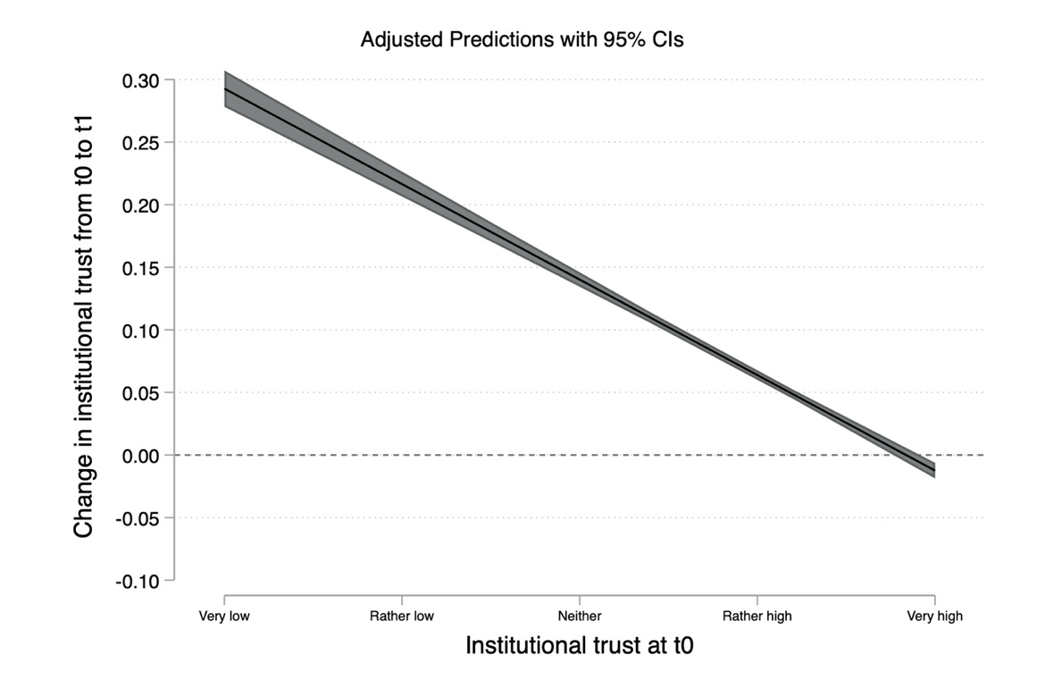
Note: The dependent variable is change in institutional trust from t0 to t1. The variable can range from -1 to 1, s.d. = 0.184, n = 7206.

Figure S5: Differential change in interpersonal trust during the crisis.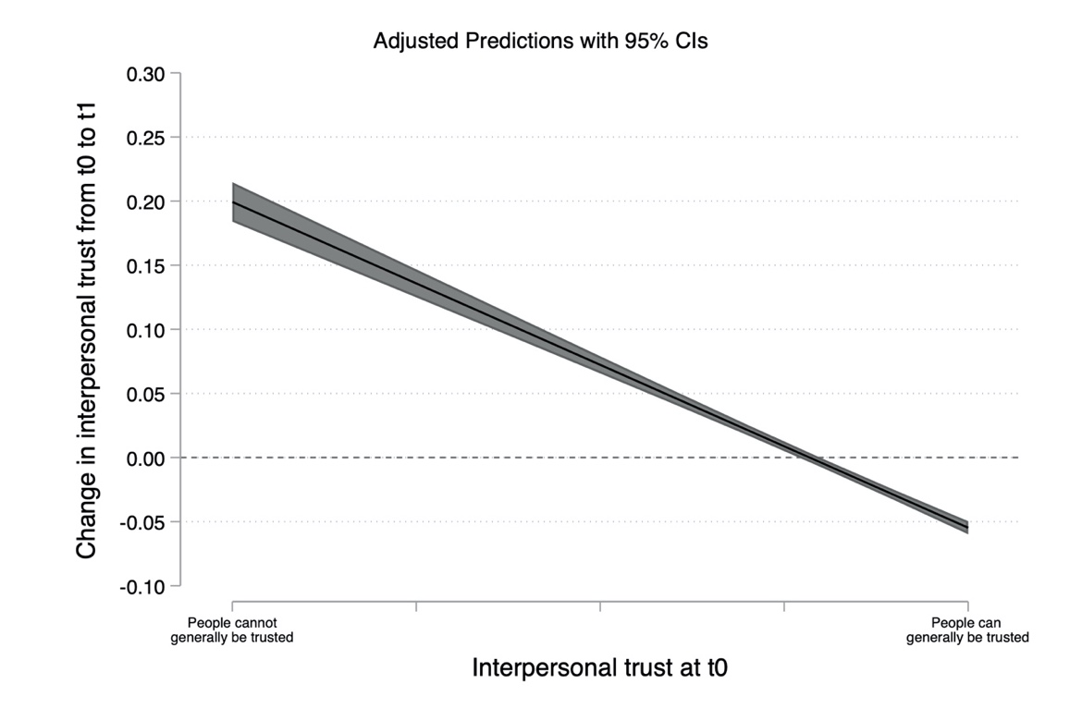
Notes: The dependent variable is change in interpersonal trust from t0 to t1. The variable can range from -1 to 1, s.d. = 0.173, n = 7184.

Table S12: Heterogenous change over time in institutional trust and interpersonal trust
 | Institutional trust |  |  | Interpersonal trust
 | (1) | (2) | (3) | (4) | (5) | (6)
 | Large sample short period | Representative sample short period | Representative sample long period | Large sample short period | Representative sample short period | Representative sample long period
Education | -0.005*** | -0.004* | -0.002 | 0.001 | 0.004 | 0.000
 | (0.001) | (0.003) | (0.003) | (0.001) | (0.002) | (0.003)
Age | 0.014*** | 0.019*** | 0.015*** | 0.002 | 0.000 | 0.002
 | (0.002) | (0.003) | (0.004) | (0.002) | (0.003) | (0.004)
Opposition party supporter | -0.013*** | -0.015 | -0.023* | -0.001 | -0.014 | 0.005
 | (0.005) | (0.012) | (0.012) | (0.005) | (0.011) | (0.012)
Other party, dk/ref | -0.001 | -0.018 | -0.018 | -0.002 | -0.006 | 0.019
 | (0.007) | (0.014) | (0.015) | (0.007) | (0.013) | (0.015)
Constant | 0.074*** | 0.064*** | 0.053** | -0.001 | -0.008 | 0.002
 | (0.012) | (0.023) | (0.025) | (0.011) | (0.022) | (0.026)
Observations | 6,909 | 1,404 | 1,404 | 6,890 | 1,396 | 1,396
R-squared | 0.014 | 0.027 | 0.015 | 0.000 | 0.004 | 0.001
Notes: The dependent variable in columns 1-3 is change in institutional trust. In column 4-6, the dependent variable is change in interpersonal trust. In models 1-2 and 4-5, the change is from t0 to t1 and in models 3 and 6 it is change from t-1 to t1. Change scores are created by subtracting the old value (t0 or t-1) from the new value (t1). Independent variables are education (coded 1-9 and age (coded 1-6). See categories in Table S6. Also included are dummy variables that measure party support by asking which party respondents would vote for if the election was held today. The baseline (i.e. the excluded category) is support for the governing parties (the Social Democrats or the Greens) or parties affiliated with the governing parties (the Liberals, the Center Party or the Left Party). The two dummy variables measure support for the opposition parties (Sweden Democrats, Moderates or Christian Democrats) or other party. The latter category also includes respondents who did not want to answer the question, did not know, or for some other reason did not intend to vote. Robust standard errors in parentheses. *** p<0.01, ** p<0.05, * p<0.1

Table S12 further explores heterogenous effects over time in institutional trust and interpersonal trust. Here, the focus is on education, age and party support.

Table S12 suggests that the largest increase in institutional trust occurred among individuals with lower educational attainment (model 1 and model 2), although the increase is not statistically significant over the longer period for the representative sample (model 3). The increase was also concentrated among older individuals. Both findings may be due to ceiling effects since education is correlated with higher institutional trust and age is correlated with lower trust. If there are ceiling effects, the across-the-board increase is more likely to be noticeable among people with lower education and among those who are older.

The largest increase in institutional trust happened among government supporters. This group had higher institutional trust before the crisis compared to opposition party supporters, yet the increase was nevertheless slightly higher among supporters of the governing parties. The effect is statistically significant at p<0.01 in model 1. The robustness of the effect can be doubted due to the lack of a statistically significant effect in model 2, however.

As for interpersonal trust, we document no heterogenous effects depending on education, age or party support regardless of sample type (models 4-6).

Table S13. Panel attrition between t0 and t1
 | (1)
VARIABLES | Model 1
Age | 1.34
 | [0.00]
Sex (Male) | 1.12
 | [0.06]
Education | 1.05
 | [0.00]
Constant | 1.40
 | [0.06]
Observations | 12,677
Notes: The dependent variable is participation at t1 given participation at t0. It is coded 1 for participation at both t0 and t1 and 0 for participation at t0 only. Age has six categories (1-6). Sex is coded 1 for female and 2 for male. Education has nine categories (1-9). See Table S6 for the categories. Entries are odds ratios based on logistic regression with p-values in brackets.

Table S6 above indicates that older individuals were somewhat more likely to participate at t1 compared to younger individuals. Table S13 finds additional evidence for this (odds ratio = 1.35, p < 0.01). Moreover, there is evidence that higher education is associated with somewhat a higher likelihood of participating at both t0 and t1 (odds ratio = 1.05, p < 0.01). As for sex, we find no evidence (p > 0.05) that it is associated with attrition. Overall, while two factors are behind statistically significant attrition, the sample composition does not change in any dramatic fashion from t0 to t1, as Table S6 shows.

Supplementary Discussion

Table S14: Countries with strong support (rally effect) for the government managing of the corona crisis, distributed by level of democracy.

Full democracies | Polls indicating support for government (rally effect)
Austria | https://www.gallup-international.com/wp-content/uploads/2020/03/GIA_SnapPoll_2020_COVID_Tables_final.pdf
Australia | https://yougov.co.uk/topics/international/articles-reports/2020/03/17/YouGov-international-COVID-19-tracker,  https://www.gallup-international.com/wp-content/uploads/2020/03/GIA_SnapPoll_2020_COVID_Tables_final.pdf
Canada | https://leger360.com/surveys/concerns-about-covid-19-april-21-2020/,  https://innovativeresearch.ca/canada-this-month-breaking-issues-covid-19/,  https://yougov.co.uk/topics/international/articles-reports/2020/03/17/YouGov-international-COVID-19-tracker
Denmark | https://yougov.se/news/2020/03/19/svenskarna-har-lagst-fortroende-myndigheternas-han/,  https://yougov.co.uk/topics/international/articles-reports/2020/03/17/YouGov-international-COVID-19-tracker
Finland | https://yougov.co.uk/topics/international/articles-reports/2020/03/17/YouGov-international-COVID-19-tracker
Germany | https://yougov.de/news/2020/03/31/massnahmen-der-krise-vertrauen-die-deutsche-regier/,  https://yougov.co.uk/topics/international/articles-reports/2020/03/17/YouGov-international-COVID-19-tracker,
Italy | https://www.statista.com/statistics/1106743/opinions-on-italian-government-s-response-to-coronavirus/,  https://yougov.co.uk/topics/international/articles-reports/2020/03/17/YouGov-international-COVID-19-tracker,  https://www.gallup-international.com/wp-content/uploads/2020/03/GIA_SnapPoll_2020_COVID_Tables_final.pdf
Netherlands | https://www.gallup-international.com/wp-content/uploads/2020/03/GIA_SnapPoll_2020_COVID_Tables_final.pdf
Norway | https://yougov.co.uk/topics/international/articles-reports/2020/03/17/YouGov-international-COVID-19-tracker
Portugal | https://sondagens-ics-ul.iscte-iul.pt/wp-content/uploads/2020/03/Sondagem-ICS_ISCTE_Mar%C3%A7o2020_Covid.pdf
Switzerland | https://www.gallup-international.com/wp-content/uploads/2020/03/GIA_SnapPoll_2020_COVID_Tables_final.pdf
UK | https://yougov.co.uk/topics/international/articles-reports/2020/03/17/YouGov-international-COVID-19-tracker,  https://yougov.co.uk/topics/health/articles-reports/2020/03/24/public-overwhelmingly-backs-governments-new-measur
Uruguay | https://equipos.com.uy/primer-mes-de-lacalle-pou-fuerte-apoyo-en-medio-de-la-pandemia/
Democracies | Polls indicating support for government (rally effect)
Argentina | https://www.gallup-international.com/wp-content/uploads/2020/03/GIA_SnapPoll_2020_COVID_Tables_final.pdf
Armenia | https://www.gallup-international.com/wp-content/uploads/2020/03/GIA_SnapPoll_2020_COVID_Tables_final.pdf
Bolivia | https://drive.google.com/file/d/14SL9aQ5tFPjIi_0moR4t_OFZ4bgv2SyP/view
Bulgaria | https://www.gallup-international.bg/en/43103/express-opinion-poll-state-of-emergency/
Table S14 (cont.)
Colombia | https://drive.google.com/file/d/19CdYcrV1du25t9MXy0RFXgqkXYJWK9Sj/view
Ghana | https://www.geopoll.com/blog/report-covid-19-coronavirus-africa/?utm_campaign=Coronavirus%202&utm_source=Wapor
India | http://cvoterindia.com/homepage/COVID_frequencies_India_Wave_1.pdf,  https://yougov.co.uk/topics/international/articles-reports/2020/03/17/YouGov-international-COVID-19-tracker,  https://www.gallup-international.com/wp-content/uploads/2020/03/GIA_SnapPoll_2020_COVID_Tables_final.pdf
Indonesia | https://www.gallup-international.com/wp-content/uploads/2020/03/GIA_SnapPoll_2020_COVID_Tables_final.pdf
Malaysia | https://www.gallup-international.com/wp-content/uploads/2020/03/GIA_SnapPoll_2020_COVID_Tables_final.pdf
North Macedonia | https://www.gallup-international.com/wp-content/uploads/2020/03/GIA_SnapPoll_2020_COVID_Tables_final.pdf
Pakistan | http://gallup.com.pk/wp-content/uploads/2020/04/Gallup-Pakistan-COVID-19-Wave-2-Report.pdf
Paraguay | http://multitarget.com.py/wp-content/uploads/2016/05/ENCUESTA-MULTITARGET-PARAGUAY-COVID-MARZO-2020.pdf
Philippines | https://www.gallup-international.com/wp-content/uploads/2020/03/GIA_SnapPoll_2020_COVID_Tables_final.pdf
South Korea | https://www.gallup-international.com/wp-content/uploads/2020/03/GIA_SnapPoll_2020_COVID_Tables_final.pdf
Anocracies | Polls indicating support for government (rally effect)
Afghanistan | https://www.gallup-international.com/wp-content/uploads/2020/03/GIA_SnapPoll_2020_COVID_Tables_final.pdf
Ecuador | https://www.gallup-international.com/wp-content/uploads/2020/03/GIA_SnapPoll_2020_COVID_Tables_final.pdf
Jordan | http://www.worldofopinions.org/?p=5378
Mozambique | https://www.geopoll.com/blog/report-covid-19-coronavirus-africa/?utm_campaign=Coronavirus%202&utm_source=Wapor
Rwanda | https://www.geopoll.com/blog/report-covid-19-coronavirus-africa/?utm_campaign=Coronavirus%202&utm_source=Wapor
Turkey | https://www.gallup-international.com/wp-content/uploads/2020/03/GIA_SnapPoll_2020_COVID_Tables_final.pdf
Azerbaijan | https://www.gallup-international.com/wp-content/uploads/2020/03/GIA_SnapPoll_2020_COVID_Tables_final.pdf

Table S14 (cont.)
Autocracies | Polls indicating support for government (rally effect)
Kazakhstan | https://www.gallup-international.com/wp-content/uploads/2020/03/GIA_SnapPoll_2020_COVID_Tables_final.pdf
Kuwait | http://www.worldofopinions.org/?p=5369
Vietnam | https://yougov.co.uk/topics/international/articles-reports/2020/03/17/YouGov-international-COVID-19-tracker

Note: The table compiles data on countries where the public opinion expresses strong support (rally effect) for the government during the corona crisis, gathered from online statistical databases. The table includes both support in general, and support for specific measures implemented by politicians and authorities. Polls that express support for an individual head of state, named politicians/ministers or a specific authority are included, as well as polls that express support for government, politicians and authorities in general. The countries have been categorized based on scores retrieved from the Polity data series (https://en.wikipedia.org/wiki/Polity_data_series).

WHO (2014). EBOLA STRATEGY Ebola and Marburg virus disease epidemics: preparedness, alert, control and evaluation. https://apps.who.int/iris/bitstream/handle/10665/130160/WHO_HSE_PED_CED_2014.05_eng.pdf. Retrieved 21.04.2020.
WHO. 2020. Novel Coronavirus (2019-nCoV) SITUATION REPORT – 1. https://www.who.int/docs/default-source/coronaviruse/situation-reports/20200121-sitrep-1-2019-ncov.pdf. Retrieved 21.04.2020..
Radio Sweden. 2020. First case of corona virus in Sweden confirmed. https://sverigesradio.se/artikel/7398979. Retrieved 20.04.2020.
Krisinformation.se.2020. The Swedish government classifies the corona virus as an illness that is dangerous to society. https://www.krisinformation.se/en/news/2020/february/the-swedish-government-classifies-the-coronavirus-as-an-illness-that-is-dangerous-to-society. Retrieved 23.04.2020.
Radio Sweden. 2020. Government seek to assure public as corona virus cases grow in Sweden. https://sverigesradio.se/artikel/7420342. Retrieved 23.04.2020.
Radio Sweden. 2020. Agency raises corona virus risk assessment level, Iran flight suspended. https://sverigesradio.se/artikel/7419578. Retrieved 23.04.2020.
Radio Sweden. 2020. Contact tracing – preventing the spread of the corona virus. https://sverigesradio.se/artikel/7418206. Retrieved 22.04.2020.
Public Health Agency. 2020. Bekräftade fall i Sverige – daglig uppdatering [Confirmed Swedish cases – daily updating]. https://experience.arcgis.com/experience/09f821667ce64bf7be6f9f87457ed9aa. Retrieved 22.04.2020.
Radio Sweden. 2020. Public health agency raises risk of covid-19 community spread in Sweden to "very high". https://sverigesradio.se/artikel/7425415. Retrieved 22.04.2020.
Public Health Agency. 2020. Bekräftade fall i Sverige – daglig uppdatering [Confirmed Swedish cases – daily updating]. https://experience.arcgis.com/experience/09f821667ce64bf7be6f9f87457ed9aa. Retrieved 22.04.2020.
WHO. 2020. Director General’s opening remarks at the media briefing on COVID-19 – 11 Marc 2020. https://www.who.int/dg/speeches/detail/who-director-general-s-opening-remarks-at-the-media-briefing-on-covid-19---11-march-2020. Retrieved 20.04.2020.
Radio Sweden. 2020. First death in Sweden from covid-19. https://sverigesradio.se/artikel/7426621. Retrieved 21.04.2020.
Radio Sweden. 2020. Public Health Agency raises risk of covid-19 community spread to “very high”. https://sverigesradio.se/artikel/7425415. Retrieved 21.04.2020.
Krisinformation.se. 2020. Abolished qualifying day of sickness due to corona virus. https://www.krisinformation.se/en/news/2020/march/abolished-qualifying-day-of-sickness-due-to-corona-virus. Retrieved 21.04.2020.
Radio Sweden. 2020. Additional amending budget due to the coronavirus. https://www.government.se/press-releases/2020/03/additional-amending-budget-due-to-the-coronavirus/. Retrieved 21.04.2020.
Radio Sweden. 2020. Swedish government to ban gatherings of more than 500. https://sverigesradio.se/artikel/7426532. Retrieved 21.04.2020.
Public Health Agency. 2020. Bekräftade fall i Sverige – daglig uppdatering [Confirmed Swedish cases – daily updating]. https://experience.arcgis.com/experience/09f821667ce64bf7be6f9f87457ed9aa. Retrieved 22.04.2020.
Krisinformation.se. 2020. The Public Health Agency of Sweden recommends remote learning. https://www.krisinformation.se/en/news/2020/march/remote-learning. Retrieved 22.04.2020.
Radio Sweden. 2020. Sweden tightens gatherings ban. https://sverigesradio.se/avsnitt/1469376?programid=2054. Retrieved 23.04.2020.
Government Offices of Sweden. 2020. Temporary ban of travel to the EU via Sweden due to COVID-19. https://www.government.se/press-releases/2020/03/temporary-ban-on-travel-to-sweden-due-to-covid-19/. Retrieved 22.04.2020.
Radio Sweden. 2020. New Coronavirus rules for bars and eateries. https://sverigesradio.se/avsnitt/1469352?programid=2054. Retrieved 23.04.2020.
Public Health Agency. 2020. FAQ about the new legislation for restaurants, bars, etc. https://www.folkhalsomyndigheten.se/the-public-health-agency-of-sweden/communicable-disease-control/covid-19-new-legislation-for-restaurants-bars-etc/. Retrieved 20.04.2020
Lund University. 2020. Sweden under fire for relaxed corona virus approach – here’s the science behind it. https://www.lunduniversity.lu.se/article/sweden-under-fire-for-relaxed-coronavirus-approach-heres-the-science-behind-it. Retrieved 22.04.2020.
Bloomberg .2020. Prognosis: Sweden says controversial virus strategy proving effective.https://www.bloomberg.com/news/articles/2020-04-19/sweden-says-controversial-covid-19-strategy-is-proving-effective. Retrieved 22.04.2020.
The Guardian. 2020. Anger in Sweden as elderly pay price for coronavirus strategy. https://www.theguardian.com/world/2020/apr/19/anger-in-sweden-as-elderly-pay-price-for-coronavirus-strategy. Retrieved 22.04.2020.
Lund University. 2020. Sweden under fire for relaxed corona virus approach – here’s the science behind it. https://www.lunduniversity.lu.se/article/sweden-under-fire-for-relaxed-coronavirus-approach-heres-the-science-behind-it. Retrieved 22.04.2020.
Public Health Agency. 2020. Bekräftade fall i Sverige – daglig uppdatering [Confirmed Swedish cases – daily updating]. https://experience.arcgis.com/experience/09f821667ce64bf7be6f9f87457ed9aa. Retrieved 22.04.2020.
Public Health Agency. 2020. Bekräftade fall i Sverige – daglig uppdatering [Confirmed Swedish cases – daily updating]. https://experience.arcgis.com/experience/09f821667ce64bf7be6f9f87457ed9aa. Retrieved 22.04.2020.

