Corruption and support for decentralization
Theresa Kuhn and Sergi Pardos-Prado
Online appendix

A. Appendix on survey experiment 2
Table A1- Descriptive statistics survey experiment 2
Table A2- Wording of treatment conditions 3
Table A3- Balance tests 5
Table A4- Ordinal logistic models predicting support for fiscal decentralization 7
Table A5- Sensitivity analysis for Average Causal Mediation Effects 8
Table A6- Interactions between corruption primes and relative regional corruption 9
Table A7- Frequency of cases across regions 10
Table A8- Replication of Table 1 with region fixed-effects 11
Table A9- Replication of Table 2 with region fixed-effects 12
Table A10- National identity mediating preferences for decentralization 13
Table A11- Average causal mediation effects of national identity 14
Figure A1- Distribution of treatment per region 15
Figure A2- Distribution of decentralization preferences per region 16
Figure A3- Average Marginal Effects of corruption primes across collective identity 17
Figure A4- Average Marginal Effects of corruption primes across party identification 18
B. Appendix on EVS 19
Table B1- Descriptive statistics 19
Table B2- National Quality of Government predicting support for sub-national government 20
Table B3- Hierarchical logit models predicting preferences for sub-national government excluding vote intention and regional GDP 22

Appendix on survey experiment

Table A1- Descriptive statistics survey experiment
Variable | N | Mean | SD | Min | Max
Support for political decentralization | 1788 | 2.18 | 1.06 | 1 | 4
Treatments | 1918 | 2.5 | 1.12 | 1 | 4
Higher education (dummy) | 1918 | .24 | .43 | 0 | 1
Age | 1918 | 40.33 | 12.47 | 18 | 64
Female (dummy) | 1918 | .5 | .5 | 0 | 1
Subjective social class | 1873 | 2.08 | .95 | 1 | 4
National identity | 1763 | 2.6 | .86 | 1 | 4
Left-right ideology | 1736 | 3.77 | 2.44 | 0 | 10
PP voter | 1918 | .06 | .25 | 0 | 1
Voter of regional incumbent party | 1918 | .09 | .28 | 0 | 1
Relative regional corruption | 1911 | 1 | .12 | .81 | 1.41
Satisfaction with national government | 1895 | 2.02 | 2.42 | 0 | 10
Satisfaction with regional government | 1888 | 2.68 | 2.53 | 0 | 10
Notes: Source: own survey experiment. Regional quality of government index (Charron et al. 2015).

Table A2- Wording of treatment conditions
Group 1  No corruption prime | Increase in regional inequality  Regional economic inequality has considerably risen in Spain over the past few years. The gap between the richest and the poorest Comunidades Autonomas has widened since the start of the economic crisis.
Group 2  General corruption prime | Increase in regional inequality and corruption scandals among politicians  Regional economic inequality has considerably risen in Spain over the last years. The gap between the richest and the poorest Comunidades Autonomas has widened since the start of the economic crisis. Moreover, politicians have been implicated in corruption scandals. By 2014, the judiciary had dealt with many cases of politicians allegedly responsible of abuse of public funds for private use.
Group 3  Central corruption prime | Increase in regional inequality and corruption scandals among central government politicians  Regional economic inequality has considerably risen in Spain over the last years. The gap between the richest and the poorest Comunidades Autonomas has widened since the start of the economic crisis. Moreover, politicians from the central government have been implicated in corruption scandals. By 2014, the judiciary had dealt with many cases of politicians linked to the central government allegedly responsible of abuse of public funds for private use.
Group 4  Regional corruption prime | Increase in regional inequality and corruption scandals among regional government politicians  Regional economic inequality has considerably risen in Spain over the last years. The gap between the richest and the poorest Comunidades Autonomas has widened since the start of the economic crisis. Moreover, politicians of different regional governments have been implicated in corruption scandals. By 2014, the judiciary had dealt with many cases of politicians linked to governments of different Comunidades Autonomas allegedly responsible of abuse of public funds for private use.

Table A3- Balance tests
 | Control group | General corruption prime | Central corruption prime | Regional corruption prime
Higher education | 0.226 (0.14) | -0.248 (0.14) | -0.005 (0.14) | 0.012 (0.14)
Working class (ref.)
Lower middle class | 0.001 (0.15) | 0.106 (0.15) | -0.016 (0.15) | -0.089 (0.15)
Middle class | 0.11 (0.14) | 0.208 (0.14) | -0.22 (0.14) | -0.1 (0.14)
Upper middle class | 0.022 (0.28) | 0.518 (0.27) | -0.313 (0.3) | -0.261 (0.29)
Regional inequality | 0.43 (0.26) | 0.126 (0.27) | -0.344 (0.27) | -0.215 (0.26)
Left-right ideology | 0.019 (0.03) | -0.035 (0.03) | 0.001 (0.03) | 0.014 (0.03)
National identity | 0.232 (0.16) | -0.013 (0.16) | -0.071 (0.17) | -0.166 (0.17)
Conservative voter | -0.32 (0.25) | 0.431 (0.23) | -0.392 (0.26) | 0.197 (0.23)
Age | -0.001 (0) | 0 (0) | 0.001 (0) | -0.001 (0)
Female | 0.045 (0.11) | -0.06 (0.11) | -0.064 (0.11) | 0.076 (0.11)
Intercept | -1.723***(0.39) | -1.188**(0.39) | -0.673 (0.39) | -0.817*(0.38)
N | 1705 | 1705 | 1705 | 1705
Log Likelihood | -956 | -951 | -945 | -965
Pseudo R squared | 0.006 | 0.006 | 0.005 | 0.002
BIC | 1933.8 | 1983.8 | 1971.88 | 2011.8
Notes: Source: own survey experiment. *** p ≤ 0.001, ** p ≤ 0.01, * p ≤ 0.05; standard errors between parentheses. Models shown in Table A3 predict being in one treatment group (vs all others). There is no significant relationship between the dependent and independent variables, confirming that the likelihood of belonging to one or another treatment group does not depend on any observable included in the models below. Models control for educational attainment (a dummy for having finished higher education), gender (a dummy where 1 equals female), age, subjective social class (working class, lower-middle, middle, and upper-middle class), and regional inequality (ratio between average regional per-capita GDP in Spain and each region’s per-capita GDP, higher values corresponding to poorer regions). Models account for Left-right ideology (operationalized in a 0-10 scale where 0 is extreme left), national identity (1 means feeling ‘only Spanish’, and 0 means feeling attached only to one’s region, more to the region than to Spain, or more to Spain than to the region). This is a widely used measure of political identity (Sinnott 2005). Feeling close to Partido Popular (Spanish conservative party in power during data collection) vs. all other parties and not feeling close to any particular party controls for partisan biases in discounting corruption at the central level.

Table A4- Ordinal logistic models predicting support for fiscal decentralization
 | Model 1 | Model 2
No corruption | ref. | ref.
Corruption in general | 0.19 (0.21) | 0.16 (0.21)
Central gov. corruption | 0.3* (0.14) | 0.24 (0.14)
Regional gov. corruption | 0.15 (0.14) | 0.11 (0.15)
Lower class |  | ref.
Lower-middle class |  | 0.03 (0.13)
Middle class |  | 0.01(0.11)
Upper-middle class |  | -0.03 (0.25)
High education |  | -0.31** (0.12)
Female |  | 0.03 (0.18)
Age |  | -0.01 (0.004)
Regional inequality |  | -1.48 (0.91)
National Spanish attachment |  | -0.86*** (0.24)
Left-right ideology |  | -0.18*** (0.02)
Conservative voter |  | 0.08 (0.25)
Cut-off point 1 | -0.73 (0.13) | -3.47 (1.09)
Cut-off point 2 | 0.55 (0.19) | -2.09 (1.1)
Cut-off point 3 | 1.79 (0.37) | -0.75 (1.2)
N individuals | 1,409 | 1,409
N regions | 19 | 19
Log-pseudolikelihood | -1914.31 | -1832.59
BIC | 3872.12 | 3781.2
Notes: Source: own survey experiment. Ordinal logit coefficients and standard errors clustered at the regional level between parentheses. *** p ≤ 0.001, ** p ≤ 0.01, * p ≤ 0.05.

Table A5- Sensitivity analysis for Average Causal Mediation Effects

The mediation models rely on the assumption of sequential ignorability. This assumption requires the observed mediator to be generated independently from the treatment conditions and any unobserved confounder. While this assumption cannot be properly tested, Imai et al. (2011) and Imai and Yamamoto (2010) suggest some sensitivity analysis to assess the robustness of the mediation findings. This analysis relies on the correlation between the residuals of the mediator and outcome models (denoted as ρ). The stronger the correlation, the stronger the suspicion that an unobserved variable is causally related to both the mediator and the outcome. Table A5 presents the value of ρ from which the average causal mediation effects that emerged as significant would be 0. While this coefficient cannot be interpreted in absolute terms to adjudicate between right or wrong models, it is possible to compare degrees of robustness across models. As shown below, the residuals of the mediator and political decentralization models need to be correlated beyond 0.3 for the ACME to be insignificant. Hence, our political decentralization models are equally and moderately robust to unobserved variable biases.

Significant ACME reported in analysis section | ρ
Effect on political decentralization support through dissatisfaction with national government | 0.3

Table A6- Interactions between corruption primes and relative regional corruption
(Status Quo = Reference category)
 | One central government |  | More Autonomy |  | Possibility to secede
Corruption in general | -1.217 | (1.11) | -0.127 | (1.58) | -1.965 | (1.11)
Central gov. corruption | -4.540** | (1.56) | -0.994 | (1.50) | -1.556 | (1.82)
Regional gov. corruption | -3.083** | (1.13) | -4.492* | (1.89) | -3.311 | (2.05)
Relative regional corruption | -3.244** | (1.03) | 0.685 | (0.81) | 2.739 | (2.64)
Corruption in general # Relative regional corruption | 0.947 | (1.05) | 0.335 | (1.44) | 1.847 | (1.06)
Central gov. corruption # Relative regional corruption | 4.494** | (1.44) | 1.409 | (1.50) | 1.608 | (1.79)
Regional gov. corruption # Relative regional corruption | 2.887* | (1.18) | 4.632* | (1.84) | 3.549 | (2.11)
Constant | 2.207* | (0.97) | 1.119 | (1.38) | 3.613 | (2.79)
Controls | Yes |  | Yes |  | Yes
N | 1502
Notes: Source: own survey experiment. Multinomial logit coefficients and standard errors clustered at the regional level between parentheses. *** p ≤ 0.001, ** p ≤ 0.01, * p ≤ 0.05.

Table A7- Frequency of cases across regions

 | Frequency | Percentage sample | Percentage overall Spanish population
Andalucía | 243 | 12.67 | 18.08
Aragón | 77 | 4.01 | 2.86
Asturias | 50 | 2.61 | 2.26
Islas Baleares | 51 | 2.66 | 2.42
Islas Canarias | 76 | 3.96 | 4.58
Cantabria | 31 | 1.62 | 1.26
Castilla La Mancha | 109 | 5.68 | 4.44
Castilla y Leon | 124 | 6.47 | 5.33
Cataluña | 308 | 16.06 | 15.92
Ceuta | 3 | 0.16 | 0.18
Comunidad Valenciana | 208 | 10.84 | 10.63
Extremadura | 49 | 2.55 | 2.35
Galicia | 123 | 6.41 | 5.89
Comunidad de Madrid | 236 | 12.30 | 13.75
Melilla | 4 | 0.21 | 0.18
Región de Murcia | 75 | 3.91 | 3.15
Navarra | 30 | 1.56 | 1.37
País Vasco | 104 | 5.42 | 4.66
La Rioja | 17 | 0.89 | 0.68
Notes: Sources: Own survey experiment; Eurostat, https://ec.europa.eu/eurostat/web/products-datasets/-/DEMO_R_D2JAN

Table A8- Replication of Table 1 with region fixed-effects

 | Model 1
One central government vs. status quo
No corruption prime | ref.
General corruption prime | -0.09 (0.15)
Central corruption prime | -0.04 (0.2)
Regional corruption prime | -0.14 (0.12)
Region fixed effects | YES
Intercept | -0.2* (0.1)
More autonomy vs. status quo
No corruption prime | ref.
General corruption prime | 0.22 (0.17)
Central corruption prime | 0.37* (0.18)
Regional corruption prime | 0.13 (0.18)
Region fixed effects | YES
Intercept | -0.58*** (0.11)
Possibility to secede vs. status quo
No corruption prime | ref.
General corruption prime | 0.09 (0.13)
Central corruption prime | 0.14 (0.24)
Regional corruption prime | 0.27 (0.17)
Region fixed effects | YES
Intercept | -2.41*** (0.09)
N individuals | 1,788
N regions | 19
Log-likelihood | -2119.06
BIC | 4380.41
Notes: Source: own survey experiment. Multinomial logit coefficients and standard errors clustered at the regional level between parentheses. *** p ≤ 0.001, ** p ≤ 0.01, * p ≤ 0.05.

Table A9- Replication of Table 2 with region fixed-effects

 | One central government vs. status quo
No corruption prime | ref.
General corruption prime | -0.39 (1.16)
Central corruption prime | -2.19* (1.05)
Regional corruption prime | -2.35*** (0.73)
Relative regional corruption | -3.87*** (0.55)
General corruption prime x relative regional corruption | 0.29 (1.13)
Central corruption prime x relative regional corruption | 2.16* (0.997)
Regional corruption prime x relative regional corruption | 2.21** (0.72)
Region fixed effects | YES
Intercept | 3.96*** (0.57)
N individuals | 1,782
N regions | 17
Log-likelihood | -2110.79
BIC | 4348.84
Notes: Source: own survey experiment. Multinomial logit coefficients and standard errors clustered at the regional level between parentheses. *** p ≤ 0.001, ** p ≤ 0.01, * p ≤ 0.05.

Table A10- National identity mediating preferences for decentralization

 | National corruption |  | Regional corruption
 | M1: logit  DV: mediator | M2: ordinal logit  DV: outcome | M5: logit  DV: mediator | M6: ordinal logit DV: outcome
Central corruption prime | -0.16 (0.19) | 0.3* (0.12)
Regional corruption prime |  |  | -0.17 (0.19) | 0.19 (0.12)
National identity |  | -1.07*** (0.18) |  | -1.28*** (0.19)
High education | 0.09 (0.22) | 0.09 (0.14) | 0.13 (0.23) | 0.04 (0.15)
Age | -0.00 (0.008) | -0.01 (0.01) | 0.003 (0.01) | -0.01 (0.01)
Female | -0.2 (0.19) | 0.12 (0.12) | -0.16 (0.19) | 0.04 (0.12)
Intercept | -1.62*** (0.39) |  | -1.79*** (0.4)
Cut-off 1 |  | -0.81** (0.26) |  | -0.97*** (0.26)
Cut-off 2 |  | 0.40 (0.26) |  | 0.33 (0.25)
Cut-off 3 |  | 1.65*** (0.27) |  | 1.48*** (0.26)
AIC | 741.59 | 2325.72 |  | 2317.82
N | 880 | 880 | 885 | 885
Notes: Source: own survey experiment. Models 1 and 3 predict national identity (Spanish identity vs. the rest). Models 2 and 4 predict support for political decentralization. Logit and ordinal logit coefficients, standard errors between parentheses. *** p ≤ 0.001; ** p ≤ 0.01; * p ≤ 0.05

Table A11- Average causal mediation effects of national identity

 | ∆P(Y=  central state) | ∆P(Y=  status quo) |  | ∆P(Y=more autonomy) |  | ∆P(Y= secession)
National government corruption via national identity
ACME (treated) | -0.01 | 0.001 | 0.003 |  | 0.003
Direct effect (treated) | -0.06* | -0.003 | 0.03* |  | 0.04*
Total effect | -0.07* | -0.001 | 0.03* |  | 0.04*
Regional government corruption via national identity
ACME (treated) | -0.01 | -0.001 |  | 0.002 |  | 0.002
Direct effect (treated) | -0.04 | -0.0005 |  | 0.02 |  | 0.02
Total effect | -0.05 | 0.001 |  | 0.02 |  | 0.02
Notes: Source: own survey experiment. *** p ≤ 0.001; ** p ≤ 0.01; * p ≤ 0.05. Significance levels estimated via nonparametric bootstrapped methods (1,000 simulations).

Figure A1- Distribution of treatment per region

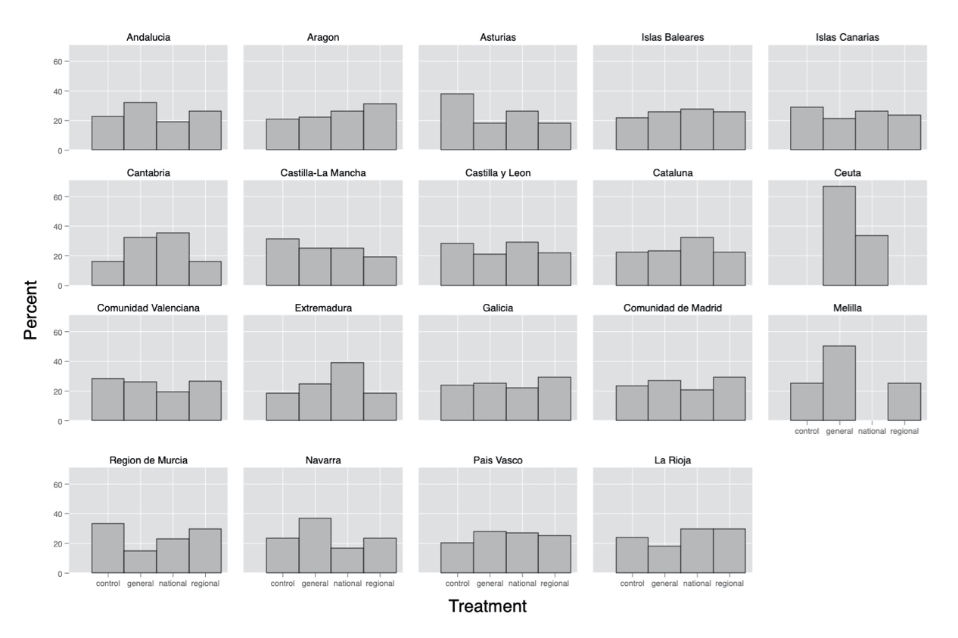Notes: Source: own survey experiment.

Figure A2- Distribution of decentralization preferences per region

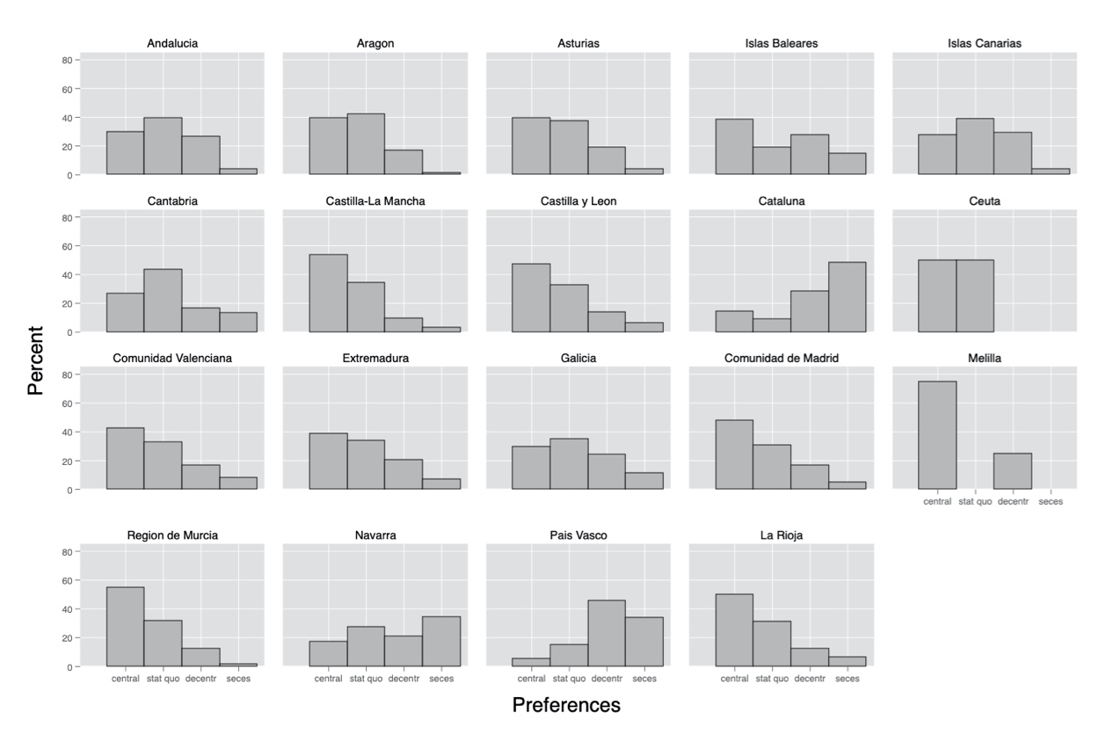Notes: Source: own survey experiment.

Figure A3- Average Marginal Effects of corruption primes across collective identity

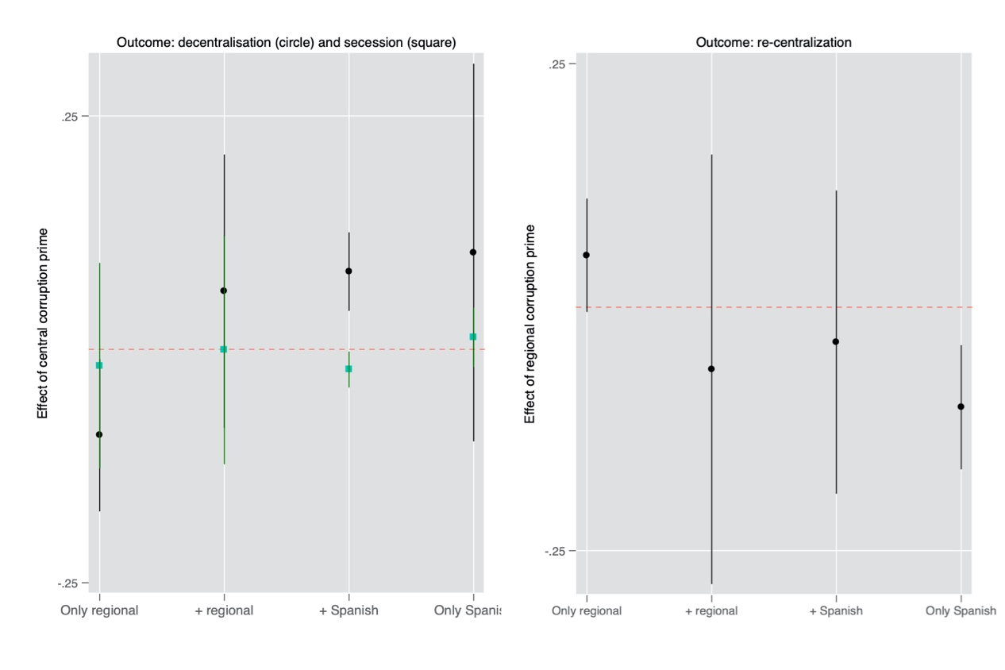
Notes: Source: own survey experiment. Dots refer to the Average Marginal Effect of central (left graph) and regional (right graph) corruption in a fully specified model, with 95 percent confidence intervals. The conditioning variable (X axis) is national identity, with exclusive regional identity as the reference category.

Figure A4- Average Marginal Effects of corruption primes across party identification

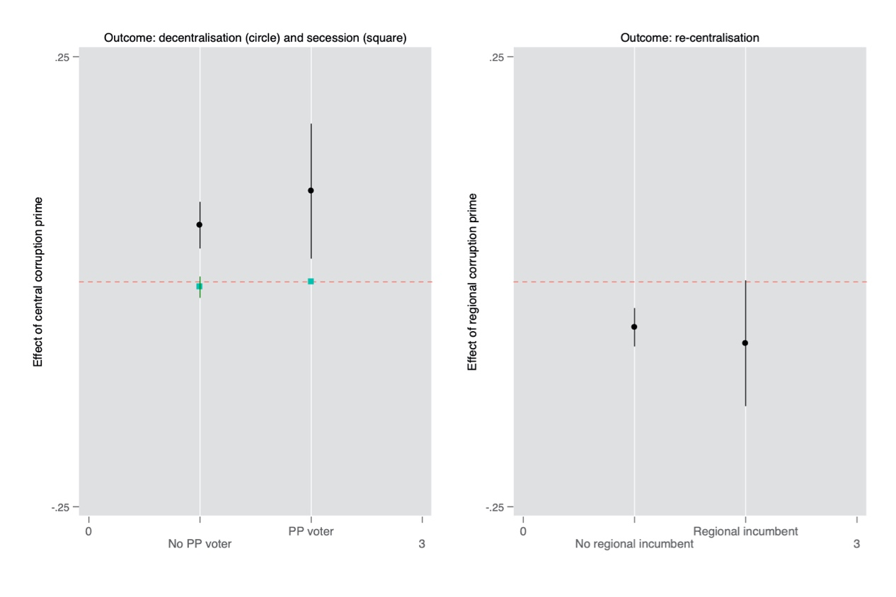
Notes: Source: own survey experiment. Dots refer to the Average Marginal Effect of central (left graph) and regional (right graph) corruption in a fully specified model, with 95 percent confidence intervals. The conditioning variable (X axis) is partisan identity for the national incumbent (left graph) and the regional incumbent (right graph).

B. Appendix on EVS

Table B1- Descriptive statistics

 | N | Mean | SD | Min | Max
Preferences sub-national government | 33,906 | 0.49 | .5 | 0 | 1
National corruption | 36,928 | -5.85 | 2.29 | -10 | -2.4
Regional corruption | 25,020 | 0.37 | .24 | 0 | 1
Relative regional corruption level within country | 25,020 | 1 | .28 | 0 | 5.59
Female | 37,919 | 0.54 | .5 | 0 | 1
Age | 37,803 | 45.01 | 17.14 | 15 | 101
High education | 37,930 | 0.19 | .39 | 0 | 1
Social class (ref. service class)
Routine non-manual | 26,435 | 0.24 | .43 | 0 | 1
Self-employed | 26,435 | 0.05 | .22 | 0 | 1
Skilled manual | 26,435 | 0.17 | .38 | 0 | 1
Semi-unskilled manual | 26,435 | 0.23 | .42 | 0 | 1
National pride | 35,304 | 0.84 | .36 | 0 | 1
Left-right scale | 30,260 | 5.37 | 2.06 | 1 | 10
Vote intention incumbent party | 23,864 | 0.42 | .49 | 0 | 1
Country GDP | 37,930 | 4.85e+11 | 6.04e+11 | 6.46e+09 | 2.12e+12
Saliency center-periphery party system | 37,930 | 2.72 | 1.61 | .06 | 5.33
Regional GDP | 28,154 | 18435.08 | 13188.43 | 800 | 52800

Table B2- National Quality of Government predicting support for sub-national government

 | Model 1 | Model 2
National Quality of Government | 2.21**  (0.83) | 1.48**  (0.55)
Female | -0.05  (0.04) | -0.02  (0.03)
Age | 0.01***  (0.001) | 0.01***  (0.001)
Higher education | 0.12*  (0.06) | 0.04  (0.04)
Service class (ref.)
Routine non-manual | 0.09  (0.06) | 0.01  (0.04)
Self-employed | 0.21*  (0.1) | 0.19*  (0.07)
Skilled manual | -0.07  (0.07) | -0.04  (0.05)
Semi-unskilled manual | 0.06  (0.07) | -0.04  (0.05)
National pride | 0.13*  (0.06) | 0.27***  (0.04)
Left-right scale | -0.002  (0.01) | 0.0001  (0.01)
Support for incumbent party | 0.06  (0.04)
Country GDP p.c. (PPP) | 8.27e-15  (1.99e-13) | -9.73e-14  (1.68e-13)
Salience center-periphery | -0.06  (0.07) | -0.05  (0.06)
Regional GDP p.c. (PPP) | 1.76e-06  (3.65e-06)
Intercept | 1.4*  (0.72) | 0.68  (0.48)
Country intercept variance | 0.27***  (0.08) | 0.23***  (0.06)
N (individuals) | 10,219 | 18,536
N (countries) | 23 | 28
Log Likelihood | -6677.57 | -12160.37
BIC | 13493.61 | 24448.5
Notes: Source: European Values Study (1999), National Quality of Government Index, ParlGov, CMP, World Bank, Eurostat, OECD. *** p ≤ 0.001, ** p ≤ 0.01, * p ≤ 0.05; Standard errors between parentheses.

Table B3- Hierarchical logit models predicting preferences for sub-national government excluding vote intention and regional GDP

 | Model 1 | Model 2
National level of corruption | 0.12**  (0.04)
Regional level of corruption |  | 2.9**  (1)
Relative regional corruption level within country |  | -0.06  (0.21)
Regional level of corruption x relative level within country |  | -1.37*  (0.6)
Female | -0.03  (0.03) | -0.06  (0.04)
Age | 0.01***  (0.001) | 0.01***  (0.001)
Higher education | 0.04  (0.04) | 0.07  (0.06)
Service class (ref.)
Routine non-manual | 0.03  (0.05) | 0.06  (0.06)
Self-employed | 0.22**  (0.07) | 0.28*  (0.09)
Skilled manual | -0.04  (0.05) | -0.09  (0.06)
Semi-unskilled manual | -0.03  (0.05) | -0.06  (0.06)
National pride | 0.27***  (0.04) | 0.13*  (0.06)
Left-right scale | -0.007  (0.01) | -0.01  (0.01)
Country GDP p.c. (PPP) | -3.71e-15  (1.62e-13) | -1.03e-13  (1.93e-13)
Salience center-periphery | -0.11  (0.06) | -0.05  (0.07)
Intercept | 0.4  (0.33) | -0.67  (0.36)
Country intercept variance | 0.2***  (0.06) | 0.19**  (0.07)
Regional intercept variance |  | 0.09***  (0.02)
N (individuals) | 17,919 | 12,280
N(countries) | 27 | 17
N (regions) |  | 149
Log Likelihood | -11784.88 | -7979.14
BIC | 23697.08 | 16108.93
Notes: Source: EVS 1999, regional Quality of Government dataset, Transparency International, CMP, World Bank. Coefficients of hierarchical logit random intercept models; standard errors between parentheses. *** p ≤ 0.001, ** p ≤ 0.01, * p ≤ 0.05.

References appendix
Imai, Kosuke, Luke Keele, Dustin Tingley, and Teppei Yamamoto. 2011. Unpacking the Black Box of Causality: Learning About Causal Mechanisms from Experimental and Observational Studies. American Political Science Review 105(04): 765-789.
Imai, Kosuke, and Teppei Yamamoto. 2010. Causal Inference with Differential Measurement Error: Nonparametric Identification and Sensitivity Analysis. American Journal of Political Science 54(2): 543-560.
Sinnott, Richard (2005). An Evaluation of the Measurement of National, Subnational and Supranational Identity in Crossnational Surveys. International Journal of Public Opinion Research 18(2): 211-223.

