Appendix 1: Additional information about the data

1. Number of MEP followers per organizations in the EU Transparency Register.

There are twenty-five organizations having more than 10% MEPs (57 or more) following them: VoteWatch Europe (183), Bruegel (123), Human Rights Watch (112), Centre for European Policy Studies (105), Open Europe (104), Wilfried Martens Centre for European Studies (98), Friends of Europe (97), World Economic Forum (90), European Movement International (87), World Wildlife Fund European Policy Programme (83), Greenpeace Europe (80), Gates Ventures (79), European Council of Foreign Relations (77), Transparency International (76), European Youth Forum (71), Young European Federalists (68), European Policy Centre (67), EU40 (67), European Women’s Lobby (66), Jacques Delors Institute (65), European Trade Union Confederation (64), Bureau of European Consumers (61), Friends of Earth Europe (58), the Union of European Federalists (57) and the New Europeans (57). All of these are well-established organizations in the EU interest group community, thus providing face validation for our measure of interest group recognition.
Figure A1.1 further shows the high skewness of the number of MEP followees across the sample of interest organizations. This supports arguments about the elite pluralist nature of the EU interest group system, and further validates our measure of interest group recognition.

Figure A1.1: Distribution of the number of MEP following interest groups on Twitter across interest organizations
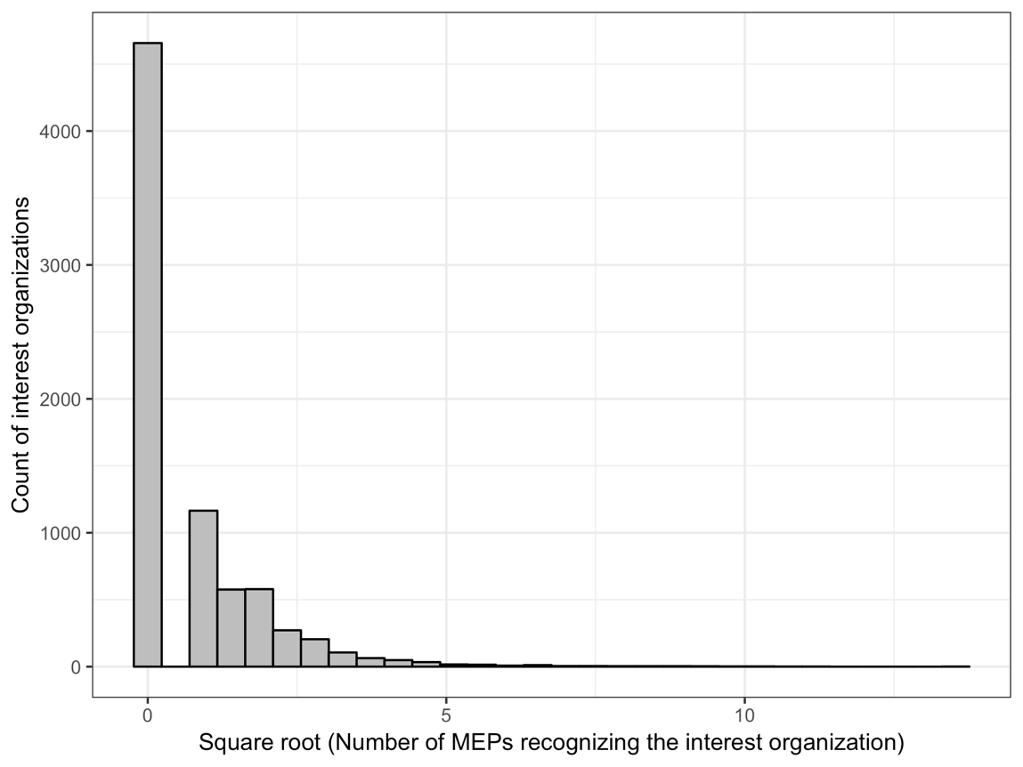

2. Measuring interest group prominence in the community of interest organizations.

In this section we provide more information about the measure of interest group prominence. This is a measure specific to a given MEP-organization dyad.
As discussed in the manuscript, the first step in constructing the measure involves establishing whether the two actors share interest in a policy domain. Interest groups indicate their policy interests in the EU Transparency Register by selecting one or more of the 41 EU policy domains. MEPs’ policy domain interests are coded based on the policy areas that are a primary responsibility of the permanent parliamentary committee(s) of which the MEP was a (full or substitute) member. Table A1.1 provides information on the distribution of 41 policy areas across EP permanent committees. Policy areas were assigned to committees based on the EP Rules of Procedure.
Approximately 60% of MEP-organization dyads have shared policy fields/domains. This is not surprising given that almost all MEPs sit in multiple committees, most of which are responsible for multiple policy areas, and that many organizations indicated interests in a large number of areas (median number of policy domains among analysed organizations is 9; SD 8.5). For the remaining 40% of MEP-organization dyads the measure takes the value of 0.
Next step involves measuring the in-degree centrality (expressed in percentage terms) of the organization in the policy field(s) shared between it and the MEP. If the organization is not followed on Twitter by any other organization that has interest in the same policy domain, the in-degree centrality score is 0. The theoretically possible maximum score is 100, representing the situation where the organization is followed by all other organizations that are interested in this policy domain. Given that each policy domain is ‘populated’ by more than one thousand groups, some several thousand, the empirically observed maximum is 28.3.
If the MEP and organization share more than one policy domain, we use the in-degree centrality score for that shared domain in which this score is highest. This score is then the value of the interest group prominence in a shared policy field. For example, if the two actors share three policy domains, and the in-degree centrality of the organization in these fields are 0, 5 and 10, the score of 10 is used. We use the maximum score because we believe that MEPs consider the prominence of interest organizations in each individual policy area, not across multiple domains that they are “interested” in. For example, a hypothetical MEP who sits in the Agriculture and Rural Development committee (AGRI) and Civil Liberties, Justice and Home Affairs committee (LIBE) has agricultural and rural development, borders and security, justice and fundamental rights and migration and asylum as her/his policy domains of interest. This MEP would judge the prominence of an important agricultural group (e.g. COPA-COGECA) based on its in-degree centrality among interest groups that are active in the agriculture and rural development field, not the average in-degree centrality of this group across four policy domains in which the MEP has an interest in.
The resulting variable is highly right-skewed and therefore in the analyses we use the quartic root transformation. The resulting maximum value is 2.3. The minimum value is 0, representing either the situation where MEP and interest organization do not share a policy interest or the situation in which they do have a shared domain but interest organization has zero in-degree centrality in that domain.
While our measure is specific to MEP-organization dyad, we can examine five most prominent groups in each of the 41 policy domains (Table A1.1). In many cases, these include organizations that are known from research as among the key players in their policy fields, such as COPA-COGECA (European Farmers) in agriculture and food safety, European Environmental Bureau in environment, maritime affairs and transport, European Public Health Alliance in public health, BUSINESSEUROPE in areas related to economy and single market, and the Bureau of European Consumers (BEUC) in consumers and single market.
Table A1.1: EP parliamentary committees, policy areas and prominent groups
Committee | Policy areas | Prominent groups
AFET: Foreign Affairs | European Neighbourhood Policy  External Relations  Foreign Affairs and Security Policy | CEPS, FoE, New Europeans, Bruegel  WEF, HRW, CEPS, FoE  WEF, HRW, CEPS, ECFR
DEVE: Development | Humanitarian Aid and Civil Protection  International Co-Operation and Development | HRW, WEF, OXFAM, FoE  WEF, HRW, OXFAM, BMGF
INTA: International Trade | Trade | WEF, CEPS, TIC, BUSINESSEUROPE
BUDG: Budgets | Budget | WEF, CEPS, EPC, Bruegel
CONT: Budgetary Control | Fraud Prevention | UNINA, ACCA, UNISI, UK Finance
ECON: Economic and Monetary Affairs | Banking and Financial Services  Competition  Economy  Finance and The Euro  Taxation | WEF, Bruegel, CEPS, EPC  WEF, TIC, CEPS, BUSINESSEUROPE  WEF, CEPS, Bruegel, TIC  WEF, CEPS, Bruegel, TIC  WEF, CEPS, Bruegel, BUSINESSEUROPE
EMPL: Employment and Social Affairs | Employment and Social Affairs | WEF, CEPS, FoE, EPC
ENVI: Environment, Public Health and Food Safety | Climate Action  Environment  Food Safety  Public Health | WEF, EEB, Climate Group, WRI  WEF, EEB, Gates Ventures, Greenpeace EU  WEF, COGECA, FoodDrinkEurope, BEUC  WEF, EPHA, Gates Ventures, BMGF
ITRE: Industry, Research and Enterprise | Business and Industry  Communication  Energy  Research and Innovation | WEF, TIC, BUSINESSEUROPE, CEPS WEF, FoE, EPC, Google  WEF, EEB, Climate Group, CEPS  WEF, Gates Ventures, TIC, CEPS
IMCO: Internal Market and Consumer Protection | Consumers  Customs  Digital Economy and Society  Single Market | WEF, BEUC, TIC, EPC  WEF, BUSINESSEUROPE, Bruegel, EPC  WEF, TIC, Google, CEPS  WEF, CEPS, BEUC, TIC
TRAN: Transport and Tourism | Trans-European Networks  Transport | WEF, FoE, EPC, BUSINESSEUROPE  WEF, T&E, EEB, CEPS
REGI: Regional Development | Regional Policy | WEF, CEPS, EPC, TIC
AGRI: Agriculture and Rural Development | Agriculture and Rural Development | WEF, COGECA, EEB, Greenpeace EU
PECH: Fisheries | Maritime Affairs and Fisheries | WEF, EHF, EEB, WWF EPO
CULT: Culture and Education | Culture  Culture and Media  Education and Training  Sport  Youth | WEF, EPC, FoE, EYF  WEF, TIC, Google, EPC  WEF, FoE, TIC, CEPS  WEF, FoE, EYF, BEUC  WEF, EYF, FoE, EPC
JURI: Legal Affairs | -
LIBE: Civil Liberties, Justice and Home Affairs | Borders and Security  Justice and Fundamental Rights  Migration and Asylum | WEF, HRW, CEPS, EPC  HRW, WEF, CEPS, TIC  CEPS, FoE, RIIA, New Europeans
AFCO: Constitutional Affairs | Enlargement  Institutional Affairs | WEF, CEPS, FoE, HRW  WEF, CEPS, Bruegel, EPC
FEMM: Women’s Rights and Gender Equality | -
PETI: Petitions | -
Abbreviations: BEUC: European Bureau of Consumers; BMGF: Bill & Melinda Gates Foundation; CEPS: Centre for European Policy Studies; COGECA: European agri-cooperatives; ECFR: European Council on Foreign Relations; EEB: European Environmental Bureau; EPC: European Policy Centre; EPHA: European Public Health Alliance; EYF: European Youth Forum; FoE: Friends of Europe; HRW: Human Rights Watch; RIIA: Royal Institute of International Affairs; T&E: Transport and Environment; TIC: Twitter International; UNINA: University of Naples Federico II; UNISI: University of Sienna; WEF: Word Economic Forum; WRI: World Resources Institute; WWF EPO: World Wildlife Fund European Policy Programme.

3. Networks of MEPs and interest organizations
Note: MEPs are represented by squares and interest groups are represented by circles

Figure A1.1: Network with all MEPs and interest groups

Figure A1.2. Network with no isolates: interest type and MEPs’ ideology
Figure A1.3. Network with no isolates: interest groups and MEPs by country of origin

Appendix 2: Additional analyses
- Full version of Table 1 in the main manuscript presenting the results of the logistic regression models of interest group recognition by MEPs

Table A2.1: Logistic regression models of interest group recognition by MEPs: Full model estimates
 | Business | NGO | TradeU | Prof. | Consult. | ThinkT | Acad. | Subnat.
 | (1) | (2) | (3) | (4) | (5) | (6) | (7) | (8)
Shared MS | 3.285** | 2.770** | 5.297** | 4.310** | 2.427** | 3.113** | 4.590** | 2.736**
 | (0.079) | (0.059) | (0.333) | (0.336) | (0.202) | (0.113) | (0.396) | (0.246)
Shared MS * Flexible | 0.884** | 0.644** | 2.415** | 0.522 | -1.164 | 1.123** | 1.470 | 2.598**
 | (0.160) | (0.128) | (0.547) | (0.678) | (0.485) | (0.318) | (0.653) | (0.520)
Shared MS * Open | 1.611** | 1.869** | 2.376** | 1.487* | 1.699** | 2.337** | 1.571* | 1.967**
 | (0.146) | (0.128) | (0.484) | (0.548) | (0.357) | (0.334) | (0.581) | (0.453)
Flexible list | -0.291 | -0.026 | -0.395 | -0.236 | -0.201 | 0.066 | 0.243 | -0.054
 | (0.246) | (0.241) | (0.417) | (0.396) | (0.330) | (0.264) | (0.599) | (0.367)
Open list/ STV | -0.132 | -0.289 | -0.478 | -0.010 | -0.081 | -0.476 | 0.313 | -0.142
 | (0.228) | (0.227) | (0.373) | (0.347) | (0.294) | (0.251) | (0.549) | (0.330)
MEPs left-right ideology | -0.01 | -0.172** | -0.247 | -0.051 | -0.011 | -0.037 | 0.033 | -0.083
 | (0.033) | (0.029) | (0.104) | (0.086) | (0.067) | (0.040) | (0.096) | (0.092)
MEP Left-right* | 0.072** | -0.045** | -0.106 | -0.094 | 0.007 | 0.046 | 0.080 | 0.047
IG prominence | (0.021) | (0.013) | (0.079) | (0.082) | (0.059) | (0.022) | (0.091) | (0.081)
Interest group inter-org. | 1.143** | 1.477** | 1.450** | 2.221** | 1.437** | 0.797** | 0.122 | 1.520**
prominence | (0.121) | (0.070) | (0.414) | (0.475) | (0.355) | (0.138) | (0.550) | (0.469)
EU-level organization | 2.238** | 1.329 | 4.037** | 2.121 |  | 1.673 | 0.668 | 1.482
 | (0.468) | (0.631) | (0.875) | (1.161) |  | (0.851) | (0.865) | (0.953)
Twitter-followees (MEP) | 0.902** | 0.980** | 0.832** | 1.006** | 1.177** | 0.959** | 1.100** | 0.888**
(log) | (0.051) | (0.046) | (0.099) | (0.094) | (0.074) | (0.060) | (0.119) | (0.092)
Twitter-followers | 0.337** | 0.500** | 0.759** | 0.509** | 0.269** | 0.678** | 0.620** | 0.367**
(interest group) (log) | (0.018) | (0.021) | (0.101) | (0.090) | (0.058) | (0.061) | (0.077) | (0.067)
Shared Language | 0.344 | 0.606** | 1.246 | 1.309 | 0.828 | 1.109** | 2.293** | 0.941
 | (0.165) | (0.121) | (0.577) | (0.584) | (0.357) | (0.251) | (0.669) | (0.481)
(Vice-)chair | 0.062 | 0.161 | 0.280 | -0.219 | 0.165 | 0.082 | -0.002 | 0.221
 | (0.142) | (0.124) | (0.244) | (0.247) | (0.174) | (0.161) | (0.307) | (0.231)
Participation | 0.068 | 0.232 | 0.310 | -0.295 | -0.060 | -0.220 | 0.065 | 0.267
 | (0.130) | (0.121) | (0.275) | (0.240) | (0.189) | (0.146) | (0.310) | (0.248)
Count of reports | 0.045 | 0.035 | -0.125 | 0.053 | 0.180* | 0.184* | 0.058 | 0.090
 | (0.056) | (0.049) | (0.101) | (0.096) | (0.065) | (0.063) | (0.116) | (0.090)
Number of terms | 0.020 | 0.045 | 0.079 | 0.123 | 0.270** | 0.115 | 0.025 | 0.123
 | (0.056) | (0.048) | (0.097) | (0.097) | (0.069) | (0.060) | (0.119) | (0.091)
CEE | 0.718* | 0.715** | 0.460 | 1.581** | 0.859* | 1.091** | 1.755** | 0.270
 | (0.223) | (0.216) | (0.427) | (0.373) | (0.310) | (0.246) | (0.488) | (0.363)
Constant | -19.305** | -20.483** | -24.150** | -18.747** | -19.468** | -19.246** | -24.985** | -21.134**
 | (1.309) | (1.208) | (2.890) | (2.511) | (1.920) | (1.550) | (3.179) | (2.545)
Observations | 1,782,150 | 1,185,920 | 58,860 | 145,515 | 274,135 | 221,815 | 134,615 | 110,090
Log Likelihood | -16,511 | -25,396 | -1,206 | -1,059 | -2,301 | -5,943 | -893 | -1,448
Number of organizations | 3270 | 2176 | 108 | 267 | 503 | 407 | 247 | 202
Number of MEPs | 545 | 545 | 545 | 545 | 545 | 545 | 545 | 545
Number of national parties | 198 | 198 | 198 | 198 | 198 | 198 | 198 | 198
Number of countries (orgs.) | 75 | 78 | 27 | 25 | 32 | 38 | 34 | 30
Number of MS | 28 | 28 | 28 | 28 | 28 | 28 | 28 | 28
Variance: organizations | 1.14 | 1.13 | 0.93 | 1.01 | 1.41 | 1.39 | 0.52 | 0.91
Variance: MEPs | 0.96 | 0.87 | 1.10 | 0.84 | 0.65 | 1.09 | 1.19 | 1.06
Variance: national parties | 0.18 | 0.30 | 0.95 | 0.00 | 0.40 | 0.00 | 0.00 | 0.00
Variance: orgs. countries | 0.44 | 0.61 | 0.71 | 1.04 | 0.52 | 0.79 | 0.68 | 0.86
Variance: MS | 0.35 | 0.37 | 0.19 | 0.42 | 0.41 | 0.37 | 0.53 | 0.37
Logistic regression models. Standard errors in parentheses. **p < 0.001; *p < 0.01.

- Models with fixed effects for European Parliament groups
In these models we examine the effect of the European Parliament group (EPG) fixed effects on recognition. The centrist liberal ALDE group is held as reference category.

The research on the European Parliament stresses that the ideology of national parties is a key factor driving their membership in EPGs (e.g. McElroy and Benoit 2012). Thus, the fixed effects of EPGs can be considered as an alternative measure of MEP ideology to our main measure based on the CHES expert survey. We would therefore expect that EPG fixed effects could show similar effects as the ones in H2a on the impact of MEP ideological preferences, although the effects may be hard to uncover given the use of two similar measures of MEP ideology. The results show support to this conjecture. Particularly trade unions are more recognised by MEPs from more leftist groups (S&D, GUE-NGL, the Greens). Business groups are somewhat more supported by MEPs from more rightist groups, at least when comparing EPP and ALDE with the Greens and GUE-NGL. Correspondingly, the effect of ideology using our main measure becomes weaker for these two types of groups, but not for NGOs and professional associations. The support to H1 and H2b is not influenced by the inclusion of EPG fixed effects.

We also observe that MEPs from the extremes of the political spectrum, especially the radical right groups, are less likely to recognise most types of interest groups. This could be a result of these groups playing a less important role in EU decision-making. As MEPs from these groups are less concerned with office and policy incentives, they are less likely to recognise interest organizations. This further supports our theoretical argument that policy and office incentives of MEPs are important explanations in their recognition of interest groups.

Table A2.2: Logistic regression models of interest group recognition by MEPs: EPG fixed effects included

 | Business | NGO | Trade Union | Prof. | Consult. | Think Tank | Academic | Subnational
 | (1) | (2) | (3) | (4) | (5) | (6) | (7) | (8)
Shared MS | 3.286** | 2.770** | 5.288** | 4.322** | 2.431** | 3.113** | 4.573** | 2.756**
 | (0.079) | (0.059) | (0.331) | (0.337) | (0.202) | (0.113) | (0.389) | (0.247)
Shared MS * Flexible | 0.880** | 0.644** | 2.410** | 0.515 | -1.210 | 1.113** | 1.434 | 2.582**
 | (0.160) | (0.128) | (0.548) | (0.679) | (0.482) | (0.317) | (0.647) | (0.521)
Shared MS * Open | 1.610** | 1.869** | 2.450** | 1.487* | 1.659** | 2.315** | 1.630* | 1.946**
 | (0.146) | (0.128) | (0.486) | (0.550) | (0.355) | (0.333) | (0.574) | (0.454)
Flexible list | -0.337 | -0.019 | -0.206 | -0.214 | -0.393 | 0.024 | 0.094 | -0.182
 | (0.234) | (0.242) | (0.384) | (0.409) | (0.323) | (0.243) | (0.522) | (0.377)
Open list/ STV | -0.176 | -0.220 | -0.454 | -0.008 | -0.091 | -0.465 | 0.279 | -0.236
 | (0.216) | (0.227) | (0.342) | (0.361) | (0.285) | (0.231) | (0.465) | (0.340)
MEPs' left-right ideology | -0.115 | -0.166* | 0.216 | -0.116 | -0.123 | -0.056 | 0.115 | -0.212
 | (0.064) | (0.057) | (0.162) | (0.132) | (0.117) | (0.076) | (0.168) | (0.144)
MEP Left-right * IG prominence | 0.073** | -0.045** | -0.112 | -0.095 | 0.005 | 0.047 | 0.087 | 0.052
 | (0.021) | (0.013) | (0.079) | (0.083) | (0.064) | (0.022) | (0.094) | (0.085)
Interest group inter-org. prominence | 1.138** | 1.478** | 1.472** | 2.229** | 1.441** | 0.789** | 0.049 | 1.474*
 | (0.122) | (0.070) | (0.414) | (0.480) | (0.374) | (0.140) | (0.565) | (0.484)
EU-level interest group | 2.238** | 1.330 | 4.051** | 2.124 |  | 1.674 | 0.690 | 1.487
 | (0.468) | (0.630) | (0.886) | (1.166) |  | (0.841) | (0.867) | (0.958)
Twitter-followees (MEP) (log) | 0.877** | 0.969** | 0.794** | 1.014** | 1.149** | 0.918** | 1.064** | 0.845**
 | (0.050) | (0.046) | (0.096) | (0.095) | (0.071) | (0.059) | (0.119) | (0.091)
Twitter-followers (interest group) (log) | 0.337** | 0.500** | 0.759** | 0.509** | 0.270** | 0.678** | 0.624** | 0.369**
 | (0.018) | (0.021) | (0.102) | (0.090) | (0.058) | (0.061) | (0.077) | (0.067)
Shared Language | 0.345 | 0.603** | 1.181 | 1.309 | 0.775 | 1.106** | 2.254** | 0.943
 | (0.164) | (0.121) | (0.558) | (0.589) | (0.355) | (0.248) | (0.638) | (0.482)
Constant | -17.634** | -20.254** | -27.660** | -18.833** | -16.222** | -17.893** | -22.759** | -18.374**
 | (1.375) | (1.274) | (3.147) | (2.759) | (2.023) | (1.637) | (3.396) | (2.701)
EPGECR | -0.126 | -0.069 | -1.586 | 0.421 | -0.580 | -0.236 | -1.756* | -0.778
 | (0.281) | (0.261) | (0.936) | (0.539) | (0.394) | (0.318) | (0.668) | (0.556)
EPGEFDD | -0.150 | 0.110 | 0.281 | 0.300 | -1.838** | -0.511 | -1.842 | -0.583
 | (0.312) | (0.300) | (0.731) | (0.588) | (0.537) | (0.371) | (0.722) | (0.528)
EPGENF | -0.610 | -0.549 | -0.990 | -0.605 | -1.380 | -0.874 | -1.254 | -0.816
 | (0.396) | (0.394) | (1.078) | (1.171) | (0.856) | (0.463) | (0.926) | (0.824)
EPGEPP | 0.172 | 0.044 | 0.285 | 0.176 | -0.247 | 0.040 | -0.406 | 0.195
 | (0.216) | (0.198) | (0.493) | (0.413) | (0.269) | (0.243) | (0.429) | (0.348)
EPGGreens/EFA | -0.649 | 0.446 | 1.888* | -0.113 | -0.961 | -0.123 | -0.825 | -0.776
 | (0.320) | (0.286) | (0.704) | (0.546) | (0.443) | (0.364) | (0.749) | (0.548)
EPGGUE-NGL | -0.932 | -0.252 | 2.352* | -0.281 | -2.278** | -0.872 | -0.698 | -1.222
 | (0.387) | (0.345) | (0.832) | (0.679) | (0.654) | (0.457) | (0.958) | (0.699)
EPGNI | -0.856 | -0.191 | -12.639 | 1.095 | -14.820 | -1.672 | -1.092 | -0.535
 | (0.547) | (0.479) | (387.761) | (0.927) | (497.717) | (0.737) | (1.283) | (1.192)
EPGS&D | -0.408 | -0.141 | 2.343** | -0.029 | -0.708 | -0.151 | -0.302 | -0.499
 | (0.251) | (0.228) | (0.583) | (0.447) | (0.341) | (0.287) | (0.545) | (0.420)
Observations | 1,782,150 | 1,185,920 | 58,860 | 145,515 | 274,135 | 221,815 | 134,615 | 110,090
Log Likelihood | -16,499.340 | -25,388.560 | -1,189.103 | -1,056.952 | -2,282.563 | -5,931.342 | -885.221 | -1,440.693
Number of organizations | 3270 | 2176 | 108 | 267 | 503 | 407 | 247 | 202
Number of MEPs | 545 | 545 | 545 | 545 | 545 | 545 | 545 | 545
Number of national parties | 197 | 197 | 197 | 197 | 197 | 197 | 197 | 197
Number of countries (orgs.) | 75 | 78 | 27 | 25 | 32 | 38 | 34 | 30
Number of MS | 28 | 28 | 28 | 28 | 28 | 28 | 28 | 28
Variance: organizations | 1.31 | 1.29 | 0.88 | 1.02 | 1.99 | 1.94 | 0.28 | 0.84
Variance: MEPs | 0.88 | 0.77 | 1.22 | 0.68 | 0.36 | 1.13 | 1.39 | 0.99
Variance: national parties | 0.01 | 0.03 | 0.43 | 0.00 | 0.05 | 0.00 | 0.00 | 0.00
Variance: orgs. countries | 0.20 | 0.38 | 0.53 | 1.11 | 0.27 | 0.60 | 0.47 | 0.74
Variance: MS | 0.10 | 0.14 | 0.00 | 0.20 | 0.17 | 0.10 | 0.00 | 0.16
NOTE: Closed-list as a reference category for electoral system. All models include variables for EP committee chair/vice-chair, participation, number of reports and legislative terms by MEP, and CEE country. Standard errors in parentheses. **p < 0.001; *p < 0.01.

- Models using gender and age of MEPs as control variables
We provide additional models with gender and age of MEPs as additional control variables. The inclusion of these variables has a minimal effect on our main results. We also find that female MEPs are somewhat more likely to recognise some interest groups (NGOs and professional organizations), while age appears to have no clear effect.

Table A2.3: Logistic regression models of interest group recognition by MEPs: Age and gender of MEPs included
 | Business | NGO | TradeU | Prof. | Consult. | ThinkT | Acad. | Subnat.
 | (1) | (2) | (3) | (4) | (5) | (6) | (7) | (8)
Shared MS | 3.285** | 2.770** | 5.289** | 4.289** | 2.425** | 3.112** | 4.579** | 2.727**
 | (0.079) | (0.059) | (0.332) | (0.335) | (0.202) | (0.113) | (0.394) | (0.245)
Shared MS * Flexible | 0.884** | 0.644** | 2.419** | 0.522 | -1.173 | 1.123** | 1.482 | 2.606**
 | (0.160) | (0.128) | (0.545) | (0.677) | (0.481) | (0.318) | (0.651) | (0.520)
Shared MS * Open | 1.610** | 1.866** | 2.374** | 1.506* | 1.686** | 2.335** | 1.588* | 1.968**
 | (0.146) | (0.128) | (0.482) | (0.546) | (0.356) | (0.334) | (0.580) | (0.453)
Flexible list | -0.299 | -0.050 | -0.407 | -0.225 | -0.211 | 0.065 | 0.272 | -0.069
 | (0.244) | (0.238) | (0.408) | (0.384) | (0.319) | (0.265) | (0.592) | (0.360)
Open list/ STV | -0.147 | -0.309 | -0.496 | -0.070 | -0.106 | -0.478 | 0.309 | -0.165
 | (0.227) | (0.225) | (0.363) | (0.334) | (0.284) | (0.253) | (0.543) | (0.323)
MEPs' left-right ideology | -0.004 | -0.154** | -0.225 | -0.035 | 0.004 | -0.035 | 0.029 | -0.066
 | (0.034) | (0.028) | (0.104) | (0.086) | (0.068) | (0.041) | (0.096) | (0.093)
MEP Left-right * IG prominence | 0.072** | -0.045** | -0.110 | -0.099 | 0.007 | 0.046 | 0.077 | 0.046
 | (0.021) | (0.013) | (0.079) | (0.081) | (0.059) | (0.022) | (0.091) | (0.081)
Interest group inter-org. prominence | 1.144** | 1.476** | 1.456** | 2.220** | 1.436** | 0.798** | 0.125 | 1.524*
 | (0.121) | (0.070) | (0.414) | (0.472) | (0.355) | (0.138) | (0.548) | (0.469)
EU-level interest group | 2.237** | 1.330 | 4.053** | 2.135 |  | 1.674 | 0.666 | 1.490
 | (0.468) | (0.630) | (0.866) | (1.159) |  | (0.851) | (0.862) | (0.953)
Twitter-followees (MEP) (log) | 0.902** | 0.971** | 0.826** | 1.022** | 1.171** | 0.959** | 1.115** | 0.889**
 | (0.051) | (0.045) | (0.099) | (0.094) | (0.074) | (0.060) | (0.120) | (0.093)
Twitter-followers (interest group) (log) | 0.337** | 0.500** | 0.759** | 0.512** | 0.270** | 0.678** | 0.621** | 0.367**
 | (0.018) | (0.021) | (0.101) | (0.090) | (0.058) | (0.061) | (0.077) | (0.067)
Shared Language | 0.345 | 0.605** | 1.212 | 1.280 | 0.825 | 1.108** | 2.310** | 0.918
 | (0.165) | (0.121) | (0.572) | (0.578) | (0.356) | (0.251) | (0.667) | (0.479)
Female | 0.235 | 0.468** | 0.349 | 0.522* | 0.242 | 0.053 | 0.057 | 0.370
 | (0.107) | (0.093) | (0.192) | (0.186) | (0.140) | (0.127) | (0.236) | (0.182)
Age | 0.003 | -0.003 | -0.001 | 0.015 | -0.005 | 0.0002 | 0.013 | -0.001
 | (0.005) | (0.005) | (0.010) | (0.009) | (0.007) | (0.006) | (0.011) | (0.009)
Constant | -19.549** | -20.512** | -24.322** | -19.586** | -19.502** | -19.272** | -25.731** | -21.229**
 | (1.332) | (1.209) | (2.944) | (2.532) | (1.947) | (1.576) | (3.249) | (2.587)
Observations | 1,782,150 | 1,185,920 | 58,860 | 145,515 | 274,135 | 221,815 | 134,615 | 110,090
Log Likelihood | -16,508.700 | -25,382.470 | -1,203.894 | -1,052.914 | -2,299.020 | -5,942.832 | -892.115 | -1,445.502
Number of organizations | 3270 | 2176 | 108 | 267 | 503 | 407 | 247 | 202
Number of MEPs | 545 | 545 | 545 | 545 | 545 | 545 | 545 | 545
Number of national parties | 197 | 197 | 197 | 197 | 197 | 197 | 197 | 197
Number of countries (orgs.) | 75 | 78 | 27 | 25 | 32 | 38 | 34 | 30
Number of MS | 28 | 28 | 28 | 28 | 28 | 28 | 28 | 28
Variance: organizations | 1.31 | 1.29 | 0.87 | 1.03 | 1.98 | 1.94 | 0.27 | 0.83
Variance: MEPs | 0.90 | 0.71 | 1.18 | 0.66 | 0.41 | 1.20 | 1.41 | 1.12
Variance: national parties | 0.04 | 0.08 | 0.93 | 0.00 | 0.16 | 0.00 | 0.00 | 0.00
Variance: orgs. countries | 0.20 | 0.38 | 0.49 | 1.09 | 0.27 | 0.62 | 0.45 | 0.74
Variance: MS | 0.12 | 0.14 | 0.01 | 0.15 | 0.14 | 0.14 | 0.26 | 0.12
NOTE: Closed-list as a reference category for electoral system. All models include variables for EP committee chair/vice-chair, participation, number of reports and legislative terms by MEP, and CEE country. Standard errors in parentheses. **p < 0.001; *p < 0.01.

- Models using different dependent variables: (1) mutual Twitter-follow btw. MEP and organization, (2) only MEP following the organization

In this section we explore how our results differ when we differentiate between the MEP-organization dyads in which both actors follow each other on Twitter and the dyads in which only MEP follows the organization. While in our measurement section we argue that the same logic drives MEPs’ behaviour when initiating the follow themselves and when MEPs follow back an interest group, this additional analysis helps us testing this assumption empirically. Given the difficulty of estimating multinomial regression models as a result of the large size and complexity of our dataset, we fit binary logistic regression models with the same random effects as in the main models. To reduce the number of empirical analyses, we only focus on four types of interest organizations that are most important for our analysis: business, NGOs, trade unions and professional associations.

Our hypotheses hold quite well in both sets of models. If anything, they are somewhat more supported in the first set of specifications (MEPs and interest groups follow each other). We take these results as an indication that MEPs’ motivations suggested by our theory are important regardless of whether interest groups initiate or reciprocate a following relationship. Further, we speculate that, by following MEPs, interest groups actually “help” them to make following decisions aligned with electoral, policy and office motivations, as we discuss in more detail in section 5 of this appendix.

Table A2.4: Logistic regression models of interest group recognition by MEPs: Mutual follow and MEP only follow
 | Business |  | NGO |  | Trade Union |  | Prof.
 | (Mutual) | (MEPOnly) | (Mutual) | (MEPOnly) | (Mutual) | (MEPOnly) | (Mutual) | (MEPOnly)
Shared MS | 3.582** | 3.059** | 2.804** | 2.571** | 5.458** | 4.529** | 3.885** | 4.233**
 | (0.128) | (0.099) | (0.085) | (0.079) | (0.553) | (0.349) | (0.473) | (0.425)
Shared MS * Flexible | 2.057** | -0.008 | 0.682** | 0.425 | 2.987** | 1.445 | 0.814 | 0.818
 | (0.254) | (0.210) | (0.170) | (0.183) | (0.803) | (0.574) | (0.856) | (0.909)
Shared MS * Open | 1.607** | 1.439** | 2.072** | 1.305** | 2.932** | 1.514* | 2.414** | 0.542
 | (0.219) | (0.179) | (0.175) | (0.169) | (0.725) | (0.469) | (0.695) | (0.729)
Flexible list | -0.308 | -0.126 | 0.002 | -0.013 | -0.020 | -0.439 | -0.191 | -0.137
 | (0.295) | (0.240) | (0.268) | (0.222) | (0.551) | (0.422) | (0.423) | (0.549)
Open list/ STV | 0.00001 | -0.178 | -0.395 | -0.114 | -0.657 | -0.286 | -0.366 | 0.423
 | (0.269) | (0.224) | (0.254) | (0.209) | (0.515) | (0.359) | (0.374) | (0.466)
MEPs' left-right ideology | -0.057 | -0.001 | -0.186** | -0.173** | -0.453* | -0.145 | -0.012 | -0.083
 | (0.051) | (0.036) | (0.036) | (0.030) | (0.159) | (0.110) | (0.121) | (0.114)
MEP Left-right * IG | 0.066 | 0.084** | -0.065** | -0.003 | 0.044 | -0.116 | -0.133 | -0.049
prominence | (0.036) | (0.025) | (0.019) | (0.016) | (0.134) | (0.088) | (0.116) | (0.112)
Interest group inter-org. | 1.822** | 0.705** | 1.877** | 0.925** | 0.735 | 1.391* | 2.564** | 1.826*
prominence | (0.208) | (0.147) | (0.104) | (0.088) | (0.632) | (0.492) | (0.699) | (0.627)
Constant | -18.061** | -19.790** | -19.419** | -20.645** | -19.553** | -24.661** | -17.137** | -20.658**
 | (1.691) | (1.374) | (1.359) | (1.333) | (3.811) | (3.089) | (2.994) | (3.288)
Observations | 1,782,150 | 1,782,150 | 1,185,920 | 1,185,920 | 58,860 | 58,860 | 145,515 | 145,515
Log Likelihood | -8,448.017 | -9,694.907 | -15,278.610 | -14,011.290 | -693.474 | -818.635 | -622.346 | -591.782
Num. obs. | 17,227.080 | 19,720.860 | 30,878.890 | 28,344.260 | 1,639.554 | 1,889.877 | 1,518.117 | 1,456.988
Number of organizations | 3270 | 3270 | 2176 | 2176 | 108 | 108 | 267 | 267
Number of MEPs | 545 | 545 | 545 | 545 | 545 | 545 | 545 | 545
Number of national parties | 197 | 197 | 197 | 197 | 197 | 197 | 197 | 197
Number of countries (orgs.) | 75 | 75 | 78 | 78 | 27 | 27 | 25 | 25
Number of MS | 28 | 28 | 28 | 28 | 28 | 28 | 28 | 28
Variance: organizations | 2.31 | 1.18 | 2.25 | 1.03 | 2.90 | 1.21 | 2.10 | 0.75
Variance: MEPs | 1.21 | 0.84 | 0.76 | 0.80 | 1.27 | 0.64 | 0.43 | 0.58
Variance: national parties | 0.11 | 0.02 | 0.17 | 0.03 | 0.80 | 0.61 | 0.07 | 0.00
Variance: orgs. countries | 0.22 | 0.11 | 0.49 | 0.31 | 0.73 | 0.00 | 0.80 | 1.10
NOTE: Closed-list as a reference category for electoral system. All models include variables for EU-level groups, MEP’s Twitter followees, IG’s Twitter followers, shared language, EP committee chair/vice-chair, participation, number of reports and legislative terms by MEP, and CEE country. Standard errors in parentheses. **p < 0.001; *p < 0.01.

- Models for different Twitter styles of MEPs and interest groups
In this section we examine how the empirical support to our hypotheses vary depending on the Twitter styles of MEPs and interest groups. While the main models include control variables for the number of Twitter accounts followed by MEPs and the number of followers that accounts of interest groups have, it is possible that the factors related to how these actors use Twitter can also condition the effect of our key predictor variables. To examine this possibility, we split our sample based on the differences in Twitter styles of MEPs and interest groups. This allows us to contextualise our findings by examining whether the effects of the predictor variables implied by our hypotheses vary depending on actors’ Twitter styles.

To capture these styles, we first differentiate between MEPs with the logged number of followees above the median value observed in the sample (6.5) and the MEPs with the number of followees below the median value. Secondly, we differentiate between interest organizations that follow at least one MEP and those that follow no MEPs (the median observed value is 0). We then combine these two criteria to arrive at four subsamples: (1) MEPs with many followees and IGs that follow MEPs, (2) MEPs with many followees, but IGs that do not follow MEPs, (3) MEPs with few followees, but IGs that follow MEPs, (4) MEPs with few followees and IGs that do not follow MEPs. To reduce the number of empirical analyses, we only focus on four types of interest organizations that are most important for our analysis: business, NGOs, trade unions and professional associations.

Our hypotheses hold quite well across all four combinations of MEPs’ and interest groups’ Twitter styles. However, our expectations have strongest support under the first scenario in which MEPs use Twitter extensively and interest organisations use Twitter to follow MEPs. In other words, MEPs are most “rational” in the sense of taking into consideration their electoral, office and policy concerns when: (1) they are active on Twitter, so are more likely to be exposed to the situation mentioned by the reviewer of having to choose between multiple IGs to follow, and (2) interest groups “help” MEPs to make these more rational decisions by “revealing” themselves and initiating a contact based on the considerations that are not unlike those of MEPs (shared policy concerns, shared country of origin). As MEPs and interest groups use Twitter less, the patterns become somewhat weaker. In this sense, the findings are somewhat conditional on social media activity and skills of actors involved. This seems sensible: the more MEPs and interest groups use Twitter, the more our Twitter measurement is useful. Importantly, greater activity does not lead to more randomness in MEPs’ decisions; in fact, it makes them more “rational”.

Table A2.5: Logistic regression models of interest group recognition by MEPs: Variation by MEPs’ and interest groups’ Twitter styles (Business and NGOs)
 | Business |  |  |  | NGOs
 | (1) | (2) | (3) | (4) | (1) | (2) | (3) | (4)
Shared MS | 3.316** | 3.898** | 3.069** | 2.893** | 2.822** | 3.166** | 2.498** | 2.244**
 | (0.105) | (0.293) | (0.141) | (0.362) | (0.071) | (0.202) | (0.144) | (0.394)
Shared MS * | 1.392** | 1.767** | -0.078 | -0.174 | 0.564** | 0.240 | 0.971* | 2.165*
Flexible | (0.214) | (0.497) | (0.298) | (0.904) | (0.151) | (0.371) | (0.347) | (0.685)
Shared MS * Open | 1.723** | 1.677** | 1.231** | 1.070 | 1.835** | 1.325** | 1.679** | 1.543
 | (0.186) | (0.443) | (0.268) | (0.562) | (0.153) | (0.340) | (0.295) | (0.642)
Flexible list | -0.551 | -0.389 | 0.017 | -0.064 | -0.175 | 0.009 | 0.252 | -0.374
 | (0.334) | (0.462) | (0.274) | (0.497) | (0.249) | (0.339) | (0.237) | (0.434)
Open list/ STV | -0.191 | -0.197 | 0.159 | 0.115 | -0.290 | -0.338 | -0.126 | -0.446
 | (0.301) | (0.430) | (0.238) | (0.450) | (0.231) | (0.322) | (0.214) | (0.398)
MEPs' left-right | -0.034 | -0.029 | 0.039 | 0.025 | -0.188** | -0.098 | -0.176** | -0.068
ideology | (0.049) | (0.101) | (0.050) | (0.092) | (0.033) | (0.061) | (0.046) | (0.107)
MEP Left-right | 0.089* | 0.043 | 0.090* | 0.019 | -0.061** | -0.112* | 0.068 | -0.040
* IG prominence | (0.030) | (0.081) | (0.035) | (0.083) | (0.016) | (0.037) | (0.032) | (0.071)
Interest group | 1.162** | 3.226** | 0.413 | 0.543 | 1.504** | 2.028** | 0.792** | 2.160**
prominence | (0.169) | (0.545) | (0.205) | (0.538) | (0.083) | (0.223) | (0.176) | (0.479)
Constant | -17.119** | -17.887** | -19.900** | -23.438** | -18.394** | -18.933** | -19.789** | -19.987**
 | (2.103) | (2.214) | (2.186) | (2.954) | (1.693) | (1.901) | (1.895) | (2.944)
Observations | 324,929 | 328,526 | 561,241 | 567,454 | 315,715 | 319,210 | 273,981 | 277,014
Log Likelihood | -9,207.990 | -1,966.711 | -4,174.760 | -781.434 | -17,300.470 | -3,969.574 | -3,397.030 | -734.686
Bayesian Inf. Crit. | 18,707.880 | 4,225.577 | 8,653.992 | 1,867.592 | 34,892.170 | 8,230.642 | 7,082.039 | 1,757.605
Organizations | 1199 | 1199 | 2071 | 2071 | 1165 | 1165 | 1011 | 1011
MEPs | 271 | 274 | 271 | 274 | 271 | 274 | 271 | 274
National parties | 119 | 132 | 119 | 132 | 119 | 132 | 119 | 132
Countries (orgs.) | 40 | 40 | 71 | 71 | 45 | 45 | 73 | 73
MS | 26 | 26 | 26 | 26 | 26 | 26 | 26 | 26
Var: organizations | 0.75 | 0.54 | 1.17 | 1.13 | 0.90 | 0.86 | 1.38 | 1.77
Var: MEPs | 1.08 | 0.74 | 0.94 | 0.57 | 0.78 | 0.57 | 0.57 | 0.35
Var: national parties | 0.08 | 0.00 | 0.09 | 0.00 | 0.00 | 0.51 | 0.00 | 0.72
Var: orgs. countries | 0.24 | 0.49 | 0.20 | 0.12 | 0.44 | 0.34 | 0.20 | 0.00
Var: MS | 0.16 | 0.41 | 0.02 | 0.30 | 0.10 | 0.14 | 0.04 | 0.08
Logistic regression models with random intercepts for interest organizations and MEPs. Standard errors in parentheses. **p < 0.001; *p < 0.01.
Models: (1) MEPs with many followees and IGs that follow MEPs, (2) MEPs with many followees, but IGs that do not follow MEPs, (3) MEPs with few followees, but IGs that follow MEPs, (4) MEPs with few followees and IGs that do not follow MEPs.

Table A2.5 continued: Logistic regression models of interest group recognition by MEPs: Variation by MEPs’ and IG’s Twitter styles (Trade unions and professional associations)
 | Trade union |  |  |  | Professional
 | (1) | (2) | (3) | (4) | (1) | (2) | (3) | (4)
Shared MS | 5.078** | 7.327** | 5.067** | 8.411** | 4.127** | 3.492* | 3.398** | 23.622
 | (0.377) | (1.057) | (0.826) | (2.492) | (0.375) | (1.141) | (0.602) | (9,725.045)
Shared MS * | 2.300** | 2.278 | 2.523 | 1.437 | 0.661 | 2.540 | 3.032 | -17.027
Flexible | (0.584) | (0.895) | (1.417) | (3.729) | (0.710) | (1.558) | (1.521) | (9,725.045)
Shared MS * Open | 2.711** | 1.373 | 2.423* | 0.917 | 1.832** | 2.403 | 1.378 | 0.809
 | (0.550) | (0.865) | (0.920) | (2.900) | (0.513) | (1.461) | (1.103) | (16,763.570)
Flexible list | -0.941 | 0.117 | -0.505 | 1.727 | -0.004 | -0.945 | -1.654 | 20.434
 | (0.479) | (0.983) | (1.029) | (1.537) | (0.425) | (0.888) | (0.936) | (9,725.045)
Open list/ STV | -0.881 | -0.422 | -0.217 | -0.031 | 0.115 | -0.960 | -0.642 | -0.221
 | (0.417) | (0.971) | (0.716) | (1.472) | (0.360) | (0.748) | (0.640) | (16,763.570)
MEPs' left-right | -0.273 | -0.684* | 0.053 | -2.240 | 0.022 | -0.127 | -0.518 | 0.481
ideology | (0.145) | (0.250) | (0.159) | (1.277) | (0.104) | (0.220) | (0.228) | (0.725)
MEP Left-right | -0.076 | 0.130 | -0.164 | 1.245 | -0.183 | -0.108 | 0.536 | -0.508
* IG prominence | (0.113) | (0.191) | (0.165) | (1.053) | (0.097) | (0.224) | (0.241) | (0.637)
Interest group | 1.515* | 0.093 | 1.511 | 16.534 | 2.405** | 2.165 | 0.326 | 10.257
prominence | (0.568) | (0.872) | (0.931) | (6.625) | (0.567) | (1.323) | (1.194) | (4.746)
Constant | -21.602** | -30.409** | -23.697** | -55.689 | -17.859** | -14.641 | -10.365 | -54.855
 | (3.878) | (6.304) | (4.881) | (22.949) | (3.170) | (6.562) | (5.290) | (9,725.067)
Observations | 15,176 | 15,344 | 14,092 | 14,248 | 28,726 | 29,044 | 43,631 | 44,114
Log Likelihood | -740.046 | -193.895 | -211.165 | -34.794 | -702.539 | -106.542 | -180.458 | -30.433
Bayesian Inf. Crit. | 1,701.524 | 609.474 | 642.057 | 289.568 | 1,641.185 | 449.444 | 606.636 | 306.841
Organizations | 271 | 274 | 271 | 274 | 271 | 274 | 271 | 274
MEPs | 119 | 132 | 119 | 132 | 119 | 132 | 119 | 132
National parties | 56 | 56 | 52 | 52 | 106 | 106 | 161 | 161
Countries (orgs.) | 26 | 26 | 26 | 26 | 26 | 26 | 26 | 26
MS | 18 | 18 | 23 | 23 | 18 | 18 | 23 | 23
Var: organizations | 1.30 | 0.85 | 0.00 | 0.00 | 0.73 | 0.00 | 0.07 | 0.00
Var: MEPs | 0.73 | 1.50 | 0.52 | 0.00 | 0.00 | 0.00 | 0.00 | 0.00
Var: national parties | 0.48 | 0.00 | 0.79 | 0.00 | 0.97 | 3.55 | 2.25 | 0.00
Var: orgs. countries | 0.00 | 0.91 | 0.17 | 0.00 | 0.12 | 0.00 | 0.00 | 0.00
Observations | 0.25 | 0.00 | 0.54 | 11.79 | 0.00 | 0.00 | 0.00 | 11.60
Logistic regression models with random intercepts for interest organizations and MEPs. Standard errors in parentheses. **p < 0.001; *p < 0.01.
Models: (1) MEPs with many followees and IGs that follow MEPs, (2) MEPs with many followees, but IGs that do not follow MEPs, (3) MEPs with few followees, but IGs that follow MEPs, (4) MEPs with few followees and IGs that do not follow MEPs.

- Rare-event models

We observe only minor differences when fitting rare event models (cf. King and Zeng 2001).

Table A2.6: Rare-event models of interest group recognition by MEPs

 | Business  (1) | NGO  (2) | TradeU  (3) | Prof.  (4) | Consult.  (5) | ThinkT  (6) | Acad.  (7) | Subnat.  (8)
(Intercept) | -15.7*** | -16.4*** | -20.8*** | -16.6*** | -16.2*** | -15.6*** | -24.7*** | -19.3***
 | (0.46) | (0.37) | (1.70) | (1.86) | (1.29) | (0.64) | (2.26) | (1.74)
Shared MS | 2.88*** | 2.34*** | 4.50*** | 3.45*** | 1.49*** | 2.69*** | 4.52*** | 2.95***
 | (0.06) | (0.05) | (0.25) | (0.26) | (0.15) | (0.09) | (0.34) | (0.19)
Flexible List | -0.20** | 0.00 | -0.73*** | -0.39 | 0.12 | -0.14 | -0.20 | 0.02
 | (0.06) | (0.04) | (0.21) | (0.25) | (0.15) | (0.08) | (0.40) | (0.21)
Open/STV | -0.13* | -0.24*** | -1.00*** | -0.35 | -0.06 | -0.48*** | 0.06 | -0.12
 | (0.05) | (0.04) | (0.19) | (0.21) | (0.13) | (0.07) | (0.38) | (0.18)
Shared MS * Flexible | 1.13*** | 0.85*** | 2.14*** | 1.79*** | -0.51 | 1.09*** | 1.46** | 1.04***
 | (0.11) | (0.09) | (0.29) | (0.45) | (0.35) | (0.21) | (0.48) | (0.30)
Shared MS * Open | 1.46*** | 1.04*** | 2.04*** | 2.23*** | 1.40*** | 0.92*** | 1.38** | 0.79**
 | (0.08) | (0.08) | (0.26) | (0.33) | (0.24) | (0.17) | (0.43) | (0.28)
MEPs' left-right ideology | -0.00 | -0.14*** | -0.18* | 0.01 | -0.01 | -0.01 | 0.01 | 0.02
 | (0.02) | (0.01) | (0.08) | (0.08) | (0.06) | (0.03) | (0.08) | (0.10)
IG prominence | 1.77*** | 1.89*** | 1.87*** | 3.05*** | 3.48*** | 1.04*** | -0.10 | 3.04***
 | (0.12) | (0.07) | (0.37) | (0.50) | (0.38) | (0.12) | (0.48) | (0.52)
MEP Left-right * IG | 0.06** | -0.04*** | -0.12 | -0.15 | 0.01 | 0.03 | 0.09 | 0.02
prominence | (0.02) | (0.01) | (0.07) | (0.09) | (0.07) | (0.02) | (0.08) | (0.09)
EU-level interest group | 1.88*** | 1.26*** | 2.94*** | 2.16*** |  | 1.54*** | 0.42 | 0.96***
 | (0.06) | (0.04) | (0.26) | (0.25) |  | (0.08) | (0.39) | (0.22)
Followees (MEP) (log) | 0.83*** | 0.85*** | 0.65*** | 1.01*** | 1.07*** | 0.80*** | 1.07*** | 0.87***
 | (0.02) | (0.01) | (0.05) | (0.07) | (0.05) | (0.02) | (0.07) | (0.05)
Followers (IG) (log) | 0.28*** | 0.30*** | 0.51*** | 0.39*** | 0.04 | 0.58*** | 0.49*** | 0.12***
 | (0.01) | (0.01) | (0.05) | (0.05) | (0.03) | (0.02) | (0.06) | (0.03)
Shared Language | 0.88*** | 0.61*** | 1.90*** | 1.74*** | 0.18 | 1.56*** | 3.41*** | 0.93**
 | (0.09) | (0.07) | (0.29) | (0.37) | (0.24) | (0.14) | (0.37) | (0.32)
AIC | 36864.41 | 59033.87 | 2873.52 | 2280.35 | 5270.71 | 14916.35 | 1957.25 | 3194.84
BIC | 37087.49 | 59249.62 | 3035.22 | 2458.33 | 5449.57 | 15101.92 | 2133.84 | 3367.81
Log Likelihood | -18414.20 | -29498.94 | -1418.76 | -1122.17 | -2618.36 | -7440.18 | -960.63 | -1579.42
Deviance | 36828.41 | 58997.87 | 2837.52 | 2244.35 | 5236.71 | 14880.35 | 1921.25 | 3158.84
Num. obs. | 1782150 | 1185920 | 58860 | 145515 | 274135 | 221815 | 134615 | 110090
Standard errors in parentheses. ***p < 0.001, **p < 0.01, *p < 0.05

- Effects of prominence and ideology in a two-dimensional space
In the manuscript, we test H2a and H2b assuming that MEPs’ and interest groups’ policy preferences align in a single-dimensional left-right space. Here we relax this assumption by examining whether our expectations are supported when assuming a two-dimensional space structured by economic left-right and social left-right dimensions.
In Figure 1, we summarise our assumptions about the ideological placement of interest groups in a two-dimensional space by using 3 X 3 matrices. These matrices are obtained by assuming three positions on each dimension: left, centre and right (economic left-right) and liberal, centre and conservative (social left-right). The shaded cells indicate where we would expect most interest groups of a particular type to position themselves ideologically. As in the main manuscript, we do not make these assumptions for subnational public institutions, think tanks, consultancies and academic institutions since these organizations are likely to represent ideologically diverse interests or avoid taking stances in ideological battles.
In making assumptions about parties’ ideological positions, we build on the literature on political divides in contemporary European democracies and the positioning of different social groups on these divides (e.g. Oesch and Rennwald 2018) and the still sparse work that uses interest group surveys to identify their ideological self-placements (e.g. Polk et al. 2017). Given the limited evidence on interest groups’ ideological placement, we avoid making very specific assumptions. For example, we assume that business groups can position themselves not only on the right end of the economic left-right dimension, but also at more centrist positions. Similarly, their positions on the social dimension can range from liberal, in line with the work showing that professionals in large international corporations might have socially liberal attitudes, to conservative, following the work suggesting that petit bourgeoisie might have socially conservative preferences.
On the MEP side, we construct a 9-category that summarizes MEPs’ policy preferences in a two-dimensional space in line with Figure 1. This is obtained by first dividing MEPs in three groups based on their positions (identified based on CHES expert survey) on the economic left-right dimension (0-3.33; 3.33-6.67; 6.67-10); then doing the same on the GALTAN dimension; and, finally, constructing the categorical variable capturing the combinations of the groups on each dimension. As in the manuscript, we fit separate logistic regression models of interest group recognition for each interest group type, and the main variables of interest here are the 9-category variable of MEP ideology, interest group prominence and the interaction between the two.

Figure 1: Assumptions about interest groups’ policy/ideological preferences
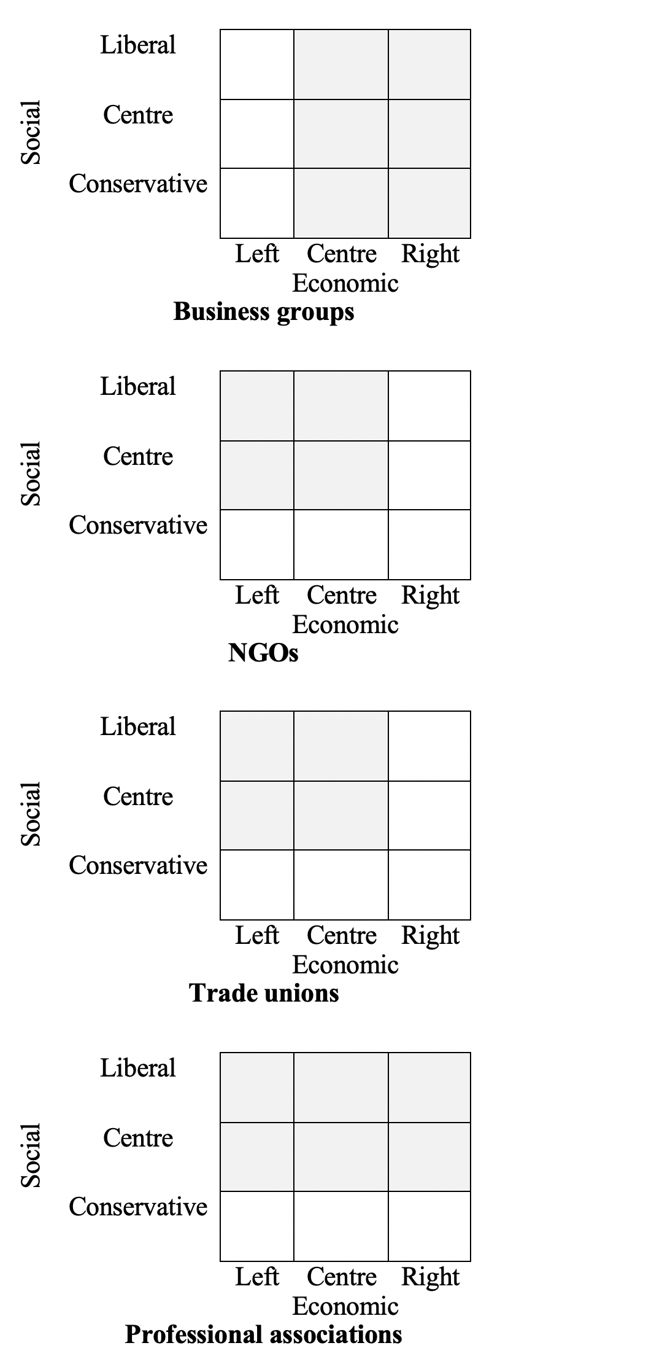

Effects of shared preferences. In line with H2a, we expect that MEPs recognise interest groups that share their policy preferences (i.e. are placed in the same cell in Figure 1), but only if these groups are prominent actors in shared policy fields. We keep the economically leftist – socially liberal (EconLeft-SocLib) MEPs as a reference category in all analyses. Thus, if the cell representing the reference category is not shaded, as is the case for business groups, we expect that the coefficients for the categories represented by shaded cells to be positive. This would indicate that MEPs holding the ideological positions represented by these cells are more likely to recognise prominent business groups than the MEPs that hold EconLeft-SocLib positions. Conversely, if the cell representing the reference category is shaded, as is the case for NGOs, trade unions and professional associations, we expect that coefficients for MEP ideological positions represented by non-shaded cells would be negative. Figure 2 summarises the results for each cell by indicating whether the coefficient for the ideological position represented by that cell, while holding EconLeft-SocLib as the reference category, is positive, negative or not statistically significantly different from 0. Each cell reports two effects: the first one is for prominent groups (with the score of the prominence variable set at 1.04 or the 90th percentile of the observed distribution) and the second one for non-prominent groups (with the score of the prominence variable set at 0 or the 10th percentile of the observed distribution). Further, Figure 3 reports the actual average marginal effects derived from the logistic regression models.

Figure 2: Effects of ideology: summary of results
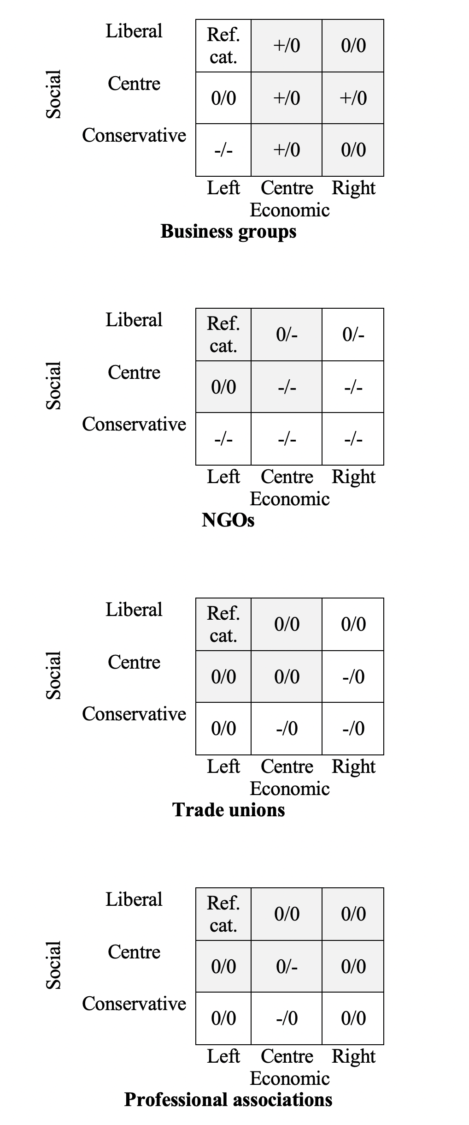
In line with H2a, and the findings for the general left-right dimension, we find relatively strong effects of MEP ideology for business, NGO and trade union samples, although there is more variation with regard to the conditioning effect of interest group prominence. Starting with prominent business groups, compared with economically leftist – socially liberal (EconLeft-SocLib) MEPs, four groups of MEPs (EconCentr-SocLib, EconCentr-SocCentr, EconCentr-SocCons and EconRight-SocCentr) are more likely to recognise business groups. However, the effects for two groups (EconRight-SocLib and EconRight-SocCons) that were expected to be more likely to recognise business groups than the reference category (EconLeft-SocLib) were not different from 0 at the 0.05 level of statistical significance. Still, in line with the expectations, EconLeft-SocCentr MEPs were equally likely to recognise prominent business groups as EconLeft-SocLib. EconLeft-SocCons were less likely to do so, which is also partially in line with the expectations.
In contrast, for non-prominent groups the only statistically significant effect is for EconLeft-SocCons MEPs who are less likely to recognise non-prominent business groups than their EconLeft-SocLib counterparts. This supports H2a: for non-prominent groups, the ideology of MEPs is not an important factor for explaining recognition.
With regard to NGOs, we find that all social conservative MEPs, regardless of their economic ideology, and EconRight-SocCentr MEPs are less likely to recognise prominent interest groups in shared policy domains. Additionally, EconCentr-SocCentr MEPs are also less likely to do so. This largely supports the expectations that recognition of NGOs is associated with economically leftist and socially liberal positions. However, the conditioning effect of IG prominence is not present: the results for less prominent groups are very similar to those for the more prominent groups.
For trade unions, in line with our expectations, we find that MEPs with three ideological positions (EconCentr-SocCons, EconRight-SocCons and EconRight-SocCentr) are less likely to recognise interest groups than the MEPs belonging to the reference category of EconLeft-SocLib. The effect only holds for prominent groups. For two categories (EconLeft-SocCons and EconRight-SocLib) we do not find significant differences with EconLeft-SocLib.
The evidence for professional associations is mixed. The EconCentr-SocCons MEPs are less likely to recognise prominent professional associations than EconLeft-SocLib. The effects for the other two groups of MEPs (EconLeft-SocCons and EconLeft-SocLib) that were expected to recognise prominent professional associations less than EconLeft-SocLib MEPs were negative, but not statistically significant. In line with the expectations, among prominent professional associations, there are no differences between EconLeft-SocLib and the remaining categories. However, EconCentr-SocCentr MEPs are less likely to recognise non-prominent professional associations.
Also, moderately in line with theoretical expectations, the effects for other types of interest groups are less clear. For prominent academic institutions, economic liberalism, when combined with moderate or liberal social dimension position, has an effect. Think tanks are recognised by MEPs representing various ideological positions with the exception of EconLeft-SocCon. The recognition of subnational governmental authorities is associated with economic centrism.
Effect of interest groups prominence amongst other interest groups in a policy domain. In line with H2b, we expect that MEPs recognise interest groups that are prominent actors in the shared policy fields, especially when these organizations share MEPs’ policy preferences/ideological leaning (i.e. are place in the same cell in Figure 1). Figure 4 reports the effect of interest organization prominence for each of the 9 categories of the MEP ideology variable and each type of interest group.
The results support H2b mostly with regard to the NGOs and trade unions. For the NGOs, the effect of prominence is stronger for the four MEP ideological positions (EconLeft-SocLib, EconLeft-SocCentr, EconCentr-SocLib and EconCentr-SocCentr) that were theorised to be in line with NGOs’ preferences than for three categories where the effects of prominence were theorised to be weaker (EconCentr-SocCon, EconRight-SocCon and EconLeft-SocCon). However, the effect of prominence is strong for MEPs with EconRight-SocLib and EconRight-SocCentr preferences. Overall, this suggests that the social dimension is more important in moderating the effect of interest group prominence: holding the level of economic liberalism constant, increasing social conservatism weakens the effect of interest group prominence. Most importantly, the effect of prominence on the recognition of NGOs is weak for MEPs with socially conservative preferences.
For trade unions, the effect of prominence is present only for the four MEP ideological positions where it was expected to be strongest (EconLeft-SocLib, EconLeft-SocCentr, EconCentr-SocLib and EconCentr-SocCentr). For all other categories, the effect is not statistically significant, although the coefficients are positive for all these categories except EconLeft-SocCon.
In the case of business groups, in line with the results reported in the manuscript that use a single left-right dimension, the conditioning effect of MEP ideology on the effect of prominence on recognition is weaker. The effect of prominence is stronger for economically rightist and centrist MEPs than for their EconLeft-SocCentr counterparts, but not for EconLeft-SocLib and EconLeft-SocCon colleagues.
For professional associations, the strongest effects are for EconCentr-SocCentr MEPs, but there is no clear evidence that the other three MEP ideological positions associated with the policy preferences of professional associations would have stronger effects of prominence.
Finally, for the other four types of interests the effects of prominence are present for most MEP ideological positions with the exception of, as in the main analyses, academic institutions. No clear associations between the strength of prominence and the MEP ideology are present though.
Figure 3: Effect of MEP’s economic and GALTAN ideology and interest organization prominence

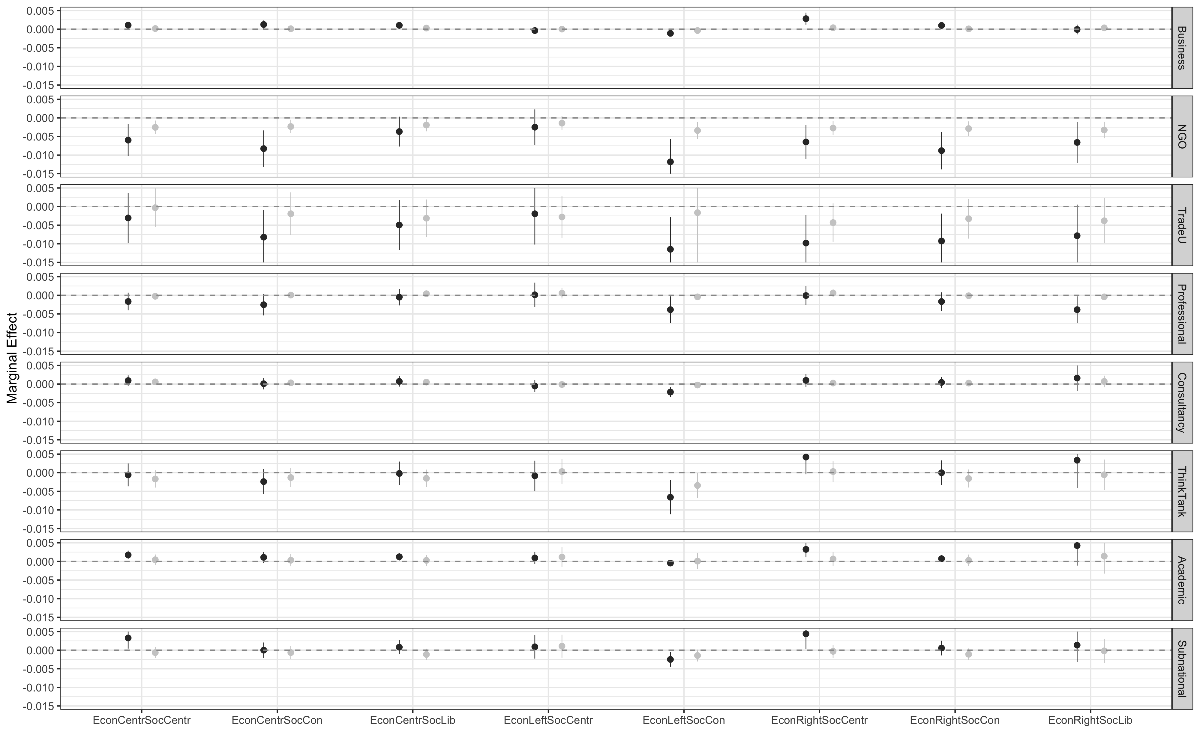
Note: Marginal effects. Reference category: economically and socially left MEP. 95% confidence intervals. Black dots: high-importance groups. Gray dots: low-prominence groups.

Figure 4: Effect of interest organization prominence and MEP’s economic and GALTAN ideology
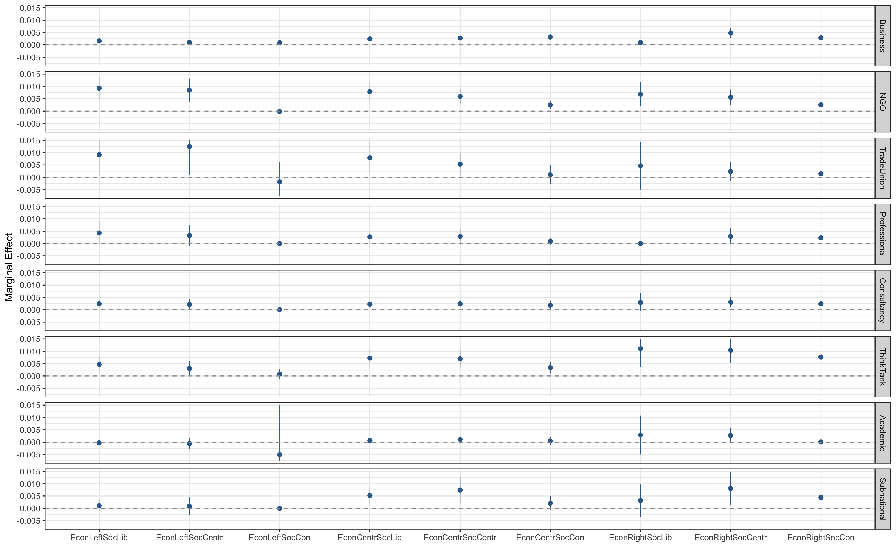

Note: Marginal effects. 95% confidence intervals.

