Online Appendix

Six scenarios of legislative oversight
This section elaborates on the institutional settings of the six scenarios of legislative oversight identified in Table 2. The effect of the four conditions listed in columns 2-5 is additive, meaning that their simultaneous presence increases the chances for one scenario to occur. The scenarios are described in order:
- Full control
The first scenario occurs when parliaments ask stronger questions as part of legislative oversight, requesting the executive to change its decisions or apply sanctions, while the executive answers through rectification, acknowledging that something needs to be changed or sanctions should be applied to the responsible parties (see Table 1). The scenario is expected in parliamentary systems (Table 2), where legislatures elect the cabinet and the composition of the government reflects parliamentary majorities – a feature generally perceived to increase the capacity for oversight (Pelizzo & Stapenhurst, 2012, p. 52)`. The assumption is that cabinets will be responsive to parliamentary majorities because they are in a direct principal-agent relationship (Strøm, 2000, p. 267). The likelihood for the first scenario to occur increases under conditions of a) high public pressure on an issue, b) multiple structural opportunities for legislative oversight (e.g. organisation of “Question Time” sessions, regular/inquiry committee hearings), c) strong parliamentary powers focused on ex ante and ex post control of the executive (e.g. Danish, Austrian, and Spanish parliaments), and d) the presence of single-party cabinets like in the United Kingdom (based on Martin, 2011; McCubbins & Schwartz, 1984; Ogul, 1976; Rockman, 1984; Russo & Wiberg, 2010; Sieberer, 2011; Wiberg & Koura, 1994).
- Answerability
The second scenario also occurs when parliaments ask stronger oversight questions, requesting executive actors to change their decisions or impose sanctions, but executive actors answer through justification rather than rectification, i.e. they focus on explaining their decisions or defending the conduct under scrutiny (Table 1). The scenario is expected in institutional contexts where the legislature constitutes an accountability forum for the executive but is not necessarily its direct principal (Bovens, 2007, p. 451). In fact, answerability is a core element in numerous definitions of accountability, captured in the ideas ‘to be called to account’ or ‘having to account to others’ (Bovens et al., 2014, p. 7; Mulgan, 2000, p. 555; Romzek & Dubnick, 1998, p. 6). Accordingly, the scenario can be encountered in parliamentary systems in the relationship between legislatures and bureaucracies or independent agencies; in presidential systems in the relationship between legislatures and cabinets; as well as in multi-level settings like the European Union (EU) – where supranational executive institutions are farther removed from the European Parliament or national parliaments (Bergman et al., 2006; Crum, 2018). In terms of likelihood of occurrence, Answerability is expected when a) public pressure on the executive actor is high, b) there are multiple structural opportunities facilitating legislative oversight, c) parliaments have strong powers to control the executive ex ante or ex post (as opposed to or next to law-marking powers), and d) the party system is conducive to single-party governments that are strongly connected to parliamentary majorities (based on Martin, 2011; McCubbins & Schwartz, 1984; Ogul, 1976; Rockman, 1984; Russo & Wiberg, 2010; Sieberer, 2011; Wiberg & Koura, 1994).
- Voluntary accountability
The third scenario occurs when parliaments ask weaker questions as part of legislative oversight, mostly requesting information and justification of conduct from bureaucracies and independent agencies (Table 1). These executive actors acknowledge on their own the need for rectification and promise to change problematic decisions or sanction individuals found responsible for past errors. The assumption is that bureaucracies and independent agencies suffer from a lack of ‘input legitimacy’ because they are not directly elected, i.e. they are non-majoritarian institutions (Thatcher & Sweet, 2002). Consequently, they can be expected to seek self-legitimation through voluntary means in any system of government (Table 2), but especially when dealing with politically salient issues (Koop, 2014; Schillemans & Busuioc, 2015). The third scenario is thus expected when a) public pressure on an issue is high, but otherwise there are b) fewer structural opportunities for legislative oversight, c) the parliament has strong law-making powers in a given institutional context (as opposed to strong elective and control powers over the executive), whereas d) the party system is conducive to coalition governments (based on Martin, 2011; McCubbins & Schwartz, 1984; Ogul, 1976; Rockman, 1984; Russo & Wiberg, 2010; Sieberer, 2011; Wiberg & Koura, 1994).
- Transparency
The fourth scenario occurs when parliaments ask weaker questions as part of legislative oversight, focusing on requests for information and justification of conduct from executive actors (Table 1). For their part, executive actors acknowledge the substance of questions and answer by justifying their decisions or defending the conduct under scrutiny. Similar to Answerability, this scenario is expected when legislatures and executive actors are not in a direct principal-agent relationship (Bovens, 2007, p. 451). Since parliaments cannot control governments by changing their composition (especially in the case of cabinets) or the legal framework in which they act (especially in the case of agencies or bureaucracies), the legislative-executive relationship focuses on transparency, i.e. the exchange of information between the two parties (Table 2). The scenario is more likely to be encountered when a) there is moderate public attention given to the issue or the executive actor under scrutiny, b) there are fewer structural opportunities for legislative oversight, while the institutional context is characterised by c) parliaments with strong law-making powers and d) a multi-party system conducive to coalition governments (based on Martin, 2011; McCubbins & Schwartz, 1984; Ogul, 1976; Rockman, 1984; Russo & Wiberg, 2010; Sieberer, 2011; Wiberg & Koura, 1994).
- Drift
The fifth scenario occurs when parliaments ask stronger oversight questions focused on changing decisions and imposing sanctions, to which executive actors respond through equivocation, evading or failing to address the substance of questions (Table 1). This scenario follows classical principal-agent expectations regarding legislative oversight, based on assumptions of asymmetric information between parliaments and government agencies with specialised knowledge, which can explain any question away regardless of the system of government (Lupia & McCubbins, 1994; Moe, 1984). Moreover, Drift is likely to occur in institutional contexts where executive decisions are taken collectively across different agencies or levels of government, thus opening the space for blame-shifting from one actor to another (Hobolt & Tilley, 2014; Hood, 2010). Legislative relationships with bureaucracies and specialised agencies are predicted to fulfil the criteria, as well as multi-level settings which mix decision-making competences, e.g. the EU (Table 2). Moreover, the scenario is expected under the following conditions: a) a moderate level of public pressure on the executive actor or the issue at stake; b) multiple structural opportunities for legislative oversight, c) strong parliamentary powers in respect to controlling the executive, and d) a party system conducive to single-party governments (based on Martin, 2011; McCubbins & Schwartz, 1984; Ogul, 1976; Rockman, 1984; Russo & Wiberg, 2010; Sieberer, 2011; Wiberg & Koura, 1994). The point here is that the legislature has both the means (structural opportunities, direct connections to the government) and the willingness to control the executive, but the latter fails to engage with oversight appropriately.
- Lack of control
The sixth and final scenario occurs when parliaments ask weaker oversight questions centred on access to information and justification of governing decisions. Yet executive actors equivocate even these questions, avoiding to answer or failing to substantively engage with the legislature (Table 1). Similar to Drift, this scenario is expected under conditions of asymmetric information and collective decision-making in various institutional settings (Hobolt & Tilley, 2014; Hood, 2010; Lupia & McCubbins, 1994; Moe, 1984). Relationships between parliaments and bureaucracies or specialised agencies fall in this category (Table 2) because the latter can exploit the legislature’s knowledge gaps and lack of time/attention to understand complex policy issues (Majone, 1999, pp. 3–4). Moreover, Lack of control is facilitated by: a) low levels of public pressure on the executive actor and the policy issues under its jurisdiction; b) fewer structural opportunities for legislative oversight, c) a parliamentary tradition focused on law-making rather than [s]election and control of the executive, and d) a multi-party system conducive to coalition governments (based on Martin, 2011; McCubbins & Schwartz, 1984; Ogul, 1976; Rockman, 1984; Russo & Wiberg, 2010; Sieberer, 2011; Wiberg & Koura, 1994). The point here is that parliaments lack both the means and willingness to ask strong oversight questions, while executives seek to obscure their conduct or shift responsibility to other actors.
From a normative perspective, the order of the scenarios is consistent with principal-agent expectations regarding the purpose of legislative oversight and accountability more generally, namely to ensure that agents are responsive to the principals that elected/appointed them (Przeworski et al., 1999). However, in some instances Answerability can be as important as Full control, depending on the specificities of the political and organisational setting under consideration (Dubnick, 2014, p. 33). For example, if governments are seen ‘to do a good job’, then the need for rectification will automatically be weaker than in contexts where executives deviate from legislative intent and hence have to be regularly ‘controlled’. Moreover, there is also the question whether rectification or executive responsiveness to legislatures is always desirable: for example, independent [regulatory] agencies were delegated to fulfil specific tasks not least in order to be insulated from political changes over time (Majone, 1999, pp. 13–14); in these cases, the justification of executive decisions might be more valuable than their rectification or appearing responsive to parliamentary pressure. The point is that researchers must decide on a case-by-case basis whether Full control or Answerability is the ‘best-case’ scenario in a given oversight context. For the case study in the article, Full control would have been unfeasible because the executive actor was a strongly independent central bank deliberately insulated from political influence.

Additional figures

European Parliament (EP) oversight of the European Central Bank (ECB): frequency of questions and answers over time

The data behind the figures is available in the Excel file part of the Online Appendix.
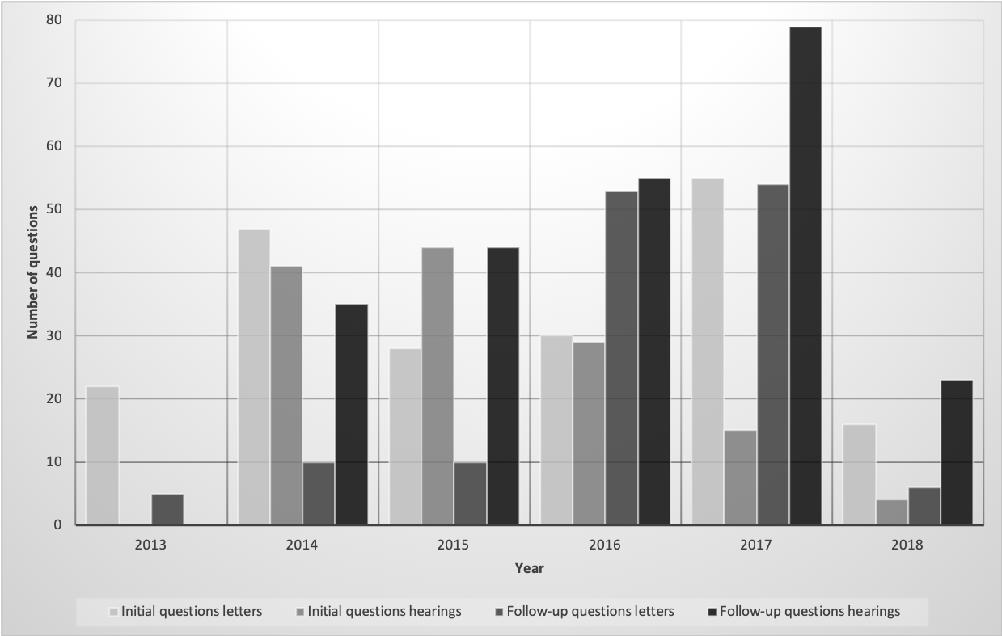
Figure A1: Types of questions per year addressed by Members of the European Parliament (MEPs) to the ECB in banking supervision, in letters and hearings (October 2013 to April 2018).

The most significant finding is the steady increase in the number of follow-up questions, parallel to the development of the SSM. In the first years (2013-2014), questions concerned the organisation of banking supervision in the euro area and the first ‘Comprehensive Assessment’ of the largest banks envisaged to be supervised directly by the ECB. As the complexity of SSM tasks increased, so did the interest of MEPs in specific issues, on which they could follow up. 2017 was a special year because in June the ECB declared three of the banks it supervises ‘failing or likely to fail’—using for the first time what is arguably the ultimate power of a bank supervisor (European Central Bank, 2018b, pp. 47–56). In November, the EP clashed with the ECB over its competence to set targets for banks for reducing ‘bad loans’ (European Central Bank, 2018a). Hearings in June and November 2017 were fierce, as suggested by the exponential increase of follow-up questions addressed orally.

Figure A2: Types of answers per year provided by the ECB to MEPs in banking supervision in both letters and hearings (October 2013-April 2018)

In respect to answers, there is no obvious pattern to explicit, intermediate, and non-replies, suggesting a consistent level of responsiveness from the ECB over time.

Codebook
Table of contents
III. Codebook 9
Introduction 9
Recognising a claim 10
Coding a claim 13
1. Year 14
2. Source 15
3. Claimant 15
4. Addressee 17
5. Issue 17
6. Initial question by legislative 19
7. Response by executive 21
8. Follow-up by legislative 25
Examples of coding 26
Example 1—written questionnaire 27
Example 2 – written question, written answer 28
Example 3 – hearing 29
References 44

Introduction
This is the methodological guide used for analysing questions and answers (Q&A) in the case of legislative oversight presented in the article. The guide loosely follows the template of the codebook provided by De Wilde and colleagues in their application of representative claim analysis in the research project ‘The Political Sociology of Cosmopolitanism and Communitarianism’ (De Wilde et al., 2014). The framework proposed in the article also uses claim analysis in order to identify and classify types of questions asked and answers provided in specific legislative oversight interactions. The classification is done manually by human coders and is thus both time- and labour-intensive (Slapin & Proksch, 2014, p. 128). For the purposes of replication, the following pages illustrate the coding process and discuss intercoder reliability.
The case study included in the article covered questions addressed by Members of the European Parliament (MEPs) to the European Central Bank (ECB) in the area of banking supervision between October 2013 and April 2018. The dataset comprises written questions identified in letters and oral questions asked during hearings with the head of the ECB in banking supervision—known as the ‘Chair of the Supervisory Board.’ Data was collected from the websites of the European Parliament (EP) and of ECB Banking Supervision (the official name of the institution).

Recognising a claim
The unit of analysis is the claim, which is a sentence or a set of sentences on a particular topic. Questions-as-claims include interrogative sentences and are often preceded by a short paragraph introducing the topic. Answers-as-claims typically include more sentences and can go on for paragraphs, elaborating on the topic.
The dataset compiled for the article consists of letters with written questions, written replies, and transcripts of public, hearings where oral questions were posed and answered. Here is an example of a question from a written letter:
‘6. How is the ECB planning to ensure that monetary and supervisory policy are strictly separated in terms of staff, reporting lines and career paths in the ECB?’ (Draghi, 2013)
The answer is comprehensive, as illustrated below:
‘To avoid any possible conflict of interest, the ECB is committed to strictly respect the principle of separation between monetary policy and banking supervision, as foreseen in the SSM Council Regulation. Such separation will ensure that the ECB will continue to fulfil its primary mandate of price stability in complete independence, in line with the Treaty. In line with the Regulation, work has started on drafting internal rules to ensure the separation, namely through measures combining organisational separation and the segregation of information flows.
Organisational separation will be applied both at the decision-making level and at staff level. An independent Supervisory Board - separate from the Governing Council - will be created to draft and enforce decisions. Its deliberations of the Governing Council on supervisory matters will be strictly separated, including separated agendas and meetings. At staff level, the four new directorates general and the Secretariat of the Supervisory Board which form part of the supervisory function will report to the Chair of the Supervisory Board.
Concerning the segregation of information flows, the ECB has experience in developing & delivering solutions that securely segregate information (e.g. to ensure the separation/Chinese wall between the ECB & ESRB related information). For the separation between monetary and supervisory policy, the ‘internal rules’ will draw in particular on (i) the ECB’s document & records management systems which provide security features (such as access groups/rights) to grant/restrict access to documents and folders, as well as (ii) the ECB’s Confidentiality Regime, which defines how to classify and handle sensitive ECB information.’ (Draghi, 2013)
A follow-up question was found in an oral hearing, when German MEP Sven Giegold—representing the Greens—asked the Chair of the Supervisory Board, Danièle Nouy:
‘Sven Giegold.- Welcome back Madame Nouy. Well, the discussion to charge the ECB with banking supervision was from the very beginning tainted with a lot of controversies and questions. We have taken that approach together with the Council, also because of the legal situation in the treaties, but we foresaw very clearly the separation between supervisory policy and monetary policy. And the regulation says very clearly that this should be done as far as possible. So I'd like to hear from you whether there were examples where the Governing Council of the ECB took over decisions and changed decisions which the supervisory arm has taken? Could you give us precise examples of what happened there and how your experience is?

The answer comes from Daniele Nouy, Chair of the Supervisory Board:
‘Danièle Nouy.- Regarding the separation principles - we now have full implementation of the principle, the decision has been fully taken by the Governing Council and, for example, access to information, cooperation or lack thereof between the different parts of the ECB. Regarding certain duties of the Supervisory Board - there was a discussion at the beginning of the comprehensive assessment whether it was preparatory work or already supervisory decisions. A number of lawyers carefully looked at the text; it was split, I must say, the feelings, almost equally between those saying it was supervision and it should only be non-objection procedure and those thinking that it was preparatory work so it had to be a normal procedure for the Governing Council taking the final decision. And this is what was decided: that the comprehensive assessment was preparatory work and, as a result, the Governing Council decided by normal procedure. In fact, it happened that what was methodology, fits very well in this distinction, but it was obvious that at the end of the exercise, the individual decisions and the outcome of the comprehensive assessment should be taken under non-objection procedure, which has been the case.’

The MEP follows up again, pushing for an answer:
‘Sven Giegold.- But do you feel comfortable with the interventions of the Governing Councils or members of the Governing Council? Is there too much intervention into your affairs as supervisor?’

And the answer comes immediately:
‘Danièle Nouy.- I have no particular problem on this side, no.’

The MEP did not push further on the topic, which suggests either that the answer was accepted, or that time was running out and Ms Nouy moved to other questions. From an empirical perspective, it is impossible to establish the ill-intent of responders, e.g. whether they do not want to say more on a topic so they address other question. Unless the question comes back in subsequent letters or hearings, the lack of follow-up is considered final.
In general, the identification of questions is facilitated visually by numbering and bullet points in the case of written questions, or by referring to them as such (‘my first question’, ‘my second question’) in the case of transcripts of hearings. The identification of answers is clear when marked correspondingly (‘in response to/in respect to/in reference to the/your first question’, ‘regarding the/your second question’). When such identifiers are missing, the coder needs to pay close attention to the content of the answer and recognise when the topic changes from one question to the next. To know whether a question is asked for the first time or it is a follow-up, the coder needs to keep track of the topics discussed in both letters and hearings. A question is considered a follow-up if it has been asked before, even if not by the same person.

Coding a claim
The claim analysis approach to legislative oversight is an adaptation of the method of political claims analysis developed by social movements scholars and later applied to politicisation research (De Wilde et al., 2014; Koopmans & Statham, 1999). Claims analysis is a form of qualitative content analysis which links actors to discourse: in a legislative oversight context, it allows the researcher to connect legislative and executive actors with the content of their interactions. Each time an actor asks a question or provides an answer, their claims are coded with variables inspired by the theoretical apparatus of the research programme (Figure 1 in the manuscript).
Accordingly, the claim analysis approach to legislative oversight directs attention to variables related to context, claimants, addressees, issues, and positions identified for I) initial questions, II) replies, and III) follow-ups, as envisaged in Figure 1. The table below provides a general overview of the core variables employed, which are detailed in the next pages.
Claim aspect | Core variables
WHEN | - Year
WHERE | - Source
WHO is making the claim? | - Claimant function  - Claimant nationality  - Claimant party
To WHOM is the claim addressed? | - Addressee function  - Addressee nationality  - Addressee party
To WHICH issue does the claim refer? | - Issue type  (dependent on policy area)
WHAT is the claimant demanding? (initial question by legislative actor) | - A. Demand information  - B. Demand justification of conduct  - C. Demand change of conduct  - D. Demand sanctions for actors  - E. Demand policy views (additional category, irrelevant for oversight)
HOW is the addressee responding? (response from executive actor) | - Explicit reply_Full answer_A.B.C.D.E.  - Non-reply_Equivocation_A.B.C.D.E  - Non-reply_Refuse to answer +reasoning_A.B.C.D.E  - Intermediate reply_Partial answer_A.B.C.D.E.  - Intermediate reply_Refer to another actor deemed responsible_A.B.C.D.E.
IS THERE a follow-up?  (by the legislative actor) | The absence of follow-up questions is a negative, so it cannot be demonstrated via the presence of claims. It thus makes more sense to count the overall instances of ‘observable’ follow-ups rather than try to trace the ‘unobservable’ lack of follow-up.  - Follow-up_Continue_A. demands for information  - Follow-up_Continue_B. demands for justification  - Follow-up_Continue_C. demands for change  - Follow-up_Continue_D. demands for sanctions  - Follow-up_Continue_E. demands for policy views

Year
The variable ‘Year’ is applied to individual documents where Q&A were found and not to the number of questions or answers per document. This allows the researcher to identify the frequency of the legislative oversight medium used (written letters, hearings) in addition to the number of questions addressed per year, which can be computed from each document.
Below is an example from the case study presented in the article:
Year_2014_Answer | Applied to documents containing written answers; code applied to the date of letters e.g. ‘Frankfurt, 3 November 2014.’
Year_2014_Question(s) | Applied to documents containing written questions; code applied to the title of documents, e.g. ‘Question for written answer Z-000019/2014 to the European Central Bank.’
Year_2014_Q&A | Applied to documents containing transcripts of hearings/meetings and questionnaires with Q&A; code applied to the date or title of the document, e.g. ‘Transcript Committee on Economic and Monetary Affairs (European Parliament), Public Hearing with Danièle Nouy, Chair of the Supervisory Board of the ECB Monday, 13 Jun 2016, 9.00 – 12.30.’

Source
The variable ‘Source’ refers to the source of the document including questions, answers, or both. In the case study presented, there were two possible sources:
Source_ECB website | Applied to documents retrieved from the official website of the European Central Bank; code applied to the signature of the letter, e.g. ‘Yours sincerely, [signed] Danièle Nouy.’
Source_EP website | Applied to documents retrieved from the official website of the European Parliament; code applied to the title of document, e.g. ‘Question for written answer Z-000014/2018 to the Chair of the Single Supervisory Mechanism Board.’

Claimant
The variable ‘Claimant’ applies to both legislative actors (in the case of questions) and executive actors (in the case of answers). The key sub-code here is ‘claimant function’, indicating the official title of the person/institutional body making the claim. When it comes to questions, claimants include individual members of parliaments, groups of members of parliaments, party factions in parliaments, parliamentary committees, chairs/leaders of committees and party groups, presidents/heads of chamber and any other variation of parliamentary functions. When it comes to answers, claimants consist of heads of government, ministers, state secretaries, heads of agencies/departments, and any other high-level government officials responsible for answering to questions from parliaments.
The case study presented in the article included the following claimants:
For questions
Claimant function_EP_ECON | Applied to questions asked collectively by the European Parliament’s (EP) Economic and Monetary Affairs Committee (ECON).
Claimant function_EP_MEP(s) | Applied to questions asked by individual or groups of Members of the European Parliament (MEPs).
Claimant function_EP_President | Applied to questions asked by the President of the European Parliament.
For answers
Claimant function_ECB _President | Applied to answers signed or provided orally by the President of the European Central Bank.
Claimant function_ECB_Chair of the Supervisory Board | Applied to answers signed or provided orally by the Chair of the Supervisory Board of the European Central Bank.
Claimant function_ECB_Vice-Chair of the Supervisory Board | Applied to answers signed or provided orally by the Vice-Chair of the Supervisory Board of the European Central Bank.
Furthermore, questions received coding related to the nationality and political affiliation of the members of parliament asking the question:
For questions
Claimant nationality_MEPs | Identified in the dataset, in alphabetical order:  - Austria, Belgium, Bulgaria, Cyprus, Czechia, Finland, France, Germany, Greece, Hungary, Ireland, Latvia, Malta, Netherlands, Poland, Portugal, Romania, Slovakia, Slovenia, Spain, Sweden, United Kingdom.
Claimant political group_MEPs | Identified in the dataset, in alphabetical order:  - ALDE (Group of the Alliance of Liberals and Democrats for Europe);  - ECR (European Conservatives and Reformists Group);  - EFDD (Europe of Freedom and Direct Democracy Group);  - ENF (Europe of Nations and Freedom);  - EPP (Group of the European People’s Party);  - Greens/EFA (The Greens-European Free Alliance);  - GUE-NGL (Confederal Group of the European United Left-Nordic Green Left);  - S&D (Group of the Progressive Alliance of Socialists and Democrats in the European Parliament.  - Non-affiliated members.  These correspond to the list of political groups in the EP’s 8th parliamentary term (2014–2019).
When it comes to answers, the categories ‘nationality’ and ‘political groups’ do not apply because ECB officials are technocrats appointed for longer time periods. Under the circumstances, only their function within the institution is relevant.

Addressee
The variable ‘Addressee’ corresponds to the ‘Claimant’, following an inverse logic: addressees of questions are the same executive actors coded as ‘claimants’ in the case of answers, while addressees of answers are the same parliamentary officials coded as ‘claimants’ in the case of questions.
For questions
Addressee function_ECB _President | Applied to questions addressed to the President of the European Central Bank.
Addressee function_ECB_Chair of the Supervisory Board | Applied to questions addressed to the Chair of the Supervisory Board of the European Central Bank.
Addressee function_ECB_Vice-Chair of the Supervisory Board | Applied to questions addressed to the Vice-Chair of the Supervisory Board of the European Central Bank.
For answers
Addressee function_EP_ECON | Applied to answers addressed to the European Parliament’s (EP) Economic and Monetary Affairs Committee (ECON).
Addressee function_EP_MEP(s) | Applied to answers addressed to individual or groups of Members of the European Parliament (MEPs).
Addressee function_EP _President | Applied to answers addressed to the President of the European Parliament.
Typically, the nationality and political affiliation of addressees is included in the analysis, but this is unnecessary here because only MEPs have a [relevant] nationality and political affiliation, and these were already coded under ‘claimant.’

Issue
The variable ‘Issue’ refers to specific policy areas in which legislative oversight can be exercised. Depending on the interest of the researcher, issues can be identified broadly (‘the economy’, ‘migration’, ‘defence’) or narrowly (‘financial stability’, ‘refugee relocation’, ‘EU army’ etc).
In the case study presented, the policy area is banking supervision, so codes were assigned to sub-issues inductively, as they came out of the analysis. The topics correspond to the mainstream issues in EU banking supervision in the period under focus, as follows:
For questions and answers
Issue_Comprehensive Assessment | Applied to Q&A on the topic of the 2014 comprehensive assessment, i.e. the initial ‘health check’ of 130 largest banks in the euro area. The comprehensive assessment was designed to facilitate the ECB takeover of banking supervision by providing a so-called asset quality review (AQR) and a stress test based on the methodology provided by the European Banking Authority (EBA).
Issue_Decision-making/Meetings | Applied to Q&A related to the decision-making process of the ECB or the institutional set-up for taking decisions in banking supervision.
Issue_ECB participation in international fora/external relations | Applied to Q&A related to the involvement of the ECB in international organisations/groups or relations with any other actors external to the EU.
Issue_Internal organisation | Applied to Q&A related to the internal organisation of EU banking supervision in terms of institutions, competences, staff, application of the principles of proportionality and subsidiarity etc.
Issue_Legislative/Policy proposals | Applied to Q&A related to any sort of proposal for a directive/regulation/recommendation/ECB policy in banking supervision that is at the time in the legislative process.
Issue_LSIs | Applied to Q&A related to ‘Less Significant Institutions’, i.e. smaller banks in the euro area that are supervised by National Competent Authorities (NCAs), with the ECB responsible for indirect supervision.
Issue_Manage capital shortfalls | Applied to Q&A related to the necessity of banks to manage capital shortfalls on their balance sheets. Often in conjunction with the code NPLs.
Issue_Mismanagement / money laundering / consumer protection | Applied to Q&A related to cases of mismanagement, money laundering, and consumer protection at specific banks. All financial crimes and corruptions cases signalled by MEPs fall in this category.
Issue_National discretions | Applied to Q&A related to the exercise of options and discretions (ODs) mentioned in the EU legislative framework in banking supervision.
Issue_NCAs | Applied to Q&A related to ‘National Competent Authorities’, i.e. national central banks or supervisors in charge of the supervision of LSIs.
Issue_NPLs | Applied to Q&A related to ‘Non-Performing Loans’, i.e. loans that are not being repaid, or ‘bad loans’, which feature prominently on balance sheets of banks.
Issue_Resolution/Likely-to-fail decision | Applied to Q&A related to supervisory decisions that banks are ‘failing or likely to fail’ (FOLTF) and subsequently need to be put into resolution. FOLTF is the classification used by supervisors for institutions that become non-viable. Resolution is the process of restructuring failing banks with minimum impact on the real economy and public finances. In the euro area, this is run 1) by the Single Resolution Board for SIs, and 2) by NCAs, national governments, and the European Commission for LSIs.
Issue_SIs | Applied to Q&A related to ‘Significant Institutions’, i.e. large banks in the euro under the direct supervision of the ECB.
Issue_Sovereign exposures | Applied to Q&A referring to sovereign exposures on the balance sheets of banks, including loans to states, local government and public-sector bodies (considered responsible for the sovereign debt crisis in the euro area).
Issue_Specific banks | Applied to Q&A that refer specifically to a bank or more banks supervised directly or indirectly by the ECB. Usually combined with other codes that denote the topic.
Issue_SREP | Applied to Q&A related to the ‘Supervisory Review and Evaluation Process’ organised by the ECB on a continuous basis. Each bank receives one SREP decision per year.

Initial question by legislative
The code ‘initial question’ applies to questions asked for the first time by legislative actors to members of the executive. In line with Figure 1, questions can be used to demand information, justification of decisions or conduct, change of decisions, and the application of sanctions. There is an additional category, labelled ‘demand policy views,’ which is considered outside the scope of legislative oversight because such questions do not contest anything about the decisions or conduct of executive actors. Requests for policy positions are part of the relationship between the legislative and the executive but do not involve the act of holding the latter accountable for past conduct (‘ex post accountability’). Instead, demands for policy views are forward-looking and thus belong to the category of ‘ex ante policy-making.’ At best, they can be used for future oversight. This line of thinking follows Mark Bovens, who argued that ‘for analytical purposes, policy making and accountability should be treated as distinctive concepts’ even though ‘the line between retrospective accounting and proactive policy making can be thin in practice’ (Bovens, 2007, p. 453).
A detailed overview of the various types of questions is provided below:
For questions asked for the first time
Initial question_A. Demand information | Applied to questions requesting transparency. Transparency refers to information regarding policy objectives, data used for making decisions, details about the content of measures taken, evidence of how decisions were implemented and their effect, but also information about the decision-making process, such as the general process of reaching a decision, minutes of deliberations, or voting records (Eijffinger & Geraats, 2006, pp. 3–5).  Examples: questions starting with ‘what’, ‘which’, ‘who’, ‘when’, ‘how many’, ‘how much’, ‘[how]will/does/has/did the ECB…’, ‘is the ECB aware…’, ‘can the ECB specify…’, and specific requests for examples or description of policies.
Initial question_B. Demand justification of conduct | Applied to questions requesting explanations for policy decisions or executive conduct.  Examples: questions starting with ‘why’, ‘how will/does/can the ECB ensure/guarantee’; ‘can the ECB explain…’, and any interrogative sentences that question ECB decisions on a specific topic, thus implying the need for justification.
● Initial question_C. Demand change of decisions / conduct | Applied to questions requesting a clear change in the decisions or conduct of the executive actor.  Examples: questions starting with ‘[can you please indicate] what steps/actions will the ECB take…’, ‘how does the ECB plan/intend to…’; ‘has the ECB envisaged the possibility to…’. Questions in this category are sometimes phrased as affirmative sentences, e.g. ‘I would urge you to take all steps in order to ensure…’.
● Initial question_D. Demand sanctions for actors | Applied to questions requesting sanctions for officials considered responsible for wrongdoing of any kind.  Examples: questions starting with ‘can the ECB detail/explain what actions it intends to take against…/it would impose on…’, ‘will the ECB consider conducting an investigation against…/be looking into…/examine…’, ‘will the ECB call for X to be removed…’.
Initial question_E. Demand policy views | Applied to questions outside the scope of oversight interactions because they do not involve an attempt by the legislative to hold the executive accountable.  Examples: questions starting with ‘does the ECB consider/believe/take the view/agree that…’ ‘what is the position of the ECB on…’ ‘would you conclude that further action by the legislator is necessary in this case?’

To apply the classification above, researchers need a basic understanding of the topic at hand in order to detect inappropriate, misdirected questions.

Response by executive
The category of codes referring to ‘replies’ applies to all answers provided by executive actors to members of the legislative in response to both initial and follow-up questions. The variation in the format for answers is much higher than in the case of questions. Answers can be short (a few sentences to one paragraph), medium (a few paragraphs), or long (a few pages of text, including graphs). Coders will assign categories to answers based on their content and not merely on the length of a reply.
As indicated in Figure 1, answers can be categorised as 1) explicit replies, 2) non-replies, or 3) intermediate replies. Explicit replies presuppose full engagement with the substance of the question. Non-replies signify evasion or a downright refusal to answer the question. Intermediate replies offer a partial response to the question or deny responsibility for the topic while at the same topic explaining which other actor is the appropriate addressee for the question. Each of these categories corresponds to the four types of questions identified, creating further sub-codes.
The table below lists the sub-codes used in the case study presented in the article:
For answers only
Explicit replies are answers that address a question head-on, without digressions or attempts at evasion. They are divided into subcategories:
- Response_Explicit_A. Full transparency | Applied to answers including concrete/extensive details about policy decisions or about the process through which a decision was taken.
- Response_Explicit_B. Provide justification of conduct/decisions | Applied to answers offering a comprehensive explanation of the rationale behind a certain decision or conduct.
- Response_Explicit_C. Accept change  - Response_Explicit_C. Defend decision | Applied to answers showing acceptance that a change is needed (‘C. Accept change’), or providing a clear defence of the conduct in question (‘C. Defend decision’).
- Response_Explicit_D. Accept sanctions  - Response_Explicit_D. Defend conduct  - Response_Explicit_D. Sanctions no longer necessary | Applied to answers showing acceptance that penalties are necessary (‘D. Accept sanctions’) or rejection of the necessity for sanctions (‘D. Reject sanctions’). In the case study presented, there were a few situations where sanctions were ‘no longer necessary’ because the person responsible had already left the position.
- Response_Explicit_E. Provide policy views | Applied to answers offering comprehensive policy views on the specific topic requested.
Non-replies are answers that completely fail to address the question through equivocation (evasion, lack of time) or by declining to answer on specific grounds (e.g. secrecy, national security, economic stability etc). Similar codes can be assigned in response to demands for information (A), justification (B), change of conduct (C), sanctions (D), or policy views (E).
• Response_Non-reply_A./B./C./D./E. Equivocation (evasion) | Applied to answers that are clear attempts to dodge the question through ‘equivocation (evasion)’—by pretending the question was not asked/understood and providing a different reply, by repeating an answer from before, or questioning the question.  There are no predetermined examples of how equivocation looks like. Generally, there is a clear mismatch between the question asked and the answer provided. However, to establish clearly whether a reply constitutes an evasion, the coder requires contextual information about the case (institutional organisation of oversight activities, executive practices of answering questions, policy jargon etc).
• Response_Non-reply_A./B./C./D./E. Equivocation (lack of time) | Applied to answers that failed to provide a reply because the time ran out in a hearing—another example of ‘equivocation.’ This is evident when one of the speakers mentions that they are out of time, or that the next question has to be addressed due to time pressure. Sometimes the answer is completely absent because there was a lengthy reply to a previous question.  Example: ‘Chair.- Thank you. We have to conclude here, there is no time anymore’ (ECON Committee, 2017).
• Response_Non-reply_A./B./C./D./E. Invoke secrecy (no answer) | Applied to replies that include downright refusals to answer for specific reasons—in this case by invoking confidentiality requirements in EU banking supervision: ‘invoke secrecy (no answer).’  Example:  ‘Please allow me to remind you that, as also laid down in the Inter-institutional Agreement, any reporting obligations vis-à-vis the European Parliament are subject to the relevant professional secrecy requirements. Therefore, the situation of and the supervisory measures taken with respect to an individual credit institution under ECB supervision can generally not be commented on’ (Nouy, 2016).
Intermediate replies lie in-between explicit and non-replies. They are not full answers engaging with the substance of a question but they acknowledge the question, and provide a partial response. They are divided into subcategories:
• Response_Intermediate_A./B. Invoke secrecy (general answer) | Applied to answers that start by mentioning confidentiality requirements and then offer general information (A) or justification (B) in response to the question asked.  Example: ‘Let me first clarify that individual supervisory actions cannot be publicly commented or disclosed. I can nevertheless inform you…[generic answer]’ (Nouy, 2015).
• Response_Intermediate_A. transparency  - Response_Intermediate_B. Partial justification | Applied to answers that offer an incomplete response, by providing some information about policy decisions and the process through which a decision was taken (‘partial transparency’), or an incomplete justification for a decision/conduct (‘partial justification’).  Coders will identify such answers when they see that a question has neither been fully addressed nor exactly dodged.
- Response_Intermediate_A. Promise to provide information in the future  - Response_Intermediate_B. Promise to provide justification in the future  - Response_Intermediate_C. Promise to change decisions/conduct in the future  - Response_Intermediate_D. Promise to impose sanctions in the future | Applied to answers that acknowledge the question and promise to provide an explicit reply in the future because the issue is still ongoing.  Coders will recognise such answers by the presence of future tense in the sentences, as claimants outline how (and when) they will address the substance of the question asked.
- Response_Intermediate_A./B/C./D.  /E. Refer question to diff actor deemed responsible | Applied to answers that acknowledge the question but explain why responsibility for the issue lies with another (executive) actor. These situations should be investigated further because they might include cases of blame-shifting or avoidance of oversight (Hood, 2010). If the question was indeed posed to an incorrect addressee, the reply is still considered ‘intermediate’ because the legislative does not receive a full response. However, the situation is not the fault of the executive actor under consideration.  Example: ‘As mentioned to you during my hearing at the ECON Committee on 19 June 2017, the ECB is not competent to supervise compliance with tax regulations. This responsibility resides with the relevant national competent authorities.’ (Nouy, 2017).
There is an additional code, complementary to the ones above, provided when the executive clarifies facts from questions:
- Response_Complementary_Clarify information from question | Applied to portions of answers in which the executive explicitly clarifies facts or information from questions. The implication is that the legislative actor had the facts wrong, which often invalidates the question. This code is used in addition to the others; it does not replace the categories of the claim analysis approach. However, it can signal problems on the side of the legislative in understanding the issues under discussion.

Follow-up by legislative
The code ‘follow-up’ applies to all questions whose exact topic has already been encountered in the coding. For this reason, coding has to be done chronologically, switching between written questions and hearings. At the same time, it is recommended that coding is done in monthly batches, without long breaks in-between, so that the topics covered are fresh in the mind of the coders. Moreover, when a follow-up question is identified in a different document, it is required to use the ‘comments’ section of the coding software in order to reference the document with the initial question. This way, follow-up questions can be cross-checked at a later point in time. The most obvious follow-up questions occur during hearings, when members of parliament ask multiple questions on the same topic, seeking to push the executive actor to provide full replies.
The coding for follow-up questions is identical to initial questions, as shown below:
For questions asked the second/third/fourth… time
Follow-up_Continue_A. demands for information | Applied to follow-up questions requesting information about policy decisions or about the process through which a decision was taken.  Examples: questions starting with ‘what’, ‘which’, ‘who’, ‘when’, ‘how many’, ‘how much’, ‘[how]will/does/has/did the ECB…’, ‘is the ECB aware…’, ‘can the ECB specify…’, and specific requests for examples or description of policies.
Follow-up_Continue_B. demands for justification | Applied to follow-up questions requesting an explanation for policy decisions or executive conduct.  Examples: questions starting with ‘why’, ‘how will/does/can the ECB ensure/guarantee/does’; ‘can the ECB explain…’, and any interrogative sentences that question ECB decisions on a specific topic, thus implying the need for justification.
Follow-up_Continue_C. demands for change of decisions/conduct | Applied to follow-up questions requesting a clear change in the decisions or conduct of the executive actor.  Examples: questions starting with ‘[can you please indicate] what steps/actions will the ECB take…’, ‘how does the ECB plan/intend to…’; ‘has the ECB envisaged the possibility to…’. Questions in this category are sometimes phrased as affirmative sentences, e.g. ‘I would urge you to take all steps in order to ensure…’.
Follow-up_Continue_D. demands for sanctions | Applied to follow-up questions requesting sanctions for officials considered responsible for wrongdoing of any kind.  Examples: questions starting with ‘can the ECB detail/explain what actions it intends to take against…/it would impose on…’, ‘will the ECB consider conducting an investigation against…/be looking into…/examine…’, ‘will the ECB call for X to be removed…’
Follow-up_Continue_E. demands for policy views | Applied to follow-up questions outside the scope of oversight interactions because they do not contest anything about the decisions or conduct of executive actors.  Examples: questions starting with ‘does the ECB consider/believe/take the view/agree that…’ ‘what is the position of the ECB on…’ ‘would you conclude that further action by the legislator is necessary in this case?’

Examples of coding
The case study presented in the article was analysed using the software ATLAS.ti. For the purposes of illustration, a few examples of the coding are provided below, using snapshots from the software:

Example 1—written questionnaire
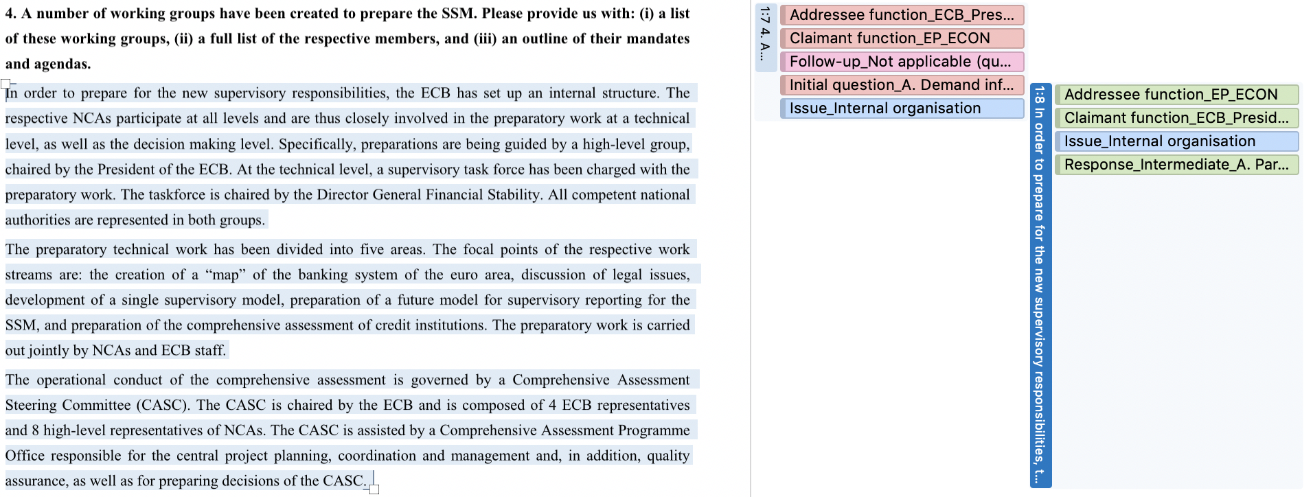
Source: (Draghi, 2013)

First, there is a questionnaire sent by the ECON Committee to the ECB in the initial phase of organising banking supervision in the euro area through the Single Supervisory Mechanism (SSM). The question is coded as an ‘Initial question_A. Demand for information’, while the reply is classified as ‘Response_Intermediate_A.Partial transparency’ because the answer refers to structures of decision-making and is incomplete, keeping in mind that point (ii) is not addressed at all. The issue is ‘Internal organisation’ in both instances, while the claimants and the addressees are coded in line with the authors of the letters. The additional code ‘Follow-up_Not applicable’ for the question means that the question has been asked for the first time, so there cannot be any follow-up.

Example 2 – written question, written answer
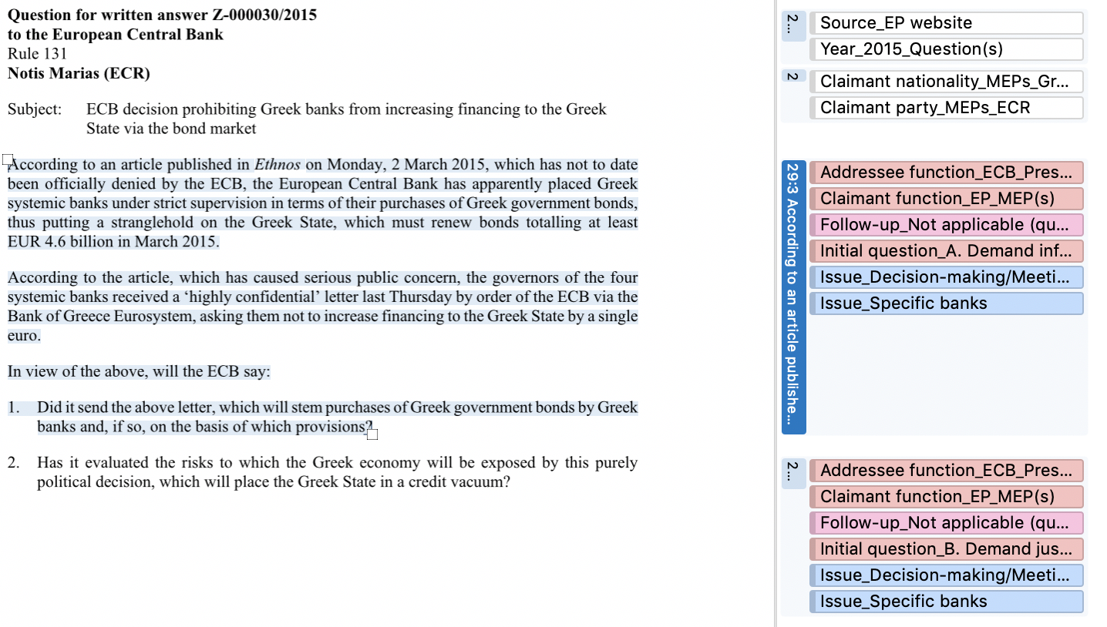
Source: (Marias, 2015)

The letter from Greek MEP Notis Maris is a typical example of how written questions are posed to the ECB. The topic of questions is first introduced, and then followed by interrogative sentences. The purpose of the letter is 1) to confirm a fact mentioned in the media (hence the code ‘Initial question_A. Demand information), and if the fact is correct, 2) to contest the decision by asking whether the ECB has evaluated its risks (‘Initial question_B_Demand justification’). The letter refers to four big systemic banks in Greece (coded as ‘Issue_Specific banks’) and refers to internal decision-making by the ECB to send letters to the banks (coded as Issue_Decision-making_Meetings). The document was additionally coded with information regarding the source (EP website), the year when it was sent (2015), and the attributes of the claimant (nationality, political affiliation).
To illustrate the parallel with replies, the answer is included below:
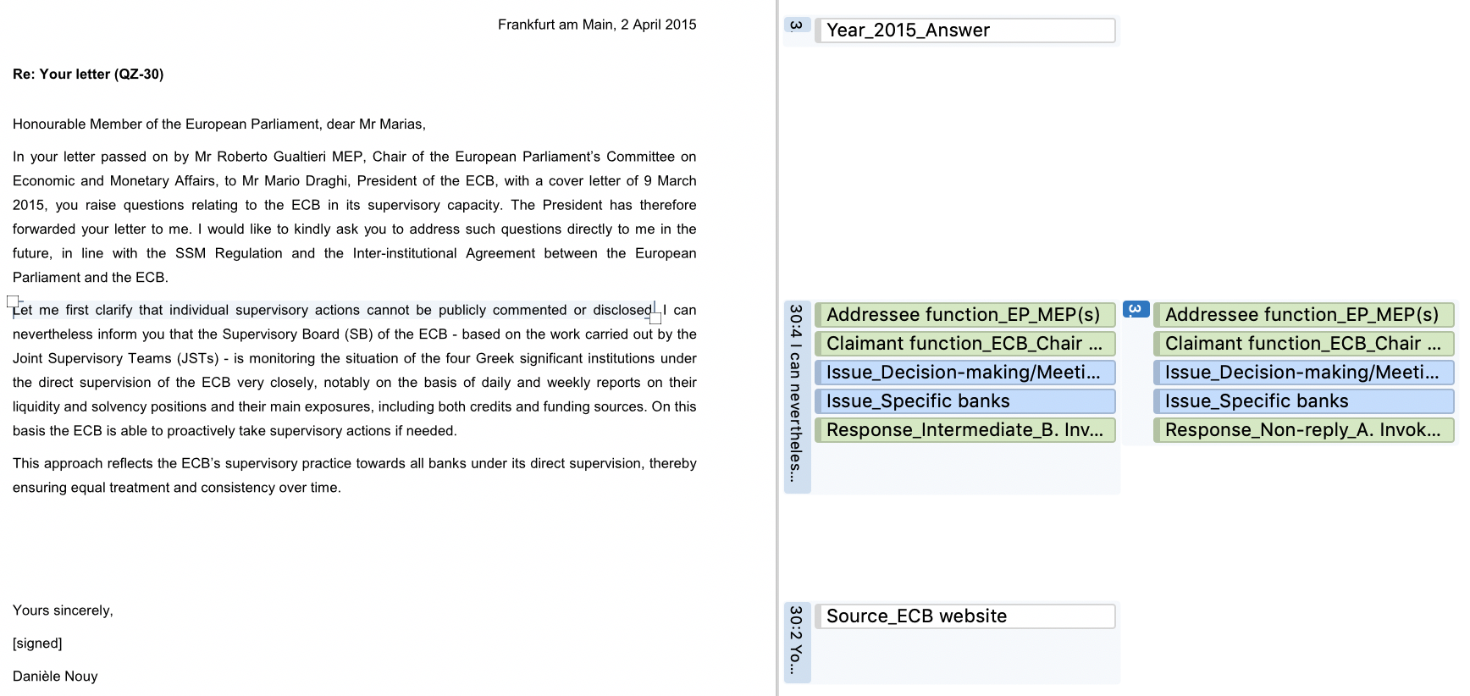
Source: (Nouy, 2015)

The reply of the Chair of the Supervisory Board Danièle Nouy is short. The first question, seeking to confirm a fact, is not answered on grounds of confidentiality—‘Response_Non-reply_A. Invoke secrecy (no answer).’ The second question gets a generic response, explaining that the ECB treats all banks equally, which is why it was assigned the code ‘Response_Intermediate_B_Invoke secrecy (general answer).’ In addition, the replies have corresponding codes for Addressees, Claimants, and Issues. Finally, the document includes the standard identifiers (Source, Year).

Example 3 – hearing
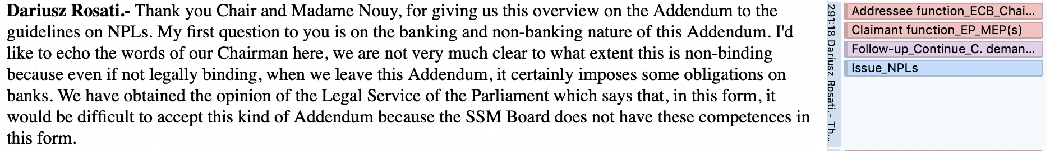
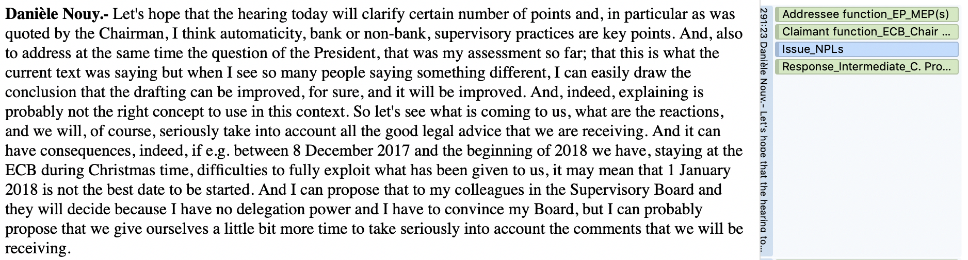
Source: (ECON Committee, 2017)

This is a short excerpt from the public hearing with the Chair of the Supervisory Board which took place on 9 November 2017 at the ECON Committee. Polish MEP Dariusz Rosati (from the European People’s Party) is following up on the remarks of the committee chairman to contest a recent ECB policy, namely the draft Addendum to the ECB Guidance on non-performing loans (NPLs), as overstepping the institution’s mandate. Although there is no interrogative sentence in the paragraph, the implication is clear: the MEP is asking for a change in the Addendum because it would impose additional obligations on banks. The reply of the Chair of the Supervisory Board Danièle Nouy is to acknowledge that changes will have to be made to the addendum in the future by ‘seriously taking into account all the good legal advice’ received. Since this is not a definitive acceptance of the specific request made by the MEP, the answer was coded as ‘Response_Intermediate_C. Promise to change decisions/conduct in the future.’ The issue under consideration is NPLs, and the claimants and the addressees were categorised accordingly.

IV. Intercoder Reliability Check
In qualitative content analysis, reliability is essential to ensure the trustworthiness of data, namely if different researchers in different environments would understand and code segments of text in a similar way (Lombard et al., 2002). For the purposes of replicability, two or more independent coders need to systematically agree on the interpretation of textual data, in line with coding instructions clearly communicated in advance (Krippendorff, 2012, p. 212). For the framework discussed in this article, reliability requires at least two people applying the codebook of the Q&A approach to legislative oversight and being able to state with confidence that there is no substantial disagreement between coders regarding the results.
To perform the intercoder reliability check, a second coder was assigned a sample of documents and given the codebook presented above. The second coder is a research associate with a similar disciplinary background as the first coder, but without any specialised knowledge of the EU or banking supervision. The codebook and the use of the software ATLAS.ti were thoroughly explained before the second coder started the work. A sample of 52 documents was extracted from the total 296 documents uploaded to ATLAS.ti. 50 documents consisted of written letters, while 2 documents were transcripts of hearings. The letters were randomly selected based on the order of documents uploaded to ATLAS.ti. Within the software, the order of letters is mostly chronological, with a few exceptions caused by the later addition of relevant material. To allow the analysis of Q&A, each letter selected was retrieved together with its corresponding question(s)/answer(s). In the case of hearings, stratified sampling was used, selecting one hearing on the annual report (2015) to cover the early period (when the ECB had just taken over banking supervision), and one ordinary hearing (2017) from the later years (when banking supervision at the ECB had already been institutionalised). Since the sample includes only a selection of the database (18,91% of the total), the second coder could not know if a question was asked before and thus constitutes a follow-up. To help the process, each document included a comment pointing to questions that had been asked before but were excluded from the sample.
The latest version of the software ATLAS.ti includes its own intercoder reliability tool developed in cooperation with Klaus Krippendorff, one of the leading experts in the field of intercoder reliability (Friese, 2019, p. 129). The software uses the term Inter-coder Agreement (ICA) rather than intercoder reliability, making a distinction between ‘what we measure’ and ‘what we wish to infer from it’ (Friese, 2019, p. 130). Accordingly, categories of codes correspond to ‘semantic domains’ made of sub-codes which can be grouped together. For example, in the framework presented in the article, a semantic domain is ‘Claimant function,’ while the sub-codes associated with it designate specific functions of the claimants (e.g. MEP, ECB Chair of the Supervisory Board etc). For questions, initial questions are distinguished from follow-up questions, while answers are divided into three semantic domains applicable to non-replies, intermediate replies, and explicit replies. Furthermore, the latest version of ATLAS.ti automatically calculates ICA coefficients, described as follows:
Coefficient type calculated in ATLAS.ti | Description
Percentage Agreement | calculates ‘the number of times a set of ratings agree, divided by the total number of units of observation that are rated, multiplied by 100.’
Krippendorff's c-Alpha binary | shows the extent to which coders agree on the relevance of texts (whether coders identify similar or the same segments of text for a code).
Krippendorff's cu-Alpha coefficient | indicates the degree to which coders identify a particular semantic domain
Krippendorff's Cu-Alpha coefficient with a capital C | indicates the extent to which coders agree on the presence or absence of semantic domains
Source: (Friese, 2019, pp. 134–136)
There are caveats to each of these coefficients. On the one hand, the percentage agreement does not take into account chance agreement between ratings, so it is not a reliable indicator of reliability. On the other hand, all of Krippendorff's alpha coefficients require that codes have been applied in a mutually exclusive manner—meaning only one of the sub-codes per domain is applied to a given quotation. In the case of Q&A, this is not possible; in certain situations, a short response given to multiple questions has to be coded as non-replies, which means that several sub-codes per domain may be overlapping. To mitigate the problem, the summary below presents not only the numerical results of the ICA coefficients, but it also displays visually the continuum of how the two coders assigned a specific code throughout the documents (possible via screenshots from ATLAS.ti). The overview is presented below:

Semantic domain/code category  (sub-codes cumulated) | Simple percentage agreement | Krippendorff’s cu-α/Cu-α* | Krippendorff’s c-α binary
Year  (applied to single documents) | 99.0% | 1.000 (Cu-α) | 0.995
Source  (applied to single documents) | 98.9% | 1.000 (cu-α) | 0.994
Claimant function  (applied to Q&A) | 95.0% | 0.940 (Cu-α) | 0.904
Claimant nationality  (applied to Q) | 98.9% | 1.000 (cu-α) | 0.995
Claimant party  (applied to Q) | 97.6% | 0.984 (cu-α) | 0.995
Addressee function  (applied to Q&A) | 95.4% | 0.995 (Cu-α) | 0.904
Issue  (applied to Q&A) | 82.3% | 0.792 (Cu-α) | 0.904
Initial question  (applied to Q) | 71.8% | 0.771 (cu-α) | 0.909
Response_Explicit  (applied to A) | 78.8% | 0.769 (Cu-α) | 0.909
Response_Intermediate  (applied to A) | 76.8% | 0.858 (Cu-α) | 0.906
Response_Non-reply  (applied to A) | 78.3% | 0.874 (Cu-α) | 0.928
Follow-up_Continue demands (applied to Q) | 81.2% | 0.884 (cu-α) | 0.927
*For some semantic domains, the cu-α could not be calculated because the sub-codes were not mutually exclusive. This is especially common in answers that respond to multiple questions evasively; several codes are assigned to the same quotation. To guarantee the accuracy of the results, the calculation of Cu-α was applied only within semantic domains and not to all codes together. This ensured that where applicable, cu-⍺=Cu-⍺.

First, we can observe very high values for the ICA coefficients in the case of descriptive variables: the year, source, claimant nationality, and claimant party. This is to be expected, since these variables are about fact-checking. Moreover, we also see high values for ‘claimant function’ and ‘addressee function’, meaning that the text that corresponds to questions and those that corresponds to answers is unambiguous within the documents. Indeed, Q&A come in separate documents and are marked visually by numbering or verbal descriptors, e.g. ‘my first question…’, ‘with regard to your second question…’, etc.
What is subject to interpretation are the variables ‘issue’ and the substantive classification of Q&A according to the claim analysis approach. The table below illustrates the number of agreements between coders on each category:
Semantic domains/code groupings  (all sub-codes cumulated) | Number of codes  applied to |  | Units of text*** applied to
Semantic domains/code groupings  (all sub-codes cumulated) | By Coder 1 | By Coder 2 | By Coder 1 | By Coder 2
Year* | 52 | 52 | 3529 | 3500
Source* | 52 | 52 | 3539 | 3504
Claimant function | 256 | 258 | 231810 | 229158
Claimant nationality** | 67 | 67 | 1518 | 1512
Claimant party** | 67 | 67 | 1518 | 1512
Addressee function | 256 | 258 | 231810 | 229158
Issue | 362 | 417 | 333712 | 375425
Initial question | 59 | 61 | 31156 | 29951
Response_Explicit | 78 | 80 | 101170 | 102228
Response_Intermediate | 32 | 31 | 33667 | 33510
Response_Non-reply | 17 | 18 | 15511 | 14813
Follow-up_continue demands | 70 | 67 | 50306 | 48216
*codes applied once per document.
**MEPs are only counted once, regardless of how many questions they ask in a letter/at a time in a hearing.
***In ATLAS.ti, one document constitutes a textual continuum in which each character of the text is a unit of analysis; multiple documents extend the size of the continuum. For this reasons, units of analysis frequently reach the range of thousands.

In terms of the number of agreements between coders, what we see is a high level of overlap, suggesting that the two coders understood the text in a similar way. The largest disparity between coders is visible for the variable ‘issue’, as coder 2 has assigned 55 more codes than Coder 1. The codebook mentions that the variable ‘issue’ can be applied multiple times to the same claim, as a question/answer can have several topics. It is obvious that coder 2 had a much broader understanding of topics than coder 1, which is probably the result of the lack of specialised knowledge about banking supervision. However, this is not considered a problem because the main goal of the claim analysis approach is not to capture the precise distribution of topics discussed in Q&A, but to establish the relevance of questions and the degree to which they are answered by executive actors.
Accordingly, what is more important is the value of coefficients for the variables ‘Initial question’, ‘Follow-up question’ and the different types of responses. Given the higher scope for interpretation, values here are lower, but they still score over 0.700 for Krippendorff's cu-α/Cu-α, which suggests the coding is reliable. The only limitation is the size of the sample, which might signal a Type 1 error, i.e. accepting data as reliable without this being the case (Friese, 2019, p. 137). To demonstrate the reliability of the coding under the circumstances, the next pages include screenshots of ATLAS.ti results, which illustrate the overlap between the two coders for each individual sub-code. Coder 1 is marked in red, coder 2 in yellow.

Year of documents (applied once per document)
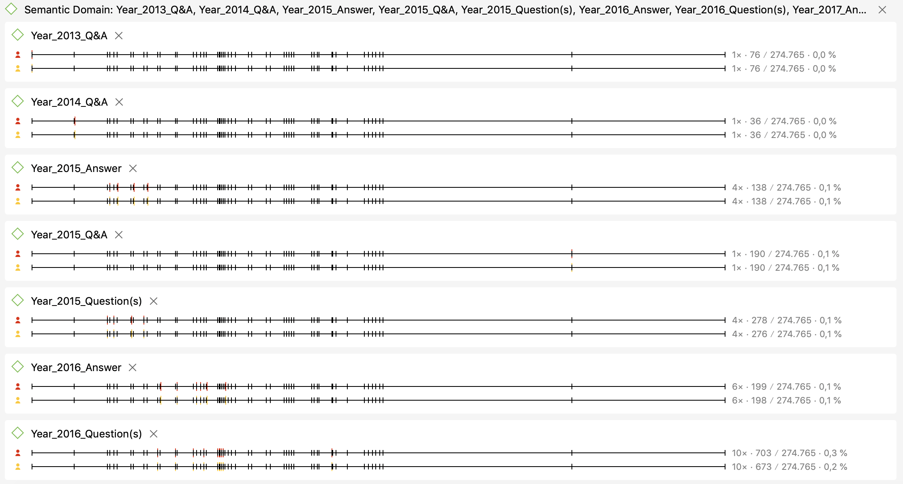
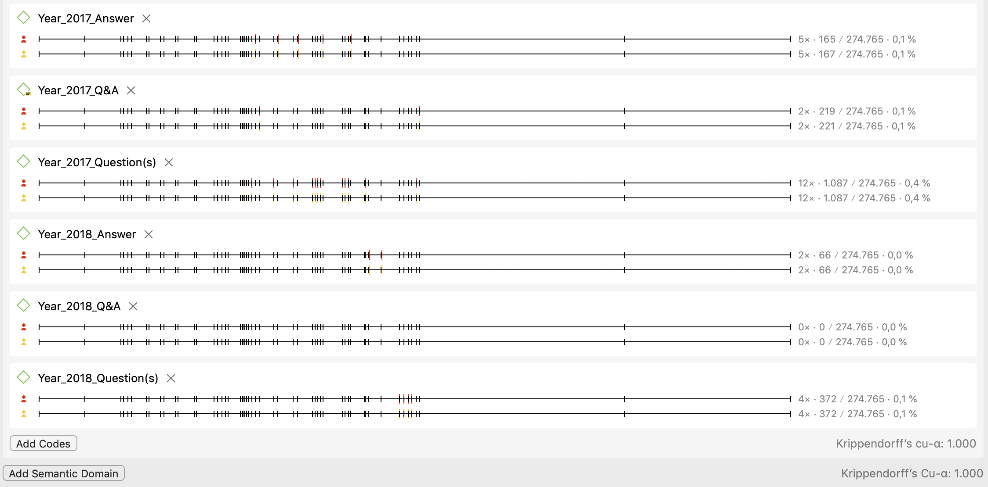

Source of documents (applied once per document)
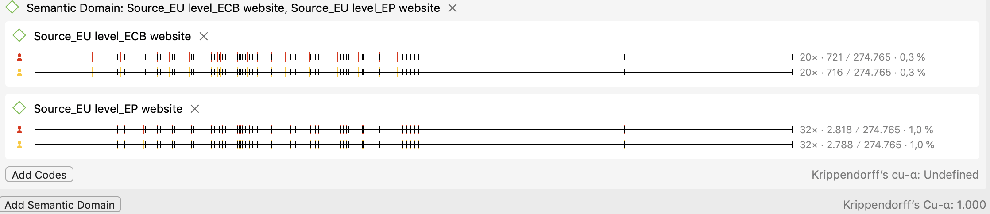
Claimant function
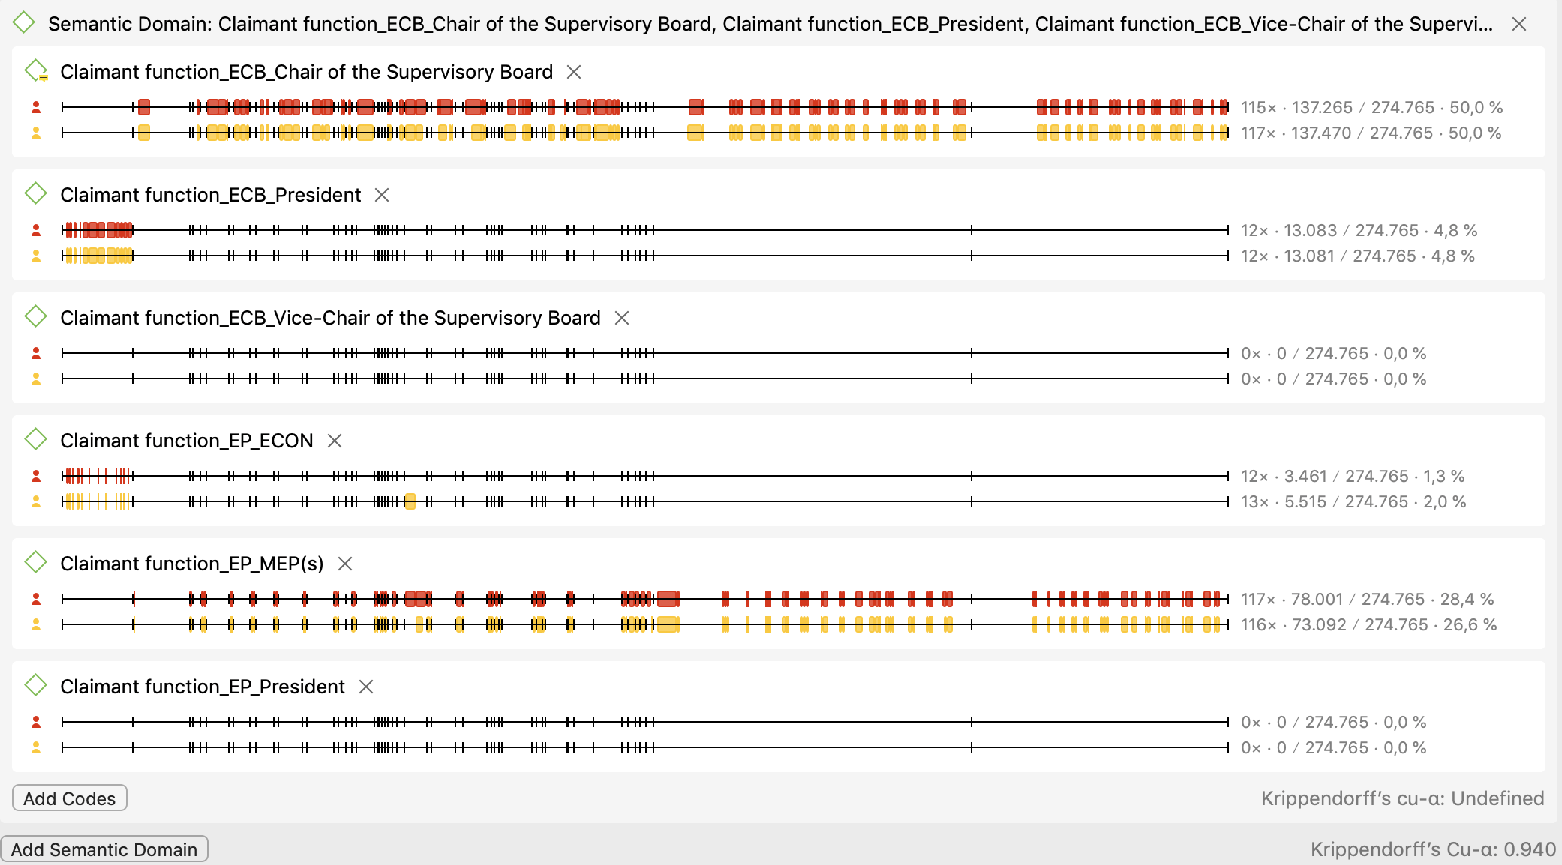

Claimant nationality (only results different from 0 for both coders)
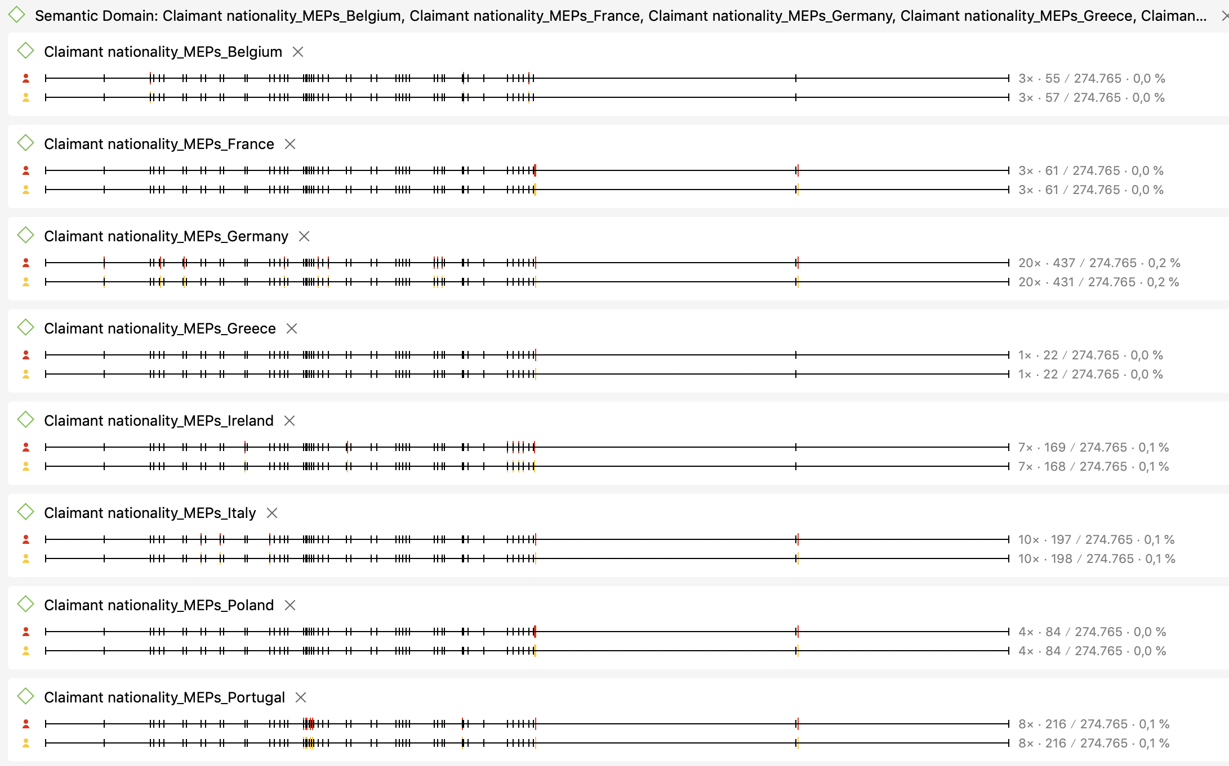
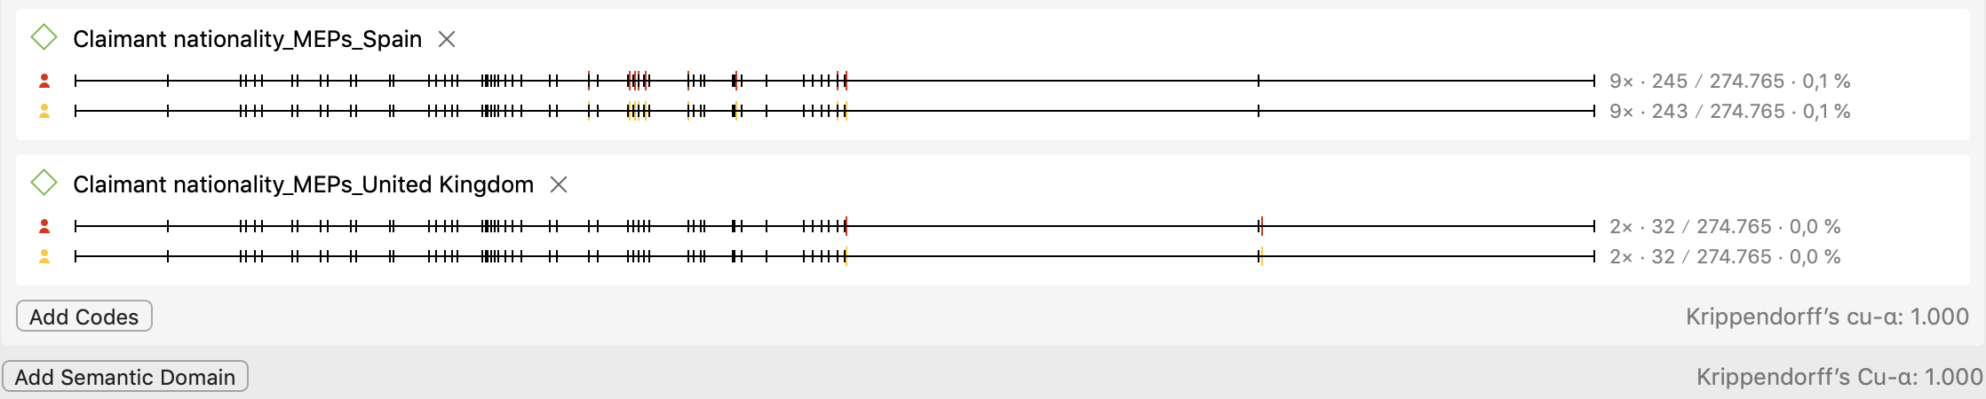

Claimant party
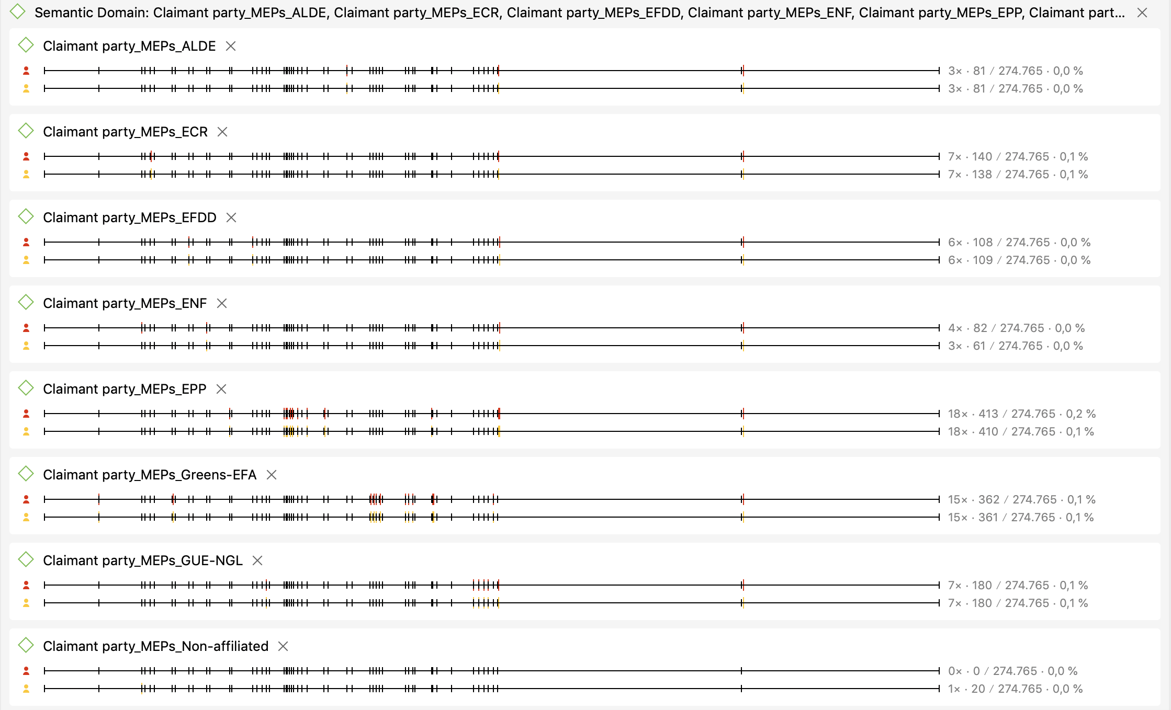
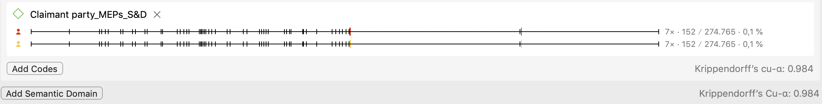

Addressee function
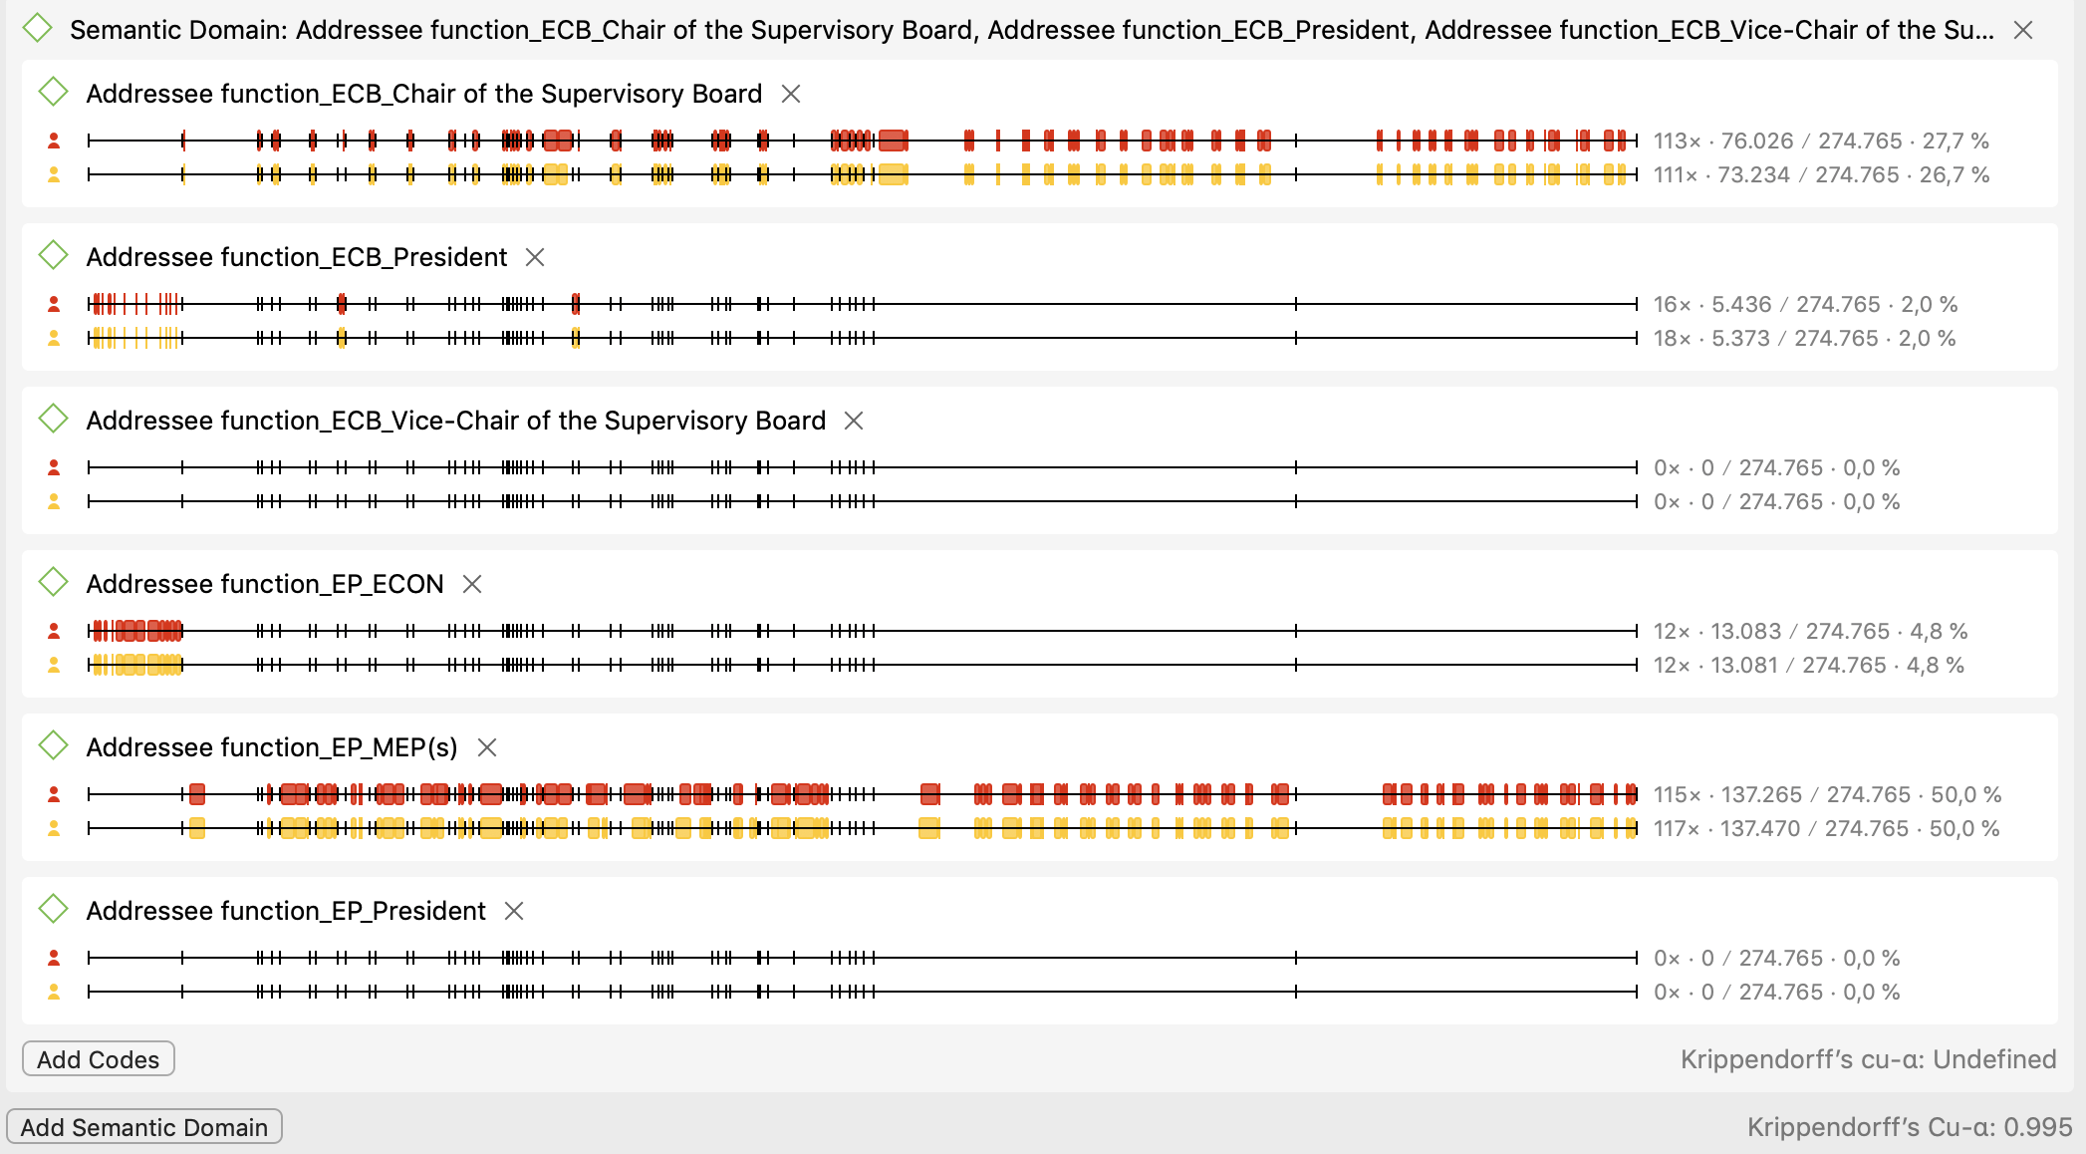

Issue
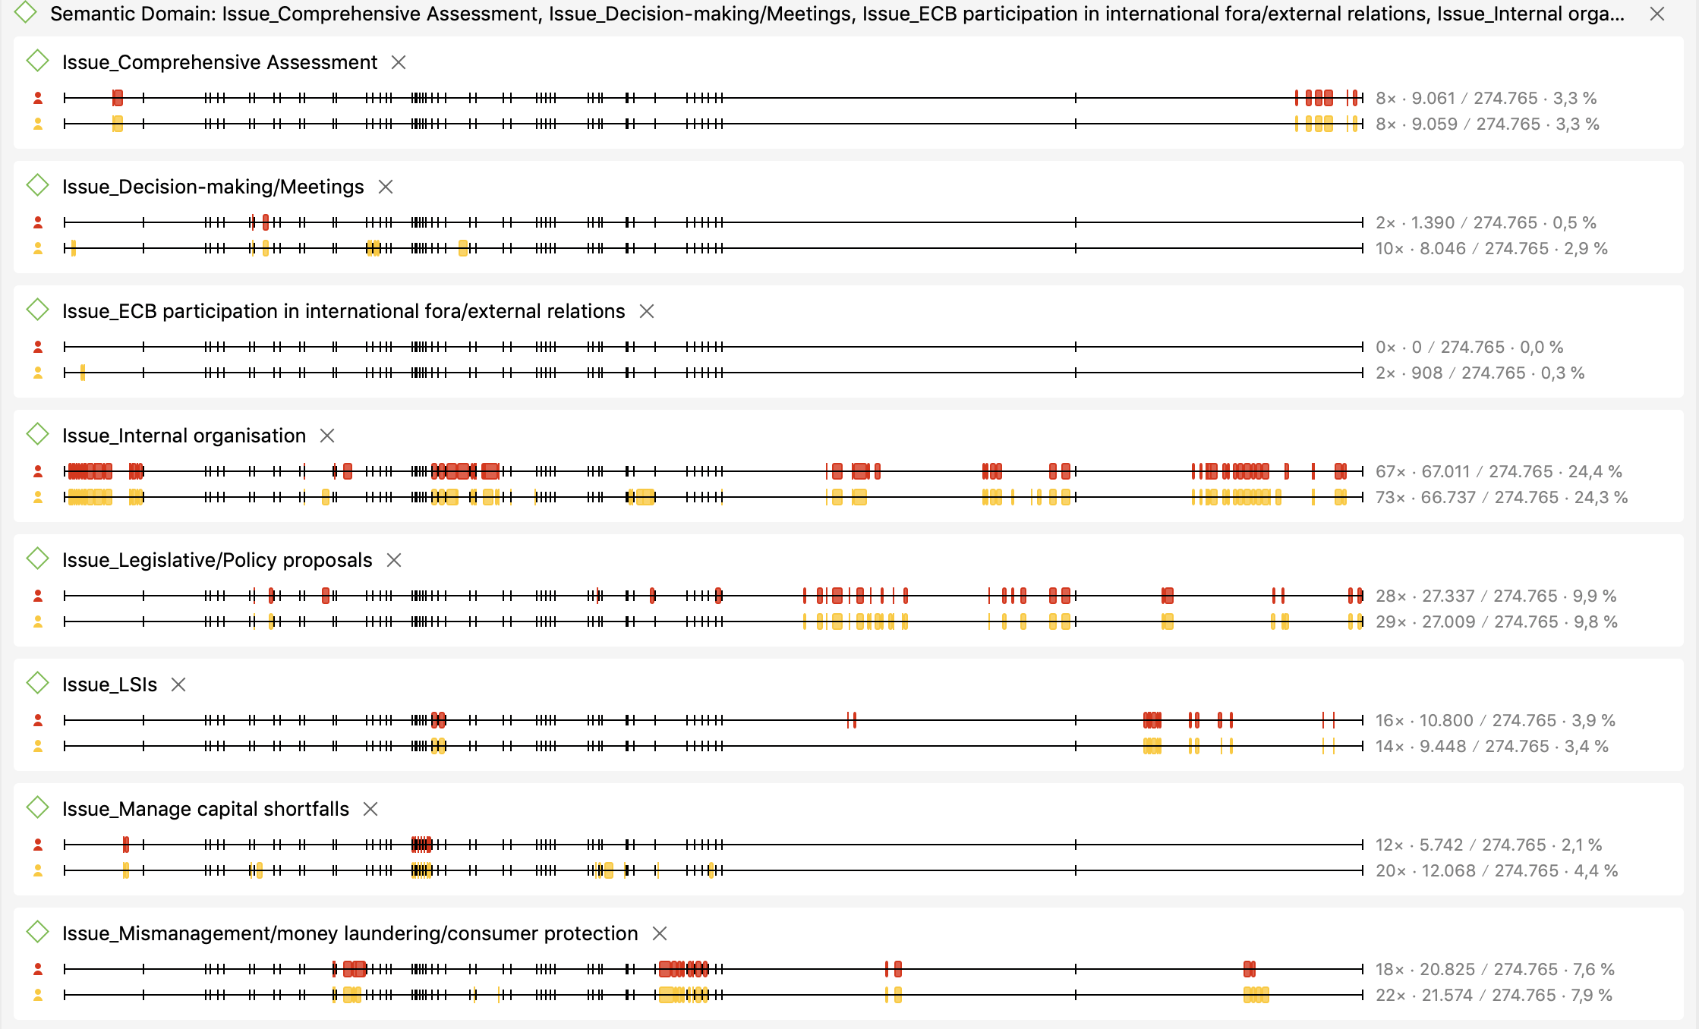
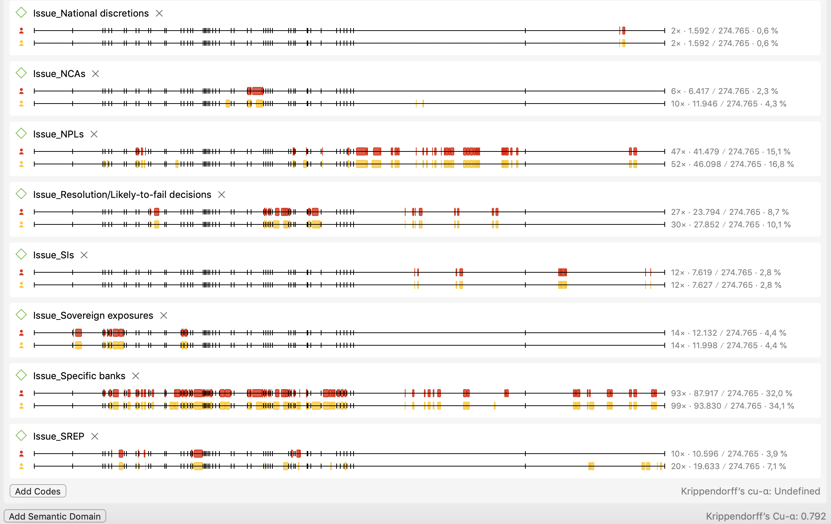

Initial question
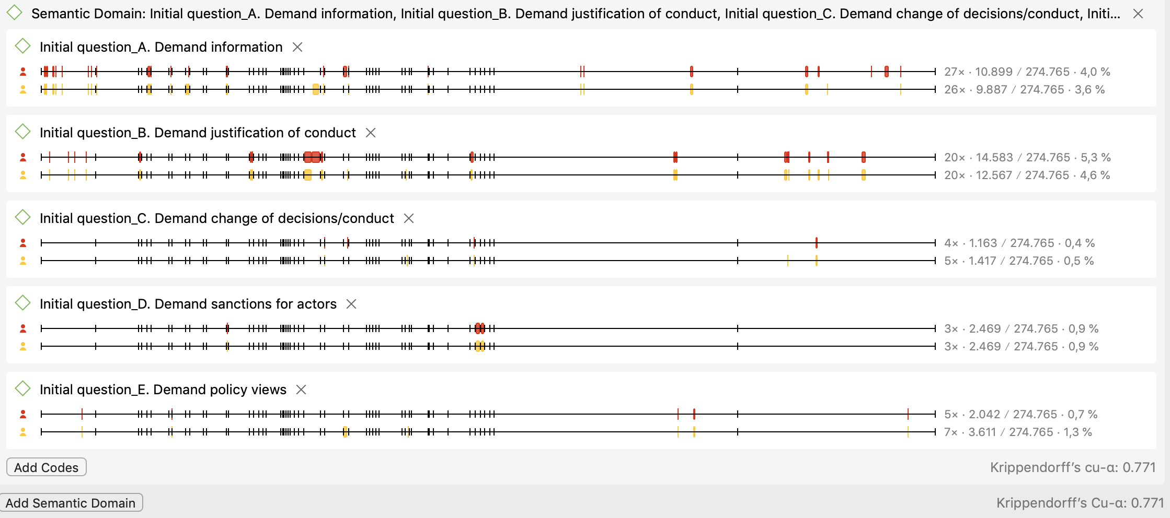

Response_explicit
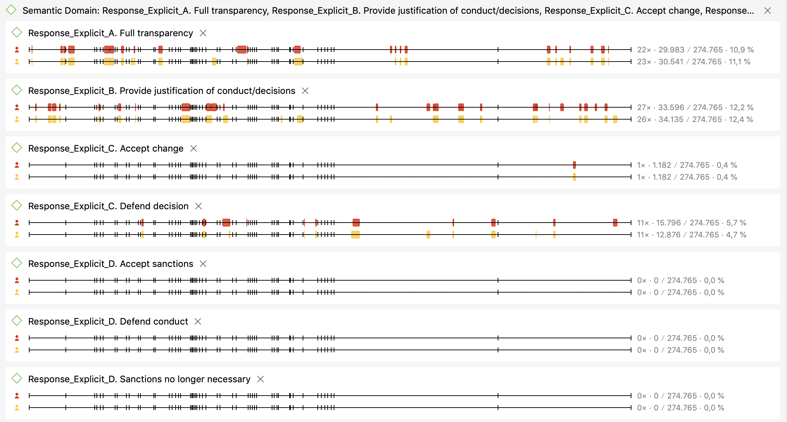
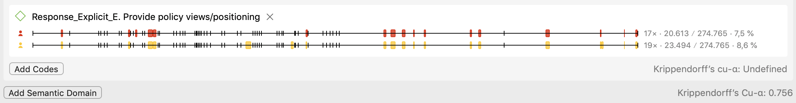

Response_intermediate
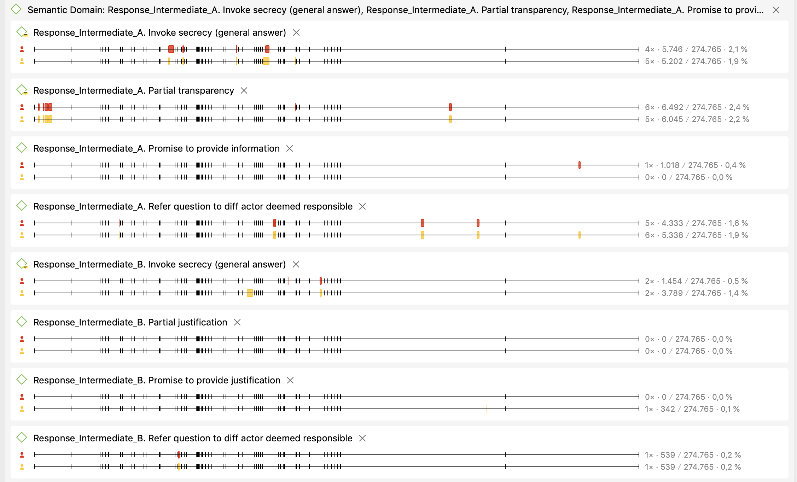
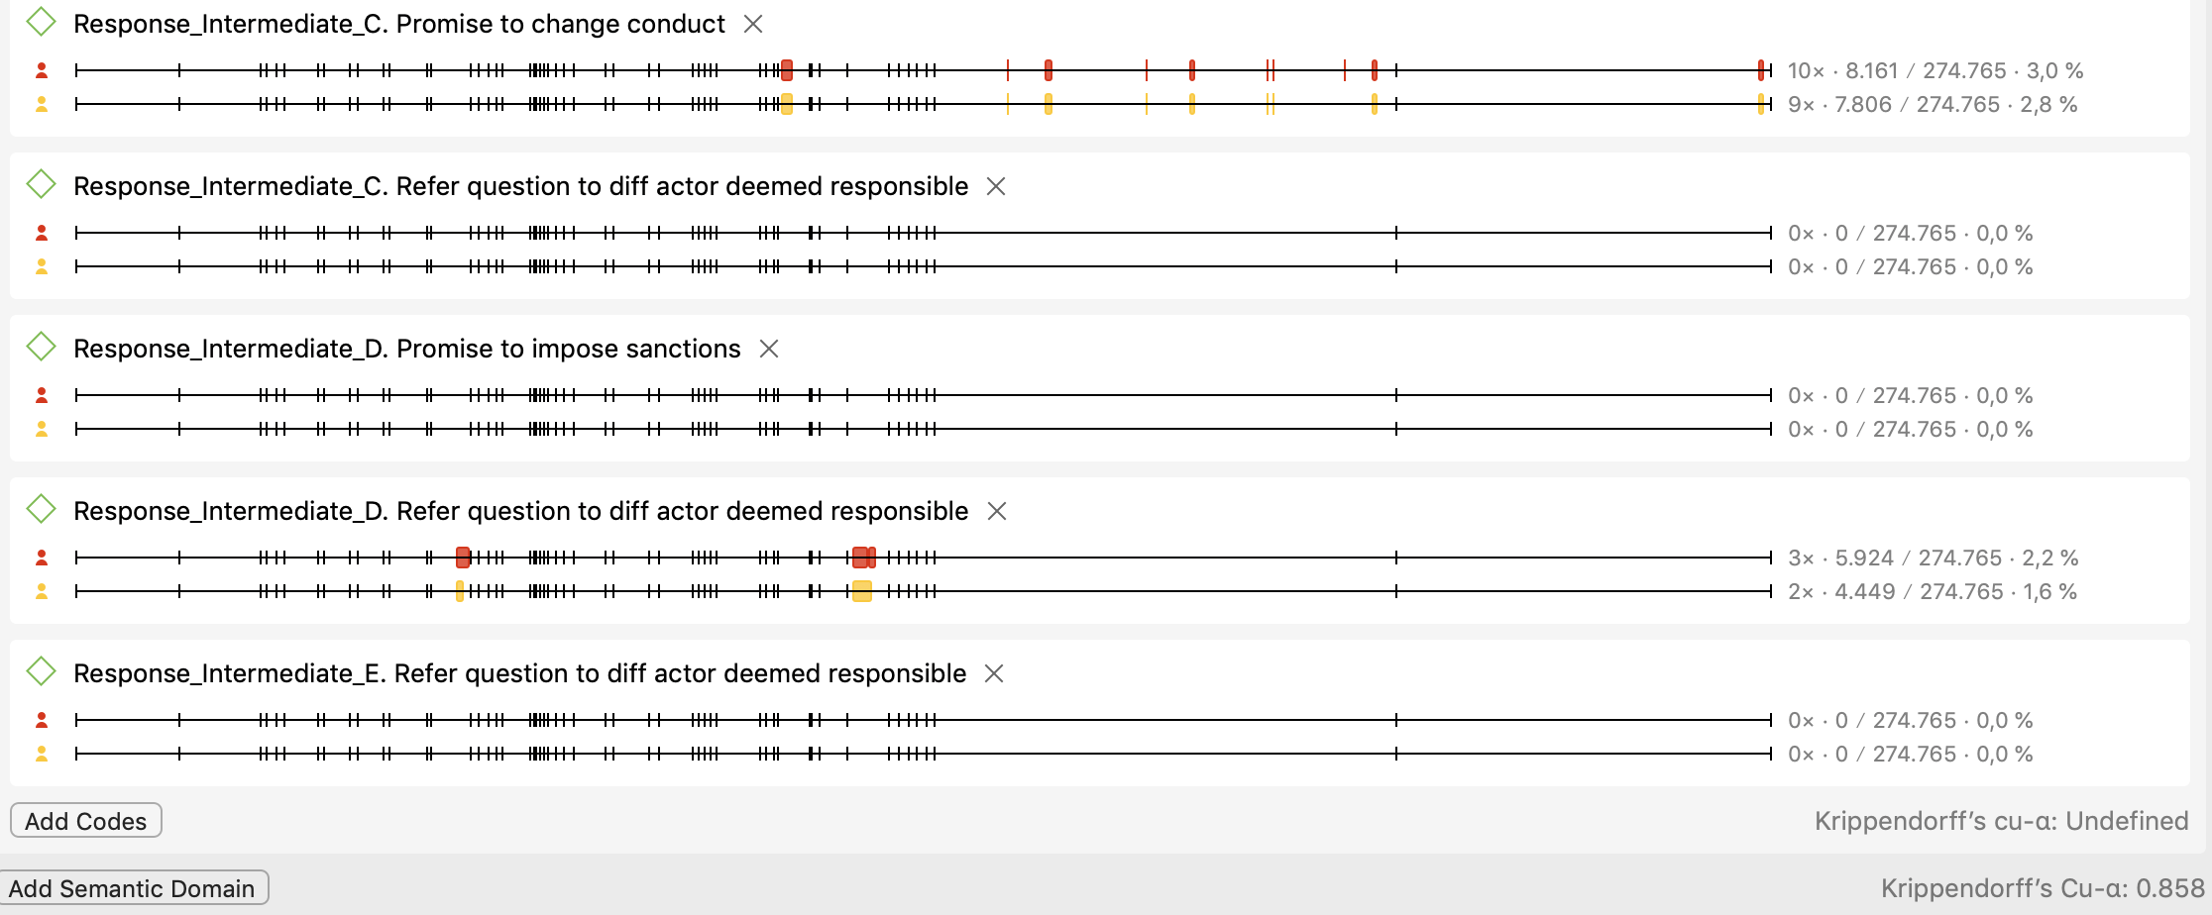

Response_non-reply
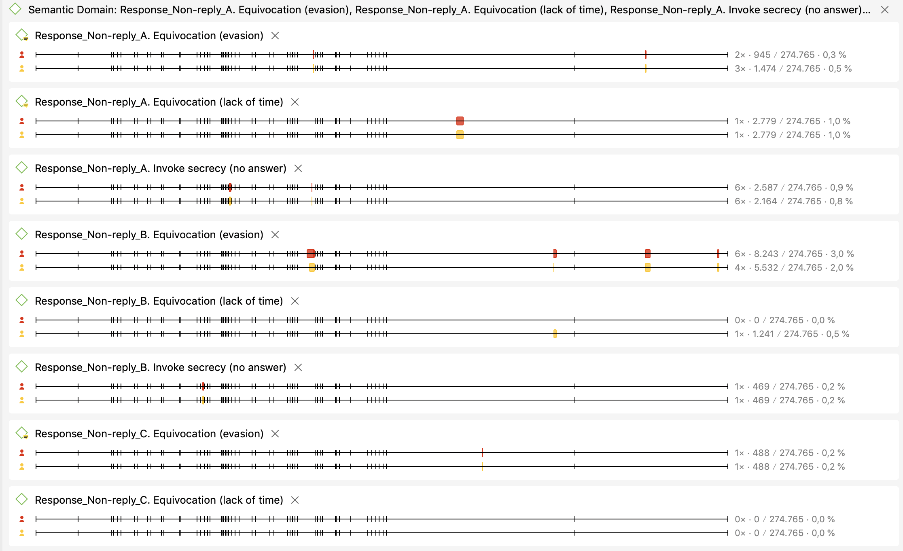
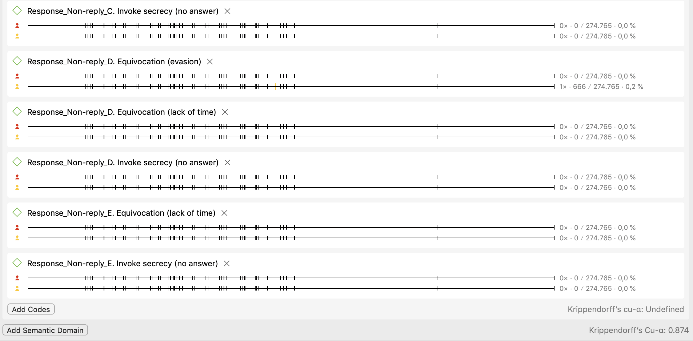

Follow-up questions
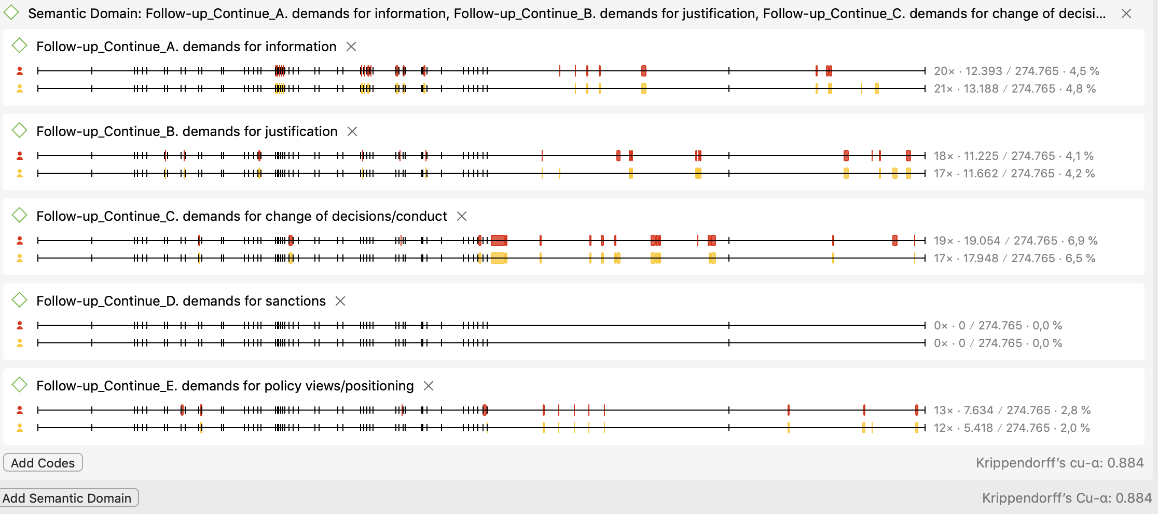

References
Bergman, T., Müller, W.C., Strøm, K. & Blomgren, M. (2006). Democratic Delegation and Accountability: Cross-national Patterns. In K. Strøm, W. C. Müller & T. Bergman (eds.), Parliamentary Democracy: Promise and Problems. Oxford: Oxford University Press.
Bovens, M. (2007). Analysing and Assessing Accountability: A Conceptual Framework. European Law Journal 13(4): 447–468.
Bovens, M., Schillemans, T. & Goodin, R.E. (2014). Public Accountability. In M. Bovens, R. E. Goodin & T. Schillemans (eds.), The Oxford Handbook Public Accountability. Oxford: Oxford University Press.
Crum, B. (2018). Parliamentary accountability in multilevel governance: what role for parliaments in post-crisis EU economic governance? Journal of European Public Policy 25(2): 268–286.
De Wilde, P., Koopmans, R. & Zürn, M. (2014). The political sociology of cosmopolitanism and communitarianism: Representative claims analysis. WZB Discussion Paper (SP IV 2014-102).
Draghi, M. (2013, November 15). Reply by the ECB President to the letter of the ECON Chair of 28 October 2013. European Parliament. Retrieved 23 July 2019, from http://www.europarl.europa.eu/document/activities/cont/201311/20131119ATT74688/20131119ATT74688EN.pdf
Dubnick, M.J. (2014). Accountability as a cultural keyword. In M. Bovens, R. E. Goodin & T. Schillemans (eds.), The Oxford Handbook Public Accountability. Oxford: Oxford University Press.
ECON Committee. (2017, November 9). Public Hearing with Danièle Nouy, Chair of the Supervisory Board of the ECB. EPTV | European Parliament. Retrieved 13 May 2019, from https://www.europarl.europa.eu/ep-live/en/committees/video?event=20171109-0900-COMMITTEE-ECON
Eijffinger, S.C.W. & Geraats, P.M. (2006). How transparent are central banks? European Journal of Political Economy 22(1): 1–21.
European Central Bank. (n.d.a). Publications published in 2013. European Central Bank - Banking Supervision. Retrieved 8 February 2019, from https://www.bankingsupervision.europa.eu/press/publications/date/2013/html/index.en.html
European Central Bank. (n.d.b). Hearings at the European Parliament. European Central Bank - Banking Supervision. Retrieved 8 February 2019, from https://www.bankingsupervision.europa.eu/press/tvservices/hearings/html/index.en.html
European Central Bank. (2013). Interinstitutional Agreement between the European Parliament and the European Central Bank on the practical modalities of the exercise of democratic accountability and oversight over the exercise of the tasks conferred on the ECB within the framework of the Single Supervisory Mechanism (2013/694/EU). Retrieved from https://www.ecb.europa.eu/ecb/legal/pdf/celex_32013q113001_en_txt.pdf
European Central Bank. (2018a, March). Comparison of pre- and post-consultation versions of the addendum. ECB Banking Supervision. Retrieved 29 August 2018, from https://www.bankingsupervision.europa.eu/legalframework/publiccons/pdf/npl2/ssm.npl_addendum_compare.en.pdf
European Central Bank. (2018b, March 15). ECB Annual Report on supervisory activities 2017. Retrieved 29 June 2018, from https://www.bankingsupervision.europa.eu/press/publications/annual-report/html/ssm.ar2017.en.html#toc26
European Parliament. (n.d.). Profile page - Sven GIEGOLD - Questions for written answer (including answers). Retrieved 8 February 2019, from http://www.europarl.europa.eu/meps/en/96730/SVEN_GIEGOLD/other-activities/written-questions-other
European Parliament Multimedia Centre. (n.d.). Recorded committee meetings. Retrieved 8 February 2019, from http://www.europarl.europa.eu/ep-live/en/committees
Friese, S. (2019). ATLAS.ti 8 Mac - User Manual. Updated for program version 8.4. Retrieved from https://downloads.atlasti.com/docs/manual/manual_a8_mac_en.pdf?_ga=2.194419115.769246916.1567676169-2079576425.1564149724
Hobolt, S.B. & Tilley, J. (2014). Blaming Europe?: Responsibility Without Accountability in the European Union. Oxford University Press.
Hood, C. (2010). The Blame Game: Spin, Bureaucracy, and Self-Preservation in Government. Princeton, NJ: Princeton University Press.
Koop, C. (2014). Theorizing and Explaining Voluntary Accountability. Public Administration 92(3): 565–581.
Koopmans, R. & Statham, P. (1999). Political claims analysis: Integrating protest event and political discourse approaches. Mobilization: An International Journal 4(2): 203–21.
Krippendorff, K. (2012). Content Analysis: An Introduction To Its Methodology (2nd ed.). Los Angeles, CA and London: Sage Publications, Inc.
Lombard, M., Snyder-Duch, J. & Bracken, C.C. (2002). Content Analysis in Mass Communication: Assessment and Reporting of Intercoder Reliability. Human Communication Research 28(4): 587–604.
Lupia, A. & McCubbins, M.D. (1994). Learning from Oversight: Fire Alarms and Police Patrols Reconstructed. Journal of Law, Economics, & Organization 10(1): 96–125.
Majone, G. (1999). The regulatory state and its legitimacy problems. West European Politics 22(1): 1–24.
Marias, N. (2015, March 9). Question for written answer Z-000030/2015 to the European Central Bank. European Parliament - Public Register of Documents. Retrieved 26 July 2019, from http://www.europarl.europa.eu/RegData/commissions/econ/questions/2015/549211/ECON_QZ(2015)549211_EN.pdf
Martin, S. (2011). Using Parliamentary Questions to Measure Constituency Focus: An Application to the Irish Case. Political Studies 59(2): 472–488.
McCubbins, M.D. & Schwartz, T. (1984). Congressional Oversight Overlooked: Police Patrols versus Fire Alarms. American Journal of Political Science 28(1): 165.
Moe, T.M. (1984). The New Economics of Organization. American Journal of Political Science 28(4): 739–777.
Mulgan, R. (2000). ‘Accountability’: An Ever-Expanding Concept? Public Administration 78(3): 555–573.
Nouy, D. (2015, April 2). Letter from Danièle Nouy, Chair of the Supervisory Board, to Mr Marias, Member of the European Parliament, on the supervision of Greek banks. ECB Banking Supervision. Retrieved 25 July 2019, from https://www.bankingsupervision.europa.eu/ecb/pub/pdf/150407letter_marias.en.pdf
Nouy, D. (2016, February 26). Letter from Danièle Nouy, Chair of the Supervisory Board, to Mr Zanni, MEP, regarding a credit institution under ECB supervision. ECB Banking Supervision. Retrieved 25 July 2019, from https://www.bankingsupervision.europa.eu/ecb/pub/pdf/160226letter_zanni.en.pdf?b3043a684302a7225d4afb12edff3f0d
Nouy, D. (2017, June 28). Letter from Danièle Nouy, Chair of the Supervisory Board, to Ms Berès, MEP, regarding taxes paid by credit institutions. ECB Banking Supervision. Retrieved 25 July 2019, from https://www.bankingsupervision.europa.eu/ecb/pub/pdf/ssm.mepletter170628_beres.en.pdf?8ca0ac35276c2984f0310fbeb5aeecdd
Ogul, M.S. (1976). Congress Oversees the Bureaucracy (1st edition.). Pittsburgh, PA: University of Pittsburgh Press.
Pelizzo, R. & Stapenhurst, F. (2012). Parliamentary Oversight Tools: A Comparative Analysis. London and New York, NY: Routledge.
Przeworski, A., Stokes, S.C. & Manin, B. (1999). Democracy, Accountability, and Representation. Cambridge University Press.
Rockman, B.A. (1984). Legislative-Executive Relations and Legislative Oversight. Legislative Studies Quarterly 9(3): 387–440.
Romzek, B. & Dubnick, M.J. (1998). Accountability. In J. M. Shafritz (ed.), International Encyclopedia of Public Policy and Administration. Boulder, CO: Westview Press.
Russo, F. & Wiberg, M. (2010). Parliamentary Questioning in 17 European Parliaments: Some Steps towards Comparison. The Journal of Legislative Studies 16(2): 215–232.
Schillemans, T. & Busuioc, M. (2015). Predicting Public Sector Accountability: From Agency Drift to Forum Drift. Journal of Public Administration Research and Theory 25(1): 191–215.
Sieberer, U. (2011). The Institutional Power of Western European Parliaments: A Multidimensional Analysis. West European Politics 34(4): 731–754.
Slapin, J.B. & Proksch, S.-O. (2014). Words as Data: Content Analysis in Legislative Studies. In S. Martin, T. Saalfeld & K. Strøm (eds.), The Oxford Handbook of Legislative Studies. Oxford: Oxford University Press.
Strøm, K. (2000). Delegation and accountability in parliamentary democracies. European Journal of Political Research 37(3): 261–289.
Thatcher, M. & Sweet, A.S. (2002). Theory and Practice of Delegation to Non-Majoritarian Institutions. West European Politics 25(1): 1–22.
Wiberg, M. & Koura, A. (1994). The logic of parliamentary questioning. In M. Wiberg (ed.), Parliamentary control in the Nordic countries: forms of questioning and behavioural trends. Helsinki: The Finnish Political Science Association.

The 2014 Comprehensive Assessment was the initial ‘health check’ of 130 largest banks in the euro area to facilitate the ECB takeover of banking supervision. A typical comprehensive assessment includes an asset quality review and a stress test based on EBA methodology. Since then, the ECB organises annual stress tests with fewer banks, sometimes outside of the official Comprehensive Assessment.
Data collection started on the ECB website in the section ‘Media & Publications > Publications by date’, where all letters addressed to MEPs are listed chronologically (European Central Bank, n.d.a). The ECB is legally obliged to publish answers within five weeks of the receipt of the question, so it is certain that all letters are included on this page (European Central Bank, 2013, Art 3). Based on the answers, the corresponding letters with questions were then retrieved from the EP’s website under the activity of each MEP (e.g. European Parliament, n.d.). Furthermore, public hearings were initially identified from the list published on the website of ECB Banking Supervision (European Central Bank, n.d.b). Next, the EP’s Multimedia Centre was used to retrieve the relevant video segment of the ECON Committee hearings in which the Chair of the Supervisory Board was present (European Parliament Multimedia Centre, n.d.). The English version of each hearing was then manually transcribed by a research associate.
ATLAS.ti does not allow changing the order of documents if additional files are uploaded to the software, so the order is not 100% chronological.

