Appendix

Table A1: Descriptive statistics
a) Country-year analysis
Variable | Definition | Obs | Mean | Sd | Min | Max
Women’s cabinet appointments | Binary indicator for a net increase in the percentage of cabinet positions held by women (Nyrup and Bramwell 2020) | 4354 | 0.290 | 0.454 | 0 | 1
IMF program | Binary indicator for whether a country is under an IMF program (Kentikelenis, Stubbs, and King 2016) | 5176 | 0.382 | 0.486 | 0 | 1
Program onset | Binary indicator for whether a country is in the first year of a new program (Kentikelenis, Stubbs, and King 2016) | 4290 | 0.200 | 0.400 | 0 | 1
Ongoing program | Binary indicator for whether a country continues an existing IMF program (Kentikelenis, Stubbs, and King 2016) | 4316 | 0.284 | 0.451 | 0 | 1
Women in parliament | Percentage of women in parliament, as collected in the World Development Indicators (World Bank 2022) | 2859 | 14.932 | 10.726 | 0 | 63.8
Woman executive | Binary indicator for a women leader (Nyrup and Bramwell 2020) | 4454 | 0.033 | 0.179 | 0 | 1
Women’s cabinet representation | Percentage of cabinet positions held by women (Nyrup and Bramwell 2020) | 4487 | 10.139 | 9.763 | 0 | 57.143
Any election | Binary indicator for any election, including executive elections and legislative elections, drawn from the Database of Political Institutions (Scartascini, Cruz, and Keefer 2018) | 5499 | 0.181 | 0.385 | 0 | 1
Left-wing government | Binary indicator for any left-wing government, drawn from the Database of Political Institutions (Scartascini, Cruz, and Keefer 2018) | 5025 | 0.278 | 0.448 | 0 | 1
GDP per capita | Logged GDP per capita, drawn from the World Development Indicators (World Bank 2022) | 4609 | 7.557 | 1.027 | 4.898 | 9.711
Democracy | Inverted Freedom House Index, defined as the sum of political rights and civil liberties, as collected in the Quality of Government Database (Teorell et al. 2020) | 4871 | 5.620 | 3.648 | 0 | 12

b) Country-minister-year analysis
Variable | Definition | Obs | Mean | Sd | Min | Max
Woman minister | Binary indicator for cabinet position held by a woman (Nyrup and Bramwell 2020) | 75853 | 0.103 | 0.305 | 0 | 1
IMF program | Binary indicator for whether a country is under an IMF program (Kentikelenis, Stubbs, and King 2016) | 76533 | 0.433 | 0.495 | 0 | 1
Program onset | Binary indicator for whether a country is in the first year of a new program (Kentikelenis, Stubbs, and King 2016) | 50671 | 0.134 | 0.341 | 0 | 1
Ongoing program | Binary indicator for whether a country continues an existing IMF program (Kentikelenis, Stubbs, and King 2016) | 69736 | 0.297 | 0.457 | 0 | 1
Austerity-bearing ministry | Dummy for whether ministry is an austerity-bearing cabinet portfolio: Children & Family, Civil Service, Culture & Heritage, Education, Training & Skills, Health & Social Welfare, Housing, Labor, Employment & Social Security, Science, Technology & Research, Sports, Women, and Youth. | 23923 | 0.818 | 0.386 | 0 | 1
Other ministry | Dummy for whether ministry is not an austerity-bearing ministry and not the finance ministry | 57449 | 0.924 | 0.265 | 0 | 1
Gender Equality Index | VDem Women’s Political Empowerment Index (Coppedge et al. 2021) | 75681 | 0.625 | 0.184 | 0.075 | 0.961
Corruption | VDem Public-Sector Corruption Index (Coppedge et al. 2021) | 69759 | 0.638 | 0.226 | 0.038 | 0.984
Crisis index | Crisis severity index, obtained as the first component from a confirmatory factor analysis including: reserves in months of imports, economic growth, financial crisis incidence, external debt, and inflation growth. Data are from the World Development Indicators (World Bank 2022) | 31611 | 0.000 | 0.538 | -2.400 | 5.360

Table A2: Areas of IMF conditionality and austerity-bearing ministries
Area of conditionality | Typical measures
External debt issues (DEB) | Ceiling on external debt
External sector (trade and exchange system) (EXT) | Exchange-rate devaluation, trade liberalization, and capital account liberalization
Land and environment (ENV) | Natural resource extraction, land use to boost export crops
Financial sector, monetary policy, and Central Bank issues (FIN) | Financial sector development, liberalization of financial services, central bank independence
Fiscal issues (FP) | Austerity measures
Labor issues (public and private sector) (LAB) | Public-sector downsizing, wage cuts, pension cuts, and labor market deregulation
SOE privatization (PRI) | Privatization of state-owned companies, layoffs of employees
SOE reform and pricing (SOE) | Lifting of price controls of utilities
Revenues and tax issues | Redesign of tax systems: broadening the tax base, altering tax rates
Institutional reforms (INS) | Make-up of state institutions and regulatory bodies
Notes: Areas in bold are the most-likely candidates for broad-based adjustment burden during an IMF program. These will likely have to be implemented by the following ministries: Children & Family, Civil Service, Education, Training & Skills, Health & Social Welfare, Housing, Labor, Employment & Social Security, Science, Technology & Research, Sports, Women, and Youth.

Table A3: Deriving the austerity-bearing ministries
 | Women-led ministry | Prestigious ministry | Conditionality-implementing ministry | Austerity-bearing ministry
Ageing & Elderly | x
Agriculture, Food, Fisheries & Livestock
Audit, Oversight & Internal Affairs
Children & Family | x |  | x | x
Civil Service |  |  | x | x
Communications & Information
Construction & Public Works
Correctional Services & Police
Culture & Heritage | x |  |  | x
Defense, Military & National Security |  | x
Education, Training & Skills | x |  | x | x
Energy
Enterprises, Companies & Business
Environment
Executive & Legislative Relations
Finance, Budget & Treasury |  | x
Foreign Economic Relations |  | x
Foreign Relations |  | x
General Economic Affairs |  | x
Government, Interior & Home Affairs |  | x
Health & Social Welfare | x |  | x | x
Housing |  |  | x | x
Immigration & Emigration
Industry & Commerce
Justice & Legal Affairs
Labor, Employment & Social Security |  |  | x | x
Local Government
Minorities
Natural Resources
Other
Planning & Development
Political Reform
Properties & Buildings
Regional
Religion
Science, Technology & Research |  |  | x | x
Sports |  |  | x | x
Tax, Revenue & Fiscal Policy |  | x
Tourism
Transport
Veterans
Without Portfolio
Women | x |  | x | x
Youth | x |  | x | x
Notes: There are other ministries which also implement IMF-mandated reforms. However, these reforms may have a positive effect on their intended target groups: Correctional Services & Police, Energy, Enterprises, Companies & Business, Industry & Commerce, Natural Resources, Transport.

Table A4: Controlling for decreases in the women’s cabinet percentage
 | (1) |  | (2) |  | (3)
IMF program _{t-1} | 0.039** | (0.018) | 0.058** | (0.023) | 0.053** | (0.023)
Decrease in women | -0.460*** | (0.014) | -0.444*** | (0.020) | -0.447*** | (0.020)
Women in parliament _{t-1} |  |  | 0.003 | (0.002) | 0.003 | (0.002)
Δ.Women in parliament |  |  | 0.002 | (0.003) | 0.002 | (0.003)
Woman executive _{t-1} |  |  | 0.052 | (0.054) | 0.049 | (0.055)
Δ.Woman executive |  |  | 0.176*** | (0.047) | 0.178*** | (0.046)
Women cabinet share _{t-1} |  |  | -0.009*** | (0.002) | -0.009*** | (0.002)
Any election _{t-1} |  |  | 0.082*** | (0.024) | 0.089*** | (0.025)
Left-wing government _{t-1} |  |  | -0.009 | (0.035) | -0.015 | (0.035)
GDP per capita _{t-1} |  |  |  |  | -0.041 | (0.068)
Δ.GDP per capita |  |  |  |  | -0.218 | (0.201)
Democracy _{t-1} |  |  |  |  | 0.003 | (0.009)
Δ.Democracy |  |  |  |  | 0.033** | (0.016)
Observations | 4326 |  | 2208 |  | 2104
Countries | 123 |  | 119 |  | 115
Adjusted R2 | 0.220 |  | 0.254 |  | 0.255
Notes: Two-way fixed effects estimations with country-clustered standard errors in parentheses. The dependent variable indicates an increase in the women cabinet percentage compared to the previous year. Significance levels: * p<.1 ** p<.05 *** p<.01.

Table A5: Alternative dependent variable: Logged positive change of women’s cabinet percentages
 | (1) |  | (2) |  | (3)
IMF program _{t-1} | 0.072* | (0.038) | 0.123** | (0.060) | 0.120* | (0.062)
Any prior women minister_{t-1} |  |  | -0.496*** | (0.093) | -0.484*** | (0.096)
Women in parliament _{t-1} |  |  | 0.004 | (0.006) | 0.003 | (0.006)
Δ.Women in parliament |  |  | 0.010 | (0.010) | 0.009 | (0.010)
Woman executive _{t-1} |  |  | 0.052 | (0.154) | 0.055 | (0.158)
Δ.Woman executive |  |  | 0.776*** | (0.244) | 0.770*** | (0.243)
Any election _{t-1} |  |  | 0.201*** | (0.068) | 0.217*** | (0.070)
Left-wing government _{t-1} |  |  | -0.075 | (0.072) | -0.077 | (0.071)
GDP per capita _{t-1} |  |  |  |  | 0.049 | (0.168)
Δ.GDP per capita |  |  |  |  | -0.073 | (0.548)
Democracy _{t-1} |  |  |  |  | 0.032 | (0.022)
Δ.Democracy |  |  |  |  | 0.098** | (0.040)
Observations | 4326 |  | 2208 |  | 2104
Countries | 123 |  | 119 |  | 115
Adjusted R2 | 0.030 |  | 0.037 |  | 0.032
Notes: Two-way fixed effects estimations with country-clustered standard errors in parentheses. The dependent variable is the logged change in women’s cabinet percentage compared to the previous year, restricted to positive values. Significance levels: * p<.1 ** p<.05 *** p<.01.

Table A6: Alternative dependent variable: Logged change of women’s cabinet percentages
 | (1) |  | (2) |  | (3)
IMF program _{t-1} | 0.113** | (0.050) | 0.160* | (0.095) | 0.160 | (0.101)
Any prior woman minister _{t-1} |  |  | -1.211*** | (0.113) | -1.217*** | (0.118)
Women in parliament _{t-1} |  |  | 0.004 | (0.008) | 0.002 | (0.008)
Δ.Women in parliament |  |  | 0.017 | (0.013) | 0.016 | (0.013)
Woman executive _{t-1} |  |  | -0.006 | (0.206) | 0.001 | (0.213)
Δ.Woman executive |  |  | 1.482*** | (0.480) | 1.476*** | (0.478)
Any election _{t-1} |  |  | 0.071 | (0.111) | 0.089 | (0.112)
Left-wing government _{t-1} |  |  | -0.102 | (0.106) | -0.093 | (0.107)
GDP per capita _{t-1} |  |  |  |  | 0.172 | (0.241)
Δ.GDP per capita |  |  |  |  | 0.110 | (0.853)
Democracy _{t-1} |  |  |  |  | 0.054 | (0.034)
Δ.Democracy |  |  |  |  | 0.129** | (0.062)
Observations | 4326 |  | 2208 |  | 2104
Countries | 123 |  | 119 |  | 115
Adjusted R2 | -0.019 |  | 0.004 |  | 0.005
Notes: Two-way fixed effects estimations with country-clustered standard errors in parentheses. The dependent variable is the logged change in women’s cabinet percentage compared to the previous year. We use the hyperbolic transformation (asinh) to avoid data loss when taking the logarithm. Significance levels: * p<.1 ** p<.05 *** p<.01.

Table A7: No effect on finance ministers
 | (1) |  | (2) |  | (3)
IMF program _{t-1} | 0.007 | (0.005) | 0.013 | (0.009) | 0.010 | (0.009)
Women in parliament _{t-1} |  |  | 0.000 | (0.001) | 0.000 | (0.001)
Δ.Women in parliament |  |  | 0.000 | (0.001) | 0.000 | (0.001)
Woman executive _{t-1} |  |  | -0.013 | (0.024) | -0.018 | (0.025)
Δ.Woman executive |  |  | 0.058 | (0.048) | 0.057 | (0.048)
Women cabinet share _{t-1} |  |  | 0.000 | (0.001) | 0.000 | (0.001)
Any election _{t-1} |  |  | 0.029*** | (0.009) | 0.030*** | (0.010)
Left-wing government _{t-1} |  |  | 0.009 | (0.013) | 0.010 | (0.013)
GDP per capita _{t-1} |  |  |  |  | -0.026 | (0.024)
Δ.GDP per capita |  |  |  |  | 0.034 | (0.076)
Democracy _{t-1} |  |  |  |  | 0.006 | (0.004)
Δ.Democracy |  |  |  |  | 0.000 | (0.005)
Observations | 4245 |  | 2193 |  | 2089
Countries | 122 |  | 119 |  | 115
Adjusted R2 | 0.012 |  | 0.012 |  | 0.011
Notes: Two-way fixed effects estimations with country-clustered standard errors in parentheses. The dependent variable indicates transition from a men finance minister to a women finance minister. Significance levels: * p<.1 ** p<.05 *** p<.01.

Table A8: Scope conditions for the relationship between IMF programs, austerity-bearing ministries, and women cabinet ministers
 | Below-mean gender norm |  | Above-mean gender norm |  | Above-mean corruption |  | Below-mean corruption |  | Severe crisis |  | Crisis is not severe
 | (1) |  | (2) |  | (3) |  | (4) |  | (5) |  | (6)
IMF program | -0.034* | (0.020) | -0.027 | (0.028) | -0.036 | (0.026) | -0.036 | (0.024) | -0.042** | (0.021) | 0.001 | (0.024)
Austerity-bearing ministry | 0.087*** | (0.021) | 0.164*** | (0.030) | 0.103*** | (0.026) | 0.129*** | (0.026) | 0.092*** | (0.023) | 0.170*** | (0.021)
(Interaction) | 0.056** | (0.024) | 0.006 | (0.033) | 0.049* | (0.029) | 0.027 | (0.028) | 0.062** | (0.025) | -0.019 | (0.027)
Pre-trend _{t-1} | -0.001 | (0.007) | -0.005 | (0.010) | 0.002 | (0.007) | -0.001 | (0.009) | 0.006 | (0.007) | -0.020* | (0.010)
Pre-trend _{t-2} | -0.003 | (0.006) | -0.005 | (0.009) | -0.000 | (0.007) | -0.007 | (0.008) | -0.007 | (0.007) | 0.008 | (0.010)
Pre-trend _{t-3} | 0.003 | (0.007) | -0.006 | (0.010) | 0.002 | (0.007) | -0.008 | (0.009) | -0.001 | (0.007) | -0.003 | (0.012)
Pre-trend _{t-4} | -0.017* | (0.009) | -0.016 | (0.012) | -0.017* | (0.010) | -0.021* | (0.011) | -0.014 | (0.009) | -0.021 | (0.015)
Observations | 13520 |  | 9949 |  | 12654 |  | 10814 |  | 16178 |  | 7291
Countries | 107 |  | 87 |  | 123 |  | 92 |  | 123 |  | 94
Adjusted R2 | 0.086 |  | 0.087 |  | 0.097 |  | 0.105 |  | 0.095 |  | 0.107
Notes: Two-way fixed effects estimations with country-clustered standard errors in parentheses. The dependent variable indicates an increase in the women’s cabinet percentage compared to the previous year. Austerity-bearing ministries include: Children & Family, Civil Service, Culture & Heritage, Education, Training & Skills, Health & Social Welfare, Housing, Labor, Employment & Social Security, Science, Technology & Research, Sports, Women, and Youth. Gender norms are measured by the VDem Gender Equality Index. Corruption is measured by the VDem Public-Sector Corruption Index. Crisis severity is the first (retained) factor from a confirmatory factor analysis of reserves, economic growth, financial crisis, external debt, and inflation growth. All moderators are taken at their means, except crisis severity which is split at the fourth quartile. Significance levels: * p<.1 ** p<.05 *** p<.01

Table A9: Alternative definitions of austerity-bearing ministries
 | Ageing & Elderly added |  | P&D added |  | Sports removed
 | (1) |  | (2) |  | (3)
Woman minister
IMF program | -0.032* | (0.017) | -0.033* | (0.017) | -0.027* | (0.016)
Austerity-bearing ministry | 0.115*** | (0.019) | 0.105*** | (0.018) | 0.119*** | (0.017)
(Interaction) | 0.038* | (0.021) | 0.043** | (0.020) | 0.037* | (0.020)
Pre-trend _{t-1} | -0.001 | (0.005) | 0.001 | (0.005) | -0.001 | (0.005)
Pre-trend _{t-2} | -0.003 | (0.005) | -0.004 | (0.005) | -0.003 | (0.005)
Pre-trend _{t-3} | -0.003 | (0.005) | -0.000 | (0.005) | -0.004 | (0.005)
Pre-trend _{t-4} | -0.018** | (0.008) | -0.016** | (0.008) | -0.019** | (0.008)
Observations | 23483 |  | 25810 |  | 23469
Countries | 123 |  | 123 |  | 123
Adjusted R2 | 0.095 |  | 0.091 |  | 0.102
Notes: Two-way fixed effects estimations with country-clustered standard errors in parentheses. The dependent variable indicates a woman minister. The treated group are austerity-bearing ministries, subject to the alterations shown in the column header. The first column adds Ageing & Elderly to the treated list. The second adds Planning & Development to the treated list. The third removes Sports from the initial list. Significance levels: * p<.1 ** p<.05 *** p<.01.

Table A10: Other ministries and women ministers under IMF programs
 | Any program |  | Program onset |  | Ongoing program
 | (1) |  | (2) |  | (3)
Woman minister
IMF program | -0.023 | (0.016) | -0.017 | (0.012) | -0.016 | (0.014)
Other ministry | 0.009 | (0.016) | 0.017 | (0.012) | 0.015 | (0.013)
(Interaction) | 0.026 | (0.017) | 0.018 | (0.013) | 0.020 | (0.015)
Pre-trend _{t-1} | -0.003 | (0.003) | -0.002 | (0.004) | -0.003 | (0.003)
Pre-trend _{t-2} | -0.002 | (0.003) | -0.002 | (0.003) | -0.002 | (0.003)
Pre-trend _{t-3} | -0.001 | (0.003) | -0.001 | (0.003) | -0.001 | (0.003)
Pre-trend _{t-4} | -0.006 | (0.004) | -0.006 | (0.004) | -0.006 | (0.004)
Observations | 56203 |  | 56567 |  | 56203
Countries | 123 |  | 123 |  | 123
Adjusted R2 | 0.055 |  | 0.055 |  | 0.055
Notes: Two-way fixed effects estimations with country-clustered standard errors in parentheses. The dependent variable indicates a woman minister. The treated group are “other ministries” relative to the finance ministry as control. Significance levels: * p<.1 ** p<.05 *** p<.01.

Table A11: Placebo check with random allocation of ministries
 | Any program |  | Program onset |  | Ongoing program
 | (1) |  | (2) |  | (3)
Woman minister
IMF program | -0.003 | (0.005) | -0.003 | (0.004) | -0.002 | (0.004)
Random ministry | 0.027*** | (0.008) | 0.029*** | (0.007) | 0.029*** | (0.007)
(Interaction) | 0.009 | (0.008) | 0.006 | (0.007) | 0.006 | (0.007)
Pre-trend _{t-1} | -0.001 | (0.002) | -0.001 | (0.004) | -0.001 | (0.003)
Pre-trend _{t-2} | -0.001 | (0.003) | -0.001 | (0.003) | -0.001 | (0.003)
Pre-trend _{t-3} | -0.002 | (0.003) | -0.002 | (0.003) | -0.001 | (0.003)
Pre-trend _{t-4} | -0.010** | (0.004) | -0.011*** | (0.004) | -0.010*** | (0.004)
Observations | 71086 |  | 71531 |  | 71086
Countries | 123 |  | 123 |  | 123
Adjusted R2 | 0.062 |  | 0.063 |  | 0.062
Notes: Two-way fixed effects estimations with country-clustered standard errors in parentheses. The dependent variable indicates a woman minister. The treated group are “random ministries” obtained by numbering all ministries consecutively and using odd numbers as treated ones (finance ministry excluded for consistency). Significance levels: * p<.1 ** p<.05 *** p<.01.

Table A12: Cabinet-fixed effects and clustered errors
 | Any program |  | Program Onset |  | Ongoing program
 | (1) |  | (2) |  | (3)
Woman minister
IMF program | -0.032** | (0.016) | -0.003 | (0.012) | -0.035*** | (0.013)
Austerity-bearing ministry | 0.116*** | (0.014) | 0.130*** | (0.011) | 0.122*** | (0.012)
(Interaction) | 0.037** | (0.017) | 0.010 | (0.013) | 0.039*** | (0.015)
Pre-trend _{t-1} | 0.001 | (0.006) | -0.002 | (0.007) | 0.000 | (0.006)
Pre-trend _{t-2} | -0.003 | (0.006) | -0.004 | (0.006) | -0.004 | (0.006)
Pre-trend _{t-3} | -0.002 | (0.006) | -0.003 | (0.006) | -0.003 | (0.006)
Pre-trend _{t-4} | -0.021** | (0.008) | -0.021** | (0.008) | -0.021*** | (0.008)
Observations | 23452 |  | 23591 |  | 23452
Countries | 698 |  | 700 |  | 698
Adjusted R2 | 0.126 |  | 0.126 |  | 0.126
Notes: Two-way fixed effects estimations with cabinet-clustered standard errors in parentheses. The dependent variable indicates a woman minister. The treated group are “austerity-bearing ministries” relative to the finance ministry as control. Significance levels: * p<.1 ** p<.05 *** p<.01.

Table A13: Country-year fixed effects
 | Any program |  | Program Onset |  | Ongoing program
 | (1) |  | (2) |  | (3)
Woman minister
IMF program
Austerity-bearing ministry | 0.117*** | (0.014) | 0.129*** | (0.011) | 0.122*** | (0.012)
(Interaction) | 0.032* | (0.017) | 0.006 | (0.014) | 0.036** | (0.015)
Pre-trend _{t-1} | 0.017 | (0.018) | 0.016 | (0.018) | 0.017 | (0.018)
Pre-trend _{t-2} | -0.015 | (0.014) | -0.016 | (0.014) | -0.015 | (0.014)
Pre-trend _{t-3} | -0.013 | (0.015) | -0.014 | (0.015) | -0.014 | (0.015)
Pre-trend _{t-4} | -0.051*** | (0.017) | -0.052*** | (0.017) | -0.051*** | (0.017)
Observations | 23418 |  | 23556 |  | 23418
Countries | 698 |  | 700 |  | 698
Adjusted R2 | 0.048 |  | 0.049 |  | 0.048
Notes: Two-way fixed effects estimations with cabinet-clustered standard errors in parentheses. The dependent variable indicates a woman minister. The treated group are “austerity-bearing ministries” relative to the finance ministry as control. Significance levels: * p<.1 ** p<.05 *** p<.01.

Table A14: Controlling for fiscal consolidation
 | (1) |  | (2) |  | (3)
IMF program _{t-1} | 0.050** | (0.021) | 0.063** | (0.029) | 0.043 | (0.029)
Budget balance _{t-1} | 0.002 | (0.008) | 0.007 | (0.011) | 0.012 | (0.011)
Δ.Budget balance | 0.016* | (0.009) | 0.017 | (0.011) | 0.018 | (0.011)
Women in parliament _{t-1} |  |  | 0.005* | (0.003) | 0.005* | (0.003)
Δ.Women in parliament |  |  | 0.003 | (0.004) | 0.004 | (0.004)
Woman executive _{t-1} |  |  | 0.141** | (0.064) | 0.123* | (0.069)
Δ.Woman executive |  |  | 0.232*** | (0.084) | 0.231*** | (0.084)
Women cabinet share _{t-1} |  |  | -0.019*** | (0.002) | -0.019*** | (0.002)
Any election _{t-1} |  |  | 0.064** | (0.030) | 0.069** | (0.030)
Left-wing government _{t-1} |  |  | 0.043 | (0.040) | 0.049 | (0.041)
GDP per capita _{t-1} |  |  |  |  | -0.157* | (0.088)
Δ.GDP per capita |  |  |  |  | -0.482 | (0.341)
Democracy _{t-1} |  |  |  |  | 0.017* | (0.009)
Δ.Democracy |  |  |  |  | 0.023 | (0.020)
Observations | 2488 |  | 1590 |  | 1551
Countries | 85 |  | 83 |  | 82
Adjusted R2 | 0.032 |  | 0.100 |  | 0.102
Notes: Two-way fixed effects estimations with country-clustered standard errors in parentheses. The dependent variable indicates an increase in the women cabinet percentage from the previous year. Significance levels: * p<.1 ** p<.05 *** p<.01.

Table A15: No effect of financial crisis on women cabinet appointments
 | (1) |  | (2) |  | (3)
Financial crisis _{t-1} | -0.008 | (0.036) | -0.083 | (0.052) | -0.089* | (0.053)
Women in parliament _{t-1} |  |  | 0.005* | (0.003) | 0.005 | (0.003)
Δ.Women in parliament |  |  | 0.004 | (0.004) | 0.005 | (0.004)
Woman executive _{t-1} |  |  | 0.125** | (0.053) | 0.116** | (0.055)
Δ.Woman executive |  |  | 0.269*** | (0.071) | 0.270*** | (0.070)
Women cabinet share _{t-1} |  |  | -0.019*** | (0.002) | -0.019*** | (0.002)
Any election _{t-1} |  |  | 0.064** | (0.026) | 0.071*** | (0.026)
Left-wing government _{t-1} |  |  | 0.017 | (0.040) | 0.013 | (0.039)
GDP per capita _{t-1} |  |  |  |  | -0.064 | (0.081)
Δ.GDP per capita |  |  |  |  | -0.241 | (0.238)
Democracy _{t-1} |  |  |  |  | 0.008 | (0.008)
Δ.Democracy |  |  |  |  | 0.034** | (0.017)
Observations | 4354 |  | 2208 |  | 2104
Countries | 123 |  | 119 |  | 115
Adjusted R2 | 0.030 |  | 0.091 |  | 0.090
Notes: Two-way fixed effects estimations with country-clustered standard errors in parentheses. The dependent variable indicates an increase in the women cabinet percentage from the previous year. Significance levels: * p<.1 ** p<.05 *** p<.01.

Table A16: Women’s cabinet share and IMF programs
 | (1) |  | (2) |  | (3) |  | (4)
Women’s cabinet share _{t-1} | -0.001 | (0.002) | -0.003 | (0.002) | -0.001 | (0.002) | -0.003 | (0.002)
Woman finance minister appointment _{t-1} | --- | --- | --- | --- | 0.010 | (0.051) | -0.054 | (0.057)
Women in parliament _{t-1} |  |  | 0.000 | (0.004) |  |  | 0.000 | (0.004)
Δ.Women in parliament |  |  | -0.005 | (0.003) |  |  | -0.004 | (0.003)
Woman executive _{t-1} |  |  | -0.054 | (0.120) |  |  | -0.059 | (0.120)
Δ.Woman executive |  |  | -0.037 | (0.098) |  |  | -0.036 | (0.099)
Any election _{t-1} |  |  | -0.018 | (0.019) |  |  | -0.013 | (0.019)
Left-wing government _{t-1} |  |  | 0.006 | (0.061) |  |  | 0.014 | (0.061)
GDP per capita _{t-1} |  |  | -0.523*** | (0.187) |  |  | -0.538*** | (0.190)
Δ.GDP per capita |  |  | -0.584* | (0.302) |  |  | -0.645** | (0.300)
Democracy _{t-1} |  |  | 0.050** | (0.022) |  |  | 0.051** | (0.022)
Δ.Democracy |  |  | 0.015 | (0.019) |  |  | 0.018 | (0.020)
Ideal-point distance to G7 _{t-1} |  |  | 0.073 | (0.057) |  |  | 0.083 | (0.056)
Reserves in months of imports _{t-1} |  |  | -0.015* | (0.008) |  |  | -0.017* | (0.009)
Economic growth _{t-1} |  |  | -0.002 | (0.002) |  |  | -0.003* | (0.002)
Financial crisis _{t-1} |  |  | 0.160*** | (0.058) |  |  | 0.158*** | (0.057)
Observations | 4337 |  | 1840 |  | 4243 |  | 1709
Countries | 123 |  | 102 |  | 122 |  | 101
Adjusted R2 | 0.305 |  | 0.397 |  | 0.333 |  | 0.395
Notes: Two-way fixed effects estimations with country-clustered standard errors in parentheses. The dependent variable indicates whether a country is under an IMF program. Significance levels: * p<.1 ** p<.05 *** p<.01.

Table A17: Women leaders are not more likely to seek IMF programs
 | Any IMF program |  | Inherited |  | Own program
 | (1) |  | (2) |  | (3)
Financial crisis _{t-1} | 0.129*** | (0.031) | 0.023 | (0.018) | 0.107*** | (0.036)
Woman leader | -0.006 | (0.089) | -0.007 | (0.031) | -0.007 | (0.054)
(Interaction) | -0.202 | (0.204) | -0.082 | (0.050) | 0.075 | (0.287)
Pre-trend _{t} | 0.006 | (0.030) | 0.004 | (0.015) | 0.076*** | (0.029)
Pre-trend _{t-1} | -0.030 | (0.033) | -0.011 | (0.012) | 0.012 | (0.030)
Pre-trend _{t-2} | -0.036 | (0.036) | -0.017 | (0.011) | -0.018 | (0.032)
Pre-trend _{t-3} | 0.011 | (0.037) | -0.032*** | (0.008) | 0.042 | (0.034)
Pre-trend _{t-4} | 0.025 | (0.041) | -0.010 | (0.016) | 0.072** | (0.036)
Observations | 5027 |  | 5027 |  | 4622
Countries | 893 |  | 893 |  | 856
Adjusted R2 | 0.357 |  | 0.080 |  | 0.242
Notes: Two-way fixed effects estimations with country-clustered standard errors in parentheses. The unit of analysis is the country-leader-year. The dependent variable indicates whether a country is under an IMF program. Significance levels: * p<.1 ** p<.05 *** p<.01.

Table A18: IMF program heterogeneity and women cabinet appointments
 | (1) |  | (2)
IMF program _{t-1} | 0.077*** | (0.024) | 0.106*** | (0.035)
Austerity conditions _{t-1} | 0.015 | (0.013) | 0.005 | (0.024)
Non-austerity conditions _{t-1} | -0.021** | (0.010) | -0.026 | (0.017)
Women in parliament _{t-1} |  |  | 0.005* | (0.003)
Δ.Women in parliament |  |  | 0.005 | (0.004)
Woman executive _{t-1} |  |  | 0.114** | (0.055)
Δ.Woman executive |  |  | 0.268*** | (0.070)
Women cabinet share _{t-1} |  |  | -0.019*** | (0.002)
Any election _{t-1} |  |  | 0.070*** | (0.026)
Left-wing government _{t-1} |  |  | 0.008 | (0.040)
GDP per capita _{t-1} |  |  | -0.050 | (0.082)
Δ.GDP per capita |  |  | -0.185 | (0.234)
Democracy _{t-1} |  |  | 0.006 | (0.008)
Δ.Democracy |  |  | 0.034** | (0.017)
Observations | 4300 |  | 2089
Countries | 122 |  | 114
Adjusted R2 | 0.033 |  | 0.093
Notes: Two-way fixed effects estimations with country-clustered standard errors in parentheses. The dependent variable indicates an increase in the women cabinet percentage from the previous year. The two new predictors respectively are the logged number of conditions associated with austerity-bearing ministries (Table A2) and the conditions associated with all other ministries. Significance levels: * p<.1 ** p<.05 *** p<.01.

Table A19: Required fiscal adjustment in program and women cabinet appointments
 | (1) |  | (2) |  | (3)
Required fiscal adjustment | 0.036** | (0.018) | 0.038** | (0.018) | 0.040** | (0.019)
Pre-program budget balance | -0.000 | (0.011) | -0.020 | (0.020) | -0.023 | (0.021)
Women minister dismissal | -0.609*** | (0.094) | -0.606*** | (0.100) | -0.625*** | (0.107)
GDP growth |  |  | 0.023 | (0.014) | 0.022 | (0.014)
Current account balance |  |  | 0.013 | (0.008) | 0.014 | (0.009)
US vote alignment |  |  | 0.022 | (0.148) | 0.025 | (0.150)
Executive election |  |  | 0.019 | (0.096) | 0.008 | (0.097)
Fiscal conditions |  |  |  |  | 0.015 | (0.017)
Observations | 135 |  | 133 |  | 133
Countries | 49 |  | 48 |  | 48
Adjusted R2 | 0.219 |  | 0.218 |  | 0.217
Notes: Two-way fixed effects estimations on a repeated cross-section of IMF programs, with country-clustered standard errors in parentheses. The dependent variable indicates an increase in the women cabinet percentage from the previous year. Significance levels: * p<.1 ** p<.05 *** p<.01.

Table A20: IMF program heterogeneity considering gendered control of the finance ministry
 | (1) |  | (2)
IMF program & woman finance minister _{t-1} | -0.104** | (0.040) | 0.029 | (0.062)
IMF program & man finance minister _{t-1} | 0.052*** | (0.017) | 0.056** | (0.027)
Women in parliament _{t-1} |  |  | 0.005* | (0.003)
Δ.Women in parliament |  |  | 0.005 | (0.004)
Woman executive _{t-1} |  |  | 0.115** | (0.057)
Δ.Woman executive |  |  | 0.265*** | (0.069)
Women cabinet share _{t-1} |  |  | -0.019*** | (0.002)
Any election _{t-1} |  |  | 0.071*** | (0.026)
Left-wing government _{t-1} |  |  | 0.011 | (0.039)
GDP per capita _{t-1} |  |  | -0.039 | (0.079)
Δ.GDP per capita |  |  | -0.172 | (0.233)
Democracy _{t-1} |  |  | 0.005 | (0.008)
Δ.Democracy |  |  | 0.033** | (0.016)
Observations | 4354 |  | 2104
Countries | 123 |  | 115
Adjusted R2 | 0.034 |  | 0.091
Notes: Two-way fixed effects estimations with country-clustered standard errors in parentheses. The dependent variable indicates an increase in the women cabinet percentage from the previous year. Significance levels: * p<.1 ** p<.05 *** p<.01.

Table A21: Text of gender-related IMF conditions
Senegal | 1986 | Submit to the IMF the national strategy on women's economic empowerment and financial inclusion (MEFP ¶40)
Nigeria | 1990 | Submit to Staff the update of the 2008 national policy on gender.
El Salvador | 1990 | Spend EGP500 million to improve the availability of public nurseries and other facilities that can enhance the ability of women to actively seek jobs. MEFP ¶26.
El Salvador | 1993 | In FY2018/19 spend EGP600 million to improve the availability of public nurseries for 0 to 4-year old children and other facilities that can enhance the ability of women to actively seek jobs. MEFP ¶25.
Kazakhstan | 1995 | Conduct a study on options for temporarily lowering payroll taxes for women and the youth and identifying offsetting parametric changes in the pension system
Kazakhstan | 1995 | Conduct a study on options for temporarily lowering payroll taxes for women and the youth and identifying offsetting parametric changes in the pension system
Panama | 1995 | Finalize BISP's banking contracts and launch financial inclusion strategy for women
Panama | 1995 | Update the benefit structure of Waseela-e-Taleem (WeT) to narrow the educational gender gap
Ukraine | 1998 | Extend maternity and child-birth benefits to unemployed women who are not registered.
Iceland | 2008 | The Government will adopt a comprehensive pension reform program before completion of the first review, with Parliamentary passage before completion of the second review. The law will provide for a raising of the pension age for women to 57 at the beginning of 1997, followed by an increase of oneyear every two years until the pension age reaches 62 years. For men, theretirement age will also be raised gradually to 62, beginning with an increase to 61 in 1998. In addition, the minimum service period will be lengthened and the noncontributory service period counted toward retirement will be reduced. On early retirement, following the reform of 1995, further disincentives will be introduced before the completion of the second review; these will include a significant lowering of the pension base for each year of retirement prior to the new statutory retirement age.
Serbia | 2012 | Serbia: Parliament to enact a pension system reform increasing the retirement age by 2 years for men and women over a period of at most 4 years; shift to inflation-based indexation of benefits over a period of at most 4 years; and replace quarterly with annual indexation.
Portugal | 2014 | Over the next few months, the Government shall present to Parliament a comprehensive plan for the reform of the pension system. Its main objective will be to strengthen the link between individuals' contributions and their entitlement to benefits. In that connection, a focus will be on measures to increase the average retirement age, including, in particular, by raising gradually the statutory retirement age for women and eliminating their right to retire only on the basis of qualifying years. Adoption by the Government of such a comprehensive reform plan will be a structural benchmark for the second review.
Serbia | 2015 | Serbia: Government to adopt a formal decision on a pension system reform that will increase the retirement age by 2 years for men and women over a period of at most 4 years; shift to inflation-based indexation of benefits over a period of at most 4 years; and replace quarterly with annual indexation.
Egypt | 2019 | Spend EGP 250 million to improve the availability of public nurseries and other facilities that can enhance the ability of women to actively seek jobs
Notes: Keyword search in the text of IMF conditions from the IMF Monitor Database (Kentikelenis, Stubbs, and King 2016). Keywords used are ‘man’, ‘men’, ‘woman’, ‘women’, ‘female’, ‘gender’, ‘sex’.
Figure A1: Probability of woman appointee by portfolio reputation
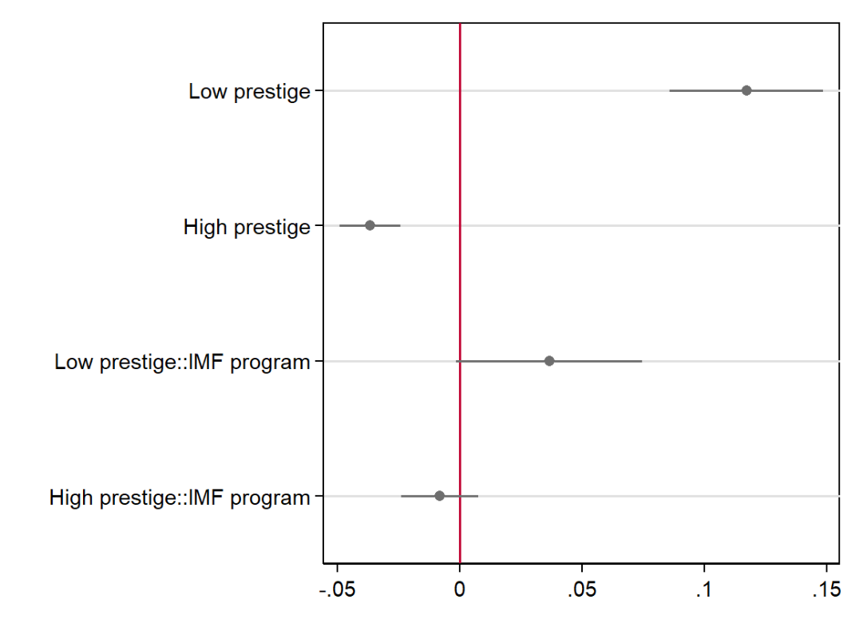

Figure A2: Probability of woman appointee by gender reputation
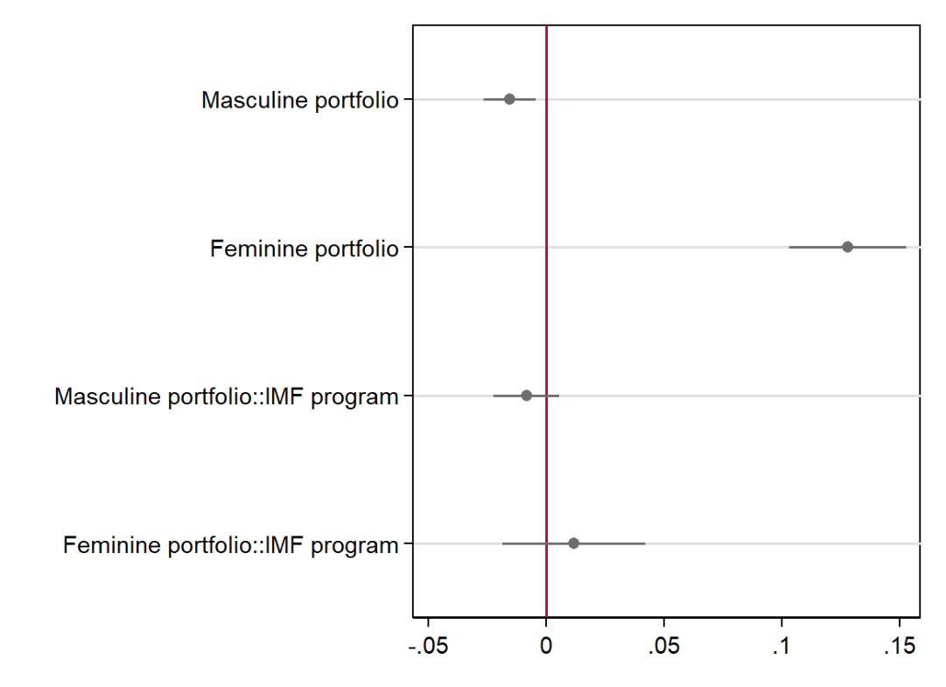

Figure A3: Number of gender-related IMF conditions over time
