Appendix
How Much Does Issue Salience Matter? A Model with Applications to UK Elections

In this appendix, we provide seven sections:
- A detailed explanation of the simulation method for the issue salience model.
- Additional information about the parties’ positions and valence image, and voter preference distributions on the three issues.
- The conditional logit models that inform our simulations, alternative model specifications, including one with a set of sociodemographic control variables, excluding the Left-Right dimension, and excluding the redistribution dimension.
- Extended results of our original simulations.
- More complex simulations with simultaneous variations of salience on two issues.
- Simulation results based on the model that excludes the Left-Right dimension and the model that exclude the redistribution dimension.
- Discussion of additional avenues for further research.

- Counterfactual calculation and the Issue Salience Model
To calculate counterfactual changes to parties’ vote shares we first estimate the parameters of the Issue Salience Model within the conditional logit framework. In particular, this model allows us to observe two important features of the British elections of 2017 and 2019. First, we estimate a baseline voting model that enables us to estimate the expected vote share of each party in each election. Second, the model allows us to estimate the salience of each issue dimension in the British Election Study (BES) surveys (Left-Right, redistribution and EU integration). The size of the coefficients on each issue proximity variable indicates the salience of this dimension for citizens’ vote choices in the election. As the magnitude of the coefficient increases (in negative terms) the electoral salience of the corresponding dimension increases, because the coefficients measure the effect of voter-party proximity on vote choice (e.g., Adams and Merrill 2000; 2005, Adams, Merrill, and Grofman 2005, Alvarez and Nagler 1995; 1998, Calvo and Hellwig 2011, Zur 2021a; 2021b). We use the conditional logit framework to estimate each respondent’s probability of voting for each party.

Table A1 below presents the parameter estimates for the conditional logit model, for the 2017 and 2019 British elections (Model 1 indicates the base model; Model 2 includes control variables and is discussed in Section 3 below). Using these model coefficients, we perform counterfactual simulations to project the effects of changes in the salience of each issue dimension. We follow the methodological approach in the references cited above, among others. These simulations represent voters’ decision rules as probabilistic functions of voter-party proximity in the three-dimensional policy space. Then, we calculate the model-projected probability of each respondent voting for each party and compute changes to each party’s expected vote share – defined as the mean probability that each respondent will vote for the focal party, averaged across all respondents – under the counterfactual conditions of interest. Specifically, we compute parties’ expected vote shares when the salience of each of the three issue dimensions varies from 50% to 200% of the value specified by the salience coefficient estimate. Figures A3-A4 (see section 4 below) display these vote share estimates. We simulate expected vote share changes when only one variable of interest (namely the salience of the focal positional issue dimension) changes, while everything else related to voters’ decision rules and parties’ strategic behavior remains unchanged. Put simply, we hold everything but the salience of a focal issue constant, while calculating the changes in the focal party’s expected vote share.

Table A1. Issue Salience Model including the base model (Model 1), with control variables (Model 2) and excluding the Left-Right dimension (Model 3) and Redistribution (Model 4)
 | 2017 |  |  |  | 2019
 | Model 1 | Model 2 | Model 3 | Model 4 | Model 1 | Model 2 | Model 3 | Model 4
Proximity Variables
Left-Right | -0.466** | -0.454** |  | -0.461** | -0.446** | -0.442** |  | -0.458**
 | (0.025) | (0.026) |  | (0.026) | (0.023) | (0.024) |  | (0.022)
Redistribution | -0.048 | -0.112** | -0.174** |  | -0.163** | -0.231** | -0.291**
 | (0.038) | (0.040) | (0.033) |  | (0.038) | (0.041) | (0.034)
EU integration | -0.238** | -0.210** | -0.293** | -0.210** | -0.336** | -0.322** | -0.338** | -0.322**
 | (0.026) | (0.027) | (0.023) | (0.027) | (0.016) | (0.017) | (0.014) | (0.016)
Intercepts
Labour | -0.017 | 1.625** | 2.003** | 1.583** | -0.581** | 0.611* | 0.892** | 0.478
 | (0.084) | (0.384) | (0.308) | (0.382) | (0.073) | (0.293) | (0.241) | (0.275)
LibDem | -2.079** | -2.121** | -1.387* | -2.116** | -1.680** | -2.000** | -1.510** | -1.861**
 | (0.115) | (0.656) | (0.606) | (0.656) | (0.081) | (0.349) | (0.313) | (0.329)
Greens | -3.319** | -15.075 | -15.735 | -16.153 | -2.968** | -2.478** | -1.975** | -2.481**
 | (0.205) | (348.29) | (540.99) | (628.24) | (0.128) | (0.540) | (0.490) | (0.511)
SNP | -3.053** | -1.307 | -0.824 | -1.308 | 2.946** | -1.270** | -0.816 | -1.540**
 | (0.168) | (0.817) | (0.764) | (0.818) | (0.121) | (0.471) | (0.427) | (0.456)
UKIP/Brexit | -3.113** | -1.475 | -0.827 | -1.368 | -3.404** | -2.055** | -2.679** | -2.420**
 | (0.187) | (0.957) | (0.872) | (0.947) | (0.190) | (0.792) | (0.762) | (0.782)
Control Variables
Labour*Age |  | -0.022** | -0.029** | -0.021** |  | -0.023** | -0.031** | -0.017**
 |  | (0.005) | (0.004) | (0.005) |  | (0.005) | (0.004) | (0.004)
LibDem*Age |  | -0.015* | -0.018** | -0.014* |  | -0.005 | -0.007 | -0.003
 |  | (0.007) | (0.007) | (0.007) |  | (0.005) | (0.005) | (0.005)
Greens*Age |  | -0.016 | -0.019 | -0.016 |  | -0.013 | -0.019* | -0.010
 |  | (0.013) | (0.012) | (0.013) |  | (0.008) | (0.008) | (0.008)
SNP*Age |  | -0.028** | -0.029** | -0.027* |  | -0.024** | -0.026** | -0.020**
 |  | (0.011) | (0.010) | (0.011) |  | (0.008) | (0.007) | (0.007)
UKIP/Brexit*Age |  | -0.002 | -0.008 | -0.002 |  | -0.016 | -0.004 | -0.013
 |  | (0.013) | (0.012) | (0.013) |  | (0.012) | (0.011) | (0.012)
Labour*Female |  | -0.096 | 0.033 | -0.027 |  | 0.200 | 0.285* | 0.105
 |  | (0.153) | (0.125) | (0.151) |  | (0.147) | (0.123) | (0.138)
LibDem*Female |  | -0.357 | -0.350 | -0.319 |  | 0.178 | 0.264 | 0.030
 |  | (0.229) | (0.219) | (0.228) |  | (0.166) | (0.152) | (0.158)
Greens*Female |  | -0.234 | -0.227 | -0.285 |  | 0.241 | 0.328 | 0.100
 |  | (0.414) | (0.393) | (0.408) |  | (0.267) | (0.251) | (0.255)
SNP*Female |  | 0.077 | 0.153 | 0.116 |  | -0.530* | -0.411 | -0.500*
 |  | (0.337) | (0.325) | (0.336) |  | (0.254) | (0.234) | (0.244)
UKIP/Brexit*Female |  | -0.661 | -0.656 | -0.733 |  | -0.268 | -0.491 | -0.366
 |  | (0.391) | (0.370) | (0.388) |  | (0.416) | (0.390) | (0.395)
Labour*Education |  | -0.055 | -0.171 | -0.044 |  | 0.258 | 0.144 | 0.255
 |  | (0.211) | (0.170) | (0.211) |  | (0.149) | (0.124) | (0.140)
LibDem*Education |  | 0.928* | 0.809 | 0.923* |  | 0.649** | 0.517** | 0.577**
 |  | (0.461) | (0.427) | (0.461) |  | (0.172) | (0.158) | (0.163)
Greens*Education |  | 13.143 | 14.103 | 14.375 |  | 0.499 | 0.321 | 0.527*
 |  | (348.29) | (540.98) | (628.24) |  | (0.277) | (0.258) | (0.267)
SNP*Education |  | -1.110** | -1.017* | -1.111** |  | 0.167 | -0.096 | 0.110
 |  | (0.421) | (0.409) | (0.420) |  | (0.250) | (0.230) | (0.242)
UKIP/Brexit*Education |  | -0.863* | -0.847* | -0.920* |  | -0.900 | -0.821 | -0.912
 |  | (0.428) | (0.403) | (0.423) |  | (0.483) | (0.447) | (0.475)
Labour*Political Knowledge |  | -0.474** | -0.356** | -0.391* |  | 0.055 | 0.053 | -0.017
 |  | (0.167) | (0.137) | (0.163) |  | (0.160) | (0.135) | (0.149)
LibDem*Political Knowledge |  | 0.363 | 0.400 | 0.399 |  | 0.630** | 0.537** | 0.563**
 |  | (0.264) | (0.256) | (0.264) |  | (0.185) | (0.170) | (0.175)
Greens*Political Knowledge |  | 0.526 | 0.347 | 0.396 |  | 0.444 | 0.494 | 0.441
 |  | (0.507) | (0.462) | (0.486) |  | (0.296) | (0.279) | (0.284)
SNP*Political Knowledge |  | 0.236 | 0.264 | 0.269 |  | 0.525 | 0.375 | 0.615*
 |  | (0.371) | (0.359) | (0.370) |  | (0.275) | (0.256) | (0.268)
UKIP/Brexit*Political Knowledge |  | -0.731 | -0.634 | -0.760 |  | -0.232 | -0.498 | -0.348
 |  | (0.404) | (0.389) | (0.399) |  | (0.441) | (0.407) | (0.411)
Labour*Political Interest |  | -0.185 | -0.300* | -0.200 |  | -0.356* | -0.212 | -0.298
 |  | (0.180) | (0.149) | (0.179) |  | (0.173) | (0.145) | (0.163)
LibDem*Political Interest |  | -0.069 | -0.370 | -0.082 |  | -0.278 | -0.312 | -0.329
 |  | (0.291) | (0.279) | (0.291) |  | (0.204) | (0.185) | (0.193)
Greens*Political Interest |  | -0.807 | -0.707 | -0.718 |  | -0.557 | -0.644* | -0.579
 |  | (0.487) | (0.474) | (0.484) |  | (0.319) | (0.287) | (0.304)
SNP*Political Interest |  | 0.553 | 0.202 | 0.545 |  | -0.717* | -0.588* | -0.595*
 |  | (0.481) | (0.450) | (0.481) |  | (0.290) | (0.270) | (0.285)
UKIP/Brexit*Political Interest |  | -0.230 | -0.571 | -0.313 |  | 0.093 | 0.293 | 0.194
 |  | (0.428) | (0.384) | (0.416) |  | (0.488) | (0.451) | (0.477)
Observations | 1,451 | 1,442 | 1,535 | 1,449 | 2,208 | 2,095 | 2,275 | 2,341
Pseudo R² | 0.48 | 0.50 | 0.42 | 0.48 | 0.50 | 0.47 | 0.41 | 0.48
Log Likelihood | -1,352 | -1,295 | -1,605 | -1,308 | -2,151 | -1,991 | -2417 | -2,915
Note: Table A1 shows conditional logit estimations of the issue salience model including a set of respondent demographics as control variables in Model 2. In Model 3 we exclude the Left-Right dimension and in Model 4 we exclude the Redistribution dimension. The dependent variable in these models is the respondent’s reported vote choice.

To better grasp our simulation method, consider the 2017 election. The coefficient estimates on the Left-Right, redistribution, and EU integration proximity variables are -0.47, -0.05, and -0.24, respectively. As explained above, a larger coefficient (in absolute terms) implies a lower probability of voting for a focal party as the distances between a voter’s self-placement and the party’s mean perceived position decreases. These values, then, represent the estimated salience of each dimension to the voter’s decision. We first recalculate parties’ expected vote shares when the salience of just the Left-Right dimension is cut to half of the value of the actual parameter estimate (-0.235), and then continue recalculations as the Left-Right coefficient changes in steps of -0.01 until the estimated salience of -0.47 is doubled to the value -0.94. The EU integration and redistribution variables are handled in a similar manner.

- Parties' Positions, Valence Image and other Non-policy variables, and Voter Preferences
Figure A1 below shows the distribution of respondents’ self-placements on each positional issue dimension, as smoothed kernel densities on the three issues in our study – Left-Right ideology, redistribution, and EU integration. The figure also shows the mean-perceived position of six British parties – including the three smaller parties the Greens, the Scottish National Party (SNP) and the United Kingdom Independence Party (renamed the Brexit Party in 2019) – and the position of the median voter (V) on each issue. The figure demonstrates the stability of parties’ perceived positions and voters’ preferences between the two elections, i.e., there are no significant changes between 2017 and 2019.

Figure A1. Voter Self-placement densities and mean-perceived party locations – 2017 and 2019 UK general elections
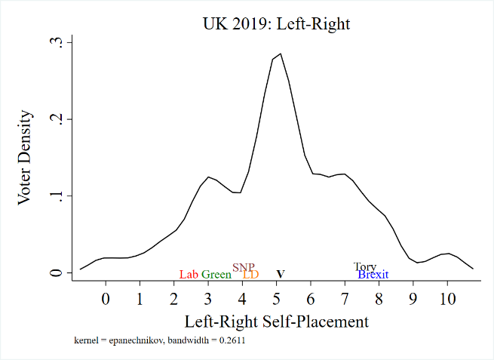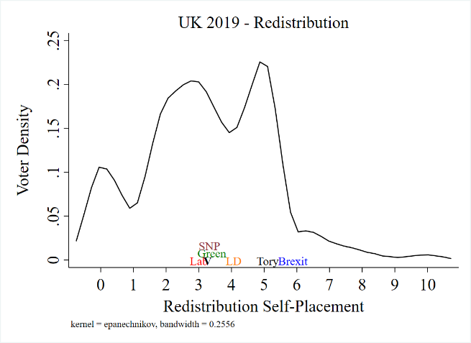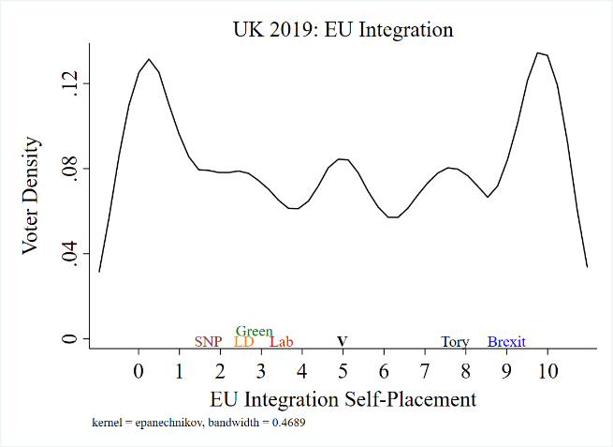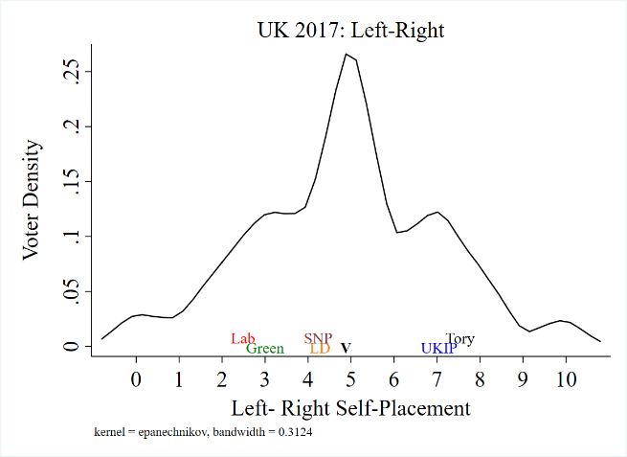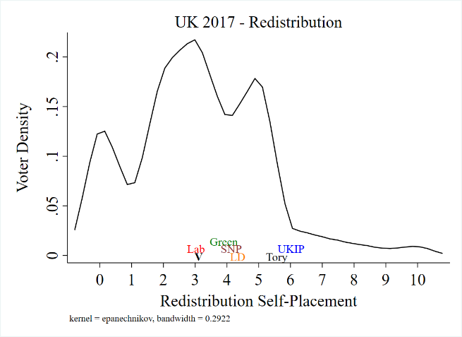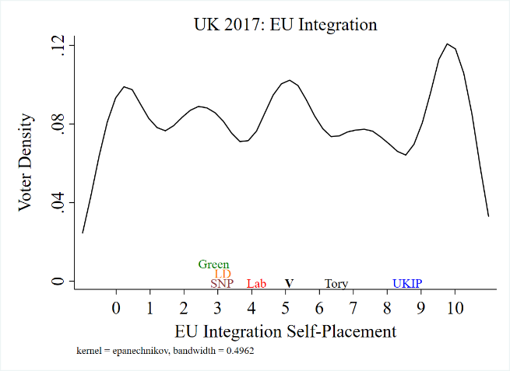
Notes: Figure A1 shows Kernel densities of voter-self placements. Party labels are centered around the parties’ mean perceived position. V marks the Median Voter position on the issue.

To assess the face-validity of the estimated party-specific intercepts as an approximation of parties’ valence image we turn to the descriptive statistics of valence-related questions in the BES data. We note, however, that these variables are not asked with respect to all parties and tend to include a relatively high percentage of missing data. Therefore, we are unable to include them as direct measures of the parties’ valence images for the vote-choice models we estimate.

The first valence-related indicator we analyze is respondents’ answers to the question ‘Which party is best able to handle this issue? We present the percentage of valid responses in Table A2. As one can see, in 2017 the two major parties are perceived as significantly more competent than the other four parties, with the Conservatives having a small advantage relative to Labour. In 2019 there is a clear competence advantage for the Conservative party over all other parties, while Labour is disadvantaged relative to the Conservatives, but advantaged relative to all other parties. These responses are also consistent with our party-specific estimations (intercepts) as proxies for valence, as can be seen in Figure A2.

Table A2. Party competence on the most important issue (% of valid responses)

 | 2017 | 2019
Conservative | 50% | 59%
Labour | 40% | 24%
LibDem | 4% | 5%
Greens | 1% | 6%
SNP | 2% | 4%
UKIP/Brexit | 3% | 1%

Figure A2. Issue Salience Model (all parties)
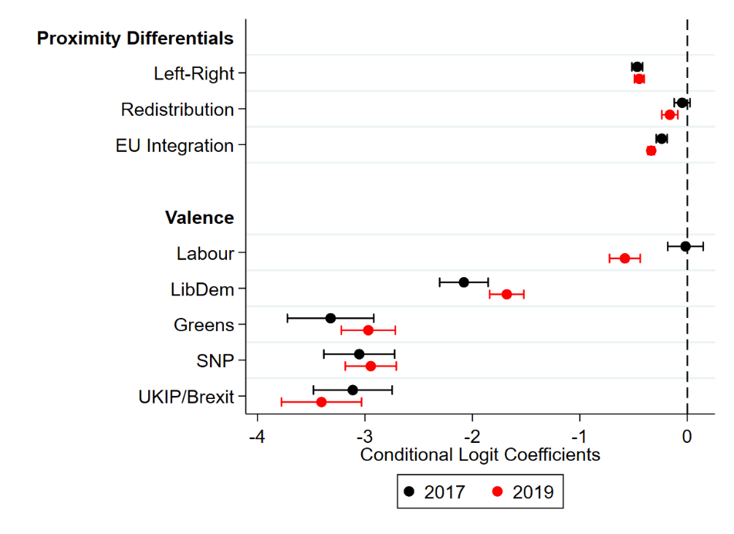
Note: This Figure shows conditional logit estimations of the voting model described in the main text. The dependent variable in these models is respondents’ reported vote choice. Nodes show conditional logit log-odds coefficients. Bars show 95% confidence intervals. Model information:
2017: Log likelihood = -1351.7, N=1451, Pseudo R²=0.48
2019: Log likelihood = -2151.1, N=2208, Pseudo R²=0.46

The second valence-related indicator we turn to is party leaders’ likeability. Voters were asked, “Using a scale that runs from 0 to 10, where 0 means strongly dislike and 10 means strongly like, how do you feel about [Party J’s leader]”. The answers to this question (see Table A3) are another good example of the face validity of our party-specific intercepts. First, we can see that almost all voters know the leaders of the Conservative and Labour parties, but most people do not have an opinion about or never heard of the leaders of the other parties. This gives descriptive evidence that the larger two parties enjoy a name-recognition advantage relative to the smaller ones. Among those who know the party leaders, Boris Johnson (2019) was rated as more likeable than Teresa May (2017) as the leader of the Conservative party, and respondents liked Jeremy Corbyn (Labour’s leader) in 2017 significantly more than in 2019. This gives evidence for our claim that the Conservatives enjoyed a large valence advantage in 2019, but not in 2017, relative to Labour.

We continue with a measure of the parties’ trustworthiness image. Respondents were asked if they view each party as a party that “Keeps its promises”, “Breaks its promises”, or “Neither or both”. In Table A4 we report the percentage of respondents who answered that the focal party keeps its promises. Unfortunately, this question was asked with regard to only three parties (Conservative, Labour, and LibDem), but we can clearly see that in this case, the trustworthiness image of the Conservatives is better than the image of Labour and the LibDems in 2019 and that Labour’s image is better than the LibDems’ image. In 2017, however, Labour was perceived as the most trustworthy party, while the Conservative party came second.

Taking all these indicators together, we think that using party-specific intercepts to model the (relative) valence dynamic between parties is sufficiently reliable. We further discuss these intercepts below.

Table A3. Party Leaders’ Likeability (% of valid responses)

Party | 2017 |  |  | 2019
 | Leader | Ave. Score | % Missing | Leader | Ave. Score | % Missing
Conservative | May | 4.4 | 1.3 | Johnson | 4.8 | 1.8
Labour | Corbyn | 4.8 | 1.7 | Corbyn | 2.9 | 0.7
LibDem | Farron | 4.1 | 24.3 | Swinson | 3.6 | 20.1
Greens | Lucas | 4.9 | 39.8 | Bartley | 4.5 | 73.3
SNP | Sturgeon | 4.4 | 92.0 | Sturgeon | 5.5 | 91.3
UKIP/Brexit | Nuttall | 2.3 | 31.5 | Farage | 2.9 | 13.5

Table A4. Party keeps its promises (% of valid responses)

 | 2017 | 2019
Conservative | 11.2% | 21.4%
Labour | 21.8% | 13.3%
LibDem | 7.26% | 8.5%

- The Issue Salience Model – Alternative Specifications
The simulations in the main text and the alternative specification below are based on multinational conditional logit models. As we have seen, Figure A2 presents estimates for the policy salience coefficients and the party-specific non-measured components V_{j} for the issue salience voting model, which are computed from the 2017 and 2019 British Election Study data (the baseline Conservative Party’s nonpolicy intercept V_{j} was set to zero). We see that Left-Right ideology was the most salient positional dimension in both elections, followed by European integration. With respect to parties’ non-policy attributes V_{j}, the estimates for the Liberal Democrats are sharply negative in both elections, while those for Labour are negative in 2019 and near zero (and hence near that of the Conservatives) in 2017. These estimates show that, relative to the Conservatives, all other parties suffered non-policy disadvantages in one or both elections: the Labour Party from a modest deficit in 2019; the Liberal Democrats from serious deficits in both elections, such that voters were unlikely to support the Lib Dems for reasons beyond their issue positions. These coefficients are estimated from a conditional logit model that includes the linear proximity differentials on the three dimensions and party-specific intercepts that capture parties’ non-policy attributes. The proximity differentials are calculated as the absolute value of the voter’s self-placement and the focal party’s mean-perceived position on each dimension.

Table A1 above assesses the robustness of our results through an alternative model specification, in which we include, in addition to the proximity measures on the three dimensions and the non-policy/valence terms, a set of respondents’ demographic characteristics as control variables. The table includes the results of the conditional logit models from the 2017 and 2019 elections. In the conditional logit framework, the respondent’s characteristics are interacted with each party choice to obtain the effect of the controls. By doing so, we can estimate the relationship between a respondents’ attribute, for example, the effect of gender on the probability of voting for a focal party relative to the baseline category (taken as the Conservative party). For example, women are not more likely to vote for Labour than for the Conservative party but are more likely to vote for the SNP over the Conservative party in 2019 than in 2017.

The set of control variables we include in Model 2 presented in Table A1 are:
- Age – coded as a continuous variable ranging from 18 to 99.
- Gender – coded as a dummy variable where 0=male and 1=female.
- Education – coded as a dummy variable where 1 is any post-high school education, and 0 otherwise.
- Political knowledge – coded as a dummy variable where 1 is above the sample’s median number of correct answers in the BES political knowledge questions, and 0 otherwise.
- Political interest – coded as a dummy variable with 0 for respondents who self-reported no or little interest in politics and 1 for respondents who self-reported some or a lot of interest in politics.
We note that adding these control variables only modestly improves our model fit. Additionally, for most controls and most parties, there is no detectable effect. Hence, we find it reasonable to focus our simulations on the simple Model 1 presented in Table A1 and in Figure A2.
We also analyze alternative model specifications in which we exclude the Left-Right dimension and the redistribution dimension. The Left-Right dimension has often been described as a general ideological dimension (e.g. Bakker, Jolly, and Polk 2020; Magyar, Wagner, and Zur 2023) that encompasses both economic and social issues. As such, it might be unclear how voters consider and how parties emphasize this dimension. While parties often use the terms “Left” and “Right” in the campaign, both positively about themselves and negatively about their competitors, we check the robustness of our models and simulations by estimating two alternative specifications in which we (1) exclude the Left-Right dimension, and (2) exclude the redistribution dimension from our analysis. In Models 3 and 4 in Table A1 above, we show that there are no substantive differences from the model that includes all three dimensions simultaneously (model 2). As one should expect, when we exclude the Left-Right or redistribution dimension the magnitude of the other two policy differential increases slightly. Meaning that, as the literature suggests, the Left-Right dimension includes both economic and social policies. There are also some minor changes to the magnitude of party-specific non-measured intercepts, which is expected given our knowledge of the role of these intercepts (Mauerer 2020), as well as some minor differences in the magnitude and significance level of the controls. Yet, none of these minor differences should change the methodological or substantive conclusions we presented in the main text.

- The empirical projections of the Issue Salience Model – Extended Results
Figures A3 and A4 present the party vote share projections computed based on the coefficient estimates for the issue salience model. That is, we display computations on how parties’ expected vote shares change as a function of changes in the importance (salience) voters attach to each of the three positional issue dimensions (Left-Right ideology, redistribution, and EU integration). Figures A3.1 and A3.2 show expected changes in parties’ vote share in the 2017 and 2019 elections, respectively. Figures A4.1 and A4.2 show the same projections, organized by issue dimension rather than party. The x-axis in these figures represents the simulated salience of the focal dimension which covers the range from 50% to 200% of its estimated value in the focal election.

Figure A3.1. Expected vote share by party as a function of simulated issue salience: 2017

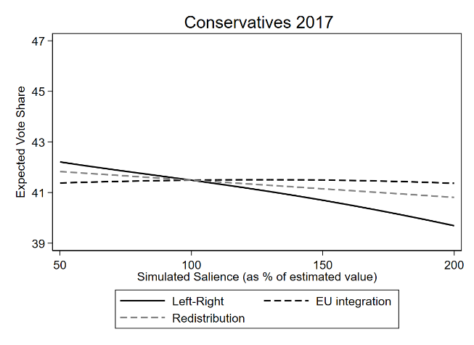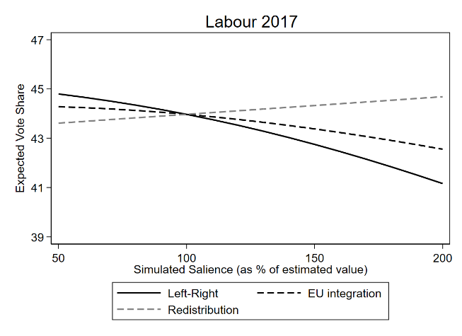
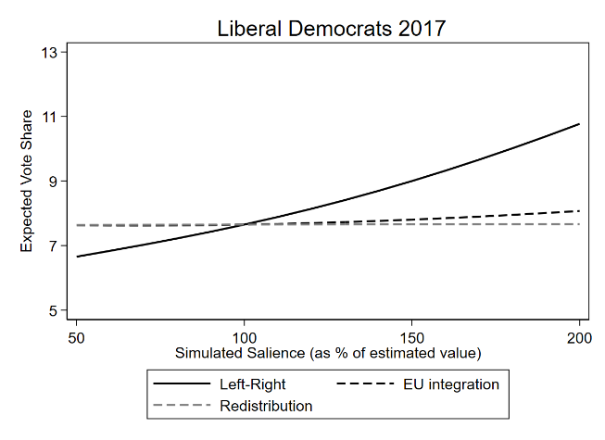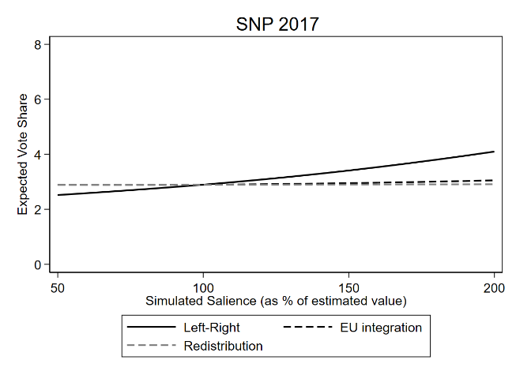
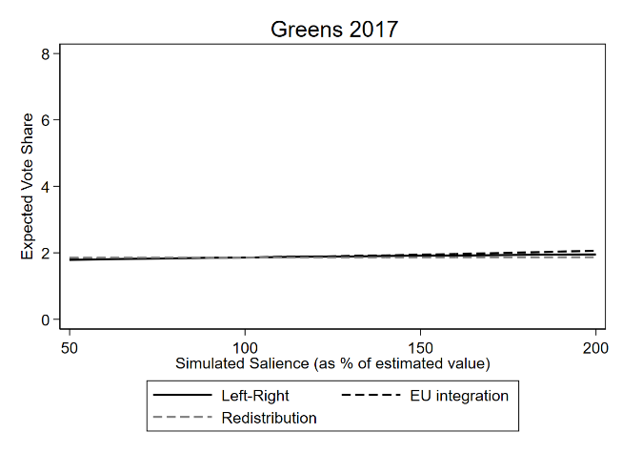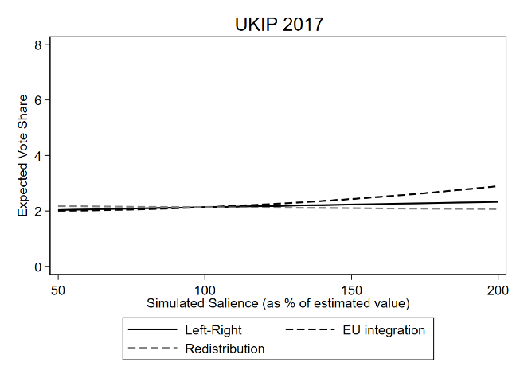

Notes: Figure A3.1 shows changes in parties’ expected vote shares as the simulated salience of the focal issue increases from 50% to 200% of the estimated salience. The estimated (observed) salience (100%) is the conditional logit coefficient from the model presented in Figure 2 in the main text.

Figure A3.2. Expected vote share by party as a function of simulated salience of issues: 2019

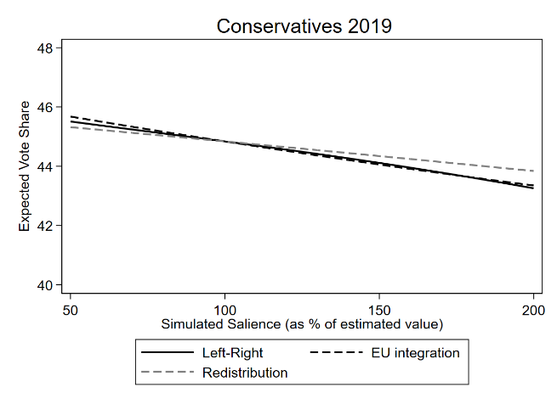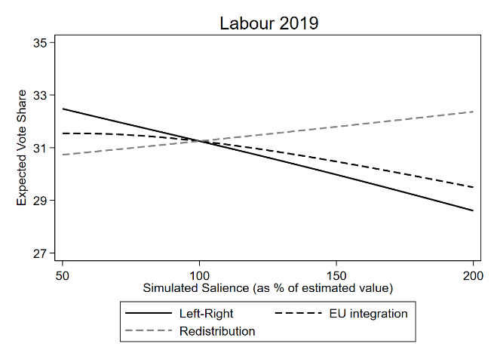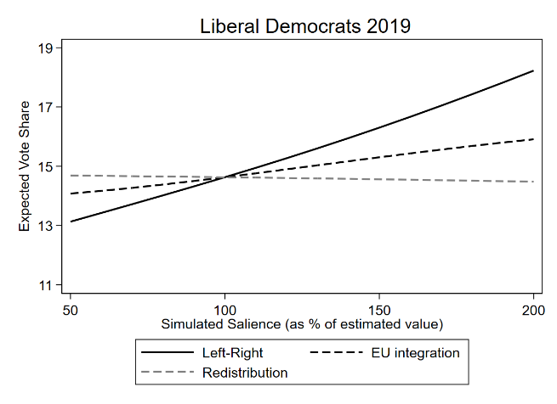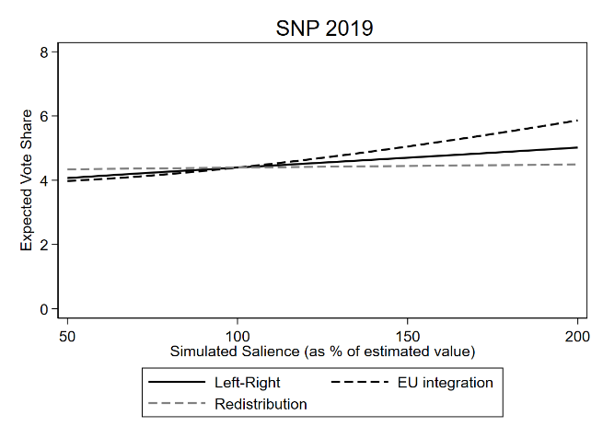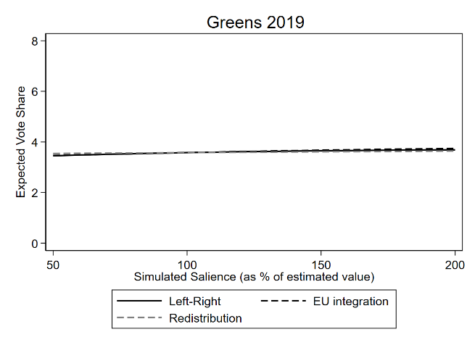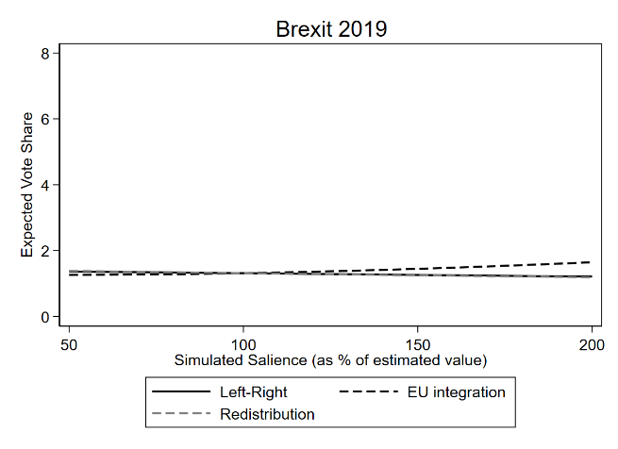

Notes: Figure A3.2 shows changes in parties’ expected vote shares as the simulated salience of the focal issue increases from 50% to 200% of the estimated (observed) value. The estimated salience (100%) is the conditional logit coefficient from the model presented in Figure 2 in the main text. The identical figures for the major three parties are shown in the main text.

Figure A4.1. Expected change in vote share by issue, as a function of simulated salience of issues: 2017

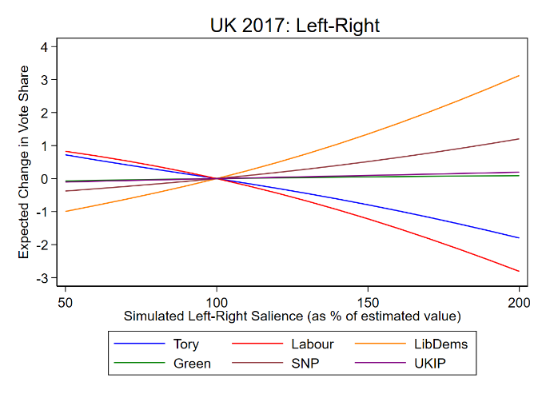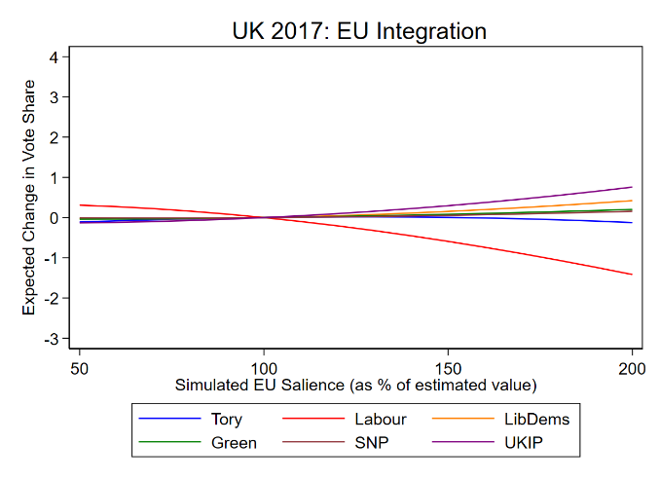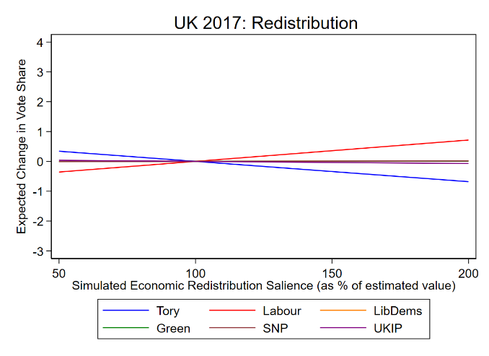

Note: The figure shows changes in parties’ expected vote share as the simulated salience of the focal issue increases from 50% to 200% of the estimated (observed) value. The estimated salience (100%) is the conditional logit coefficient from the model presented in Figure 2 in the main text.

Figure A4.2. Expected change in vote share by issue, as a function of simulated salience of issues: 2019

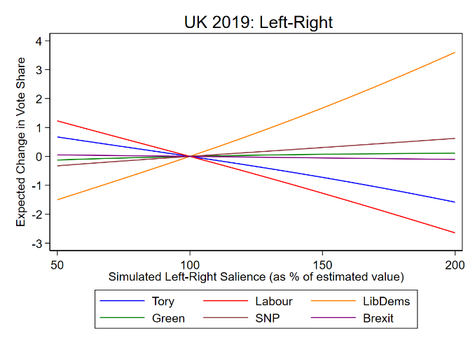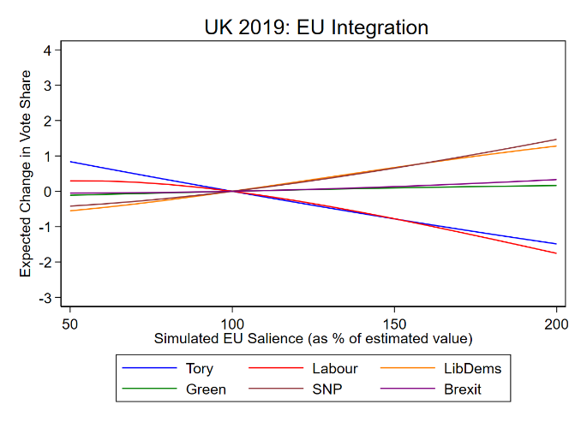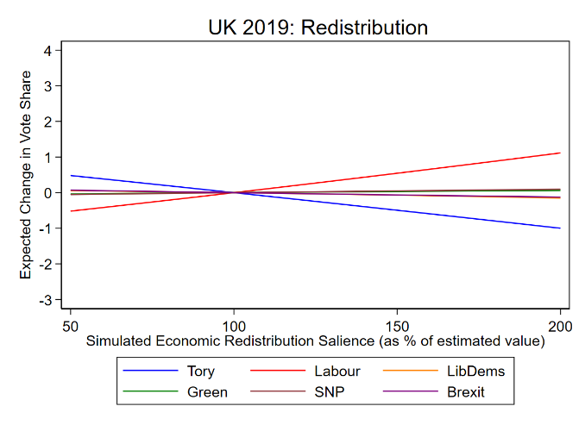

Note: This figure shows changes in parties’ expected vote shares as the simulated salience of the focal issue increases from 50% to 200% of the estimated value. The estimated salience (100%) is the conditional logit coefficient from the model presented in Figure 2 in the main text.

Table A5 below summarizes the information in Figures A3 and A4 above. For each election there are 18 party-issue pairs, and the estimates reported in the table represent the total projected change in percent of party vote share, as the issue-salience of the focal dimension is varied over the 50%-200% range. Hence positive (negative) values denote that the party’s project vote increases (decreases) as the issue’s salience is increased from 50% to 200% of its estimated value in the election. Projected vote share changes of more than one percentage point (which we take as our criterion for a substantively significant change) are indicated in bold. We discuss the important take-aways from these tables in the main text. The vote shares of the smaller British parties, i.e., the Greens, SNP, and UKIP/Brexit, are in most cases only slightly affected by changes in issue salience. However, we project that the SNP could have gained from increased salience of the EU issue in 2019, and from increased salience of the overarching Left-Right dimension in 2017. We also project that the United Kingdom Independent Party (UKIP) could have slightly increased its 2017 vote share if EU integration had been more salient.
Table A5. Salience-projected changes in vote-share UK 2017 and 2019

UK 2019
 | Left-Right | Redistribution | EU integration
Conservatives | -2.25 | -1.48 | -2.33
Labour | -3.87 | 1.63 | -2.05
Liberal Democrats | 5.10 | -0.21 | 1.83
Greens | 0.24 | 0.1 | 0.27
SNP | 0.95 | 0.15 | 1.89
Brexit | -0.16 | -0.19 | 0.38

UK 2017
 | Left-Right | Redistribution | EU integration
Conservatives | -2.52 | -1.02 | -0.01
Labour | -3.64 | 1.07 | -1.72
Liberal Democrats | 4.12 | 0.02 | 0.44
Greens | 0.16 | 0.01 | 0.24
SNP | 1.58 | 0.02 | 0.16
UKIP | 0.30 | -0.11 | 0.89

Note: This Table shows changes to parties’ expected vote share when we varied a focal dimension’s salience from 50% to 200% of the estimated salience (in Figure 2), while we set the other two dimensions’ salience to their observed value (100%).

- Simultaneous Variations of Salience on Two Issues
To substantiate the robustness of our substantive conclusions, we present in Table A6 below a set of alternative counterfactual simulations for which the salience of pairs of issue dimensions varies simultaneously, specifically one dimension’s salience increases from 50% to 200% of the observed salience, while the salience of the other dimension drops from 200% to 50% of the observed salience. This specification is intended to capture the possibility that citizens’ increased attention to one issue entails diminished attention to some other issue, as is plausible if citizens’ total amount of issue attention is relatively fixed. For both the 2017 and 2019 elections we present salience-projected percentage vote share changes for the top six parties in the UK based on six counterfactuals. In column 1 we show the salience-projected percentage vote share changes when the salience of Left-Right (issue A) changes from 50% to 200% of its estimated level, while that of redistribution (issue B) varies from 200% to 50% of its estimated level and the salience of the EU integration is held constant at 100%.
Similarly, in column 2 the salience of Left-Right ideology (again issue A) increases from 50% to 200% of its estimated level, while EU integration is issue B and decreases from 200% to 50% and the salience of redistribution is held constant. In column 3 the salience of Left-Right is held constant, while the salience of redistribution (issue A) increases and the salience of EU integration (issue B) decreases.

Table A6. Salience-projected percentage vote share changes in the UK 2017 and 2019 elections, resulting from simultaneous changes in the salience of pairs of issues

UK 2019
 | A = Left-Right,  B = Redistribution | A = Left-Right,  B = EU Integration | A = Redistribution,  B = EU Integration
 | 1 | 2 | 3
Conservatives | -0.73 | -0.37 | 0.81
Labour | -5.55 | -1.94 | 3.71
Liberal Democrats | 5.30 | 3.68 | -2.04
Greens | 0.14 | -0.02 | -0.17
SNP | 0.80 | -0.80 | -1.72
Brexit | 0.04 | -0.55 | -0.59

UK 2017
 | A = Left-Right,  B = Redistribution | A = Left-Right,  B = EU Integration | A = Redistribution,  B = EU Integration
 | 1 | 2 | 3
Conservatives | -1.40 | -2.60 | -1.00
Labour | -4.80 | -1.91 | 2.79
Liberal Democrats | 4.09 | 3.75 | -0.42
Greens | 0.15 | -0.09 | -0.23
SNP | 1.55 | 1.45 | -0.14
UKIP | 0.41 | -0.60 | -1.00

Note. The values reported in the table represent the salience-projected percentage changes in party vote shares when the salience of issue A increases from 50% to 200% of its estimated (observed) level, while that of issue B declines from 200% to 50% and the salience of the remaining issue is held constant at 100%.

It is informative to compare the values in Table A6 above in which the salience of two issues varies simultaneously, with the values in Table A5 (and Table 1 in the main text) in which these variations are computed separately, i.e., where salience is varied on only one issue at a time. In fact, the projected effect on vote shares of simultaneous changes in the salience of any pair of issues reported in Table A6 above is approximately the value of the combined effects of those changes projected separately, as reported in Table A5. That is, the combined projected vote share effects of varying the salience of two issue dimensions simultaneously is (approximately) an additive function of the effects of varying the salience of each dimension separately, i.e., there appears to be little interactive effect on expected vote share of simultaneously varying the salience of two issue dimensions. We note that we are cautious about extending this substantive conclusion beyond the range of issue salience values we explore here, which range from 50% to 200% of the estimated salience of each dimension. The comparison of simultaneous and separate variation of issue salience is illustrated below in Table A7. These results suggest an estimate of the effect of simultaneous variation of issue salience computed from the (signed) addition of the separate effects of the type we report in our main text may not be substantially changed by direct simulation of the effect of simultaneous variation. Thus, the simultaneous effects of salience variation for multiple issues can be projected from separate simulations each based on a salience variation over a single issue. This supports the robustness of the analyses performed in the main text based on simulations performed on separate issues one at a time.

Table A7. Comparison of simultaneous and separate variation of salience on pairs of issue dimensions

UK 2019
 | A = Left-Right,  B = Redistribution |  | A = Left-Right,  B = EU Integration |  | A = Redistribution,  B = EU Integration
 | Simultaneous | Separate | Simultaneous | Separate | Simultaneous | Separate
 | 1 | 2 | 3 | 4 | 5 | 6
Conservatives | -0.73 | -0.77 | -0.37 | 0.07 | 0.81 | 0.84
Labour | -5.55 | -5.51 | -1.94 | -1.82 | 3.71 | 3.68
Liberal Dems | 5.30 | 5.31 | 3.68 | 3.27 | -2.04 | -2.04
Greens | 0.14 | 0.14 | -0.02 | -0.04 | -0.17 | -0.18
SNP | 0.80 | 0.80 | -0.80 | -0.94 | -1.72 | -1.74
Brexit | 0.04 | 0.04 | -0.55 | -0.54 | -0.59 | -0.58

UK 2017
 | A = Left-Right,  B = Redistribution |  | A = Left-Right,  B = EU Integration |  | A = Redistribution,  B = EU Integration
 | Simultaneous | Separate | Simultaneous | Separate | Simultaneous | Separate
 | 1 | 2 | 3 | 4 | 5 | 6
Conservatives | -1.40 | -1.50 | -2.60 | -2.51 | -1.00 | -1.01
Labour | -4.80 | -4.71 | -1.91 | -1.91 | 2.79 | 2.80
Liberal Dems | 4.09 | 4.09 | 3.75 | 3.67 | -0.42 | -0.42
Greens | 0.15 | 0.15 | -0.09 | -0.08 | -0.23 | -0.23
SNP | 1.55 | 1.56 | 1.45 | 1.42 | -0.14 | -0.14
UKIP | 0.41 | 0.40 | -0.60 | -0.59 | -1.00 | -1.00

Note. Table values for simultaneous variation represent the salience-projected percentage changes in vote shares when the salience of issue A changes from 50% to 200%, while that of issue B varies from 200% to 50% and the salience of the remaining issue is held constant at 100%. Values for separate variation represent the addition of the salience-projected percentage changes in vote shares when the salience of issue A changes from 50% to 200% while that of the other two issues is held constant on the one hand, and the similar changes in vote-shares when the salience of issue B changes from 200% to 50% while that of the other two issues is held constant on the other hand.

- Simulation Results Based on Model 3
In this section we report the simulation results based on Model 3 described above and presented in Table A1. Comparing the changes in the expected vote shares of the major parties in 2019 (presented in Figure A5 below) and the results from the main text (presented in Figure 2), we can conclude that excluding the overarching Left-Right dimension does not alter our substantive results. That is, in both cases, Labour is expected to gain votes when the salience of redistribution increases and lose votes when the salience of EU integration increases, while the opposite is true for the Liberal Democrats, and the Conservative party is expected to lose votes when either of the two dimensions’ salience increases. The same is true when we perform the simulation based on a model the exclude redistribution (Model 4 in Table A1). We present these simulated results in Figure A6.

Figure A5. Expected vote share by party as a function of simulated salience of Redistribution and European Integration: 2019

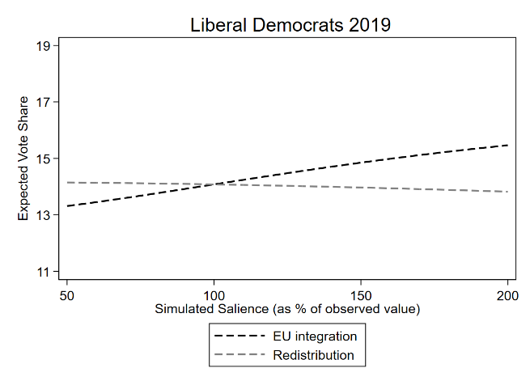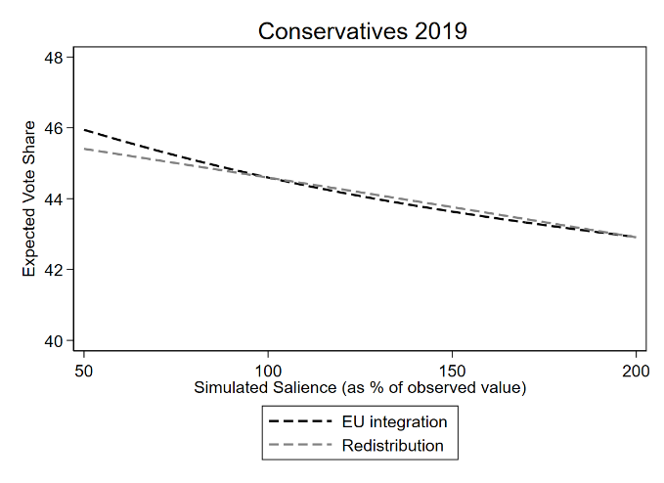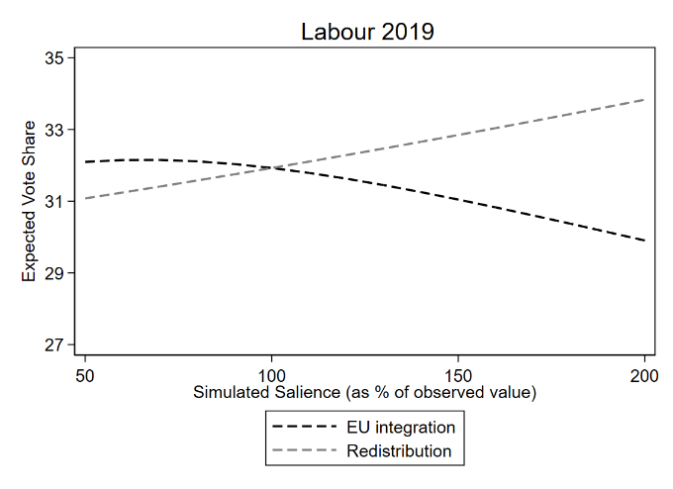

Figure A6. Expected vote share by party as a function of simulated salience of Left-Right and European Integration: 2019

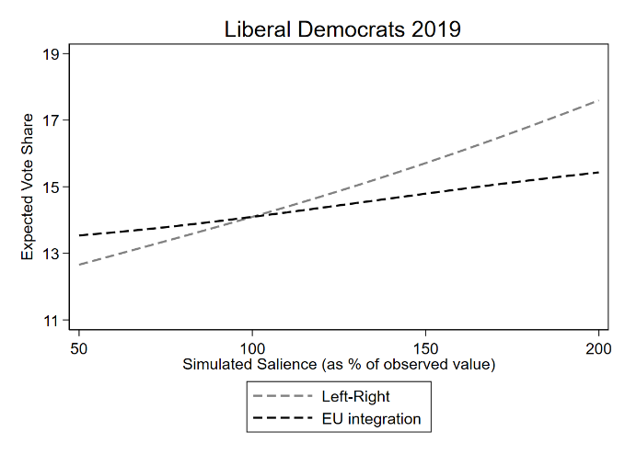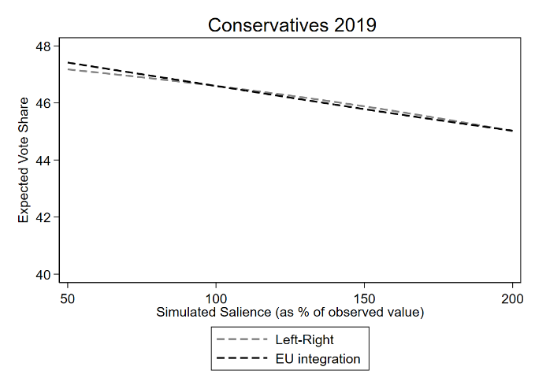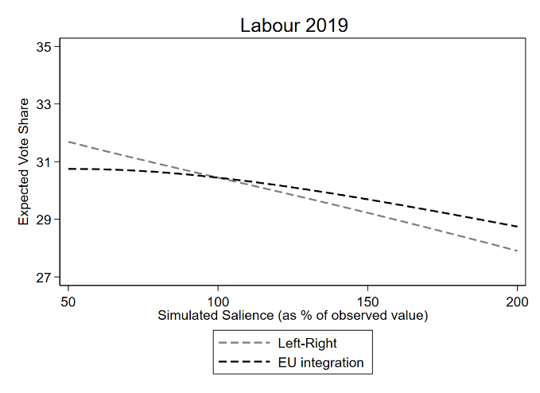

- Avenues for Further Research
Altering issue salience as a party strategy: We have used the observed degree of issue salience in a specific election to anchor the interval over which salience is varied. But the observed degree of salience is, of course, endogenous to the analysis. As indicated above, the level of emphasis in a particular election depends on efforts by one or more parties to influence that level, as well as on external events, media response, and the potential emotional energy that an issue might generate.

Uncertainties notwithstanding, insofar as a party has the resources and the opportunity to bring about salience changes – either increases or decreases – our findings suggest strategies that such a party might take. If in fact, a party can influence the salience that voters attach to a given issue, then a particular portion of the interval over which salience is analyzed (for example, from 50% to 100% of observed, or, alternatively, from 100% to 200% of observed) may be most relevant. For most UK parties and issues, however, the vote share vs salience curves (Figure A3.1 and A3.2) are fairly close to linear, so that the slope of the curve does not change greatly over the salience values in the interval we use, so that an endogenous anchor point may not matter much. Still, in some cases, there is some variation in slope, as for the Liberal-Democrats on Left-Right in 2017, so that in particular, the Liberal-Democrats appear to have a bit more to gain by increasing the salience of Left-Right beyond that observed (specified as 100% in the Figures) than they might lose if it decreased below that observed. Such effects, however, appear to be small.

Furthermore, according to the expectations outlined in the main text, influences on the salience of any given issue are often outside the control of a specific party and are typically uncertain. Thus, parties can be expected to have only a very general idea of the likely effects of any attempts to set the issue salience at the desired level.

References
Adams, J. and Merrill, S. 2000. “Spatial models of candidate competition and the 1988 French presidential election: Are presidential candidates vote-maximizers?” Journal of Politics 62(3): 729–756.

Adams, J. and Merrill S. 2005. "Candidates’ Policy Platforms and Election Outcomes: The Three Faces of Policy Representation." European Journal of Political Research 44(6):899-918.

Adams, J., Merrill, S. and Grofman, B. 2005. A Unified Theory of Party Competition: A Cross-National Analysis Integrating Spatial and Behavioral Factors. Cambridge University Press.

Alvarez, R. Michael and Jonathan Nagler. 1995. “Economics, issues and the Perot candidacy: Voter choice in the 1992 presidential election.” American Journal of Political Science 39(3): 714–744.

Alvarez, R. Michael and Jonathan Nagler. 1998. Economics, entitlements and social issues: Voter choice in the 1996 presidential election. American Journal of Political Science 42(4): 1349–1363.

Bakker, Ryan, Seth Jolly, and Jonathan Polk. "Multidimensional incongruence, political disaffection, and support for anti-establishment parties." Journal of European public policy 27, no. 2 (2020): 292-309.

Calvo, E. and Hellwig, T. 2011. “Centripetal and Centrifugal Incentives under Different Electoral Systems.” American Journal of Political Science, 55: 27-41.

Magyar, Agnes, Sarah Wagner, and Roi Zur. "Party strategies: Valence versus position." The Routledge Handbook of Political Parties (2023): 199-210.

Mauerer, Ingrid. "The neglected role and variability of party intercepts in the spatial valence approach." Political Analysis 28, no. 3 (2020): 303-317.

Zur, R. 2021a. “Stuck in the middle: Ideology, valence and the electoral failures of centrist parties.” British Journal of Political Science, 51(2), 706-723.

Zur, R. 2021b. “The multidimensional disadvantages of centrist parties in Western Europe.” Political Behavior, 43, 1755–1777.

The wording for these questions are: Left-Right: “In politics people sometimes talk of left and right. Where would you place yourself on the following scale?” … where the end marked 0 means Left and the end marked with 10 means Right. Economic redistribution: “… where the end marked 0 means that government should cut taxes a lot and spend much less on health and social services, and the end marked 10 means that government should raise taxes a lot and spend much more on health and social services, where would you place yourself on this scale?”. European Integration: Ranging from “Britain should do all it can to unite fully with the European Union” (0) to “Britain should do all it can to protect its independence from the European Union” (10).
In these analyses, the number of observations equals the number of parties in the system multiplied by the number of survey respondents that reported their vote. For example, in 2017, 1,451 respondents reported their vote in the BES data and placed themselves on all three dimensions; given that we estimate the model for 6 parties, the total number of observations in our 2017 models is 8,706.
Note that the vote share change when the salience of an issue changes from 200% to 50% (with other saliences held fixed) is simply the negative of the vote share change when the salience of the same issue changes from 50% to 200% (the latter values are available from Table A5 or from Table 1 in the main text). Furthermore, let V(50, 200) denote the vote share for a focal party when the salience of issue A is at 50% and the salience of issue B is at 200%. Similarly, V(200, 50) is the vote share when salience of A is 200% and that of issue B is 50%, etc. Then the vote share change when the salience of issue A changes from 50% to 200% while simultaneously the salience of issue B changes from 200% to 50%, is given by: V(200, 50) – V(50, 200); similarly, the vote share change when the salience of issue A changes from 200% to 50% while simultaneously the salience of issue B changes from 50% to 200% is given by: V(50, 200) - V(200, 50), which is exactly the negative of the quantity in bold above.
An example, however, of a situation where simultaneous variation in salience might give different results than can be computed from separate variation in salience might occur in a two-dimensional spatial model where first voters choose deterministically for the closest party on dimension 1, then choose deterministically for the closest party on dimension 2.

