Appendix 1 – Sources of Data

A1.1 Command papers

Command papers published after the beginning of the 2007-2008 parliament (coinciding with the start of the Brown government) can be found on the UK government official documents portal, gov.uk/official-documents. Command papers published before that date can be obtained from the House of Commons library archive, available through ProQuest (parlipapers.proquest.com). Papers are referred to by their number, with the prefix Cmnd. (up to 1986), Cm. (1986-2018), and CP (2018-).
There were 4366 non-treaty command papers published between 1 January 1983 and 1 August 2021. A limited number of papers are very long, usually due to appendices. The length of the documents has been limited to approximately the first 20000 words (in practice 20000*5 characters, including whitespace). To process the documents, those present in less than .05% and more than 75% of documents have been removed – as they are very unlikely to lead to meaningful topics, as were all one- and two-character words.
Examples of fragments from various command papers are included below:

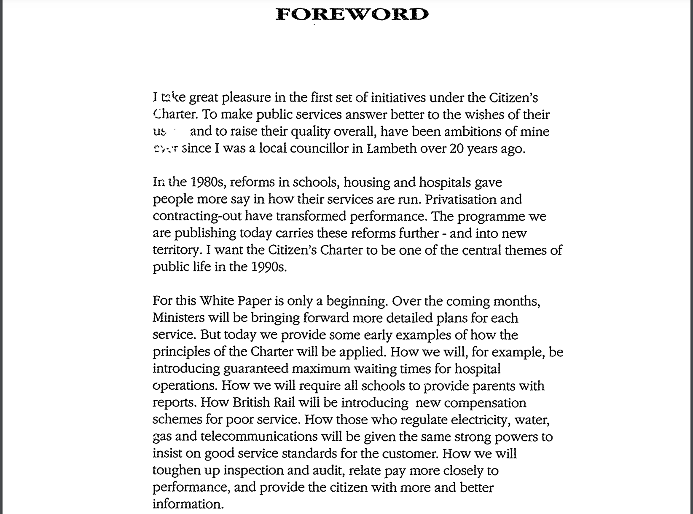
Example 1: Cm. 1599 – The Citizen’s Charter, from 1991

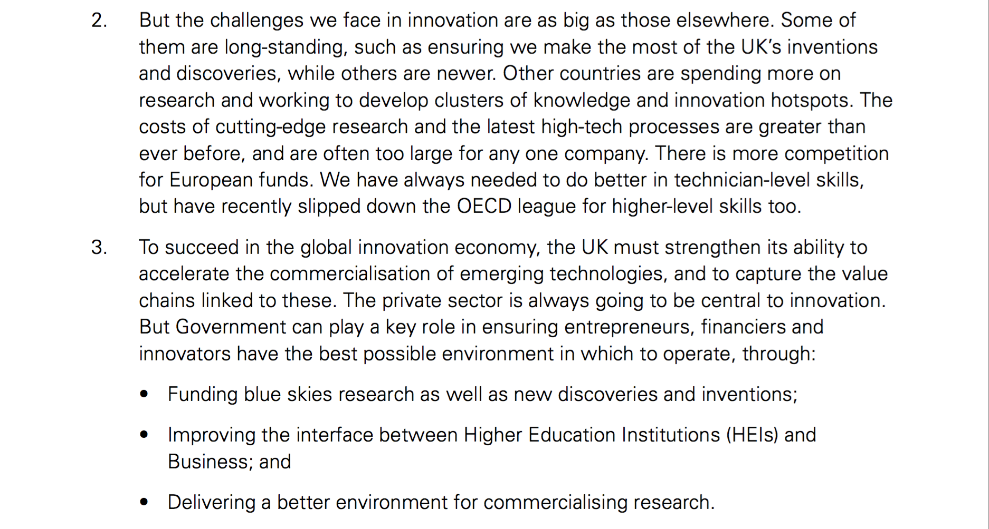
Example 2: Cm. 8239 – Innovation and Research for Growth, from 2011

A.1.2 COFOG Spending Data

The data from 1995 onwards was collected from the OECD (stats.oecd.org). The limited data series from before 1983-1995 come from Cm. 3901, table 3.2. The full classification is:

General public services (Executive and legislative organs, financial and fiscal affairs, external affairs; Foreign economic aid; General services; Basic research; R&D general public services; General public services nec; Public debt transactions; Transfers of a general character between different levels of government)

Defence (Military defence; Civil defence; Foreign military aid; R&D defence; Defence nec ; Public order and safety; Police services; Fire-protection services; Law courts; Prisons; R&D public order and safety; Public order and safety nec)

Economic affairs (General economic, commercial and labour affairs; Agriculture, forestry, fishing and hunting; Fuel and energy; Mining, manufacturing and construction; Transport; Communication ; Other industries; R&D economic affairs; Economic affairs nec)

Environmental protection (Waste management; Waste water management; Pollution abatement; Protection of biodiversity and landscape; R&D environmental protection; Environmental protection nec)

Housing and community amenities (Housing development; Community development; Water supply; Street lighting; R&D housing and community amenities; Housing and community amenities nec)

Health (Medical products, appliances and equipment; Outpatient services; Hospital services; Public health services; R&D health; Health nec)

Recreation, culture and religion (Recreational and sporting services; Cultural services; Broadcasting and publishing services; Religious and other community services; R&D recreation, culture and religion; Recreation, culture and religion nec)

Education (Pre-primary and primary education; Secondary education; Post-secondary non-tertiary education; Tertiary education; Education not definable by level; Subsidiary services to education; R&D education; Education nec)

Social protection (Sickness and disability; Old age; Survivors; Family and children; Unemployment; Housing; Social exclusion nec; R&D social protection; Social protection nec)

A.1.3 Cabinet papers

Cabinet meeting minutes (officially called cabinet conclusions) are available under the CAB 128 category at the National Archives (nationalarchives.gov.uk). For each meeting, the foreign affairs section of the document has been eliminated, to parallel the command papers corpus, and each agenda item has been coded as a document. There are 2034 such agenda items. The following presents one relatively short entry, on a postal services strike, in 1988:

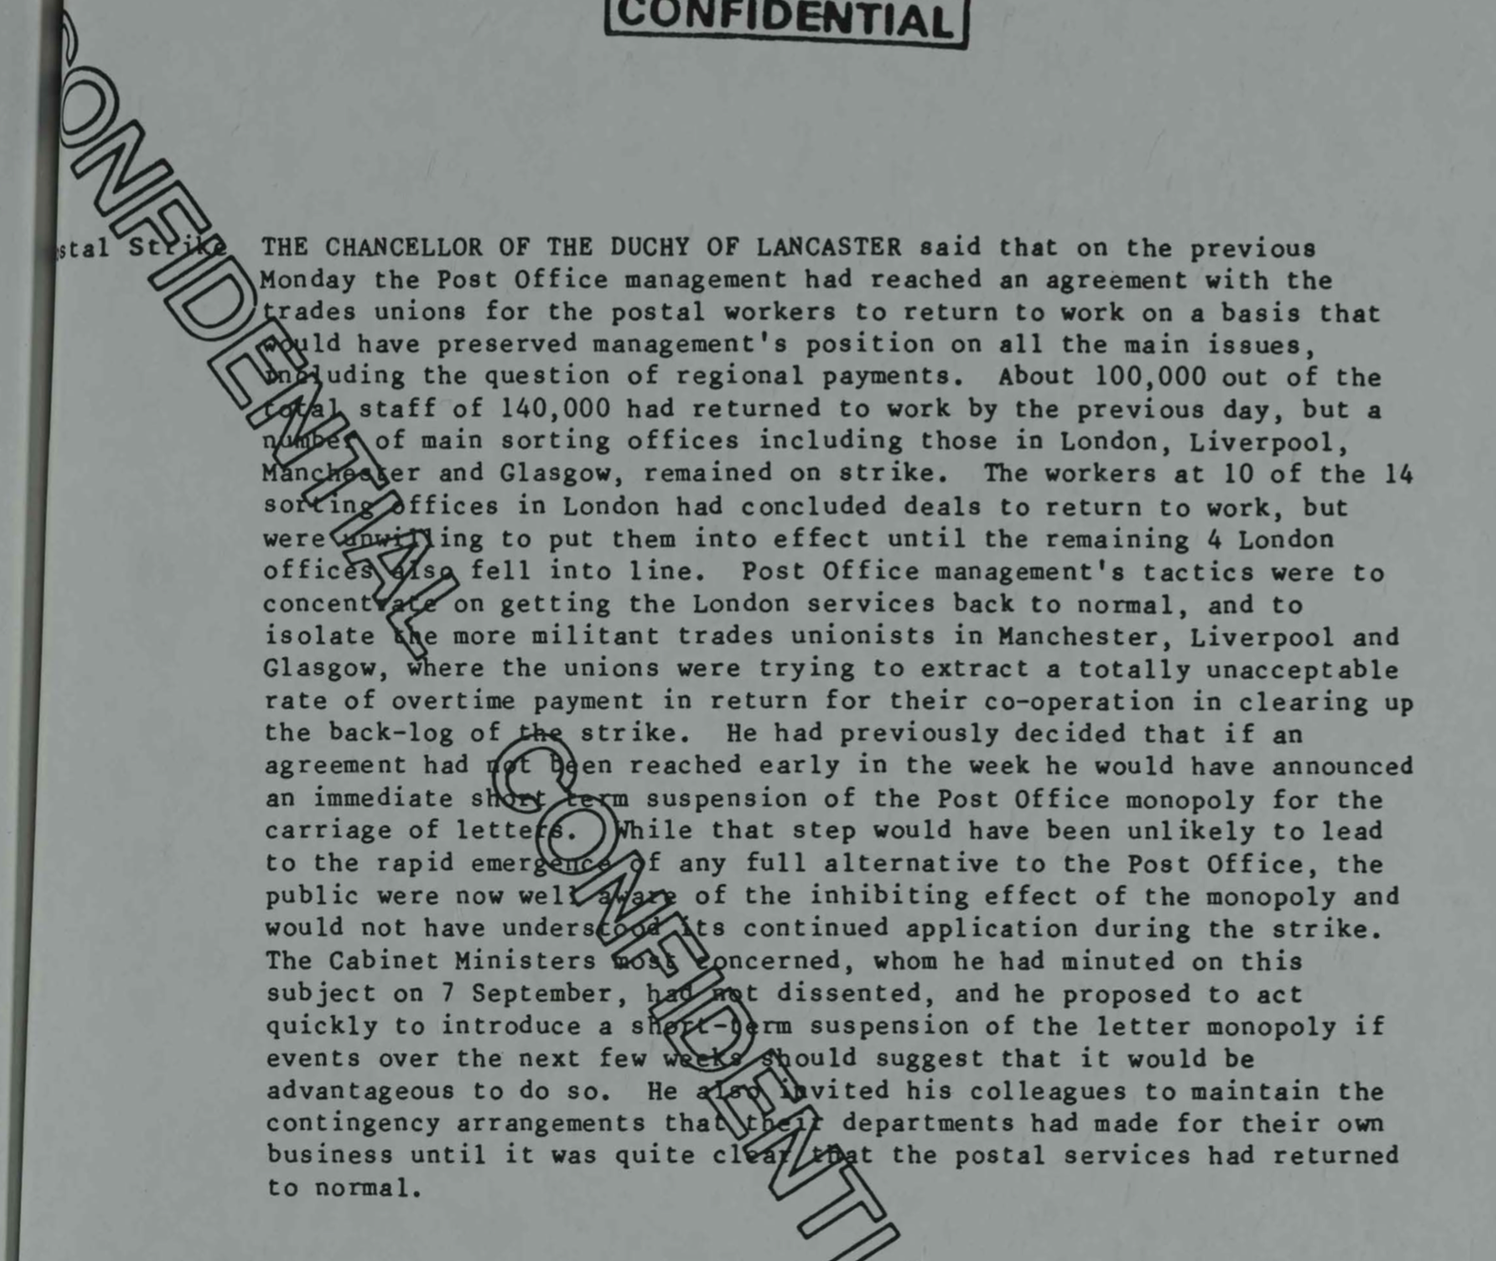
Example 4: Presentation on a strike, 1988

Appendix 2 – Further Results on the Command Papers Corpus

2.1 Full results for K=20
Topic model with 20 topics, 4366 documents and a 15962 word dictionary.
Topic 1: Independent inquiry reports
Highest Prob: committee, evidence, cases, present, staff, might, recommendations
FREX: complaints, para, wkh, inquiry, complaint, death, investigation
Lift: mittee's, conscientious, wkh, recollection, verdicts, fatality, mendation
Score: coroner, murder, wkh, inquiry, recommend, death, complaints
Representative documents: Statement of changes in immigration rules, Draft public service ombudsman bill, Public inquiry into the identification of victims following traffic accidents.
Notes: This topic deals with both government responses to parliamentary committee inquiries, and independent inquiries, including government responses to them.
Topic 2: Immigration
Highest Prob: per, cent, immigration, united, applications, kingdom, entry
FREX: indian, continent, nationals, nationality, acceptances, immigration, asylum
Lift: ati, ghana, nationalities, bangladesh, abode, americas, visa
Score: immigration, asylum, indian, cent, continent, americas, acceptances
Representative documents: Control of immigration statistics, Control of immigration statistics, Control of immigration statistics
Notes: Both representative words and representative documents refer to immigration and asylum matters.
Topic 3: Public consultations and committee inquiries
Highest Prob: committee, response, recommendation, consultation, process, risk, local
FREX: committee's, agrees, pac, recommendation, responses, respondents, response
Lift: atos, descriptors, wca, pac, mutuals, ehrc, dashboard
Score: pac, recommendation, committee's, respondents, regulatory, consultation, committee
Representative documents: The Queen’s ambulance service medal, Government response [...] on the effectiveness of local authority overview and scrutiny committees, Government response to the annual report on the operation of the terrorism act [...].
Notes: There is some overlap between this and topic 1. Representative documents for this topic also include matters related to public consultations (green papers).
Topic 4: Economic outlook
Highest Prob: per, cent, economic, growth, spending, forecast, billion
FREX: gdp, wage, fiscal, forecast, banks, outlook, obr
Lift: cyclically, chote, dfid's, efo, hipc, obr's, psnb
Score: gdp, obr, cent, forecast, per, wage, spending
Representative documents: Economic and fiscal outlook, Economic and fiscal outlook, Economic and fiscal outlook.
Notes: Representative documents include mostly "economic and fiscal outlook" publications from the Office for Budget Responsibility. These documents present independent analyses of government expenditure plans and their impacts on economic output (economic growth).
Topic 5: Devolution and international/treaties
Highest Prob: ireland, northern, scotland, scottish, wales, shall, agreement
FREX: elections, les, convention, election, assembly, article, devolution
Lift: depositary, plenary, ratifications, ratifies, sinn, jmc, assembly's
Score: article, assembly, electoral, shall, les, convention, scottish
Notes: This topic deals with matters related to Wales, Scotland, Northern Ireland (and implicitly the Republic of Ireland), but also international treaties which have not been filtered out.
Topic 6: Research and innovation
Highest Prob: research, business, trade, industry, investment, science, technology
FREX: digital, bbc, innovation, science, broadcasting, universities, arts
Lift: nesta, doctoral, telecoms, ukti, dti's, ecgd, wellcome
Score: ecgd, export, science, bbc, ofcom, innovation, museums
Representative documents: Innovation and research strategy for growth, Innovation and research strategy for growth, Innovation Nation.
Notes: this topic deals largely with matters related to innovation and research, industrial policy, and general business support. A few documents and keywords related to the media, digital policy, and the arts are also included.
Topic 7: Health and safety/agriculture
Highest Prob: food, safety, procedures, animal, per, regulations, research
FREX: animals, animal, meat, asbestos, lung, species, sheep
Lift: allergic, carcinogens, contaminants, ewes, farmed, ionising, potatoes
Score: animal, animals, species, anaesthesia, genetic, tonnes, beef
Representative documents: Scientific procedures on live animals, Scientific procedures on live animals, Scientific procedures on live animals
Notes: This topic deals with public health regulations, especially related to agriculture but also animal rights.
Topic 8: Bills in Parliament
Highest Prob: section, bill, law, person, provisions, provision, regulations
FREX: subsection, clause, schedule, bill, commonhold, section, draft
Lift: commonhold, subsection, subsections, hoggett, eh9, causewayside, revocations
Score: subsection, clause, commonhold, offence, bill, gambling, person
Representative documents: Draft heritage protection bill, Draft registration of overseas entities bill, Draft regulatory enforcement and sanctions bill.
Notes: This topic features representative documents which are draft bills. Governments sometimes publish draft bills as command papers, to attract public comments.
Topic 9: Public sector pay
Highest Prob: pay, per, staff, cent, evidence, recommendations, recruitment
FREX: dms, salary, pay, recruitment, morale, grades, dentists
Lift: ceas, gdps, greenaway, omps, www.ome.uk.com, ddrb, 4ad
Score: dms, teachers, gmps, cent, bda, pay, nhs
Representative documents: Review body for nursing staff, Armed forces’ pay review body, Review body on armed forces pay.
Notes: All representative documents for this topic related to reviews of public sector pay. These are produced annually for the major groups of public sector employees - in healthcare, education, the military, and so on.
Topic 10: Energy and climate (plus transport)
Highest Prob: transport, energy, water, rail, carbon, emissions, electricity
FREX: emissions, hs2, carbon, rail, electricity, renewable, fuel
Lift: decarbonisation, biofuels, chp, crossrail, decarbonise, kwh, ofgem's
Score: hs2, emissions, carbon, energy, crewe, electricity, rail
Representative documents: High speed rail, The UK renewable energy strategy, Gas generation strategy.
Notes: The language and representative documents for this topic relate to the connected issues of energy policy, climate change, and transport. There are many documents related to the HS2 high speed rail project.
Topic 11: Defence
Highest Prob: security, defence, forces, terrorism, intelligence, international, armed
FREX: terrorism, terrorist, interception, nca, raf, terrorists, nato
Lift: navy's, qa'ida, adversaries, ballistic, battalion, berriew, chinook
Score: terrorism, nca, tpim, defence, nato, terrorist, mod
Representative documents: Securing Britain in an age of uncertainty, Delivering security in a changing world, Defending our future.
Notes: These terms and representative documents refer to defense policy, including terrorism.
Topic 12: Justice
Highest Prob: court, cases, legal, justice, courts, law, judicial
FREX: tribunals, judicial, judges, judgments, solicitors, cps, court
Lift: interlocutory, ecthr, habeas, litigated, litigant, litigants, wardship
Score: court, courts, judicial, justice, criminal, cps, magistrates
Representative documents: Judicial statistics, Judicial and court statistics, Judicial and court statistics
Notes: These terms and documents refer to the justice system, but not necessarily crime and policing.
Topic 13: Local government
Highest Prob: local, housing, fire, authorities, planning, area, building
FREX: fire, brigades, trinity, newspapers, fires, borough, titles
Lift: dumbarton, qfsm, riba, chimney, skye, brownfield, strathspey
Score: fire, newspapers, brigades, housing, local, brigade, trinity
Representative documents: Boundary commission for England, Boundary commission for England, The ancient and historical monuments of Argyll
Notes: These terms and documents deal with matters related to planning, local authorities, and locally provided public services.
Topic 14: Public spending
Highest Prob: expenditure, total, capital, table, outturn, net, cash
FREX: del, expenditure, voted, cash, outturn, receipts, ame
Lift: rfr, 9sp, appropriations, cferd, ilps, nlf, rfr1
Score: outturn, receipts, expenditure, del, appropriations, rfr, ame
Representative documents: Charity commission spring supplementary estimates, Office of fair trading winter supplementary estimates, Charity commission winter supplementary estimates.
Notes: The representative documents all refer to expenditure plans for various government departments.
Topic 15: Health
Highest Prob: health, care, nhs, local, social, people, patients
FREX: patients, patient, healthcare, care, nhs, hospitals, mental
Lift: hee, pcts, healthwatch, cqc, cqc's, shas, clinicians
Score: nhs, patients, health, care, patient, clinical, mental
Representative documents: The NHS improvement plan, Pharmacy in England, The NHS and public health service in England.
Notes: Language and representative documents all refer to the public healthcare system.
Topic 16: Education
Highest Prob: people, education, children, schools, local, skills, young
FREX: schools, pupils, parents, school, children's, childcare, qualifications
Lift: numeracy, www.education.gov.uk, childminders, ofsted's, truancy, underachievement, maths
Score: children, parents, schools, education, child, childcare, pupils
Representative documents: Your child, your schools, our future, Schools achieving success, Education and training for the 21st century.
Notes: Language and all representative documents refer to education, including vocational training.
Topic 17: Social insurance
Highest Prob: pension, benefit, scheme, benefits, income, pensions, social
FREX: pension, pensioners, retirement, claimants, pensions, benefit, insurance
Lift: daykin, f.i.a, optants, outgo, serfs, serps, passported
Score: pension, pensions, earnings, claimants, rebates, income, pensioners
Representative documents: Report by the government actuary on the drafts of the social security benefits up-rating order.
Notes: Language and representative documents refer to various aspects of the social insurance system: pensions, welfare benefits, other transfers.
Topic 18: Crime
Highest Prob: police, prison, crime, offences, criminal, justice, offenders
FREX: prisoners, offenders, sentenced, offender, prisons, prison, remand
Lift: borstal, cautioning, reconvicted, remand, sentencers, unsentenced, barlinnie
Score: prison, prisoners, offences, offenders, police, offence, sentenced
Representative documents: Criminal statistics, Criminal statistics, Criminal statistics.
Notes: All documents refer to criminality and policing.
Topic 19: Markets and competition
Highest Prob: per, market, cent, competition, companies, united, sales
FREX: merger, mmc, retailers, monopoly, advertising, sales, stagecoach
Lift: ackers, baillieu, brewers, britz, divestment, eilon, godfray
Score: mmc, cent, stagecoach, market, merger, per, milk
Representative documents: Interbrew SA and Bass plc, Soluble coffee, Sylvan International and Locker group plc,
Notes: Language and representative documents refer to competition policy and merger regulation.
Topic 20: Public sector performance
Highest Prob: performance, target, targets, management, progress, programme, staff
FREX: psa, targets, target, performance, department's, baseline, objectives
Lift: dsos, psa1, psas, sr2002, sr2004, psa4, psa2
Score: psa, outturn, targets, pesa, target, sr2002, sr2004
Representative documents; Annual performance report Cabinet Office, Departmental report Cabinet Office, Departmental report Cabinet Office.
Notes: The representative documents refer to evaluations of departments' targets, performance, and management.

Table A2.1: Full results of the STM for K=20

Number of topics (K) | Semantic Coherence
15 | -14.546
20 | -14.454
25 | -15.213
Table A2.1.2: Semantic coherence for various K

2.2. Full results for K=15

Topic model with 15 topics, 4366 documents and a 15962 word dictionary.
Topic 1 Top Words:
Highest Prob: health, care, nhs, social, patients, staff, mental
FREX: patients, patient, mental, care, healthcare, commissioning, hospitals
Topic 2 Top Words:
Highest Prob: fire, commission, board, committee, scotland, local, area
FREX: fire, brigades, gambling, bbc, fires, geo, brigade
Topic 3 Top Words:
Highest Prob: performance, target, management, targets, progress, programme, business
FREX: psa, pac, targets, target, performance, baseline, corporate
Topic 4 Top Words:
Highest Prob: pension, per, benefit, cent, rate, income, benefits
FREX: wage, pension, fiscal, gdp, pensioners, forecast, retirement
Topic 5 Top Words:
Highest Prob: ireland, wales, northern, scotland, shall, scottish, assembly
FREX: assembly, electoral, convention, article, elections, shall, les
Topic 6 Top Words:
Highest Prob: research, food, safety, procedures, regulations, science, animal
FREX: animals, animal, asbestos, lung, genetic, meat, species
Topic 7 Top Words:
Highest Prob: per, market, cent, companies, competition, united, million
FREX: merger, newspapers, mmc, titles, newspaper, advertising, monopoly
Topic 8 Top Words:
Highest Prob: section, law, bill, person, cases, legal, consultation
FREX: clause, subsection, schedule, fee, person, notice, disclosure
Topic 9 Top Words:
Highest Prob: pay, per, staff, cent, evidence, recommendations, recruitment
FREX: salary, dms, pay, dentists, retention, morale, recruitment
Topic 10 Top Words:
Highest Prob: transport, energy, water, rail, environmental, carbon, emissions
FREX: emissions, hs2, carbon, rail, electricity, renewable, fuel
Topic 11 Top Words:
Highest Prob: police, security, defence, crime, forces, terrorism, home
FREX: terrorism, terrorist, policing, nca, interception, cyber, nato
Topic 12 Top Words:
Highest Prob: court, justice, criminal, offences, per, courts, cent
FREX: sentence, offenders, sentenced, sentences, cps, offences, offender
Topic 13 Top Words:
Highest Prob: local, authorities, sector, funding, response, housing, recommendation
FREX: committee's, digital, homes, agrees, communities, funding, innovation
Topic 14 Top Words:
Highest Prob: expenditure, total, table, capital, outturn, net, million
FREX: del, expenditure, outturn, receipts, cash, voted, loans
Topic 15 Top Words:
Highest Prob: people, education, children, schools, young, school, skills
FREX: parents, pupils, schools, school, childcare, disabled, children's

Table A2.2: Results for K=15

2.3. Full results for K=25

A topic model with 25 topics, 4366 documents and a 15962 word dictionary.
Topic 1 Top Words:
Highest Prob: committee, recommendation, response, consultation, evidence, process, committee's
FREX: committee's, respondents, recommendation, responses, agrees, response, agree
Topic 2 Top Words:
Highest Prob: data, enforcement, customs, tax, registration, immigration, agency
FREX: card, cards, excise, border, customs, identity, hmrc
Topic 3 Top Words:
Highest Prob: performance, target, management, targets, programme, progress, staff
FREX: psa, pac, targets, target, performance, progress, baseline
Topic 4 Top Words:
Highest Prob: per, cent, growth, economic, forecast, rate, spending
FREX: wage, fiscal, gdp, forecast, outlook, obr, inflation
Topic 5 Top Words:
Highest Prob: scotland, ireland, wales, northern, scottish, assembly, members
FREX: assembly, electoral, elections, les, election, constituency, constituencies
Topic 6 Top Words:
Highest Prob: research, science, statistics, commission, business, technology, industry
FREX: arts, museums, dcms, heritage, science, museum, innovation
Topic 7 Top Words:
Highest Prob: food, safety, procedures, regulations, animal, per, research
FREX: animals, animal, asbestos, species, meat, lung, fish
Topic 8 Top Words:
Highest Prob: section, law, bill, person, provisions, provision, regulations
FREX: subsection, clause, schedule, section, commonhold, person, draft
Topic 9 Top Words:
Highest Prob: education, schools, school, training, teachers, skills, local
FREX: teachers, pupils, teacher, schools, teaching, curriculum, pupil
Topic 10 Top Words:
Highest Prob: transport, rail, road, london, bus, network, traffic
FREX: hs2, bus, rail, crewe, fares, trains, stagecoach
Topic 11 Top Words:
Highest Prob: security, defence, forces, terrorism, intelligence, international, terrorist
FREX: terrorism, terrorist, interception, nato, cyber, terrorists, intercept
Topic 12 Top Words:
Highest Prob: court, cases, legal, courts, justice, judicial, law
FREX: tribunals, judicial, judges, judgments, cps, solicitors, tribunal
Topic 13 Top Words:
Highest Prob: local, authorities, housing, planning, authority, communities, community
FREX: housing, tenants, homes, landlords, local, communities, authorities
Topic 14 Top Words:
Highest Prob: expenditure, net, accounts, capital, payments, receipts, cash
FREX: loans, auditor, accounting, comptroller, ended, totalling, loan
Topic 15 Top Words:
Highest Prob: health, care, nhs, local, social, patients, mental
FREX: patients, patient, healthcare, care, nhs, commissioning, hospitals
Topic 16 Top Words:
Highest Prob: people, children, help, child, employment, parents, social
FREX: parents, families, disabled, child, children, lives, people
Topic 17 Top Words:
Highest Prob: pension, scheme, benefit, pensions, benefits, income, social
FREX: pension, retirement, pensioners, claimants, pensions, benefit, contracted
Topic 18 Top Words:
Highest Prob: police, prison, crime, offences, justice, criminal, offenders
FREX: prisoners, offenders, offender, sentenced, prisons, prison, sentences
Topic 19 Top Words:
Highest Prob: market, regulatory, business, regulation, companies, consumer, consumers
FREX: gambling, banks, bbc, banking, regulators, consumer, regulatory
Topic 20 Top Words:
Highest Prob: expenditure, table, total, outturn, budget, million, spending
FREX: outturn, del, voted, ame, expenditure, corporations, budget
Topic 21 Top Words:
Highest Prob: per, cent, market, million, merger, sales, united
FREX: merger, newspapers, mmc, titles, newspaper, retailers, trinity
Topic 22 Top Words:
Highest Prob: energy, water, gas, carbon, electricity, emissions, climate
FREX: carbon, emissions, electricity, gas, energy, renewable, climate
Topic 23 Top Words:
Highest Prob: shall, article, united, agreement, kingdom, convention, per
FREX: continent, indian, convention, article, shall, acceptances, africa
Topic 24 Top Words:
Highest Prob: pay, per, staff, cent, evidence, recommendations, recruitment
FREX: dms, pay, salary, dentists, morale, recruitment, retention
Topic 25 Top Words:
Highest Prob: fire, staff, present, cases, evidence, board, committee
FREX: brigades, fire, brigade, fires, inspector, incident, inquiry
Table A.2.3: Results for K=25

2.4. Point estimates of topic prevalence in different governments, K=20

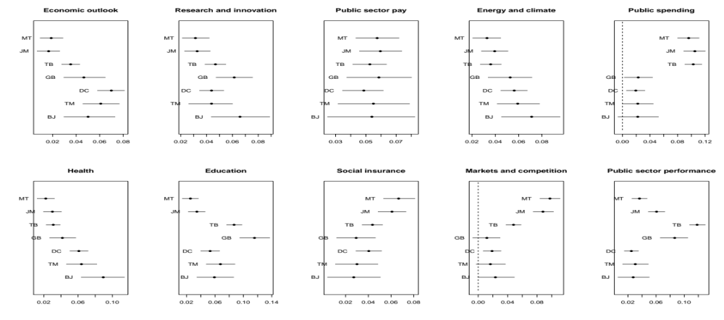
Figure A.2.4: Topic prevalence in different governments

2.5. Results on mentions of economic agents

A further robustness check on the conclusions related to the three policy eras can be performed by analyzing the frequency of mentions for various types of economic agents in the documents. If the three policy eras indeed exist, we would expect references to particular groups that arise independent of any topic modelling to reflect them. To test for this, I have selected from the top 2000 terms in the document-feature matrix all terms that indicate an individual or collective agent – for example “staff”, “teachers”, “union”, “business”, “industry”, “families”, or “consumers”. The full list is available in appendix 2. These were grouped into three classes: those referring to citizens as employees (n=23), those referring to citizens as consumers (n=27), and those referring to business (n=15). Government departments and agencies are not recorded in these groups, and non-informative and uncertain terms have been classified as “other”. A more limited group of employee references, includes terms such as “workers”, “labour” and so on, but not names of professions. If claims regarding the three eras hold, we would expect to first observe a shift towards consumers, which would correspond to the second era, and a later shift towards business, which correspond to the third era. Table A.2.5 presents simple linear trends in the prevalence of the three groups (with the employee group defined both in a limited and a more inclusive manner).
 | Ln(employees) | Ln(employees lim) | Ln(business) | Ln(consumers)
Year x 10 | .09*** | .08*** | .27*** | .32***
 | (.02) | (.02) | (.02) | (.02)
Intercept | -15.55*** | -14.22*** | -51.28*** | -60.38
Note: coefficients indicate predicted change in dependent variable given a decade change in time.
Table A.2.5: Time trends in mentions of the three groups
The table shows that, while all groups display a positive trend, the rate of growth for references to business is some 3.5 times higher than for references to employees, and the rate of growth for references to consumers is about four times higher. Figure A.2.5 illustrates the evolution over time using a nonparametric lowess fit. The patterns correspond very closely to the three eras already identified. While references to employees were dominant at the beginning of the observation period, they are first supplanted by an early increase in references to consumers, and a later increase in references to business, which becomes the most important group by the end of the observation period. These patterns show that changes in topic prevalence are paralleled by changes in the nature of the groups mentioned in the policy documents, the latter of which are identified independently of the topic modelling effort.
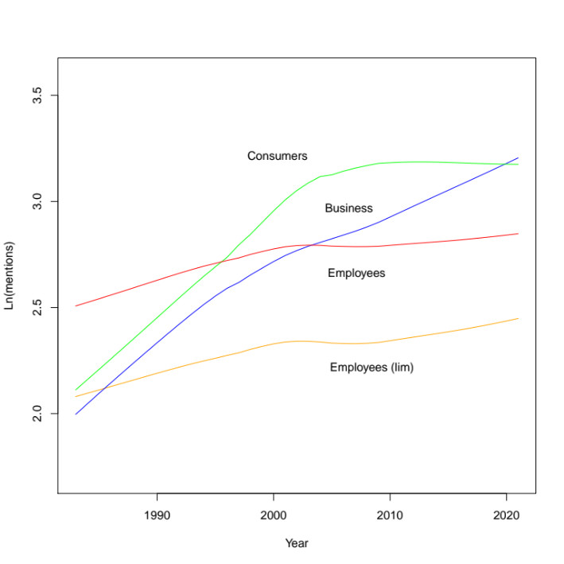
Figure A.2.5: Nonparametric modelling of references to groups

The full list of agents identified among the top 2000 words in the document-feature matrix is presented below. The list for employees includes terms related to employment and to the benefits that arise from it, such as pensions. The list for consumers includes all references to individuals as users of public services.

Employees: staff, officers, officer, teachers, workers, labour, personnel, workforce, union, employees, doctors, specialist, claimants, consultants, teacher, manpower, practitioners, dentists, claimant, unions, unemployed, poor, pensioners.

Employees (limited definition): staff, workers, labour, personnel, workforce, union, employees, claimants, manpower, claimant, unions, unemployed, poor, pensioners.

Consumers: children, community, young, child, communities, family, parents, customers, families, patients, consumer, victims, consumers, users, disabled, customer, stakeholders, patient, children's, students, youth, pupils, passenger, parent, carers, student, victim

Business: sector, business, industry, companies, employers, businesses, sectors, bank, suppliers, corporate, employer, banks, corporation, manufacturers, firm

Other: people, management, members, person, organisations, individuals, parties, chief, offenders, providers, organisation, party, respondents, prisoners, association, partners, team, professor, adult, media, military, leadership, managers, university, establishments, households, boards, adults, offender, professionals, representatives, citizens, administrations, applicants, household, universities, institute, colleges, people's, agents, chair, leaders, expert, prisoner, associations, female, auditor, inspector, brigades, male
Table A.2.5.2: Full list of agents

2.6. Autocorrelation checks

A.2.6.1 Models from figure 1 (command papers flexible modelling)

Note: Figures on the left present average residuals emerging from the models in figure 1, body of paper, plotted over time. Figures on the right present autocorrelation coefficients of order 1-5 for the same models. Blue bars indicate level at which coefficients become significant at the .95 level. Under a typical AR(1) model affecting the residuals of regression models, we would expect a high positive first-order autocorrelation coefficient, followed by a gradual decline towards zero.

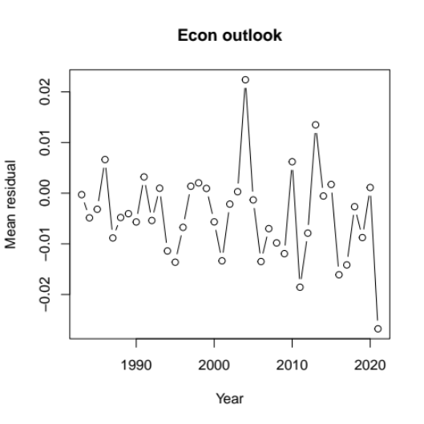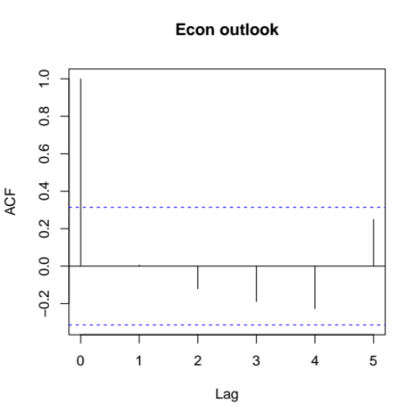
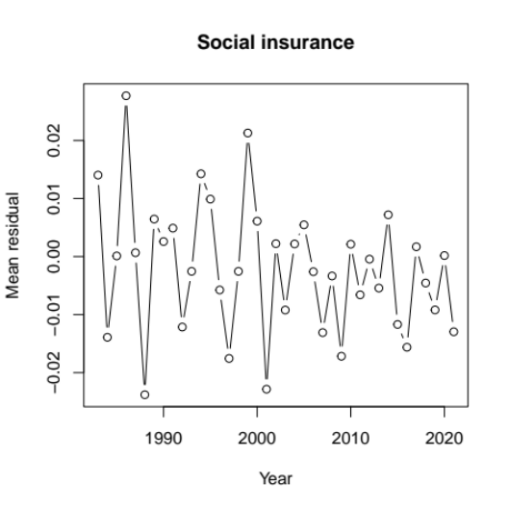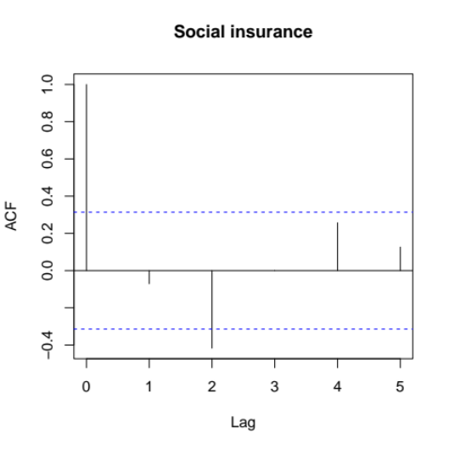
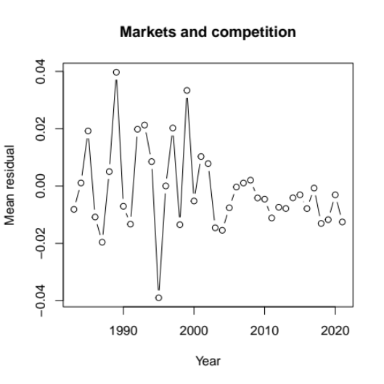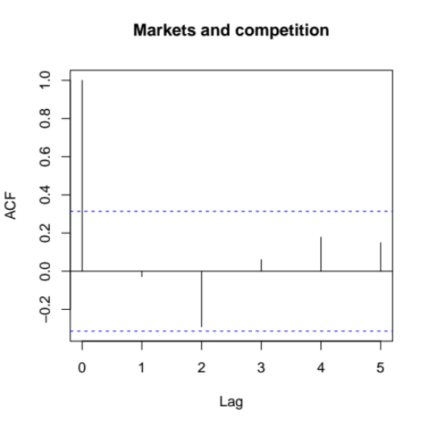
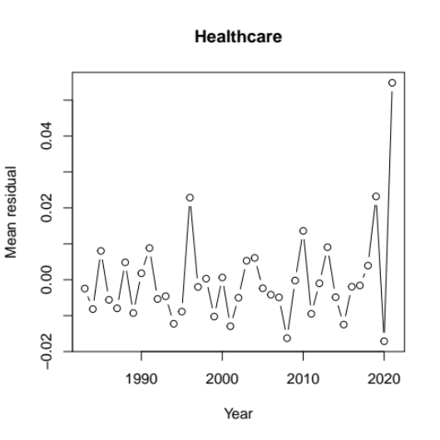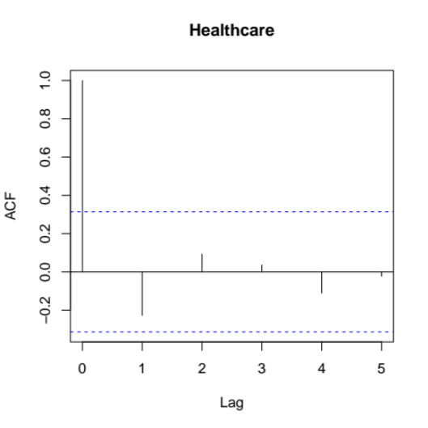
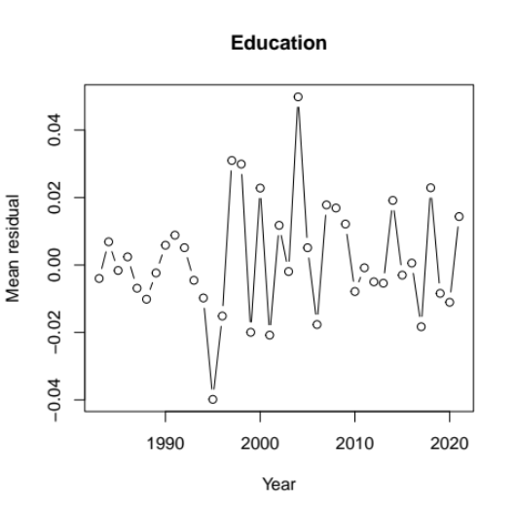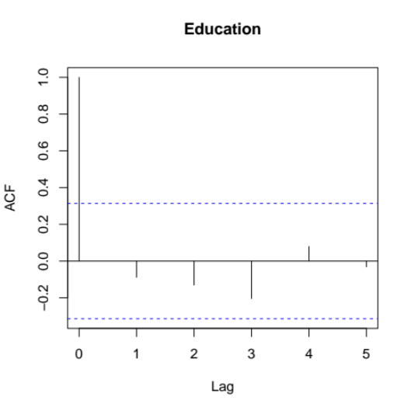
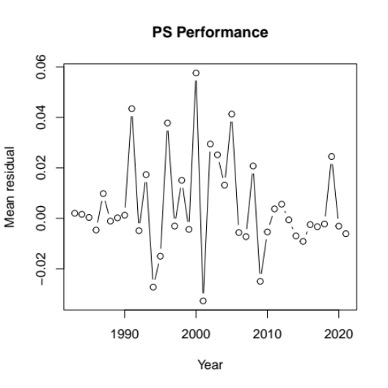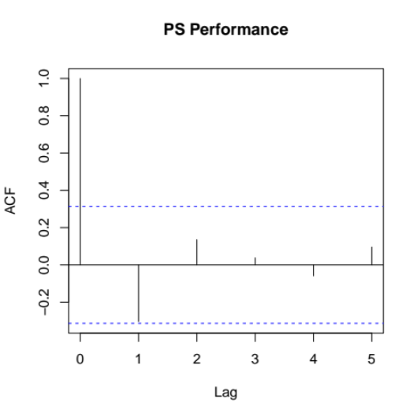

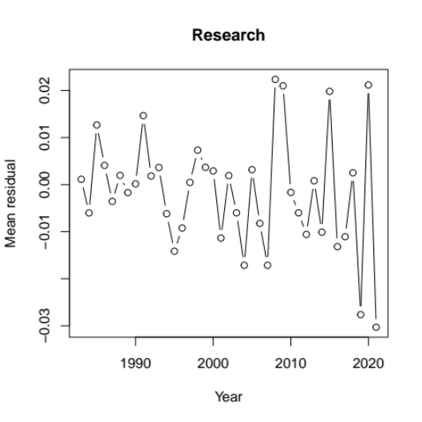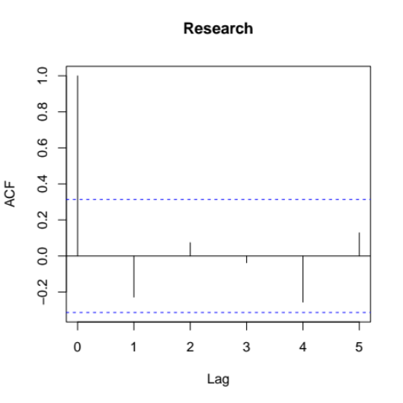
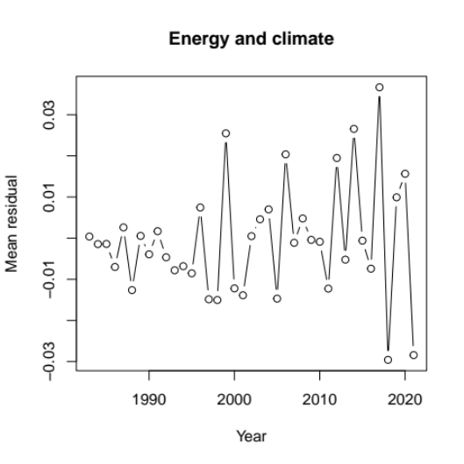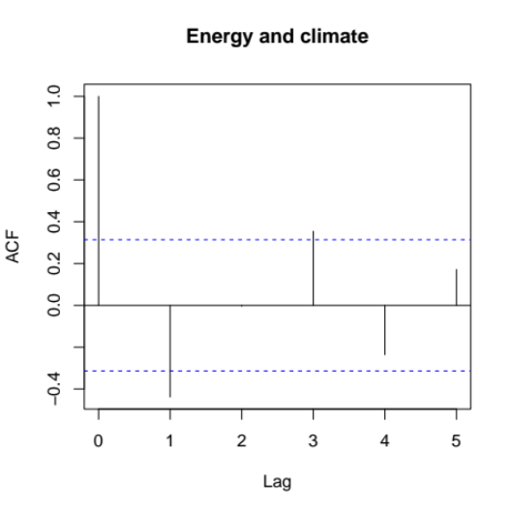

Figure A.2.6.1: Residuals over time and Box-Jenkins autocorrelation function, command papers data

2.7. Topic correlations

Correlations between topics can be displayed using a network structure, in which an edge represents a significant connection between two topics in terms of their lexical content. Quinn et al. (2010) and Boussalis and Coan (2016) argue that one validity check for the labelling of the topics is to examine whether topics which should be close to each other in terms of content are indeed close according to measures of topic distance. The figure below plots the topic correlation network for the command papers corpus. In support of the validity of the coding, we note that:

- The economic and noneconomic topics are for the most part separated, and seven of the ten topics we categorized as economic form a distinct cluster.
- The topics of consultations, bills, and inquiries all occupy central positions in the graph, as we would expect given their procedural content, that relates to all other topics.
- Most connections between topics are easy to explain - for example the two public finance-related topics are connected, and are also connected to the public sector performance topic. The two public service topics are connected, and so on.

Points that require some discussion are:

- Three of the economic topics are separated from the others: The social insurance topic is only connected to a procedural (bills) topic. Given the legalistic nature of many representative documents for this topic, this is not surprising. The energy and climate topic (which also includes transport) is linked to health and safety and local government. This is not surprising as both it and health and safety deal with environmental matters, and also transport will also show up in local government discussions.
- More unusual is the link between the markets and competition topic and local government. Closer examination of the local government topic (see above) indicates it also contains some language on press regulation that relates closely with the regulatory language in markets and competition. Given that the local government topic is not part of the main analysis, this does not affect our conclusions in any way.

Given these points, the topics' network structure provides support for the validity of the labels and interpretations given to the topics. A further validity check for the command papers corpus is provided in the section below, and the topic network analysis is repeated for the cabinet minutes corpus in section 4.4.

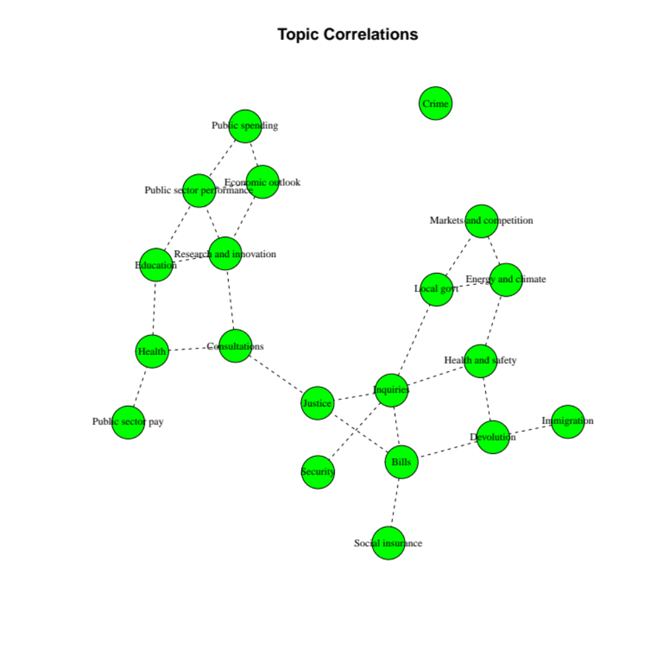
Figure 2.6: Topic correlations, command papers

2.8. Model validity using human coding of topics.

I used the approach taken in Boussalis and Coan (2016) to assess the validity of the topic labelling against human expert coding. Following their procedure, one of the human coders was the author, and the other was an academic unconnected to this project but with extensive knowledge of British politics, Dr. Mark Wickham-Jones. Given that the command paper documents are too long to be read by the coders in large numbers, I selected the first 5000 characters (approximately 1000 words) from each. Both human coders read the 1000 words and had to choose one of the 20 topics as the most prevalent in the document, after seeing table 1 from the paper. We first discussed coding choices over a limited sample of 10 documents. We then each coded 100 additional documents that led to the results below. In the table below, I present the proportion of assignments which match the model's top choice for that document. (That is, if the coder chooses topic 6 as the most likely for the document, and the model selects topic 6 as the most present in the document, we record a 1, otherwise a zero). Given that documents are a mixture of topics, this is a very conservative evaluation of the model's validity. A less strict approach would be to also consider situations in which the coder's choice was predicted as the second by the model. This is likely to be a common instance, because many documents are characterized by both a substantive topic (say health), and a procedural one (say, draft bills, or consultations), and choosing among the two as the top choice can be largely arbitrary.

Aggregate |  | Coder 1 |  | Coder 2
Prop matches top 1 | Prop matches top 2 | Prop matches top 1 | Prop matches top 2 | Prop matches top 1 | Prop matches top 2
.64 | .80 | .68 | .86 | .60 | .74
(.033) | (.028) | (.046) | (.034) | (.048) | (.043)
Note: Table presents proportions of accurate classifications (precision) for both coders and in the aggregate. "Prop matches top 2" refers to situations in which the topic selected by the human coder was in the top two topics selected by the model. Standard errors for the mean of a binomial distribution presented in parentheses. A proportions equality test fails to reject the null of no difference between the precision of the first coder and second coder (p=.23)

Interestingly, the aggregate accuracy measures, .64 for the first topic, and .80 for the first two topics, are very similar to those in Boussalis and Coan (2016). Given the overlap between substantive and procedural topics, it is not surprising that a very large proportion of the errors are given by situations in the chosen topic is actually ranked second by the model. We also suspect reading longer fragments from the documents could improve the agreement rate, as in almost all cases in which an error occurs, the human coder's choice appears plausible given the fragment given. These results are again very encouraging for the validity of the interpretation of the model given by the chosen labels.

2.9 Similarity between included text and text beyond the 20,000 cutoff

To show that text beyond the cutoff used in the main results is similar on a document-by-document basis to the included text, the table below presents measures of cosine similarity between the included and excluded text in each to document, as well as for random matches between between included texts and excluded fragments, as a baseline for comparison.

Cosine similarity: | Quartile 1 | Median | Quartile 3
Doc-by-doc match | .91 | .96 | .97
Random match | .77 | .84 | .88
Table A.2.9: Cosine similarity scores between included and excluded text

2.10 Results on a sample using a threshold of approximately 60,000 words

To illustrate that imposing a cutoff of approximately 20,000 words on the command paper documents does not bias the results, this section repeats the main STM model using a much higher threshold, of 60,000 words. The table below presents a new topic model, estimated on this sample, together with correspondences between the topics and those in the main STM model, based on overlap of the characteristic terms. The figure below then replicates the over-time evolution of the economic topics from figure 1 in the paper, showing virtually identical patterns.

Topic model with 20 topics, 4366 documents and a 22789 word dictionary.
Topic 1, corresponds to topic 3.
Highest Prob: committee, recommendation, consultation, risk, legislation, recommendations
FREX: committee’s, respondents, responses, agrees, recommendation, regulators, regulatory
Topic 2, corresponds to topic 5
Highest Prob: scottish, scotland, wales, ireland, northern, assembly, welsh
FREX: mae, gyfer, llywodraeth, bydd, mewn, swyddfa, yng
Topic 3, corresponds to topic 17
Highest Prob: pension, benefit, scheme, benefits, income, pensions, age
FREX: pension, pensioners, claimants, lone, retirement, pensions, dwp
Topic 4, corresponds to topic 4
Highest Prob: per, cent, growth, forecast, economic, rate, gdp
FREX: wage, gdp, fiscal, forecast, outlook, obr, inflation
Topic 5, corresponds partially to topic 5
Highest Prob: european, shall, article, agreement, international, states, member
FREX: les, pour, des, par, article, est, card
Topic 6, corresponds to topic 1
Highest Prob: board, paragraph, investigation, inquiry, death, might, staff
FREX: coroner, asbestos, exposure, death, injuries, incident, lung
Topic 7, corresponds to topic 6
Highest Prob: business, sector, investment, strategy, across, research, help
FREX: innovation, digital, global, dfid, businesses, innovative, infrastructure
Topic 8, corresponds to topic 19
Highest Prob: per, cent, competition, market, companies, merger, newspapers
FREX: newspapers, titles, newspaper, stagecoach, advertising, trinity, advertisers
Topic 9, corresponds to topic 10
Highest Prob: energy, transport, water, gas, rail, waste, carbon
FREX: hs2, emissions, carbon, electricity, hydrogen, pollution, waste
Topic 10, corresponds to topic 16
Highest Prob: education, schools, children, school, training, teachers, young
FREX: pupils, teachers, schools, teacher, pupil, curriculum, school
Topic 11, corresponds to topic 8
Highest Prob: section, person, bill, paragraph, provisions, subsection, authority
FREX: subsection, clause, schedule, commonhold, repeal, section, notice
Topic 12, corresponds to topic 11
Highest Prob: defence, fire, security, forces, personnel, mod, military
FREX: brigades, raf, brigade, army, nato, aircrew, civilian
Topic 13, corresponds to topic 20
Highest Prob: target, performance, programme, targets, progress, agency, plans
FREX: psa, targets, target, defra, baseline, census, performance
Topic 14, corresponds to topic 12
Highest Prob: court, law, legal, courts, justice, judicial, proceedings
FREX: judicial, judges, tribunals, solicitors, judgments, bench, defendant
Topic 15, corresponds to topic 9
Highest Prob: pay, staff, per, cent, said, recruitment, salary
FREX: salary, dentists, bma, pay, morale, gmps, grades
Topic 16, corresponds partially to topic 13
Highest Prob: commission, building, council, design, planning, buildings, site
FREX: gambling, museum, gallery, heritage, architects, museums, betting
Topic 17, corresponds to topic 15
Highest Prob: health, care, nhs, social, patients, mental, needs
FREX: patients, patient, healthcare, care, mental, commissioning, health
Topic 18, corresponds to topic 19
Highest Prob: market, per, cent, products, prices, price, sales
FREX: wholesalers, milk, retailers, brands, brewers, manufacturers, animals
Topic 19, corresponds to topic 14
Highest Prob: expenditure, outturn, capital, table, net, million, budget
FREX: outturn, del, expenditure, ame, voted, receipts, accounting
Topic 20, corresponds to topic 18
Highest Prob: police, prison, crime, offences, criminal, justice, prisoners
FREX: prisoners, offenders, prisoner, sentenced, prisons, remand, offender

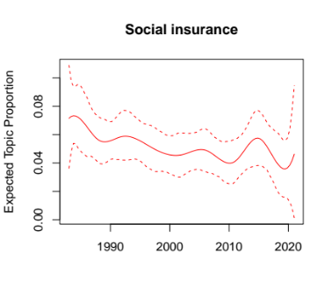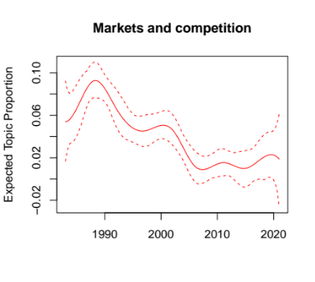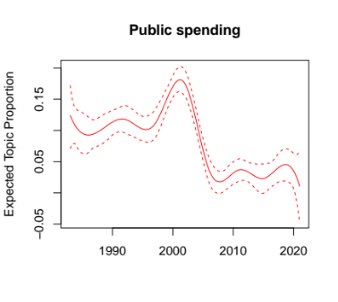
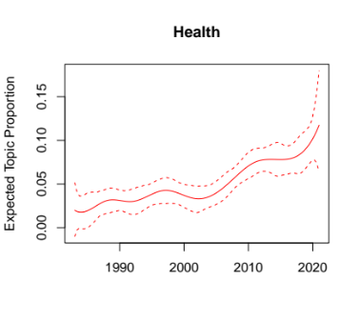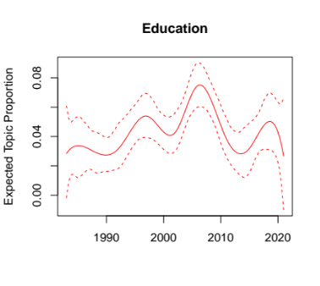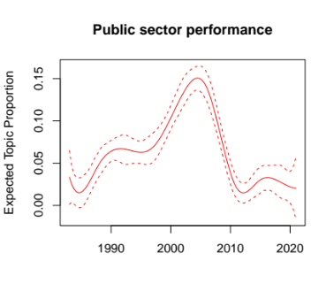
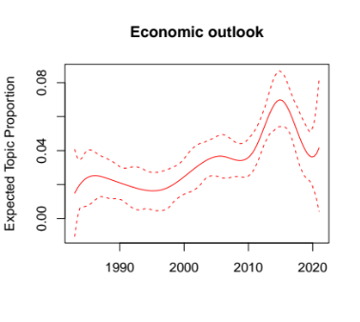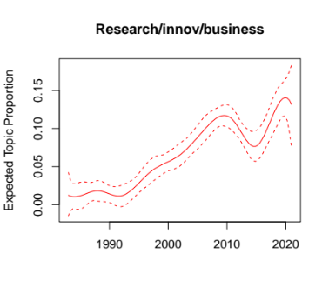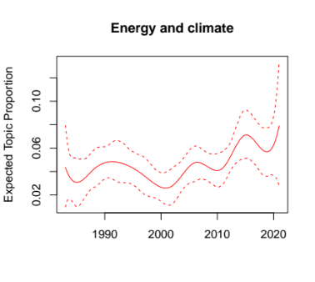
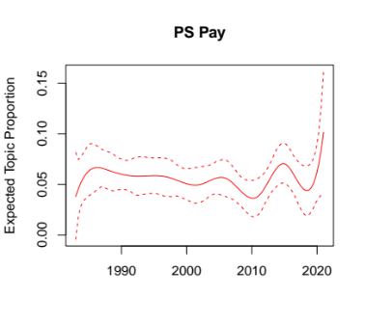
Figure 2.10.1: Replication of figure 1 from body, using the larger-document sample

2.11 Results on a sample using a threshold of approximately 10,000 words

The results below repeat the main model on a sample using cut-off point of approximately 10,000 words. The results are very similar to the ones using the 20,000 word cutoff. The business/innovation/research topic (6) form the main results is now split into an innovation/research topic (6) and a business/regulation topic (3), both of which show the same upward trend. The public finance topic is split in two (14 and 17), both of which show a downward trend. The figure below the list of topics shows the over-time evolutions of the economic topics in this sample, which are very similar to those estimated for the 20,000 sample, keeping in mind the topic changes mentioned above.

Topic model with 20 topics, 4366 documents and a 12441 word dictionary.
Topic 1, corresponds to topic 1
Highest Prob: commission, committee, evidence, cases, present, case, staff
FREX: complaints, para, complaint, inquiry, inquiries, investigations, death
Topic 2, corresponds to topic 20
Highest Prob: performance, targets, target, progress, management, review, objectives
FREX: psa, targets, performance, target, objectives, baseline, delivery
Topic 3, partially corresponds to topic 6
Highest Prob: financial, tax, business, treasury, committee, market, sector
FREX: pac, banks, banking, hmrc, consumer, consumers, tax
Topic 4, corresponds to topics 4 and 10
Highest Prob: energy, economic, growth, per, cent, economy, change
FREX: carbon, energy, climate, wage, renewable, electricity, fuel
Topic 5, corresponds to topic 5
Highest Prob: scotland, wales, ireland, northern, scottish, assembly, welsh
FREX: electoral, assembly, devolution, scottish, elections, welsh, les
Topic 6, partially corresponds to topic 6
Highest Prob: people, skills, research, help, sector, education, development
FREX: science, innovation, skills, universities, opportunities, want, technology
Topic 7, corresponds to topic 8
Highest Prob: act, section, law, bill, order, person, provisions
FREX: subsection, clause, schedule, section, person, act, draft
Topic 8, corresponds to topic 18
Highest Prob: police, prison, offences, crime, justice, criminal, offenders
FREX: prisoners, offenders, prison, sentences, sentenced, offender, prisons
Topic 9, corresponds to topic 13
Highest Prob: local, transport, housing, authorities, planning, water, environment
FREX: hs2, rail, waste, pollution, crewe, railway, water
Topic 10, corresponds to topic 19
Highest Prob: per, cent, market, million, merger, companies, supply
FREX: newspapers, merger, mmc, animals, newspaper, milk, titles
Topic 11, corresponds to topic 12
Highest Prob: court, cases, courts, justice, legal, judicial, applications
FREX: judicial, tribunals, judges, asylum, appeals, judgments, appeal
Topic 12, corresponds to topic 16
Highest Prob: children, education, schools, child, young, school, people
FREX: parents, pupils, teachers, schools, school, teacher, children
Topic 13, corresponds to topic 15
Highest Prob: health, care, nhs, local, social, people, patients
FREX: patients, patient, healthcare, mental, commissioning, care, health
Topic 14, corresponds to topic 14
Highest Prob: expenditure, table, total, spending, outturn, budget, cash
FREX: del, outturn, voted, expenditure, ame, pesa, budget
Topic 15, corresponds to topic 15
Highest Prob: security, defence, fire, terrorism, forces, intelligence, crime
FREX: terrorism, brigades, terrorist, fire, nca, cyber, brigade
Topic 16, corresponds to topic 17
Highest Prob: pension, benefit, scheme, social, pensions, benefits, security
FREX: pension, claimants, occupational, retirement, pensioners, exposure, pensions
Topic 17, corresponds to topic 14
Highest Prob: financial, payments, expenditure, accounts, net, receipts, capital
FREX: loans, auditor, ended, expenses, accounting, comptroller, audit
Topic 18, partially corresponds to topic 5
Highest Prob: shall, agreement, article, european, united, international, convention
FREX: gambling, bbc, shall, convention, directive, article, protocol
Topic 19, corresponds to topic 9
Highest Prob: pay, evidence, review, staff, per, cent, recommendations
FREX: dms, pay, salary, remit, dentists, retention, recruitment
Topic 20, corresponds to topic 3
Highest Prob: consultation, response, review, committee, paragraph, system, process
FREX: respondents, responses, consultation, response, select, committee’s, agree

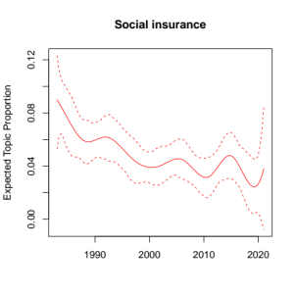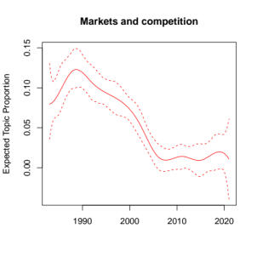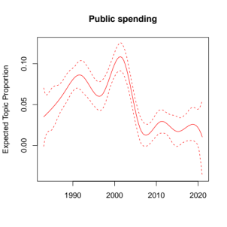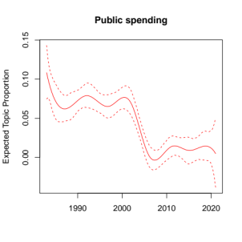
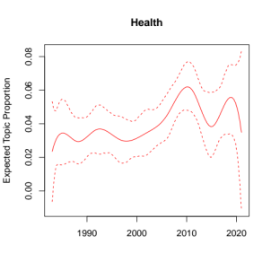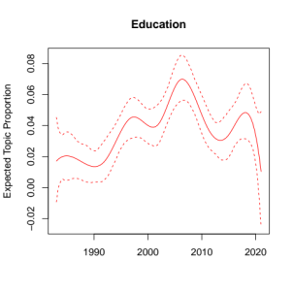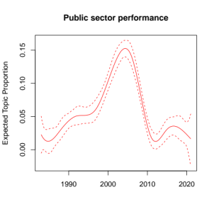
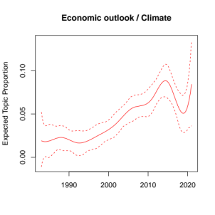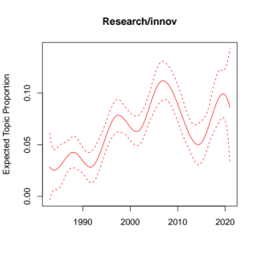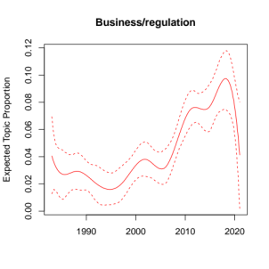
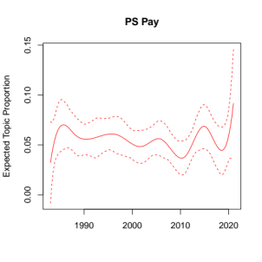
Figure 2.11.1: Topic evolution using the 10,000 word cutoff

2.12. Alternative trimming thresholds for the document-feature matrix

The table below presents the highest probability words for the ten economic topics under different strategies for trimming the document-feature matrix. "Default" refers to the model presented in the paper. The .01, .02, and .075 thresholds refer to alternative values for trimming infrequent words. The "no upper threshold" entry refers to no trimming of frequent terms.

Topic 4: Economic outlook
Default: per, cent, economic, growth, spending, forecast, billion
.01 threshold: per, energy, cent, growth, economic, forecast, market
.02 threshold: energy, per, growth, cent, economic, forecast, carbon
.075 threshold: per, cent, growth, economic, forecast, rate, economy
No upper thr: economic, growth, government, per, cent, investment, business
Topic 6: Research and innovation
Default: research, business, trade, industry, investment, science, technology
.01 threshold: business, strategy, investment, industry, sector, research, international
.02 threshold: business, trade, research, industry, international, investment, world
.075 threshold: local, sector, people, business, housing, help, communities
No upper thr: Topic keywords split between economic outlook (investment, business, trade) and education (research, science).
Topic 9: Public sector pay
Default: pay, per, staff, cent, evidence, recommendations, recruitment
.01 threshold: pay, per, staff, cent, evidence, recommendations, recruitment
.02 threshold: pay, per, staff, cent, evidence, recommendations, recruitment
.075 threshold: pay, per, staff, cent, evidence, recommendations, recruitment
No upper thr: pay, per, staff, cent, evidence, service, review
Topic 10: Energy and climate
Default: transport, energy, water, rail, carbon, emissions, electricity
.01 threshold: transport, local, london, rail, road, planning, water
.02 threshold: transport, water, london, local, rail, road, area
.075 threshold: transport, energy, water, rail, gas, emissions, carbon
No upper thr: energy, transport, water, government, new, rail, also
Topic 14: Public spending
Default: expenditure, total, capital, table, outturn, net, cash
.01 threshold: expenditure, total, outturn, table, capital, spending, budget
.02 threshold: expenditure, total, outturn, table, capital, spending, budget
.075 threshold: expenditure, table, outturn, total, spending, plans, million
No upper thr: expenditure, total, services, capital, department, table, office
Note: A second public spending topic emerges in .075 threshold model
Topic 15: Healthcare
Default: health, care, nhs, local, social, people, patients
.01 threshold: health, local, care, nhs, authorities, social, england
.02 threshold: health, care, nhs, local, social, patients, england
.075 threshold: health, care, nhs, local, social, people, patients
No upper thr: government, health, public, local, nhs, response, ensure
Topic 16: Education
Default: people, education, children, schools, local, skills, young
.01 threshold: education, schools, school, training, teachers, skills, local
.02 threshold: education, schools, school, training, teachers, skills, local
.075 threshold: education, children, people, schools, school, training, young
No upper thr: education, schools, school, training, teachers, skills, research
Topic 17: Social insurance
Default: pension, benefit, scheme, benefits, income, pensions, social
.01 threshold: pension, scheme, benefit, income, payments, pensions, social
.02 threshold: pension, scheme, benefit, income, payments, pensions, social
.075 threshold: pension, benefit, scheme, benefits, pensions, income, social
No upper thr: pension, benefit, scheme, benefits, pensions, income, social
Topic 19: Markets and competition
Default: per, market, cent, competition, companies, united, sales
.01 threshold: per, cent, market, companies, competition, million, sales
.02 threshold: per, cent, market, united, million, competition, companies
.075 threshold: per, market, cent, companies, competition, million, sales
No upper thr: per, market, cent, services, companies, competition, also
Topic 20: Public service performance
Default: performance, target, targets, management, progress, programme, staff
.01 threshold: performance, target, management, targets, progress, programme, staff
.02 threshold: local, target, targets, performance, progress, housing, programme
.075 threshold: performance, target, management, targets, progress, programme, data
No upper thr: department, report, service, performance, public, target, year

Appendix 3: Further Results on Spending Data

3.1. Evolution of theoretically-relevant spending categories.

Categories which are relevant for the liberalization era.
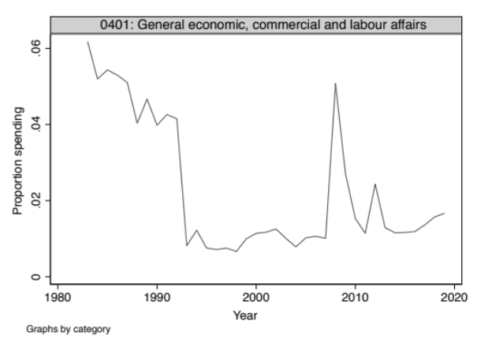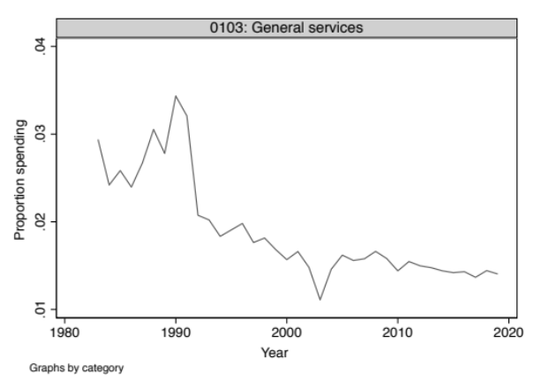
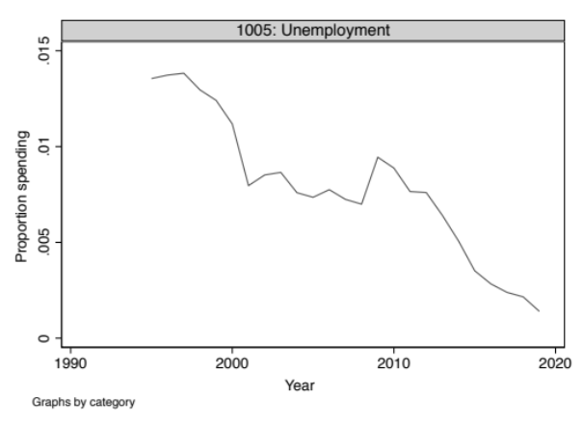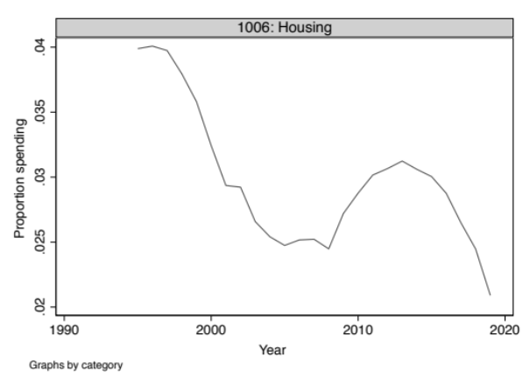
Categories which are relevant for the public service delivery era
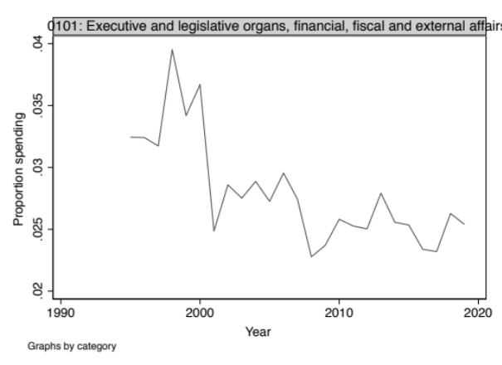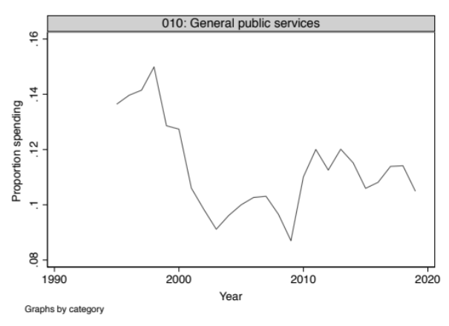
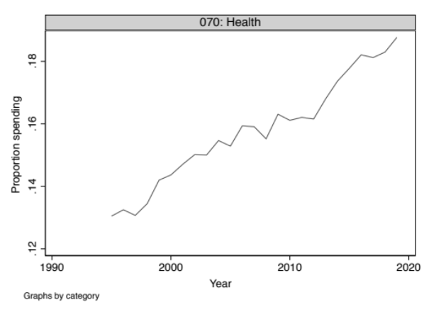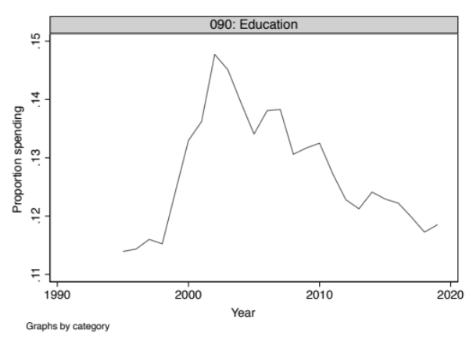

Categories which are relevant for the industrial strategy era
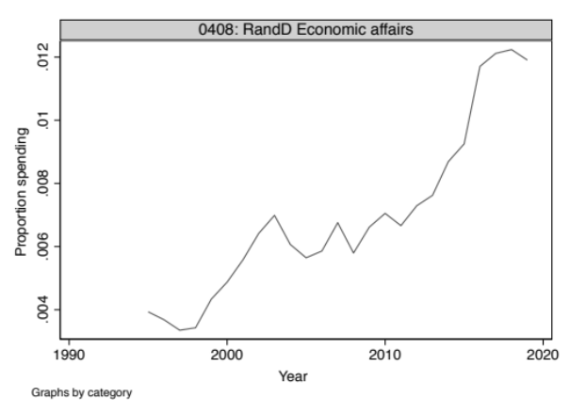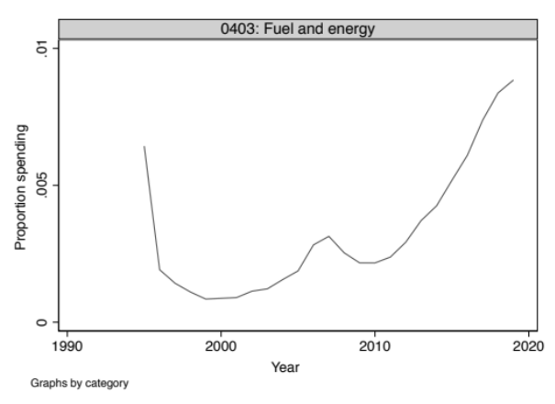
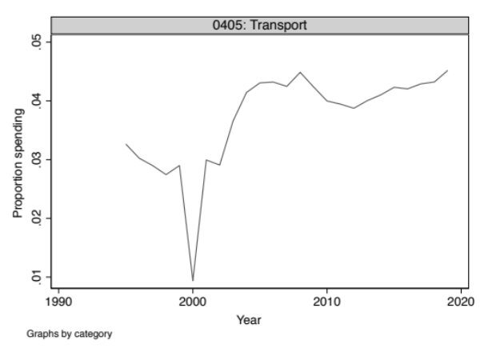

3.2. Spending categories ranked by increases

Note: The table below presents coefficients on all COFOG categories in linear models regressed against time, as in table 5 in the body. Categories in bold type are first-level COFOG categories. Categories in regular type are second-order COFOG categories. Categories are ranked from the strongest decrease to the highest increase.

Category | Time | Standard error
010: General public services | -0.100 | 0.059
1004: Family and children | -0.098 | 0.026
020: Defence | -0.098 | 0.011
0201: Military defence | -0.090 | 0.017
0107: Public debt transactions | -0.081 | 0.049
100: Social protection | -0.071 | 0.042
0901: Pre-primary and primary education | -0.056 | 0.024
1006: Housing | -0.048 | 0.016
1005: Unemployment | -0.046 | 0.004
0101: Executive and legislative organs, financial, fiscal and external affairs | -0.043 | 0.010
1001: Sickness and disability | -0.042 | 0.022
030: Public order and safety | -0.039 | 0.020
080: Recreation, culture and religion | -0.038 | 0.012
0601: Housing development | -0.027 | 0.006
0905: Education not definable by level | -0.026 | 0.005
060: Housing and community amenities | -0.024 | 0.013
0301: Police services | -0.021 | 0.011
0908: Education n.e.c. | -0.020 | 0.005
0402: Agriculture, forestry, fishing and hunting | -0.017 | 0.003
1003: Survivors | -0.017 | 0.001
0103: General services | -0.017 | 0.005
0205: Defence n.e.c. | -0.016 | 0.003
090: Education | -0.016 | 0.045
0802: Cultural services | -0.013 | 0.006
0701: Medical products, appliances and equipment | -0.012 | 0.008
0903: Post-secondary non-tertiary education | -0.012 | 0.013
0803: Broadcasting and publishing services | -0.012 | 0.002
1009: Social protection n.e.c. | -0.011 | 0.004
0801: Recreational and sporting services | -0.010 | 0.006
0303: Law courts | -0.009 | 0.006
0304: Prisons | -0.007 | 0.003
0302: Fire-protection services | -0.007 | 0.001
0404: Mining, manufacturing and construction | -0.006 | 0.001
0602: Community development | -0.006 | 0.006
0806: Recreation, culture and religion n.e.c. | -0.005 | 0.002
0409: Economic affairs n.e.c. | -0.004 | 0.001
0503: Pollution abatement | -0.001 | 0.001
0406: Communication | -0.001 | 0.001
0603: Water supply | -0.001 | 0.001
0305: RandD Public order and safety | 0.000 | 0.000
0904: Tertiary education | 0.000 | 0.003
0605: RandD Housing and community amenities | 0.000 | 0.000
1008: RandD Social protection | 0.000 | 0.000
0407: Other industries | 0.000 | 0.001
0202: Civil defence | 0.000 | 0.000
0502: Waste water management | 0.000 | 0.000
0108: Transfers of a general character between different levels of government | 0.000 | 0.000
0104: Basic research | 0.000 | 0.000
0804: Religious and other community services | 0.001 | 0.000
0105: RandD General public services | 0.001 | 0.000
0504: Protection of biodiversity and landscape | 0.001 | 0.001
0805: RandD Recreation, culture and religion | 0.001 | 0.000
0203: Foreign military aid | 0.001 | 0.006
0505: RandD Environmental protection | 0.001 | 0.001
0906: Subsidiary services to education | 0.001 | 0.001
0106: General public services n.e.c. | 0.002 | 0.001
0604: Street lighting | 0.003 | 0.001
0506: Environmental protection n.e.c. | 0.005 | 0.003
0306: Public order and safety n.e.c. | 0.005 | 0.001
0907: RandD Education | 0.006 | 0.003
0705: RandD Health | 0.006 | 0.002
0606: Housing and community amenities n.e.c. | 0.007 | 0.002
0204: RandD Defence | 0.008 | 0.004
0501: Waste management | 0.009 | 0.008
050: Environment protection | 0.016 | 0.013
0403: Fuel and energy | 0.023 | 0.009
0704: Public health services | 0.023 | 0.005
0706: Health n.e.c. | 0.025 | 0.003
0408: RandD Economic affairs | 0.034 | 0.004
0401: General economic, commercial and labour affairs | 0.038 | 0.015
0102: Foreign economic aid | 0.038 | 0.003
0702: Outpatient services | 0.047 | 0.017
1007: Social exclusion n.e.c. | 0.063 | 0.014
0405: Transport | 0.078 | 0.018
0902: Secondary education | 0.092 | 0.007
1002: Old age | 0.129 | 0.024
0703: Hospital services | 0.137 | 0.017
040: Economic affairs | 0.144 | 0.024
070: Health | 0.226 | 0.010

Appendix 4: Further Results on the Cabinet Minutes Corpus

4.1 Full results for the STM with K=20

A topic model with 20 topics, 2034 documents and a 2442 word dictionary.
Economic topics highlighted in bold.

Topic 1 Top Words:
Highest Prob: home, police, secretary, prison, action, crime, chief
FREX: prison, police, crime, prisoners, home, officers, necessarily
Lift: necessarily, prison, prisons, prisoners, crime, sentences, liverpool
Score: necessarily, police, prison, crime, prisoners, prisons, officers
Representative documents: Prisons, Industrial Action `at Wymott Prison, Industrial Action in Prisons.
Topic 2 Top Words:
Highest Prob: cabinet, prime, minister, discussion, ministers, government, summing
FREX: prime, ministers, minister, approval, statements, colleagues, summing
Lift: express, co-ordination, appointment, announcements, statements, briefing, remarks
Score: express, ministers, prime, president, lord, minister, announcements
Representative documents: Timing of Statements, Coordination and Presentation of Government Policies, Disturbances at Handsworth.
Topic 3 Top Words: “Employment”
Highest Prob: unemployment, since, million, employment, previous, figures, number
FREX: west, unemployment, east, fallen, moved, north, south
Lift: moved, west, weather, east, midlands, region, job
Score: moved, unemployment, seasonally, vacancies, fallen, west, figures
Representative documents: Unemployment, Unemployment, Unemployment.
Topic 4 Top Words:
Highest Prob: secretary, state, day, united, previous, kingdom, european
FREX: european, former, kingdom, affairs, war, asylum, foreign
Lift: gov, applications, immigration, asylum, broadcasting, former, nations
Score: gov, united, asylum, kingdom, inquiry, european, immigration
Representative documents: Refugees from Former Yugoslavia, Unemployment Figures, Refugees from Former Yugoslavia
Topic 5 Top Words:
Highest Prob: ireland, northern, irish, government, agreement, talks, state
FREX: ireland, northern, unionist, fein, sinn, irish, talks
Lift: paisley, taoiseach, anglo-irish, ceasefire, fein, sinn, unionist
Score: irish, ireland, northern, wou, fein, unionist, sinn
Representative documents: Northern Ireland, Northern Ireland, Northern Ireland
Topic 6 Top Words:
Highest Prob: local, authorities, government, environment, charge, state, secretary
FREX: authorities, charge, local, environment, grant, community, authority
Lift: committed, charge, inner, grant, authorities, councils, rating
Score: committed, local, authorities, charge, grant, environment, education
Representative documents: Local Authority Finance, Education in London, Abolition of the GLC.
Topic 7 Top Words:
Highest Prob: national, reference, crown, cab, copyright, archives, government
FREX: archives, copyright, crown, cab, lconfidentiali, national, food
Lift: article, archives, lconfidentiali, copyright, lconfidentiall, bse, cab
Score: archives, copyright, crown, article, cab, food, lconfidentiali
Representative documents: Bovine Spongiform Enteropathy.
Topic 8 Top Words: “SOEs, privatization”
Highest Prob: industry, british, secretary, state, trade, defence, united
FREX: water, company, industry, electricity, nuclear, companies, gas
Lift: nuclear, shares, flotation, water, company, electricity, purchase
Score: shares, nuclear, water, electricity, industry, company, privatisation
Representative documents: Defence Suppression Weapon for the Air Force, British Leyland, Defence Suppression Weapon for the Air Force

Topic 9 Top Words:
Highest Prob: house, bill, commons, lords, government, debate, opposition
FREX: house, commons, lords, motion, amendment, vote, debate
Lift: peers, lobby, motion, vote, commons, defeats, house
Score: lords, bill, house, commons, lobby, amendment, motion
Representative documents: Parliamentary Affairs, Parliamentary Affairs, British Nationality Hong Kong Bill
Topic 10 Top Words: “Economic prospects”
Highest Prob: budget, chancellor, exchequer, economic, rates, interest, tax
FREX: budget, exchequer, markets, rates, tax, economic, forecast
Lift: banks, dollar, deficit, monetary, sterling, psbr, taxes
Score: banks, budget, psbr, inflation, rates, tax, deficit
Representative documents: Exchange Rates, Economic Strategy, Economic Affairs
Topic 11 Top Words:
Highest Prob: bill, programme, bills, legislation, session, might, provisions
FREX: bills, session, legislative, programme, provisions, legislation, bill
Lift: railways, bill's, assent, bills, session, queen's, enacted
Score: bill, bills, railways, session, programme, legislation, legislative
Representative documents: Legislative Programme, Legislative Programme, Legislative Programme
Topic 12 Top Words: “Pay negotiations”
Highest Prob: pay, per, cent, increase, review, service, teachers
FREX: teachers, pay, salaries, review, body, civil, increases
Lift: limits, tsrb, teachers, salary, salaries, top, servants
Score: limits, pay, teachers, salaries, tsrb, cent, salary
Representative documents: Review Body Reports, Pay Review Body Reports, Salaries of Ministers and Office Holders
Topic 13 Top Words: “Health”
Highest Prob: health, service, services, nhs, general, scheme, state
FREX: nhs, health, ihe, patients, ports, medical, services
Lift: evious, patients, practitioners, ports, ihe, nhs, hospitals
Score: health, nhs, evious, practitioners, patients, ihe, medical
Representative documents: National Health Service Reforms, National Health Service Reform Bill, National Health Service Reforms
Topic 14 Top Words: “Public spending”
Highest Prob: expenditure, public, year, secret, spending, billion, treasury
FREX: expenditure, spending, programmes, survey, secret, billion, treasury
Lift: baseline, totals, 1985-86, receipts, programmes, spending, survey
Score: baseline, spending, expenditure, survey, billion, programmes, totals
Representative documents: Public Expenditure, Public Expenditure, Public Expenditure Survey 1985
Topic 15 Top Words: “Strikes”
Highest Prob: action, union, strike, industrial, dispute, national, coal
FREX: num, dispute, strike, coal, ncb, pits, union
Lift: locomotive, ncb, drivers, engineers, mineworkers, num, one-day
Score: ncb, railway, num, miners, coal, pits, strike
Representative documents: Industrial Action in the NHS, Industrial Action in the Coal Industry, Industrial Action in the Transport Sector
Topic 16 Top Words: “Public sector reform”
Highest Prob: government, paper, confidential, white, education, important, proposals
FREX: paper, white, schools, charter, project, testing, green
Lift: radical, testing, strategic, project, white, charter, paper
Score: radical, white, paper, charter, education, schools, green
Representative documents: National Curriculum and Testing in Schools, Government Information Service, The Citizen's Charter
Topic 17 Top Words: “Economic statistics”
Highest Prob: per, cent, figures, unemployment, increase, employment, year
FREX: showed, statistics, figures, risen, manufacturing, cent, average
Lift: steady, statistics, manufacturing, risen, indicators, trend, headline
Score: cent, unemployment, per, figures, steady, statistics, inflation
Representative documents: Labour Market Statistics
Topic 18 Top Words: “Social insurance”
Highest Prob: social, security, state, benefit, secretary, support, pension
FREX: social, pension, benefit, pensions, security, benefits, income
Lift: agreements, pensioners, child, pensions, pension, uprating, family
Score: agreements, social, pension, security, income, benefit, child
Representative documents: Social Security Review, Child Support Policy, Social Security Strike Pay
Topic 19 Top Words:
Highest Prob: might, case, court, matter, action, law, report
FREX: court, justice, legal, law, appeal, act, matter
Lift: sunday, attorney, court, appeal, justice, magistrates, restrictions
Score: sunday, court, justice, appeal, courts, attorney, criminal
Representative documents: Sunday Trading, Draft Order on Finance for EC, Report of the Parliamentary Boundary Commission
Topic 20 Top Words:
Highest Prob: inquiry, security, forces, two, previous, people, incident
FREX: incident, investigation, accident, disaster, forces, bomb, inquiry
Lift: investigation, disaster, warning, incident, bomb, troops, accident
Score: warning, pira, bomb, accident, incident, injured, investigation
Representative documents: Explosion at 10 Downing Street, Terrorist Incidents in London and Derby, Bomb Explosions in Eltham and Wembley

4.2 Further results on topic evolution
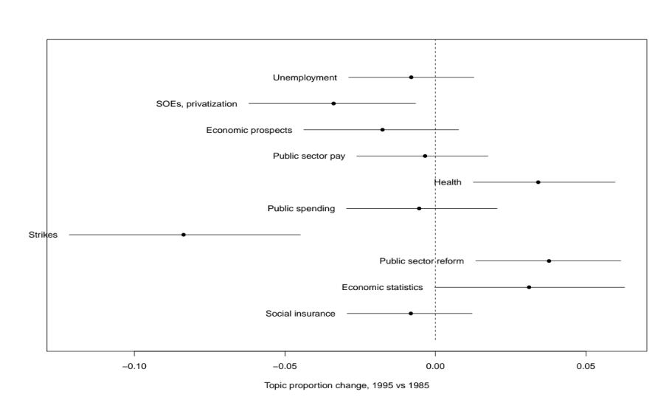
Figure A.4.2: Topic evolution, 1995 vs 1985

4.3 Autocorrelation checks - cabinet minutes models

A.4.3.1 Models from figure 4 in the body (Cabinet minutes flexible modelling)

Note: Figures present the Box-Jenkins autocorrelation function for models in figure 4, body of paper. Blue bars represent levels at which autocorrelation estimates with be statistically significant at the .95 level. In the presence of a typical pattern of autocorrelation in the residuals, we would expect to see a high positive first-order autocorrelation, gradually declining to zero. The strikes topic is the only one clearly reflecting this pattern.

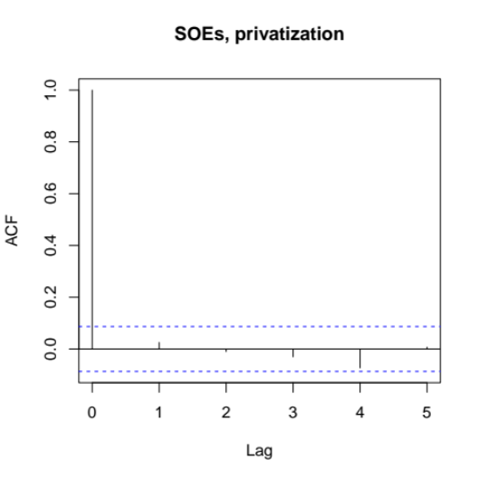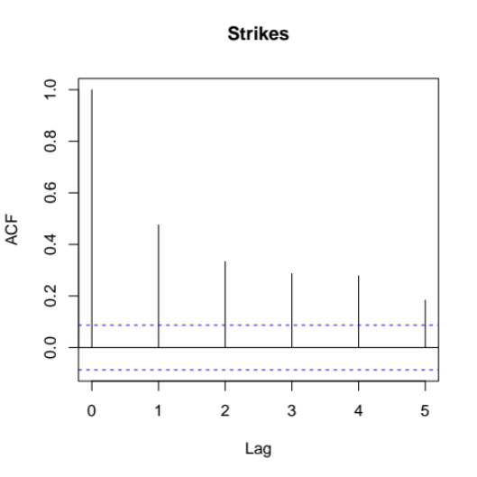
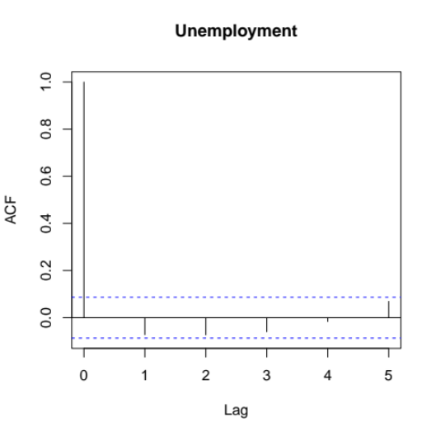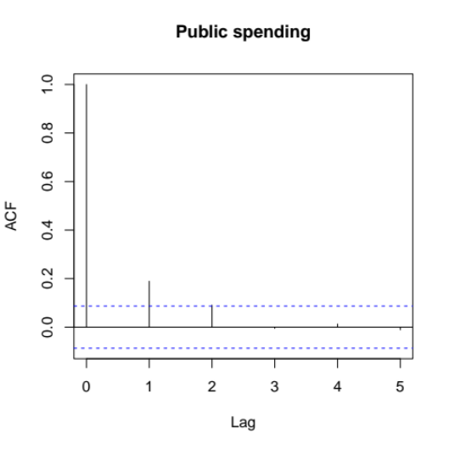
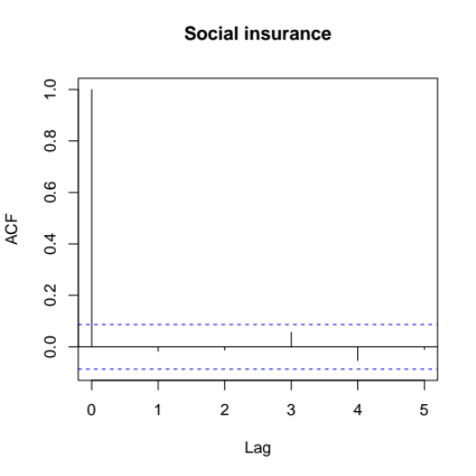

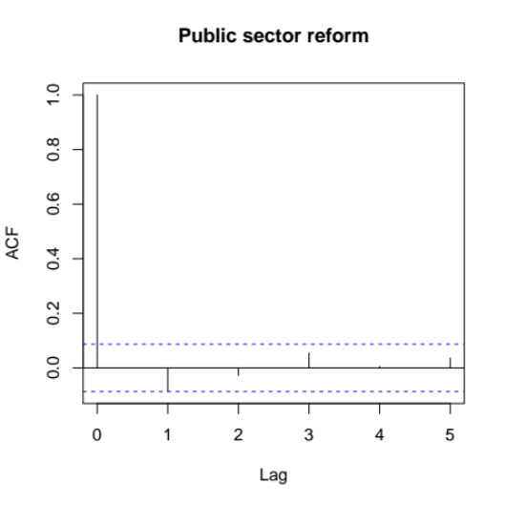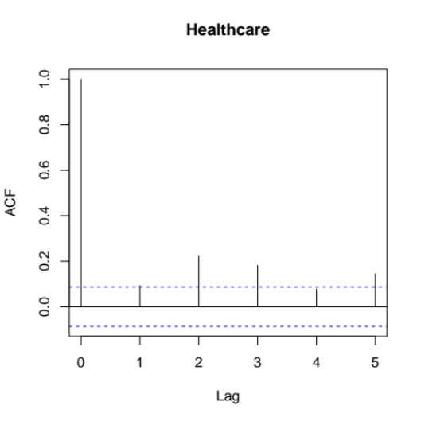

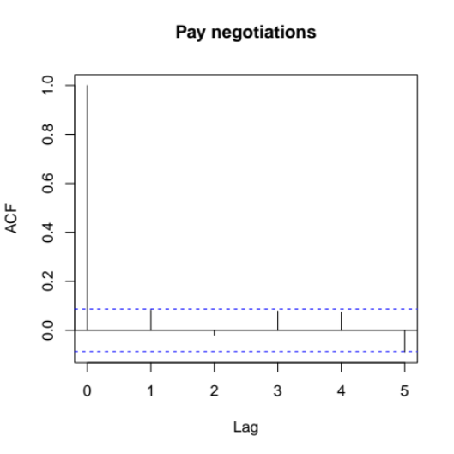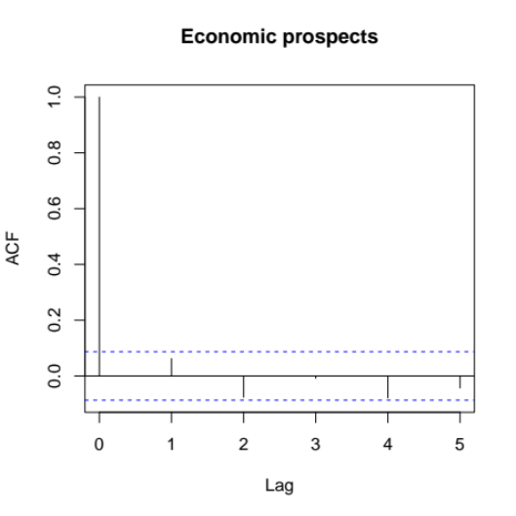
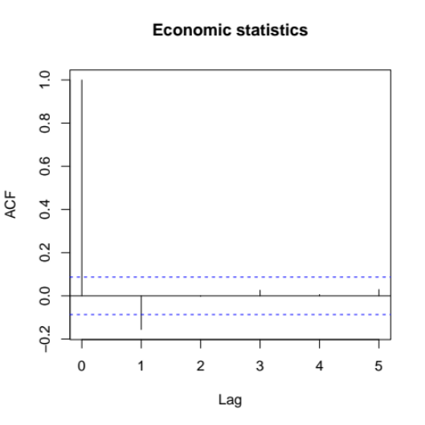
Figure A.4.3.1: Autocorrelation function for models in figure 4 in the body

A.4.3.1: Models from table 5 in the body (linear models on cabinet minutes)

The figures below present the autocorrelation function for the linear models presented in table 5. Blue bars represent the level at which estimates become significant at the .95 level. A typical pattern of AR(1) autocorrelation in the residuals of a regression model would show a high positive first-order autocorrelation, followed by a decline towards zero. The strikes topic shows such a pattern, as well as to a lesser extent the public spending and healthcare topics. The latter two are not significant in the linear model. The strikes topic is highly significand and a doubling of its standard error estimates would still leave it significant.
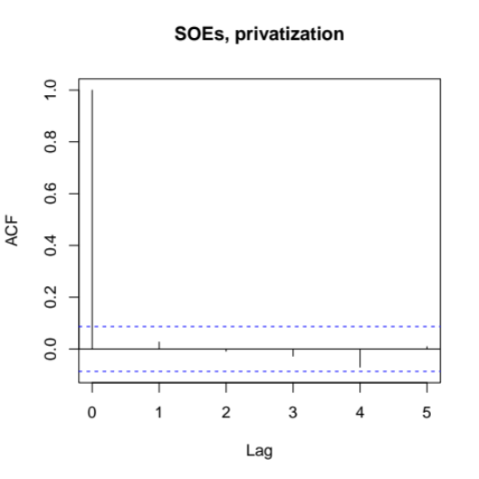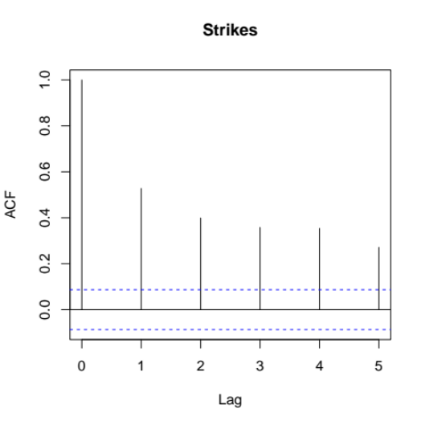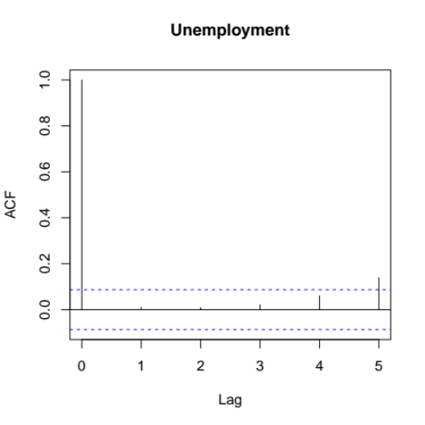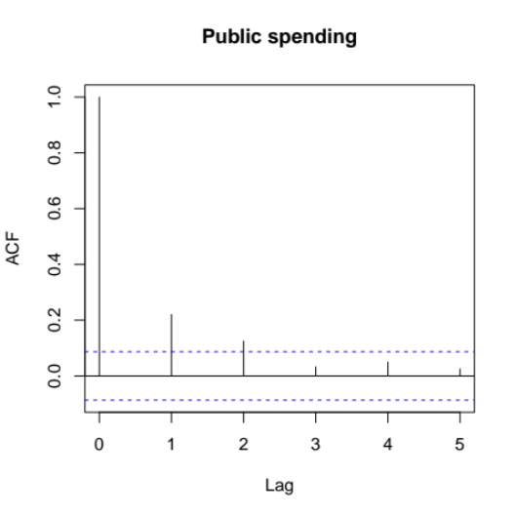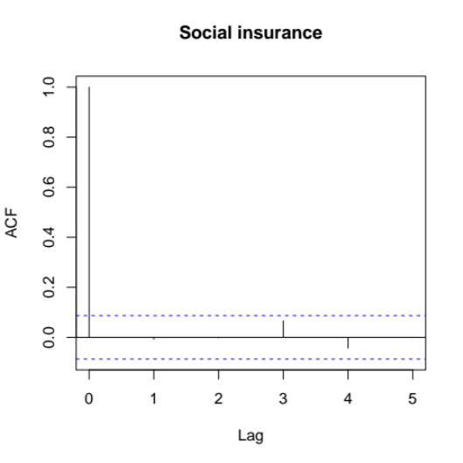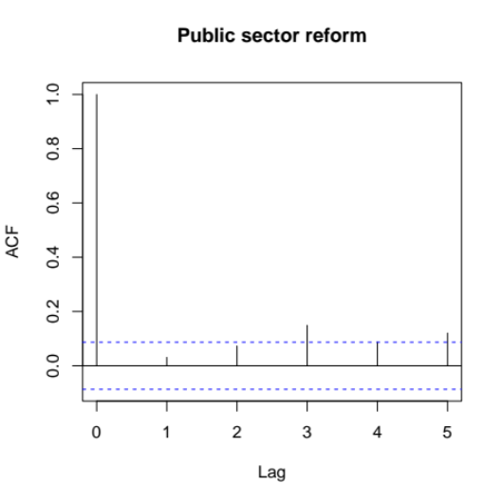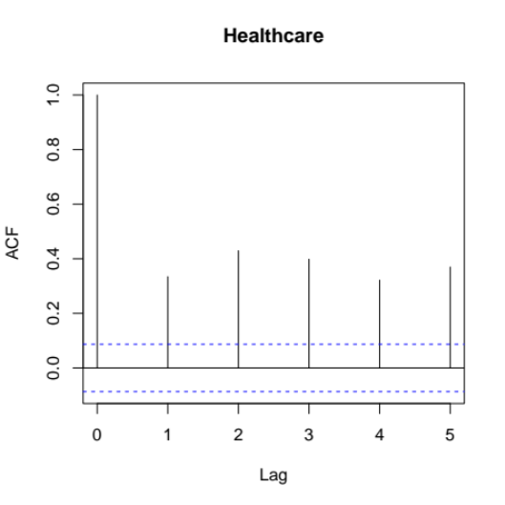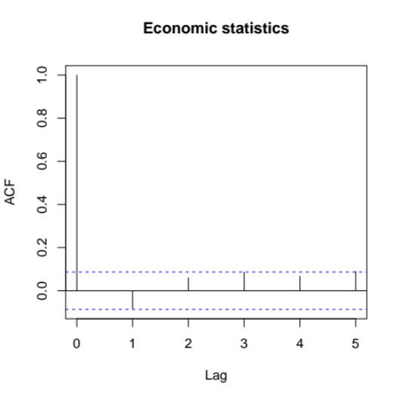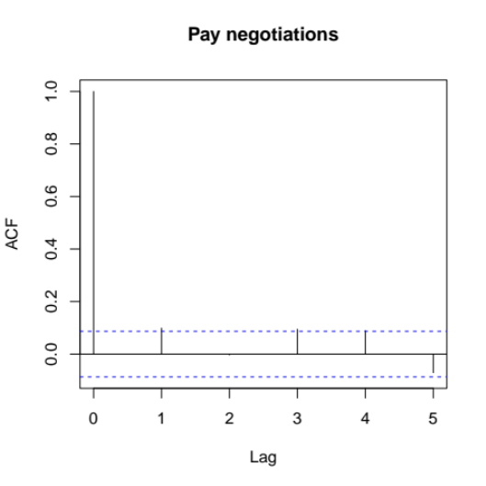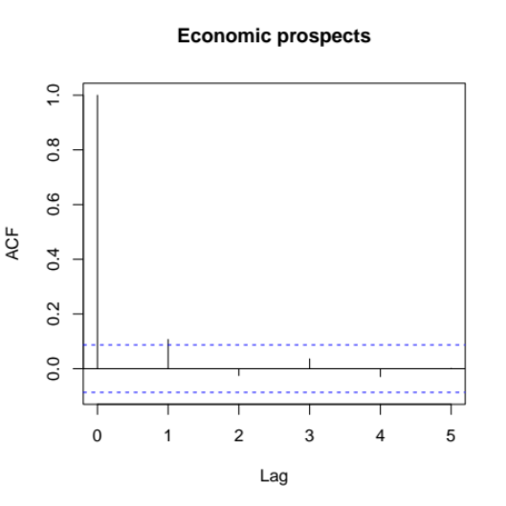
Figure A.4.3.2: Autocorrelation function for linear model in table 5 in body

4.4 Topic correlations on the cabinet minutes

Much like in the case of the command papers, a check on the validity of the labelling of the topics is given by examining their correlation network. The figure below supports the validity of the labelling:

- The economic and noneconomic topics are almost completely separated. The economic topic most closely linked with noneconomic topics is public service reform - which is natural given the wide relevance of this topic. The noneconomic topic most closely associated with the economic ones is local government - again natural given the public spending implications.
- Links between topics are generally easy to explain: For example public spending is connected to pay negotiations, social insurance, and economic prospects.

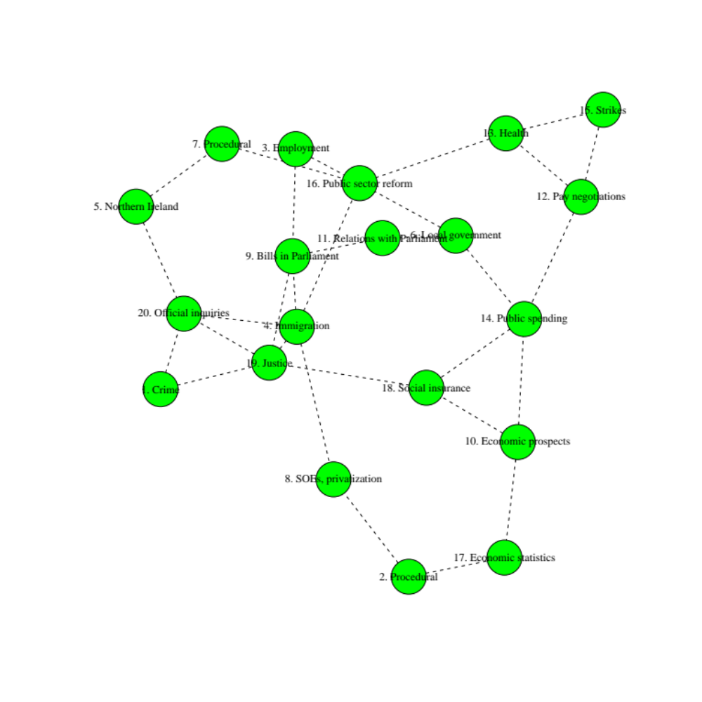
Figure 4.4: Topic correlations in the cabinet minutes

