Supplementary materials
We collected the data, using the scheme in Table S1 to code reforms of policy integration and administrative coordination. For each country and sector, we created a review sheet of reforms that we submitted to at least one expert in the policy field for review, if there was no in-house expertise for the policy field. The response rate for the policy sheets was at 80 percent (in-house expertise included (in-house expertise was consulted for public health policy in Australia, Germany, Switzerland, UK, and US only)). Data collection was done according to the following steps:
- Survey of secondary literature, edited books, policy reports (international organizations, governments)
- Creation of time series of reforms
- Data sheets validated by experts
- Exclusion reforms that are unclear in their relevance for our analytical focus

Operationalization of dependent variable
In the following, we explain in more detail the operationalization of our dependent variable. Table S1 provides the detailed of the strategy that we applied to collect our data. After that we present some example reforms for the different policy fields to provide more details regarding the data we collected.
Table S1: Operationalization of reforms re-centering the nation state
Policy field | Policy integration | Administrative coordination
Environment (Object of integration: creation of a field of environmental policy; no purely sectoral integration of environmental concerns in other policies) | - National strategies and action plans for the integration of sustainable development policies  - Framework legislation that integrates environmental matters of various sectoral policies  - Environmental (framework) legislation that integrates formerly disperse legislation and reduces fragmentation  - Constitutional law on environmental protection:  - Central legislation that leads to harmonization of sub-national policy (in federal systems)  - Environmental planning at ministerial level | - Transversal bodies for environmental policy at the level of the central government, with competences for formulating national environmental policy and coordinating the implementation of national environmental strategies  - Inter-sectoral ministerial councils or working groups for environmental policy, e.g. “green cabinets”  - Increase of the Ministry of Environment’s responsibilities of transversal coordination of environmental policy  - Intergovernmental agreements and units for environmental policy (in federal systems) that delimit the respective responsibilities  - Joint federal and sub-national bodies for nation-wide harmonization and/or coordination  - Reorganizations of the central government that lead to integration of the environmental portfolio:  - Reorganization at the level of regulatory agencies that lead to integration of competences for environmental policy or that create coordinative capacities  - Creation of a public service for the environment or of sustainability units in the public service  - Strategies for the promotion of employment in the environmental sector  - Reforms that harmonize or coordinate administrative procedures regarding e.g. departmental environmental reporting systems or the development of sustainability action plans
Migration (Object of integration: integration and coordination of immigration and immigrant integration policies and organizations, as well as mainstreaming of immigrant integration policies) | - Integration or coordination of laws referring to temporary and permanent residence  - National action plans or strategies for immigration and immigrant integration  - Integration policy action plan  - Strategy to harmonize immigration and integration policies between sectors and levels of government  - Labor market integration and education reforms that make further immigration benefits conditional on employment and education efforts of the applicant | - Organization to integrate or coordinate different ministries and levels of government that are related to immigration and immigrant integration  - Accumulating immigration and integration portfolios in one ministry  - Creation of interdepartmental working groups  - Councils to coordinate different ministries in the field  - Commissioner for foreigners  - Conditionality of immigration benefits for integration efforts  - Organizations that bring together policymakers from different sectors and different levels of government at same time
Public health (Object of integration: integration and coordination of curative and preventative elements of health policy) | - Reforms that include preventive measures into health the services paid by the general health insurance, such as screening programs  - Health promotion and legislation with a focus on the coordination and integration of prevention and cure – either in general or with a focus on specific diseases  - General and specific national health strategies (e.g., cancer, diabetes, HIV, tobacco, nutrition, etc.)  - Strategies that focus on health inequalities  - Public health funds that allow organizations and levels of government to operate policy programs that coordinate or even integrate preventive and curative measures | - Network amongst hospitals with a particular focus on health promotion and prevention  - National public health agency and ministry that includes sections for disease prevention and others that are responsible for curative aspects of health policy  - Public organizations that coordinate the prevention and treatment of specific diseases and/or the policy advocacy for it  - Establishment of institutions of health information  - Inter-ministerial conferences and councils that coordinate preventative and curative aspects concerning certain diseases and/or risk factors, such as drugs, tobacco, cancer etc.
Unemployment (Object of integration: integration and coordination of activation and benefit related policies) | - National strategies, action plans or reform packages that integrate active and passive labour market policies (e.g. “welfare to work” principle)  - Employment policy reforms that introduce or enhance activation measures in employment policy  - Reforms that integrate formerly separated social assistance and/or unemployment benefits, e.g. by creating an integrates system of income and employment benefits  - Adoption of reforms that apply an activation approach to pension, family or invalidity policy | - Creation of transversal bodies for employment policy at the level of the central government  - Creation of intergovernmental agreements or units (in federal systems) for nation-wide harmonization and/or coordination of employment policy  - Reorganizations of the central government that lead to integration of employment portfolio by merging the ministries responsible for various sectors such as employment, social affairs, health, etc.  - Reorganization of implementation administrations that lead to integration of active and passive employment policy and/or services for employment and social assistance:  - Creation of one-stop shop service centers that offer comprehensive services related to social assistance, unemployment benefits, and job placement  - Introduction of an individualized approach to employment assistance  - Integration of administrative procedures for both unemployment and social security administrations such as unified electronic declarations or social identification cards  - Procedures that enhance or institutionalize inter-agency collaboration between unemployment and social security administrations

In the following, we present examples for the reforms in each of the policy fields:
- “For environmental policy, a typical example of policy integration and administrative coordination is a reform that aims to produce integrated sustainability or climate policies (Jordan and Lenschow 2010). Such reforms obligate decision makers and professionals from different policy sectors to develop coordinated environmental policy, such as a common sustainable development strategy. A specific example is the Sustainable Development Strategy put into place by the UK government in 1999, which underlines the government’s commitment to establishing integrated impact assessment and sustainable development tools.
- For migration policy, a typical reform seeks to coordinate or integrate immigration and immigrant integration policies and programs (Geddes and Scholten 2016). A specific example of administrative coordination in this policy area is the establishment of the Swedish Integration Board in 1998. Although direct responsibility for newly arrived immigrants remained in municipal hands, the new Board was given jurisdiction over disbursing their introduction allowance and issuing general integration guidelines (Lemaître 2007, 15).
- For public health policy, we focus on policy and administrative reforms that combine curative and preventative elements of health policy, whether aimed at one specific health problem, such as cancer, or more generally (Trein 2017). National health strategies provide one illustration. A specific example includes the Australian government’s 1991 national AIDS strategy, which combined preventative and curative elements in responding to the AIDS epidemic (Baum 2008, 494).
- For unemployment policy, we focus on the integration and coordination of welfare benefits and labor market activation measures (Claasen and Clegg 2011). One example is the German labor market reform of 2004, which merged unemployment insurance and social assistance. The reform restructured benefits and reintegration efforts and created one-stop municipal shops that administered benefits and reintegration measures together (Schiller 2016). This reform combined administrative coordination and policy integration.”

Operationalization of independent variables
Politicization of bureaucracy
To operationalize the politicization of the bureaucracy (as opposed to professionalized bureaucracy where civil servants are appointed mostly according to a professional logic), we created a compound variable combining information on administrative traditions and political corruption. Therefore, we proceeded in three steps.
- First, we coded a variable with information on administrative traditions and ranked countries’ bureaucracies from less politicized (i.e. little political control of government/governing parties over appointments in the civil service) to very politicized. The countries are ranked as follows: “1” Canada, New Zealand, UK, “2” Australia, Netherlands, Sweden, Switzerland, “3” Austria, Germany, United States, “4” Belgium, Italy, using information by Painter and Peters (2010) as well as our own knowledge of various administrative systems.
- Second, we created a variable measuring political corruption based on information from the Quality of Government Dataset (Teorell et al. 2017).
- Third, in using regression scores from principal component analysis, we combined information on the politicization of bureaucrats with political corruption into a variable recording the politicization of bureaucrats.

Capacity to act of agencies at the national level
To operationalize agency autonomy, we created a compound variable that combines a binary variable for the presence of a (1) civil law system, (2) the age of the independent regulatory agency in the policy field, and the (3) degree of politicization of bureaucrats (Maggetti and Verhoest 2014) as well as the (4) presence of agencies in the country. Therefore, we proceeded with the following steps:
- First, we created a variable recording the presence of a civil law system through a binary variable that takes the value “1” for Australia, Canada, New Zealand, UK, and U.S.
- Second, we coded a binary variable operationalizing the age of the regulatory agency in the policy field based on the data from Jordana et al. (2011), which contains information on the age of agencies.
- Third, we created a variable measuring autonomy, in combining our variables regarding a civil law system, the age of the independent regulatory agency in the policy field, and the degree of politicization of bureaucrats through regression scores from principal component analysis. All three variables loaded on one factor, which permitted us to combined them into a single measurement.
- Fourth, we linked the measures for the number and presence of agencies with the above-explained regarding the autonomy of independent regulatory agencies using regression scores from principal component analysis.

Description of the dependent variable
Figure S1: Re-centering over time
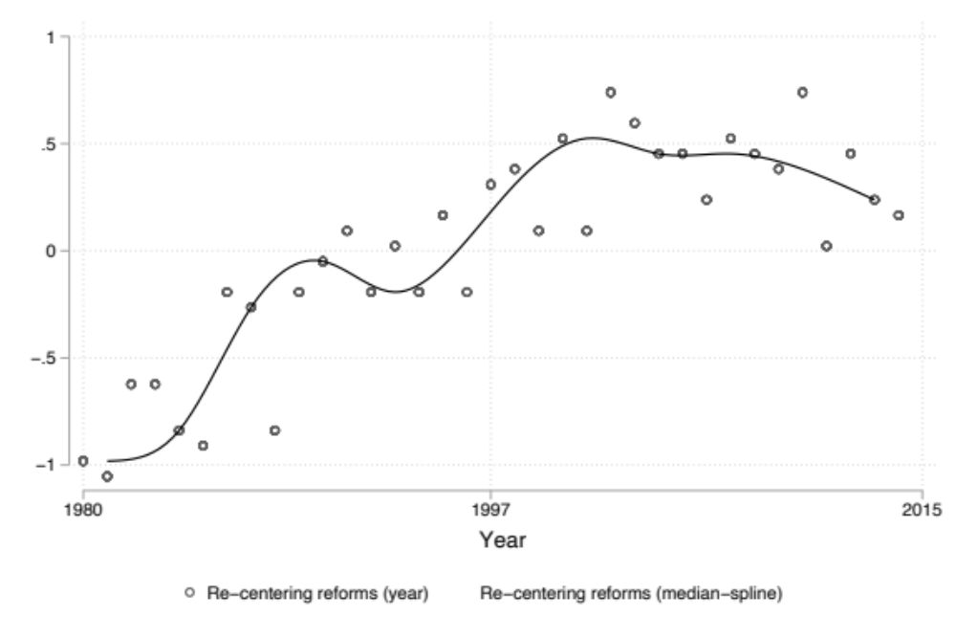
Figure S2: Re-centering across countries
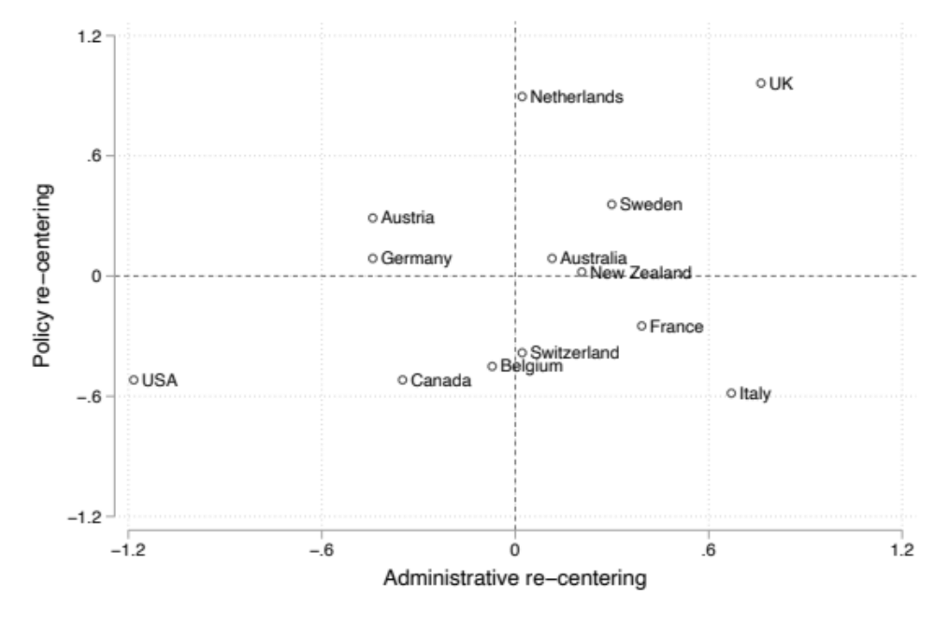

Regression analyses and robustness checks
In the following, we present more information regarding the robustness tests for our regression analyses. The indicator for the Quality of Government is taken from this dataset: (Teorell et al. 2017). The base category for the categorical variable regarding policy fields in Table S8 is environmental policy.

Table S2: Correlation between independent variables
 | Upward delegation: general purpose jurisdiction (EU) | Upward capacity to act: general purpose jurisdiction (EU) | Downward delegation: general purpose jurisdiction (self-rule) | Downward capacity to act: general purpose jurisdiction (shared-rule) | Upward delegation: task specific jurisdictions (GEF, IOM, ILO, WHO) | Upward capacity to act: task specific jurisdictions (GEF, IOM, ILO, WHO) | Upward-Sideward double delegation: task specific jurisdictions (EU-Agencies) | Upward-Sideward capacity to act: task specific jurisdictions (EU-Agencies) | Sideward delegation: task specific jurisdictions (Presence of Independent Regulatory Agencies) | Sideward capacity to act: task specific jurisdictions (Autonomy of Independent Regulatory Agencies)
Upward delegation: general purpose jurisdiction (EU) | 1
Upward capacity to act: general purpose jurisdiction (EU) | 0.8639 | 1
Downward delegation: general purpose jurisdiction (self-rule) | -0.0344 | -0.0123 | 1
Downward capacity to act: general purpose jurisdiction (shared-rule) | -0.0707 | -0.0488 | 0.4134 | 1
Upward delegation: task specific jurisdictions (GEF, IOM, ILO, WHO) | 0.0634 | 0.0467 | 0.0417 | 0.0224 | 1
Upward capacity to act: task specific jurisdictions (GEF, IOM, ILO, WHO) | 0.0581 | 0.0428 | 0.0382 | 0.0205 | -0.0208 | 1
Upward-Sideward double delegation: task specific jurisdictions (EU-Agencies) | 0.5177 | 0.4794 | 0.061 | -0.006 | -0.1074 | 0.2009 | 1
Upward-Sideward capacity to act: task specific jurisdictions (EU-Agencies) | 0.4851 | 0.4839 | 0.0625 | -0.0067 | -0.1322 | 0.1553 | 0.8836 | 1
Sideward delegation: task specific jurisdictions (Presence of Independent Regulatory Agencies) | 0.0244 | 0.0805 | 0.1523 | 0.0667 | 0.1775 | 0.1626 | 0.2969 | 0.33 | 1
Sideward capacity to act: task specific jurisdictions (Autonomy of Independent Regulatory Agencies) | -0.3337 | -0.2487 | -0.1405 | -0.0084 | 0.0835 | 0.0908 | 0.0527 | 0.0799 | 0.8035 | 1

To assess the robustness of our findings, we pursue three avenues. Firstly, we assess the substantial robustness of our operationalization of the upward denationalization in general-purpose jurisdictions by using membership in international organizations for non-EU members. Therefore, we estimate the model using variables that measure delegation and capacity to act beyond the EU for those countries that are not EU members but are integrated in other international organizations. We code Australia and New Zealand as members of the Commonwealth of Nations, and Canada and the U.S. as members of the Organization of American States, using the variables on delegation and pooling of authority in these organizations (Hooghe et al. 2019). For Switzerland, we use the values for the UN, starting in 2002 The results are very robust for the variable measuring upward delegation to general-purpose jurisdictions, but a bit less for the measure that assesses upward denationalization through capacity to act (Table S4, Supplementary Materials).
Secondly, we conduct robustness checks with alternative estimation strategies. Since our data uses only 13 countries, the estimated country effects could be biased (Bryan and Jenkins 2015). To account for this issue, we “jackknifed” the countries, i.e., removed each country one after the other while re-estimating the model, to verify whether single countries drive the results (van der Meer et al. 2010). Our results are largely robust to this check, i.e., the significance levels are lower for some of the variables, but the findings are stable overall (Table S5). Furthermore, we estimate linear probability models using the Satterthwaite’s sample correction strategy (Elff et al. 2021). According to this robustness check, the coefficients for the variables measuring upward delegation to general-purpose jurisdictions as well as both measures regarding delegation and capacity to act for lower levels of government are not significant statistically (Table S6); however, the other variables remain statistically significant. Overall, our robustness checks support our finding that especially sideways and upward-sideways delegation, as well as the attribution of capacity to act in these two dimensions, drive recentring reforms. Thirdly, we estimate additional models controlling for government effectiveness and include a categorical variable for the difference between policy fields (Tables S7 and S8). The findings are robust to these additional tests.

Table S3: Alternative measures for delegation and capacity to act of general-purpose jurisdictions
Variable | Obs. | Mean | Std. Dev. | Min | Max
Upward delegation | 1,820 | 0 | .5 | -.7464324 | .5191375
Upward capacity to act | 1,820 | 0 | .5 | -.6243435 | 1.098675
Quality of government | 1,612 | 0 | .5 | -2.03002 | .4983835

Table S4: Models with alternative measures for delegation and capacity to act of general-purpose jurisdictions
 | Delegation |  | Capacity to act
 | Model 1 |  | Model 2
Upward delegation: general purpose jurisdictions | 0.172*** | (0.0546)
Downward delegation: general purpose jurisdictions | -0.170*** | (0.0564)
Upward capacity to act: general purpose jurisdictions |  |  | 0.180 | (0.117)
Downward capacity to act: general purpose jurisdictions |  |  | -0.153*** | (0.0501)
Left parties dominate government | 0.207*** | (0.0521) | 0.237*** | (0.0634)
Multiparty government | -0.0195 | (0.0871) | 0.0482 | (0.0859)
Politicization of bureaucracy | -0.0582 | (0.0690) | -0.141* | (0.0835)
Policy problem pressure | -0.252*** | (0.0844) | -0.258*** | (0.0915)
Debt (% of GDP) | 0.0166 | (0.103) | 0.0392 | (0.118)
t (time) | 3.055*** | (0.926) | 2.604** | (1.084)
t²/10 | -3.928* | (2.170) | -2.641 | (2.503)
t³/100 | 1.781 | (1.402) | 0.813 | (1.603)
Constant | -0.563*** | (0.0425) | -0.569*** | (0.0474)
Variance (Policy field, country) | 0.00768 | (0.0113) | 0.0181 | (0.0120)
AIC | 1554.93 |  | 1556.98
BIC | 1617 |  | 1619
Observations | 1304 |  | 1304
* p<0.1; ** p<0.05; *** p<0.01

Table S5: Multilevel models with country-jackknifing (standard errors in parentheses)
 | General purpose jurisdictions |  | Task specific jurisdictions
 | Delegation | Capacity to act | Delegation | Capacity to act
 | Model 1 | Model 2 | Model 3 | Model 4
Upward delegation: general purpose jurisdictions | 0.170*
Upward delegation: general purpose jurisdictions | (0.091)
Downward delegation: general purpose jurisdictions | -0.168*
Downward delegation: general purpose jurisdictions | (0.092)
Upward capacity to act: general purpose jurisdictions |  | 0.272*
Upward capacity to act: general purpose jurisdictions |  | (0.139)
Downward capacity to act: general purpose jurisdictions |  | -0.131
Downward capacity to act: general purpose jurisdictions |  | (0.094)
Upward delegation: task specific jurisdictions |  |  | -0.036
Upward delegation: task specific jurisdictions |  |  | (0.114)
Sideward delegation: task specific jurisdictions |  |  | 0.324**
Sideward delegation: task specific jurisdictions |  |  | (0.127)
Upward-Sideward double delegation: task specific jurisdictions |  |  | 0.177**
 |  |  | (0.079)
Upward capacity to act: task specific jurisdictions |  |  |  | 0.019
Upward capacity to act: task specific jurisdictions |  |  |  | (0.111)
Sideward capacity to act: task specific jurisdictions |  |  |  | 0.419**
Sideward capacity to act: task specific jurisdictions |  |  |  | (0.159)
Upward-Sideward capacity to act: task specific jurisdictions |  |  |  | 0.198*
Upward-Sideward capacity to act: task specific jurisdictions |  |  |  | (0.092)
Left parties dominate government | 0.203*** | 0.209*** | 0.261*** | 0.284***
Left parties dominate government | (0.063) | (0.068) | (0.070) | (0.075)
Multiparty government | -0.018 | 0.014 | 0.110 | 0.157
Multiparty government | (0.116) | (0.099) | (0.103) | (0.114)
Politicization of bureaucracy | -0.075 | -0.185 | -0.200 | -0.007
Politicization of bureaucracy | (0.175) | (0.165) | (0.187) | (0.184)
Policy problem pressure | -0.257 | -0.269 | -0.211* | -0.223*
Policy problem pressure | (0.167) | (0.179) | (0.114) | (0.116)
Debt (% of GDP) | 0.023 | 0.028 | 0.102 | 0.117
Debt (% of GDP) | (0.155) | (0.168) | (0.167) | (0.167)
t (time) | 3.015** | 2.366* | 2.193* | 2.326*
t (time) | (0.993) | (1.200) | (1.179) | (1.206)
t²/10 | -3.800 | -1.938 | -2.567 | -2.828
t²/10 | (2.327) | (2.788) | (2.410) | (2.575)
t³/100 | 1.700 | 0.299 | 0.818 | 0.958
t³/100 | (1.500) | (1.756) | (1.395) | (1.508)
Constant | -0.563*** | -0.572*** | -0.584*** | -0.583***
Constant | (0.053) | (0.057) | (0.072) | (0.067)
Variance (Policy field, country) | 0.008 | 0.012 | 0.039** | 0.038*
Variance (Policy field, country) | (0.010) | (0.010) | (0.016) | (0.018)
AIC | 1554.98 | 1554.04 | 1762.58 | 1761.47
BIC | 1617 | 1616 | 1826 | 1825
Observations | 1304 | 1304 | 1468 | 1468
* p<0.1; ** p<0.05; *** p<0.01
Table S6: Linear probability models (Standard errors in parentheses)
 | General purpose jurisdictions |  | Task specific jurisdictions
 | Delegation | Capacity to act | Delegation | Capacity to act
 | Model 1 | Model 2 | Model 3 | Model 4
Upward delegation: general purpose jurisdictions | 0.060
Upward delegation: general purpose jurisdictions | (0.037)
Downward delegation: general purpose jurisdictions | -0.053
Downward delegation: general purpose jurisdictions | (0.038)
Upward capacity to act: general purpose jurisdictions |  | 0.097**
Upward capacity to act: general purpose jurisdictions |  | (0.041)
Downward capacity to act: general purpose jurisdictions |  | -0.046
Downward capacity to act: general purpose jurisdictions |  | (0.033)
Upward delegation: task specific jurisdictions |  |  | -0.011
Upward delegation: task specific jurisdictions |  |  | (0.038)
Sideward delegation: task specific jurisdictions |  |  | 0.117***
Sideward delegation: task specific jurisdictions |  |  | (0.045)
Upward-Sideward double delegation: task specific jurisdictions |  |  | 0.068**
 |  |  | (0.032)
Upward capacity to act: task specific jurisdictions |  |  |  | 0.008
Upward capacity to act: task specific jurisdictions |  |  |  | (0.033)
Sideward capacity to act: task specific jurisdictions |  |  |  | 0.153***
Sideward capacity to act: task specific jurisdictions |  |  |  | (0.055)
Upward-Sideward capacity to act: task specific jurisdictions |  |  |  | 0.073**
Upward-Sideward capacity to act: task specific jurisdictions |  |  |  | (0.029)
Left parties dominate government | 0.070*** | 0.072*** | 0.093*** | 0.101***
Left parties dominate government | (0.027) | (0.027) | (0.026) | (0.026)
Multiparty government | -0.006 | 0.005 | 0.043 | 0.060*
Multiparty government | (0.032) | (0.034) | (0.034) | (0.036)
Politicization of bureaucracy | -0.036 | -0.072* | -0.076* | -0.005
Politicization of bureaucracy | (0.043) | (0.039) | (0.041) | (0.048)
Policy problem pressure | -0.071** | -0.074** | -0.064** | -0.069**
Policy problem pressure | (0.030) | (0.030) | (0.031) | (0.032)
Debt (% of GDP) | 0.015 | 0.019 | 0.044 | 0.049
Debt (% of GDP) | (0.038) | (0.038) | (0.037) | (0.037)
t (time) | 0.463 | 0.259 | 0.301 | 0.338
t (time) | (0.319) | (0.326) | (0.277) | (0.274)
t²/10 | -0.210 | 0.390 | -0.105 | -0.172
t²/10 | (0.817) | (0.844) | (0.648) | (0.638)
t³/100 | -0.016 | -0.474 | -0.109 | -0.075
t³/100 | (0.561) | (0.587) | (0.401) | (0.395)
Constant | 0.313*** | 0.310*** | 0.308*** | 0.308***
Constant | (0.017) | (0.018) | (0.017) | (0.017)
lns1_1_1 Constant | -2.964*** | -2.879*** | -2.515*** | -2.540***
lns1_1_1 Constant | (0.450) | (0.393) | (0.227) | (0.233)
lnsig_e Constant | -0.800*** | -0.801*** | -0.802*** | -0.802***
lnsig_e Constant | (0.020) | (0.020) | (0.019) | (0.019)
AIC | 1693.95 | 1692.18 | 1916.29 | 1915.22
BIC | 1761 | 1759 | 1990 | 1989
Observations | 1304 | 1304 | 1468 | 1468
* p<0.1; ** p<0.05; *** p<0.01
Table S7: Models with Quality of Government (Standard errors in parentheses)
 | General purpose jurisdictions |  | Task specific jurisdictions
 | Delegation | Capacity to act | Delegation | Capacity to act
 | Model 1 | Model 2 | Model 3 | Model 4
Upward delegation: general purpose jurisdictions | 0.167***
Upward delegation: general purpose jurisdictions | (0.046)
Downward delegation: general purpose jurisdictions | -0.209***
Downward delegation: general purpose jurisdictions | (0.070)
Upward capacity to act: general purpose jurisdictions |  | 0.288**
Upward capacity to act: general purpose jurisdictions |  | (0.116)
Downward capacity to act: general purpose jurisdictions |  | -0.095
Downward capacity to act: general purpose jurisdictions |  | (0.070)
Upward delegation: task specific jurisdictions |  |  | -0.030
Upward delegation: task specific jurisdictions |  |  | (0.116)
Sideward delegation: task specific jurisdictions |  |  | 0.351***
Sideward delegation: task specific jurisdictions |  |  | (0.119)
Upward-Sideward double delegation: task specific jurisdictions |  |  | 0.194**
 |  |  | (0.078)
Upward capacity to act: task specific jurisdictions |  |  |  | 0.024
Upward capacity to act: task specific jurisdictions |  |  |  | (0.110)
Sideward capacity to act: task specific jurisdictions |  |  |  | 0.422***
Sideward capacity to act: task specific jurisdictions |  |  |  | (0.153)
Upward-Sideward capacity to act: task specific jurisdictions |  |  |  | 0.215**
Upward-Sideward capacity to act: task specific jurisdictions |  |  |  | (0.088)
Left parties dominate government | 0.195*** | 0.205*** | 0.249*** | 0.269***
Left parties dominate government | (0.059) | (0.065) | (0.066) | (0.071)
Multiparty government | 0.009 | 0.016 | 0.120 | 0.155*
Multiparty government | (0.072) | (0.070) | (0.074) | (0.086)
Politicization of bureaucracy | -0.268* | -0.330 | -0.349 | -0.114
Politicization of bureaucracy | (0.153) | (0.208) | (0.223) | (0.244)
Policy problem pressure | -0.252*** | -0.275*** | -0.217*** | -0.228***
Policy problem pressure | (0.093) | (0.102) | (0.078) | (0.078)
Debt (% of GDP) | 0.062 | 0.038 | 0.118 | 0.131
Debt (% of GDP) | (0.109) | (0.113) | (0.110) | (0.114)
Quality of government indicator | -0.251* | -0.182 | -0.181 | -0.134
Quality of government indicator | (0.134) | (0.165) | (0.188) | (0.194)
t (time) | 5.444*** | 4.270*** | 3.252** | 3.376**
t (time) | (1.147) | (1.103) | (1.307) | (1.315)
t²/10 | -8.864*** | -5.832** | -4.789* | -4.885*
t²/10 | (2.593) | (2.418) | (2.585) | (2.709)
t³/100 | 4.574*** | 2.473 | 2.018 | 2.038
t³/100 | (1.742) | (1.555) | (1.471) | (1.566)
Constant | -0.609*** | -0.613*** | -0.611*** | -0.614***
Constant | (0.043) | (0.046) | (0.062) | (0.057)
Variance (Policy field, country) | 0.011 | 0.017 | 0.043*** | 0.042**
Variance (Policy field, country) | (0.013) | (0.012) | (0.016) | (0.017)
AIC | 1505.94 | 1507.44 | 1715.34 | 1714.99
BIC | 1567 | 1569 | 1778 | 1778
Observations | 1224 | 1224 | 1388 | 1388
* p<0.1; ** p<0.05; *** p<0.01
Table S8: Models with Controls for policy fields (Standard errors in parentheses)
 | General purpose jurisdictions |  | Task specific jurisdictions
 | Delegation | Capacity to act | Delegation | Capacity to act
 | Model 1 | Model 2 | Model 3 | Model 4
Upward delegation: general purpose jurisdictions | 0.168***
Upward delegation: general purpose jurisdictions | (0.048)
Downward delegation: general purpose jurisdictions | -0.193***
Downward delegation: general purpose jurisdictions | (0.052)
Upward capacity to act: general purpose jurisdictions |  | 0.280***
Upward capacity to act: general purpose jurisdictions |  | (0.104)
Downward capacity to act: general purpose jurisdictions |  | -0.135***
Downward capacity to act: general purpose jurisdictions |  | (0.052)
Upward delegation: task specific jurisdictions |  |  | -0.088
Upward delegation: task specific jurisdictions |  |  | (0.164)
Sideward delegation: task specific jurisdictions |  |  | 0.274***
Sideward delegation: task specific jurisdictions |  |  | (0.088)
Upward-Sideward double delegation: task specific jurisdictions |  |  | 0.143*
 |  |  | (0.076)
Upward capacity to act: task specific jurisdictions |  |  |  | -0.051
Upward capacity to act: task specific jurisdictions |  |  |  | (0.186)
Sideward capacity to act: task specific jurisdictions |  |  |  | 0.364***
Sideward capacity to act: task specific jurisdictions |  |  |  | (0.117)
Upward-Sideward capacity to act: task specific jurisdictions |  |  |  | 0.203**
Upward-Sideward capacity to act: task specific jurisdictions |  |  |  | (0.087)
Left parties dominate government | 0.209*** | 0.214*** | 0.262*** | 0.283***
Left parties dominate government | (0.049) | (0.057) | (0.064) | (0.064)
Multiparty government | -0.010 | 0.023 | 0.104 | 0.152*
Multiparty government | (0.083) | (0.077) | (0.081) | (0.089)
Politicization of bureaucracy | -0.065 | -0.185** | -0.166* | -0.010
Politicization of bureaucracy | (0.070) | (0.091) | (0.092) | (0.102)
Policy problem pressure | -0.155* | -0.177* | -0.172** | -0.176**
Policy problem pressure | (0.092) | (0.101) | (0.079) | (0.084)
Debt (% of GDP) | 0.022 | 0.015 | 0.049 | 0.060
Debt (% of GDP) | (0.093) | (0.108) | (0.103) | (0.106)
t (time) | 2.982*** | 2.345** | 2.154** | 2.271**
t (time) | (0.911) | (1.082) | (1.093) | (1.089)
t²/10 | -3.818* | -1.985 | -2.332 | -2.663
t²/10 | (2.075) | (2.452) | (2.301) | (2.328)
t³/100 | 1.742 | 0.352 | 0.661 | 0.860
t³/100 | (1.334) | (1.522) | (1.344) | (1.366)
Migration policy | -0.255* | -0.242 | -0.143 | -0.151
Migration policy | (0.144) | (0.149) | (0.150) | (0.140)
Unemployment policy | -0.184* | -0.179* | -0.056 | -0.162
Unemployment policy | (0.108) | (0.109) | (0.160) | (0.188)
Health policy | -0.113 | -0.109 | -0.133 | -0.217
Health policy | (0.156) | (0.157) | (0.154) | (0.157)
Constant | -0.415*** | -0.430*** | -0.490*** | -0.437***
Constant | (0.099) | (0.099) | (0.084) | (0.104)
AIC | 1550.59 | 1550.34 | 1766.82 | 1763.57
BIC | 1613 | 1612 | 1830 | 1827
Observations | 1304 | 1304 | 1468 | 1468
* p<0.1; ** p<0.05; *** p<0.01

Bibliography

Baum, Fran. 2008. The New Public Health. Melbourne; New York: Oxford University Press.
Elff, Martin, Jan Paul Heisi, Merlin Schaeffer and Susumu Shikano. 2021. “Multilevel Analysis with Few Clusters: Improving Likelihood-based Methods to Provide Unbiased Estimates and Accurate Inference.” British Journal of Political Science, 51(1): 412-426.
Geddes, Andrew., and Peter Scholten. 2016. The politics of migration and immigration in Europe. London: Sage.
Clasen, Jochen, and Daniel Clegg, eds. 2011. Regulating the Risk of Unemployment: National Adaptations to Post-industrial Labour Markets in Europe. Oxford: Oxford University Press.
Hooghe, Liesbet, Gary Marks, Tobias Lenz, Jeanine Bezuijen, Besir Ceka, and Svet Derderyan. 2019. Measuring International Authority. Volume III: A Postfunctionalist Theory of Governance. Oxford: Oxford University Press.
Jordana, Jacint, David Levi-Faur, and Xavier Fernández i Marín. 2011. "The Global Diffusion of Regulatory Agencies: Channels of Transfer and Stages of Diffusion." Comparative Political Studies 44 (10):1343-69.
Jordan, Andrew and Andrea Lenschow. 2010. “Environmental Policy Integration: A State of the Art Review. Environmental Policy and Governance, 20(3):147-158.
Lemaitre, Georges. 2011. “The Integration of Immigrants into the Labour Market: The Case of Sweden”, OECD Social, Employment and Migration Working Papers (48), Paris: OECD Publishing.
Maggetti, Martino, and Koen Verhoest. 2014. "Unexplored aspects of bureaucratic autonomy: a state of the field and ways forward." International Review of Administrative Sciences 80 (2):239-56.
Painter, Martin, and B. Guy Peters. 2010. "Administrative Traditions in Comparative Perspective: Families Groups and Hybrids." In Tradition and Public Administration, ed. M. Painter and B. G. Peters. New York: Palgrave Macmillan, 19-30.
Schiller, Christof. 2016. The Politics of Welfare State Transformation in Germany. Still a Semi-souvereign State? Milton Park & New York: Routledge.
Teorell, Jan, Stefan Dahlberg, Sören Holmberg, Bo Rothstein, Anna Khomenko, and Richard Svensson. 2017. The Quality of Government Standard Dataset. University of Gothenburg: The Quality of Government Institute.
Trein, Philipp. 2017. “Coevolution of policy sectors: A comparative analysis of healthcare and public health.” Public Administration, 95(3), 744-758.
van der Meer, Tom, Manfred Te Grotenhuis, and Ben Pelzer. 2010. "Influential cases in multilevel modeling: a methodological comment." American Sociological Review 75(1): 173-178.

The following four paragraphs are taken from another article, in which we discuss the operationalization of our dependent variable (Author 2021).

