Appendix

for

International threats and support for European security and defence integration: Evidence from 25 countries, European Journal of Political Research

Matthias Mader¶, Konstantin Gavras, Stephanie C. Hofmann,
Jason Reifler, , Harald Schoen, Catarina Thomson

Data availability statement: Reproduction materials for this article are available at Harvard Dataverse: https://doi.org/10.7910/DVN/7OY1CI.

Contents:

A1: Measures and question wording 2
A2: Additional descriptive statistics 5
A3: Factor analysis of threat items 12
A4: Regression tables 15
A5: More restrictive models 23
A6: Alternative threat measures 24
A7: Alternative interaction variable: attachment to Europe 27
A8: Alternative interaction variable: EU attitude 30
A9: Additional interaction variable: NATO attitude 33
A10: Additional outcome variables: CSDP activities and decision rule 34

——————————————
¶ Corresponding author; Department of Politics and Public Administration, University of Konstanz, P.O. Box 91, 78457 Konstanz. Email: matthias.mader@uni-konstanz.de. Web: http://matthias.mader.com.

A1: Measures and question wording
Issue | Question | Answer categories
Attitudes towards European defence integration  (Main DV) | As you may know, EU member states are cooperating in security and defence. How integrated would you like countries in the EU to be when it comes to defence and security matters? | (1) Extremely integrated  (2) Very integrated  (3) Somewhat integrated  (4) Slightly integrated  (5) Not very integrated  (6) Not at all integrated  (-98) Don’t know
Identity constellation  (Main interaction variable) | [The following items were used to code the three identity constellations: (1) Exclusive national identity (if item A>4 and B<5; (2) Inclusive identity (if B>4); no territorial identity (if A<5 and B<5)]  How attached do you feel to each of the following?  (A) [country]  (B) Europe | (1) 1 – Not at all attached  (2) 2  (3) 3  (4) 4  (5) 5  (6) 6  (7) 7 – Extremely attached  (-98) Don’t know
Threat perceptions  (Main IV) | Below is a list of threats that some people consider as a critical threat to the security of [country] today while others do not consider it to be a threat at all. For each one, please select how critical a threat you think it is.  (A) Terrorist attacks in [country]  (B) Cyber-attacks on [country]'s computer networks  (C) Hostile states influencing [country]’s elections  (D) Russia's territorial ambitions  (E) The development of China as a world power | (1) 1 – No threat at all  (2) 2  (3) 3  (4) 4  (5) 5  (6) 6  (7) 7 – Critical threat  (-98) Don’t know
Political sophistication  (Main interaction variable | We want to know how much information gets out to the public. For the following statements about the European Union, please indicate whether you think they are true or false. If you don't know, please just say so:  (A) The EU parliament meets in both Brussels (Belgium) and Strasbourg (France).  (B) Switzerland is a full member of the European Union.  (C) The term of office for a member of the European Parliament is five years.  (D) Russia spends more on national defence than all EU member states combined. | (1) True  (2) False  (-98) Don’t know
Anti-Elitism  (Control variable) | Please state whether you agree or disagree with the following statements.  (A) The government is run by a few big interests looking out for themselves.  (B) Politicians talk too much and take too little action.  (C) Leaders in government and business think they are better than other people.  (D) The people who run things are always sure they are right, when in fact they are often wrong. | (1) Strongly agree  (2) Agree  (3) Neither agree nor disagree  (4) Disagree  (5) Strongly disagree  (-98) Don’t know
Isolationism  (Control variable) | Please say whether you agree or disagree with each of the following statements:  (J) [Country]’s interests are best protected by avoiding any involvement with other nations.  (K) [Country] shouldn't risk its citizens' happiness and wellbeing by getting involved with other nations.  (L) [Country] should withdraw from international affairs and simply mind its own business. | (1) Strongly agree  (2) Agree  (3) Neither agree nor disagree  (4) Disagree  (5) Strongly disagree  (-98) Don’t know
Willingness to compromise  (Control variable) | Please say whether you agree or disagree with each of the following statements:  (G) In deciding on its foreign policies, [country] should take into account the view of other countries.  (H) To ensure international cooperation, [country] must be willing to compromise.  (I) [Country] should be prepared to follow the leadership of other countries. | (1) Strongly agree  (2) Agree  (3) Neither agree nor disagree  (4) Disagree  (5) Strongly disagree  (-98) Don’t know
Militarism  (Control variable) | Please say whether you agree or disagree with each of the following statements:  (M) [Country] needs a strong military to be effective in international affairs.  (N) [Country] should be more committed to diplomacy and avoid the use of military force in international crises.  (O) [Country] should take all steps including the use of force to prevent aggression by any expansionist power. | (1) Strongly agree  (2) Agree  (3) Neither agree nor disagree  (4) Disagree  (5) Strongly disagree  (-98) Don’t know
Gender  (Control variable) | Are you…? | - Male  - Female  - Other
Age  (Control variable) | What is your date of birth?
Education  (Control variable) | What is the highest level of education you have successfully completed? | - Low (ISCED <3)  - Medium (3 ≤ ISCED ≤ 4  - High (ISCED ≥ 5)
EU attitude  (Alternative interaction variable, see appendix A8) | Next you will see a series of people, countries and groups. We'd like to know how you feel about each person or group. Please use the following scales from 0 to 10, where 0 represents feeling very coldly or very unfavourably towards that person or group and 10 represents feeling very warmly or very favourably towards that person or group.: The European Union | (1) 0 – Very coldly  (2) 1  (3) 2  (4) 3  (5) 4  (6) 5  (7) 6  (8) 7  (9) 8  (10) 9  (11) 10 – Very warmly  (-98) Don’t know
CSDP decision rule  (Additional DV, see appendix A10) | As you may know, the Council of the European Union is the body that is made up of the Ministers of EU members. In your opinion, how large a majority should be required when the Council makes decisions about EU defence and security issues? | (1) Greater than 50 % (50 % plus 1 member state in favour)  (2) Qualified majority (55 % of Member States in favour and representing at least 65 % of total EU population)  (3) Unanimity (100 % of Member States in favour)  (-98) Don’t know
CSDP Tasks  (Additional DV, see appendix A10) | There are different activities that the European Union could engage in as part of its Common Security and Defence Policy. Would you approve or disapprove of the European Union engaging in the following activities:  (A) Acquiring joint military equipment such as transport or fighter aircraft.  (B) Creating a common military budget based on mandatory national contributions.  (C) Establishing common arms exports regulations for all EU member states.  (D) Deploying military combat forces to fight in crisis situations to establish peace.  (E) Training military personnel in countries outside the EU to increase their capacity of maintaining stability on their own.  (F) Strengthening civilian state capacities in countries outside the EU through training judges, customs officers, and police. | (1) 1 – Strongly approve  (2) 2  (3) 3  (4) 4 – Neither approve nor disapprove  (5) 5  (6) 6  (7) 7 – Strongly disapprove  (-98) Don’t know

A2: Additional descriptive statistics

Figure A2.1: Distribution of attitudes towards European defence integration
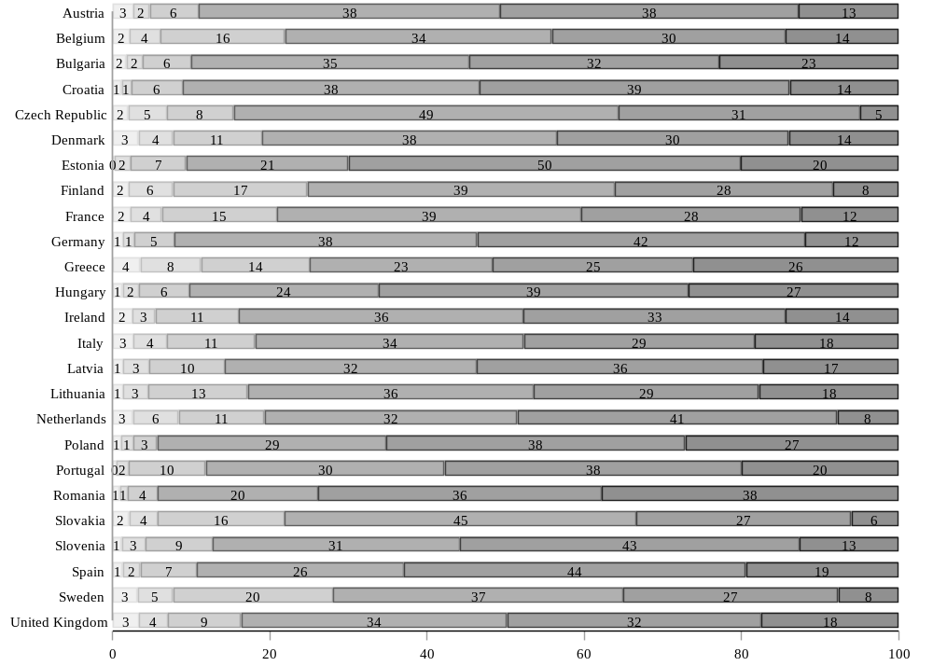
Note: Reported are, from left to right, response frequencies for the reversed 6-point scale (1 = “Not integrated at all” – 6 = “Extremely integrated”).

Figure A2.2: Distribution of threat perceptions: Terrorist attacks in [country]
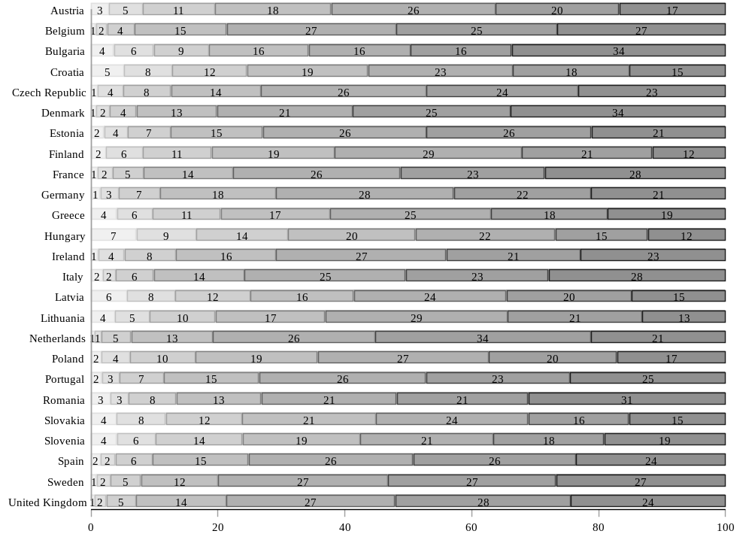
Note: Reported are, from left to right, response frequencies for the original 7-point scale (1 = “No threat at all” – 7 = “Critical threat”).

Figure A2.3: Distribution of threat perceptions: Cyber attacks on [country]’s computer networks
Note: Reported are, from left to right, response frequencies for the original 7-point scale (1 = “No threat at all” – 7 = “Critical threat”).

Figure A2.4: Distribution of threat perceptions: Hostile states influencing [country]’s elections
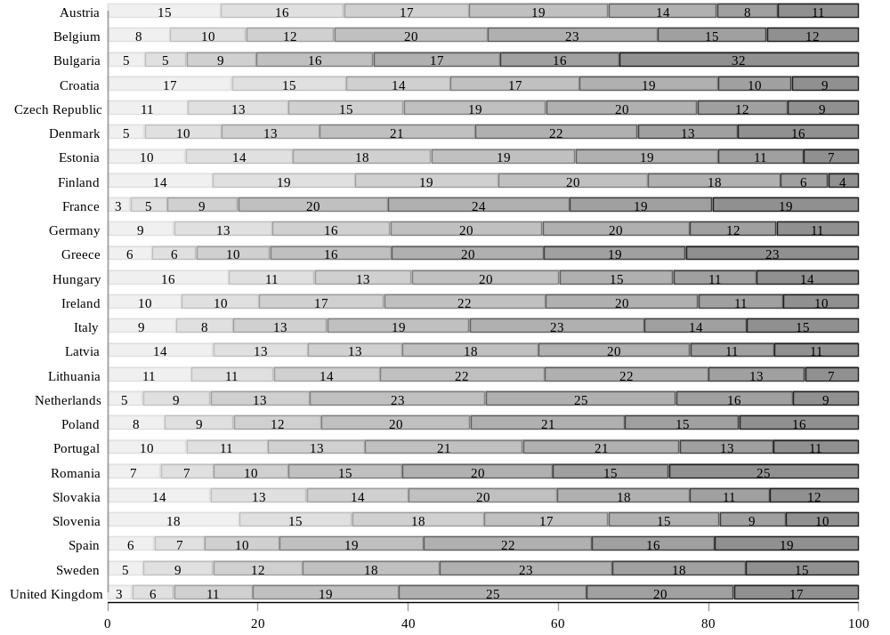
Note: Reported are, from left to right, response frequencies for the original 7-point scale (1 = “No threat at all” – 7 = “Critical threat”).

Figure A2.5: Distribution of threat perceptions: Russia’s territorial ambitions
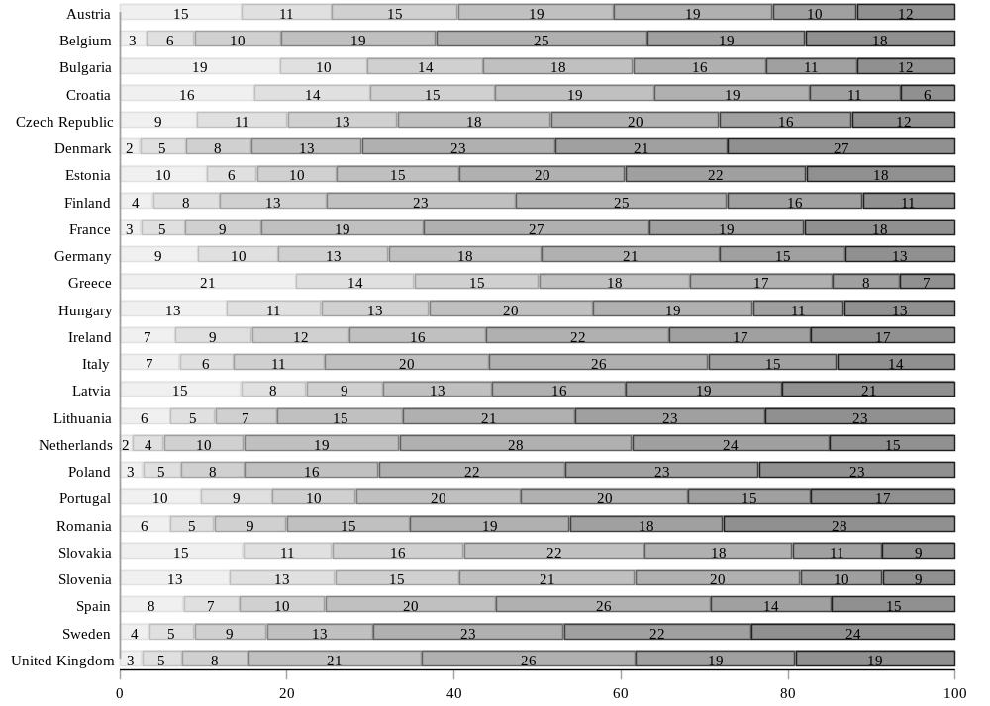
Note: Reported are, from left to right, response frequencies for the original 7-point scale (1 = “No threat at all” – 7 = “Critical threat”).

Figure A2.6: Distribution of threat perceptions: The development of China as a world power
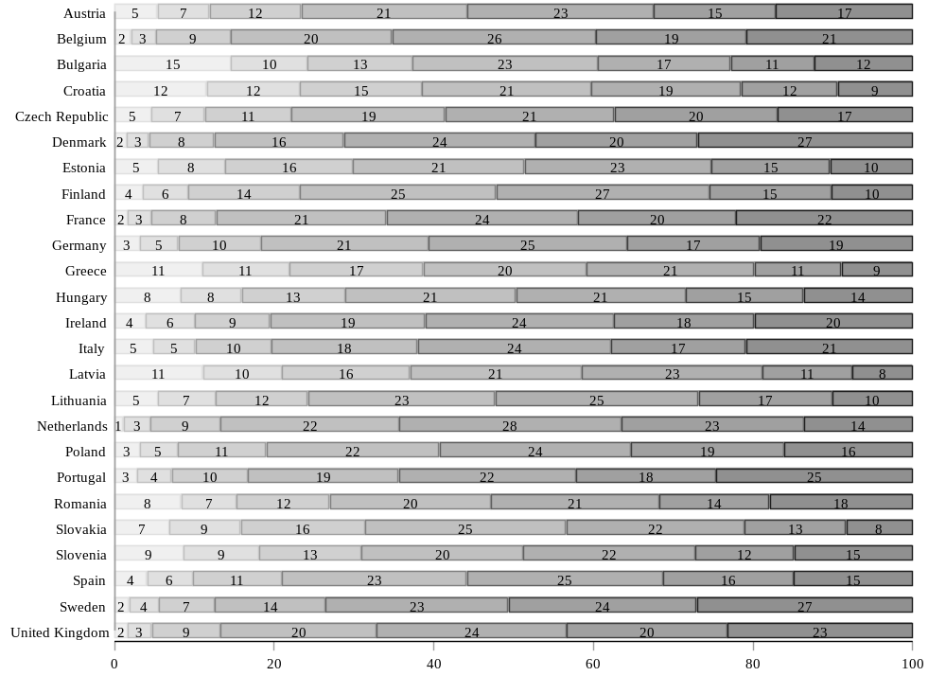
Note: Reported are, from left to right, response frequencies for the original 7-point scale (1 = “No threat at all” – 7 = “Critical threat”).

Figure A2.7: Distribution of identity types
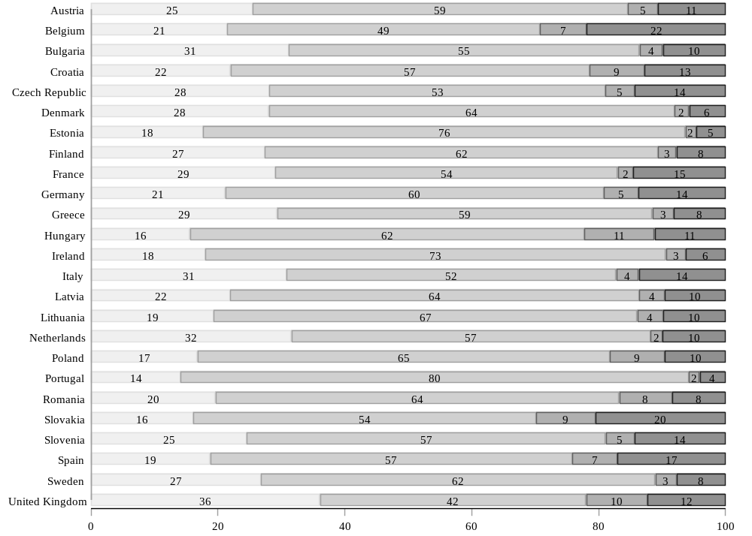
Note: Reported are, from left to right, frequencies of identity type (1 = Exclusive nationalist; 2 = inclusive nationalist; 3 = Exclusive Europeanist; 4 = No territorial ID).

A3: Factor analysis of threat items
We explored the structure of responses to the threat items in a stepwise fashion by estimating exploratory factor models (with promax rotation) with increasingly more factors prespecified to be extracted. We report the results for 1- and 2-factor models below. For a discussion of the results, see footnote 9 in the article.
Table A3.1: 1-factor solution
 | All countries
 | F1
Terrorism | 0.60
Cyber | 0.65
Election meddling | 0.64
Russia | 0.63
China | 0.58
Eigenvalue | 1.91

Table A3.1: Continued
 | Austria | Belgium | Bulgaria | Croatia | Czech  Republic | Denmark | Estonia
 | F1 | F1 | F1 | F1 | F1 | F1 | F1
Terrorism | 0.60 | 0.58 | 0.60 | 0.61 | 0.41 | 0.66 | 0.41
Cyber | 0.65 | 0.68 | 0.61 | 0.60 | 0.54 | 0.67 | 0.57
Election meddling | 0.66 | 0.61 | 0.58 | 0.60 | 0.66 | 0.64 | 0.69
Russia | 0.55 | 0.65 | 0.54 | 0.58 | 0.67 | 0.68 | 0.72
China | 0.52 | 0.61 | 0.47 | 0.47 | 0.66 | 0.67 | 0.59
Eigenvalue | 1.79 | 1.97 | 1.58 | 1.63 | 1.78 | 2.21 | 1.83

Table A3.1: Continued
 | Finland | France | Germany | Greece | Hungary | Ireland
 | F1 | F1 | F1 | F1 | F1 | F1
Terrorism | 0.55 | 0.59 | 0.55 | 0.65 | 0.55 | 0.59
Cyber | 0.60 | 0.71 | 0.64 | 0.63 | 0.64 | 0.59
Election Meddling | 0.63 | 0.62 | 0.67 | 0.61 | 0.56 | 0.64
Russia | 0.64 | 0.63 | 0.63 | 0.60 | 0.51 | 0.65
China | 0.55 | 0.60 | 0.55 | 0.51 | 0.55 | 0.60
Eigenvalue | 1.77 | 1.99 | 1.86 | 1.82 | 1.59 | 1.90

Table A3.1: Continued
 | Italy | Latvia | Lithuania | Netherlands | Poland | Portugal
 | F1 | F1 | F1 | F1 | F1 | F1
Terrorism | 0.55 | 0.45 | 0.56 | 0.57 | 0.62 | 0.63
Cyber | 0.62 | 0.61 | 0.71 | 0.65 | 0.67 | 0.55
Election Meddling | 0.63 | 0.71 | 0.71 | 0.66 | 0.64 | 0.64
Russia | 0.58 | 0.70 | 0.68 | 0.72 | 0.66 | 0.59
China | 0.48 | 0.54 | 0.56 | 0.66 | 0.62 | 0.46
Eigenvalue | 1.65 | 1.87 | 2.10 | 2.14 | 2.07 | 1.66

Table A3.1: Continued
 | Romania | Slovakia | Slovenia | Spain | Sweden | UK
 | F1 | F1 | F1 | F1 | F1 | F1
Terrorism | 0.59 | 0.65 | 0.66 | 0.58 | 0.49 | 0.65
Cyber | 0.66 | 0.64 | 0.60 | 0.66 | 0.67 | 0.67
Election Meddling | 0.61 | 0.60 | 0.64 | 0.67 | 0.69 | 0.66
Russia | 0.68 | 0.61 | 0.62 | 0.61 | 0.72 | 0.69
China | 0.55 | 0.61 | 0.52 | 0.47 | 0.63 | 0.63
Eigenvalue | 1.92 | 1.93 | 1.86 | 1.81 | 2.07 | 2.18

Table A3.2: 2-factor solution
All
countries
 | F1 | F2
Terrorism | 0.60 | 0.04
Cyber | 0.53 | 0.17
Election meddling | 0.49 | 0.19
Russia | 0.13 | 0.55
China | 0.08 | 0.55
Eigenvalue | 1.71 | 1.61

Table A3.2: Continued
 | Austria |  | Belgium |  | Bulgaria |  | Croatia |  | Czech  Republic
 | F1 | F2 | F1 | F2 | F1 | F2 | F1 | F2 | F1 | F2
Terrorism | 0.61 | 0.01 | 0.03 | 0.60 | 0.66 | -0.02 | 0.68 | -0.03 | -0.12 | 0.62
Cyber | 0.54 | 0.14 | 0.25 | 0.48 | 0.61 | 0.04 | 0.61 | 0.03 | 0.12 | 0.52
Election meddling | 0.60 | 0.10 | 0.25 | 0.41 | 0.52 | 0.10 | 0.45 | 0.20 | 0.30 | 0.46
Russia | 0.11 | 0.51 | 0.60 | 0.10 | 0.06 | 0.58 | 0.10 | 0.57 | 0.71 | 0.02
China | 0.08 | 0.51 | 0.56 | 0.10 | -0.01 | 0.58 | -0.05 | 0.61 | 0.71 | 0.01
Eigenvalue | 1.66 | 1.41 | 1.72 | 1.71 | 1.43 | 1.19 | 1.46 | 1.26 | 1.55 | 1.36

Table A3.2: Continued
 | Denmark |  | Estonia |  | Finland |  | France |  | Germany
 | F1 | F2 | F1 | F2 | F1 | F2 | F1 | F2 | F1 | F2
Terrorism | 0.10 | 0.60 | 0.06 | 0.43 | 0.10 | 0.49 | 0.56 | 0.07 | 0.12 | 0.47
Cyber | 0.20 | 0.52 | 0.38 | 0.25 | 0.23 | 0.42 | 0.55 | 0.20 | 0.23 | 0.46
Election meddling | 0.33 | 0.35 | 0.41 | 0.36 | 0.33 | 0.34 | 0.36 | 0.31 | 0.42 | 0.29
Russia | 0.60 | 0.12 | 0.66 | 0.10 | 0.51 | 0.16 | 0.14 | 0.53 | 0.55 | 0.11
China | 0.58 | 0.14 | 0.62 | -0.01 | 0.49 | 0.10 | 0.17 | 0.47 | 0.40 | 0.18
Eigenvalue | 1.97 | 1.95 | 1.71 | 1.28 | 1.57 | 1.52 | 1.78 | 1.72 | 1.66 | 1.60

Table A3.2: Continued
 | Greece |  | Hungary |  | Ireland |  | Italy |  | Latvia
 | F1 | F2 | F1 | F2 | F1 | F2 | F1 | F2 | F1 | F2
Terrorism | 0.62 | 0.06 | 0.59 | 0.00 | 0.61 | 0.02 | 0.09 | 0.51 | 0.13 | 0.40
Cyber | 0.61 | 0.06 | 0.55 | 0.14 | 0.46 | 0.17 | 0.16 | 0.51 | 0.39 | 0.28
Election meddling | 0.50 | 0.15 | 0.59 | 0.01 | 0.51 | 0.18 | 0.42 | 0.26 | 0.53 | 0.24
Russia | 0.16 | 0.50 | 0.02 | 0.58 | 0.12 | 0.58 | 0.47 | 0.16 | 0.67 | 0.06
China | 0.03 | 0.54 | 0.07 | 0.57 | 0.06 | 0.60 | 0.45 | 0.06 | 0.56 | -0.01
Eigenvalue | 1.68 | 1.45 | 1.42 | 1.21 | 1.68 | 1.63 | 1.43 | 1.42 | 1.78 | 1.27

Table A3.2: Continued
 | Lithuania |  | Netherlands |  | Poland |  | Portugal |  | Romania
 | F1 | F2 | F1 | F2 | F1 | F2 | F1 | F2 | F1 | F2
Terrorism | 0.58 | -0.03 | 0.11 | 0.50 | 0.60 | 0.06 | 0.67 | -0.01 | 0.48 | 0.15
Cyber | 0.70 | 0.01 | 0.25 | 0.45 | 0.51 | 0.21 | 0.47 | 0.12 | 0.48 | 0.23
Election meddling | 0.71 | 0.02 | 0.39 | 0.31 | 0.49 | 0.19 | 0.54 | 0.14 | 0.44 | 0.20
Russia | 0.65 | 0.08 | 0.61 | 0.15 | 0.14 | 0.58 | 0.16 | 0.50 | 0.29 | 0.43
China | 0.52 | 0.09 | 0.59 | 0.10 | 0.10 | 0.57 | -0.01 | 0.54 | 0.15 | 0.44
Eigenvalue | 2.09 | 0.42 | 1.97 | 1.82 | 1.84 | 1.78 | 1.52 | 1.30 | 1.74 | 1.61

Table A3.2: Continued
 | Slovakia |  | Slovenia |  | Spain |  | Sweden |  | UK
 | F1 | F2 | F1 | F2 | F1 | F2 | F1 | F2 | F1 | F2
Terrorism | 0.61 | 0.08 | 0.62 | 0.08 | 0.61 | 0.01 | 0.19 | 0.34 | 0.52 | 0.17
Cyber | 0.47 | 0.23 | 0.48 | 0.15 | 0.59 | 0.12 | 0.34 | 0.37 | 0.56 | 0.15
Election meddling | 0.63 | 0.01 | 0.55 | 0.13 | 0.42 | 0.32 | 0.43 | 0.30 | 0.40 | 0.30
Russia | 0.05 | 0.62 | 0.20 | 0.48 | 0.17 | 0.51 | 0.65 | 0.10 | 0.18 | 0.56
China | 0.08 | 0.60 | 0.07 | 0.51 | 0.02 | 0.51 | 0.56 | 0.09 | 0.14 | 0.53
Eigenvalue | 1.71 | 1.61 | 1.72 | 1.53 | 1.61 | 1.44 | 1.97 | 1.69 | 1.95 | 1.92

A4: Regression tables

Pooled analysis
Below are the full regression tables for the models underlying Figure 3 and Table 1.
Table A4.1: Pooled regression models
 | M1 | M2 | M3
Threat perception | .10*** | .10*** | .06**
 | (.01) | (.01) | (.02)
Inclusive identity | .05*** | .05*** | .03
 | (.00) | (.01) | (.02)
No territorial ID | -.02*** | -.02 | -.05**
 | (.00) | (.01) | (.02)
Political sophistication |  |  | -.06*
 |  |  | (.02)
Inclusive identity * Threat perception |  | -.01 | .01
 |  | (.01) | (.03)
No territorial ID * Threat perception |  | -.01 | .03
 |  | (.02) | (.03)
Threat perception * Political sophistication |  |  | .09*
 |  |  | (.04)
Inclusive identity * Political sophistication |  |  | .05
 |  |  | (.03)
No territorial ID * Political sophistication |  |  | .08*
 |  |  | (.04)
Inclusive identity * Threat perception * Political sophistication |  |  | -.03
 |  |  | (.04)
No territorial ID * Threat perception * Political sophistication |  |  | -.07
 |  |  | (.06)
Isolationism | -.14*** | -.14*** | -.14***
 | (.01) | (.01) | (.01)
Willingness to compromise | .24*** | .24*** | .24***
 | (.01) | (.01) | (.01)
Attitudes towards the use of force | .06*** | .06*** | .06***
 | (.01) | (.01) | (.01)
Age (in years) | .00*** | .00*** | .00***
 | (.00) | (.00) | (.00)
Gender (female) | -.01*** | -.01*** | -.01***
 | (.00) | (.00) | (.00)
Formal education: low | -.01 | -.01 | -.01
 | (.00) | (.00) | (.00)
Formal education: high | -.00 | -.00 | -.00
 | (.00) | (.00) | (.00)
Belgium | -.06*** | -.06*** | -.06***
 | (.01) | (.01) | (.01)
Bulgaria | .04*** | .04*** | .04***
 | (.01) | (.01) | (.01)
Croatia | -.00 | -.00 | -.00
 | (.01) | (.01) | (.01)
Czech Republic | -.07*** | -.07*** | -.07***
 | (.01) | (.01) | (.01)
Denmark | -.07*** | -.07*** | -.07***
 | (.01) | (.01) | (.01)
Estonia | .03*** | .03*** | .04***
 | (.01) | (.01) | (.01)
Finland | -.08*** | -.08*** | -.07***
 | (.01) | (.01) | (.01)
France | -.07*** | -.07*** | -.07***
 | (.01) | (.01) | (.01)
Germany | -.01 | -.01 | -.01
 | (.01) | (.01) | (.01)
Greece | -.02* | -.02* | -.02*
 | (.01) | (.01) | (.01)
Hungary | .05*** | .05*** | .06***
 | (.01) | (.01) | (.01)
Ireland | -.05*** | -.05*** | -.05***
 | (.01) | (.01) | (.01)
Italy | -.01* | -.01* | -.01
 | (.01) | (.01) | (.01)
Latvia | .00 | .00 | .00
 | (.01) | (.01) | (.01)
Lithuania | -.03*** | -.03*** | -.03***
 | (.01) | (.01) | (.01)
Netherlands | -.07*** | -.07*** | -.07***
 | (.01) | (.01) | (.01)
Poland | .03*** | .03*** | .03***
 | (.01) | (.01) | (.01)
Portugal | -.01 | -.01 | -.00
 | (.01) | (.01) | (.01)
Romania | .09*** | .09*** | .10***
 | (.01) | (.01) | (.01)
Slovakia | -.07*** | -.07*** | -.06***
 | (.01) | (.01) | (.01)
Slovenia | .03*** | .03*** | .03***
 | (.01) | (.01) | (.01)
Spain | .01 | .01 | .01
 | (.01) | (.01) | (.01)
Sweden | -.10*** | -.10*** | -.10***
 | (.01) | (.01) | (.01)
UK | -.05*** | -.05*** | -.05***
 | (.01) | (.01) | (.01)
Constant | .51*** | .51*** | .54***
 | (.01) | (.01) | (.02)
N | 35914 | 35914 | 35914
Standard errors in parentheses
* p < 0.05, ** p < 0.01, *** p < 0.001

Country-by-country analysis
Below are the full regression tables for the models underlying Figure 4 and Table 2.

Table A4.2: Average effect models, country-by-country
 | Austria | Belgium | Bulgaria | Croatia | Czech Republic | Denmark | Estonia | Finland
Threat perception | .09*** | .05 | .08** | -.00 | .13*** | .12*** | .22*** | .16***
 | (.03) | (.03) | (.03) | (.02) | (.03) | (.03) | (.03) | (.03)
Inclusive identity | .03* | .03* | .05*** | .05*** | .02* | .08*** | .02 | .07***
 | (.01) | (.02) | (.01) | (.01) | (.01) | (.01) | (.01) | (.01)
No territorial ID | -.04 | -.02 | -.05** | .02 | -.01 | .03 | -.09*** | -.03
 | (.02) | (.02) | (.02) | (.02) | (.02) | (.03) | (.02) | (.02)
Isolationism | -.09** | -.22*** | -.10*** | -.12*** | -.14*** | -.15*** | -.17*** | -.11***
 | (.03) | (.03) | (.03) | (.03) | (.03) | (.03) | (.03) | (.03)
Willingness to compromise | .24*** | .19*** | .15*** | .18*** | .18*** | .29*** | .15*** | .31***
 | (.03) | (.04) | (.03) | (.03) | (.03) | (.03) | (.03) | (.03)
Attitudes towards the use of force | .01 | .10** | .00 | .10*** | .16*** | .10** | .13*** | .09**
 | (.03) | (.03) | (.03) | (.03) | (.03) | (.03) | (.03) | (.03)
Age (in years) | .00* | .00** | .00*** | .00** | -.00 | -.00* | .00*** | -.00
 | (.00) | (.00) | (.00) | (.00) | (.00) | (.00) | (.00) | (.00)
Gender (female) | .00 | -.02 | -.00 | -.00 | .00 | .00 | -.01 | -.03**
 | (.01) | (.01) | (.01) | (.01) | (.01) | (.01) | (.01) | (.01)
Formal education: low | .00 | -.05** | -.04 | -.00 | .05* | -.01 | -.03 | .03
 | (.02) | (.02) | (.04) | (.05) | (.02) | (.02) | (.03) | (.02)
Formal education: high | -.01 | .02 | -.01 | -.01 | .02 | -.04** | .01 | -.01
 | (.01) | (.01) | (.01) | (.01) | (.01) | (.01) | (.01) | (.01)
Constant | .50*** | .51*** | .53*** | .53*** | .45*** | .44*** | .49*** | .36***
 | (.03) | (.04) | (.04) | (.03) | (.03) | (.04) | (.03) | (.04)
N | 1337 | 1315 | 1333 | 1393 | 1225 | 1311 | 1390 | 1251
Standard errors in parentheses
* p < 0.05, ** p < 0.01, *** p < 0.001

Table A4.2: Continued
 | France | Germany | Greece | Hungary | Ireland | Italy | Latvia | Lithuania
Threat perception | .06* | .10*** | .01 | .02 | .11*** | .07* | .16*** | .17***
 | (.03) | (.02) | (.04) | (.03) | (.03) | (.03) | (.03) | (.03)
Inclusive identity | .04*** | .05*** | .06*** | .06*** | .05*** | .07*** | .03* | .05**
 | (.01) | (.01) | (.02) | (.02) | (.01) | (.01) | (.01) | (.02)
No territorial ID | -.02 | .00 | -.06 | -.03 | -.01 | -.05** | -.08*** | -.00
 | (.02) | (.01) | (.03) | (.02) | (.03) | (.02) | (.02) | (.02)
Isolationism | -.13*** | -.12*** | -.11** | -.05 | -.22*** | -.22*** | -.15*** | -.10**
 | (.02) | (.02) | (.04) | (.03) | (.03) | (.03) | (.03) | (.03)
Willingness to compromise | .24*** | .19*** | .15*** | .32*** | .31*** | .10*** | .14*** | .23***
 | (.03) | (.02) | (.04) | (.03) | (.03) | (.03) | (.03) | (.04)
Attitudes towards the use of force | .16*** | .05* | .04 | -.05 | .22*** | -.01 | .05 | .10**
 | (.03) | (.02) | (.04) | (.03) | (.03) | (.03) | (.03) | (.03)
Age (in years) | .00 | .00 | .00 | .00** | -.00 | .00* | .00 | .00
 | (.00) | (.00) | (.00) | (.00) | (.00) | (.00) | (.00) | (.00)
Gender (female) | .00 | -.01 | .01 | -.02* | -.02 | -.03** | -.01 | -.02
 | (.01) | (.01) | (.02) | (.01) | (.01) | (.01) | (.01) | (.01)
Formal education: low | .01 | .01 | -.00 | .03 | .01 | -.01 | -.02 | -.02
 | (.02) | (.01) | (.02) | (.02) | (.02) | (.01) | (.02) | (.02)
Formal education: high | .01 | .00 | -.02 | .00 | -.01 | .03 | -.02 | .01
 | (.01) | (.01) | (.02) | (.01) | (.01) | (.01) | (.01) | (.01)
Constant | .40*** | .53*** | .58*** | .51*** | .42*** | .64*** | .58*** | .40***
 | (.04) | (.03) | (.05) | (.04) | (.04) | (.03) | (.04) | (.04)
N | 1650 | 1754 | 1403 | 1373 | 1372 | 1756 | 1372 | 1322
Standard errors in parentheses
* p < 0.05, ** p < 0.01, *** p < 0.001

Table A4.2: Continued
 | Netherl. | Poland | Portugal | Romania | Slovakia | Slovenia | Spain | Sweden | UK
Threat perception | .16*** | .08*** | .06* | .13*** | .13*** | .05 | .04 | .20*** | .16***
 | (.04) | (.02) | (.03) | (.02) | (.03) | (.03) | (.03) | (.03) | (.03)
Inclusive identity | .04** | .05*** | .03 | .05*** | .03 | .02 | .04** | .06*** | .06***
 | (.01) | (.01) | (.01) | (.01) | (.01) | (.01) | (.01) | (.01) | (.01)
No territorial ID | -.05* | .01 | -.02 | -.03 | .00 | -.04* | -.05** | -.02 | -.02
 | (.02) | (.02) | (.03) | (.02) | (.02) | (.02) | (.02) | (.02) | (.02)
Isolationism | -.18*** | -.15*** | -.14*** | -.15*** | -.16*** | -.02 | -.17*** | -.23*** | -.09***
 | (.03) | (.02) | (.03) | (.02) | (.03) | (.03) | (.02) | (.03) | (.02)
Willingness to compromise | .22*** | .34*** | .31*** | .17*** | .30*** | .21*** | .26*** | .26*** | .43***
 | (.04) | (.02) | (.03) | (.03) | (.03) | (.03) | (.03) | (.03) | (.03)
Attitudes towards the use of force | .05 | -.04 | -.02 | .01 | .03 | .13*** | .13*** | .14*** | .00
 | (.04) | (.03) | (.03) | (.03) | (.03) | (.03) | (.02) | (.03) | (.03)
Age (in years) | .00 | .00** | .00 | .00* | -.00 | .00 | .00* | -.00*** | .00
 | (.00) | (.00) | (.00) | (.00) | (.00) | (.00) | (.00) | (.00) | (.00)
Gender (female) | -.01 | -.01 | -.02* | -.01 | -.02* | -.03** | -.03*** | -.01 | .01
 | (.01) | (.01) | (.01) | (.01) | (.01) | (.01) | (.01) | (.01) | (.01)
Formal education: low | -.01 | -.02 | -.01 | .03 | -.04 | .01 | -.02 | .04* | -.01
 | (.02) | (.02) | (.01) | (.02) | (.02) | (.03) | (.01) | (.02) | (.02)
Formal education: high | .00 | -.02* | -.01 | -.00 | .00 | .00 | -.01 | .01 | -.01
 | (.01) | (.01) | (.01) | (.01) | (.01) | (.01) | (.01) | (.01) | (.01)
Constant | .43*** | .53*** | .54*** | .63*** | .47*** | .50*** | .54*** | .40*** | .31***
 | (.05) | (.03) | (.04) | (.03) | (.03) | (.04) | (.03) | (.04) | (.04)
N | 1309 | 1853 | 1405 | 1365 | 1296 | 1391 | 1758 | 1287 | 1693
Standard errors in parentheses
* p < 0.05, ** p < 0.01, *** p < 0.001

Country-by-country analysis
Interaction effect models

Table A4.3: Interaction effect models, country-by-country
 | Austria | Belgium | Bulgaria | Croatia | Czech  Republic | Denmark | Estonia | Finland
Threat perception | .09 | .14 | .18*** | -.05 | .11* | .10 | .27*** | .20**
 | (.05) | (.08) | (.05) | (.05) | (.05) | (.06) | (.05) | (.06)
Inclusive identity | .04 | .10 | .12** | .02 | -.01 | .07 | .07* | .12**
 | (.04) | (.06) | (.04) | (.03) | (.04) | (.05) | (.03) | (.04)
No territorial ID | -.06 | .06 | .07 | -.03 | -.00 | -.02 | -.21*** | -.21**
 | (.05) | (.07) | (.06) | (.04) | (.05) | (.08) | (.06) | (.07)
Inclusive identity * Threat perception | -.01 | -.10 | -.13* | .05 | .05 | .02 | -.08 | -.08
 | (.06) | (.09) | (.06) | (.06) | (.06) | (.07) | (.06) | (.07)
No territorial ID * Threat perception | .05 | -.13 | -.23* | .14 | -.02 | .09 | .28* | .35**
 | (.09) | (.10) | (.10) | (.09) | (.08) | (.14) | (.12) | (.13)
Isolationism | -.09** | -.22*** | -.10*** | -.12*** | -.14*** | -.14*** | -.16*** | -.12***
 | (.03) | (.03) | (.03) | (.03) | (.03) | (.03) | (.03) | (.03)
Willingness to compromise | .24*** | .19*** | .15*** | .18*** | .18*** | .29*** | .16*** | .32***
 | (.03) | (.04) | (.03) | (.03) | (.03) | (.03) | (.03) | (.03)
Attitudes towards the use of force | .01 | .10** | .00 | .10*** | .16*** | .10** | .13*** | .09**
 | (.03) | (.03) | (.03) | (.03) | (.03) | (.03) | (.03) | (.03)
Age (in years) | .00* | .00** | .00*** | .00** | -.00 | -.00* | .00*** | -.00
 | (.00) | (.00) | (.00) | (.00) | (.00) | (.00) | (.00) | (.00)
Gender (female) | .00 | -.02 | -.00 | -.00 | .00 | .00 | -.01 | -.03**
 | (.01) | (.01) | (.01) | (.01) | (.01) | (.01) | (.01) | (.01)
Formal education: low | .00 | -.05** | -.04 | -.00 | .05* | -.01 | -.03 | .03
 | (.02) | (.02) | (.04) | (.05) | (.02) | (.02) | (.03) | (.02)
Formal education: high | -.01 | .02 | -.01 | -.01 | .02 | -.04** | .01 | -.01
 | (.01) | (.01) | (.01) | (.01) | (.01) | (.01) | (.01) | (.01)
Constant | .50*** | .45*** | .48*** | .56*** | .46*** | .45*** | .47*** | .34***
 | (.04) | (.06) | (.04) | (.04) | (.04) | (.05) | (.04) | (.04)
N | 1337 | 1315 | 1333 | 1393 | 1225 | 1311 | 1390 | 1251
Standard errors in parentheses
* p < 0.05, ** p < 0.01, *** p < 0.001

Table A4.3: Continued
 | France | Germany | Greece | Hungary | Ireland | Italy | Latvia | Lithuania
Threat perception | .08 | .09 | -.07 | -.05 | .04 | .25*** | .15* | .14
 | (.07) | (.05) | (.07) | (.07) | (.09) | (.06) | (.07) | (.08)
EU attitude | .14 | .11* | .11 | .08 | .13 | .40*** | .17*** | .21***
 | (.09) | (.05) | (.07) | (.05) | (.07) | (.06) | (.05) | (.06)
Threat perception * EU attitude | -.00 | -.00 | .14 | .13 | .09 | -.32*** | .00 | .03
 | (.11) | (.07) | (.12) | (.09) | (.12) | (.09) | (.10) | (.10)
Isolationism | -.12*** | -.11*** | -.09* | -.04 | -.21*** | -.19*** | -.13*** | -.06
 | (.03) | (.02) | (.04) | (.03) | (.03) | (.03) | (.03) | (.03)
Willingness to compromise | .21*** | .18*** | .09* | .25*** | .27*** | .07* | .09** | .16***
 | (.03) | (.02) | (.05) | (.03) | (.03) | (.03) | (.03) | (.04)
Attitudes towards the use of force | .17*** | .05* | .06 | -.03 | .24*** | .00 | .03 | .09*
 | (.03) | (.02) | (.04) | (.03) | (.03) | (.03) | (.03) | (.03)
Age (in years) | .00 | .00 | .00 | .00*** | -.00 | .00* | .00 | .00*
 | (.00) | (.00) | (.00) | (.00) | (.00) | (.00) | (.00) | (.00)
Gender (female) | -.00 | -.02 | .01 | -.03* | -.02 | -.03** | -.01 | -.02*
 | (.01) | (.01) | (.02) | (.01) | (.01) | (.01) | (.01) | (.01)
Formal education: low | -.00 | .01 | -.01 | .03 | -.00 | -.01 | -.04 | -.02
 | (.02) | (.01) | (.02) | (.02) | (.02) | (.01) | (.02) | (.02)
Formal education: high | .01 | .00 | -.01 | .00 | -.01 | .02 | -.02* | .01
 | (.01) | (.01) | (.02) | (.01) | (.01) | (.01) | (.01) | (.01)
Constant | .34*** | .49*** | .54*** | .52*** | .39*** | .44*** | .50*** | .29***
 | (.06) | (.04) | (.06) | (.05) | (.06) | (.05) | (.05) | (.06)
N | 1647 | 1760 | 1405 | 1364 | 1362 | 1750 | 1373 | 1327
Standard errors in parentheses
* p < 0.05, ** p < 0.01, *** p < 0.001

Table A4.3: Continued
 | Netherl. | Poland | Portugal | Romania | Slovakia | Slovenia | Spain | Sweden | UK
Threat perception | .29*** | .10* | .08 | .22*** | .13* | .09 | .04 | .22*** | .17***
 | (.06) | (.05) | (.07) | (.05) | (.06) | (.05) | (.05) | (.06) | (.05)
Inclusive identity | .18*** | .07* | .04 | .12** | .02 | .05 | .01 | .07 | .08
 | (.05) | (.04) | (.05) | (.04) | (.04) | (.03) | (.04) | (.05) | (.05)
No territorial ID | -.00 | -.01 | .02 | -.00 | -.00 | -.03 | -.01 | .03 | -.02
 | (.07) | (.05) | (.09) | (.05) | (.04) | (.04) | (.05) | (.07) | (.06)
Inclusive identity * Threat perception | -.21** | -.04 | -.02 | -.12* | .00 | -.06 | .04 | -.01 | -.03
 | (.07) | (.06) | (.07) | (.06) | (.07) | (.06) | (.06) | (.07) | (.06)
No territorial ID * Threat perception | -.07 | .04 | -.07 | -.03 | .01 | -.02 | -.07 | -.07 | .01
 | (.12) | (.08) | (.15) | (.09) | (.08) | (.08) | (.08) | (.11) | (.09)
Isolationism | -.18*** | -.15*** | -.14*** | -.15*** | -.16*** | -.02 | -.17*** | -.23*** | -.09***
 | (.03) | (.02) | (.03) | (.02) | (.03) | (.03) | (.02) | (.03) | (.02)
Willingness to compromise | .22*** | .34*** | .31*** | .18*** | .30*** | .21*** | .26*** | .26*** | .43***
 | (.04) | (.02) | (.03) | (.03) | (.03) | (.03) | (.03) | (.03) | (.03)
Attitudes towards the use of force | .05 | -.04 | -.02 | .00 | .03 | .13*** | .13*** | .14*** | .00
 | (.04) | (.03) | (.03) | (.03) | (.03) | (.03) | (.02) | (.03) | (.03)
Age (in years) | .00 | .00** | .00 | .00* | -.00 | .00 | .00* | -.00*** | .00
 | (.00) | (.00) | (.00) | (.00) | (.00) | (.00) | (.00) | (.00) | (.00)
Gender (female) | -.01 | -.01 | -.02* | -.01 | -.02* | -.03** | -.03*** | -.01 | .01
 | (.01) | (.01) | (.01) | (.01) | (.01) | (.01) | (.01) | (.01) | (.01)
Formal education: low | -.01 | -.02 | -.01 | .03 | -.04 | .01 | -.02 | .04* | -.01
 | (.02) | (.02) | (.01) | (.02) | (.02) | (.03) | (.01) | (.02) | (.02)
Formal education: high | .00 | -.02* | -.01 | -.00 | .00 | .00 | -.01 | .01 | -.01
 | (.01) | (.01) | (.01) | (.01) | (.01) | (.01) | (.01) | (.01) | (.01)
Constant | .35*** | .52*** | .53*** | .57*** | .47*** | .48*** | .55*** | .39*** | .30***
 | (.06) | (.04) | (.05) | (.05) | (.04) | (.04) | (.04) | (.05) | (.05)
N | 1309 | 1853 | 1405 | 1365 | 1296 | 1391 | 1758 | 1287 | 1693
Standard errors in parentheses
* p < 0.05, ** p < 0.01, *** p < 0.001

A5: More restrictive models
We replicated the aggregate analyses reported in the article by estimating the regression models with more restrictive controls, namely 1) attitude towards the EU, 3) anti-elitism, and 4) feelings towards [COUNTRY] government. The results are substantively the same as those reported in the article.

Figure A5.1: Aggregate effect of threat perception on support for European security and defence integration
TOTAL SAMPLE
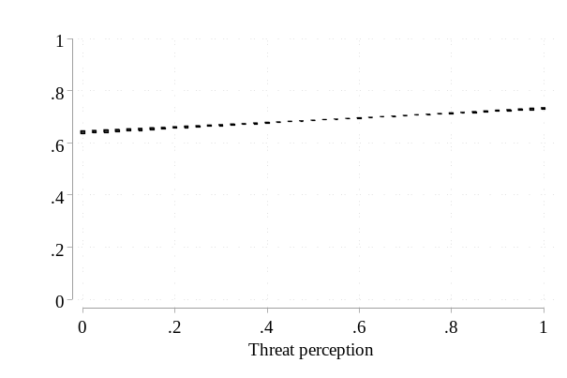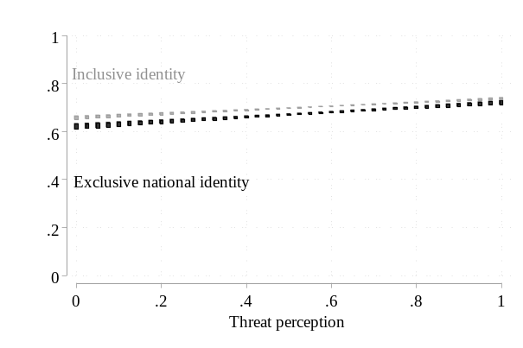
BY POLITICAL SOPHISTICATION
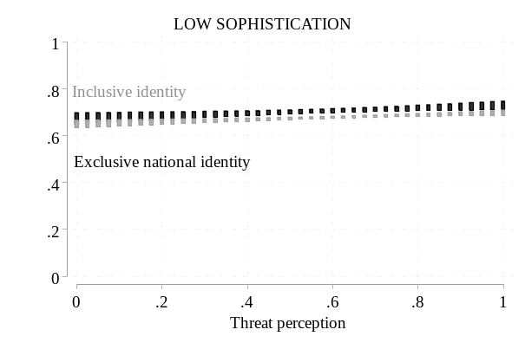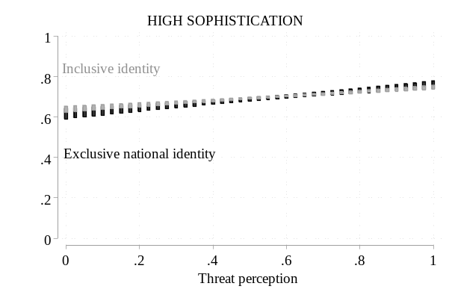

A6: Alternative threat measures
We replicated the aggregate analyses reported in the article by estimating the regression models with alternative threat measures. Specifically, we computed two indexes based on the results from the factor analyses reported in appendix A2 above. Accordingly, there are two subdimensions of international threat in our threat battery, one consisting of traditional, country-related perceptions (Russia’s territorial ambitions and the rise of China), and the other consisting of new, and (often) asymmetrical, threats (terrorist attacks, cyber attacks, and election mingling). Repeating the aggregate analysis using an index measure of either of these subdimensions (which are correlated with r=.50, ranging from .35 in Bulgaria to .60 in the Netherlands) produce substantively the same results as those reported in the article.
In the following, we use this notation:
Threat perception A = Russia and China
Threat perception B = Terrorism, Cyber, and election mingling

Figure A6.1: Pooled effect of threat perception A on support for European defence integration
TOTAL SAMPLE
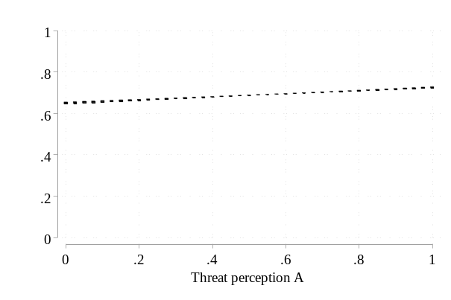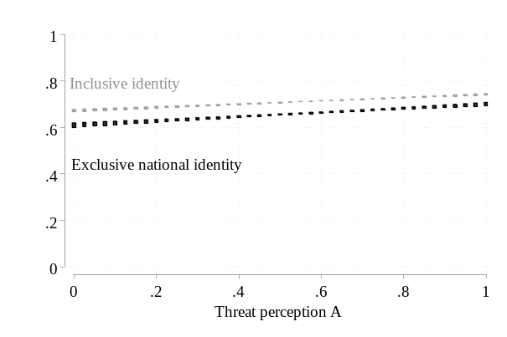
BY POLITICAL SOPHISTICATION
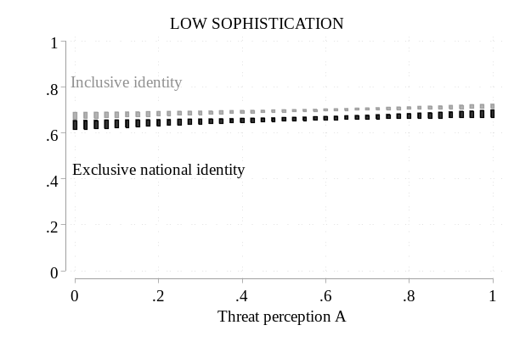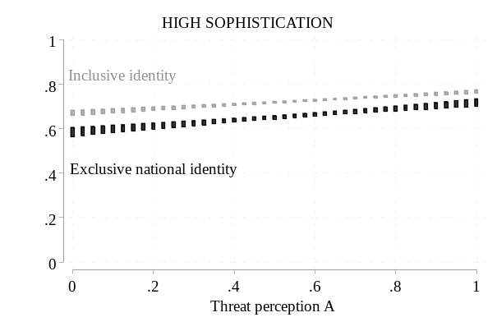

Figure A6.2: Pooled effect of threat perception B on support for European defence integration
TOTAL SAMPLE
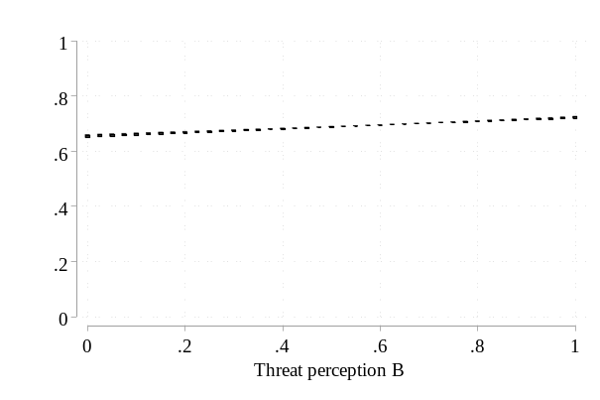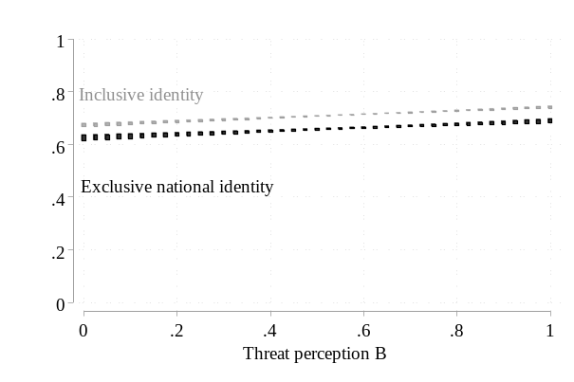
BY POLITICAL SOPHISTICATION
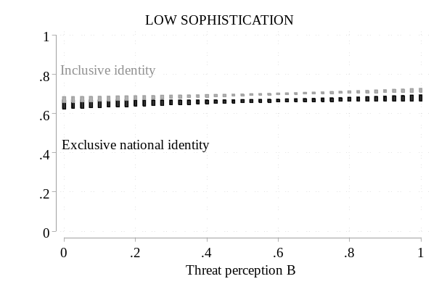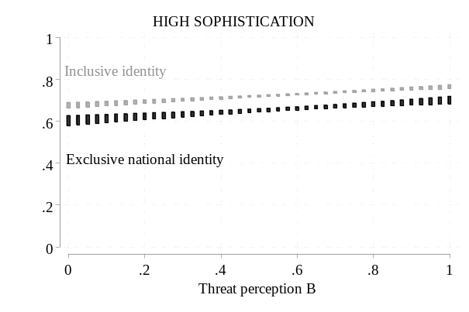

A7: Alternative interaction variable: attachment to Europe
We replicated the aggregate analyses reported in the article by estimating the regression models using attachment to Europe as the interaction variable. The results are substantively the same as those reported in the article.
(Figure A7.1, top left panel = Figure 5, top left panel in main article)

Figure A7.1: Aggregate effect of threat perception on support for European defence integration, attachment to Europe as interaction variable
TOTAL SAMPLE
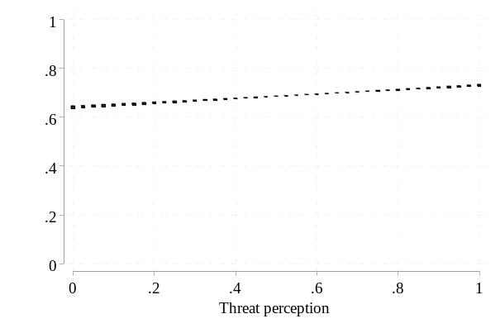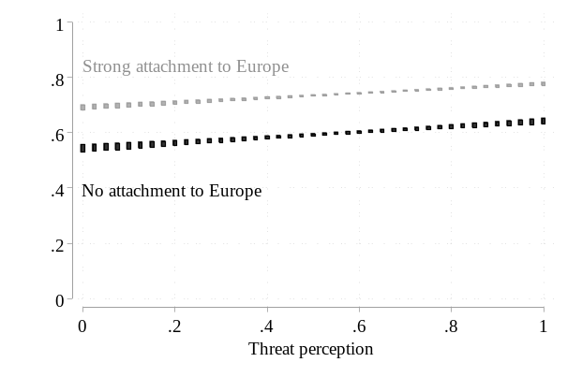
BY POLITICAL SOPHISTICATION
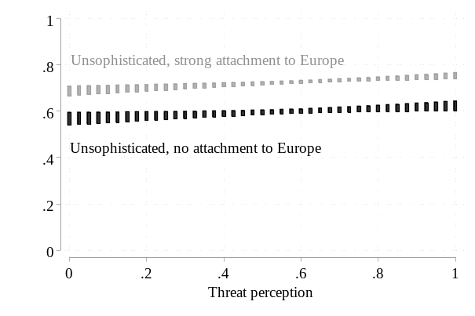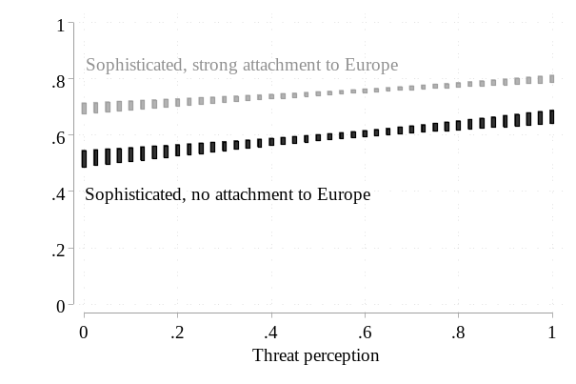

Table A7.1: Pooled average and conditional effects of perceived threat, attachment to Europe as interaction variable
 | Avg. effect  of threat  perception | Conditional effect
 | Avg. effect  of threat  perception | No attachment | Strong attachment
Total sample | .09*** | .10*** | .09***
Pol. unsophisticated | .06*** | .06* | .07***
Pol. sophisticated | .12*** | .15*** | .10***
Note: Entries are unstandardized marginal effects. Subgroup effects calculated based on extreme (max/min) values. * p < 0.05, ** p < 0.01, *** p < 0.001

Table A7.2: Average and conditional effect of perceived threat, country-by-country results (interaction variable: attachment to Europe)
 | Avg. effect  of threat  perception | Conditional effect
 | Avg. effect  of threat  perception | No attachment | Strong attachment | Difference#
Austria | .09** | .09 | .09* | .00
Belgium | .05 | .08 | .02 | -.06
Bulgaria | .08** | .10 | .07 | -.04
Croatia | -.00 | -.03 | .01 | .04
Czech Republic | .12*** | .02 | .19*** | .17
Denmark | .11** | .03 | .15** | .12
Estonia | .21*** | .36*** | .15*** | -.21*
Finland | .16*** | .37*** | .05 | -.32**
France | .06 | .05 | .06 | .02
Germany | .08*** | .03 | .11** | .08
Greece | .01 | -.06 | .05 | .12
Hungary | .01 | -.24** | .11* | .34***
Ireland | .11*** | -.06 | .17*** | .23*
Italy | .07* | .22*** | -.06 | -.28**
Latvia | .15*** | .16* | .14*** | -.02
Lithuania | .15*** | .14* | .16*** | .01
Netherlands | .16*** | .40*** | -.03 | -.43***
Poland | .07** | .16** | .04 | -.12
Portugal | .06* | .06 | .06 | -.00
Romania | .12*** | .29*** | .06 | -.24**
Slovakia | .13*** | .10 | .14*** | .04
Slovenia | .05 | .09 | .02 | -.07
Spain | .04 | .04 | .04 | .00
Sweden | .19*** | .24** | .15*** | -.09
United Kingdom | .15*** | .27*** | .05 | -.22**
Note: Entries are unstandardized marginal effects from linear regressions. Subgroup effects calculated based on extreme (max/min) values of Attachment to Europe variable. # Coefficient of interaction term Threat*Attachment to Europe. * p < 0.05, ** p < 0.01, *** p < 0.001

Figure A7.2: Coutry-by-country support for European defence and security integration, by threat perception and attachment to Europe
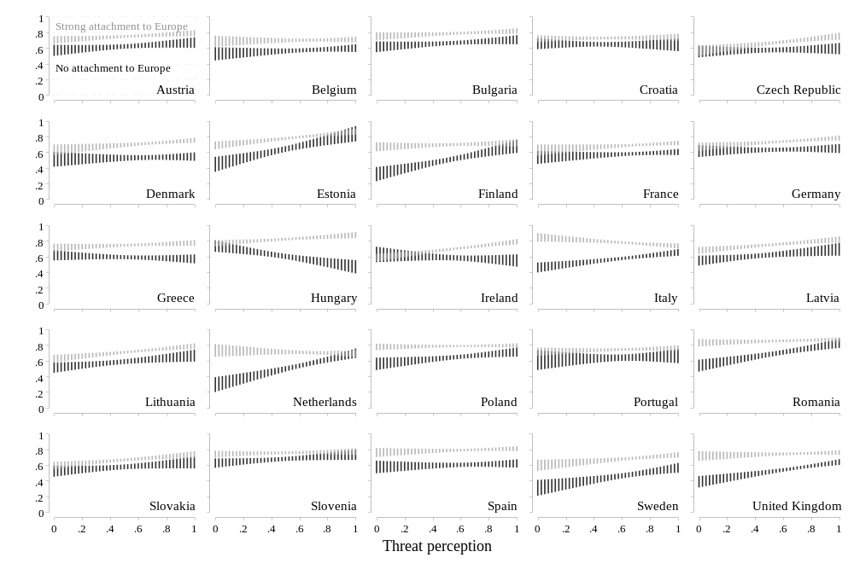

A8: Alternative interaction variable: EU attitude
We replicated the aggregate analyses reported in the article by estimating the regression models using feelings towards the EU as the interaction variable. The results are substantively the same as those reported in the article.
(Figure A7.1, top left panel = Figure 5, top right panel in main article)

Figure A8.1: Aggregate effect of threat perception on support for European defence integration, EU attitude as interaction variable
TOTAL SAMPLE
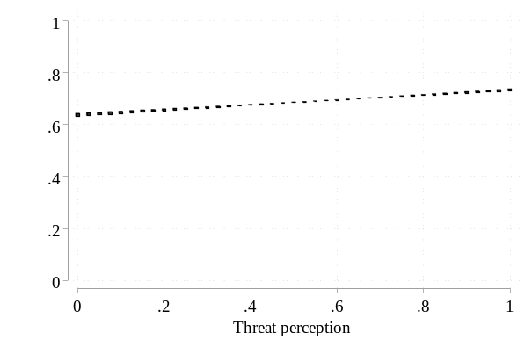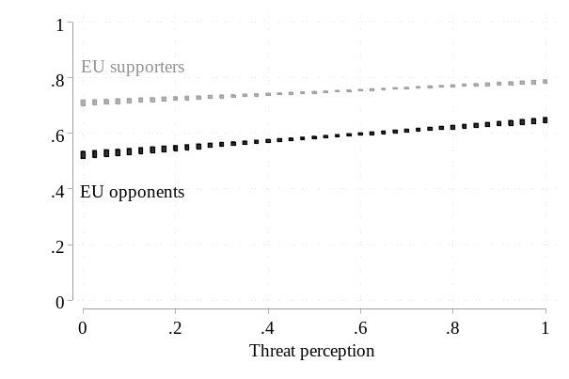
BY POLITICAL SOPHISTICATION
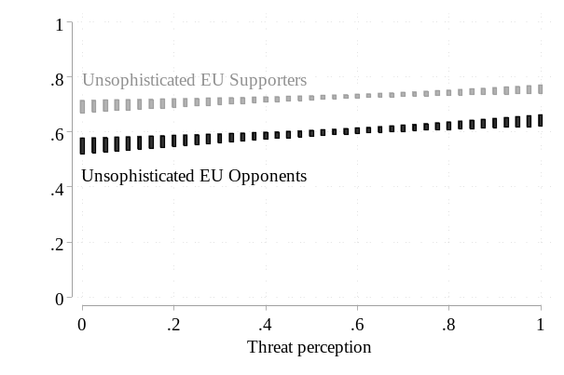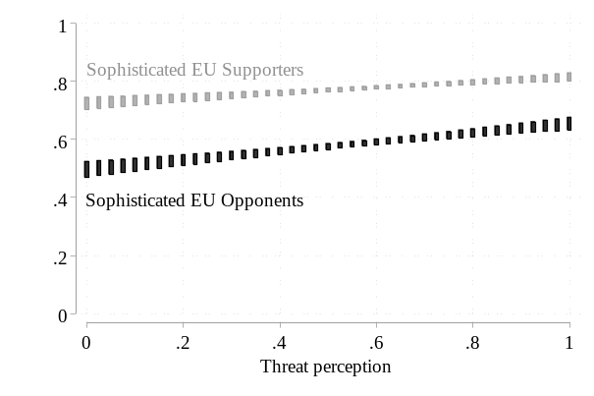

Table A8.1: Pooled average and conditional effects of perceived threat, EU attitude as interaction variable
 | Effect of  threat perception | Effect among
 | Effect of  threat perception | EU opponents | EU supporters
Total sample | .10*** | .12*** | .08***
Pol. unsophisticated | .07*** | .09*** | .06**
Pol. sophisticated | .12*** | .16*** | .09***
Note: Entries are unstandardized marginal effects. Subgroup effects calculated based on extreme (max/min) values. # Coefficient of interaction term Threat*EU attitude. * p < 0.05, ** p < 0.01, *** p < 0.001

Table A8.2: Average and conditional effect of perceived threat, country-by-country results, EU attitude as interaction variable
 | Average effect | Effect among
 | Average effect | EU Opponents | EU Supporters | Difference#
Austria | .09*** | .21*** | -.00 | -.22**
Belgium | .05 | .16* | -.04 | -.21
Bulgaria | .08** | .11 | .05 | -.06
Croatia | .00 | .11 | -.06 | -.17
Czech Republic | .13*** | .21*** | .01 | -.20*
Denmark | .12*** | .08 | .16** | .08
Estonia | .22*** | .21*** | .23*** | .01
Finland | .18*** | .36*** | .06 | -.29**
France | .08* | .08 | .08 | -.00
Germany | .09*** | .09 | .09* | -.00
Greece | .01 | -.07 | .07 | .14
Hungary | .03 | -.05 | .07 | .13
Ireland | .10*** | .04 | .13** | .09
Italy | .08** | .25*** | -.07 | -.32***
Latvia | .16*** | .15* | .16** | .00
Lithuania | .16*** | .14 | .17*** | .03
Netherlands | .18*** | .49*** | -.10 | -.58***
Poland | .08*** | .10* | .08 | -.02
Portugal | .06* | .19* | .01 | -.17
Romania | .13*** | .19*** | .09** | -.09
Slovakia | .12*** | .23*** | .03 | -.20*
Slovenia | .05* | .10 | .02 | -.07
Spain | .05* | .04 | .06 | .02
Sweden | .19*** | .30*** | .09 | -.21*
United Kingdom | .15*** | .23*** | .08 | -.15
Note: Entries are unstandardized marginal effects from linear regressions. Subgroup effects calculated based on extreme (max/min) values of EU attitude variable. # Coefficient of interaction term Threat*EU attitude. * p < 0.05, ** p < 0.01, *** p < 0.001

Figure A8.2: Coutry-by-country support for European defence and security integration, by threat perception and EU attitude
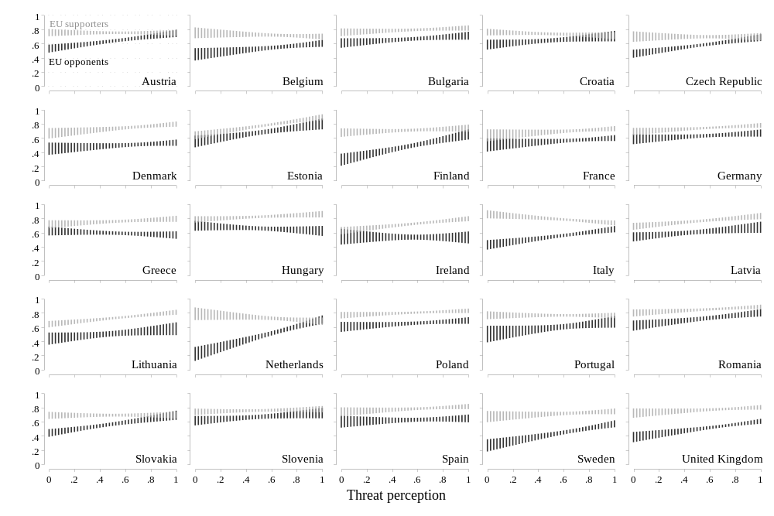

A9: Additional interaction variable: NATO attitude
To explore whether threat perceptions increase support for European defence integration among people who support NATO, we included a measure of general NATO in the aggregate analysis of European security and defence attitudes—first as a direct control, then in a three-way interaction between threat perceptions, identity constellation, and NATO feelings. The results show that even “NATO-phile” respondents exhibit increased support for European defence integration as their level of threat perception rises.

Figure A9.1: Aggregate effect of threat perception on support for European defence integration, feelings toward EU and NATO as interaction variables
TOTAL SAMPLE
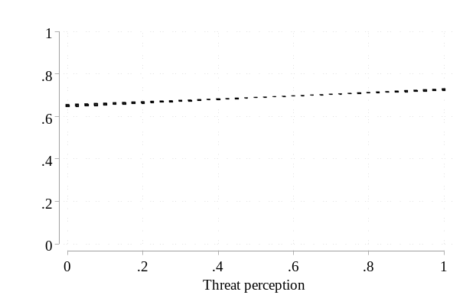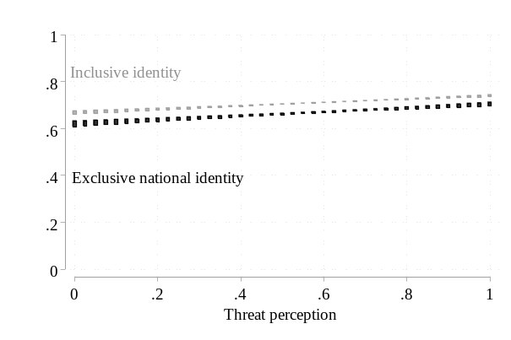
BY NATO ATTITUDE
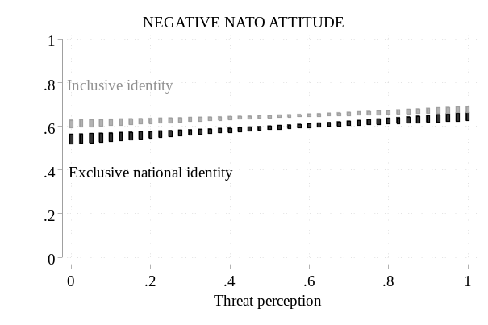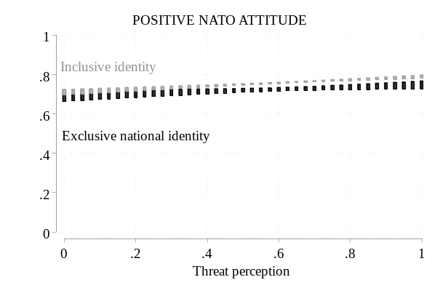

A10: Additional outcome variables: CSDP activities and decision rule

Outcome variable: CSDP activities
We replicated the aggregate analysis reported in the article using preferences regarding the range of EU activities in the security and defence domain as an alternative outcome variable. This variable is an index of responses to a battery of items in which respondents were asked to state their support for the European Union being engaged in a range of security and defence activities (battery was not included in the UK survey). The results are substantively the same as those reported in the article for the general attitude towards European defence integration.
(Figure A10.1, top left panel = Figure 5, bottom left panel in main article)

Figure A10.1: Pooled effect of threat perception on support for CSDP tasks
TOTAL SAMPLE
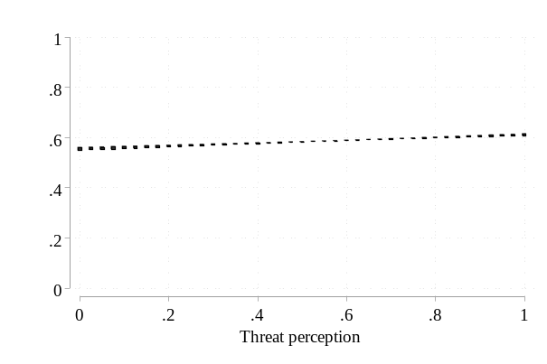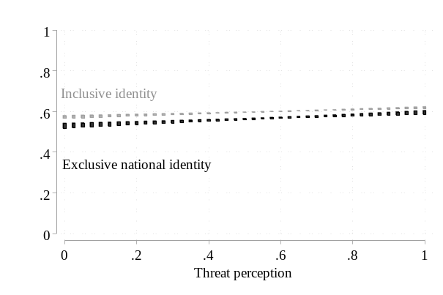
BY POLITICAL SOPHISTICATION
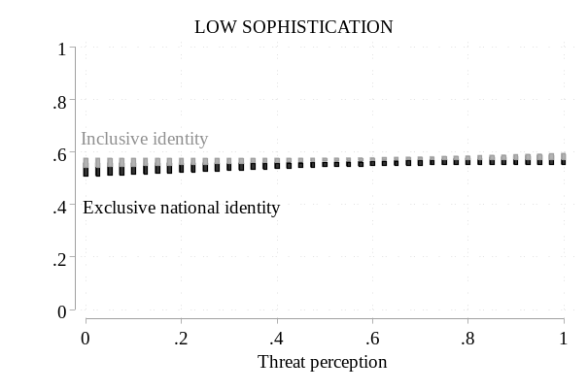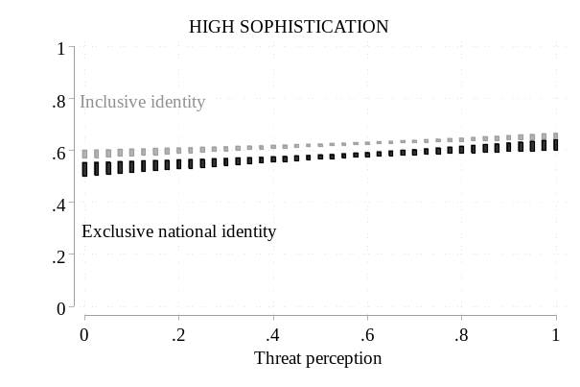

Outcome variable: Decision rule
We replicated the aggregate analysis reported in the article using preferences regarding the EU’s decision rule in the security and defence domain as an alternative outcome variable. Respondents indicated how large a majority should be required when the Council makes decisions about EU defence and security issues. The response options were (1) “Greater than 50 % (50 % plus 1 member state in favour)”, (2) “Qualified majority (55 % of Member States in favour and representing at least 65 % of total EU population)”, and (3) “Unanimity (100 % of Member States in favour)” (question was not included in the UK survey). We estimated an ordered logistic regression and report the estimates for the probability of choosing the simple majority rule in the figure below. The results are essentially the same as those reported in the article for general attitudes toward European security and defence integration.
(Figure A10.2, top left panel = Figure 5, bottom right panel in main article)

Figure A10.2: Pooled effect of threat perception on support for majority rule
TOTAL SAMPLE
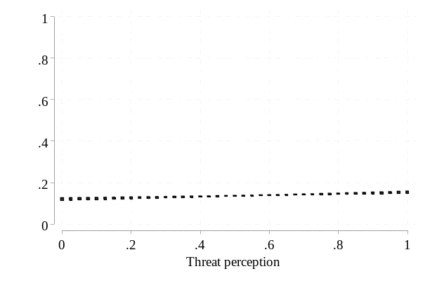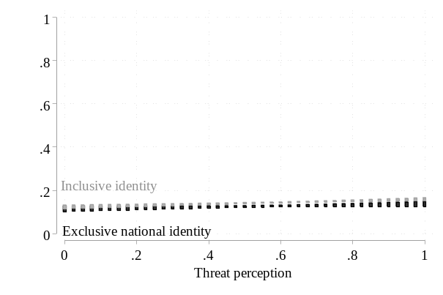
BY POLITICAL SOPHISTIACTION
