Supplemental Material

Contents
A1. General Appendix 3
A1.1. List of included case studies 3
A1.2 In depth description of case studies 4
Case Study 1, Israel, January 05, 2003: Tel Aviv Central bus station massacre 4
Case Study 2, The Netherlands, November 2, 2004: Murder of Theo Van Gogh 4
Case Study 3, Russia, December 03, 2008: Caucasus Emirate members kill family of three 5
Case Study 4, Russia, January 24, 2011: Moscow, Domodedovo Airport, Suicide Bombing 6
Case Study 5, Israel, November 15, 2012: Kiryat Malachi city, Hamas kill 3 civilians in air strike 7
Case Study 6, France, January 07, 2015: Charlie Hebdo attack 8
Case Study 7, Germany, December 19, 2016: Berlin Christmas market attack 10
Case Study 8, France December 11, 2018: Strasbourg Christmas market attack 11
Case Study X, Israel October 07, 2015: Hamas member wounds a civilian and a soldier 12
A1.3. Reliability analyses 13
A1.4 Meta regression results 14
A2. Assumption Checks 15
A2. 1. Results from different bandwidths and covariate adjustments 15
A2. 2. Testing for placebo effects at the median of the control groups 21
A2. 3. Assessing pre-existing time trends 22
A2. 4. Falsifications with different units 23
A2. 5. Falsifications with different outcomes 24
A2. 6. Pseudo-Manipulation checks 25
A2.8. Robustness to excluding less robust case studies 26
A3. Robustness to design choices 28
A3.1. Excluding Case study 3 Russia 2008 28
A3.2. Including Case study X Israel 2015 30
A3.3. Exclude respondents interviewed on the day of the event 31
A4. Non-preregistered exploratory analyses 33
A4. 1 Excluding all Russian case studies 33
A4. 2 Excluding all Israeli case studies 35
A4. 2 Excluding all Russian and Israeli case studies 37
A5. Summary of deviations from pre-registration 38

This appendix is structured as follows. Section A1 gives some general information like an overview of all included case studies, an in-depth description of the events, results from the reliability analyses, as well as other analyses that were not presented in the paper. Section A2 is dedicated to the assumption checks. In section A3 you can find the results from different design choices that are discussed in the paper, such as including and excluding several case studies due to methodological or conceptual reasons. Section A4 includes all exploratory analyses. That is all analyses which were not pre-registered. Finally, section A5 provides a list of all deviations from the pre-registration that were necessary due to methodological issues or miscoding in the pre-registration. In cases where we did not already explain the details of the additional analyses in the paper, or in cases where their purpose is not clear, we added some additional explanation why we ran these specific tests.

A1. General Appendix

A1.1. List of included case studies

Tab. A1. Included case studies of incidents
Case Study and Country | ESS Round | Fieldwork | Short Description | Date | pre n | post n | Fatalities | Injuries
Case Study 1, Israel | 1 | 2002-10-15 - 2003-01-15 | Tel Aviv, suicide bombers killed 22 civilians | jan 5, 2003 | 2349 (94.0%) | 127 (5.1%) | 23 | 100
Case Study 2, The Netherlands | 2 | 2004-09-11 - 2005-02-19 | Amsterdam, Murder of Theo Van Gogh | nov 2, 2004 | 1094 (58.2%) | 787 (41,8%) | 1 | 0
Case Study 3, Russia | 4 | 2008-11-08 - 2009-04-09 | Chechnya, Caucasus Emirate killed three civilians | dec 3, 2008 | 1829 (72.8%) | 683 (27.2%) | 3 | 0
Case Study 4, Russia | 5 | 2010-12-24 - 2011-05-14 | Moscow, Domodedovo Airport, Suicide Bombing | jan 24, 2011 | 779 (30.0%) | 1816 (70.0%) | 37 | 173
Case Study 5, Israel | 6 | 2012-09-03 - 2013-03-15 | Kiryat Malachi city, Hamas killed 3 civilians | nov 15, 2012 | 1158 (46.2%) | 1350 (53.8%) | 3 | 0
Case Study 6, France | 7 | 2014-10-31 - 2015-03-03 | Paris, Charlie Hebdo attack | jan 7, 2015 | 1620 (84.5%) | 297 (15.5%) | 17 | 19
Case Study 7, Germany | 8 | 2016-08-23 - 2017-03-26 | Berlin, Christmas Market attack, | dec 19, 2016 | 2408 (84.4%) | 444 (15.6%) | 13 | 48
Case Study 8, France | 9 | 2018-10-19 - 2019-04-01 | Strasbourg, Christmas market attack | dec 11, 2018 | 999 (49.7%) | 1011 (50.3%) | 5 | 11

A1.2 In depth description of case studies

This section provides a detailed description of all incidents as well as both a link to the incident in the Global Terrorism Database and one other source (Wikipedia, Lexis Nexis, BBC). If possible, an illustration of a 30 days before and after Google Trends search with the theme “terror” is also included to give an idea of how the event did or did not rise in salience.
We coded a case study as having passed the excludability assumption check for clear google trends analyses, when the peak of the trend for the search theme “terror” is after the respective date of the event but within a 30 day timeframe (see table 1 in the paper for a list of all assumption checks).

Case Study 1, Israel, January 05, 2003: Tel Aviv Central bus station massacre
The Tel Aviv central bus station massacre was a terrorist attack on January 5, 2003, that occurred around 6:30 p.m. – peak rush hour in Tel Aviv. Two Palestinian suicide bombers ignited bombs outside the Tel Aviv Central Bus Station within 500 meters from each other, killing themselves and 23 civilians while injuring over 100 others. While the attack itself was immediately considered an Islamic terror strike, responsibilities were not entirely clear. The Palestinian militant organization Al-Aqsa Martyrs Brigade claimed responsibility for the attack and stated that Boraq Abdel Rahman Halfa and Saber al-Nour were the perpetrators. However, in a fax sent later to CNN on the group's letterhead, the group denied responsibility again. The Islamic Jihad, another terrorist organization, also claimed responsibility but its military leaders later denied the claim as well. The attack was the deadliest in Israel since March 2002, when the bombing of a hotel dining room during a ritual feast killed 29 Israelis and wounded 140.
GTD Link, Wiki Link

Case Study 2, The Netherlands, November 2, 2004: Murder of Theo Van Gogh
Theo Van Gogh a Dutch director, film and television producer, actor and author who previously produced an Islam-critical movie was shot and stabbed by Mohammed Bouyeri while cycling to work on 2 November 2004 at about 9:00 in the morning. The incident happened in front of the Amsterdam-Oost borough office. Bouyeri, who also injured some bystanders left a note pinned to Van Gogh's stomach with a knife containing death threats to Ayaan Hirsi Ali, the writer of the said movie. The note also threatened Western countries in general as well as Jews, and referred to ideologies of the Egyptian organization Jama'at al-Muslimin. Bouyeri, a 26-year-old Dutch Moroccan citizen, was busted by police after the attack. Law Enforcement Authorities later alleged that he had terrorist ties with the Dutch Islamist Hofstad Network. The attack sparked outrage and grief throughout the Netherlands.
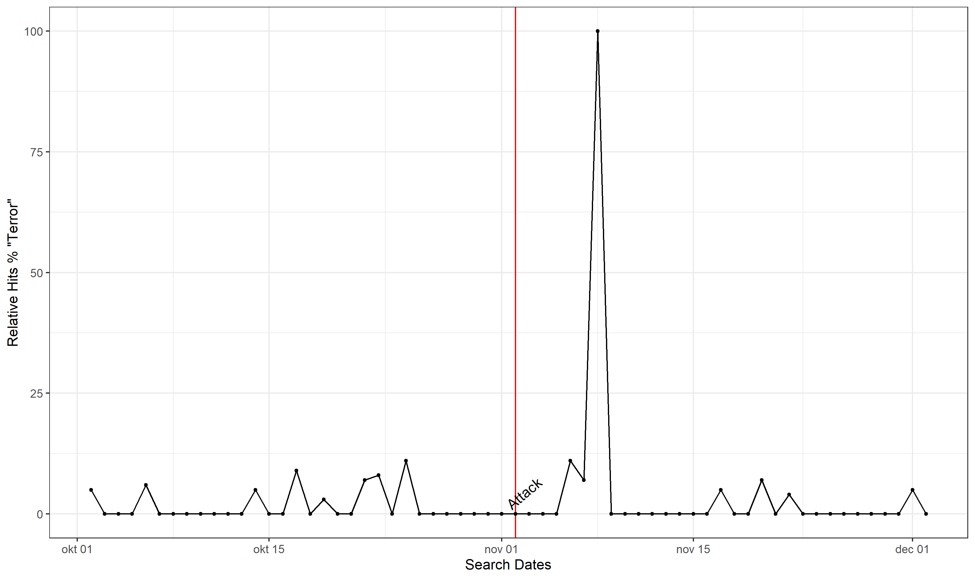
Figure A1. Case Study 2 Google trends.
GTD Link, Wiki Link

Case Study 3, Russia, December 03, 2008: Caucasus Emirate members kill family of three
According to a text report by the Russian internet news agency Regnum, unidentified people shot dead a family of three people and then set fire to their house in the village of Agishty in Chechnya's Shalinskiy District in the night from December 3 to December 4, 2008. The source states "The head of the family, Khadzhi Suleymanov, born in 1936, his wife Taus Sadulayev, born in 1950, and their son Salman, born in 1976, were killed in their own house. The house was then set on fire by criminals. The Shalinskiy District interior department's duty unit received the report on the emergency at about 0200 Moscow time [2300 gmt on 3 December]. Police officers and an investigation team immediately left for the scene [of the incident],". On December 4, s Chechen rebel website called ‘’Kavkaz-Tsentr’ reported that rebels had entered the village of Agishty on 3 December, set up checkpoints, kept the village under their control until the morning of 4 December, and finally killed the Sadulayevs. The report added that the Sadulayevs were killed after the rebels established that it was the former village administration head, Khozha Sadulayev, who "leaked" information about three rebels who were killed in Agishty on 18 January 2006. The site added that Sadulayev's wife and son helped him in this, which is considered the reason for the assasination. Unfortunately, there is little additional information on the incident. While the incident fits all pre-registered criteria, its background is not entirely clear. Because of this, and because the post-incident distribution indicates a distinct non-response pattern, we re-ran the analyses without this specific case.
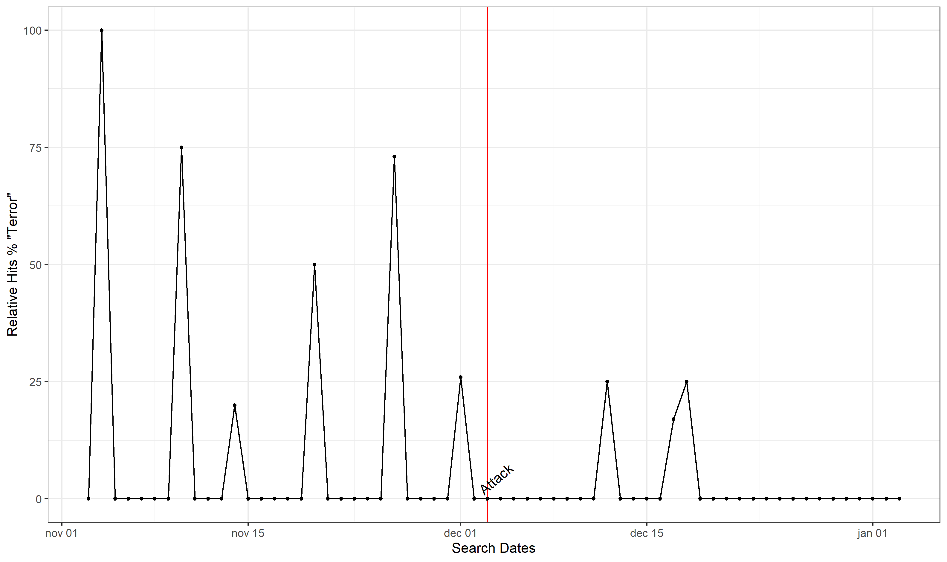
Figure A2. Case Study 3 Google trends.
GTD Link,

Case Study 4, Russia, January 24, 2011: Moscow, Domodedovo Airport, Suicide Bombing

The terrorist attack at Moscow Domodedovo Airport occurred at 16:32 Moscow time on January 24, 2011. The suicide attack killed 36 people and injured another 152, 58 of whom required hospital treatment. In February, the Chechen rebel leader Doku Khamatovich Umarov took political responsibility for the attack. The Russian Federal Investigation Committee later identified the suicide bomber as a 20-year-old from the North Caucasus and said the attack was "primarily" aimed at foreign citizens. Russia suffered a similarly heavy attack in March 2010 when two female suicide bombers from Dagestan set off explosives in the metro, killing 40 people.
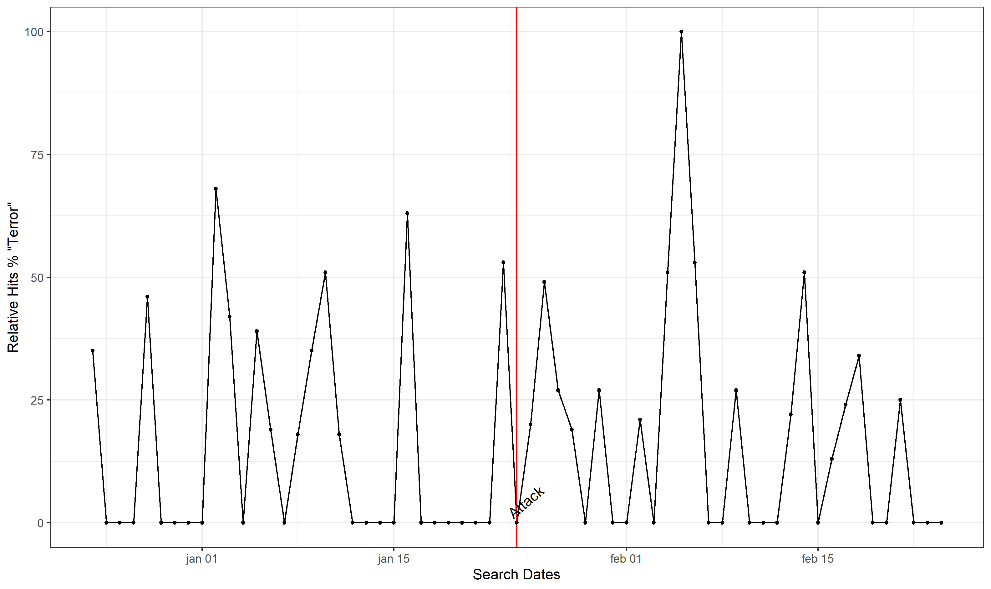
Figure A3. Case Study 4 Google trends.
GTD Link, Wiki Link

Case Study 5, Israel, November 15, 2012: Kiryat Malachi city, Hamas kill 3 civilians in air strike

In a missile attack fired by Palestinians from Gaza on November 15, 2012, three Israelis were killed and two injured in Kiryat Malachi, which is approximately 25 km north of Gaza. Palestinian Islamist group Hamas claimed the responsibility for the attack, which can be considered a retaliation since Israel killed Hamas' military chief in Gaza just a few days before the incident. Israeli Prime Minister at the time Benjamin Netanyahu stated: "There is no moral symmetry between Israel and the terrorists in Gaza... Hamas deliberately targets children, and they deliberately place their rockets next to their children.". The Israeli Air Force responded to the attack with hitting more than 100 targets in the Gaza Strip in the next 24 hours. Palistinian sources say that 13 civilians were killed as consequence of those hits.
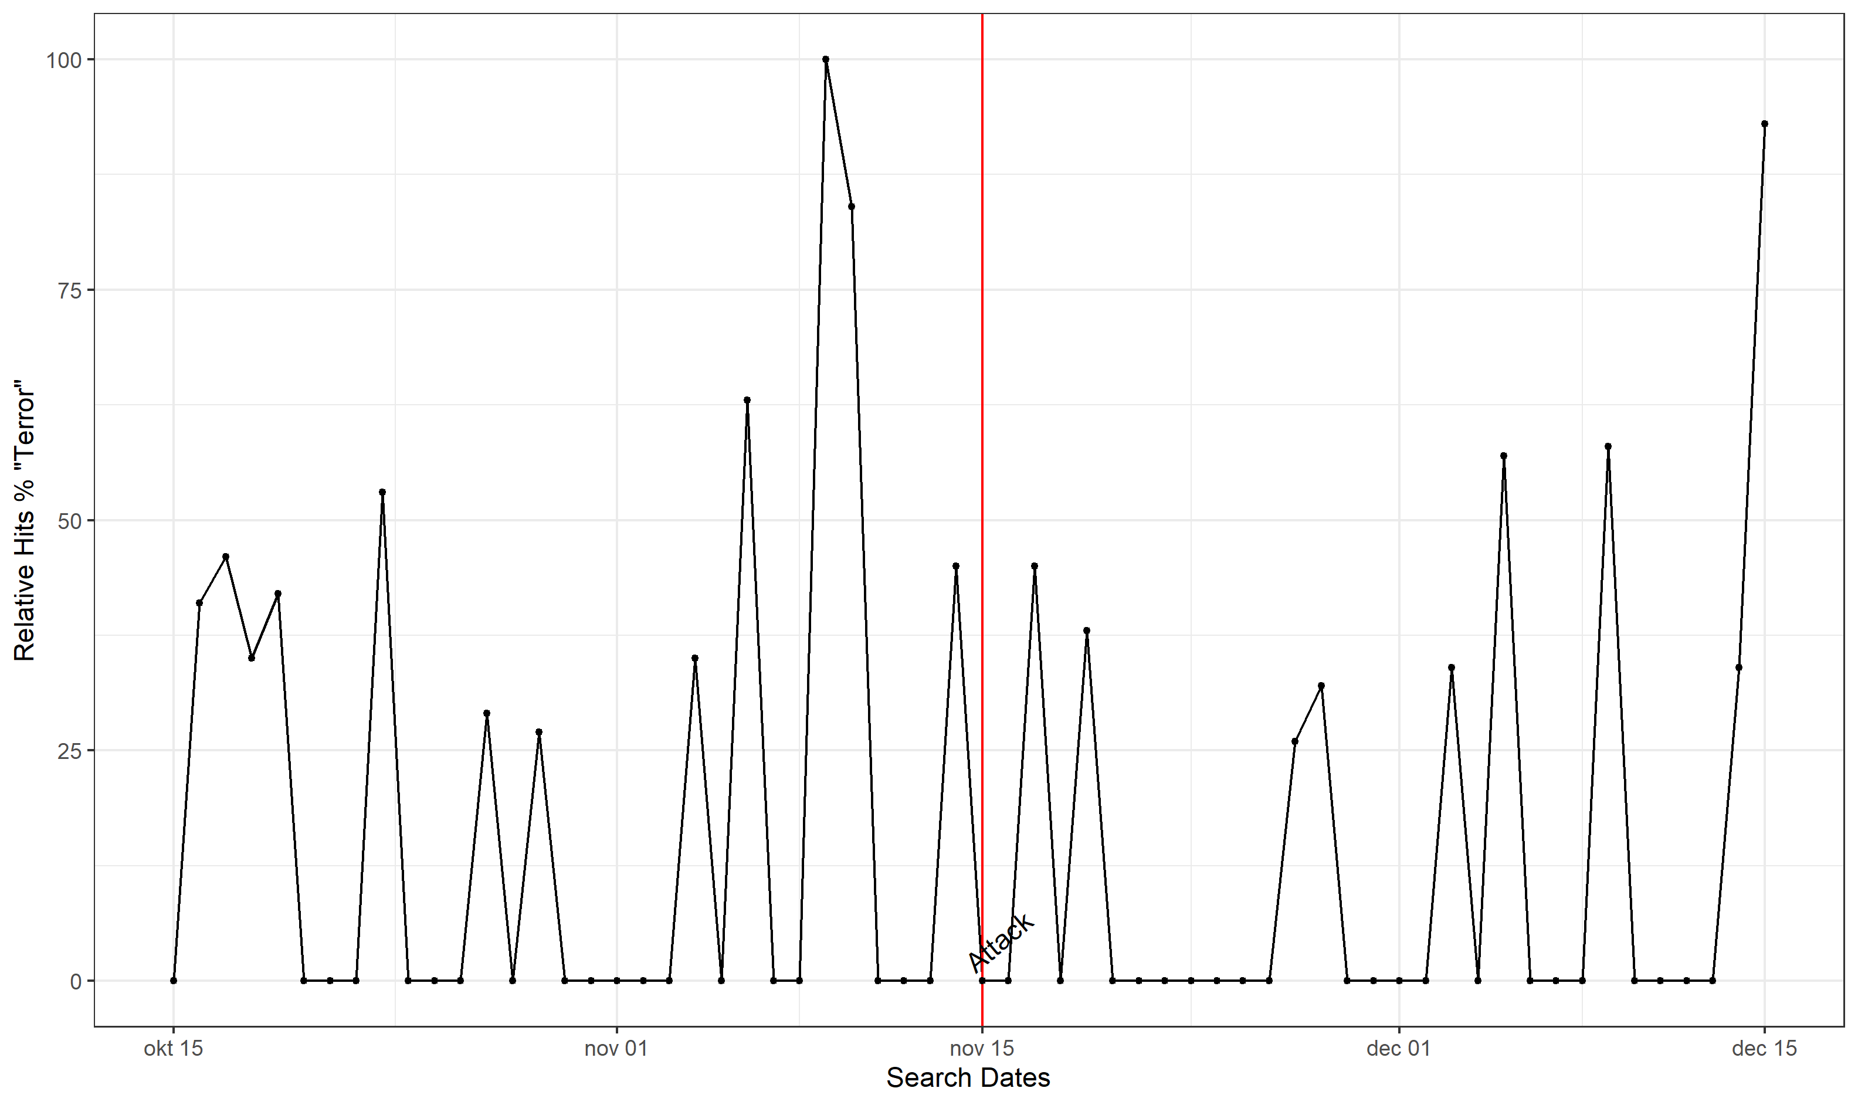
Figure A4. Case Study 5 Google trends.

GTD Link,, BBC

Case Study 6, France, January 07, 2015: Charlie Hebdo attack

Two masked perpetrators, Saïd and Chérif Kouachi, who later declared their allegiance to Al-Qaida in Yemen, entered the editorial offices of “Charlie Hebdo”, a satire magazine, in Paris and killed eleven people (including a policeman assigned to protect the editors), injured several people present and murdered another policeman as they fled. On 9 January, they barricaded themselves in Dammartin-en-Goële. There, security forces finally shot the two perpetrators. On 8 January, a policewoman was shot dead by another heavily armed perpetrator in the south of Paris. The following day, he attacked a supermarket for Jewish goods in eastern Paris, killing four people and taking others hostage. The perpetrator declared his allegiance to the Islamic State by telephone and said his actions were linked to the attack on Charlie Hebdo. He too was shot dead when security forces stormed the supermarket. People around the world spontaneously took to the streets after the attack became known, many carrying placards declaring "Je suis Charlie" ("I am Charlie") in solidarity or proclaiming the same statement on social mediua.
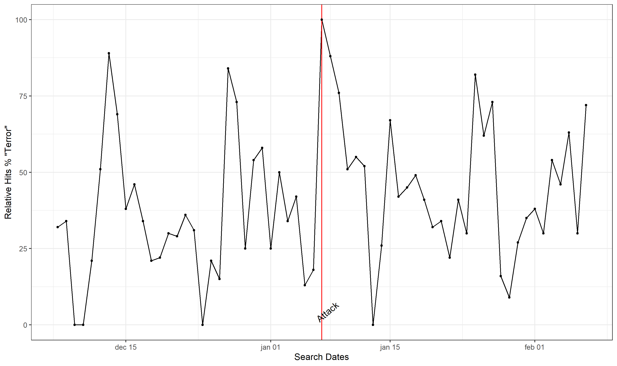
Figure A5. Case Study 5 Google trends.
GTD Link, Wiki

Case Study 7, Germany, December 19, 2016: Berlin Christmas market attack

At 8 p.m. on December 19, 2016, the Islamist terrorist Anis Amri drove a truck into a crowd at the Christmas market at the Kaiser Wilhelm Memorial Church in Berlin. In the course of the attack, 11 visitors were struck and killed by the truck, and another 55 were injured. The twelfth victim of the d attack was the Polish driver of the semi-trailer, whom Amri shot and killed in the course of stealing his truck. Though Amri managed to escape after the attack, he was eventually shot dead by a police officer on December 23, 2016, during a personnel check in Sesto San Giovanni, north of Milan, Italy. The “Amaq News Agency,” which functions as the news channel of the terrorist militia IS, announced on December 20, 2016, that the assassin had acted as a soldier of the Islamic State.
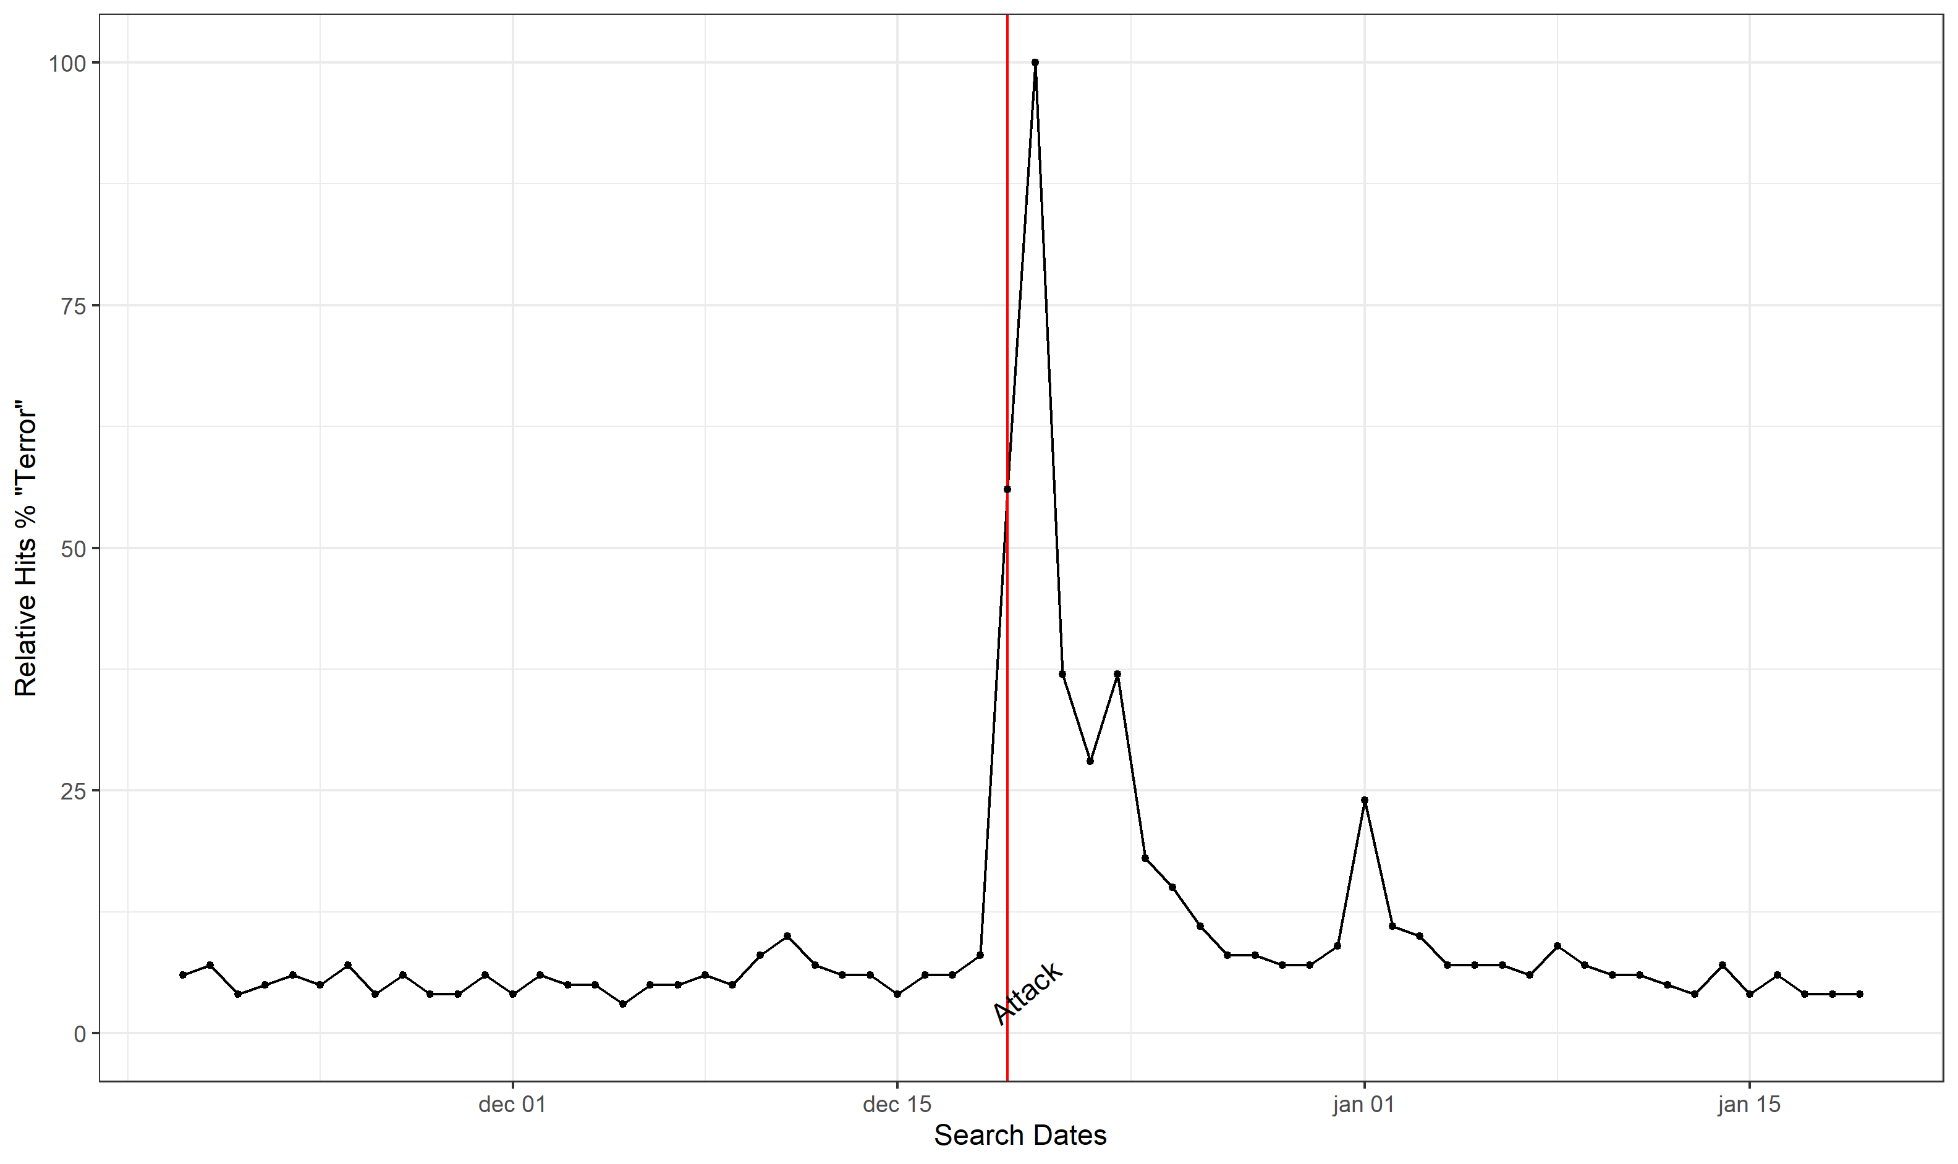
Figure A6. Case Study 7 Google trends.
GTD Link, Wiki

Case Study 8, France December 11, 2018: Strasbourg Christmas market attack

On December 11, 2008, five people died, and eleven people were injured, some seriously, during an Islamist-motivated terrorist attack that occurred near the Strasbourg Christmas market. The perpetrator, Chérif Chekatt, had been born in Strasbourg, was of French nationality with roots in Morocco, and was 29 years old at the time of the attack. He was killed two days later in an exchange of fire with police in the French city of Strasbourg. In the course of the investigation, it became clear that the habitual criminal perpetrator acted from Islamist fanatical motives and assigned himself to the terrorist organization Islamic State.

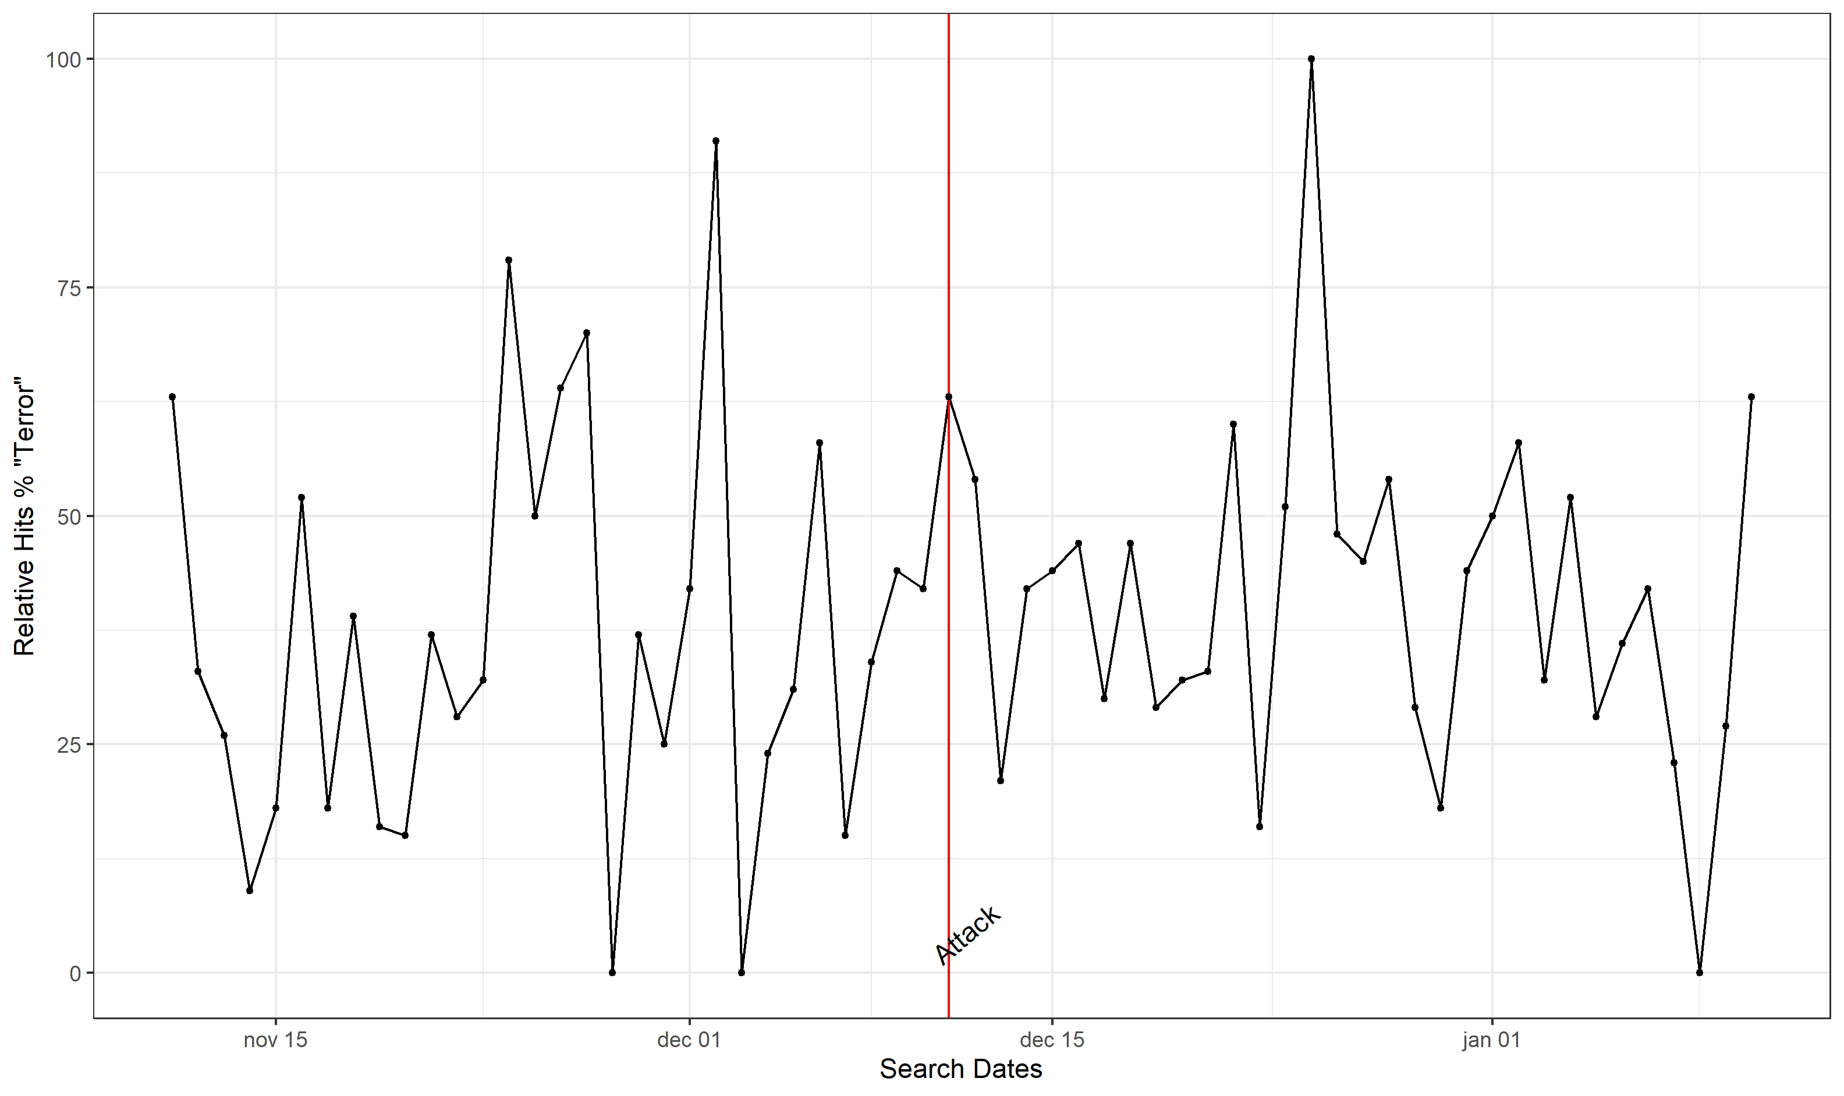
Figure A7. Case Study 8 Google trends.
GTD Link, Wiki

Case Study X, Israel October 07, 2015: Hamas member wounds a civilian and a soldier

An Arab terrorist stabbed an Israel Defense Forces soldier in the southern town of Kiryat Gat. According to reports, the terrorist took the soldier’s weapon and then hid in a nearby building, before being shot dead by police. The soldier was lightly wounded.
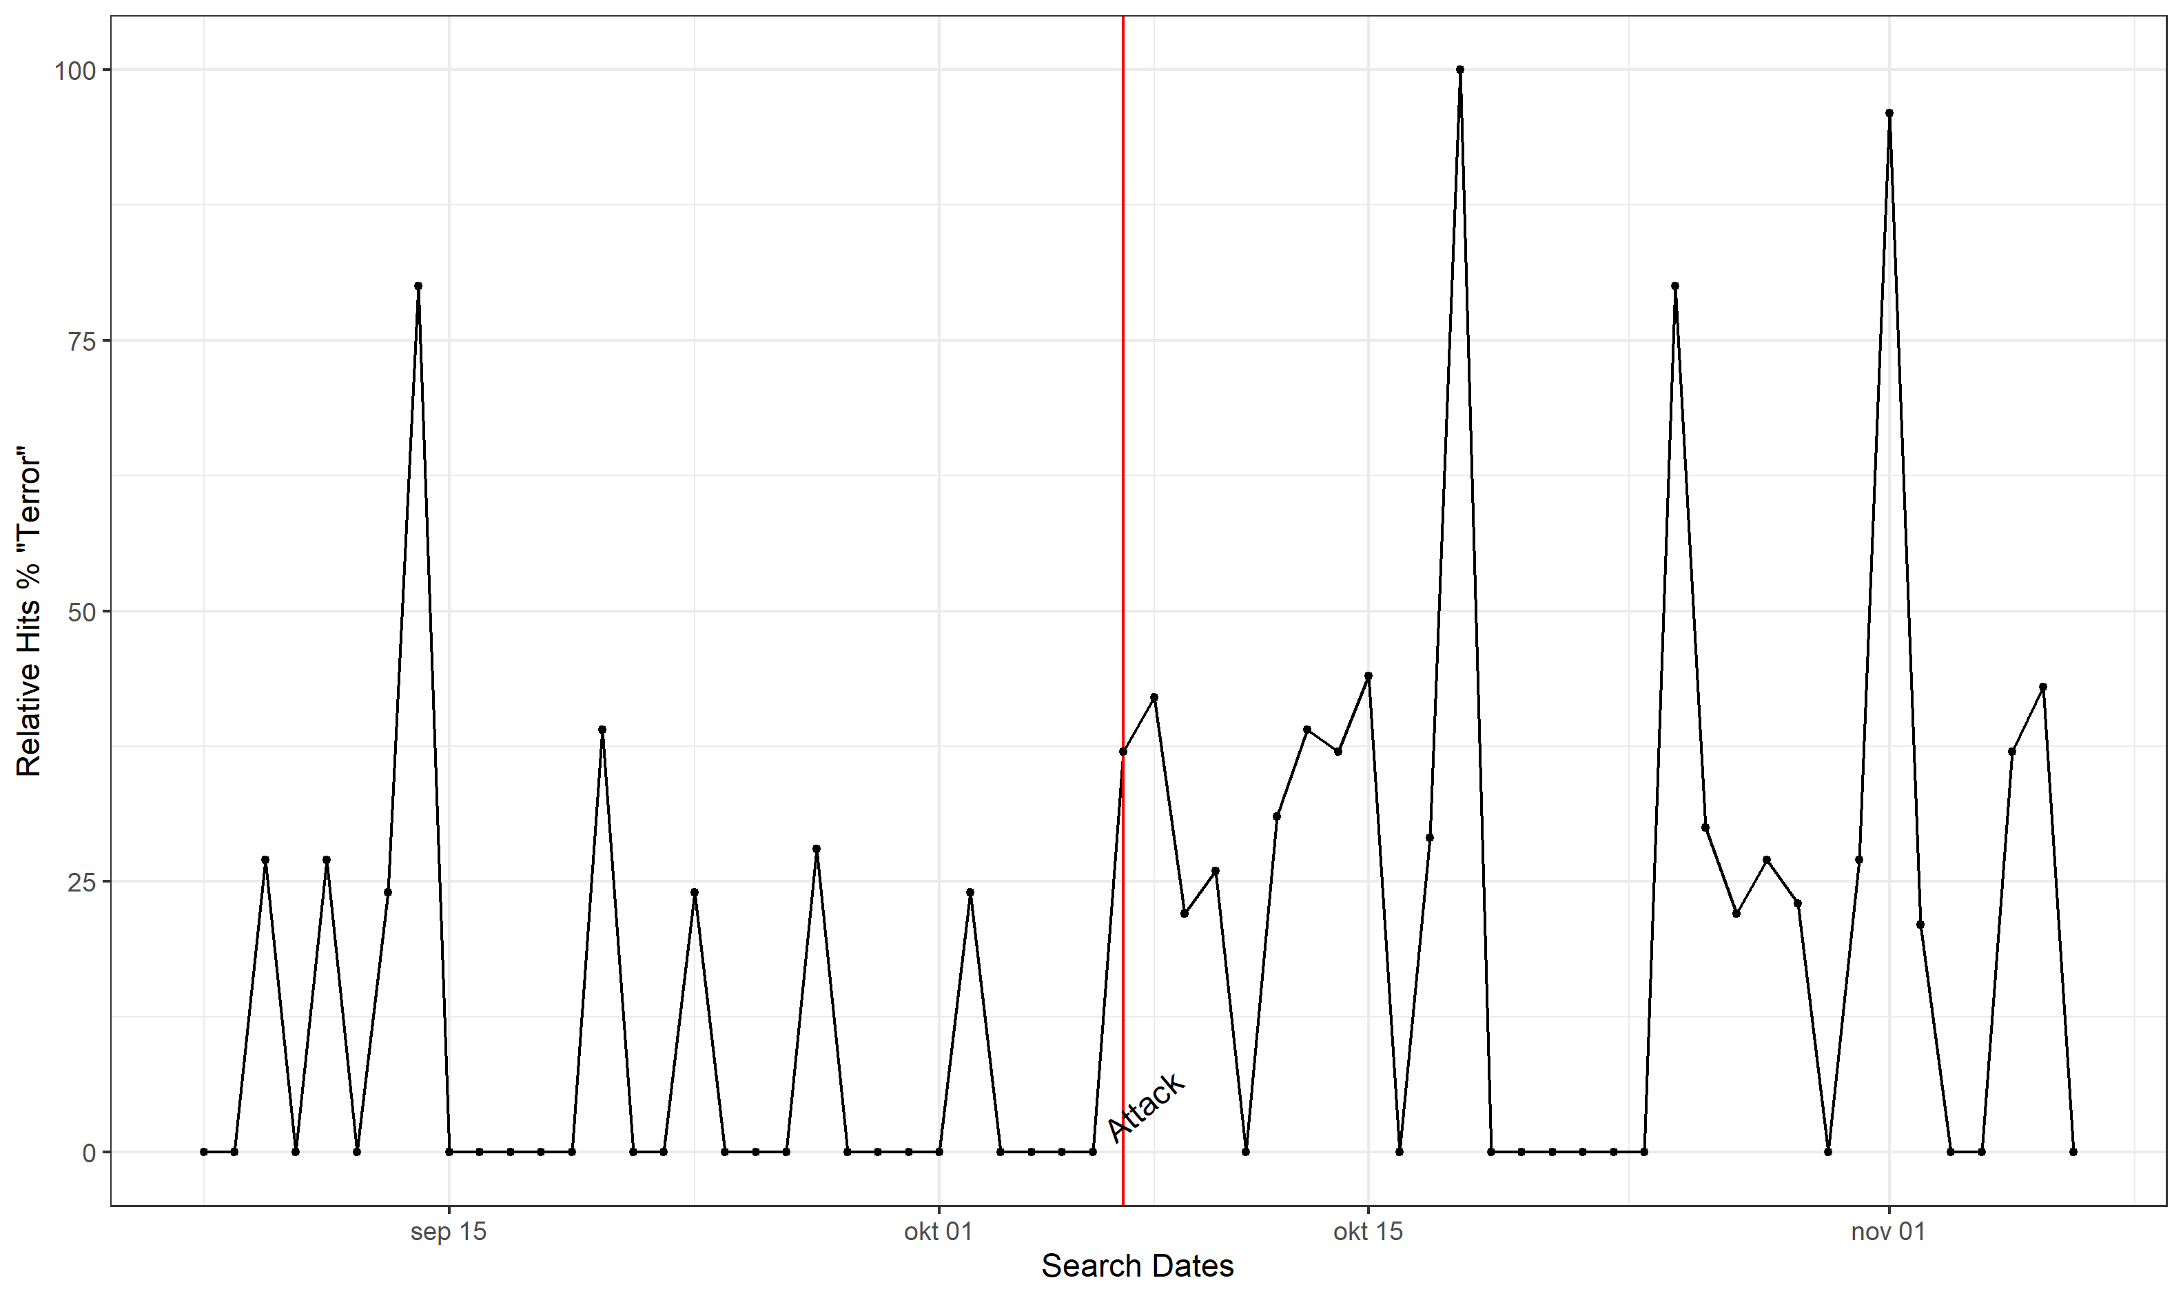
Figure A8. Case Study X Google trends.
GTD Link, Lexis Nexis

A1.3. Reliability analyses
Tab. A2. Cronbach's alpha values of mean scales
ESS | Country | Reliability
1 | Israel | 0.79
2 | Netherlands | 0.83
4 | Russia | 0.86
5 | Sweden | 0.82
5 | Russia | 0.91
6 | Israel | 0.81
7 | France | 0.8
8 | Germany | 0.83
9 | France | 0.79

A1.4 Meta regression results
Tab. A3. Meta regression bandwidth
 |  | Model 1: Three-level mixed effects model | Model 2: Robust variance estimator
Legal System | coef. | -0.011 | -0.010
 | SE | 0.028 | 0.022
 | 95%Cis | (-0.066,0.045) | (-0.066,0.046)
 | p-value | 0.703 | 0.670
Police | coef. | -0.012 | 0.0003
 | SE | 0.027 | 0.015
 | 95%Cis | (-0.065,0.041) | (-0.038,0.038)
 | p-value | 0.652 | 0.985
Politicians | coef. | 0.016 | -0.001
 | SE | 0.026 | 0.012
 | 95%Cis | (-0.035,0.068) | (-0.030,0.028)
 | p-value | 0.533 | 0.934
Parliament | coef. | 0.027 | 0.005
 | SE | 0.028 | 0.023
 | 95%Cis | (-0.028,0.083) | (-0.052,0.062)
 | p-value | 0.324 | 0.842
Index | coef. | 0.004 | -0.009
 | SE | 0.022 | 0.014
 | 95%Cis | (-0.041,0.049) | (-0.046,0.028)
 | p-value | 0.861 | 0.564
Note. Summary effects for Model 1 were estimated using a three-level mixed effects meta-analytical model. Model 2 was estimated using correlated hierarchical effects models with robust variance estimation.

A2. Assumption Checks

A2. 1. Summary of post-hoc assumption checks
Table A4. Summary of results from testing excludability and ignorability assumption checks. A ‘1’ indicates a passed check and a ‘0’ a failed check.

Case Study | Ignorability assumption |  |  |  | Excludability |  |  |  |  | Both
Case Study | No Imbalance | Robust to different Bandwidths | Robust to Covariate adjustment | No Non-response pattern | No sig. Placebo effect at median of control group | No sig. Pre-existing time trends | No sig. Falsification tests (other units) | No sig. Falsification tests (other outcomes) | Clear Google Trend Analysis | Passed one Pseudo Manipulation Check | Score
Case Study 1 | 0 | 0 | 1 | 1 | 1 | 1 | 1 | 1 | 0 | 0 | 6
Case Study 2 | 1 | 0 | 1 | 1 | 1 | 1 | 1 | 1 | 1 | 1 | 9
Case Study 3 | 0 | 1 | 1 | 0 | 1 | 1 | 1 | 1 | 0 | 1 | 7
Case Study 4 | 0 | 1 | 1 | 1 | 1 | 1 | 0 | 1 | 1 | 1 | 8
Case Study 5 | 0 | 1 | 1 | 1 | 1 | 1 | 1 | 1 | 0 | 1 | 8
Case Study 6 | 1 | 1 | 1 | 0 | 1 | 1 | 1 | 1 | 1 | 1 | 9
Case Study 7 | 1 | 0 | 1 | 1 | 1 | 1 | 1 | 1 | 1 | 0 | 8
Case Study 8 | 1 | 0 | 1 | 1 | 1 | 1 | 1 | 1 | 1 | 0 | 8

A2. 2. Results from different bandwidths and covariate adjustments

To assess whether a case study passed or failed the tests for robustness to different bandwidths and covariate adjustment we coded those studies that show a random pattern of significant and non-significant effects as having failed those tests. For example, case study 1 only shows four significant effect sizes for one outcome: “trust in the police”. The coefficient is significantly different from zero for the 14 days bandwidth sample with and without covariates, as well as for the 28 days bandwidth sample with and without covariates (see figure A9). For all larger and smaller post-period samples the effects are non-significant, pointing to a spurious finding. Similar patterns are visible in case studies 2, 7, and 8. Accordingly, these studies were coded as having failed those tests on at least one outcome. Of course, effects on other outcomes might be more stable but we opted for this coding strategy to arrive at a more conservative design. Covariate adjustment does not seem to affect the stability of the coefficient in any case.
Figure A9. Different bandwidth results for trust in politicians, with and without covariates.
Figure A10. Different bandwidth results for trust in police, with and without covariates.

Figure A11. Different bandwidth results for trust in the parliament, with and without covariates

Figure A12. Different bandwidth results for trust in the legal system, with and without covariates
Figure A13. Different bandwidth results for the additive institutional trust index, with and without covariates

A2. 2. Testing for placebo effects at the median of the control groups
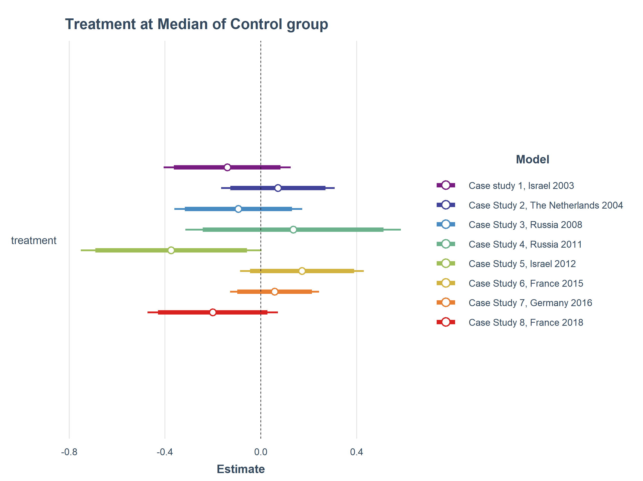
Figure A14. ‘Fake’ Treatment results when choosing the middle of the control groups as the treatment cut point. Full Bandwidth models include covariates and use HC0 robust standard errors.

A2. 3. Assessing pre-existing time trends
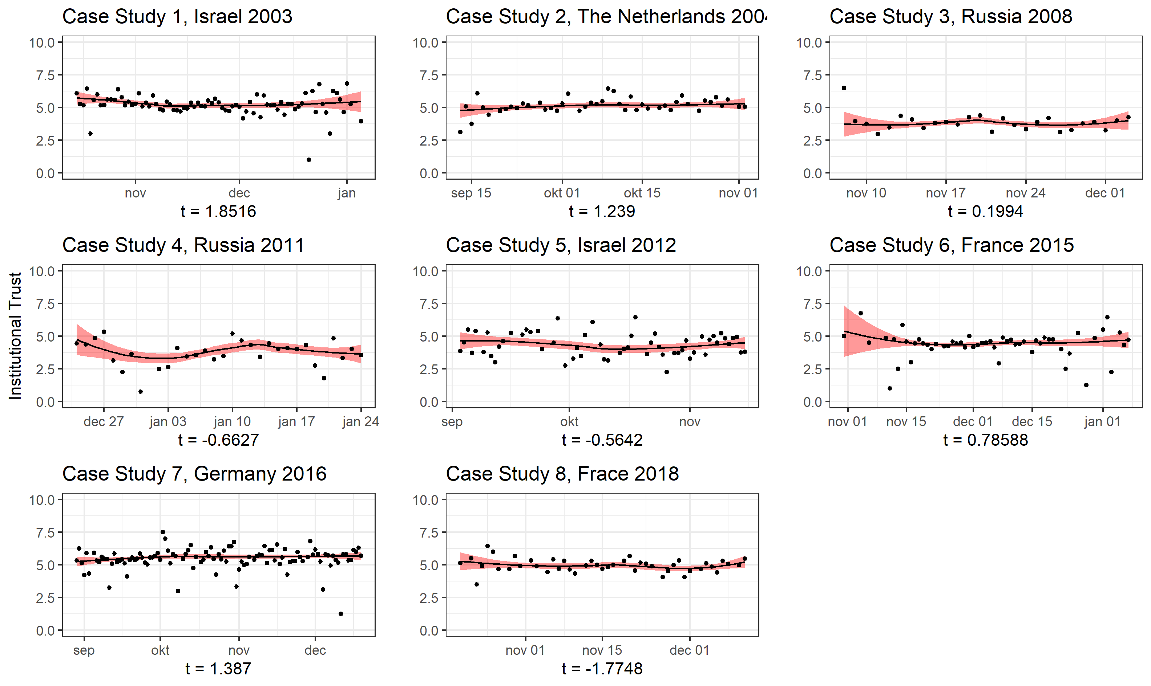
Figure A15. Assessing pre-existing time-trends.

A2. 4. Falsifications with different units
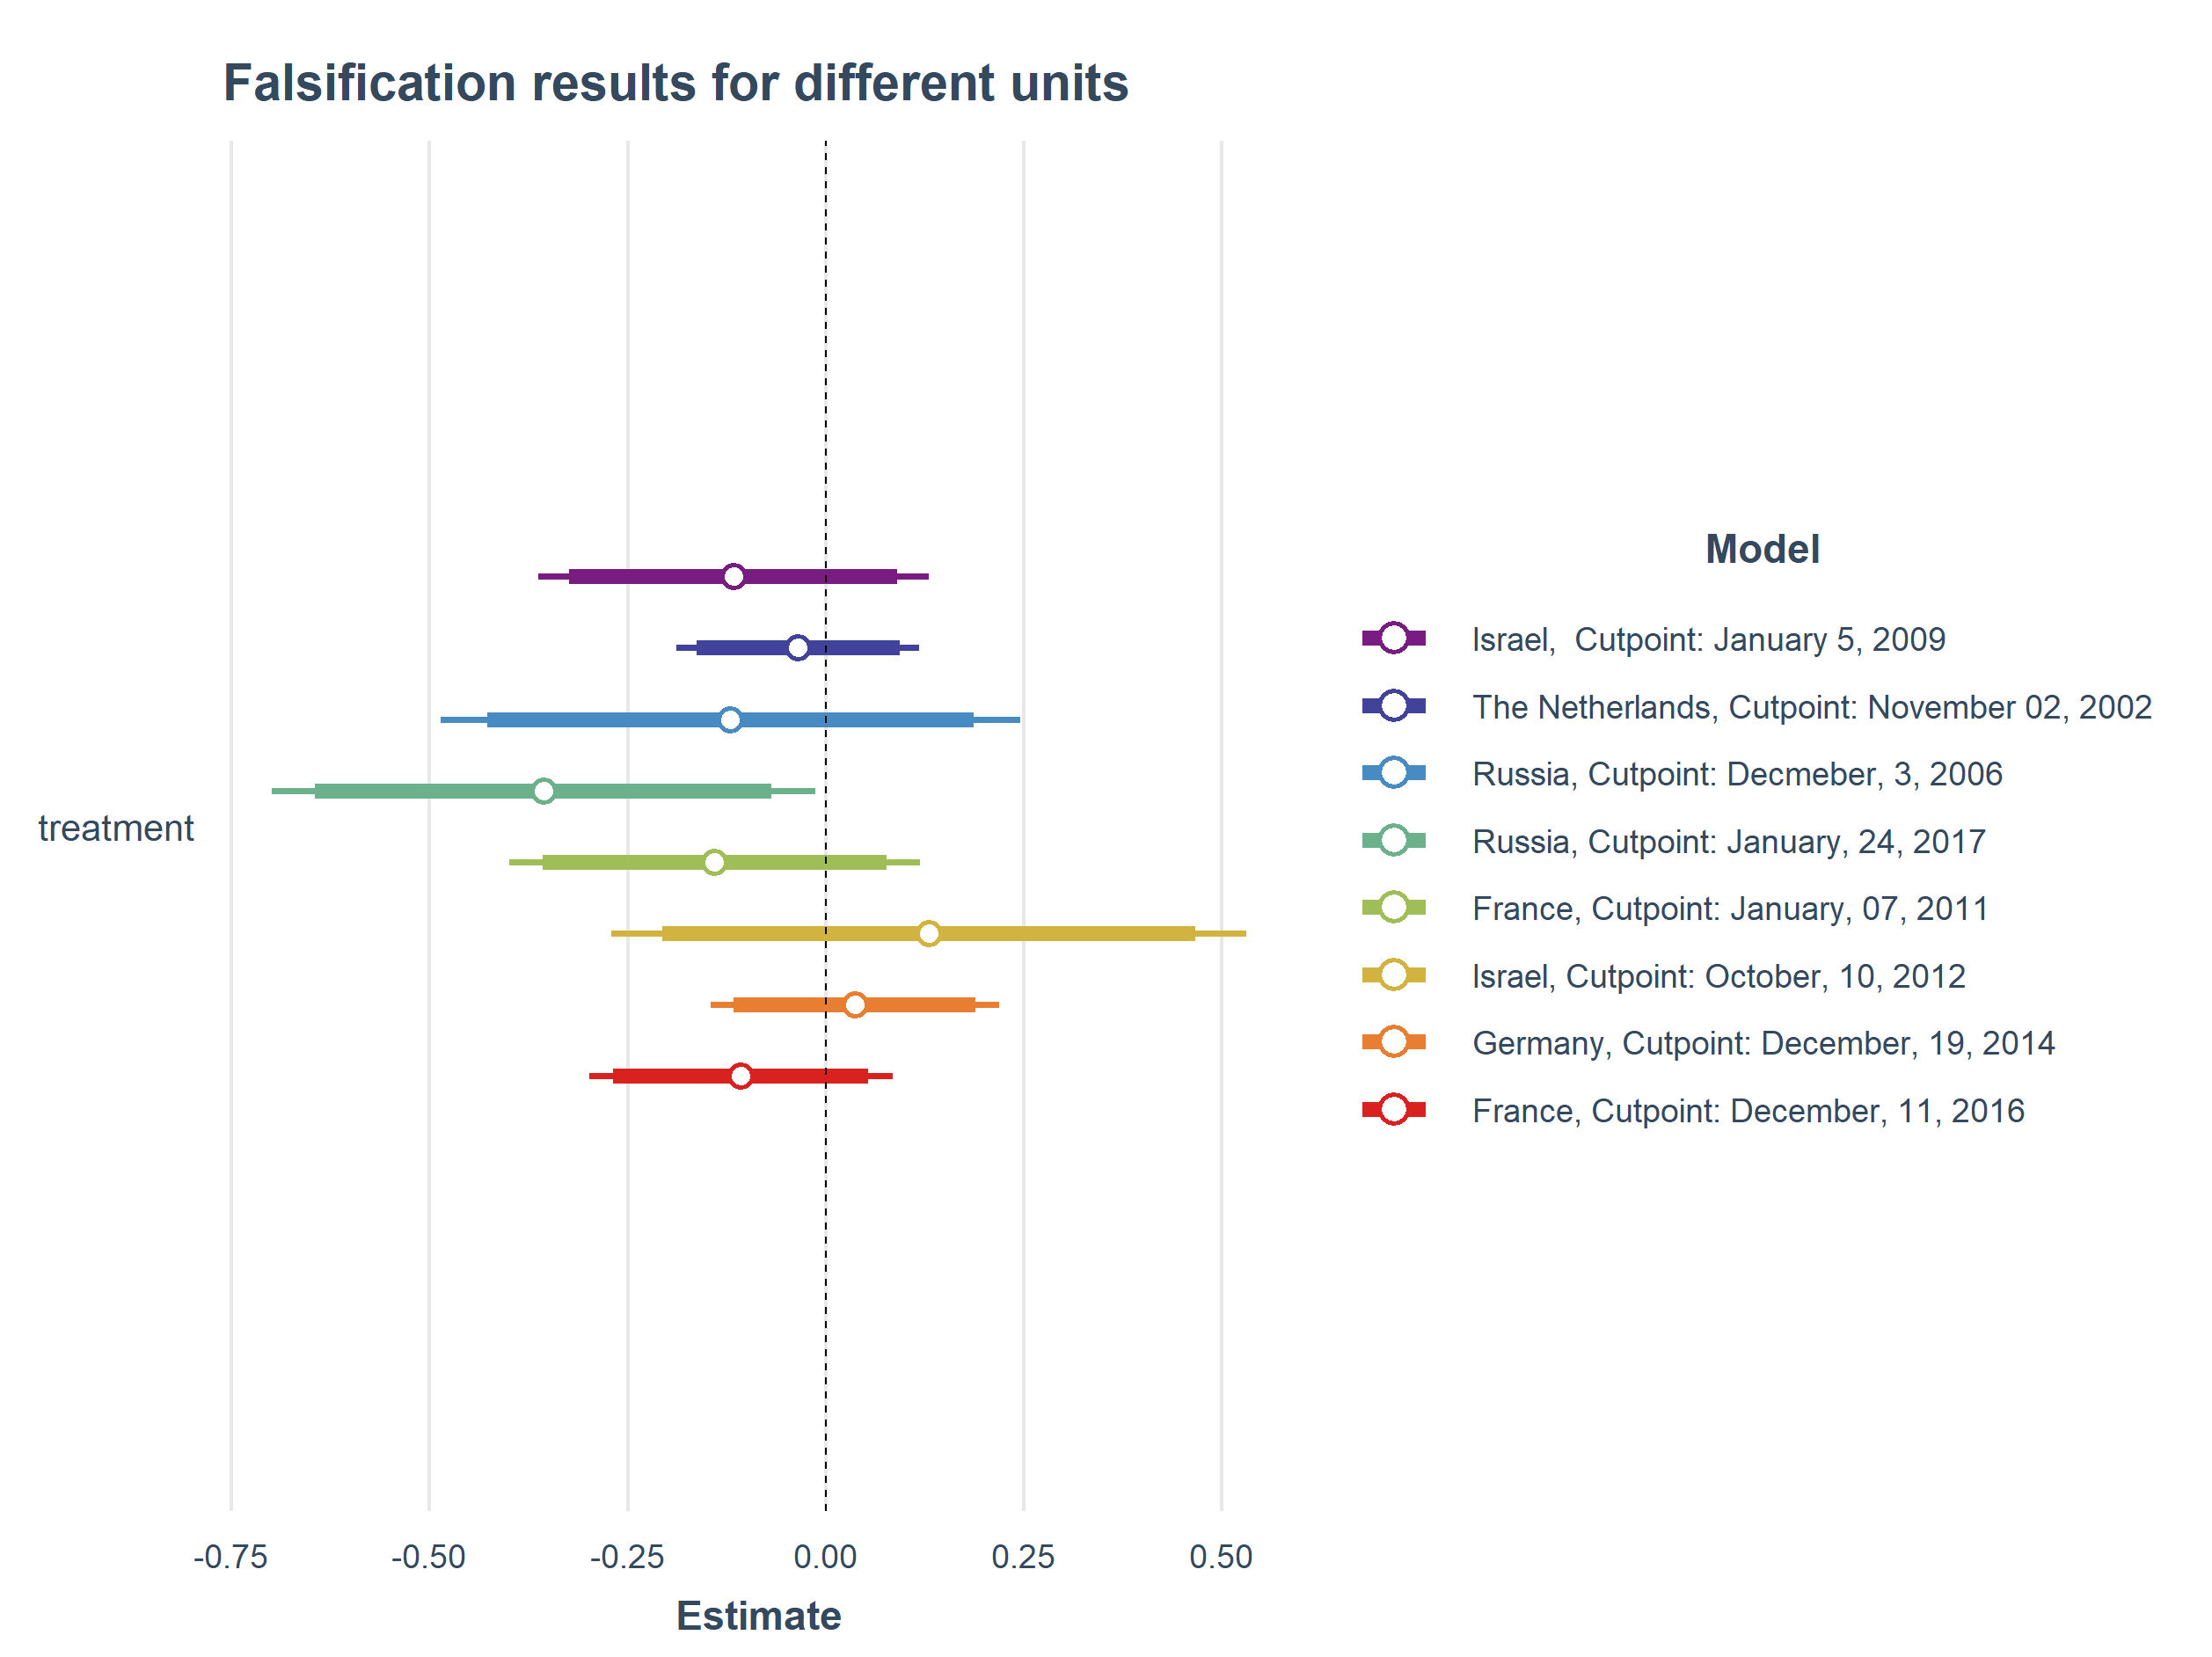
Figure A16. Using different ESS round in the same country with the equivalent date as cut point. Full Bandwidth models include covariates and use HC0 robust standard errors.

A2. 5. Falsifications with different outcomes
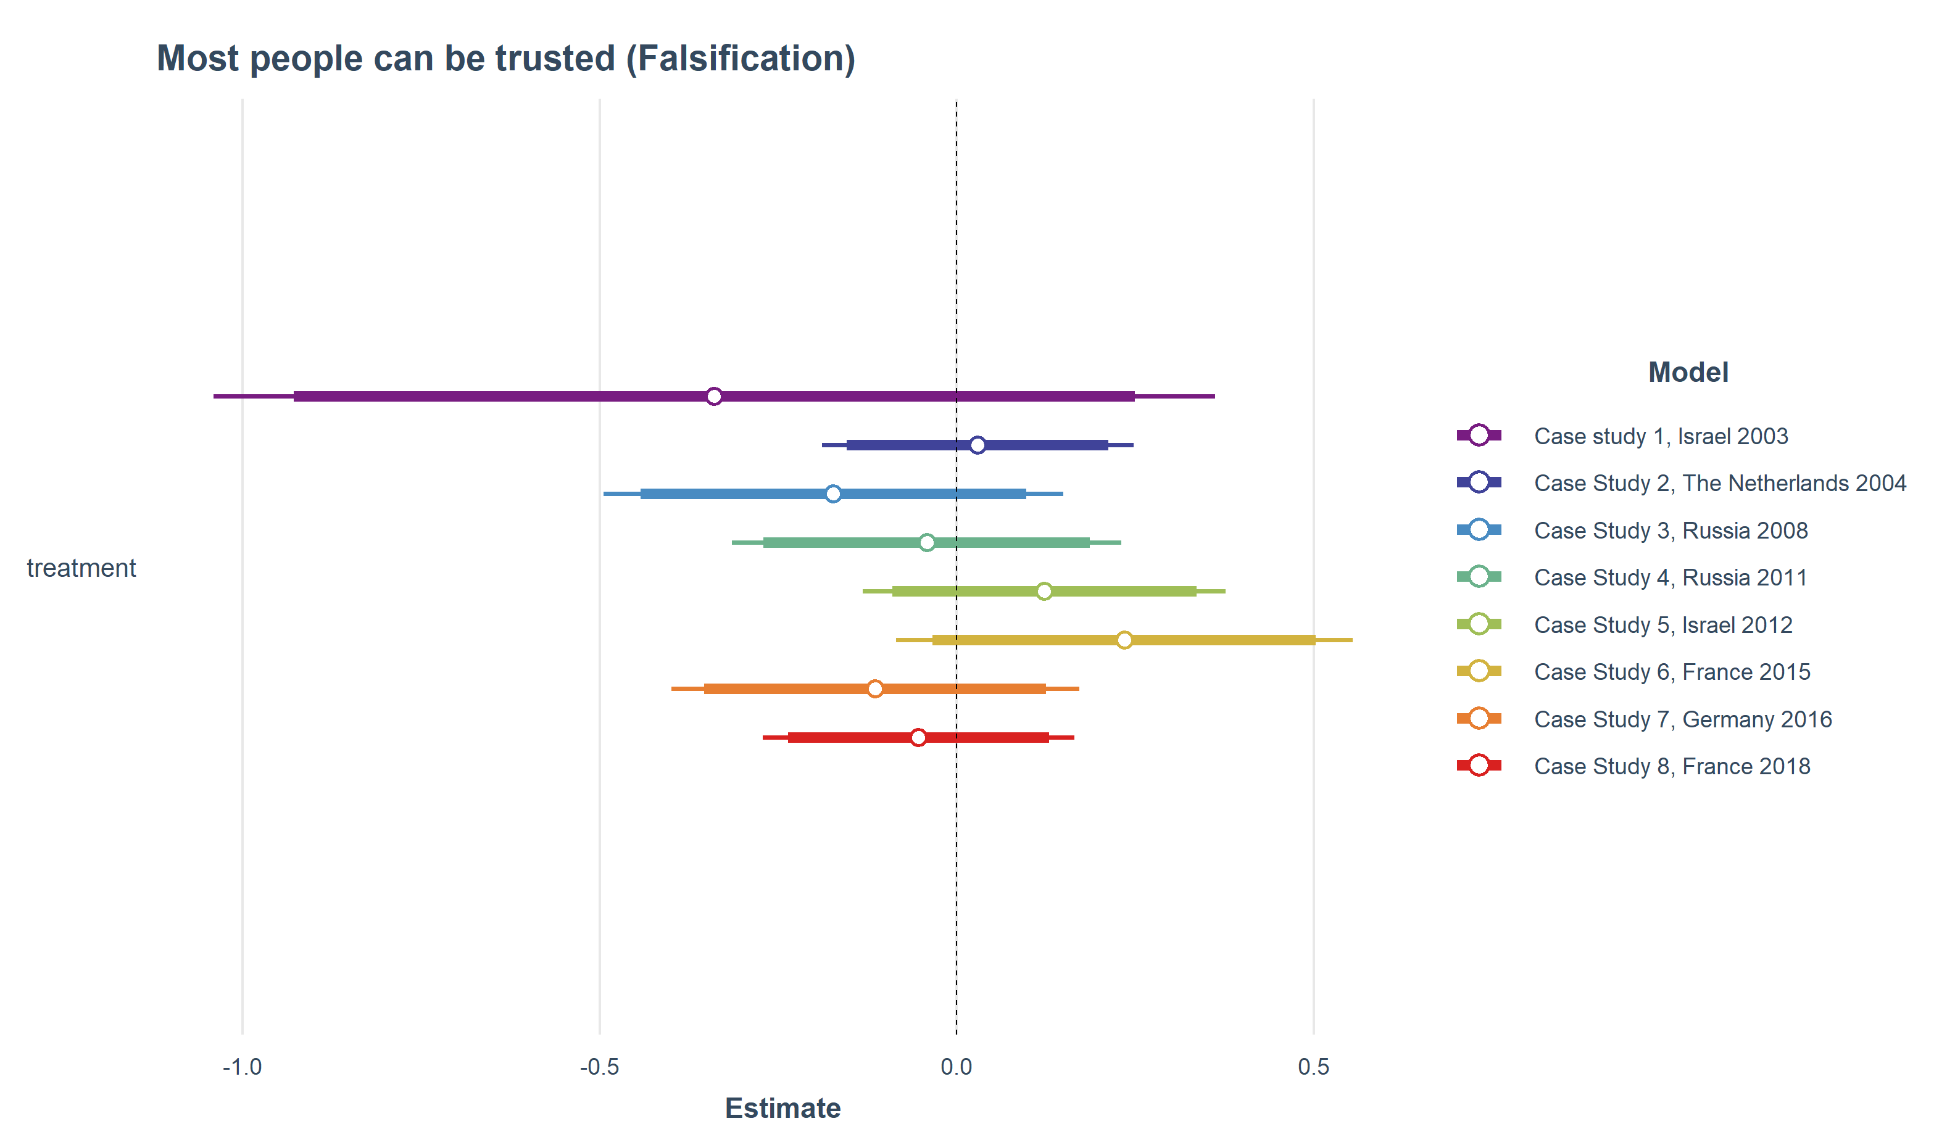
Figure A17. Falsification tests using ‘interpersonal trust’ as dependent variable. Full Bandwidth models include covariates and use HC0 robust standard errors.

Recall that the excludability assumption states that the interview date is an instrumental variable which should affect the outcome(s) only through the event. A convenient way to test this assumption is therefore to run ‘placebo’ regressions on outcomes that are very close to the actual outcome but should, theoretically, not be affected by the interview timing. Since our outcomes of interest refer to institutional trust, we chose the interpersonal trust item which included in every ESS round to conduct this falsification test. The item is affected in none of the included case studies.

A2. 6. Pseudo-Manipulation checks
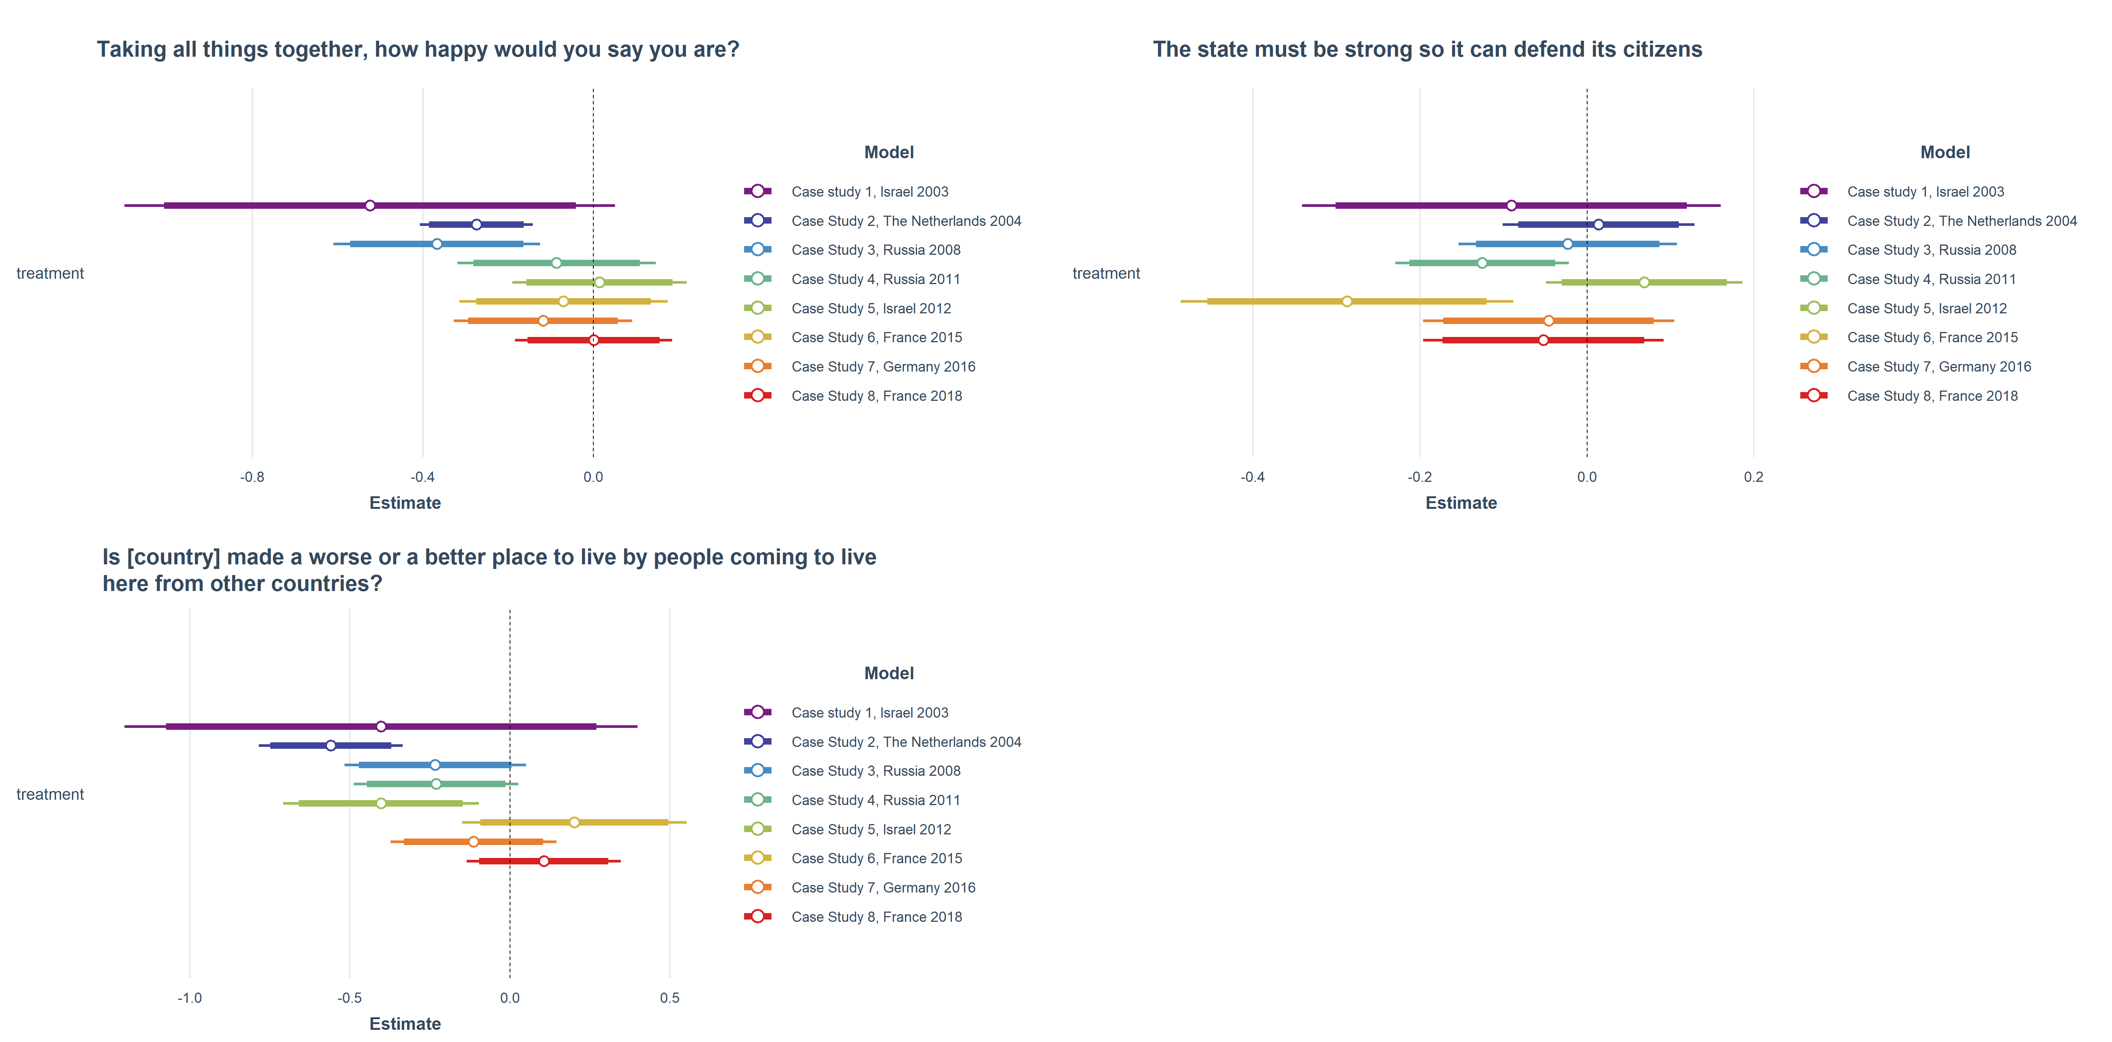
Figure A18. Pseudo-manipulation checks on various plausible items included in the ESS.

Pseudo-Manipulation checks are a way to assess whether there exists a one-sided non-compliance problem within the case studies. Unlike in a ‘real’ experiment where the treatment might be more direct, it is possible that respondents in the control group were not exposed to the stimuli. In our setup for example, this could be the case, when people did not hear, read, or watch the news. To test this, we assessed a series of outcome variables, that could theoretically also be affected by terrorist attacks. These include, feelings of happiness, feelings of security, and outgroup attitudes.

A2.8. Robustness to excluding less robust case studies
Figure A19. Results from meta-analysis when excluding case studies 1 and 3.

Figure A20. Meta regressions results using a specification without case studies 1 and 3.

A3. Robustness to design choices

A3.1. Excluding Case study 3 Russia 2008
Figure A21. Results from meta-analysis when excluding case study 3.

Figure A22. Meta regressions results when excluding case study 3.

A3.2. Including Case study X Israel 2015

Figure A23. Results from meta-analysis when including case study X, Israel 2015.

A3.3. Exclude respondents interviewed on the day of the event
Figure A 24. Baseline results of all case studies when excluding respondents interviewed on the day of the event.

Figure A25. Results from meta-analysis when excluding respondents interviewed on the date of the event.

A4. Non-preregistered exploratory analyses

A4. 1 Excluding all Russian case studies
Figure A26. Results from meta-analysis when excluding all Russian case studies.

Figure A27. Meta regressions results when excluding all Russian case studies.

A4. 2 Excluding all Israeli case studies
Figure A28. Results from meta-analysis when excluding all Israeli case studies.

Figure A29. Meta regressions results when excluding all Israeli case studies.

A4. 3 Excluding all Russian and Israeli case studies
Figure A30. Results from meta-analysis when excluding all Israeli and Russian case studies.

A4. 4 Adding “party in power” as additional covariate in regression models
Figure A31. Results from meta-analyses when including the covariate “party in power”.

Figure A32. Results from meta-regressions when including the covariate “party in power”.

A4.5 Employing matching algorithms to reduce sample imbalance
Figure A33. Balance improvements after matching in standardized mean differences (SMD). “Nearest Neighbor” matching algorithm applied in all studies but study 5 which uses “Coarsened Exact Matching”.
Figure A34. Results from multilevel meta-analysis after matching. “Nearest Neighbor” Matching was used for all case studies except for case study 5 which used “Coarsened Exact Matching. Panel a presents the summary effects estimated using the three-level mixed effects meta-analytical model. Panel b presents the summary effects using the CHE with robust variance estimator model.

We opted for propensity score matching (PSM) since it is widely used in political science and related fields. We chose the same covariates that we also used as controls in our regression models to estimate the propensity scores through a logit model. We then adopted a matching algorithm via the “MatchIt” R package that finds pairs of observations that have similar propensity scores, but differ in their treatment assignment. Observations were matched based on the “nearest neighbor” method. As King & Nielsen (2019) report, PSM can increase bias if balance between treatment and control groups is already high without matching. We assessed pre-post differences in standardized means in each case study, and indeed encountered greater imbalances in case study 5. Accordingly, we employed Coarsened Exact Matching (CEM) as an alternative matching procedure in this specific case study. CEM “coarsens” values from a set of variables (the same covariates we used in PSM) by creating a set of strata, each with the same coarsened values of these variables. Units in strata that do not contain at least one treatment and one control unit are pruned from the analysis (Iacus, King, and Porro 2009). Since sample sizes were substantially decreased by both the PSM as well as CEM algorithms, it was not possible to run analyses on all bandwidth choices. We therefore decided to include only full bandwidth models. This made it impossible to test hypothesis 6. Figure A33 illustrates in how far the matching method (PSM or CEM) decreased existing imbalances. Except for case study 5, PSM performed quite well and reduced imbalances to a SMD <.1. Another exception is the imbalance in case study 8 on the gender variable which exceeds the conservative SMD limit of.1 with a difference of .118. The matched sample is still less imbalanced on that variable than the unmatched sample which shows a SMD of 0.149 on gender. Figure A34 finally illustrates results of meta analyses after applying our matching strategy, which largely reproduce our null findings without matching. Comparable null results are obtained by either applying CEM or PSM exclusively (not shown).

A5. Summary of deviations from pre-registration

- Omission of an incident in Israel on October 07, 2015, since it did not meet our inclusion criteria. A Hamas-member wounded a civilian and a soldier. However, there were no civilian casualties. We refer to this incident as case study X and provide our summary results with and without including this specific case.
- Estimation of correlated and hierarchical effects models with robust variance estimation for each summary effect and meta-regression instead of regular multilevel meta-analysis models. Both results are presented.
- Omission of Kongsberg attack in Norway since (1) the corresponding ESS data has not been published yet (2) it is not included in the GTD and (3) it is not clearly attributable to a Jihadist motive.
- In the pre-registration, we stated to use the following R code to compute heteroscedasticity robust standard errors:

> cov <- vcovHC(m, type = "HC0")
> robust_se <- sqrt(diag(cov1))

For computational reasons, we decided to use the built-in function to apply heteroscedasticity robust standard error (HC0) from the lm_robust function of the estimatr package instead. Of course, results from both procedures are equivalent.

References
Iacus, Stefano M., Gary King, and Giuseppe Porro. 2009. “Cem : Software for Coarsened Exact Matching.” Journal of Statistical Software 30(9). doi: 10.18637/jss.v030.i09.
King, Gary, and Richard Nielsen. 2019. “Why Propensity Scores Should Not Be Used for Matching.” Political Analysis 27(4):435–54. doi: 10.1017/pan.2019.11.

We originally misread the GTD report and believed the soldier had been killed. We realized, however, that this case does in fact not meet our inclusion criteria since there has been no non-perpetrator fatality. Results do not change when this case study is included.
This test is not possible for case study 1 since there are no google trends accessible prior to 2004.

