Online Appendix
Appendix Table 1: models of all democracies with control variable results.
All Democracies
 | Dependent variable:
 | Renewable Energy Consumption
 | No lag | 1 lag | 2 lags | 3 lags
Women in Parliament | -0.004 | 0.001 | 0.006 | 0.011*
 | (0.003) | (0.004) | (0.005) | (0.005)
log GDP per capita | -0.059 | -0.100 | -0.277** | -0.346**
 | (0.065) | (0.076) | (0.097) | (0.110)
Vulnerability | 5.979** | 5.811* | 5.230 | 2.231
 | (2.222) | (2.784) | (3.846) | (5.141)
Resource Rents | -0.006 | -0.004 | 0.014 | 0.029**
 | (0.004) | (0.007) | (0.011) | (0.011)
Democracy Score | 0.123** | 0.053 | -0.138. | -0.079
 | (0.045) | (0.066) | (0.082) | (0.097)
HDI | -0.540 | -0.678 | 0.542 | 2.724
 | (1.130) | (1.423) | (2.071) | (2.725)
Observations | 481 | 388 | 295 | 204
R² | 0.075 | 0.059 | 0.114 | 0.190
Adjusted R² | -0.203 | -0.315 | -0.378 | -0.469
F Statistic | 5.014*** (df = 6; 369) | 2.872** (df = 6; 277) | 4.066*** (df = 6; 189) | 4.366*** (df = 6; 112)
Significance levels | *p<0.1; **p<0.05; ***p<0.01

Appendix Table 2: Interactions of the proportion of women in parliament with democracy score, followed by the marginal effects of women in parliament on renewable energy consumption.
Interaction of Women in Parliament and Democracy Score
 | Dependent variable:
 | Renewable Energy Consumption
 | No lag | 1 lag | 2 lag | 3 lags
Women in Parliament | -0.083*** | -0.097*** | -0.055 | 0.077.
 | (0.018) | (0.025) | (0.033) | (0.040)
Women in Parliament x Democracy score | 0.009*** | 0.011*** | 0.007. | -0.007.
 | (0.002) | (0.003) | (0.004) | (0.004)
Democracy Score | -0.053 | -0.144. | -0.240* | 0.011
 | (0.058) | (0.081) | (0.098) | (0.110)
log GDP per capita | -0.035 | -0.076 | -0.253* | -0.396***
 | (0.064) | (0.074) | (0.097) | (0.113)
Vulnerability | 3.558 | 3.296 | 3.533 | 3.553
 | (2.227) | (2.790) | (3.931) | (5.160)
Resource Rents | -0.007 | -0.006 | 0.011 | 0.035**
 | (0.004) | (0.007) | (0.011) | (0.011)
HDI | -0.546 | -0.927 | 0.239 | 3.262
 | (1.100) | (1.389) | (2.064) | (2.722)
Observations | 481 | 388 | 295 | 204
R² | 0.126 | 0.108 | 0.130 | 0.210
Adjusted R² | -0.140 | -0.251 | -0.360 | -0.446
F Statistic | 7.557*** (df = 7; 368) | 4.775*** (df = 7; 276) | 4.016*** (df = 7; 188) | 4.205*** (df = 7; 111)
Significance levels | *p<0.1; **p<0.05; ***p<0.01

Appendix Figure 1: Plotted marginal effects of women in parliament on renewable energy consumption by Democracy Score at all lag structures.

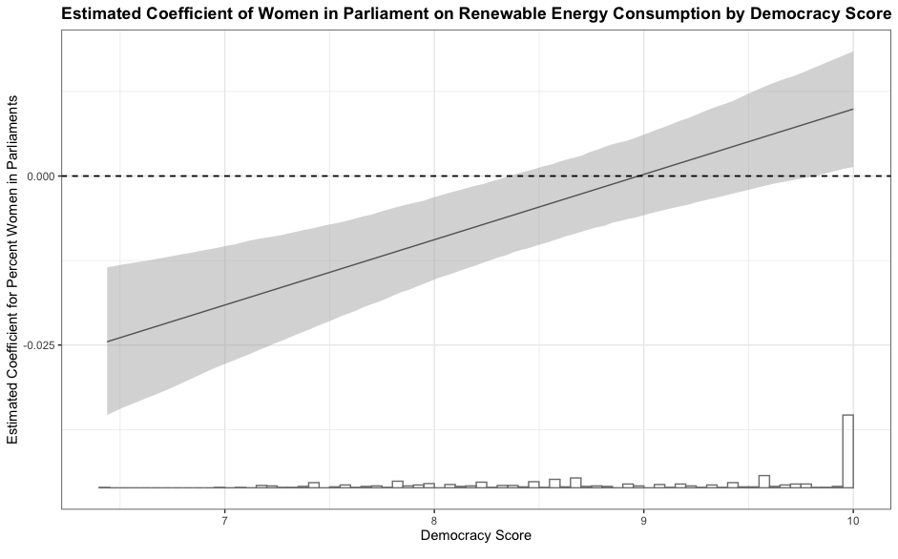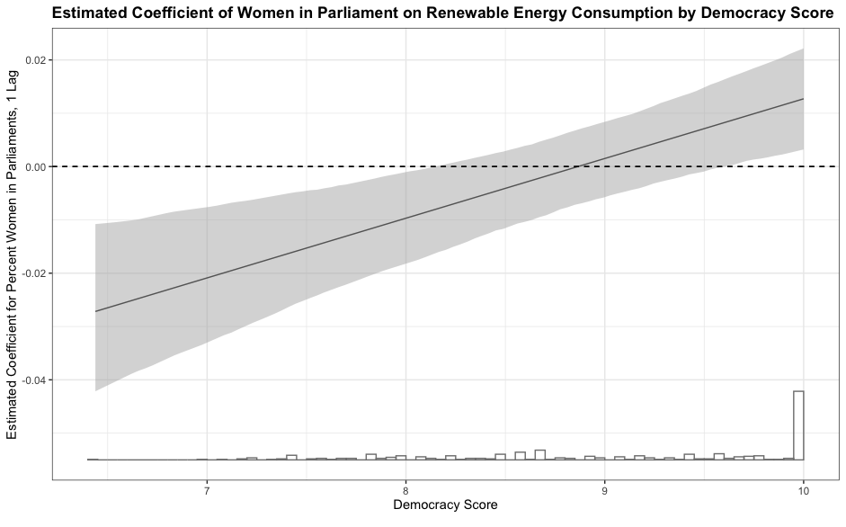

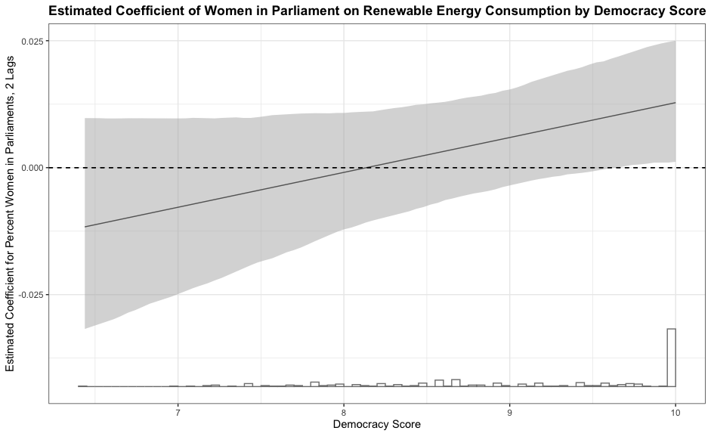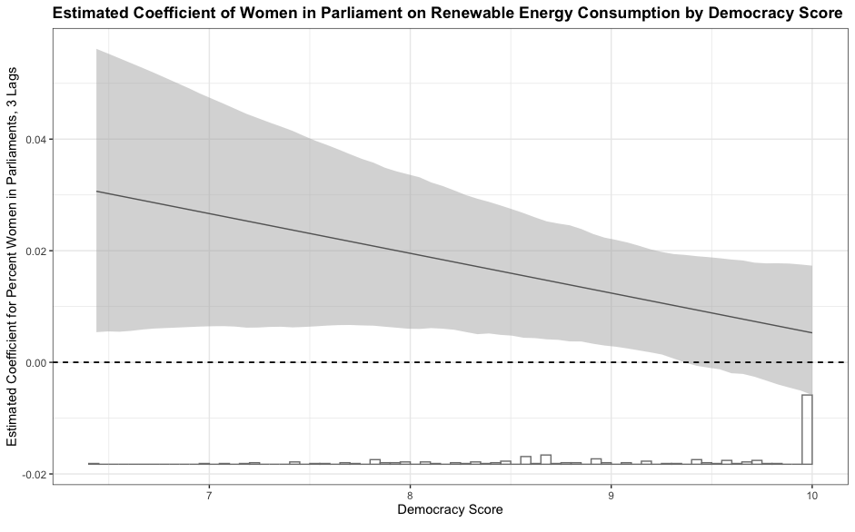

Appendix Table 3: Robustness test of the interactions of the proportion of women in parliament with HDI, followed by the marginal effects of women in parliament on renewable energy consumption.

Interaction of Women in Parliament and HDI
 | Dependent variable:
 | Renewable Energy Consumption
 | No lag | 1 lag | 2 lags | 3 lags
Women in Parliament | -0.074*** | -0.085*** | -0.079** | 0.022
 | (0.014) | (0.020) | (0.026) | (0.038)
Women in Parliament x HDI | 0.097*** | 0.113*** | 0.109*** | -0.014
 | (0.018) | (0.026) | (0.033) | (0.046)
HDI | -0.991 | -1.271 | -0.260 | 2.956
 | (1.094) | (1.385) | (2.031) | (2.845)
log GDP per capita | -0.037 | -0.089 | -0.268** | -0.352**
 | (0.063) | (0.074) | (0.095) | (0.113)
Vulnerability | 3.795. | 3.526 | 1.518 | 2.770
 | (2.182) | (2.747) | (3.906) | (5.473)
Resource Rents | -0.007. | -0.004 | 0.015 | 0.030**
 | (0.004) | (0.007) | (0.011) | (0.011)
Democracy Score | 0.092* | 0.028 | -0.144. | -0.079
 | (0.044) | (0.064) | (0.080) | (0.098)
Observations | 481 | 388 | 295 | 204
R² | 0.142 | 0.120 | 0.164 | 0.190
Adjusted R² | -0.119 | -0.234 | -0.307 | -0.481
F Statistic | 8.686*** (df = 7; 368) | 5.357*** (df = 7; 276) | 5.282*** (df = 7; 188) | 3.724** (df = 7; 111)
Significance levels | *p<0.1; **p<0.05; ***p<0.01

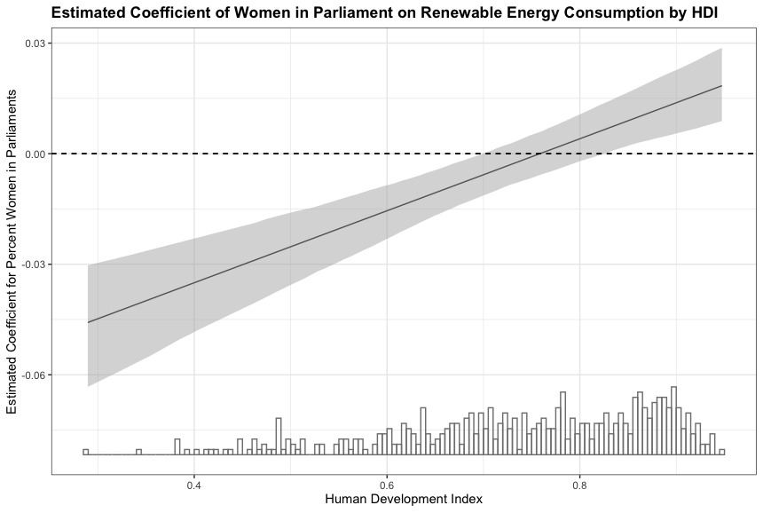
Appendix Figure 2: Plotted marginal effects of the participation of women in parliaments by HDI.
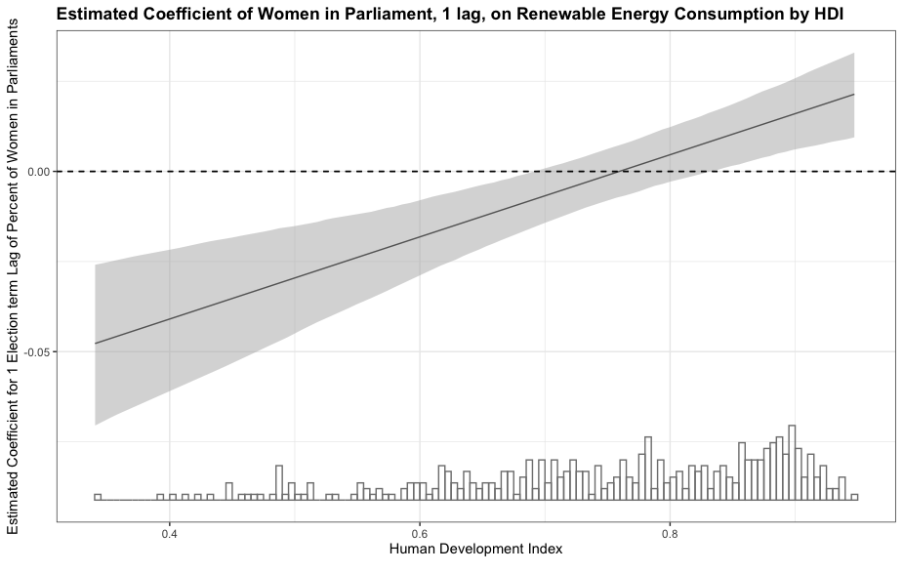

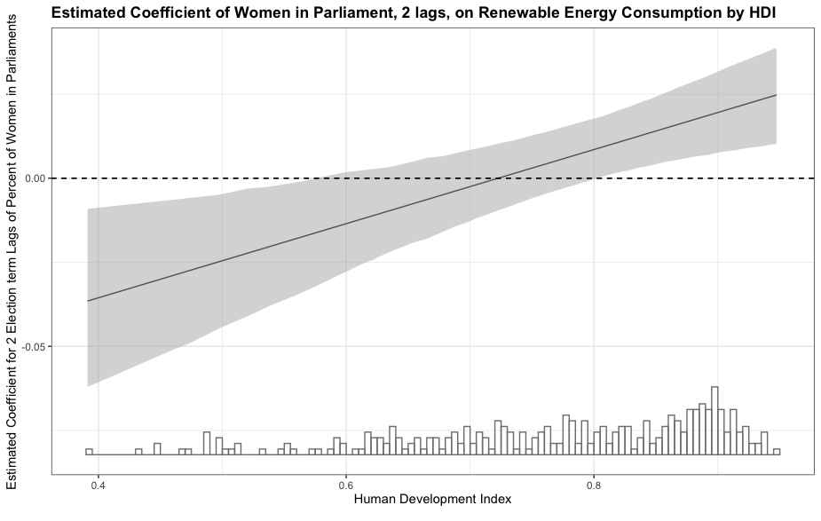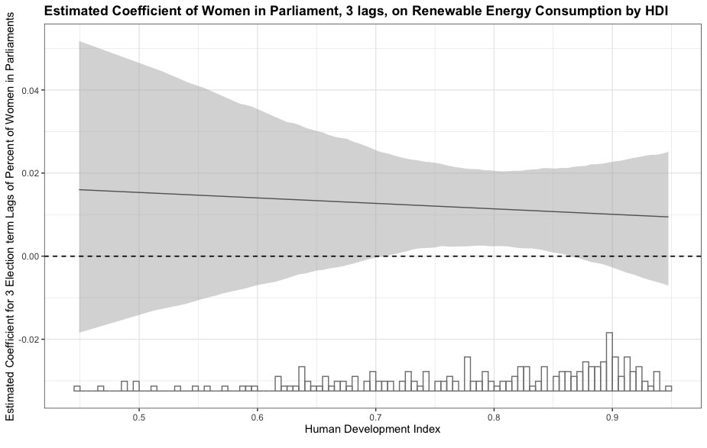

I created the weighted value of government lean utilizing data from the Manifesto Project (Volkens 2020). The vote percentage garnered by each country’s parties in each year was multiplied by each party’s value for left-right ideological position, resulting in a weighted value of each party’s ideological position; party values are then combined to form a government left-right ideological position value, such that:

Government Left-Right Position= Vote share Party A∗ left-right position (Party A) + Vote share Party B∗ left-right position (Party B) …+Vote share Party N∗ left-right position (Party N)

The observations of government left-right ideological position per country and year were then averaged by election term period, consistent with the data format used to conduct the previous models. On this scale, higher positive values indicate more extreme right positions while lower negative values indicate more extreme left positions. For example, Australia’s second election period demonstrates a substantial right-lean, with a weighted score of 3,377.4. Japan’s fifth election term demonstrates, in the opposite direction, a substantial left-lean, with a score of -3,612.3.

Appendix Table 4: Robustness tests including a measure of government’s left-right ideological position with country and year fixed effects and control variables.
All Democracies with Government Lean Control
 | Dependent variable:
 | Renewable Energy Consumption
 | No lag | 1 lag | 2 lags | 3 lags
Women in Parliament | -0.004 | 0.002 | 0.013 | 0.018
 | (0.006) | (0.008) | (0.010) | (0.011)
log GDP per capita | -0.148 | -0.147 | -0.070 | 0.183
 | (0.118) | (0.157) | (0.188) | (0.333)
Vulnerability | 7.790 | 8.892 | 8.311 | 1.745
 | (5.088) | (6.778) | (8.685) | (12.697)
Resource Rents | 0.001 | 0.012 | 0.040 | 0.053
 | (0.023) | (0.031) | (0.033) | (0.061)
Gov Left-Right Position | 0.00001 | -0.00001 | 0.00002 | 0.00003
 | (0.00002) | (0.00003) | (0.00003) | (0.00004)
Democracy Score | 0.220. | 0.263 | 0.082 | 0.253
 | (0.113) | (0.192) | (0.252) | (0.372)
HDI | 4.143. | 4.635 | 9.295* | 6.170
 | (2.413) | (3.764) | (4.593) | (7.946)
Observations | 180 | 126 | 94 | 61
R² | 0.085 | 0.075 | 0.201 | 0.371
Adjusted R² | -0.331 | -0.542 | -0.689 | -0.888
F Statistic | 1.637 (df = 7; 123) | 0.868 (df = 7; 75) | 1.582 (df = 7; 44) | 1.683 (df = 7; 20)
Significance levels | *p<0.1; **p<0.05; ***p<0.01

Appendix Table 5: Robustness tests including a measure of government’s left-right ideological position with an interaction of the proportion of women in parliament and GDP per capita, with country and year fixed effects and control variables.
Interactions of Women in Parliament and GDP, including Government Lean
 | Dependent variable:
 | Renewable Energy Consumption
 | No lag | 1 lag | 2 lags | 3 lags
Women in Parliament | -0.073* | -0.034 | 0.129* | 0.111
 | (0.034) | (0.050) | (0.049) | (0.071)
Women in Parliament x GDP per capita | 0.008* | 0.004 | -0.013* | -0.009
 | (0.004) | (0.005) | (0.005) | (0.007)
log GDP per capita | -0.327* | -0.231 | 0.080 | 0.253
 | (0.139) | (0.176) | (0.189) | (0.331)
Vulnerability | 4.787 | 6.548 | 13.204 | 0.213
 | (5.405) | (7.447) | (8.507) | (12.513)
Resource Rents | -0.001 | 0.007 | 0.056. | 0.053
 | (0.025) | (0.033) | (0.032) | (0.060)
Democracy Score | 0.345** | 0.325 | -0.014 | 0.225
 | (0.131) | (0.210) | (0.243) | (0.365)
HDI | 6.071* | 7.121. | 7.253 | -0.776
 | (2.688) | (4.232) | (4.449) | (9.388)
Gov Left-Right Position | 0.00003 | -0.00001 | -0.00002 | 0.00002
 | (0.00003) | (0.00003) | (0.00003) | (0.00004)
Observations | 159 | 116 | 89 | 60
R² | 0.150 | 0.097 | 0.294 | 0.424
Adjusted R² | -0.221 | -0.484 | -0.444 | -0.788
F Statistic | 2.420* (df = 8; 110) | 0.938 (df = 8; 70) | 2.243* (df = 8; 43) | 1.750 (df = 8; 19)
Significance levels | *p<0.1; **p<0.05; ***p<0.01

Appendix Figure 3: Plotted marginal effects of women in parliament on renewable energy consumption by GDP per capita at all lag structures.
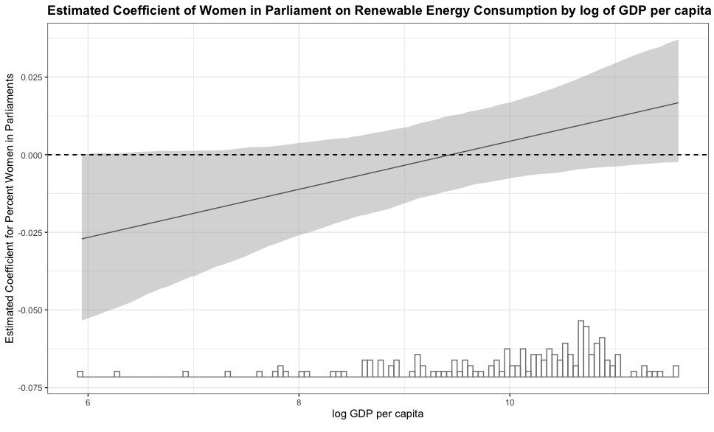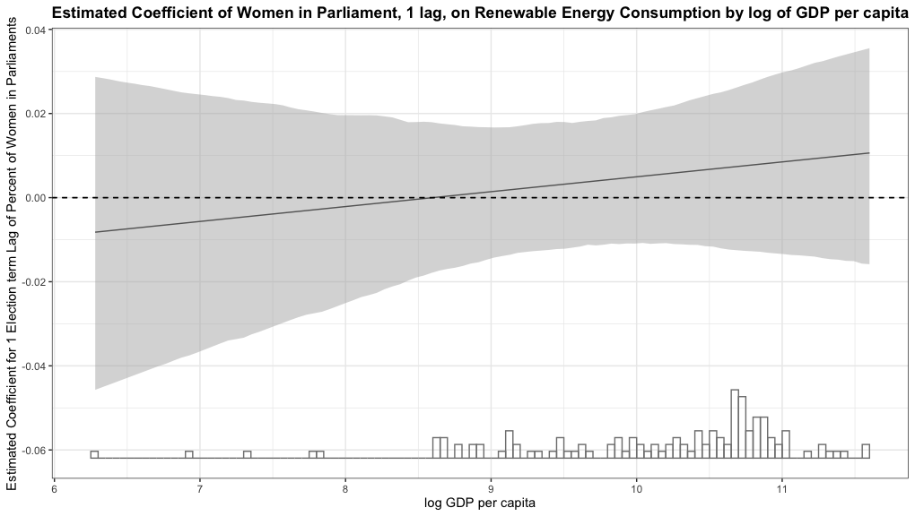

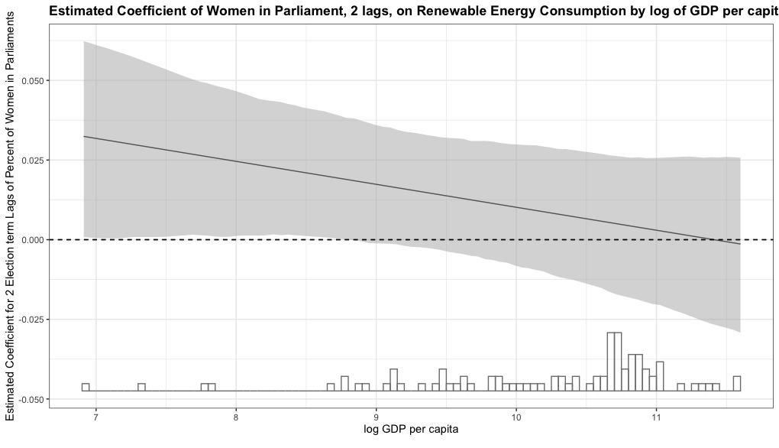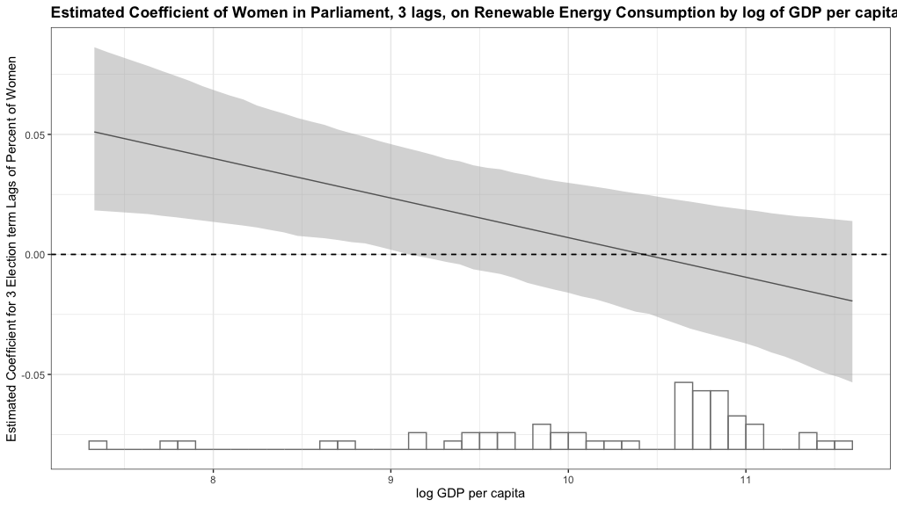

Appendix Table 6: Robustness tests including a measure of government’s left-right ideological position with an interaction of the proportion of women in parliament and democracy score, with country and year fixed effects and control variables.

Interactions of Women in Parliament and Democracy Score, including Government Lean
 | Dependent variable:
 | Renewable Energy Consumption
 | No lags | 1 lags | 2 lags | 3 lags
Women in Parliament | -0.076. | -0.005 | 0.133. | 0.191*
 | (0.045) | (0.078) | (0.073) | (0.082)
Women in Parliament x Democracy | 0.008. | 0.001 | -0.013 | -0.019*
 | (0.005) | (0.008) | (0.008) | (0.009)
Freedom House Score | 0.069 | 0.283 | 0.499. | 0.641.
 | (0.206) | (0.256) | (0.260) | (0.341)
log GDP per capita | -0.182 | -0.182 | -0.243 | 0.087
 | (0.129) | (0.171) | (0.199) | (0.303)
Vulnerability | 5.622 | 8.181 | 8.418 | 14.747
 | (5.421) | (7.261) | (8.962) | (11.507)
Resource Rents | -0.002 | 0.012 | 0.067. | 0.030
 | (0.025) | (0.032) | (0.033) | (0.051)
HDI | 4.606. | 6.218 | 6.665 | 8.997
 | (2.593) | (4.124) | (4.613) | (7.808)
Gov Left-Right Position | 0.00002 | -0.00001 | -0.00001 | -0.00002
 | (0.00003) | (0.00003) | (0.00003) | (0.00004)
Observations | 159 | 116 | 91 | 57
R² | 0.135 | 0.090 | 0.263 | 0.571
Adjusted R² | -0.242 | -0.495 | -0.474 | -0.413
F Statistic | 2.151* (df = 8; 110) | 0.867 (df = 8; 70) | 2.007. (df = 8; 45) | 2.828* (df = 8; 17)
Significance levels | *p<0.1; **p<0.05; ***p<0.01

Appendix Figure 4: Plotted marginal effects of women in parliament on renewable energy consumption by democracy score at all lag structures.

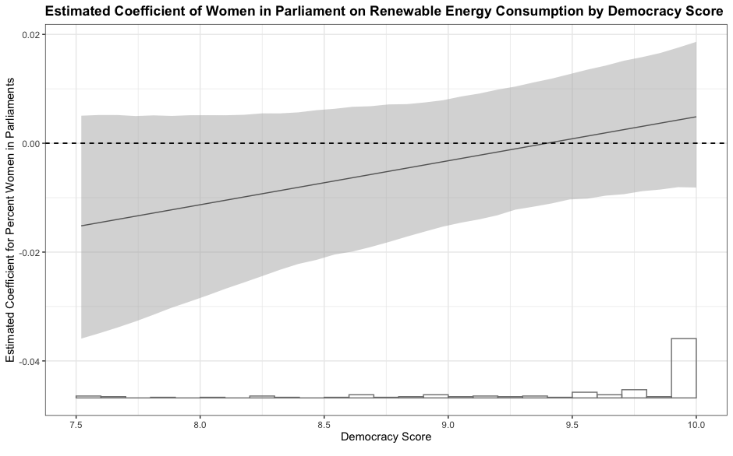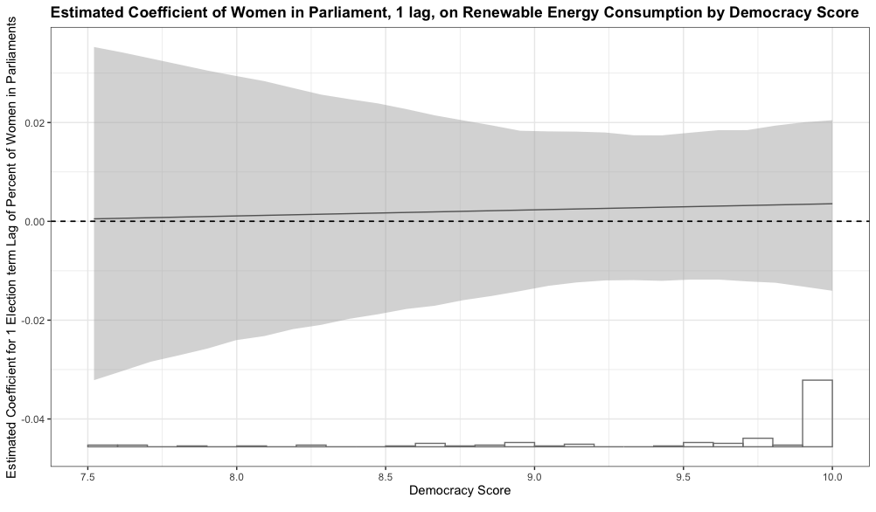

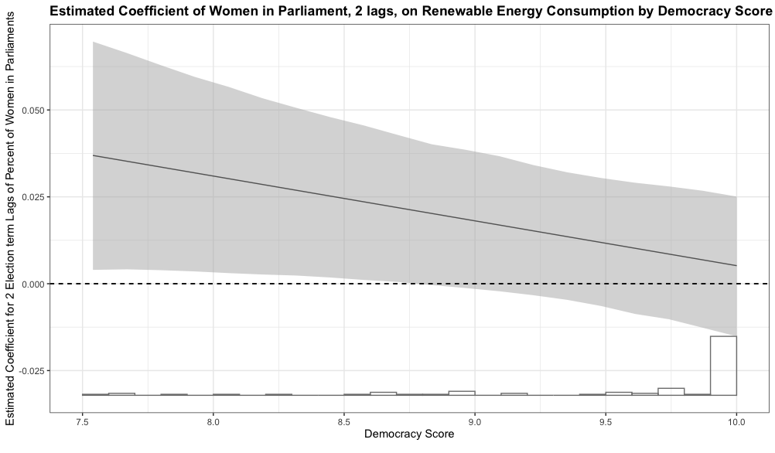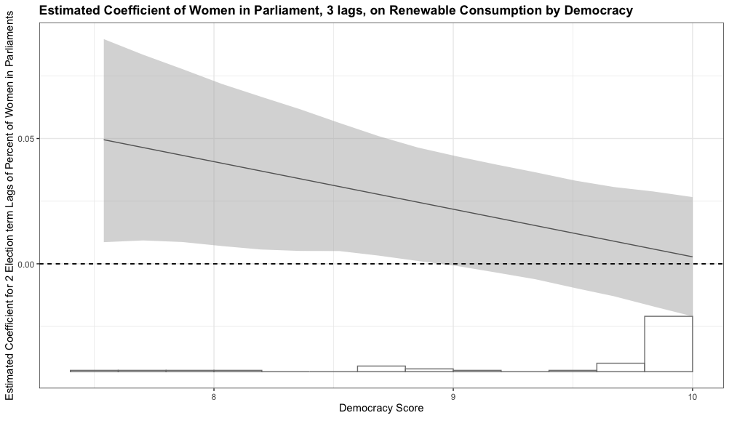

Appendix Table 7: Robustness tests of Appendix Table 1, in which observations before election term 3 are discounted and models are rerun.
Models: Observations Removed before 3 Lags
 | Dependent variable:
 | Renewable Energy Consumption
 | No lag | 1 lag | 2 lags | 3 lags
Women in Parliament | -0.010* | -0.009. | 0.009 | 0.011*
 | (0.004) | (0.005) | (0.006) | (0.005)
log GDP per capita | -0.341** | -0.350** | -0.344** | -0.346**
 | (0.110) | (0.111) | (0.113) | (0.110)
Vulnerability | -1.177 | 1.565 | 1.863 | 2.231
 | (5.260) | (5.170) | (5.250) | (5.141)
Resource Rents | 0.021. | 0.024* | 0.022* | 0.029**
 | (0.011) | (0.011) | (0.011) | (0.011)
Democracy Score | -0.060 | -0.049 | -0.029 | -0.079
 | (0.097) | (0.098) | (0.100) | (0.097)
HDI | 2.211 | 3.023 | 1.890 | 2.724
 | (2.737) | (2.752) | (2.796) | (2.725)
Observations | 204 | 204 | 201 | 204
R² | 0.982 | 0.982 | 0.982 | 0.982
Adjusted R² | 0.968 | 0.968 | 0.967 | 0.968
Residual Std. Error | 0.162 (df = 112) | 0.163 (df = 112) | 0.163 (df = 110) | 0.161 (df = 112)
F Statistic | 68.424*** (df = 91; 112) | 67.531*** (df = 91; 112) | 65.591*** (df = 90; 110) | 68.641*** (df = 91; 112)
Significance levels | *p**p***p<0.01

Appendix Table 8: Robustness tests of Appendix Table 2, in which observations before election term 3 are discounted and models are rerun.
Models: Women in Parliament x GDP Interactions with Observations Removed before 3 Lags
 | Dependent variable:
 | Renewable Energy Consumption
 | No lag | 1 lag | 2 lags | 3 lags
Women in Parliament | -0.069* | -0.018 | 0.003 | 0.036
 | (0.031) | (0.038) | (0.036) | (0.033)
Women in Parliament x GDP per capita | 0.007. | 0.001 | 0.001 | -0.003
 | (0.003) | (0.004) | (0.004) | (0.003)
log GDP per capita | -0.456*** | -0.367** | -0.353** | -0.318**
 | (0.124) | (0.135) | (0.125) | (0.116)
Vulnerability | -3.599 | 1.275 | 1.641 | 3.290
 | (5.341) | (5.350) | (5.417) | (5.347)
Resource Rents | 0.017 | 0.023* | 0.022* | 0.031**
 | (0.011) | (0.011) | (0.011) | (0.011)
Democracy Score | -0.076 | -0.048 | -0.029 | -0.079
 | (0.096) | (0.099) | (0.101) | (0.098)
HDI | 2.247 | 3.024 | 1.959 | 2.658
 | (2.703) | (2.764) | (2.835) | (2.732)
Observations | 204 | 204 | 201 | 204
R² | 0.983 | 0.982 | 0.982 | 0.982
Adjusted R² | 0.969 | 0.967 | 0.966 | 0.968
Residual Std. Error | 0.160 (df = 111) | 0.163 (df = 111) | 0.164 (df = 109) | 0.162 (df = 111)
F Statistic | 69.427*** (df = 92; 111) | 66.231*** (df = 92; 111) | 64.300*** (df = 91; 109) | 67.624*** (df = 92; 111)
Significance levels | *p**p***p<0.01

Appendix Table 9: Time-series cross-sectional analysis of FITs with country and year fixed effects and an interaction of women in parliament and GDP per capita.

Interaction of Women in Parliament and GDP on FITs
 | Dependent variable:
 | FITs
 | No lag | 1 lag | 2 lags | 3 lags
Women in Parliament | 1.003 | 1.486. | -2.121* | -0.525
 | (1.178) | (0.828) | (0.890) | (0.822)
Women in Parliament x GDP per cap | -0.074 | -0.130 | 0.195* | 0.052
 | (0.135) | (0.090) | (0.091) | (0.086)
logGDP | 5.842 | 10.611* | 4.185 | 3.883
 | (5.089) | (5.128) | (4.918) | (5.217)
Vulnerability | -432.244** | -484.426** | -519.715** | -491.893**
 | (161.075) | (165.853) | (166.943) | (166.881)
ResourceRents | -0.196 | -0.257 | -0.061 | -0.311
 | (0.501) | (0.509) | (0.517) | (0.514)
FreedomHouse | -0.082 | -0.843 | -1.457 | -0.730
 | (3.209) | (3.306) | (3.358) | (3.315)
HDI | -14.180 | -83.824 | -53.516 | -16.431
 | (87.381) | (85.071) | (86.634) | (85.827)
Observations | 268 | 255 | 256 | 258
R² | 0.313 | 0.326 | 0.332 | 0.304
Adjusted R² | 0.082 | 0.090 | 0.099 | 0.063
Residual Std. Error | 12.446 (df = 200) | 12.704 (df = 188) | 12.614 (df = 189) | 12.813 (df = 191)
F Statistic | 1.357. (df = 67; 200) | 1.379* (df = 66; 188) | 1.425* (df = 66; 189) | 1.262 (df = 66; 191)
Significance levels | *p**p***p<0.01

Appendix Figure 5.: Plotted marginal effects of women in parliament on FITs by GDP per capita at all lag structures.

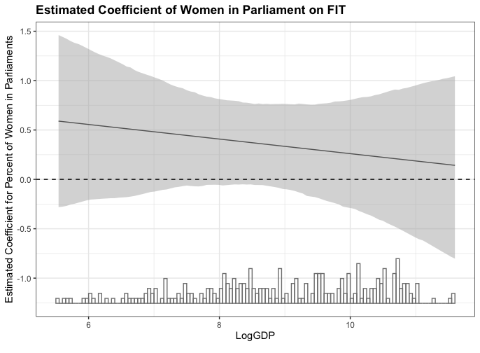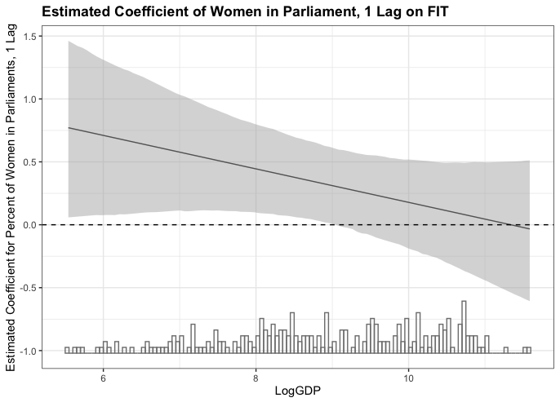
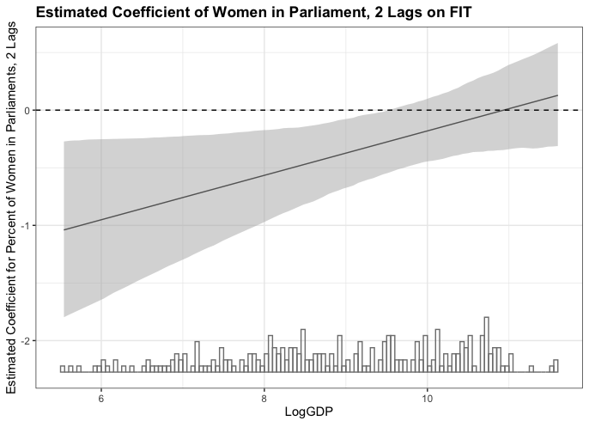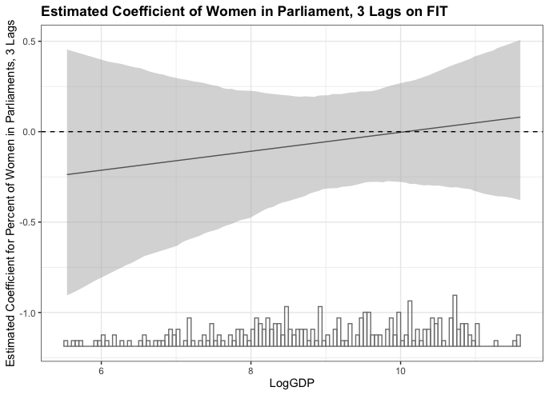

Appendix Table 10: Time-series cross-sectional analysis of renewable energy consumption with country and year fixed effects and an interaction of women in cabinets and GDP per capita.

Interaction of Women in Cabinets and GDP per capita
 | Dependent variable:
 | Renewable Energy Consumption
 | No lag | 1 lag | 2 lags | 3 lags
Women in Cabinets | -0.058 | -0.142 | -0.269 | -0.453.
 | (0.086) | (0.101) | (0.167) | (0.237)
Women in Cabinets x log GDP per capita | 0.003 | 0.014 | 0.028. | 0.039.
 | (0.009) | (0.011) | (0.016) | (0.023)
log GDP per capita | -0.215* | -0.305* | -0.519** | -0.629***
 | (0.098) | (0.123) | (0.153) | (0.181)
Women in Parliament | -0.099*** | -0.086** | -0.079. | -0.040
 | (0.026) | (0.032) | (0.042) | (0.048)
Vulnerability | 4.263 | 1.247 | 3.415 | 1.776
 | (3.373) | (4.618) | (5.721) | (9.054)
Resource Rents | -0.022. | -0.034* | -0.011 | 0.0003
 | (0.011) | (0.013) | (0.018) | (0.021)
Freedom House Score | -0.046 | -0.132 | -0.340** | -0.207
 | (0.065) | (0.093) | (0.109) | (0.129)
HDI | 0.550 | -1.030 | 0.404 | 2.208
 | (1.766) | (2.084) | (3.097) | (3.899)
Women in parliament x log GDP | 0.011*** | 0.009* | 0.008 | 0.003
 | (0.003) | (0.004) | (0.005) | (0.005)
Observations | 247 | 202 | 157 | 111
R² | 0.202 | 0.235 | 0.318 | 0.369
Adjusted R² | -0.079 | -0.114 | -0.132 | -0.285
F Statistic | 5.119*** (df = 9; 182) | 4.718*** (df = 9; 138) | 4.865*** (df = 9; 94) | 3.512** (df = 9; 54)
Significance levels | *p**p***p<0.01

Appendix Figure 6.: Plotted marginal effects of women in cabinets on renewable energy consumption by GDP per capita at all lag structures

