Appendix A: Pre-registration

Deviations from the pre-registration
1) Hypotheses
We have made several minor changes to the hypothesis:
- For all hypotheses, we substituted “implemented” for “adopted”, because we feel that is more accurate for our study.
- We summarised the first hypotheses (1a-1c) into one single hypothesis, without making substantive changes.
- Hypothesis 2a and 2b did not specify that these are about the general public, but the design implies that respondents in the experiment do not partake in the minipublic. We therefore rephrased them to “Taking notice of a deliberative minipublic …”. Besides, we replaced “compared to a decision-making process that does not include a minipublic” to “compared a representative decision-making process”. We make use of placebo conditions so we believe this specification better suits our purpose and design.
- For the third hypothesis, we replaced “depending on the policy uptake of a mini-public” with “depending on the use of a minipublics and its subsequent policy adoption”. We feel this better reflects and summarises the previous hypotheses to which the third hypothesis refers. We also replaced “whether” with “the extent to which”, because it better fits the continuous nature of our measurement of outcome favourability. Finally, we replaced “policies realised” with “policies adopted” to fit the focus of our study.

2) Dependent variable
In the translation from English to Dutch, two minor differences occurred. For the question on domain-specific trust in government, we asked “about mobility” and not “on the theme of mobility”. For the question on perceived procedural fairness has occurred, we asked about the “way in which” decision was made instead of stating the “process by which”.

We have not tested the process assessment items separately, as factor analysis shows that the sum scale provides a reliable measure (factor loadings ≥ 0.62; Cronbach’s alpha = 0.83).

3) Placebo conditions
We have not tested whether the difference between the placebo condition with low consultation and treatment conditions are larger than the difference between the placebo condition with high consultation and treatment conditions. The reason for this is twofold. On the one hand, this difference spelled out likely depends on which treatment condition you take. For the full adoption condition, the difference with the low consultation placebo is indeed probably bigger than with the high consultation placebo. For the no adoption condition, the reverse is likely to be true. As we did not specify this in the pre-registration, we decided not to test it. On the other hand, the main aim of having two placebo conditions is to assess whether our results hold regardless of the portrayal of a representative processes. This turns out to be the case.

We have reported the results using the low consultation placebo condition in the main text, and those using the high consultation placebo condition in the Appendix. Because both produce highly similar findings, we feel that it is unnecessary to present both in the main text.

4) Covariate-adjusted estimates
We have not reported the covariate-adjusted estimates because we find our samples to be balanced as regards the covariates listed in the preregistration (balance checks available upon request; Mutz & Pemantle, 2015).

5) Outcome favourability
We have reversely coded the variable outcome favourability to make the interpretation of the results more intuitive.

6) Manipulation check
In the translation, a small difference occurred for one of the items used as a factual manipulation check. Instead of stating “The Flemish government disregarded…”, we asked about “The Flemish government decided to disregard…”.

Appendix B: Sample description

Table B1: Socio-demographic distributions of respondents (n = 3,102)
Gender
Male: 69.5% | Female: 30.4% | Other: 0.1% (n = 2)
Age
18-34 years old: 10.4% | 35-54 years old: 27.9% | 55+ years old: 61.7%
Education level
No higher education: 29.1% | Higher education: 70.9%
Political interest
Mean = 5.89; SD = 1.11
(seven-point scale)

Table B2: Socio-demographic distributions in the Flemish population
Gender
Male: 49.5% | Female: 50.5%
Age
18-34 years old: 24.9% | 35-54 years old: 32.6% | 55+ years old: 42.5%
Education level
No higher education: 61.7% | Higher education: 38.3%
Source: StatBel 2020

Appendix C: Pre-treatment questions, vignettes and manipulation checks

Overview of used survey questions from the pre-experimental stage
Gender
“What is your gender?”
Answer options: Male; Female; Other.

Age
“What is your age?”
Drop-down list with options ranging from ‘Younger than 18’; 18 to 120.
Note: Respondents who indicated to be younger than 18 years old were redirected to the end of the survey.

Education level
“What is the highest level of education you have achieved?”
Answer options: 1 = No or elementary education; 2 = Secondary education, incomplete (lower ASO, BSO or TSO); 3 = Secondary education, complete (ASO, BSO or TSO); 4 = Higher non-university education; 5 = University education.
Note: Recoded to 0 = No higher education; 1 = Higher education

Region
“In which region do you live?”
Answer options: Flanders; Wallonia; Brussels; Other, namely: [text box].
Note: Respondents who reported to live in a region other than Flanders were redirected to the end of the survey.

Political interest
“To what extent are you interested in politics in general?”
Answer scale: 0 = Not interested at all; 10 = Very much interested

Preferences towards policy measures
“Mobility in Flanders has been a topic of discussion in recent years. To improve mobility in Flanders, various measures are possible. Obviously not all measures can be carried out, for example, because the reserved budget does not allow this.

Below we present you with various policy proposals to improve mobility in Flanders. Which proposals would you prefer? Please put the proposal you prefer the most at the top, and continue until the one that you prefer the least. By clicking on a policy proposal, you can drag it to another position.”

Investments in bus, metro and tram
Investments in the railway network
More and safer bicycle lanes
More bicycle parking facilities at stations
More facilities at train stations to transit to different modes of transportation
More parking spots for carpooling
More restricted traffic areas in city centres
More smart traffic lights

Note: The order in which they policy measures were presented to respondents was randomised.
Note II: Respondents were presented with this list of policy measures before being assigned to an experimental condition.

Experimental vignettes

Example of formatting:

Citizens’ forum hands over advice to improve mobility to Flemish government
Monday 17 February 2020
Last Saturday, the Flemish Citizens’ Forum on mobility opened its last session. The fifty participating citizens met again to formulate a proposal of two policy measures. After discussing, the citizens’ forum advises the Flemish government to realise {Proposal1} {Proposal2}.

The Forum was initiated by the Flemish government, and brought together a group of fifty Flemings to give advice on the investment of €10 million in measures to improve mobility. This sum is reserved in the Flemish budget of 2020 for extra investments in this domain. The participants were randomly selected so that the group was broadly representative of the Flemish population.

During the previous two sessions, the participants listened to presentations from experts, posed questions and engaged in small-group discussions. In this way, the participants gained insights into the issue of mobility and were able to debate various solutions.

The last session concluded with an anonymous vote. Two policy recommendations emerged as winners from the vote: {Proposal1} {Proposal2}. The advisory report of the forum will be presented to the Flemish government, but is not legally binding. As one of the organisers explains: “The Flemish government is not obliged to follow the recommendations of the citizens’ forum in its decisions.”

Text C1: Vignette for all treatment groups
Burgerforum overhandigt adviezen om mobiliteit te verbeteren aan Vlaamse regering  Maandag 17 februari 2020  Afgelopen zaterdag opende het Vlaamse Burgerforum over mobiliteit zijn laatste sessie. De vijftig deelnemende burgers kwamen opnieuw bijeen om tot een voorstel van twee beleidsmaatregelen te komen. Na overleg adviseert het burgerforum de Vlaamse regering om ${e://Field/MP_Voorstel1} en  ${e://Field/MP_Voorstel2} te realiseren.  Het forum werd geïnitieerd door de Vlaamse regering, en bracht een groep van vijftig Vlamingen samen om advies uit te brengen over het investeren van €10 miljoen in maatregelen om de mobiliteit te verbeteren. Dit bedrag is gereserveerd in de Vlaamse begroting van 2020 voor extra investeringen in dit domein. De deelnemers werden willekeurig geselecteerd zodat de groep in grote lijnen representatief was voor de Vlaamse bevolking.  Tijdens de vorige twee sessies luisterden de deelnemers naar presentaties van experten, stelden ze vragen en gingen ze in kleine groepen met elkaar in gesprek. Op die manier kregen de deelnemers inzicht in de mobiliteitsproblematiek, en konden ze debatteren over verschillende oplossingen.  De laatste bijeenkomst werd afgesloten met een anonieme stemming. Uit de stemming kwamen twee beleidsadviezen als winnaar uit de bus: ${e://Field/  MP_Voorstel1} en ${e://Field/MP_Voorstel2}. Het adviesrapport van het forum wordt voorgelegd aan de Vlaamse regering, maar is niet wettelijk bindend. Zoals één van de organisatoren uitlegt: “De Vlaamse regering is niet verplicht om de aanbevelingen van het burgerforum te volgen in haar beslissingen.” | Citizens’ forum hands over advice to improve mobility to Flemish government  Monday 17 February 2020  Last Saturday, the Flemish Citizens’ Forum on mobility opened its last session. The fifty participating citizens met again to formulate a proposal of two policy measures. After discussing, the citizens’ forum advises the Flemish government to realise {Proposal1} {Proposal2}.  The Forum was initiated by the Flemish government, and brought together a group of fifty Flemings to give advice on the investment of €10 million in measures to improve mobility. This sum is reserved in the Flemish budget of 2020 for extra investments in this domain. The participants were randomly selected so that the group was broadly representative of the Flemish population.  During the previous two sessions, the participants listened to presentations from experts, posed questions and engaged in small-group discussions. In this way, the participants gained insights into the issue of mobility and were able to debate various solutions.  The last session concluded with an anonymous vote. Two policy recommendations emerged as winners from the vote: {Proposal1} {Proposal2}. The advisory report of the forum will be presented to the Flemish government, but is not legally binding. As one of the organisers explains: “The Flemish government is not obliged to follow the recommendations of the citizens’ forum in its decisions.”

Text C2: Vignette for treatment condition 1 (full policy adoption)
Vlaamse regering besluit advies Burgerforum over mobiliteitsmaatregelen te volgen  Donderdag 5 maart 2020  Na veel discussie besloten de Vlaamse regeringspartijen N-VA, CD&V en Open VLD gisteren om de uitkomst van het burgerforum te volgen. De regering zal €10 miljoen besteden aan ${e://Field/Adopted_1} en ${e://Field/Adopted_2}.  Vorige maand formuleerde het burgerforum haar finale advies over hoe de mobiliteit in Vlaanderen te verbeteren. Kort daarna werd het adviesrapport aan de Vlaamse regering overhandigd.  Gisteren maakte de Vlaams minister van Mobiliteit en Openbare Werken, Lydia Peeters (Open VLD), bekend dat beide aanbevelingen van het burgerforum gevolgd zullen worden. Daarmee besloot de regering om ${e://Field/Adopted_1} en ${e://Field/Adopted_2} te realiseren. | Flemish government decides to follow advise Citizens’ Forum on mobility measures  Thursday 5 March 2020  After much discussion, the Flemish government parties N-VA, CD&V and Open VLD decided yesterday to follow the outcome of the citizens’ forum. The government will spend €10 million on {Adopted1} and {Adopted2}.  Last month, the citizens’ forum formulated its final advice on how to improve mobility in Flanders. Shortly afterwards, the advisory report was handed over to the Flemish government.  Yesterday, the Flemish minister of Mobility and Public Works, Lydia Peeters (Open VLD), announced that both recommendations of the citizens’ forum will be followed. With that, the government decided to realise {Adopted1} and {Adopted2}.
Note: {Adopted1} and {Adopted2} are the same policy measures as {Proposal1} and {Proposal2}.

Text C3: Vignette for treatment condition 2 (no policy adoption)
Vlaamse regering besluit advies burgerforum over mobiliteitsmaatregelen niet te volgen  Donderdag 5 maart 2020  Na veel discussie besloten de Vlaamse regeringspartijen N-VA, CD&V en Open VLD gisteren om de uitkomst van het burgerforum niet te volgen. De regering zal €10 miljoen besteden aan ${e://Field/Adopted_1} en ${e://Field/Adopted_2}.  Vorige maand formuleerde het burgerforum haar finale advies over hoe de mobiliteit in Vlaanderen te verbeteren. Kort daarna werd het adviesrapport aan de Vlaamse regering overhandigd.  Gisteren maakte de Vlaams minister van Mobiliteit en Openbare Werken, Lydia Peeters (Open VLD), bekend dat de aanbevelingen van het burgerforum niet gevolgd zullen worden. Daarmee besloot de Vlaamse regering om niet te investeren in de adviezen van het burgerforum, ${e://Field/NonAdopted_1} en ${e://Field/ NonAdopted_2}.  In plaats daarvan koos de Vlaamse regering ervoor om ${e://Field/Adopted_1} en ${e://Field/Adopted_2} te realiseren. | Flemish government decides not to follow advise Citizens’ Forum on mobility measures  Thursday 5 March 2020  After much discussion, the Flemish government parties N-VA, CD&V and Open VLD decided yesterday not to follow the outcome of the citizens’ forum. The government will spend €10 million on {Adopted1} and {Adopted2}.  Last month, the citizens’ forum formulated its final advice on how to improve mobility in Flanders. Shortly afterwards, the advisory report was handed over to the Flemish government.  Yesterday, the Flemish minister of Mobility and Public Works, Lydia Peeters (Open VLD), announced that the recommendations of the citizens’ forum will not be followed. With that, the Flemish government decided not to invest in the recommendations of the citizens’ forum, {NonAdopted1} and {NonAdopted2}.  Instead, the Flemish government chose to realise {Adopted1} and {Adopted2}.
Note: {NonAdopted1} and {NonAdopted2} are the same policy measures as {Proposal1} and {Proposal2}.

Text C4: Vigentte for treatment condition 3 (partial policy adoption)
Vlaamse regering besluit advies burgerforum over mobiliteitsmaatregelen gedeeltelijk te volgen  Donderdag 5 maart 2020  Na veel discussie besloten de Vlaamse regeringspartijen N-VA, CD&V en Open VLD gisteren om de uitkomst van het burgerforum deels te volgen. De regering zal €10 miljoen besteden aan ${e://Field/Adopted_1} en ${e://Field/Adopted_2}.  Vorige maand formuleerde het burgerforum haar finale advies over hoe de mobiliteit in Vlaanderen te verbeteren. Kort daarna werd het adviesrapport aan de Vlaamse regering overhandigd.  Gisteren maakte de Vlaams minister van Mobiliteit en Openbare Werken, Lydia Peeters (Open VLD), bekend dat de aanbevelingen van het burgerforum slechts gedeeltelijk gevolgd zullen worden. De Vlaamse regering besloot om één van de adviezen van het burgerforum te realiseren, ${e://Field/Adopted_1}. Het andere advies, ${e://Field/NonAdopted_1}, werd niet meegenomen.  In plaats daarvan koos de Vlaamse regering ervoor om ${e://Field/Adopted_2} te realiseren. | Flemish government decides to partially follow advise Citizens’ Forum on mobility measures  Thursday 5 March 2020  After much discussion, the Flemish government parties N-VA, CD&V and Open VLD decided to partially follow the outcome of the citizens’ forum. The government will spend €10 million on {Adopted1} and {Adopted2}.  Last month, the citizens’ forum formulated its final advice on how to improve mobility in Flanders. Shortly afterwards, the advisory report was handed over to the Flemish government.  Yesterday, the Flemish minister of Mobility and Public Works, Lydia Peeters (Open VLD), announced that the recommendations of the citizens’ forum will only be followed in part. The Flemish government decided to realise one of the recommendations of the citizens’ forum, {Adopted1}. The other recommendation, {NonAdopted1}, was not included.  Instead, the Flemish government chose to realise {Adopted2}.
Note: {Adopted1} and {NonAdopted1} are the same policy measures as {Proposal1} and {Proposal2}.

Text C5: Vignette for placebo conditions
Vlaamse regering neemt {na overleg} {na consultatieronde} besluit over maatregelen om mobiliteit in Vlaanderen te verbeteren  Donderdag 5 maart 2020  Na veel discussie namen de Vlaamse regeringspartijen N-VA, CD&V en Open VLD een beslissing inzake mobiliteitsmaatregelen. De regering zal €10 miljoen besteden aan ${e://Field/Adopted_1} en ${e://Field/Adopted_2}.  Binnen de regering was het de afgelopen maand wachten op een besluit inzake de mobiliteitsplannen. De regering moest een beslissing nemen over de investering van €10 miljoen aan mobiliteitsmaatregelen. Dit bedrag is gereserveerd in de Vlaamse begroting van 2020 voor extra investeringen in dit domein.  {Na verschillende interne overlegmomenten} {Na een brede ronde van consultatie met experten en belangengroepen} werd gisteren een besluit genomen. De Vlaams minister van Mobiliteit en Openbare Werken, Lydia Peeters (Open VLD), maakte bekend dat de Vlaamse regering besloot om twee maatregelen te realiseren: ${e://Field/Adopted_1} en ${e://FieldAdopted_2}. | Flemish government decides on measures to improve mobility in Flanders {after discussion}{after round of consultation}.  Thursday 5 March 2020  After much discussion, the Flemish government parties N-VA, CD&V and Open VLD made a decision regarding mobility measures. The government will spend €10 million on {Adopted1} and {Adopted2}.  In the last month, it had been about waiting for the government to decide on the mobility plans. The government had to decide on the investment of €10 million on mobility measures. This sum is reserved in the Flemish budget of 2020 for extra investments in this domain.  {After various internal rounds of discussion}{After a broad round of consultation with experts and interest groups}, a decision was taken yesterday. The Flemish minister of Mobility and Public Works, Lydia Peeters (Open VLD), announced that the Flemish government decided to realise two measures: {Adopted1} and {Adopted2}.

Table C1: Manipulation checks
Manipulation check | Condition | Mean | SD | t-statistic
# 1 (all conditions)  “The newspaper article described an advisory citizens’ forum.” | Placebo | 1.47 | 0.69 | Placebo – treatment:  t(3016)= –69.90***
 | Treatment | 3.33 | 0.74 | Placebo – treatment:  t(3016)= –69.90***
# 2 (treatment only)  “The Flemish government decided to disregard the recommendations from the citizens’ forum altogether.” | Full adoption | 1.27 | 0.56 | Full – partial adoption:  t(1203)= –11.74***  Partial – no adoption:  t(1205)= –38.58***  Full – no adoption:  t(1202)= –54.36***
 | Partial adoption | 1.71 | 0.73
 | No adoption | 3.37 | 0.77
# 3 (placebo only)  “The Flemish government took into account the opinion of experts and interest groups.” | Low consultation | 2.18 | 0.84 | Low – high consultation:  t(1205)= –9.37***
 | High consultation | 2.65 | 0.90 | Low – high consultation:  t(1205)= –9.37***
Note: Four-point response scale (1 = Totally disagree; 2 = Disagree; 3 = Agree; 4 = Totally agree).
⁺p<0.10; *p<0.05; **p<0.01; ***p<0.001

Appendix D: ITT analyses

Table D1: Political support across treatment conditions; full policy adoption as the reference category (ITT)
 | General trust in government | Domain-specific trust in government | Procedural fairness judgements | Decision acceptance
Treatment condition
(ref: Full policy adoption)
Partial policy adoption | -0.22* | -0.37*** | -0.79*** | -0.77***
Partial policy adoption | (0.09) | (0.09) | (0.07) | (0.09)
No policy adoption | -0.32*** | -0.47*** | -1.27*** | -0.99***
No policy adoption | (0.09) | (0.09) | (0.07) | (0.09)
Constant | 3.88*** | 3.84*** | 4.87*** | 5.00***
Constant | (0.06) | (0.06) | (0.05) | (0.06)
R² | 0.01 | 0.02 | 0.16 | 0.07
Adj. R² | 0.01 | 0.02 | 0.15 | 0.06
N | 1856 | 1852 | 1828 | 1851
⁺p<0.10; *p<0.05; **p<0.01; ***p<0.001
Note: Non-standardised regression coefficients, standard error between parentheses.

Table D2: Political support across treatment conditions; partial policy adoption as the reference category (ITT)
 | General trust in government | Domain-specific trust in government | Procedural fairness judgements | Decision acceptance
Treatment condition
(ref: Partial policy adoption)
No policy adoption | -0.09 | -0.10 | -0.48*** | -0.21*
No policy adoption | (0.09) | (0.09) | (0.07) | (0.09)
Constant | 3.66*** | 3.48*** | 4.08*** | 4.23***
Constant | (0.06) | (0.06) | (0.05) | (0.07)
R² | 0.00 | 0.00 | 0.04 | 0.00
Adj. R² | 0.00 | 0.00 | 0.04 | 0.00
N | 1236 | 1234 | 1218 | 1233
⁺p<0.10; *p<0.05; **p<0.01; ***p<0.001
Note: Non-standardised regression coefficients, standard error between parentheses.
Table D3: Political support between a decision-making process with and without a mini-public; using the ‘high consultation’ placebo group (ITT)
 | General trust in government | Domain-specific trust in government | Procedural fairness judgements | Decision acceptance
Treatment condition
(ref: High consultation placebo)
Full policy adoption | 0.05 | 0.16+ | 0.64*** | 0.42***
Full policy adoption | (0.09) | (0.09) | (0.07) | (0.09)
No policy adoption | -0.26** | -0.31*** | -0.63*** | -0.57***
No policy adoption | (0.09) | (0.09) | (0.07) | (0.09)
Partial policy adoption | -0.17* | -0.20* | -0.14* | -0.35***
Partial policy adoption | (0.09) | (0.09) | (0.07) | (0.09)
Constant | 3.83*** | 3.68*** | 4.22*** | 4.58***
Constant | (0.06) | (0.06) | (0.05) | (0.06)
R² | 0.01 | 0.01 | 0.13 | 0.05
Adj. R² | 0.01 | 0.01 | 0.13 | 0.05
N | 2477 | 2473 | 2439 | 2470
⁺p<0.10; *p<0.05; **p<0.01; ***p<0.001
Note: Non-standardised regression coefficients, standard error between parentheses.

Table D4: Interaction effect for full vs. partial policy adoption conditions (ITT)
 | General trust in government | Domain-specific trust | Procedural fairness judgements | Decision acceptance
Treatment condition
(ref: Full policy adoption)
Partial policy adoption | -0.66** | -0.47* | -0.86*** | -0.63**
Partial policy adoption | (0.22) | (0.22) | (0.18) | (0.22)
Outcome favourability | 0.01 | 0.06** | 0.08*** | 0.15***
Outcome favourability | (0.02) | (0.02) | (0.02) | (0.02)
Interaction effect | 0.06* | 0.02 | 0.01 | -0.02
Interaction effect | (0.03) | (0.03) | (0.02) | (0.03)
Constant | 3.82*** | 3.42*** | 4.26*** | 3.93***
Constant | (0.16) | (0.16) | (0.13) | (0.16)
R² | 0.02 | 0.03 | 0.14 | 0.13
Adj. R² | 0.01 | 0.03 | 0.14 | 0.13
N | 1239 | 1237 | 1224 | 1237
⁺p<0.10; *p<0.05; **p<0.01; ***p<0.001
Note: Non-standardised regression coefficients, standard error between parentheses.

Figure D1: Conditional marginal effects of full vs. partial policy adoption (with 95% CI)
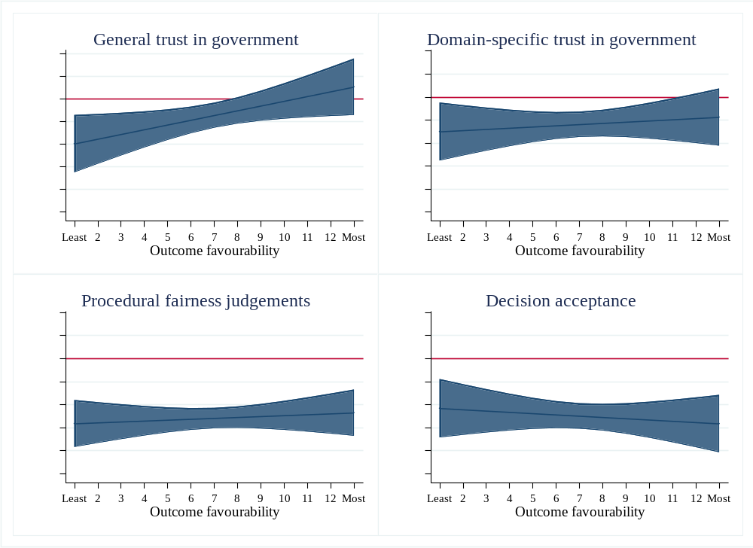

Table D5: Interaction effect for full vs. no policy adoption conditions (ITT)
 | General trust in government | Domain-specific trust | Procedural fairness judgements | Decision acceptance
Treatment condition
(ref: Full policy adoption)
No policy adoption | -0.63** | -0.87*** | -1.38*** | -1.20***
No policy adoption | (0.23) | (0.23) | (0.18) | (0.23)
Outcome favourability | 0.01 | 0.06** | 0.08*** | 0.15***
Outcome favourability | (0.02) | (0.02) | (0.02) | (0.02)
Interaction effect | 0.04 | 0.06* | 0.02 | 0.03
Interaction effect | (0.03) | (0.03) | (0.02) | (0.03)
Constant | 3.82*** | 3.42*** | 4.26*** | 3.93***
Constant | (0.16) | (0.16) | (0.13) | (0.16)
R² | 0.02 | 0.05 | 0.25 | 0.17
Adj. R² | 0.01 | 0.05 | 0.25 | 0.17
N | 1237 | 1233 | 1214 | 1232
⁺p<0.10; *p<0.05; **p<0.01; ***p<0.001
Note: Non-standardised regression coefficients, standard error between parentheses.

Figure D2: Conditional marginal effects of full vs. no policy adoption (with 95% CI)
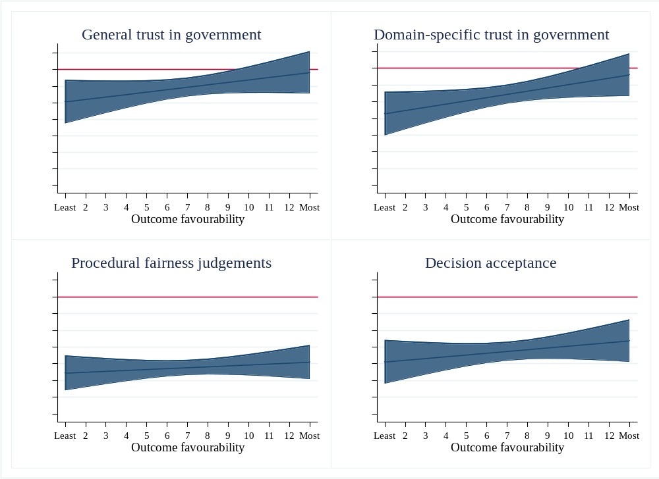

Table D6: Interaction effect for partial vs. no policy adoption conditions (ITT)
 | General trust in government | Domain-specific trust | Procedural fairness judgements | Decision acceptance
Treatment condition
(ref: Partial policy adoption)
No policy adoption | 0.03 | -0.41+ | -0.52** | -0.57*
No policy adoption | (0.22) | (0.22) | (0.17) | (0.23)
Outcome favourability | 0.07*** | 0.08*** | 0.10*** | 0.13***
Outcome favourability | (0.02) | (0.02) | (0.02) | (0.02)
Interaction effect | -0.02 | 0.04 | 0.00 | 0.05
Interaction effect | (0.03) | (0.03) | (0.02) | (0.03)
Constant | 3.16*** | 2.95*** | 3.40*** | 3.30***
Constant | (0.16) | (0.15) | (0.12) | (0.16)
R² | 0.02 | 0.04 | 0.09 | 0.08
Adj. R² | 0.01 | 0.04 | 0.09 | 0.08
N | 1236 | 1234 | 1218 | 1233
⁺p<0.10; *p<0.05; **p<0.01; ***p<0.001
Note: Non-standardised regression coefficients, standard error between parentheses.

Figure D3: Conditional marginal effects of partial vs. no policy adoption (with 95% CI)
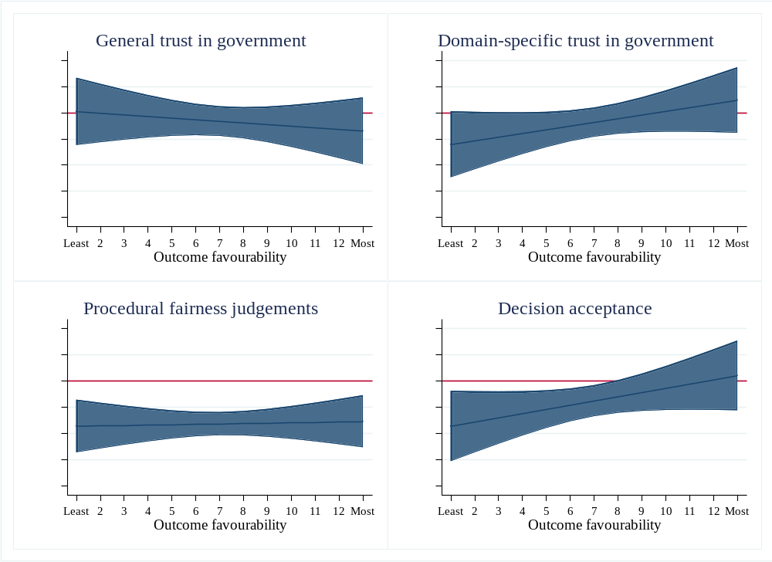

Table D7: Interaction effect for low consultation placebo vs. full policy adoption conditions (ITT)
 | General trust in government | Domain-specific trust | Procedural fairness judgements | Decision acceptance
Treatment condition
(ref: Low consultation placebo)
Full policy adoption | 0.39+ | 0.21 | 0.61*** | 0.20
Full policy adoption | (0.23) | (0.22) | (0.17) | (0.21)
Outcome favourability | 0.05** | 0.06** | 0.08*** | 0.12***
Outcome favourability | (0.02) | (0.02) | (0.02) | (0.02)
Interaction effect | -0.04 | -0.00 | 0.00 | 0.03
Interaction effect | (0.03) | (0.03) | (0.02) | (0.03)
Constant | 3.43*** | 3.20*** | 3.66*** | 3.73***
Constant | (0.16) | (0.15) | (0.12) | (0.15)
R² | 0.01 | 0.02 | 0.11 | 0.09
Adj. R² | 0.00 | 0.02 | 0.11 | 0.09
N | 1238 | 1238 | 1221 | 1237
⁺p<0.10; *p<0.05; **p<0.01; ***p<0.001
Note: Non-standardised regression coefficients, standard error between parentheses. See Figure 2 in main text for the conditional marginal effects plot.

Table D8: Interaction effect for low consultation placebo vs. no policy adoption conditions (ITT)
 | General trust in government | Domain-specific trust | Procedural fairness judgements | Decision acceptance
Treatment condition
(ref: Low consultation placebo)
No policy adoption | -0.24 | -0.66** | -0.78*** | -1.00***
No policy adoption | (0.23) | (0.22) | (0.17) | (0.22)
Outcome favourability | 0.05* | 0.06** | 0.08*** | 0.12***
Outcome favourability | (0.02) | (0.02) | (0.02) | (0.02)
Interaction effect | -0.00 | 0.06+ | 0.02 | 0.07*
Interaction effect | (0.03) | (0.03) | (0.02) | (0.03)
Constant | 3.43*** | 3.20*** | 3.66*** | 3.73***
Constant | (0.16) | (0.16) | (0.12) | (0.16)
R² | 0.02 | 0.04 | 0.12 | 0.11
Adj. R² | 0.01 | 0.04 | 0.12 | 0.10
N | 1235 | 1235 | 1215 | 1233
⁺p<0.10; *p<0.05; **p<0.01; ***p<0.001
Note: Non-standardised regression coefficients, standard error between parentheses. See Figure 3 in main text for the conditional marginal effects plot.
Table D9: Interaction effect for high consultation placebo vs. full policy adoption conditions (ITT)
 | General trust in government | Domain-specific trust | Procedural fairness judgements | Decision acceptance
Treatment condition
(ref: High consultation placebo)
Full policy adoption | 0.25 | 0.26 | 0.52** | 0.22
Full policy adoption | (0.22) | (0.22) | (0.17) | (0.21)
Outcome favourability | 0.04+ | 0.07*** | 0.07*** | 0.12***
Outcome favourability | (0.02) | (0.02) | (0.02) | (0.02)
Interaction effect | -0.03 | -0.01 | 0.02 | 0.03
Interaction effect | (0.03) | (0.03) | (0.02) | (0.03)
Constant | 3.57*** | 3.16*** | 3.74*** | 3.72***
Constant | (0.15) | (0.15) | (0.11) | (0.14)
R² | 0.00 | 0.02 | 0.11 | 0.09
Adj. R² | 0.00 | 0.02 | 0.11 | 0.09
N | 1241 | 1239 | 1221 | 1237
⁺p<0.10; *p<0.05; **p<0.01; ***p<0.001
Note: Non-standardised regression coefficients, standard error between parentheses.

Figure D4: Conditional marginal effects of high consultation placebo vs. full policy adoption (with 95% CI)
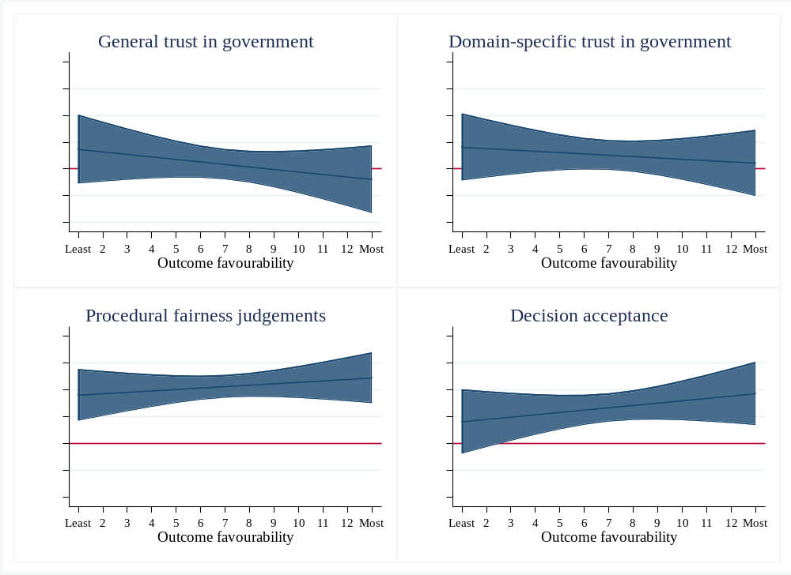
Table D10: Interaction effect for high consultation placebo vs. no policy adoption conditions (ITT)
 | General trust in government | Domain-specific trust | Procedural fairness judgements | Decision acceptance
Treatment condition
(ref: High consultation placebo)
No policy adoption | -0.38+ | -0.62** | -0.86*** | -0.98***
No policy adoption | (0.23) | (0.22) | (0.16) | (0.22)
Outcome favourability | 0.04+ | 0.07*** | 0.07*** | 0.12***
Outcome favourability | (0.02) | (0.02) | (0.01) | (0.02)
Interaction effect | 0.02 | 0.04 | 0.03 | 0.06*
Interaction effect | (0.03) | (0.03) | (0.02) | (0.03)
Constant | 3.57*** | 3.16*** | 3.74*** | 3.72***
Constant | (0.16) | (0.15) | (0.11) | (0.15)
R² | 0.01 | 0.05 | 0.12 | 0.11
Adj. R² | 0.01 | 0.04 | 0.11 | 0.11
N | 1238 | 1236 | 1215 | 1233
⁺p<0.10; *p<0.05; **p<0.01; ***p<0.001
Note: Non-standardised regression coefficients, standard error between parentheses.

Figure D5: Conditional marginal effects of high consultation placebo vs. no policy adoption (with 95% CI)
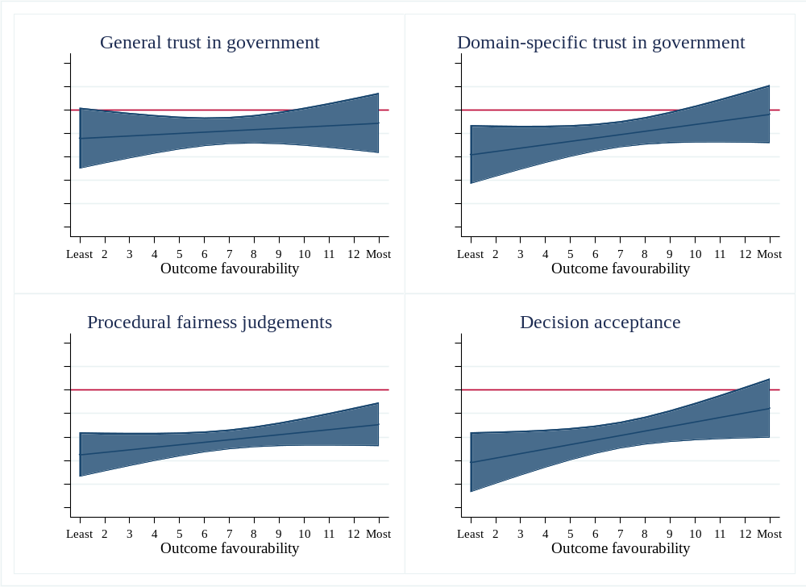

Appendix E: CACE analyses

Definition of compliance
To be considered a complier, respondents had to (i) answer the attention check correctly, and (ii) spent sufficient time on the page(s) displaying the newspaper article(s) to be able to have read them – that is, approx. 70 percent of the average reading time for adults. The attention check asked respondents whether they agreed with the item: “The newspaper article(s) was(were) about measures to improve the education system in Flanders”. Based on our assessment of the time needed to read the articles, sufficient reading time was defined as follows. Treatment conditions: at least 45 seconds on first newspaper article and at least 20 second on the second article. Placebo conditions: at least 25 seconds on the newspaper article.

Table E1: Political support across treatment conditions; full policy adoption as the reference category (CACE)
 | General trust in government | Domain-specific trust in government | Procedural fairness judgements | Decision acceptance
Treatment condition
(ref: Full policy adoption)
Partial policy adoption | -0.34** | -0.50*** | -0.88*** | -0.86***
Partial policy adoption | (0.11) | (0.11) | (0.09) | (0.12)
No policy adoption | -0.51*** | -0.68*** | -1.43*** | -1.20***
No policy adoption | (0.11) | (0.11) | (0.09) | (0.12)
Constant | 3.97*** | 3.94*** | 4.95*** | 5.08***
Constant | (0.08) | (0.08) | (0.07) | (0.09)
R² | 0.02 | 0.03 | 0.18 | 0.09
Adj. R² | 0.02 | 0.03 | 0.18 | 0.09
N | 1122 | 1120 | 1114 | 1120
⁺p<0.10; *p<0.05; **p<0.01; ***p<0.001
Note: Non-standardised regression coefficients, standard error between parentheses.

Table E2: Political support across treatment conditions; partial policy adoption as the reference category (CACE)
 | General trust in government | Domain-specific trust in government | Procedural fairness judgements | Decision acceptance
Treatment condition
(ref: Partial policy adoption)
No policy adoption | -0.18 | -0.17 | -0.55*** | -0.33**
No policy adoption | (0.11) | (0.11) | (0.09) | (0.12)
Constant | 3.63*** | 3.43*** | 4.06*** | 4.21***
Constant | (0.08) | (0.08) | (0.06) | (0.08)
R² | 0.00 | 0.00 | 0.05 | 0.01
Adj. R² | 0.00 | 0.00 | 0.05 | 0.01
N | 777 | 776 | 773 | 776
⁺p<0.10; *p<0.05; **p<0.01; ***p<0.001
Note: Non-standardised regression coefficients, standard error between parentheses.

Table E3: Political support in decision-making processes with and without a mini-public; low consultation placebo (CACE)
 | General trust in government | Domain-specific trust in government | Procedural fairness judgements | Decision acceptance
Treatment condition
(ref: Low consultation placebo)
Full policy adoption | 0.17 | 0.29** | 0.67*** | 0.48***
Full policy adoption | (0.11) | (0.11) | (0.08) | (0.11)
No policy adoption | -0.35*** | -0.39*** | -0.76*** | -0.72***
No policy adoption | (0.10) | (0.10) | (0.08) | (0.11)
Partial policy adoption | -0.17+ | -0.22* | -0.21** | -0.39***
Partial policy adoption | (0.10) | (0.10) | (0.08) | (0.11)
Constant | 3.80*** | 3.65*** | 4.27*** | 4.60***
Constant | (0.07) | (0.07) | (0.05) | (0.07)
R² | 0.01 | 0.02 | 0.15 | 0.07
Adj. R² | 0.01 | 0.02 | 0.14 | 0.07
N | 1605 | 1604 | 1592 | 1603
⁺p<0.10; *p<0.05; **p<0.01; ***p<0.001
Note: Non-standardised regression coefficients, standard error between parentheses.

Table E4: Political support in decision-making processes with and without a mini-public; high consultation placebo (CACE)
 | General trust in government | Domain-specific trust in government | Procedural fairness judgements | Decision acceptance
Treatment condition
(ref: High consultation placebo)
Full policy adoption | 0.13 | 0.28** | 0.72*** | 0.48***
Full policy adoption | (0.10) | (0.10) | (0.08) | (0.11)
No policy adoption | -0.38*** | -0.39*** | -0.71*** | -0.72***
No policy adoption | (0.10) | (0.10) | (0.08) | (0.11)
Partial policy adoption | -0.21* | -0.22* | -0.16* | -0.38***
Partial policy adoption | (0.10) | (0.10) | (0.08) | (0.10)
Constant | 3.83*** | 3.65*** | 4.23*** | 4.60***
Constant | (0.07) | (0.07) | (0.05) | (0.07)
R² | 0.02 | 0.02 | 0.14 | 0.07
Adj. R² | 0.01 | 0.02 | 0.14 | 0.07
N | 1635 | 1635 | 1623 | 1633
⁺p<0.10; *p<0.05; **p<0.01; ***p<0.001
Note: Non-standardised regression coefficients, standard error between parentheses.

Table E5: Interaction effect for full vs. partial policy adoption conditions (CACE)
 | General trust in government | Domain-specific trust | Procedural fairness judgements | Decision acceptance
Treatment condition
(ref: Full policy adoption)
Partial policy adoption | -0.72* | -0.42 | -1.14*** | -0.65*
Partial policy adoption | (0.28) | (0.28) | (0.23) | (0.28)
Outcome favourability | 0.04 | 0.10*** | 0.07** | 0.17***
Outcome favourability | (0.03) | (0.03) | (0.02) | (0.03)
Interaction effect | 0.06 | -0.01 | 0.04 | -0.02
Interaction effect | (0.04) | (0.04) | (0.03) | (0.04)
Constant | 3.71*** | 3.23*** | 4.47*** | 3.85***
Constant | (0.21) | (0.21) | (0.17) | (0.21)
R² | 0.03 | 0.06 | 0.16 | 0.16
Adj. R² | 0.03 | 0.06 | 0.16 | 0.15
N | 737 | 736 | 732 | 736
⁺p<0.10; *p<0.05; **p<0.01; ***p<0.001
Note: Non-standardised regression coefficients, standard error between parentheses.

Figure E1: Conditional marginal effects of full vs. partial policy adoption (with 95% CI)
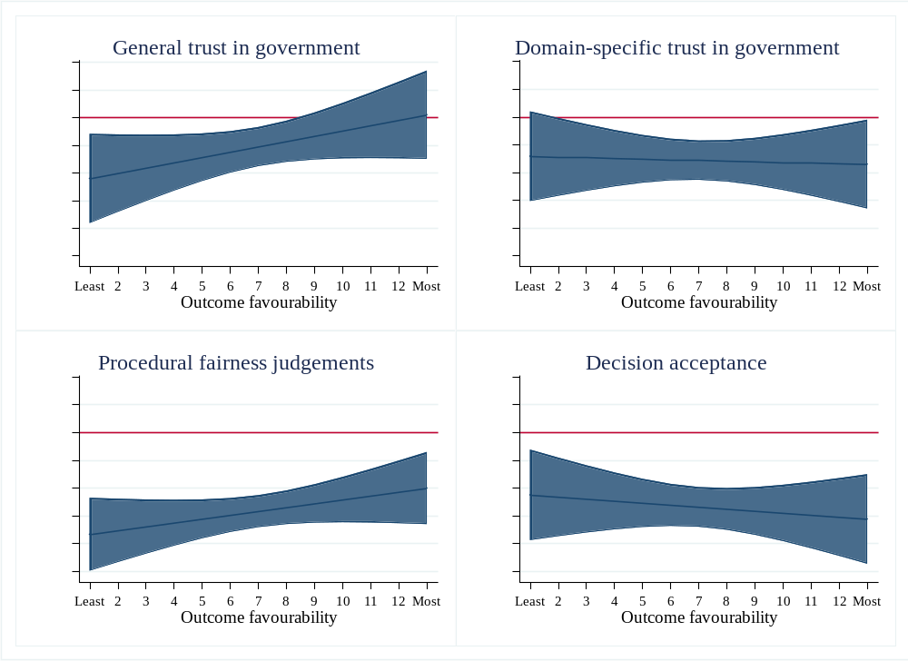

Table E6: Interaction effect for full vs. no policy adoption conditions (CACE)
 | General trust in government | Domain-specific trust | Procedural fairness judgements | Decision acceptance
Treatment condition
(ref: Full policy adoption)
No policy adoption | -0.71* | -0.94** | -1.80*** | -1.46***
No policy adoption | (0.29) | (0.30) | (0.23) | (0.29)
Outcome favourability | 0.04 | 0.10*** | 0.07** | 0.17***
Outcome favourability | (0.03) | (0.03) | (0.02) | (0.03)
Interaction effect | 0.03 | 0.04 | 0.05+ | 0.04
Interaction effect | (0.04) | (0.04) | (0.03) | (0.04)
Constant | 3.71*** | 3.23*** | 4.47*** | 3.85***
Constant | (0.22) | (0.22) | (0.17) | (0.22)
R² | 0.04 | 0.10 | 0.30 | 0.23
Adj. R² | 0.03 | 0.09 | 0.29 | 0.23
N | 730 | 728 | 723 | 728
⁺p<0.10; *p<0.05; **p<0.01; ***p<0.001
Note: Non-standardised regression coefficients, standard error between parentheses.

Figure E2: Conditional marginal effects of full vs. no policy adoption (with 95% CI)
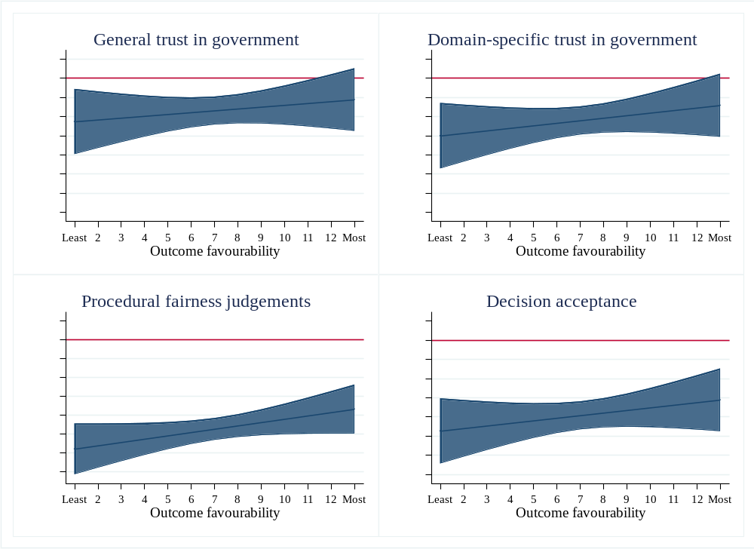

Table E7: Interaction effect for partial vs. no policy adoption conditions (CACE)
 | General trust in government | Domain-specific trust | Procedural fairness judgements | Decision acceptance
Treatment condition
(ref: Partial policy adoption)
No policy adoption | 0.01 | -0.52+ | -0.65** | -0.81**
No policy adoption | (0.27) | (0.27) | (0.22) | (0.29)
Outcome favourability | 0.09*** | 0.09*** | 0.11*** | 0.15***
Outcome favourability | (0.03) | (0.02) | (0.02) | (0.03)
Interaction effect | -0.03 | 0.05 | 0.01 | 0.06
Interaction effect | (0.04) | (0.04) | (0.03) | (0.04)
Constant | 2.99*** | 2.81*** | 3.32*** | 3.20***
Constant | (0.19) | (0.19) | (0.15) | (0.20)
R² | 0.03 | 0.05 | 0.12 | 0.11
Adj. R² | 0.02 | 0.05 | 0.12 | 0.11
N | 777 | 776 | 773 | 776
+p<0.10; *p<0.05; **p<0.01; ***p<0.001
Note: Non-standardised regression coefficients, standard error between parentheses.

Figure E3: Conditional marginal effects of partial vs. no policy adoption (with 95% CI)
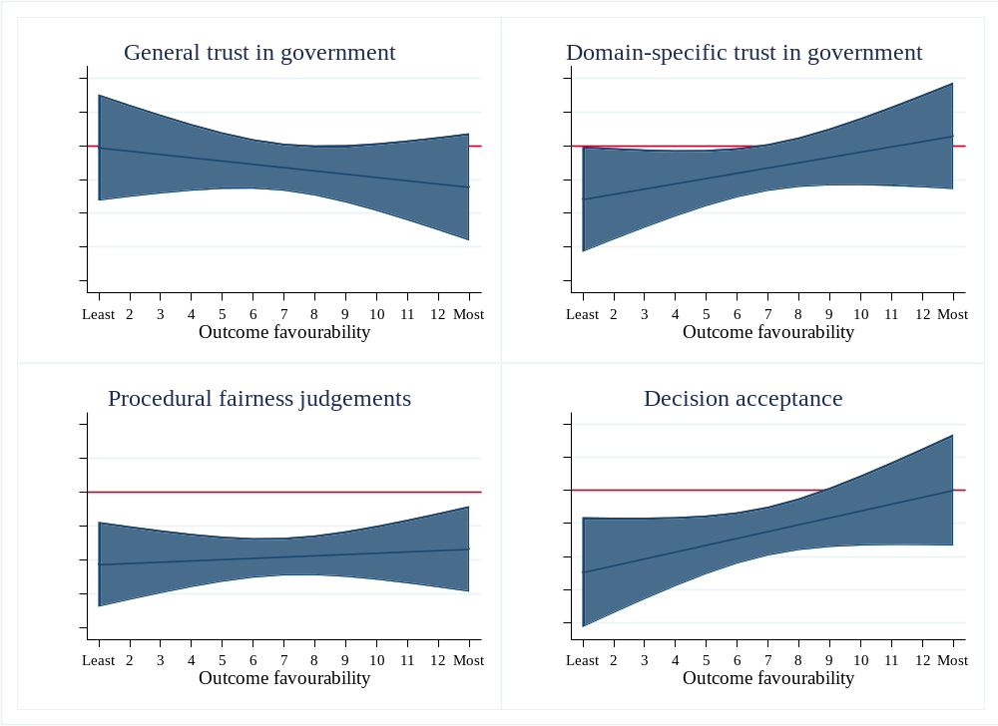

Table E8: Interaction effect for low consultation placebo vs. full policy adoption conditions (CACE)
 | General trust in government | Domain-specific trust | Procedural fairness judgements | Decision acceptance
Treatment condition
(ref: Low consultation placebo)
Full policy adoption | 0.28 | 0.04 | 0.85*** | 0.26
Full policy adoption | (0.28) | (0.28) | (0.21) | (0.26)
Outcome favourability | 0.05* | 0.06** | 0.09*** | 0.14***
Outcome favourability | (0.02) | (0.02) | (0.02) | (0.02)
Interaction effect | -0.02 | 0.03 | -0.02 | 0.03
Interaction effect | (0.04) | (0.04) | (0.03) | (0.03)
Constant | 3.43*** | 3.19*** | 3.62*** | 3.59***
Constant | (0.18) | (0.18) | (0.13) | (0.17)
R² | 0.01 | 0.03 | 0.12 | 0.12
Adj. R² | 0.01 | 0.03 | 0.12 | 0.11
N | 828 | 828 | 819 | 827
+p<0.10; *p<0.05; **p<0.01; ***p<0.001
Note: Non-standardised regression coefficients, standard error between parentheses.

Figure E4: Conditional marginal effects of low consultation placebo vs. full policy adoption (with 95% CI)
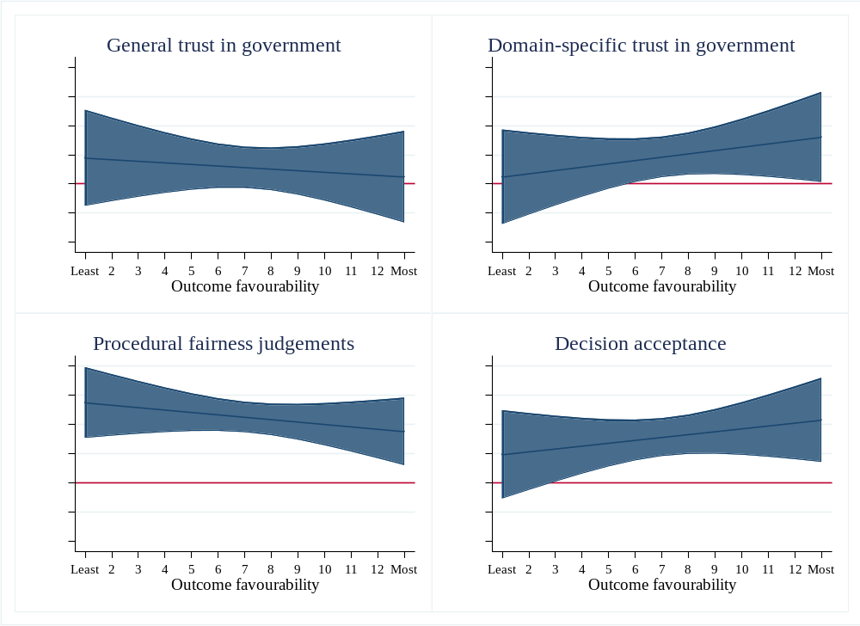

Table E9: Interaction effect for low consultation placebo vs. no policy adoption conditions (CACE)
 | General trust in government | Domain-specific trust | Procedural fairness judgements | Decision acceptance
Treatment condition
(ref: Low consultation placebo)
No policy adoption | -0.43 | -0.91*** | -0.95*** | -1.20***
No policy adoption | (0.28) | (0.27) | (0.20) | (0.27)
Outcome favourability | 0.05* | 0.06** | 0.09*** | 0.14***
Outcome favourability | (0.02) | (0.02) | (0.02) | (0.02)
Interaction effect | 0.01 | 0.07* | 0.03 | 0.07*
Interaction effect | (0.04) | (0.04) | (0.03) | (0.03)
Constant | 3.43*** | 3.19*** | 3.62*** | 3.59***
Constant | (0.18) | (0.18) | (0.13) | (0.18)
R² | 0.02 | 0.05 | 0.16 | 0.15
Adj. R² | 0.02 | 0.05 | 0.16 | 0.15
N | 868 | 868 | 860 | 867
+p<0.10; *p<0.05; **p<0.01; ***p<0.001
Note: Non-standardised regression coefficients, standard error between parentheses.

Figure E5: Conditional marginal effects of low consultation placebo vs. no policy adoption (with 95% CI)
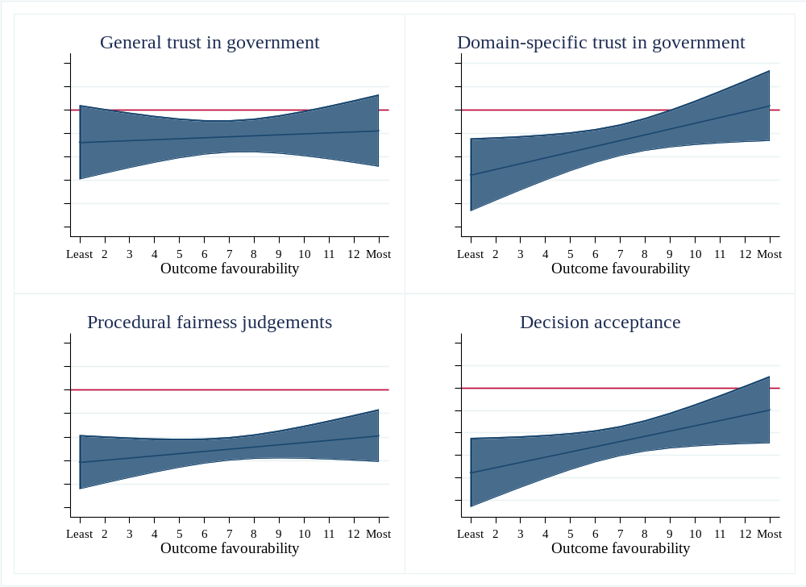

Table E8: Interaction effect for high consultation placebo vs. full policy adoption conditions (CACE)
 | General trust in government | Domain-specific trust | Procedural fairness judgements | Decision acceptance
Treatment condition
(ref: High consultation placebo)
Full policy adoption | 0.21 | 0.17 | 0.74*** | 0.16
Full policy adoption | (0.27) | (0.27) | (0.20) | (0.25)
Outcome favourability | 0.05* | 0.09*** | 0.07*** | 0.13***
Outcome favourability | (0.02) | (0.02) | (0.02) | (0.02)
Interaction effect | -0.01 | 0.01 | -0.01 | 0.04
Interaction effect | (0.04) | (0.03) | (0.03) | (0.03)
Constant | 3.50*** | 3.06*** | 3.72*** | 3.69***
Constant | (0.17) | (0.16) | (0.12) | (0.16)
R² | 0.01 | 0.04 | 0.12 | 0.11
Adj. R² | 0.01 | 0.04 | 0.12 | 0.11
N | 858 | 859 | 850 | 857
+p<0.10; *p<0.05; **p<0.01; ***p<0.001
Note: Non-standardised regression coefficients, standard error between parentheses.

Figure E6: Conditional marginal effects of high consultation placebo vs. full policy adoption (with 95% CI)
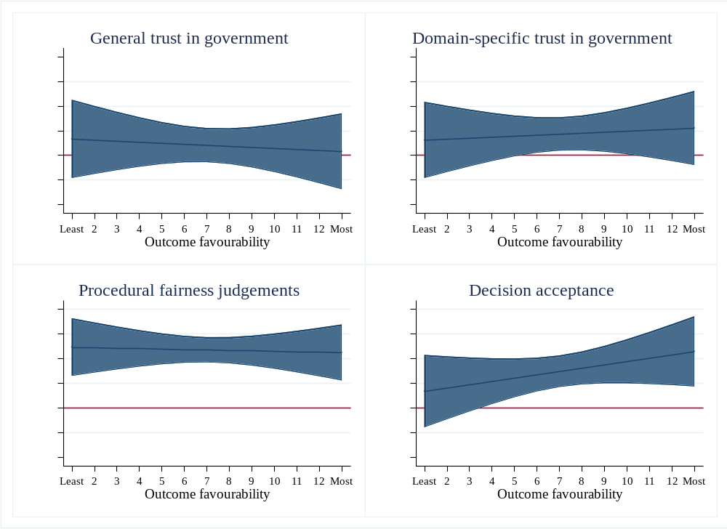

Table E9: Interaction effect for high consultation placebo vs. no policy adoption conditions (CACE)
 | General trust in government | Domain-specific trust | Procedural fairness judgements | Decision acceptance
Treatment condition
(ref: High consultation placebo)
No policy adoption | -0.50+ | -0.77** | -1.06*** | -1.30***
No policy adoption | (0.26) | (0.26) | (0.19) | (0.26)
Outcome favourability | 0.05* | 0.09*** | 0.07*** | 0.13***
Outcome favourability | (0.02) | (0.02) | (0.02) | (0.02)
Interaction effect | 0.02 | 0.05 | 0.05+ | 0.08*
Interaction effect | (0.03) | (0.03) | (0.03) | (0.03)
Constant | 3.50*** | 3.06*** | 3.72*** | 3.69***
Constant | (0.17) | (0.16) | (0.12) | (0.16)
R² | 0.03 | 0.06 | 0.14 | 0.15
Adj. R² | 0.02 | 0.06 | 0.14 | 0.14
N | 898 | 899 | 891 | 897
+p<0.10; *p<0.05; **p<0.01; ***p<0.001
Note: Non-standardised regression coefficients, standard error between parentheses.

Figure E7: Conditional marginal effects of high consultation placebo vs. no policy adoption (with 95% CI)
