Virtuous Party Linkages: Developing a Data-Based Analytical Model to Explain Voters’ Attitudes towards Political Parties

-- Appendix --

Table of Contents

Appendix A: Focus group design (group composition, location, moderation guide, and stimuli) 2
Table A1. Group composition 3
Table A2. Moderator guide 3
Figure A1. Picture of focus group setting 6
Figure A2. Stimulus 1 7
Appendix B: Coding (coding frames, coding validity, and reliability) 8
Table B1. Provisional coding frame with deductive codes for functional linkages 9
Table B2. Inductively identified codes 10
Table B3. Axial coding 11
Table B4. Coding agreement across two coders for each focus group transcript, percent 12
Table B5. Coding agreement in identifying expectations in focus groups across two coders. 13
Table B6. Ranking of expectations based on prevalence in focus groups across two coders. 14
Table B7. Prevalence of expectations in pre-discussion survey material and in focus group discussions. 14
Table B8. Presence of expectations in focus groups across groups. 15
Table B9. Expressions of within-person ambivalence. 16
Appendix C: Ethical considerations 17
Figure C1. Research permit focus groups 18
Figure C2. Consent form focus groups 19
References 20

Appendix A: Focus group design (group composition, location, moderation guide, and stimuli)
Table A1 provides details on group compositions in terms of age, gender, political leaning, political interest, and education. Participants in Group 1 had similar educational backgrounds (“short” education, which denotes primary, secondary or one to two years of post-secondary education) but varied in terms of political interest (2–4 on five-point scale). Group 2 also had similar educational backgrounds (4 years or more of higher education), and similar political interest (3–4 on five-point scale). In Group 3, we allowed both education and political interest to vary, recruiting participants with short and long education and low as well as high political interest. Finally, for Group 4 we recruited participants with short education but with high (4–5) political interest. We hereby constructed our groups to provide variation in their composition regarding education and political interest, both of which likely relate to expectations as well as participation in political discussions (Stubager et al., 2018; Nie et al., 1996; Denny & Doyle, 2008). We aimed for mixed groups in terms of gender, age (above 18 to qualify as a voter), and political leaning to give rise to as many types of expectations as possible within the group of Danish voters. Figure A1 provides an image of the location for the group discussions.
Table A2 shows the moderator guide. The guide was structured by themes, moderation prompts, and aims of insights (output). Stimuli were linked to each theme to decrease risk of confusion on the side of the moderator. Moderation prompts were spelled out literally to promote comparability across groups and assist moderation. However, the moderator was instructed to follow up on interesting discussions, unclear statements, or group dynamics of, for instance, dominance or lack of participation. The aim of each theme was specified to align the moderation with the study’s purpose and to assist the moderator in on-site evaluation of discussion coverage. Only the empirical material connected to the opening theme is used for this study. Subsequent themes are presented for information but will be used for other research purposes as they are more specific. Figure A2 shows the first stimulus consisting of a poster with the logos of major Danish political parties.

Table A1. Group composition

 | Group 1 |  |  |  | Group 2 |  |  |  | Group 3 |  |  |  | Group 4
 | Mean | Max | Min | N | Mean | Max | Min | N | Mean | Max | Min | N | Mean | Max | Min | N
Female | 57 | - | - | 6 | 43 | - | - | 7 | 43 | - | - | 7 | 33 | - | - | 6
Age | 45 | 64 | 22 | 6 | 37.71 | 57 | 26 | 7 | 39 | 59 | 23 | 7 | 43.33 | 61 | 26 | 6
Self-placement on left–right scale | 5.83 | 9 | 1 | 6 | 4.43 | 8 | 1 | 7 | 4.86 | 10 | 2 | 7 | 4.83 | 10 | 3 | 6
Political interest | 3.5 | 4 | 2 | 6 | 3.29 | 4 | 3 | 7 | 3.57 | 5 | 2 | 7 | 4.33 | 5 | 4 | 6
Education |  |  |  | 6 |  |  |  | 7 |  |  |  | 7 |  |  |  | 6
Nothing but primary school | 16.7 |  |  |  | 0 |  |  |  | 0 |  |  |  | 16.7
Practical education | 16.7 |  |  |  | 0 |  |  |  | 0 |  |  |  | 16.7
High school | 16.7 |  |  |  | 0 |  |  |  | 0 |  |  |  | 50.0
Short higher education (1 year) | 50.0 |  |  |  | 0 |  |  |  | 28.6 |  |  |  | 16.7
Medium–long higher education (<4 years) | 0 |  |  |  | 57.0 |  |  |  | 57.1 |  |  |  | 0
Long higher education (>4 years) | 0 |  |  |  | 43.0 |  |  |  | 15.3 |  |  |  | 0
Note: Self-placement on left–right scale is measured by the following item: “Where will you place yourself on a political left–right scale if 1 is left and 10 is right?” Political interest is measured by the item: “How strong is your interest in politics?” (1: Not at all interested, 2: Interested to a low degree, 3: Interested to some degree, 4: Interested to a high degree, and 5: Interested to a very high degree).

Table A2. Moderator guide

Overview | Moderation | Output
Opening  Stimulus 1:  Poster | Welcome to this group discussion. Let us first start with a round of presentation so we know whom we are talking to. I am …  What we would like to discuss with you is political parties and their role in our political system. There are no right or wrong answers—we want to learn about your understandings and perceptions of political parties. Also, you do not need to reach any agreement; we would like to hear from all of you and learn how you may look upon political parties in different ways. We ask you to respect each other’s points of view, be bold enough to participate, and allow everyone to participate by not interrupting and engaging in the discussion with curiosity. We want you to discuss with each other, not for you to answer my questions.  So, I will first show you this poster. What comes to mind when looking at this? Please first write down three things that come to mind and afterwards share your thoughts with each other.  (Prompt: So why do we have these parties? What would you like to get from them?) | Party associations  - Similarity across individual notes  - Agreements and disagreements in group  - Five main associations across groups
Functions: Candidate selection  Stimulus 2:  Range of options on how to do it | Even though political parties are quite different, they all perform some of the same things. They select candidates for election, formulate some kind of political program, and they participate in parliamentary activities that produce policy.  If we just focus on candidate selection, how do you think this process takes place in the political parties today?  Are you happy with the way it works, or do you see any problems with the current system?  Let us say that you were to decide the procedure for selecting candidates for all parties for the next general election, probably in 2023. Which candidate selection procedure would you decide on? (Prompt 1: Would you use existing procedures, or are there any alternatives you might prefer? Prompt 2: Since it is difficult to involve everyone, are there groups you would prioritize? Prompt 3: What do you think might happen if they do it this way?)  Why do you think candidate selection is not already set up this way? | Party knowledge  - Level of knowledge across groups  Party performance  - Evaluation of functional performance and expectation across individuals and groups (pro–con scheme)  - Presumed motives of party (leadership)
Functions: Programmatic ideas  Stimulus 3:  Printed party programs  Stimulus 4:  Scheme of alternatives for whom to consult | If we then move beyond candidate selection, parties also formulate some kind of political program.  How do you think parties decide what to write in these programs?  Are you happy with the way it works, or do you see any problems with the current system?  Imagine again that you can decide for all parties the procedure for writing their programs in the run-up to the 2023 election. How do you think they should do it? (Prompt: What groups do you think they should consult with when they’re writing their programs?)  Why do you think parties don’t currently write their programs this way?
Functions:  Party policy decision making  Stimulus 5: Dilemma case | When parties are elected to Parliament, they use their election programs to propose policy, which Parliament then votes on to turn them into law.  I want to show you a real case from Danish politics for how election programs are translated into policy proposals.  Please read this short summary of this case. What are your reflections on this matter? What should Party M do? Why?  What do you think most of our parties in Parliament would do in such a situation?  Why do you think they act that way?
Trust:  Stimulus 6: Graph of trust | Now, we have discussed some of the key tasks of political parties. Most often people discuss or evaluate political parties in more general terms. If we look at this graph, Danish voters tend to trust political parties less than the government or the Parliament. What is your interpretation of this? Why do you think parties face relatively low trust among voters? | Connection between party performance and party evaluation
Trust | If you were to mention one or two things that would increase your trust in parties, what would that be?  - Please use the pen and paper again to note your own thoughts.  - Please share your thoughts with the group.
Note: Grey parts are not used for this study. Stimulus 1 can be found in Figure A2.

Figure A1. Picture of focus group setting

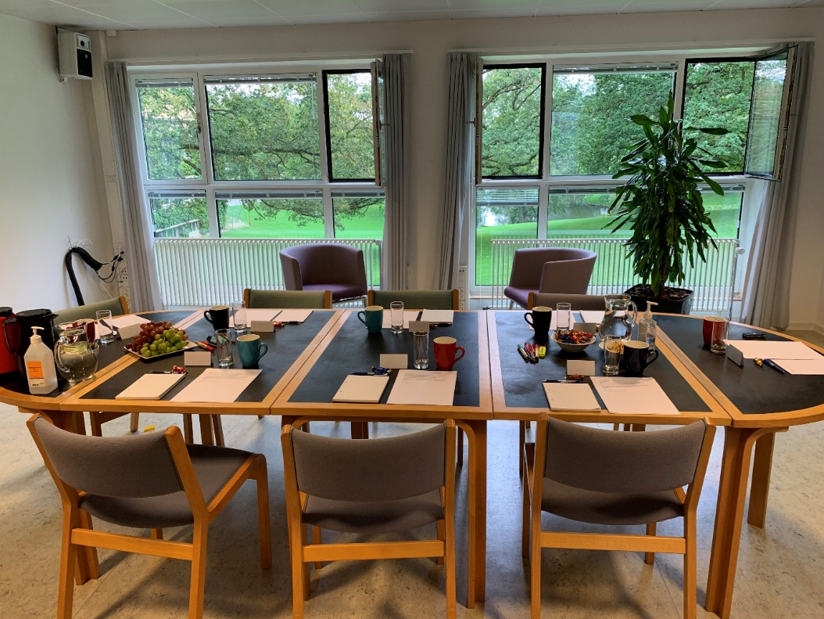

Figure A2. Stimulus 1

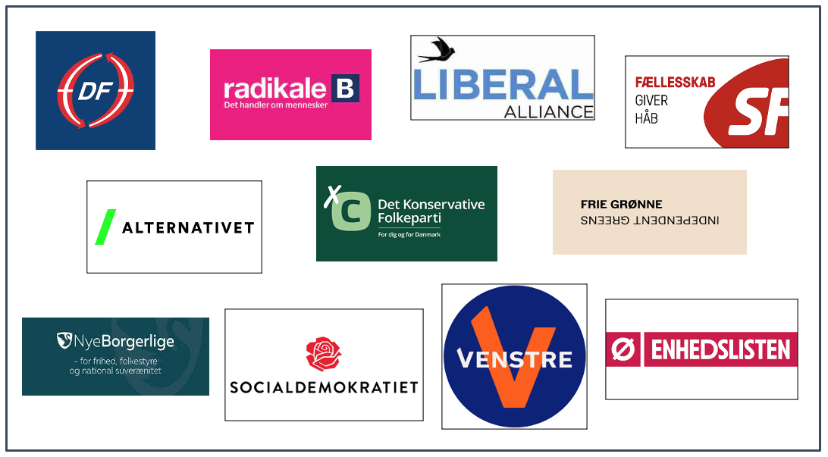

Appendix B: Coding (coding frames, coding validity, and reliability)
Table B1 shows our coding description of the functional party linkages as defined by Dalton et al. (2011). This is the initial coding frame used for closed coding of the material in the first round of coding. As a second round of coding, we coded all the material inductively to capture all other expectations expressed during the discussions. We do not enter the material “empty headed”, as we know the literature on public opinion, but we take measures to stay “open minded” letting the discussions inform our understanding and conceptualization of voter expectations (Bryant & Charmaz 2007). Table B2 shows the list of codes obtained from this open coding staying close the words used by participants. Table B3 documents the axial coding combining and connecting the deductive and inductive coding lists. The right-hand column (Resulting codes) indicates how codes are connected into a shorter, manageable list of expectations. Here, the code description for policy was further adapted to include policy compromises that, in a Danish context with no majority party, is closely related to producing public policy (Green-Pedersen & Thomsen, 2005). The final coding frame, defining the resulting codes, is included in the main text as Table 2.
Tables B4–B8 document the validity and reliability of the coding based on five coding comparisons. After specifying the final coding list (Table 2 in manuscript), two coders (the authors) coded all material independently of each other and of previous coding rounds. Table B4 shows a simple coding agreement score capturing the extent to which the two coders assigned the same text to the same codes. It shows a very high percentage of agreement across all codes and groups, which is a first and strong indication of coding reliability. Table B5 shows prevalence of different codes across two coders, which serves as a reliability test of the findings on the prevalence of different expectations in our material. This is further simplified in Table B6 showing the ranking of expectation based on coding prevalence across the two coders. In combination, these analyses document similarity in results across two coders. Table B7 compares the prevalence of expectations in the open-ended survey question presented to participants prior to the discussion to their prevalence within group discussions to evaluate the extent to which expectations were developed during the discussion or brought into the discussion pre-formed. As such, the comparison serves as an evaluation of the ecological validity of the results. Table B7 not only shows that expectations are found in the survey material but also that the ranking based on prevalence is approximately the same. Finally, Table B8 reports the existence of different expectations across the four groups. This documents only very limited variation in the number of expectations discussed in each group. Hence, results presented in the main text are not driven by rich discussions in a single group but rather reflect common patterns in the four conducted group discussions.

Table B1. Provisional coding frame with deductive codes for functional linkages

Deductive codes | Definition (Dalton et al. 2011) | Description for deductive coding
Candidate | Parties recruit candidates and set the parameters of the electoral process. | Expressions of participant expecting/wanting parties to recruit and/or organize politicians
Mobilization | Parties activate citizens during elections and mobilize them to vote. | Expressions of participant expecting/wanting parties to engage and mobilize voters in or between elections
Ideology | Parties inform voters about policy choices in elections, and voters strongly base their voting preferences on these policy alternatives. | Expressions of participant expecting/wanting parties to offer political ideas for voters to choose between
Representation | Elections achieve good congruence between citizens’ policy preferences and the policies of the parties represented in parliament and the government. | Expressions of participant expecting/wanting parties to promote interests and/or voice attitudes of voters
Policy | Parties deliver on the policies they advocated in the election. | Expressions of participant expecting/wanting parties to deliver public policies

Table B2. Inductively identified codes

Inductive codes | Code description
Expertise | Expressions of participant expecting/wanting parties to hold expert knowledge of key societal issues
Promise-keeping | Expressions of participant expecting/wanting parties to keep the promises they formulate in electoral campaigns
Policy-motivated | Expressions of participant expecting/wanting parties to be driven by policy motives rather than populist or self-interested motives
Lawful | Expressions of participant expecting/wanting parties to act lawfully
Democratic “vehicles” | Expressions of participant expecting/wanting parties to contribute to democracy by participating in political debates and/or voting on decisions
Honest | Expressions of participant expecting/wanting parties to be honest when communicating with voters
Unity | Expressions of participant expecting/wanting parties to find agreements or compromises that solve problems in unity with each other
Responsibility | Expressions of participant expecting/wanting parties to be responsible leaders
Administrating democracy | Expressions of participant expecting/wanting parties to be respectful administrators of the country’s democratic past and future
Explaining democratic practice | Expressions of participant expecting/wanting parties to elaborate on or explain democratic practices and principles
Solve problems | Expressions of participant expecting/wanting parties to develop society and solve problems with an eye towards needs and developments

Table B3. Axial coding
Initial Codes | Code descriptions | Resulting Codes
Deductive codes
Candidate | Expressions of participant expecting/wanting parties to recruit and/or organize politicians | Candidate
Mobilization | Expressions of participant expecting/wanting parties to engage and mobilize voters in or between elections | Mobilization
Policy choices | Expressions of participant expecting/wanting parties to offer political ideas for voters to choose between | Policy Choices
Representation | Expressions of participant expecting/wanting parties to promote interests and/or voice attitudes of voters | Representation
Policy | Expressions of participant expecting/wanting parties to deliver public policies | Policy
Inductive codes
Expertise | Expressions of participant expecting/wanting parties to hold expert knowledge of key societal issues | Competent Agents
Promise-keeping | Expressions of participant expecting/wanting parties to keep the promises they formulate in electoral campaigns | Reliable Agents
Policy-motivated | Expressions of participant expecting/wanting parties to be driven by policy motives rather than populist or self-interested motives | Reliable Agents
Lawful | Expressions of participant expecting/wanting parties to act lawfully | Reliable Agents
Democratic “vehicles” | Expressions of participant expecting/wanting parties to contribute to democracy by participating in political debates and/or voting on decisions | Educational Agents
Honest | Expressions of participant expecting/wanting parties to be honest when communicating with voters | Reliable Agents
Unity | Expressions of participant expecting/wanting parties to find agreements or compromises that solve problems in unity | Policy
Responsibility | Expressions of participant expecting/wanting parties to be responsible leaders | Competent Agents
Administrating democracy | Expressions of participant expecting/wanting parties to be respectful administrators of the country’s democratic past and future | Educational Agents
Explaining democratic practice | Expressions of participant expecting/wanting parties to elaborate on or explain democratic practices and principles | Educational Agents
Solve problems | Expressions of participant expecting/wanting parties to develop society and solve problems with an eye towards needs and developments | Competent Agents
Note: Through axial coding, we merge inductive In Vivo codes into manageable coding units. “Expertise,” “Responsibility,” and “Solve problems” relate to expectations of political parties managing the state—a technocratic rather than responsive expectation related to wanting parties to know which societal problems to solve and how. We combine these inductive codes into a code labeled “Competent Agents.” “Promise-keeping,” “Policy-motivated,” “Lawful,” and “Honest” all relate to intrinsic qualities of parties as actors that can be trusted or relied on. We summarize this expectation as wanting parties to be “Reliable Agents.” The codes “Administrating democracy” and “Explaining democracy” both relate to how parties should promote and take care of democracy as a common good beyond representing specific interests. We therefore cluster these codes into the code “Educational Agents.” Finally, the inductive code “Unity” describes expectations of parties being able to form compromises with other parties (not within the party) and thereby produce policies. This aligns with the policy linkage code, and we therefore redefine the definition of “Policy” to include coalition formation.

Table B4. Coding agreement across two coders for each focus group transcript, percent
Code | Sub-code | Group 1 | Group 2 | Group 3 | Group 4 | Mean
Candidate |  | 100 | 100 | 100 | 98.9 | 99.7
Mobilization |  | 100 | 100 | 100 | 100 | 100
Policy Choices |  | 93.8 | 72 | 81.4 | 81.6 | 82.2
Representation |  | 98.6 | 93.1 | 94.3 | 100 | 96.5
Policy |  | 96.7 | 91.9 | 96.2 | 97.5 | 95.6
Competent Agents |  | 100 | 95.3 | 96.8 | 82.0 | 93.5
Educational Agents |  | 99.9 | 82.1 | 100.0 | 100 | 95.5
Reliable Agents | Promise-keeping | 100.0 | 100 | 93.0 | 97.5 | 97.6
Reliable Agents | Policy-motivated | 82.1 | 93.6 | 98.6 | 94.8 | 92.3
Reliable Agents | Lawful | 100 | 100 | 98.4 | 96.7 | 98.8
Reliable Agents | Honest | 91.5 | 100 | 100 | 100 | 97.9

Table B5. Coding agreement in identifying expectations in focus groups across two coders.
 |  | CODER 1 |  |  | CODER 2
Main codes | Sub-codes | Groups | Participants | References | Groups | Participants | References
Candidate |  | 0 | 0 | 0 | 1 | 3 | 3
Mobilization |  | 0 | 0 | 0 | 0 | 0 | 0
Policy Choices |  | 4 | 22 | 40 | 4 | 22 | 41
Representation |  | 3 | 7 | 11 | 3 | 8 | 12
Policy |  | 4 | 9 | 13 | 4 | 10 | 16
Competent Agents |  | 3 | 9 | 12 | 3 | 9 | 14
Educational Agents |  | 2 | 2 | 5 | 3 | 4 | 9
Reliable Agents
Reliable Agents | Promise-keeping | 3 | 3 | 3 | 3 | 3 | 3
Reliable Agents | Policy-motivated | 4 | 13 | 18 | 4 | 14 | 16
Reliable Agents | Lawful | 2 | 2 | 2 | 2 | 2 | 2
Reliable Agents | Honest | 1 | 2 | 2 | 1 | 2 | 3
Total |  | 4 | 26 | 106 | 4 | 26 | 145

Note: The table shows how many times each of the codes has been used by each of the two coders. “Groups” refer to focus groups. For example, both coders coded “Policy choices” in four focus groups. “Participants” refer to group participants. For example, both coders coded “Policy choices” for 22 participants. “References” refer to the number of times a code was used. We deliberately did not specify coding units to be able to be more inclusive, ranging from individual expressions of agreement to longer monologues. This is also the reason why the total number of references varies across the two coders. The number of references also provides further indication of the prevalence of the different expectations.

Table B6. Ranking of expectations based on prevalence in focus groups across two coders.
Rank | Coder 1 | Coder 2
1 | Policy Choices | Policy Choices
2 | Reliable Agents | Reliable Agents
3 | Policy | Policy
4 | Competent Agents | Competent Agents
5 | Representation | Representation
6 | Educational Agents | Educational Agents
7 | Candidate &  Mobilization | Candidate
8 |  | Mobilization
Note: Ranking is based on Table B5. Highest rank (1) is given to the expectation mentioned in the most groups and by the most participants.

Table B7. Prevalence of expectations in pre-discussion survey material and in focus group discussions.
 | Prevalence in survey | Prevalence in discussion (coder average)
Candidate | 1 | 1.5
Mobilization | 1 | 0
Policy Choices | 10 | 40.5
Representation | 9 | 11.5
Policy | 10 | 14.5
Competent Agents | 4 | 13
Educational Agents | 5 | 7
Reliable Agents | 9 | 24.5
Note: The survey was distributed to all participants (26) before the discussion. Two did not answer the survey as they arrived late and are therefore excluded from this analysis. The question was “What do you expect political parties to do as important actors in a representative democracy? Please write down the first things that come to mind.” The number of codes in the table does not add up to the 24 respondents because participants could express more than one expectation. The prevalence in discussions is given by the average number of references given by each coder (see Table B5). The number of references is higher in the discussions as participants discussed the expectations rather than just stating them. The main point is that all expectations were identified in the pre-analysis survey and that the relative prevalence of expectations as a potential indicator of importance is similar across survey and discussion material.

Table B8. Presence of expectations in focus groups across groups.
 | Group 1  (short education) | Group 2  (long education) | Group 3  (mixed education) | Group 4  (short education) | Number of groups expressing an expectation
Candidates | No | No | No | Yes | 1
Mobilization | No | No | No | No | 0
Policy Choice | Yes | Yes | Yes | Yes | 4
Representation | Yes | Yes | Yes | No | 3
Policy | Yes | Yes | Yes | Yes | 4
Competent Agents | No | Yes | Yes | Yes | 4
Educational Agents | Yes | Yes | Yes | No | 3
Reliable Agents | Yes | Yes | Yes | Yes | 4
Number of expectations | 5 | 6 | 6 | 5

Note: The table shows that the group discussions—independently of composition—were highly similar in the range of expressed expectations. All groups expressed expectations regarding parties providing policy choices, public policy, and being reliable agents. Most groups expressed expectations that parties represent the voters, manage the state, and contribute to democratic processes. Few or no groups expressed expectations regarding organization of candidates and citizen mobilization.

Table B9. Expressions of within-person ambivalence.
Focus Group 1, Participant F | Well, it usually requires those 90 [laughs]. To come to an agreement or to get something done, right? And that's probably why it's sometimes difficult to keep all election promises, at least, because you can easily say anything, but if you don't have 90 mandates, it doesn't matter, in principle at least.
Focus Group 2, Participant E | Well, then it's about them being willing to take responsibility for the country they're supposed to lead. We've chosen them to lead, and I think the people in the parties have entered into it because they want some power and influence, and I think it's important that they handle it in a responsible way, even if it sometimes means making unpopular decisions, whatever that may be. But meeting in the middle is also a good step, compromises to take responsibility.
Focus Group 2, Participant D | But that's what we're discussing, whether the popular opinion in the population is necessarily the 'right opinion,' because didn't we just agree earlier that politicians sometimes have to make uncomfortable decisions that go against what the population is saying?
Focus Group 3, Participant C | But when you say that they should offer or follow their voters' wishes, it's a bit of a two-sided, it's a process, right? Because they also have to offer a solid core of viewpoints based on what their voters want. That's more how I see it. Or it's my hope that they do, so one can, what's it called, find a party that reflects one's beliefs.
Focus Group 3, Participant E | I mean, I think that if I were to get one thing from a party, it's that they have that balance between visions and compromises. Visions to inspire people, but compromises to make it work in practice. So for me, it's important that they strike a balance between those two things
Focus Group 4, Participant D | Well, you asked if we think they kind of deliver what they should, and I often hear that parties are accused of not keeping their promises when they get into the Folketinget, and that they maybe cozy up to other parties and try to make themselves popular. But you can also see it as a way of collaborating because there are several parties in there, and you have to move a bit on some of the different things you've said, I believe.

Note: Within-person ambivalence is defined as expressions of understanding the trade-offs political parties face when delivering multiple functions or virtues by one individual participant either in one statement or across statements by the same participant during the same dialogue.

Appendix C: Ethical considerations
During the data collection and data analysis stage, we always complied with the standards for ethical research, including the American Political Science Association’s (2020) “Principles and Guidance for Human Subjects Research.”
All participants in our research participated voluntarily and received full information about the proceedings of their participation and our aims before participating. Participants in our focus groups were recruited by an external research company, Norstat. They were also informed by Norstat that their participation was voluntary and that researchers could not exercise any power over them. To underscore the voluntary nature of their participation, Norstat compensated participants DKK 400 (approx. USD 53) for their time and travel expenses. In light of Denmark’s high minimum wage and generous welfare state, it is unlikely that participants considered their participation to be a source of income.
We secured the anonymity of our participants in all possible ways and have no way of personally identifying participants. Norstat recruited participants and gave them information about the location and time of the focus groups. We never had access to participants’ contact details. Participants shared their beliefs and attitudes during the recruitment process through a regular survey conducted by Norstat. However, we only had access to the group-level information presented in Table A1 above. The nature of our research (focus groups), however, requires participants’ presence in the room. This means that participants were not anonymous in the data collection process. They shared their beliefs and attitudes during the discussions.
We thus use personal data in the project. We informed participants about how their data would be used and that they had the right to interrupt their participation in the focus group discussion or withdraw their data from the project at any time. Figures C1 and C2 show the research permit and consent form participants received and signed prior to the focus group discussion. Participants were also provided with an information sheet on how [University] processes personal data, and participants had the opportunity to ask clarifying questions prior to as well as after the focus group discussions. After data collection was completed, all material—transcripts of discussions and survey answers—were fully anonymized.
In sum, to the best of our knowledge, our research was conducted in full compliance with the current guidelines and principles for ethical and transparent research.

Figure C1. Research permit focus groups
Research Permit

Data collected in relation to the research project on citizens’ perceptions of the importance of political parties for democracy are used for research with the aim of publishing the results in scientific journals and/or books. Data collected in relation to the project are analyzed and archived in anonymized form. The information form describes how Aarhus University processes personal data.

I confirm that I am informed about the subject of the research project and about the processing of personal data. My involvement in the project consists of participation in a focus group discussion, my participation is voluntary, and I can interrupt my participation at any time.

Figure C2. Consent form focus groups
Consent to the processing of your personal data in the research project at Aarhus University

In relation to your participation in a research project at Aarhus University, we need your consent for us to process your personal data in accordance with the rules in the data protection regulation. The research project is about citizens’ perceptions of the importance of political parties to democracy and is based on focus group interviews.

I hereby consent to Aarhus University registering and processing my personal data in the aforementioned research project.

Consent is voluntary, and you can withdraw your consent to the processing of personal data at any time by contacting Helene Helboe Pedersen (helene@ps.au.dk). If you withdraw your consent, it does not affect the lawfulness of our work with your personal data in the project up until this point. Your personal data will thus continue to be included in the work carried out in the project until you have withdrawn your consent.

References
American Political Science Association. (2020). Principles and guidance for human subjects research. https://www.apsanet.org/Portals/54/diversity%20and%20inclusion%20prgms/Ethics/Final_Principles%20with%20Guidance%20with%20intro.pdf?ver=2020-04-20-211740-153
Bryant, A., & Charmaz, K. (eds.) (2007). The Sage Handbook of Grounded Theory, London: Sage
Dalton, R. J., Farrell, D. M., & McAllister, I. (2011). Political parties and democratic linkage: How parties organize democracy. Oxford University Press.
Denny, K., and Doyle, O. (2008). Political interest, cognitive ability and personality: Determinants of voter turnout in Britain. British Journal of Political Science, 38(2), 291–310.
Green-Pedersen, C., & Thomsen, L. H. (2005). Bloc politics vs. broad cooperation? The functioning of Danish minority parliamentarism. The Journal of Legislative Studies, 11(2), 153–69.
Nie, N. H., Junn, J., & Stehlik-Barry, K. (1996). Education and democratic citizenship in America. University of Chicago Press.
Stubager, R., Seeberg, H. B., & So, F. (2018). One size doesn’t fit all: Voter decision criteria heterogeneity and vote choice. Electoral Studies, 52, 1–10.

Although this is the exact wording in Dalton et al. (2011, p.7), in the elaboration that follows, the authors make no reference to the promise-keeping element. Instead, they elaborate that this linkage is about whether parties have an impact on policy output and the extent to which voters preferences match ”those of their parties in parliament and government overall” (Dalton et al., p.9). We therefore also only focussed on this part in our deductive code.

