The light side of darkness? The dark triad of personality as positive and negative predictors of L2 language learning
Supplementary Materials
Measurement Models
The four measurement models utilised in the structural equation models of this study were tested in JASP (version 0.18.3), using diagonally weighted least squares with standard errors. All measurement models achieved close fit (see Table S1), with CFI and TLI > .95 and RMSEA and SRMR < .05 (Kenny, 2020). The measurement models are visually depicted in Figures S1 – S4.

Table S1
Measurement Model Fit
 | χ² | df | CFI | TLI | RMSEA | SRMR
Dark Triad | 129.638 | 51 | .961 | .950 | .060 | .087
L2 Motivational Selves | 427.208 | 167 | .991 | .989 | .060 | .060
L2 Engagement | 212.784 | 125 | .994 | .993 | .040 | .049
L2 WTC | 124.348 | 35 | .992 | .990 | .077 | .062

Figure S1
Dark Triad Measurement Model
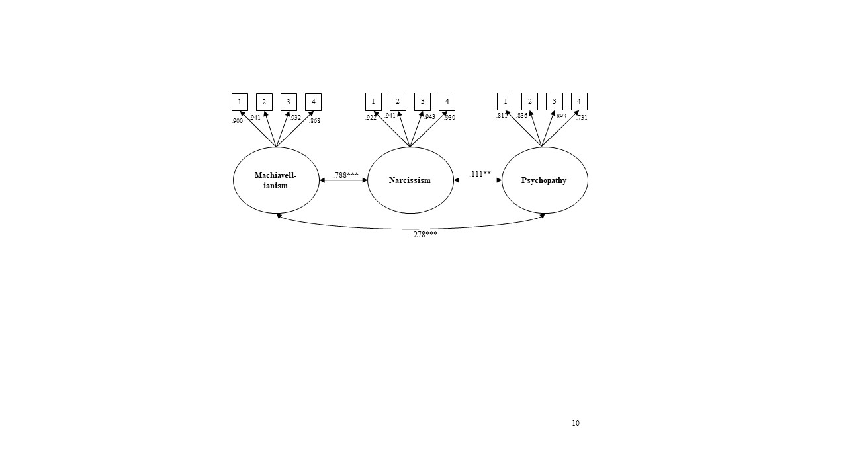
Note. ***p < .001; **p < .01; *p < .05. All factor loadings were significant to p < .001.
Figure S2
L2 Motivational Selves Measurement Model
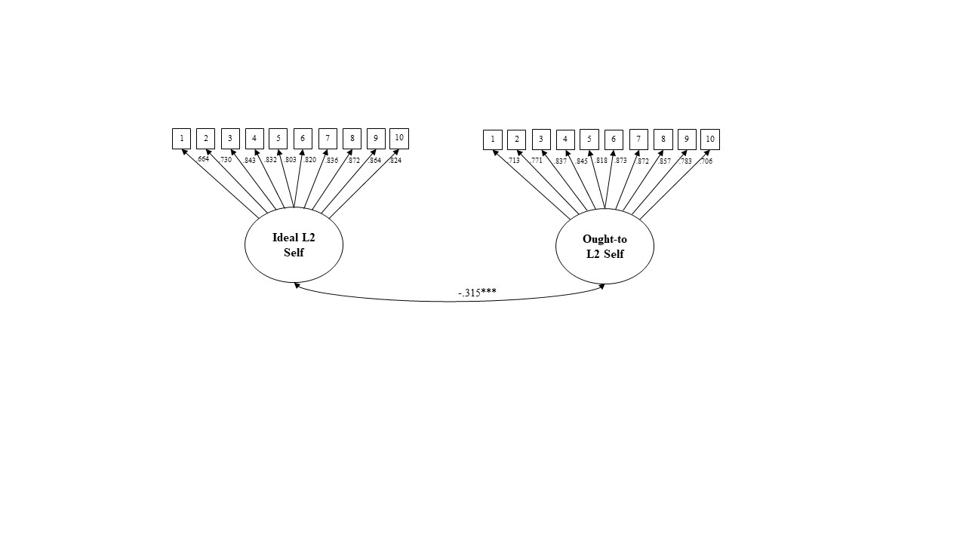
Note. ***p < .001; **p < .01; *p < .05. All factor loadings were significant to p < .001.

Figure S3
L2 Engagement Measurement Model
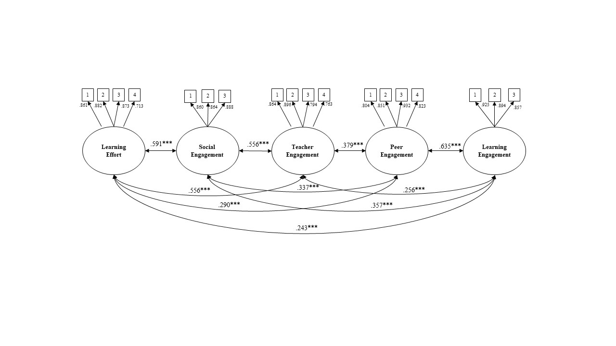
Note. ***p < .001; **p < .01; *p < .05. All factor loadings were significant to p < .001.

Figure S4
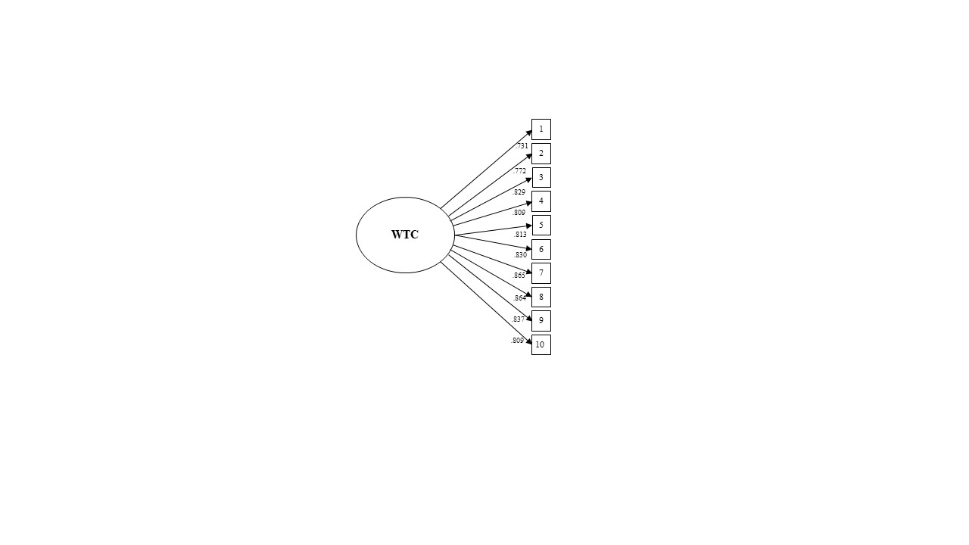
L2 WTC Measurement Model
Note. ***p < .001; **p < .01; *p < .05. All factor loadings were significant to p < .001.
Structural Equation Models

Table S4
Structural Equation Models Fit Summary
DT predicting… | χ² | df | CFI | TLI | RMSEA | SRMR
L2 Motivational Selves (RQ1) | 654.314 | 452 | .995 | .994 | .032 | .049
L2 Engagement (RQ2) | 422.959 | 377 | .998 | .998 | .017 | .044
L2 Achievement (RQ3) | 285.795 | 69 | .994 | .992 | .086 | .037
L2 WTC (RQ4) | 284.022 | 203 | .996 | .996 | .030 | .048

Table S5
Latent Regression Paths Summary

Predictor | Outcome | β | p-value
Machiavellianism | Ideal L2 Self | .006 | .896
 | Ought-to L2 Self | .196 | <.001
 | Learning Effort | -.004 | .936
 | Social Engagement | .188 | <.001
 | Teacher Engagement | -.029 | .515
 | Peer Engagement | .331 | <.001
 | Learning Engagement | .276 | <.001
 | Academic Achievement | .075 | <.001
 | Self-Perceived Achievement | .268 | <.001
 | WTC | .047 | .068
Narcissism | Ideal L2 Self | .380 | <.001
 | Ought-to L2 Self | -.233 | <.001
 | Learning Effort | .204 | <.001
 | Social Engagement | -.194 | <.001
 | Teacher Engagement | .210 | <.001
 | Peer Engagement | -.202 | <.001
 | Learning Engagement | -.258 | <.001
 | Academic Achievement | .047 | <.001
 | Self-Perceived Achievement | .232 | <.001
 | WTC | .235 | <.001
Psychopathy | Ideal L2 Self | -.084 | <.001
 | Ought-to L2 Self | -.078 | <.001
 | Learning Effort | -.108 | <.001
 | Social Engagement | -.123 | <.001
 | Teacher Engagement | .015 | .522
 | Peer Engagement | -.074 | .001
 | Learning Engagement | -.084 | .001
 | Academic Achievement | .068 | <.001
 | Self-Perceived Achievement | .153 | <.001
 | WTC | -.055 | <.001

