**Appendix A**

Pooled Correlation Coefficients of Fluency/Comprehensibility Subgroups

|  |  |  |  |  |  |  |
| --- | --- | --- | --- | --- | --- | --- |
|  | | *k* | *r* | SE | 95% CIs | |
| Lower | Upper |
| Study context | L2 | 25 | .81 | .05 | .76 | .84 |
|  | ML | 8 | .85 | .20 | .65 | .94 |
| Listener language background | L1  L2 | 21  11 | .82  .79 | .07  .24 | .77  .49 | .86  .92 |
|  | Mixed | 2 | .77 | .26 | -.98 | 1 |
| Listener experience | Experienced | 7 | .79 | .07 | .72 | .85 |
|  | Naïve | 6 | .85 | .22 | .59 | .95 |
| Task type | Controlled | 6 | .81 | .22 | .50 | .94 |
|  | Closed | 18 | .81 | .06 | .77 | .85 |
|  | Open | 10 | .82 | .12 | .71 | .89 |
| Task mode | Monologic | 31 | .82 | .07 | .76 | .86 |
|  | Dialogic | 3 | .81 | .14 | .46 | .94 |
| Rating scale | Discrete | 20 | .81 | .08 | .75 | .86 |
|  | Continuous | 14 | .81 | .08 | .74 | .86 |
| Rating location | In-person | 28 | .83 | .08 | .77 | .88 |
|  | Online | 4 | .84 | .19 | .55 | .95 |
| Dimension definition | Yes | 27 | .81 | .06 | .77 | .85 |
|  | No | 7 | .81 | .27 | .40 | .95 |
| Rating practice | Yes | 22 | .83 | .10 | .76 | .89 |
|  | No | 12 | .80 | .08 | .73 | .86 |
| Dimension number | 2 | 13 | .88 | .13 | .80 | .93 |
|  | 3 | 20 | .79 | .05 | .75 | .83 |
| Rating order | Consecutive | 9 | .84 | .13 | .73 | .91 |
|  | Non-consecutive | 25 | .81 | .06 | .76 | .85 |
| L1 stimuli | Yes | 7 | .82 | .12 | .69 | .90 |
|  | No | 27 | .82 | .08 | .75 | .87 |

Pooled Correlation Coefficients of Fluency/Accentedness Subgroups

|  |  |  |  |  |  |  |
| --- | --- | --- | --- | --- | --- | --- |
|  | | *k* | *r* | SE | 95% CIs | |
| Lower | Upper |
| Study context | L2 | 15 | .64 | .09 | .51 | .73 |
|  | ML | 3 | .61 | .27 | -.45 | .96 |
| Listener language background | L1 | 17 | .61 | .08 | .49 | .71 |
|  | Mixed | 2 | .68 | .34 | -1 | 1 |
| Listener experience | Experienced | 5 | .54 | .10 | .32 | .71 |
|  | Naïve | 6 | .68 | .13 | .46 | .83 |
| Task type | Controlled | 3 | .81 | .14 | .48 | .94 |
|  | Closed | 8 | .63 | .07 | .51 | .72 |
|  | Open | 8 | .52 | .10 | .34 | .67 |
| Task mode | Monologic | 15 | .63 | .09 | .50 | .73 |
|  | Dialogic | 4 | .58 | .17 | .13 | .84 |
| Rating scale | Discrete | 14 | .61 | .10 | .46 | .72 |
|  | Continuous | 5 | .70 | .18 | .34 | .88 |
| Rating location | In-person | 14 | .66 | .07 | .57 | .74 |
|  | Online | 3 | .64 | .27 | -.42 | .96 |
| Dimension definition | Yes | 15 | .63 | .10 | .48 | .74 |
|  | No | 4 | .63 | .18 | .16 | .86 |
| Rating practice | Yes | 11 | .58 | .09 | .43 | .70 |
|  | No | 8 | .68 | .13 | .48 | .81 |
| L1 stimuli | Yes | 7 | .64 | .14 | .40 | .80 |
|  | No | 12 | .61 | .11 | .45 | .74 |

Pooled Correlation Coefficients of Intelligibility/Comprehensibility Subgroups

|  |  |  |  |  |  |  |
| --- | --- | --- | --- | --- | --- | --- |
|  | | *k* | *r* | SE | 95% CIs | |
| Lower | Upper |
| Study context | L2 | 7 | .63 | .07 | .52 | .73 |
|  | ML | 8 | .69 | .29 | .13 | .92 |
| Listener language background | L1 | 9 | .71 | .17 | .47 | .86 |
|  | L2 | 4 | .52 | .28 | -.33 | .90 |
|  | Mixed | 4 | .44 | .26 | -.34 | .86 |
| Listener experience | Experienced | 3 | .34 | .25 | -.63 | .90 |
|  | Naïve | 6 | .68 | .09 | .53 | .78 |
| Task type | Controlled | 5 | .86 | .31 | .37 | .97 |
|  | Closed | 3 | .61 | .12 | .19 | .84 |
|  | Open | 9 | .46 | .13 | .20 | .66 |
| Task mode | Monologic | 14 | .68 | .15 | .46 | .81 |
|  | Dialogic | 3 | .45 | .29 | -.67 | .94 |
| Rating scale | Discrete | 15 | .64 | .15 | .40 | .79 |
|  | Continuous | 2 | .65 | .11 | -.58 | .98 |
| Rating location | In-person | 8 | .74 | .25 | .33 | .91 |
|  | Online | 5 | .58 | .18 | .14 | .83 |
| Dimension definition | Yes | 6 | .57 | .13 | .29 | .76 |
|  | No | 11 | .67 | .22 | .31 | .86 |
| Rating practice | Yes | 12 | .60 | .11 | .42 | .73 |
|  | No | 5 | .73 | .35 | -.09 | .96 |
| Dimension number | 2 | 2 | .37 | .36 | -1 | 1 |
|  | 3 | 14 | .67 | .17 | .42 | .83 |
| Rating order | Consecutive | 6 | .82 | .25 | .45 | .95 |
|  | Non-consecutive | 11 | .50 | .11 | .29 | .67 |
| L1 stimuli | Yes | 9 | .73 | .27 | .28 | .92 |
|  | No | 8 | .54 | .14 | .27 | .73 |

Pooled Correlations of Intelligibility/Accentedness Subgroups

|  |  |  |  |  |  |  |
| --- | --- | --- | --- | --- | --- | --- |
| Subgroups | | *k* | *r* | SE | 95% CIs | |
| Lower | Upper |
| Study context | L2 | 10 | .33 | .23 | -.19 | .70 |
|  | ML | 9 | .29 | .09 | .09 | .47 |
| Listener language background | L1 | 12 | .33 | .16 | -.01 | .61 |
|  | L2 | 4 | .17 | .17 | -.36 | .61 |
|  | Mixed | 3 | .36 | .27 | -.67 | .92 |
| Task type | Controlled | 7 | .53 | .15 | .22 | .74 |
|  | Closed | 4 | .46 | .08 | .22 | .64 |
|  | Open | 8 | .04 | .17 | -.34 | .41 |
| Task mode | Monologic | 15 | .42 | .10 | .23 | .58 |
|  | Dialogic | 4 | -.16 | .40 | -.91 | .83 |
| Rating scale | Discrete | 17 | .31 | .14 | .03 | .54 |
|  | Continuous | 2 | .39 | .11 | -.77 | .95 |
| Rating location | In-person | 10 | .29 | .23 | -.22 | .68 |
|  | Online | 3 | .48 | .17 | -.21 | .85 |
| Dimension definition | Yes | 5 | -.01 | .30 | -.70 | .69 |
|  | No | 14 | .44 | .11 | .23 | .61 |
| Rating practice | Yes | 10 | .29 | .10 | .08 | .48 |
|  | No | 9 | .32 | .25 | .25 | .73 |
| Dimension number | 2 | 3 | .12 | .60 | -.99 | 1 |
|  | 3 | 15 | .38 | .06 | .27 | .48 |
| Rating order | Consecutive | 6 | .41 | .11 | .16 | .61 |
|  | Non-consecutive | 13 | .25 | .19 | -.15 | .58 |
| L1 stimuli | Yes | 10 | .45 | .14 | .17 | .66 |
|  | No | 9 | .15 | .20 | -.31 | .55 |

Pooled Correlation Coefficients of Comprehensibility/Accentedness Subgroups

|  |  |  |  |  |  |  |
| --- | --- | --- | --- | --- | --- | --- |
| Subgroups | | *k* | *r* | SE | 95% CIs | |
| Lower | Upper |
| Study context | L2 | 26 | .79 | .10 | .70 | .85 |
|  | ML | 22 | .66 | .11 | .52 | .77 |
| Listener language background | L1 | 38 | .77 | .09 | .69 | .83 |
|  | L2 | 6 | .37 | .16 | -.01 | .66 |
|  | Mixed | 6 | .77 | .17 | .52 | .90 |
| Listener experience | Experienced | 10 | .76 | .13 | .61 | .86 |
|  | Naïve | 16 | .84 | .13 | .73 | .90 |
| Task type | Controlled | 17 | .76 | .18 | .55 | .88 |
|  | Closed | 18 | .77 | .10 | .66 | .84 |
|  | Open | 13 | .69 | .12 | .53 | .81 |
| Task mode | Monologic | 46 | .76 | .09 | .67 | .82 |
|  | Dialogic | 4 | .66 | .13 | .37 | .83 |
| Rating scale | Discrete | 42 | .73 | .09 | .64 | .81 |
|  | Continuous | 8 | .83 | .10 | .74 | .89 |
| Rating location | In-person | 32 | .78 | .10 | .69 | .84 |
|  | Online | 12 | .78 | .15 | .61 | .88 |
| Dimension definition | Yes | 28 | .79 | .09 | .71 | .85 |
|  | No | 22 | .66 | .12 | .49 | .78 |
| Rating practice | Yes | 28 | .74 | .10 | .64 | .82 |
|  | No | 22 | .76 | .13 | .61 | .85 |
| Dimension number | 2 | 17 | .84 | .13 | .74 | .91 |
|  | 3 | 32 | .69 | .08 | .61 | .77 |
| Rating order | Consecutive | 8 | .65 | .09 | .51 | .76 |
|  | Non-consecutive | 42 | .76 | .01 | .68 | .83 |
| L1 stimuli | Yes | 19 | .76 | .10 | .66 | .84 |
|  | No | 31 | .74 | .11 | .63 | .83 |

**Appendix B**

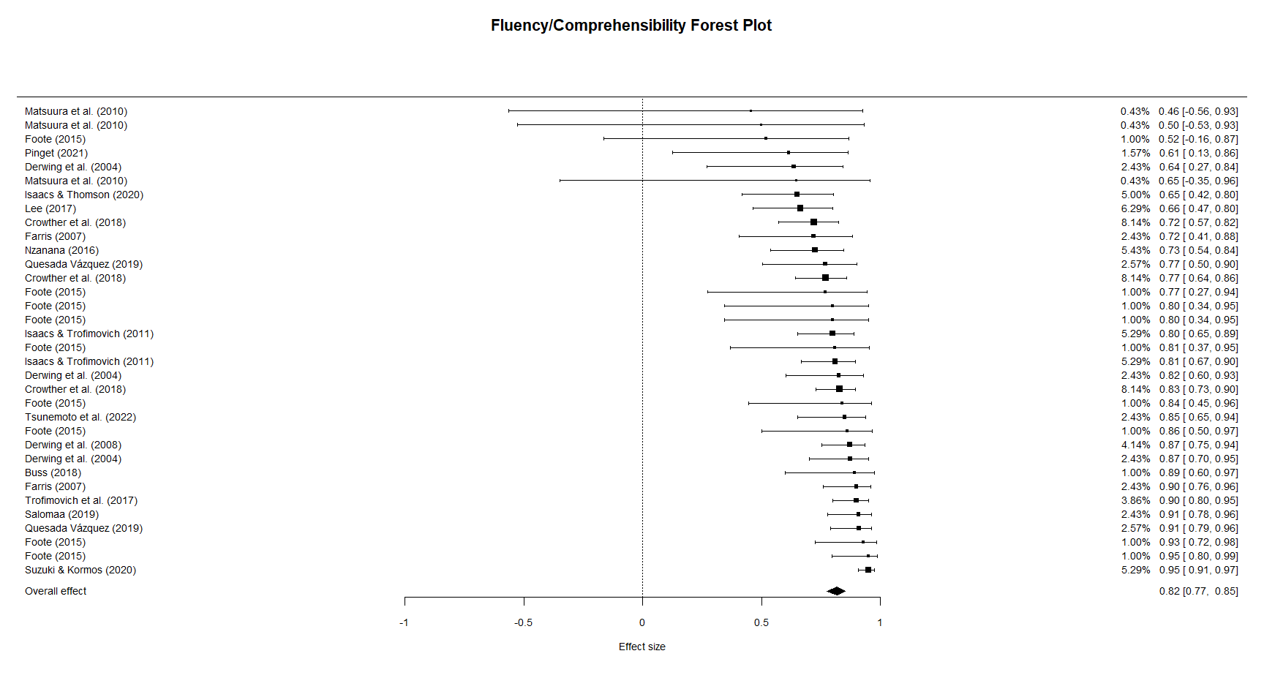

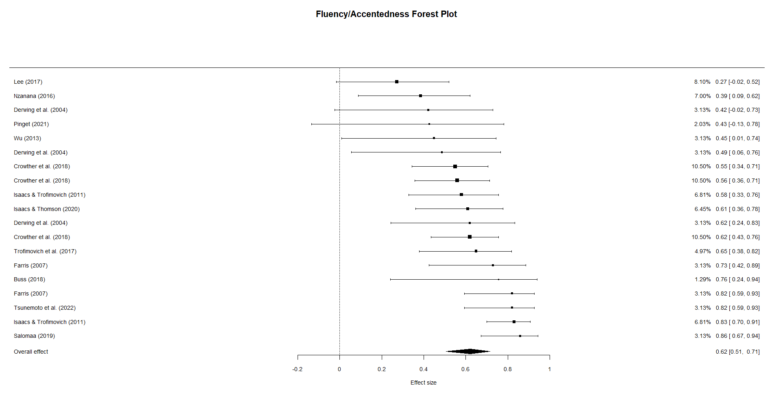

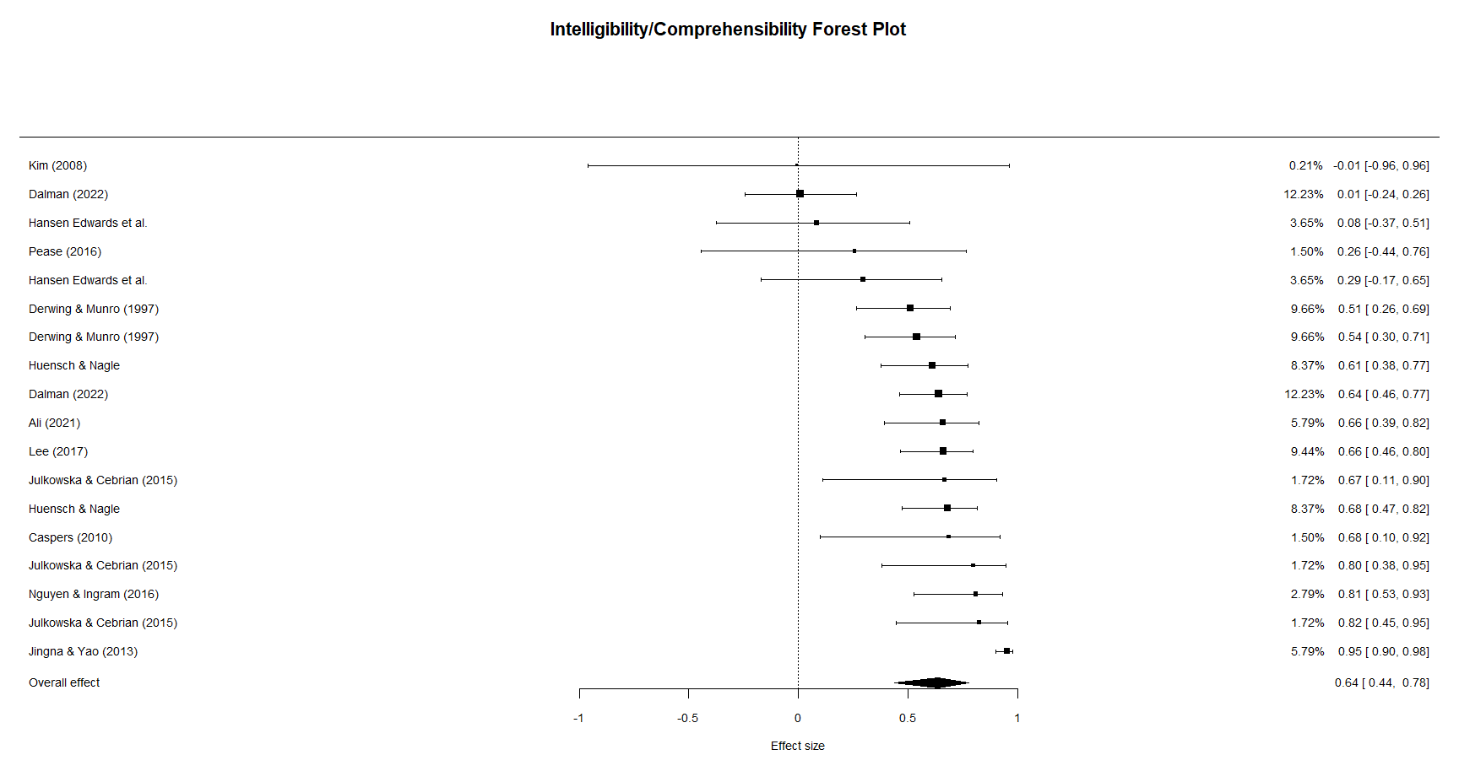

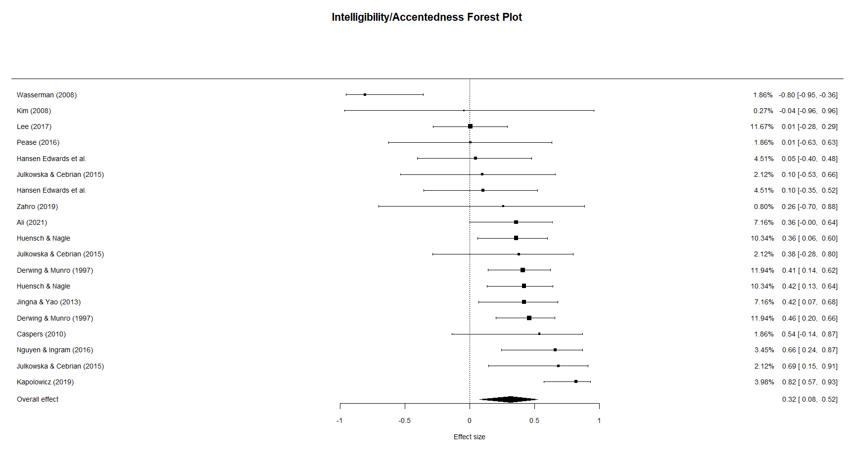

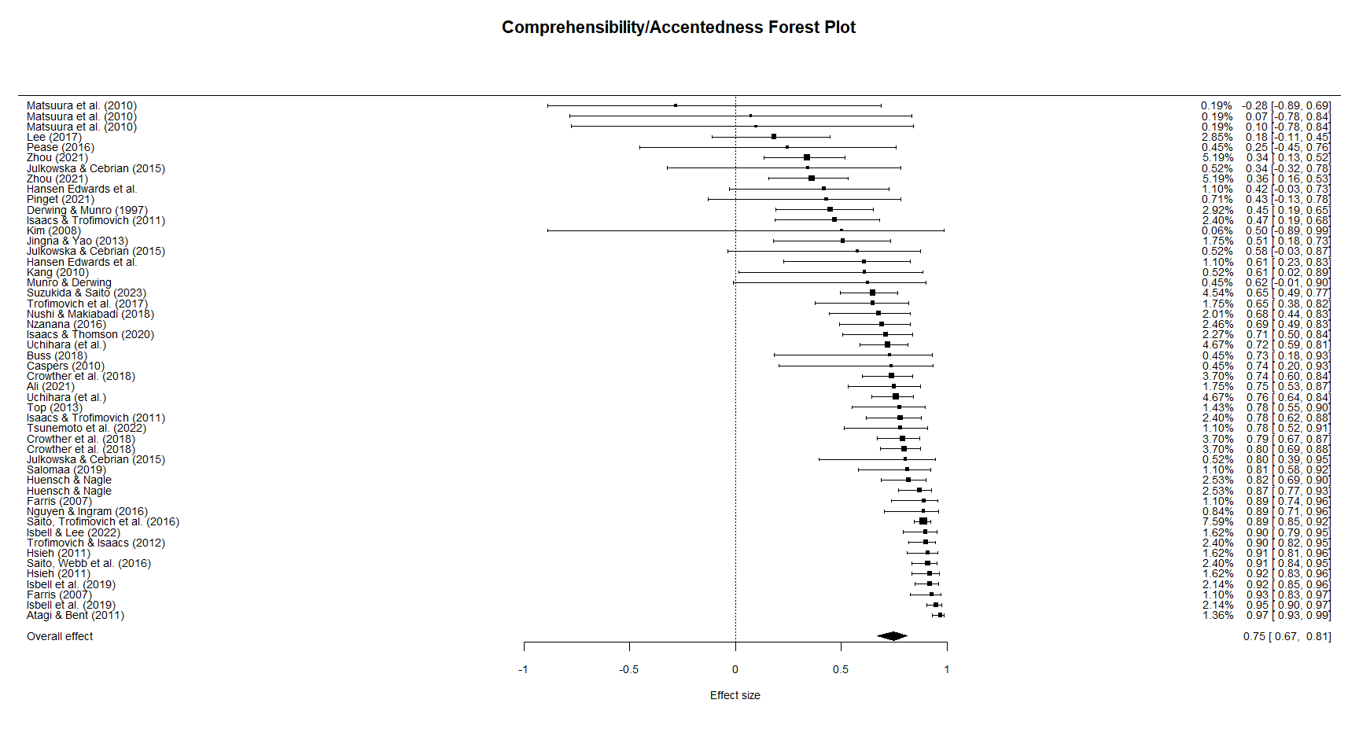

**Appendix C**



