Supplementary Material A1. The first language represented in the data
First Language | Frequency | First Language | Frequency
English | 3,048 | Danish | 2
Spanish (all varieties) | 199 | Indonesian | 2
Chinese (all varieties) | 64 | Kazakh | 2
French | 46 | Serbian | 2
Russian | 24 | Thai | 2
Arabic (all varieties) | 23 | Yoruba | 2
Portuguese (all varieties) | 22 | Akan | 1
Persian/Farsi | 16 | Alaska | 1
German | 15 | Azari | 1
Japanese | 14 | Bangladesh | 1
Polish | 14 | Bisaya | 1
Korean | 13 | Burmese | 1
Vietnamese | 13 | Cebuano | 1
Filipino/Tagalog | 11 | Chavacano | 1
Hindi | 11 | Chichewa | 1
Italian | 9 | Icelandic | 1
Tamil | 9 | Igbo | 1
Malayalam | 6 | Kannada | 1
Urdu | 6 | Kapampangan | 1
Bengali | 5 | Kutchi | 1
Bulgarian | 5 | Khmer | 1
Haitian Creole | 5 | Kikuyu | 1
Hebrew | 5 | Konkani | 1
Marathi | 5 | Laos | 1
Turkish | 5 | Lithuanian | 1
Greek | 4 | Malay | 1
Gujrati | 4 | Mixtec | 1
Swedish | 4 | Mongolian | 1
Ukrainian | 4 | Nepal Bahasa | 1
Croatian | 3 | Punjabi | 1
Dutch | 3 | Sindhi | 1
Nepali | 3 | Telugu | 1
Romanian | 3 | Tibetan | 1
Slovak | 3 | Yiddish | 1
(Ki)swahili | 3 | Missing data | 1
Armenian | 2 | Total | 3,670
Supplementary Material A2. Countries represented in the data outside of the U.S.
Country | Frequency | Country | Frequency
Canada | 376 | Hong Kong | 2
Australia | 98 | India | 2
Germany | 32 | Malaysia | 2
United Kingdom | 31 | Nepal | 2
Mexico | 20 | Panama | 2
New Zealand | 19 | Saudi Arabia | 2
France | 16 | South Africa | 2
Japan | 15 | Tanzania | 2
Nigeria | 11 | Ukraine | 2
Italy | 8 | Uzbekistan | 2
Ireland | 7 | Angola | 1
Egypt | 5 | Bulgaria | 1
Netherlands | 5 | Cameroon | 1
South Korea | 5 | Costa Rica | 1
Thailand | 5 | Indonesia | 1
Chile | 4 | Iraq | 1
Dominican Republic | 4 | Kazakhstan | 1
Peru | 4 | Lebanon | 1
Philippines | 4 | Montenegro | 1
Switzerland | 4 | Morocco | 1
Brazil | 3 | Myanmar | 1
Colombia | 3 | Norway | 1
Jordan | 3 | Palestine | 1
Spain | 3 | Poland | 1
Taiwan | 3 | Sweden | 1
Argentina | 2 | Turkey | 1
Austria | 2 | United Arab Emirates | 1
Ecuador | 2 | Venezuela | 1
Greece | 2 | Vietnam | 1
Guatemala | 2 | Zambia | 1

Supplementary Material B. Results of the clustering validation indices using NbClust package
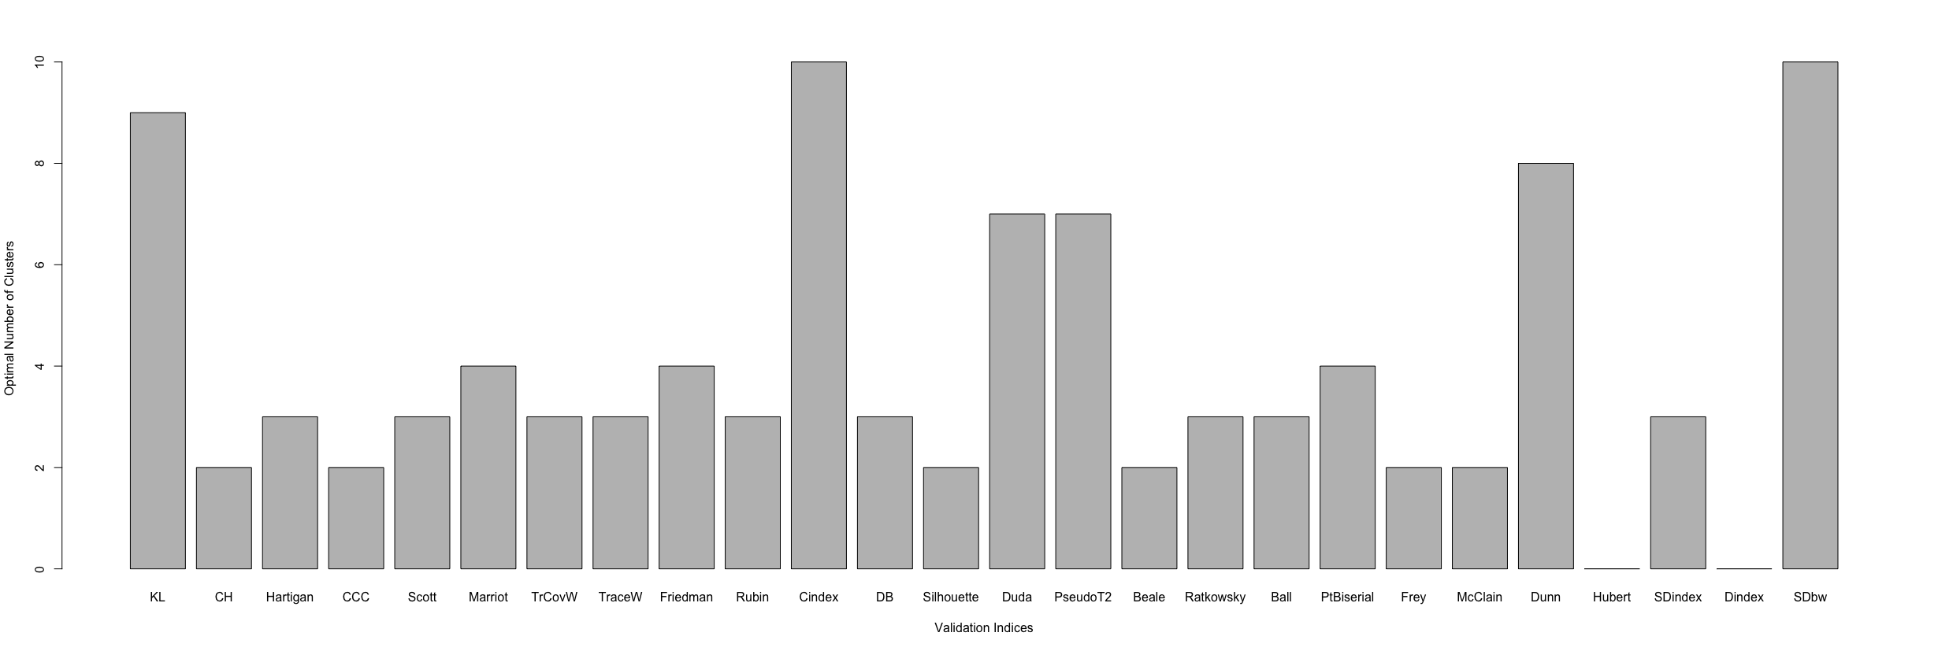
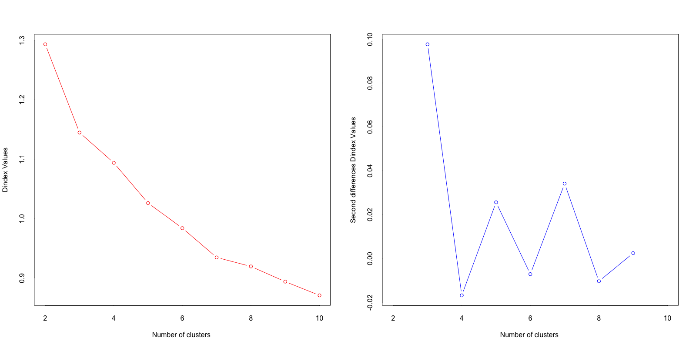
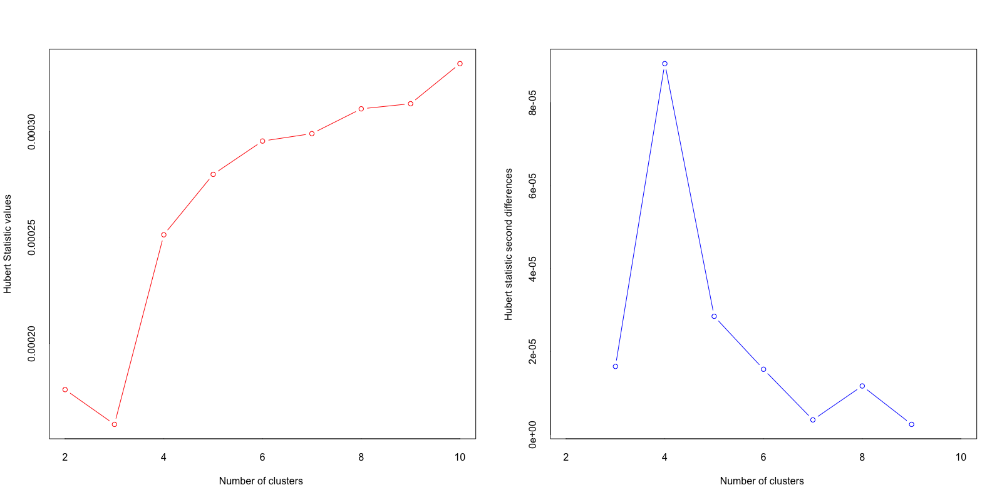

Supplementary Material C. Results of principal component analysis

[Eigenvalues of Principal Component Analysis]
 | Eigenvalue | Percentage of the variance explained | Cumulative percentage of the variance explained
Component 1 | 2.4691169 | 49.382338 | 49.38234
Component 2 | 0.9912536 | 19.825072 | 69.20741
Component 3 | 0.9348608 | 18.697216 | 87.90463
Component 4 | 0.3748043 | 7.496086 | 95.40071
Component 5 | 0.2299644 | 4.599288 | 100.00000

[Correlations (Contributions)]
 | Component 1 | Component 2 | Component 3 | Component 4 | Component 5
Performance Expectancy | 0.87 (30.88%) | -0.04 (0.16%) | -0.16 (2.77%) | -0.38 (39.85%) | -0.24 (26.32%)
Effort Expectancy | 0.86 (30.04%) | -0.13 (1.89%) | 0.01 (0.02%) | 0.46 (57.11%) | -0.15 (10.91%)
Facilitating Conditions | 0.32 (4.37%) | 0.28 (8.46%) | 0.89 (85.97%) | -0.06 (1.08%) | 0.01 (0.09%)
Social Influence | 0.18 (1.45%) | 0.93 (87.75%) | -0.30 (9.63%) | 0.06 (1.06%) | 0.01 (0.09%)
MALL Attitude | 0.90 (33.24%) | -0.13 (1.72%) | -0.12 (1.58%) | -0.05 (0.87%) | 0.37 (62.56%)

Supplementary Material D. Descriptive statistics of UTAUT determinants

[Performance expectancy]
 | n | Mean | 95% CI |  | SD | Median | Min. | Max. | SE
 |  |  | LCI | UCI
Cluster 1 | 1,620 | 4.55 | 4.53 | 4.58 | 0.50 | 4.67 | 2.67 | 5 | 0.01
Cluster 2 | 1,276 | 4.39 | 4.37 | 4.43 | 0.54 | 4.33 | 2.67 | 5 | 0.02
Cluster 3 | 768 | 3.15 | 3.10 | 3.20 | 0.75 | 3.33 | 1 | 5 | 0.03

[Effort expectancy]
 | n | Mean | 95% CI |  | SD | Median | Min. | Max. | SE
 |  |  | LCI | UCI
Cluster 1 | 1,620 | 4.73 | 4.71 | 4.76 | 0.42 | 5 | 3 | 5 | 0.01
Cluster 2 | 1,276 | 4.72 | 4.70 | 4.74 | 0.42 | 5 | 3 | 5 | 0.01
Cluster 3 | 768 | 3.46 | 3.40 | 3.52 | 0.86 | 3.5 | 1 | 5 | 0.03

[Social influence]
 | n | Mean | 95% CI |  | SD | Median | Min. | Max. | SE
 |  |  | LCI | UCI
Cluster 1 | 1,620 | 3.47 | 3.44 | 3.50 | 0.63 | 3.25 | 2.75 | 5 | 0.02
Cluster 2 | 1,276 | 1.84 | 1.82 | 1.88 | 0.53 | 2 | 1 | 2.75 | 0.01
Cluster 3 | 768 | 2.59 | 2.54 | 2.65 | 0.75 | 2.75 | 1 | 5 | 0.03

[Facilitating conditions]
 | n | Mean | 95% CI |  | SD | Median | Min. | Max. | SE
 |  |  | LCI | UCI
Cluster 1 | 1,620 | 4.75 | 4.72 | 4.77 | 0.47 | 5 | 1 | 5 | 0.01
Cluster 2 | 1,276 | 4.70 | 4.67 | 4.73 | 0.55 | 4.8 | 1 | 5 | 0.02
Cluster 3 | 768 | 4.48 | 4.44 | 4.53 | 0.68 | 5 | 1 | 5 | 0.02

[MALL attitude]
 | n | Mean | 95% CI |  | SD | Median | Min. | Max. | SE
 |  |  | LCI | UCI
Cluster 1 | 1,620 | 4.82 | 4.81 | 4.84 | 0.34 | 5 | 3.33 | 5 | 0.01
Cluster 2 | 1,276 | 4.77 | 4.76 | 4.80 | 0.37 | 5 | 3.33 | 5 | 0.01
Cluster 3 | 768 | 3.52 | 3.47 | 3.58 | 0.78 | 3.67 | 1 | 5 | 0.03

Supplementary Material E. Descriptive statistics of the survey questionnaire (frequency distribution)

[MALL acceptance level]
 | Scale | Continuous MALL engagement | Recommendation of MALL | More investment into MALL | Learning extra language using MALL
Cluster 1 | 1 | 3 | 3 | 9 | 57
(n = 1,620) | 2 | 16 | 6 | 33 | 66
 | 3 | 34 | 39 | 139 | 230
 | 4 | 242 | 272 | 249 | 391
 | 5 | 1,325 | 1,300 | 1,190 | 876
Cluster 2 | 1 | 8 | 2 | 20 | 73
(n = 1,276) | 2 | 12 | 3 | 47 | 69
 | 3 | 27 | 67 | 126 | 262
 | 4 | 259 | 310 | 281 | 317
 | 5 | 970 | 894 | 802 | 555
Cluster 3 | 1 | 46 | 36 | 48 | 87
(n = 768) | 2 | 83 | 81 | 72 | 92
 | 3 | 139 | 215 | 123 | 222
 | 4 | 375 | 336 | 304 | 275
 | 5 | 125 | 100 | 221 | 92
Note. 1: Strongly disagree, 5: Strongly agree.

[Age]
 | n | 20s and below | 30s | 40s | 50s | 60s+
Cluster 1 | 1,620 | 457 | 448 | 253 | 159 | 303
Cluster 2 | 1,276 | 238 | 239 | 193 | 193 | 413
Cluster 3 | 768 | 202 | 198 | 128 | 100 | 140

[Reasons for L2 learning]
 | Scale | Self-satisfaction | Learning cultures | Communication | Job requirement | Academic requirement
Cluster 1 | 1 | 54 | 57 | 151 | 952 | 1,107
(n = 1,620) | 2 | 27 | 60 | 90 | 125 | 126
 | 3 | 53 | 154 | 167 | 196 | 173
 | 4 | 475 | 607 | 477 | 206 | 104
 | 5 | 1,011 | 742 | 735 | 141 | 110
Cluster 2 | 1 | 43 | 94 | 265 | 988 | 1,085
(n = 1,276) | 2 | 22 | 53 | 97 | 74 | 59
 | 3 | 37 | 187 | 147 | 99 | 69
 | 4 | 330 | 489 | 394 | 75 | 31
 | 5 | 844 | 453 | 373 | 40 | 32
Cluster 3 | 1 | 39 | 50 | 92 | 482 | 565
(n = 768) | 2 | 25 | 43 | 69 | 65 | 55
 | 3 | 56 | 117 | 112 | 100 | 74
 | 4 | 303 | 339 | 269 | 83 | 48
 | 5 | 345 | 219 | 226 | 38 | 26
Note. 1: Strongly disagree, 5: Strongly agree.

[L2 learning environments]
 | Scale | Social situation | Current living | Relocation planning | Professional position
Cluster 1 | No | 987 | 1,170 | 1,194 | 1,380
(n = 1,620) | Yes | 633 | 450 | 426 | 240
Cluster 2 | No | 1,014 | 1,052 | 1,098 | 1,196
(n = 1,276) | Yes | 262 | 224 | 178 | 80
Cluster 3 | No | 524 | 592 | 593 | 680
(n = 768) | Yes | 244 | 176 | 175 | 88

[L2 skill practice on the app]
 | Scale | Listening | Speaking | Pronunciation | Vocabulary | Grammar | Reading
Cluster 1 | 1 | 4 | 26 | 35 | 20 | 37 | 103
(n = 1,620) | 2 | 80 | 121 | 124 | 114 | 175 | 252
 | 3 | 305 | 314 | 326 | 338 | 420 | 453
 | 4 | 562 | 494 | 522 | 563 | 504 | 422
 | 5 | 669 | 665 | 613 | 585 | 484 | 390
Cluster 2 | 1 | 8 | 30 | 26 | 10 | 32 | 123
(n = 1,276) | 2 | 67 | 94 | 96 | 84 | 152 | 195
 | 3 | 231 | 217 | 252 | 273 | 324 | 357
 | 4 | 402 | 363 | 382 | 403 | 353 | 275
 | 5 | 568 | 572 | 520 | 506 | 415 | 326
Cluster 3 | 1 | 47 | 89 | 86 | 60 | 88 | 140
(n = 768) | 2 | 181 | 193 | 200 | 209 | 251 | 266
 | 3 | 266 | 235 | 240 | 261 | 267 | 215
 | 4 | 175 | 161 | 161 | 168 | 106 | 97
 | 5 | 99 | 90 | 81 | 70 | 56 | 50
Note. 1: Never, 5: Always.

[Satisfaction on L2 skill practice on the app]
 | Scale | Listening | Speaking | Pronunciation | Vocabulary | Grammar | Reading
Cluster 1 | 1 | 9 | 6 | 9 | 7 | 13 | 25
(n = 1,620) | 2 | 27 | 58 | 56 | 49 | 85 | 67
 | 3 | 61 | 148 | 148 | 143 | 227 | 291
 | 4 | 522 | 552 | 518 | 656 | 624 | 639
 | 5 | 1,001 | 856 | 889 | 765 | 671 | 598
Cluster 2 | 1 | 8 | 9 | 9 | 11 | 16 | 16
(n = 1,276) | 2 | 22 | 44 | 37 | 45 | 99 | 76
 | 3 | 70 | 154 | 146 | 149 | 236 | 260
 | 4 | 435 | 395 | 407 | 520 | 466 | 486
 | 5 | 741 | 674 | 677 | 551 | 459 | 438
Cluster 3 | 1 | 27 | 44 | 38 | 28 | 49 | 43
(n = 768) | 2 | 89 | 118 | 99 | 123 | 137 | 147
 | 3 | 200 | 251 | 242 | 257 | 290 | 293
 | 4 | 359 | 276 | 300 | 307 | 244 | 260
 | 5 | 93 | 79 | 89 | 53 | 48 | 25
Note. 1: Strongly disagree, 5: Strongly agree.

Supplementary Material F1. Descriptive statistics and regression analysis of intensity, frequency, and duration (winsorization)

[Intensity: winsorization]
 | n | Mean | 95% CI |  | SD | Median | Min. | Max. | SE
 |  |  | LCI | UCI
Cluster 1 | 1,482 | 338.20 | 331.84 | 344.57 | 124.91 | 320.39 | 148.92 | 614.35 | 3.24
Cluster 2 | 1,168 | 357.43 | 349.80 | 365.07 | 133.04 | 340.85 | 148.92 | 614.35 | 3.89
Cluster 3 | 669 | 311.61 | 302.19 | 321.02 | 124.03 | 287.81 | 148.92 | 614.35 | 4.80

 | Estimate | 95% CIs |  | SE | t | p
 |  | LCI | UCI
Intercept | 311.606 | 301.92888 | 321.28289 | 4.936 | 63.135*** | < 2e-1
Cluster 1 | 26.598 | 14.93965 | 38.25635 | 5.946 | 4.473*** | 7.96e-06
Cluster 2 | 45.829 | 33.69309 | 57.96501 | 6.190 | 7.404*** | 1.67e-13
Notes. F(2, 3316) = 27.57; ***p < .001; R² = 0.01636; Adjusted R² = 0.01576; r = .13; Cluster 3 as a reference group.

[Frequency: winsorization]
 | n | Mean | 95% CI |  | SD | Median | Min. | Max. | SE
 |  |  | LCI | UCI
Cluster 1 | 1,466 | 4.81 | 4.65 | 4.96 | 3.02 | 3.90 | 1.5 | 12.83 | 0.08
Cluster 2 | 1,164 | 5.19 | 5.00 | 5.37 | 3.21 | 4.21 | 1.5 | 12.83 | 0.09
Cluster 3 | 660 | 4.11 | 3.90 | 4.32 | 2.70 | 3.24 | 1.5 | 12.83 | 0.11

 | Estimate | 95% CIs |  | SE | t | p
 |  | LCI | UCI
Intercept | 4.1098 | 3.8787170 | 4.3408789 | 0.1179 | 34.871*** | < 2e-16
Cluster 1 | 0.6955 | 0.4172385 | 0.9737945 | 0.1419 | 4.900*** | 1.00e-06
Cluster 2 | 1.0796 | 0.7902914 | 1.3688271 | 0.1475 | 7.317*** | 3.16e-13
Notes. F(2, 3287) = 26.77; ***p < .001; R² = 0.01603; Adjusted R² = 0.01543; r = .13; Cluster 3 as a reference group.

[Duration: winsorization]
 | n | Mean | 95% CI |  | SD | Median | Min. | Max. | SE
 |  |  | LCI | UCI
Cluster 1 | 1,294 | 7.28 | 6.79 | 7.77 | 8.96 | 4 | 1 | 36 | 0.25
Cluster 2 | 1,050 | 9.32 | 8.69 | 9.95 | 10.44 | 5 | 1 | 36 | 0.32
Cluster 3 | 518 | 5.46 | 4.80 | 6.12 | 7.65 | 2 | 1 | 36 | 0.34

 | Estimate | 95% CIs |  | SE | t | p
 |  | LCI | UCI
Intercept | 5.4614 | 4.6584618 | 6.264318 | 0.4095 | 13.337*** | < 2e-16
Cluster 1 | 1.8191 | 0.8689932 | 2.769278 | 0.4846 | 3.754*** | 0.000177
Cluster 2 | 3.8586 | 2.8774156 | 4.839804 | 0.5004 | 7.711*** | 1.71e-14
Notes. F(2, 2859) = 32.12; ***p < .001; R² = 0.02197; Adjusted R² = 0.02129; r = .15; Cluster 3 as a reference group.

Supplementary Material F2. Descriptive statistics and regression analysis of intensity, frequency, and duration (no winsorization)

[Intensity: no winsorization]
 | n | Mean | 95% CI |  | SD | Median | Min. | Max. | SE
 |  |  | LCI | UCI
Cluster 1 | 1,482 | 341.91 | 334.50 | 349.33 | 145.50 | 320.39 | 3.74 | 1170.9 | 3.78
Cluster 2 | 1,168 | 365.00 | 355.84 | 374.17 | 159.67 | 340.85 | 35.68 | 1259.66 | 4.67
Cluster 3 | 669 | 313.75 | 302.72 | 324.78 | 145.30 | 287.81 | 26.11 | 1800.91 | 5.62

 | Estimate | 95% CIs |  | SE | t | p
 |  | LCI | UCI
Intercept | 313.749 | 302.33297 | 325.16529 | 5.823 | 53.885*** | < 2e-16
Cluster 1 | 28.164 | 14.41066 | 41.91784 | 7.015 | 4.015*** | 6.08e-05
Cluster 2 | 51.253 | 36.93628 | 65.57036 | 7.302 | 7.019*** | 2.70e-12
Notes. F(2, 3316) = 24.99; ***p < .001; R² = 0.01485; Adjusted R² = 0.01425; r = .12; Cluster 3 as a reference group.

[Frequency: no winsorization]
 | n | Mean | 95% CI |  | SD | Median | Min. | Max. | SE
 |  |  | LCI | UCI
Cluster 1 | 1,466 | 5.08 | 4.87 | 5.30 | 4.16 | 3.90 | 1 | 38.26 | 0.11
Cluster 2 | 1,164 | 5.56 | 5.29 | 5.82 | 4.58 | 4.21 | 1 | 41.21 | 0.13
Cluster 3 | 660 | 4.19 | 3.94 | 4.44 | 3.29 | 3.24 | 1 | 32.85 | 0.13

 | Estimate | 95% CIs |  | SE | t | p
 |  | LCI | UCI
Intercept | 4.1882 | 3.8705493 | 4.505751 | 0.1620 | 25.855*** | < 2e-16
Cluster 1 | 0.8966 | 0.5141256 | 1.279064 | 0.1951 | 4.596*** | 4.46e-06
Cluster 2 | 1.3679 | 0.9703359 | 1.765484 | 0.2028 | 6.746*** | 1.79e-11
Notes. F(2, 3287) = 22.77; ***p < .001; R² = 0.01366; Adjusted R² = 0.01306; r = .12; Cluster 3 as a reference group.

[Duration: no winsorization]
 | n | Mean | 95% CI |  | SD | Median | Min. | Max. | SE
 |  |  | LCI | UCI
Cluster 1 | 1,294 | 8.50 | 7.70 | 9.30 | 14.66 | 4 | 1 | 169 | 0.41
Cluster 2 | 1,050 | 11.07 | 10.00 | 12.10 | 17.17 | 5 | 1 | 193 | 0.53
Cluster 3 | 518 | 5.77 | 4.98 | 6.56 | 9.12 | 2 | 1 | 71 | 0.40

 | Estimate | 95% CIs |  | SE | t | p
 |  | LCI | UCI
Intercept | 5.7683 | 4.489291 | 7.047389 | 0.6523 | 8.843*** | < 2e-16
Cluster 1 | 2.7355 | 1.221966 | 4.249082 | 0.7719 | 3.544*** | 0.000401
Cluster 2 | 5.2983 | 3.735303 | 6.861351 | 0.7971 | 6.647*** | 3.58e-11
Notes. F(2, 2859) = 23.15; ***p < .001; R² = 0.01594; Adjusted R² = 0.01525; r = .13; Cluster 3 as a reference group.

Supplementary Material G1. App usage starting year by cluster
Cluster | Year | Frequency | Percentage | Cluster | Year | Frequency | Percentage
1 | 2023 | 121 | 0.09805511 | 1 | 2015 | 52 | 0.04213938
2 | 2023 | 103 | 0.10019455 | 2 | 2015 | 37 | 0.03599222
3 | 2023 | 48 | 0.10322581 | 3 | 2015 | 17 | 0.03655914
1 | 2022 | 301 | 0.2439222 | 1 | 2014 | 35 | 0.02836305
2 | 2022 | 217 | 0.21108949 | 2 | 2014 | 30 | 0.02918288
3 | 2022 | 105 | 0.22580645 | 3 | 2014 | 16 | 0.0344086
1 | 2021 | 127 | 0.10291734 | 1 | 2013 | 25 | 0.02025932
2 | 2021 | 88 | 0.08560311 | 2 | 2013 | 27 | 0.02626459
3 | 2021 | 46 | 0.09892473 | 3 | 2013 | 14 | 0.03010753
1 | 2020 | 149 | 0.12074554 | 1 | 2012 | 16 | 0.01296596
2 | 2020 | 150 | 0.1459144 | 2 | 2012 | 28 | 0.02723735
3 | 2020 | 56 | 0.12043011 | 3 | 2012 | 4 | 0.00860215
1 | 2019 | 114 | 0.0923825 | 1 | 2011 | 24 | 0.01944895
2 | 2019 | 106 | 0.10311284 | 2 | 2011 | 27 | 0.02626459
3 | 2019 | 54 | 0.11612903 | 3 | 2011 | 7 | 0.01505376
1 | 2018 | 94 | 0.07617504 | 1 | 2010 | 8 | 0.00648298
2 | 2018 | 78 | 0.07587549 | 2 | 2010 | 16 | 0.0155642
3 | 2018 | 36 | 0.07741936 | 3 | 2010 | 9 | 0.01935484
1 | 2017 | 94 | 0.07617504 | 1 | 2009 | 6 | 0.00486224
2 | 2017 | 68 | 0.06614786 | 2 | 2009 | 4 | 0.00389105
3 | 2017 | 31 | 0.06666667
1 | 2016 | 68 | 0.05510535
2 | 2016 | 49 | 0.04766537
3 | 2016 | 22 | 0.04731183

Supplementary Material G2. Descriptive statistics of the recurrent event analysis
[The number of pauses observed]
 | n | Mean | 95% CI |  | SD | Median | Min. | Max. | SE
 |  |  | LCI | UCI
Cluster 1 | 785 | 3.28 | 3.08 | 3.49 | 2.97 | 2 | 1 | 19 | 0.11
Cluster 2 | 643 | 3.53 | 3.30 | 3.77 | 3.06 | 2 | 1 | 23 | 0.12
Cluster 3 | 253 | 2.74 | 2.45 | 3.03 | 2.34 | 2 | 1 | 12 | 0.15
Note. n only includes the individuals who experienced a pause event at least once (N = 1,681).

[Active engagement streak (months)]
 | n | Mean | 95% CI |  | SD | Median | Min. | Max. | SE
 |  |  | LCI | UCI
Cluster 1 | 1,234 | 3.80 | 3.50 | 4.11 | 5.49 | 2 | 1 | 50 | 0.16
Cluster 2 | 1,028 | 4.77 | 4.32 | 5.22 | 7.36 | 2.5 | 1 | 82 | 0.23
Cluster 3 | 465 | 3.00 | 2.59 | 3.42 | 4.53 | 1.75 | 1 | 52 | 0.21

[Length of dormancy period (months)]
 | n | Mean | 95% CI |  | SD | Median | Min. | Max. | SE
 |  |  | LCI | UCI
Cluster 1 | 785 | 11.41 | 10.24 | 12.58 | 16.68 | 5 | 1 | 127 | 0.60
Cluster 2 | 643 | 11.31 | 9.98 | 12.64 | 17.15 | 5.33 | 1 | 155 | 0.68
Cluster 3 | 253 | 13.38 | 11.19 | 15.59 | 17.77 | 6.86 | 1 | 146 | 1.12
Note. n only includes the individuals who experienced dormancy period at least once (N = 1,681).

[Time between the first and last active engagement (months)]
 | n | Mean | 95% CI |  | SD | Median | Min. | Max. | SE
 |  |  | LCI | UCI
Cluster 1 | 1,234 | 28.34 | 26.49 | 30.20 | 33.18 | 14 | 1 | 169 | 0.94
Cluster 2 | 1,028 | 30.96 | 28.87 | 33.04 | 34.07 | 18 | 1 | 164 | 1.06
Cluster 3 | 465 | 22.95 | 20.13 | 25.78 | 31.00 | 9 | 1 | 152 | 1.44

[Time leading up to a drop-out (months)]
 | n | Mean | 95% CI |  | SD | Median | Min. | Max. | SE
 |  |  | LCI | UCI
Cluster 1 | 317 | 22.73 | 19.48 | 25.98 | 29.41 | 7 | 1 | 137 | 1.65
Cluster 2 | 274 | 24.75 | 20.86 | 28.65 | 32.74 | 9 | 1 | 159 | 1.98
Cluster 3 | 206 | 20.78 | 16.63 | 24.93 | 30.22 | 5 | 1 | 148 | 2.11
Note. n only includes the individuals who dropped out (N = 797).

Supplementary Material G3. Drop-out frequency over time (N = 797)
Month | Frequency | Percentage | Month | Frequency | Percentage | Month | Frequency | Percentage
1 | 255 | 31.99 | 41 | 5 | 0.63 | 82 | 3 | 0.38
2 | 52 | 6.52 | 42 | 5 | 0.63 | 83 | 2 | 0.25
3 | 37 | 4.64 | 43 | 7 | 0.88 | 84 | 2 | 0.25
4 | 19 | 2.38 | 44 | 1 | 0.13 | 85 | 2 | 0.25
5 | 22 | 2.76 | 45 | 5 | 0.63 | 86 | 3 | 0.38
6 | 14 | 1.76 | 46 | 6 | 0.75 | 87 | 2 | 0.25
7 | 8 | 1.00 | 47 | 4 | 0.50 | 88 | 2 | 0.25
8 | 4 | 0.50 | 48 | 3 | 0.38 | 89 | 1 | 0.13
9 | 11 | 1.38 | 49 | 2 | 0.25 | 93 | 2 | 0.25
10 | 4 | 0.50 | 50 | 6 | 0.75 | 94 | 1 | 0.13
11 | 9 | 1.13 | 51 | 5 | 0.63 | 95 | 1 | 0.13
12 | 11 | 1.38 | 52 | 3 | 0.38 | 97 | 1 | 0.13
13 | 8 | 1.00 | 53 | 3 | 0.38 | 98 | 2 | 0.25
14 | 6 | 0.75 | 54 | 3 | 0.38 | 100 | 1 | 0.13
15 | 9 | 1.13 | 55 | 1 | 0.13 | 101 | 1 | 0.13
16 | 9 | 1.13 | 56 | 3 | 0.38 | 105 | 2 | 0.25
17 | 9 | 1.13 | 57 | 2 | 0.25 | 106 | 1 | 0.13
18 | 9 | 1.13 | 58 | 10 | 1.25 | 110 | 2 | 0.25
19 | 8 | 1.00 | 59 | 1 | 0.13 | 114 | 1 | 0.13
20 | 10 | 1.25 | 61 | 1 | 0.13 | 116 | 1 | 0.13
21 | 5 | 0.63 | 62 | 4 | 0.50 | 117 | 1 | 0.13
22 | 6 | 0.75 | 63 | 4 | 0.50 | 118 | 1 | 0.13
23 | 5 | 0.63 | 64 | 1 | 0.13 | 119 | 2 | 0.25
24 | 4 | 0.50 | 65 | 3 | 0.38 | 121 | 2 | 0.25
25 | 6 | 0.75 | 66 | 1 | 0.13 | 124 | 1 | 0.13
26 | 7 | 0.88 | 67 | 1 | 0.13 | 126 | 1 | 0.13
27 | 9 | 1.13 | 68 | 1 | 0.13 | 128 | 1 | 0.13
28 | 4 | 0.50 | 69 | 4 | 0.50 | 129 | 1 | 0.13
29 | 6 | 0.75 | 70 | 7 | 0.88 | 130 | 2 | 0.25
30 | 5 | 0.63 | 71 | 5 | 0.63 | 132 | 1 | 0.13
31 | 4 | 0.50 | 72 | 2 | 0.25 | 136 | 1 | 0.13
32 | 8 | 1.00 | 73 | 1 | 0.13 | 137 | 1 | 0.13
33 | 9 | 1.13 | 74 | 5 | 0.63 | 140 | 1 | 0.13
34 | 5 | 0.63 | 75 | 1 | 0.13 | 148 | 2 | 0.25
35 | 3 | 0.38 | 76 | 2 | 0.25 | 159 | 1 | 0.13
36 | 5 | 0.63 | 77 | 2 | 0.25
37 | 4 | 0.50 | 78 | 1 | 0.13
38 | 5 | 0.63 | 79 | 1 | 0.13
39 | 4 | 0.50 | 80 | 2 | 0.25
40 | 2 | 0.25 | 81 | 1 | 0.13

Supplementary Material G4. Drop-out frequency over time (Cluster 1, n = 317)
Month | Frequency | Percentage | Month | Frequency | Percentage | Month | Frequency | Percentage
1 | 99 | 31.200 | 45 | 4 | 1.260 | 119 | 1 | 0.315
2 | 20 | 6.310 | 46 | 4 | 1.260 | 126 | 1 | 0.315
3 | 15 | 4.730 | 47 | 1 | 0.315 | 136 | 1 | 0.315
4 | 7 | 2.210 | 48 | 1 | 0.315 | 137 | 1 | 0.315
5 | 9 | 2.840 | 50 | 3 | 0.946
6 | 6 | 1.890 | 51 | 1 | 0.315
7 | 4 | 1.260 | 52 | 1 | 0.315
9 | 3 | 0.946 | 53 | 1 | 0.315
10 | 1 | 0.315 | 55 | 1 | 0.315
11 | 6 | 1.890 | 56 | 1 | 0.315
12 | 3 | 0.946 | 57 | 2 | 0.631
13 | 5 | 1.580 | 58 | 5 | 1.580
14 | 4 | 1.260 | 61 | 1 | 0.315
15 | 4 | 1.260 | 62 | 1 | 0.315
16 | 4 | 1.260 | 64 | 1 | 0.315
17 | 2 | 0.631 | 65 | 2 | 0.631
18 | 3 | 0.946 | 67 | 1 | 0.315
19 | 5 | 1.580 | 68 | 1 | 0.315
20 | 5 | 1.580 | 69 | 1 | 0.315
21 | 1 | 0.315 | 70 | 4 | 1.260
22 | 1 | 0.315 | 71 | 2 | 0.631
23 | 5 | 1.580 | 72 | 1 | 0.315
24 | 2 | 0.631 | 73 | 1 | 0.315
25 | 1 | 0.315 | 74 | 3 | 0.946
26 | 2 | 0.631 | 76 | 1 | 0.315
27 | 5 | 1.580 | 77 | 2 | 0.631
28 | 2 | 0.631 | 78 | 1 | 0.315
29 | 5 | 1.580 | 79 | 1 | 0.315
30 | 1 | 0.315 | 81 | 1 | 0.315
31 | 2 | 0.631 | 82 | 3 | 0.946
32 | 3 | 0.946 | 83 | 1 | 0.315
33 | 3 | 0.946 | 84 | 2 | 0.631
36 | 3 | 0.946 | 86 | 1 | 0.315
38 | 1 | 0.315 | 87 | 1 | 0.315
39 | 1 | 0.315 | 93 | 1 | 0.315
40 | 1 | 0.315 | 97 | 1 | 0.315
41 | 1 | 0.315 | 98 | 1 | 0.315
42 | 1 | 0.315 | 105 | 1 | 0.315
43 | 2 | 0.631 | 116 | 1 | 0.315
44 | 1 | 0.315 | 118 | 1 | 0.315

Supplementary Material G5. Drop-out frequency over time (Cluster 2, n = 274)
Month | Frequency | Percentage | Month | Frequency | Percentage | Month | Frequency | Percentage
1 | 79 | 28.800 | 45 | 1 | 0.365 | 132 | 1 | 0.365
2 | 15 | 5.470 | 46 | 2 | 0.730 | 159 | 1 | 0.365
3 | 18 | 6.570 | 47 | 2 | 0.730
4 | 8 | 2.920 | 48 | 1 | 0.365
5 | 7 | 2.550 | 49 | 1 | 0.365
6 | 4 | 1.460 | 50 | 3 | 1.090
7 | 2 | 0.730 | 51 | 2 | 0.730
8 | 3 | 1.090 | 52 | 1 | 0.365
9 | 6 | 2.190 | 53 | 1 | 0.365
10 | 1 | 0.365 | 54 | 1 | 0.365
11 | 2 | 0.730 | 56 | 1 | 0.365
12 | 3 | 1.090 | 58 | 3 | 1.090
13 | 2 | 0.730 | 59 | 1 | 0.365
15 | 3 | 1.090 | 62 | 1 | 0.365
16 | 3 | 1.090 | 63 | 2 | 0.730
17 | 6 | 2.190 | 65 | 1 | 0.365
18 | 3 | 1.090 | 66 | 1 | 0.365
19 | 1 | 0.365 | 69 | 1 | 0.365
20 | 2 | 0.730 | 71 | 2 | 0.730
21 | 2 | 0.730 | 72 | 1 | 0.365
22 | 4 | 1.460 | 74 | 2 | 0.730
24 | 1 | 0.365 | 75 | 1 | 0.365
25 | 2 | 0.730 | 83 | 1 | 0.365
26 | 3 | 1.090 | 85 | 1 | 0.365
27 | 4 | 1.460 | 86 | 2 | 0.730
28 | 2 | 0.730 | 87 | 1 | 0.365
29 | 1 | 0.365 | 88 | 2 | 0.730
30 | 3 | 1.090 | 89 | 1 | 0.365
31 | 2 | 0.730 | 93 | 1 | 0.365
32 | 3 | 1.090 | 95 | 1 | 0.365
33 | 2 | 0.730 | 101 | 1 | 0.365
34 | 5 | 1.820 | 106 | 1 | 0.365
35 | 3 | 1.090 | 110 | 2 | 0.730
37 | 2 | 0.730 | 114 | 1 | 0.365
38 | 2 | 0.730 | 119 | 1 | 0.365
39 | 1 | 0.365 | 121 | 1 | 0.365
40 | 1 | 0.365 | 124 | 1 | 0.365
41 | 1 | 0.365 | 128 | 1 | 0.365
42 | 4 | 1.460 | 129 | 1 | 0.365
43 | 2 | 0.730 | 130 | 2 | 0.730

Supplementary Material G6. Drop-out frequency over time (Cluster 3, n = 206)
Month | Frequency | Percentage | Month | Frequency | Percentage
1 | 77 | 37.400 | 54 | 2 | 0.971
2 | 17 | 8.250 | 56 | 1 | 0.485
3 | 4 | 1.940 | 58 | 2 | 0.971
4 | 4 | 1.940 | 62 | 2 | 0.971
5 | 6 | 2.910 | 63 | 2 | 0.971
6 | 4 | 1.940 | 69 | 2 | 0.971
7 | 2 | 0.971 | 70 | 3 | 1.460
8 | 1 | 0.485 | 71 | 1 | 0.485
9 | 2 | 0.971 | 76 | 1 | 0.485
10 | 2 | 0.971 | 80 | 2 | 0.971
11 | 1 | 0.485 | 85 | 1 | 0.485
12 | 5 | 2.430 | 94 | 1 | 0.485
13 | 1 | 0.485 | 98 | 1 | 0.485
14 | 2 | 0.971 | 100 | 1 | 0.485
15 | 2 | 0.971 | 105 | 1 | 0.485
16 | 2 | 0.971 | 117 | 1 | 0.485
17 | 1 | 0.485 | 121 | 1 | 0.485
18 | 3 | 1.460 | 140 | 1 | 0.485
19 | 2 | 0.971 | 148 | 2 | 0.971
20 | 3 | 1.460
21 | 2 | 0.971
22 | 1 | 0.485
24 | 1 | 0.485
25 | 3 | 1.460
26 | 2 | 0.971
30 | 1 | 0.485
32 | 2 | 0.971
33 | 4 | 1.940
36 | 2 | 0.971
37 | 2 | 0.971
38 | 2 | 0.971
39 | 2 | 0.971
41 | 3 | 1.460
43 | 3 | 1.460
47 | 1 | 0.485
48 | 1 | 0.485
49 | 1 | 0.485
51 | 2 | 0.971
52 | 1 | 0.485
53 | 1 | 0.485

