Supplementary Materials

Part 1

L2 Grit Scale

 | Not like me at all | Not much like me | Somewhat like me | Mostly like me | Very much  like me
1. I am a diligent English language learner. | 1 | 2 | 3 | 4 | 5
2. My interests in learning English change from year to year. | 1 | 2 | 3 | 4 | 5
3. When it comes to English, I am a hard-working learner. | 1 | 2 | 3 | 4 | 5
4. I think I have lost my interest in learning English. | 1 | 2 | 3 | 4 | 5
5. Now that I have decided to learn English, nothing can prevent me from reaching this goal. | 1 | 2 | 3 | 4 | 5
6. I will not allow anything to stop me from my progress in learning English. | 1 | 2 | 3 | 4 | 5
7. I am not as interested in learning English as I used to be. | 1 | 2 | 3 | 4 | 5
8. I was obsessed with learning English in the past but have lost interest recently. | 1 | 2 | 3 | 4 | 5
9. I put much time and effort into improving my English language weaknesses. | 1 | 2 | 3 | 4 | 5
Grouped-items
Persistence
Q1. I am a diligent English language learner.
Q3. When it comes to English, I am a hard-working learner.
Q5. Now that I have decided to learn English, nothing can prevent me from reaching this goal.
Q6. I will not allow anything stops me from my progress in learning English.
Q9. I put much time and effort into improving my English language weaknesses.
Passion
Q2. My interests in learning English change from year to year.
Q4. I think I have lost my interest in learning English.
Q7. I am not as interested in learning English as I used to be.
Q8. I was obsessed with learning English in the past but have lost interest recently.
Scoring
For questions 1, 3, 5, 6, 9, assign the following points:
5 = Very much like me
4 = Mostly like me
3 = Somehow like me
2 = Not much like me
1 = Not like me at all

For questions 2, 4, 7, 8, assign the following points:

5 = Not like me at all
4 = Not much like me
3 = Somehow like me
2 = Mostly like me
1 = Very much like me

Add up all the scores and then divide by 9. Your calculated score should fall within 1-5 (5 = extremely gritty in L2 learning and 1 = not gritty at all in L2 learning).
Reference
Teimouri, Y., Plonsky, L., & Tabandeh, F. (in press). L2 grit: Perseverance and passion of learning a new language. Language Teaching Research.

Mindsets
Fixed Mindset
- You have a certain amount of intelligence, and you can’t do much to change it.
- Your intelligence is something that you can’t change very much.

Growth mindset
- You can always greatly change how intelligent you are.
- No matter how much intelligence you have, you can always change it quite a bit.

The Self-rated English Language Proficiency
We measured students’ English language proficiency by using Taguchi et al.’s (2009) self-rated English proficiency. Below you can see a description of each proficiency level from 1 (Beginner level) to 5 (Upper Intermediate level and over):
5. Upper Intermediate level and over: Able to converse about general matters of daily life and topics of one’s specialty and grasp the gist of lectures and broadcasts. Able to read high-level materials such as newspapers and write about personal ideas.
4. Intermediate level: Able to converse about general matters of daily life. Able to read general materials related to daily life and write simple passages.
3. Lower Intermediate level: Able to converse about familiar daily topics. Able to read materials about familiar everyday topics and write simple letters.
2. Post-Beginner level: Able to hold a simple conversation such as greeting and introducing someone. Able to read simple materials and write a simple passage in elementary English.
1. Beginner level: Able to give simple greetings using set words and phrases. Able to read simple sentences, grasp the gist of short passages, and to write a simple sentence in basic English.

Part 2
Mid-term and Final Exams used in the study for calculating the students’ final grades for Grammar Course, Speaking Course, and Lab (Listening) Course.

Grammar Exam Section: Mid-term
Choose the answer that correctly completes each sentence.

1. It was snowing when we …………………. the house.
a. left b. have left c. will leave

2. will be here to help you in just a minute. Please sit down.
a. Anyone b. No one c. Someone

3. Steve Anita twice before.
a. has met b. will meet c. was meeting

4. Have you eaten such strange food?
a. yet b. ever c. before

5. There are nice things about this hotel.
a. lots of b. much c. any

6. I you not to speed many times. Slow down!
a. was telling b. have told c. am telling

7. Lana has been working 8:00 in the morning.
a. for b. until c. since

8. Jim would like to walk, but Brent would rather .
a. drive b. to drive c. have driven.

9. If the hotel has a room for me, I there.
a. would stay b. stayed c. will stay

10. Do you have sunscreen? I don’t want to burn.
a. many b. a c. any

11. Please don’t tell that I was here.
a. anyone b. no one c. someone

12. I don’t usually enjoy new foods, but this salad was great!
a. try b. to try c. trying

13. That photograph two years ago.
a. was took b. was taken c. taken

14. If I a father, I would spend a lot of time with my children.
a. am b. be c. were

15. Katherine is going to check the website what time the event starts.
a. to see b. seeing c. for seeing

16. I drink a lot of soda, but now I’m cutting back.
a. use to b. used to c. usually

17. If I who won the contest, I would tell you.
a. knew b. find out c. would know

18. Zachary is allergic to milk, so if he it, he would get really sick.
a. drank b. drinks c. would drink

19. I make $10 an hour, and Bill makes $27 an hour. I don’t make as much as he does.
a. nearly b. quite c. not nearly

20. I’ve been working so long that I’m getting really tired of .
a. study b. to study c. studying

Grammar Exam Section: Final
Choose the answer that correctly completes each sentence.

1. The party hadn’t yet begun when ……………….. .
a. we had arrived b. we arrive c. we arrived

2. They had left early, so I my ride.
a. will miss b. missed c. might miss

3. My brother will get the salesman us.
a. helping b. to be helping c. to help

4. The boss had me a delivery service.
a. contact b. to contact c. to be contacting

5. The Dutch people live in the Netherlands, ?
a. don’t they b. aren’t they c. didn’t they

6. Joaquin is from Mexico. He know Spanish.
a. may b. must c. will

7. Fred be able to come to the meeting. He isn’t sure.
a. must b. might c. will

8. It’s important to be on time, ?
a. won’t it b. aren’t they c. isn’t it

9. I need to know .
a. whose book this is b. whose book is this c. whose book

10. The emergency workers told everyone inside their homes.
a. stay b. to stay c. should stay

11. Erica said that she to the festival next week.
a. going b. would go c. went

12. I liked the book, but I can’t remember .
a. who is the writer b. is who the writer c. who the writer is

13. The doctor that my arm is broken.
a. told b. tells c. says

14. She went to the dentist to
a. have cleaned her teeth b. clean her teeth c. have her teeth cleaned

15. The police officer said down that street.
a. not to drive b. don’t drive c. we not to drive
16. Your birthday is a special day once a year.
a. celebrating b. who is celebrated c. that is celebrated

17. Jeffrey a teacher when he grew up. His mother was quite sure of it.
a. might be b. would become c. will be

18. If Columbus to find India, would Europe have known about the Americas?
a. hadn’t tried b. never tried c. wouldn’t have tried

19. The rushing water is too dangerous .
a. for to swim in b. for anyone swimming c. for people to swim in

20. The conservatives wouldn’t have won the election if they support from moderates.
a. don’t have b. hadn’t had c. weren’t having

21. The airlines require ……………. a passport for international travel.
a. all passengers to have b. all passengers having c. them having

22. will be an important issue in the next election.
a. Education b. The education c. The educations

23. Senegal is the west coast of Africa.
a. in b. of c. on

24. The students the teacher’s instructions, but they had no idea what she was talking about.
a. pretended understanding b. pretended to understand c. pretended

25. I convinced letters to support raising the driving age to 21.
a. to write b. my friends write c. my friends to write

26. The state of Maine is the northeastern United States.
a. in b. to c. on

27. If you had bought some ice cream, we for dessert.
a. may have it b. could have had it c. must have had it

28. If you have everyone one thing to the party, it won’t be a lot of work.
a. bring b. bringing c. to bring

29. I that movie, but I heard it was awful, so I changed my mind.
a. was going to see b. should have seen c. must have seen

30. Labor Day is a U.S. holiday …………. in September.
a. takes place b. that takes place c. that it takes place

Speaking Exam Section: Mid-term

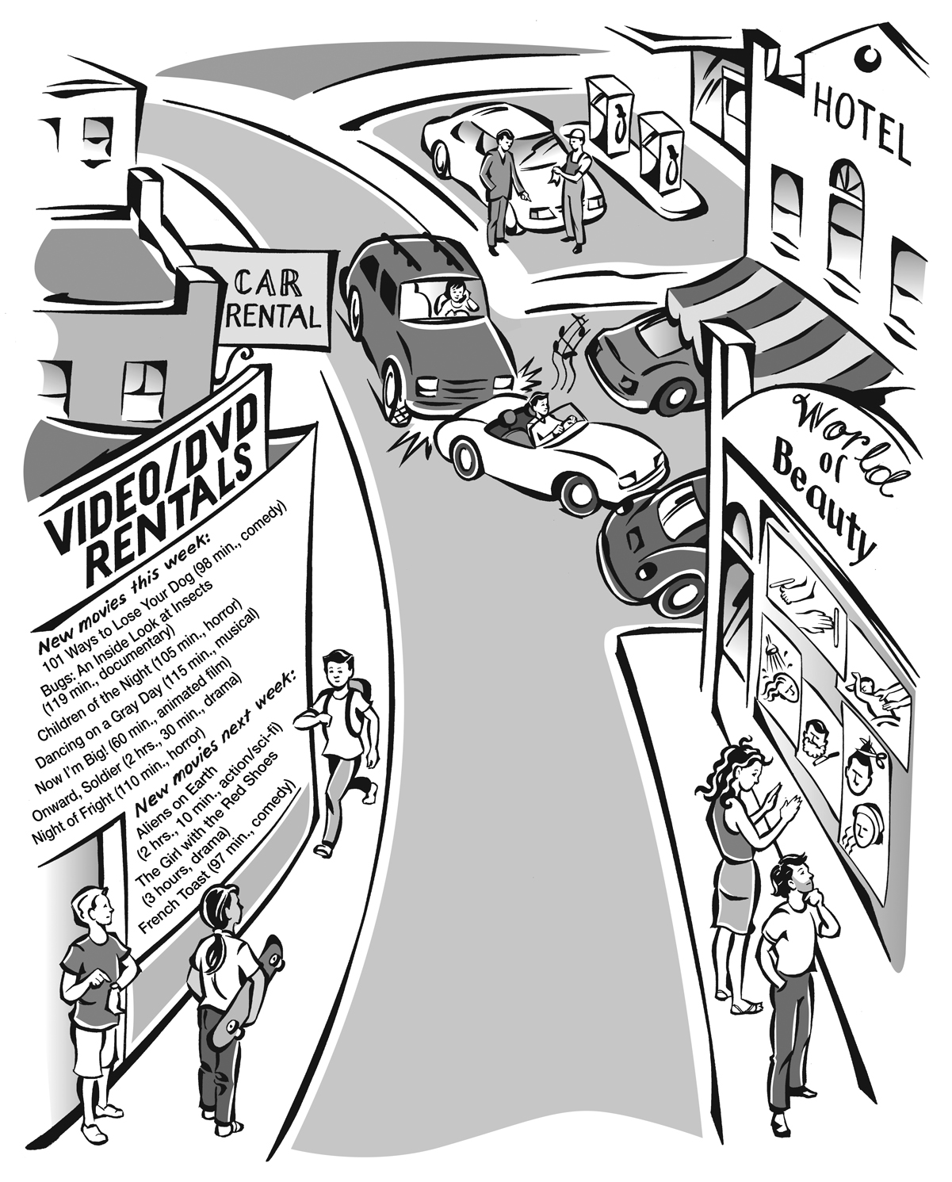
Speaking Task 1

Look at the picture. Answer the questions.
Picture response questions
1. Look at the car accident. What was the driver of the SUV doing? What was the driver of the convertible doing? What happened?
2. Look at the couple in front of the salon. What salon service do you think she will ask for? What salon service do you think he will ask for?

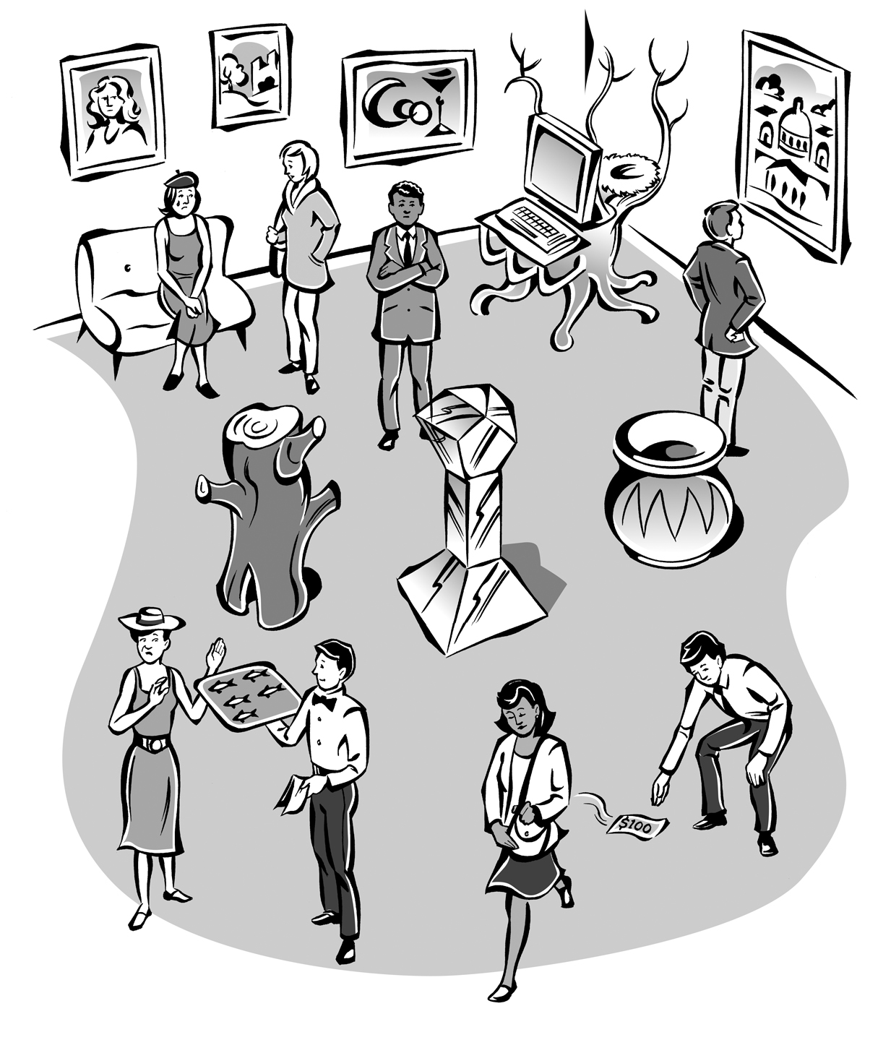
Speaking Task 2
Look at the picture. Answer the questions.

Picture response questions

1. Look at the woman refusing the food. What do you think she’s saying?

2. Look at the man reaching for the money on the ground. If you were this man, what would you do?

Personal questions

3. Describe one of your favorite dishes or foods.
Speaking Exam Section: Final
Speaking Task

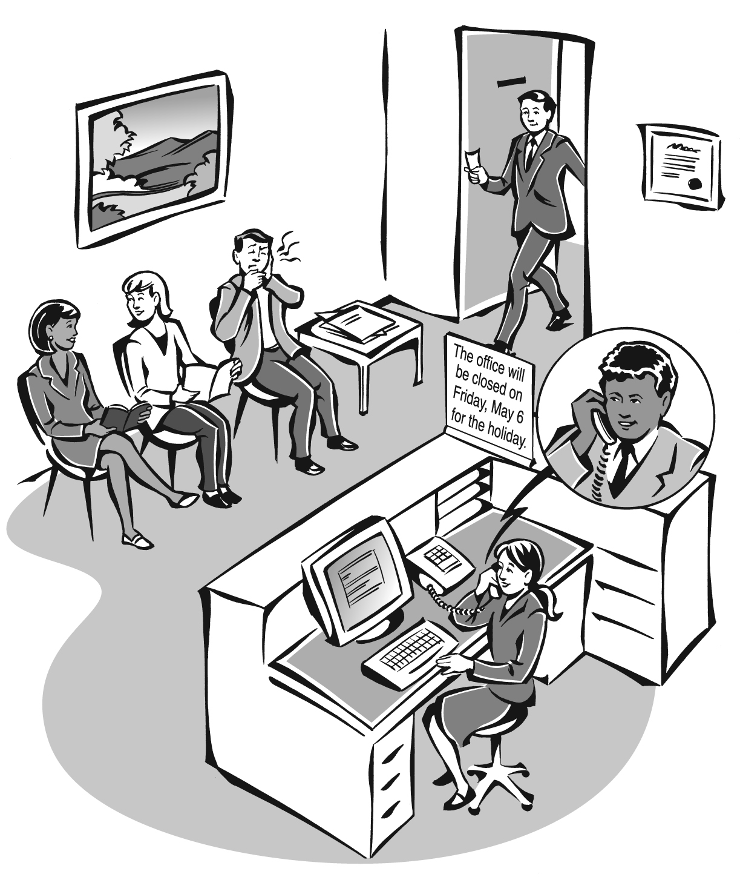

Look at the picture. Answer the questions below.

Picture response questions

1. This is a picture of a dentist’s office. Look at the man leaving the examining room and coming into the waiting room. Make a conclusion about how he is feeling using the word must.

2. Look at the receptionist talking to a man on the phone. A patient has called to make an appointment. Create a conversation for the receptionist and the patient.

3. Look at the two women talking. These women are making small talk. Create a conversation for them.

4. Look at the man holding his mouth in pain. What’s wrong with this man?

Personal question

5. What is something you had already done by 2014?

Lab Exam Section: Mid-term
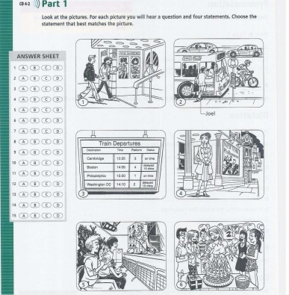

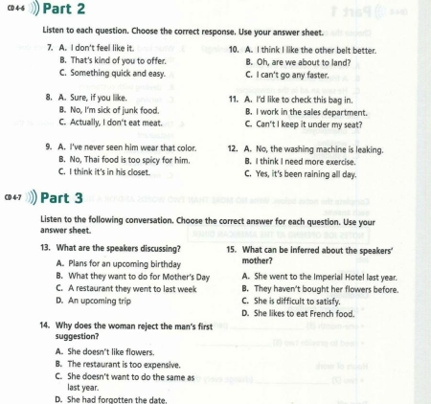

Lab Exam Section: Final
