S1 Power Analysis
Used following version of G*Power
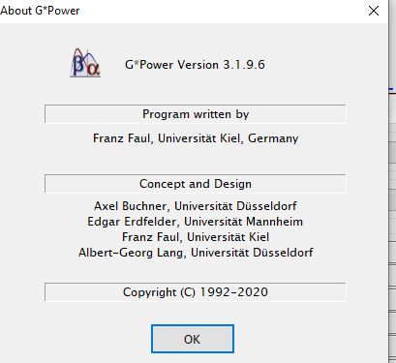
Used R^2 values from Darcy et al. (2016) hierarchical multiple regressions.
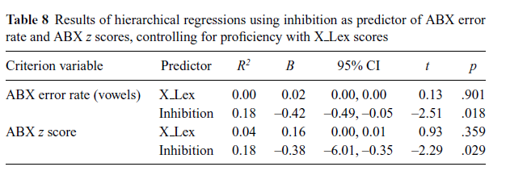
Test for ABX z score
- Open G*Power
- Select F tests
- Select Linear Multiple Regression: Fixed model, R^2 increase
- Set power to .80
- Set Total number of predictors to 2
- Click Determine
- For Variance explained by special effect, input .18 (from ABX z score above)
- For Residual variance, input .82 (1-.18)
- Click calculate and transfer to main window
- Click calculate (on main window)
- This results in a sample size of n=48

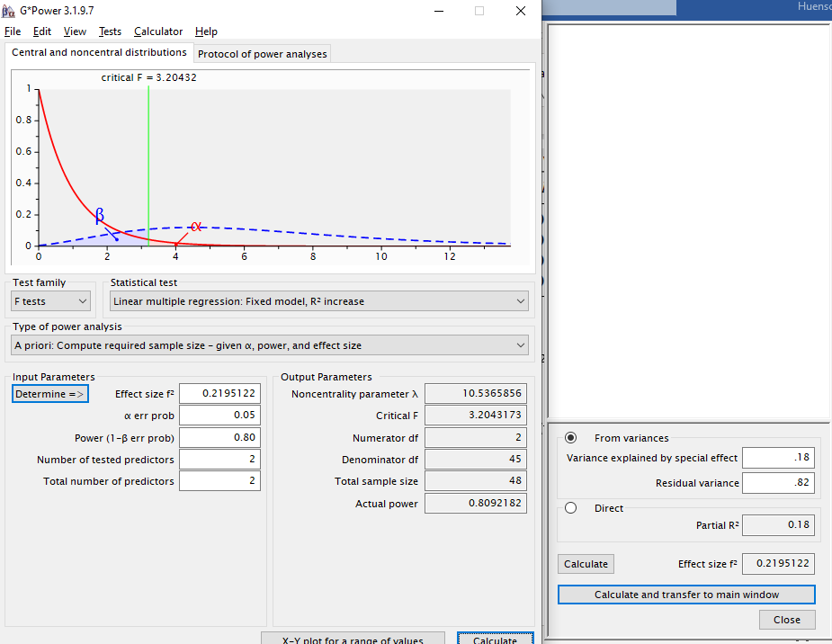
Test for ABX error rate (vowels)
- Open G*Power
- Select F tests
- Select Linear Multiple Regression: Fixed model, R^2 increase
- Set power to .80
- Set Total number of predictors to 2
- Click Determine
- For Variance explained by special effect, input .14 (from ABX error rate [vowels])
- For Residual variance, input .82 (1-.18)
- Click calculate and transfer to main window
- Click calculate (on main window)
- This results in a sample size of n=60

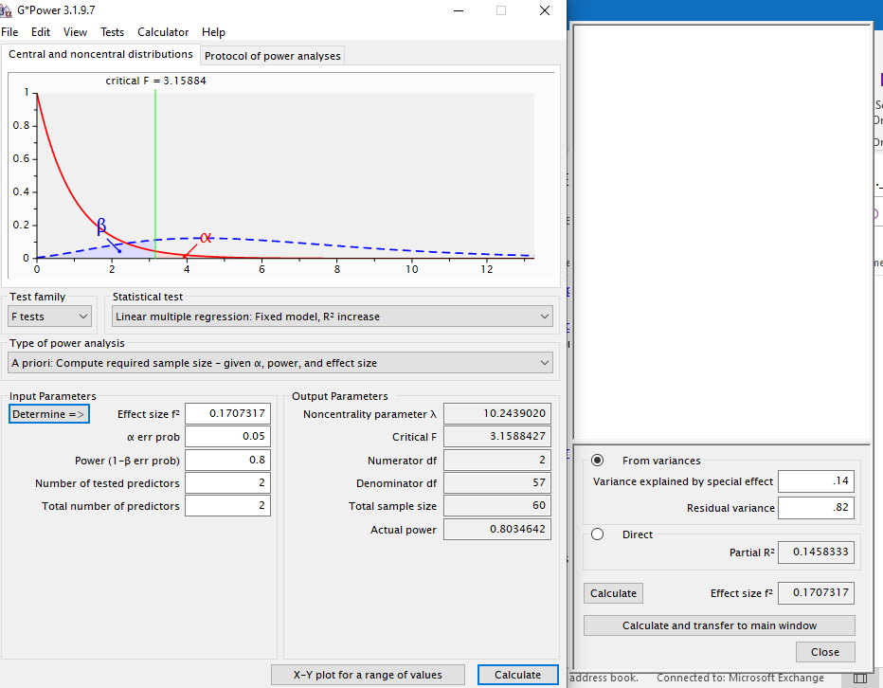

S2 Partial Correlation Test Assumptions
Figure S2-1
Histograms for Raw and Log-transformed Perception Effects
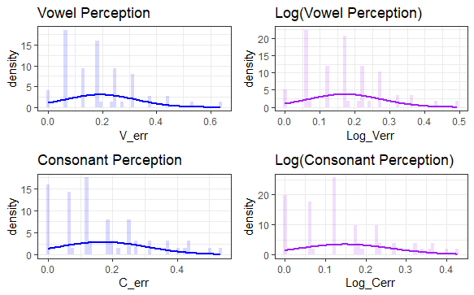
Figure S2-2
Histograms for Raw and Log-transformed Production Effects
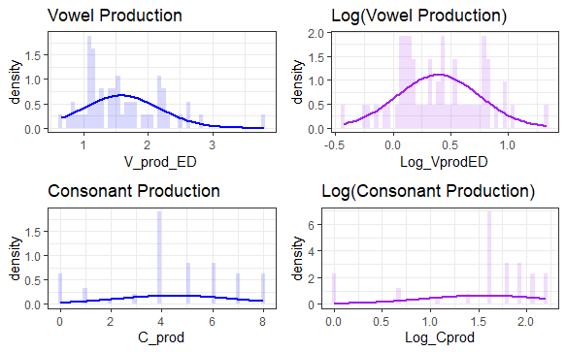
Figure S2-3
QQ plots for Raw and Log-transformed Perception Effects
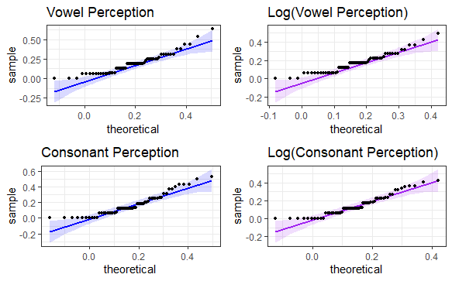
Figure S2-4
QQ plots for Raw and Log-transformed Production Effects
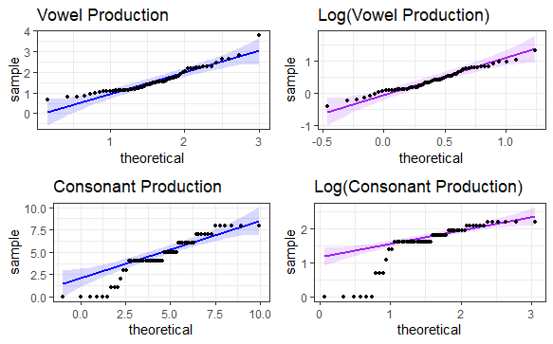
Figure S2-5
QQ plots for Xlex and Inhibition Variables
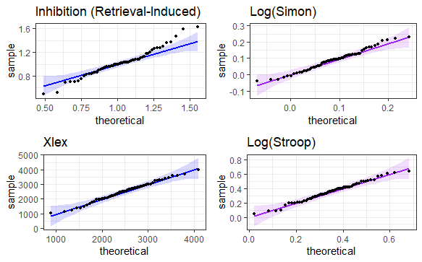
Figure S2-6
Histograms for Xlex and Inhibition Variables
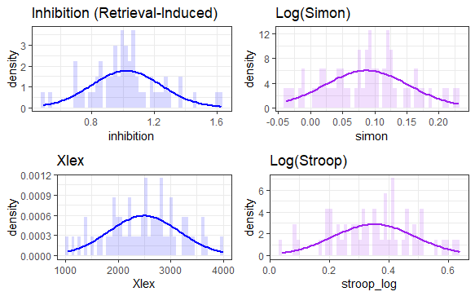
Table S2-1
Shapiro-Wilk Tests of Normality
 | Shapiro-Wilk
ABX error (vowel) | W = 0.92, p < .001*
Log ABX error (Vowel) | W = 0.94, p = .008*
ABX error (consonant) | W = 0.91, p < .001*
Log ABX error (consonant) | W = 0.93, p = .002*
Consonant production | W = 0.92, p < .001*
Log consonant production | W = 0.76, p < .001*
Vowel production | W = 0.91, p < .001*
Log vowel production | W = 0.98, p = .584
Inhibition (retrieval-induced) | W = 0.97, p = .251
Log Simon | W = 0.98, p = .555
Log Stroop | W = 0.99, p = .827
Xlex | W = 0.99, p = .947
ABX error (vowel) | 0.918

The following tables report the results of the Pearson partial correlation analyses. As some test assumptions were violated, Spearman partial correlation analyses are reported. For interested readers, the results of the Pearson partial correlation analyses are reported here but must be interpreted with caution as assumptions were violated.

Table S2-2
Partial Correlations (Pearson) between Phonological Variables and the Three Measures of Inhibition
 | Retrieval-induced | Simon | Stroop
ABX error (vowels) | –0.15 [–0.39, 0.11] | –0.16 [–0.40, 0.10] | 0.17 [–0.09, 0.41]
ABX error (consonants) | –0.10 [–0.35, 0.16] | 0.03 [–0.23, 0.29] | 0.19 [–0.07, 0.43]
Vowel production z score | 0.14 [–0.13, 0.38] | –0.22 [–0.45, 0.04] | 0.14 [–0.12, 0.39]
Consonant production (max. 8) | 0.10 [–0.16, 0.35] | 0.05 [–0.21, 0.30] | 0.00 [–0.25, 0.26]

S3 Testing Simon and Stroop Effect Normality
Figure S3-1
Histograms and QQ plots for Raw Simon Effects
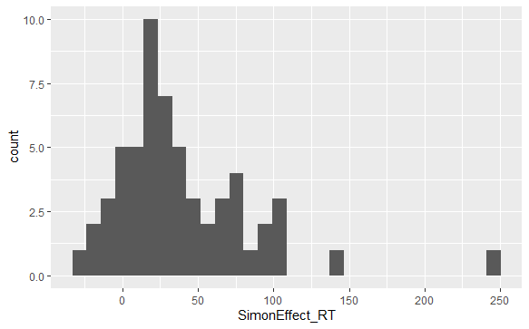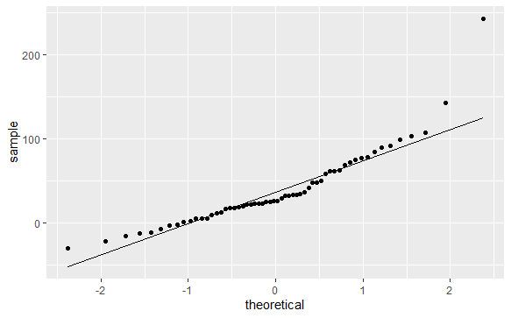
Figure S3-2
Histograms and QQ plots for Log-transformed Simon Effects
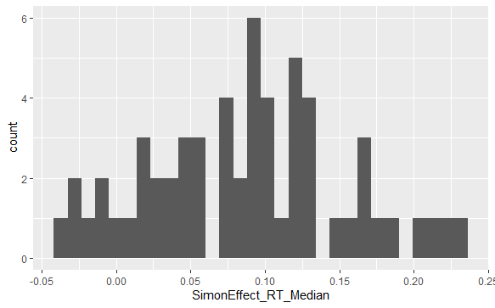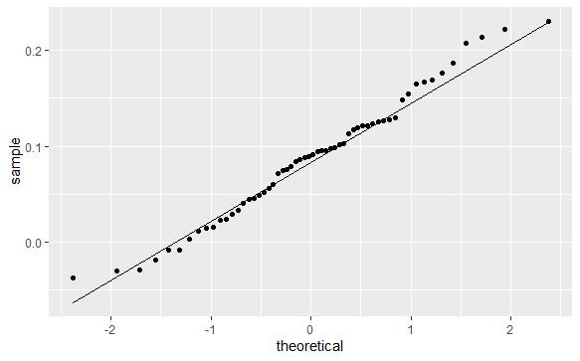

Figure S3-3
Histograms and QQ plots for Raw Stroop Effects
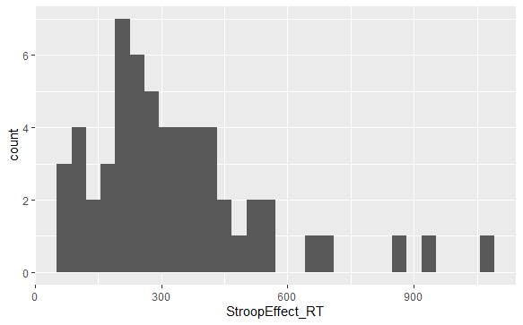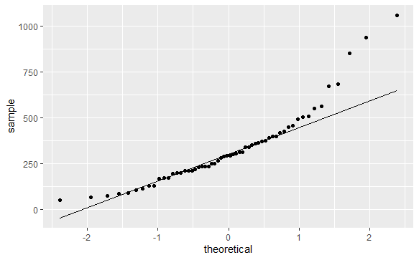
Figure S3-4
Histograms and QQ plots for Log-transformed Stroop Effects
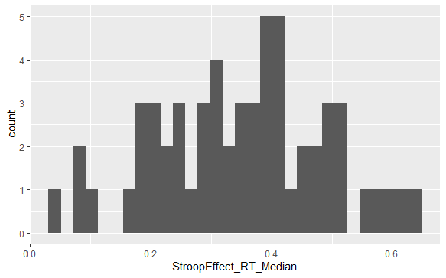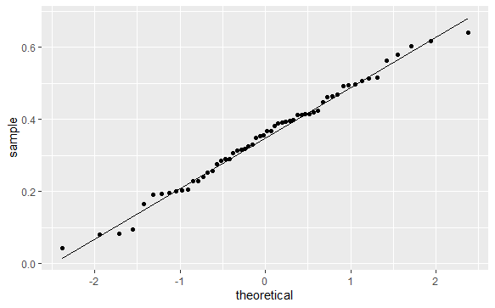

Table S3
Shapiro-Wilk Tests of Normality
 | Shapiro-Wilk
Raw Simon Effects | W = 0.87, p < .001*
Log-transformed Simon Effects | W = 0.98, p < .555
Raw Stroop Effects | W = 0.88, p < .001*
Log-transformed Stroop Effects | W = 0.99, p < .827

S4 Comparison of Means and SDs of Target Cognitive and Phonological Variables Using Hedge’s g Effect Sizes
Table S4
Means and SDs of Target Cognitive and Phonological Variables in DM&D (2016) and the Current Replication
 | Darcy et al.  L2 Spanish (n=18) | Darcy et al.  All learners (n=34) | Current Study  L2 Spanish (n=58) | Effect Size  Hedge’s g | Effect Size  Hedge’s g
Retrieval-induced inhibition | 1.01 (0.11) | 1.03 (0.21) | 1.02 (0.23) | –0.05 [–0.58, 0.48] | 0.04 [–0.38, 0.47]
ABX error (vowels) | 0.20 (0.14) | 0.24 (0.14) | 19.2 (13.2) | 0.06 [–0.47, 0.59] | 0.35 [–0.07, 0.78]
ABX error (consonants) | n/a | n/a | 16.8 (14.0)
Vowel production z score | –2.54 (0.78) | –3.08 (0.86) | –2.27 (0.85) | –0.32 [–0.85, 0.21] | –0.94 [–1.39, –0.50]
Consonant production (max. 8) | 4.09 (2.45) | 5.41 (2.42) | 4.50 (2.31) | –0.17 [–0.70, 0.36] | 0.38 [–0.04, 0.81]

