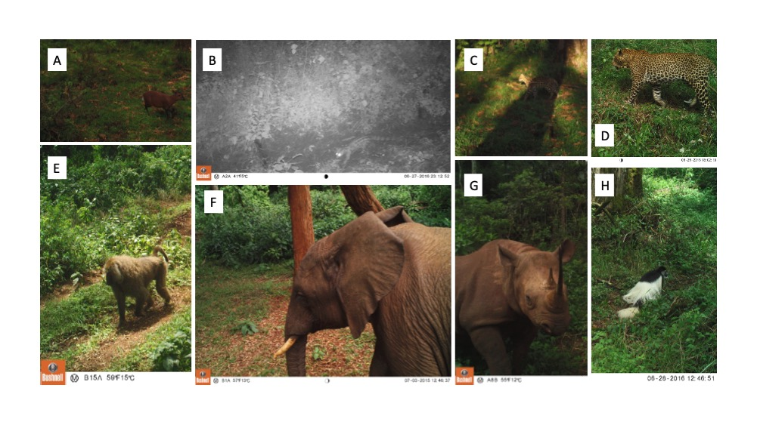Supp.Figure 1. Examples of mammal species observed on camera trap footage in the Aberdare National Park, Kenya in 2015, and 2016. (A) Harvey’s duiker (Cephalophus harveyi) (B) spotted genet (Genetta maculata) (C) serval (Leptailurus serval) (D) leopard (Panthera pardus) (E) olive baboon (Papio anubis) (F) African elephant (Loxodonta africana), (G) black rhino (Diceros bicornis), and (H) Mantled colobus (Colobus guereza).

