# Supplementary material

Supplementary material is available <online>

## Supplementary material Appendix A: R code

**Camp RJ 1, Bak TM 2, Burt M 3 and Vogt S 3** (Year) Using distance sampling with camera traps to estimate densities of ungulates on tropical, oceanic islands.

1 U.S. Geological Survey, Pacific Island Ecosystems Research Center, Kīlauea Field Station, P.O. Box 44, Hawai‘i National Park, HI 96718; [rcamp@usgs.gov](mailto:rcamp@usgs.gov)

2 Hawai‘i Cooperative Studies Unit, University of Hawai‘i at Hilo, P.O. Box 44, Hawai‘i National Park, HI 96718

3 Naval Facilities Marianas, Andersen Air Force Base, 36 Civil Engineering Squadron, Environmental Flight, Unit 14007, APO AP 96543

Any use of trade, firm, or product names is for descriptive purposes only and does not imply endorsement by the U.S. Government

The following *R* code was used for modeling activity levels and estimating density using distance sampling for camera trap (CTDS) methods. Although these data have been processed successfully on a computer system at the U.S. Geological Survey (USGS), no warranty expressed or implied is made regarding the display or utility of the data for other purposes, nor on all computer systems, nor shall the act of distribution constitute any such warranty. The USGS or the U.S. Government shall not be held liable for improper or incorrect use of the data described and/or contained herein.

Modeling activity level

CTDS methods can be sensitive to temporal variation in animal activity patterns and requires censoring the sampling period to the proportion of the day when animals are available for detection (peak activity; Howe *et al*. 2017). Animal activity patterns were modeled to determine peak levels using the *R* package *activity* (Rowcliffe 2021).

## Temporal availability----

library(activity)

#Data is in the data.frame ‘dat’

#Number of hours & proportion of time cameras operated per day

camera.operation.per.day <- 24

prop.camera.time <- camera.operation.per.day/24

#Time recorded on 24:00 clock in the Video_Time field; convert to radian time using gettime() function

dat$TimeRad <- gettime(dat$Video_Time, "%H:%M", scale="radian")

#Apply kernal smoother using fitact() function

act_result <- fitact(dat$TimeRad, sample="data", reps=1000)

plot(act_result)

print(act_result@act)

#Temporal availability multiplier for dht2() function

avail <- list(creation=data.frame(rate=act_result@act[1]/prop.camera.time,

                                  SE = act_result@act[2]/prop.camera.time))

#Temporal availability multiplier for bootdht() function

mult <- list(availability=make_activity_fn(dat.pa$TimeRad, sample="data",

                                           detector_daily_duration = camera.operation.per.day))

#END SCRIPT

Estimating densities using CTDS methods

Animal densities were modeled using the *R* package *distance* (Miller *et al*. 2019) following methods described in Howe *et al*. (2017, 2019).

## Density estimation----

library(Distance)

library(knitr)

#Data is in the data.frame ‘dat’

#Variables----

#Determine conversion units for distance, area

conversion <- convert_units("meter", NULL, "hectare")

#Length of snapshot moment, in seconds, used for calculating effort

Snapshot_Int <- 2

#Number of hours & proportion of time cameras were operating per day

camera.operation.per.day <- 24

prop.camera.time <- camera.operation.per.day/24

#Assign FOV by camera make and model; measurement of each camera’s field of view available from the manufacturer

viewangle.Bushnell <- 45 # degrees

samfrac.Bushnell <- viewangle.Bushnell / 360

viewangle.Moultrie <- 35 # degrees

samfrac.Moultrie <- viewangle.Moultrie / 360

#Create data.frame with Sample.Label and fraction for dht2() modeling

#Add sampling fraction to data.frame accounting for different camera make and model FOVs

samfrac <- dat %>%

  mutate(fraction = if_else(Manufacturer %in% "Moultrie",

 samfrac.Moultrie, samfrac.Bushnell)) %>%

  select(Sample.Label, fraction) %>%

  group_by(Sample.Label, fraction) %>%

  summarise() %>%

  as.data.frame()

#Explore cutpoints (example cutpoints provided)

breakpoints <- c(0, seq(0.5,5.5,1), 8.5)

#Left-truncate at 0.5, right-truncate at 10.5 m, and group data from 5.5 to 7.5 m and 7.5-10.5 m

#trunc.list <- list(left=0.5, right=10.5)

#breakpoints <- c(seq(0.5,5.5,1), 7.5, 10.5)

#View distance recordings with breakpoints

ggplot(data = dat, aes(x = distance)) +

  geom_histogram(breaks = breakpoints)

#Detection function modeling----

#Example distance sampling code to fit half-normal (hn) key detection function model. Similar models should be generated for the half-normal model with cosine and Hermite polynomial adjustment terms, for the hazard rate (hr) key and cosine and simple polynomial adjustment term detection functions, and the uniform (un) detection function with one and two cosine adjustment terms.

hn <- ds(dat,

         transect="point",

         key="hn",

         adjustment=NULL,

         monotonicity=FALSE,

         convert_units=conversion,

         er_var="P3",

         #truncation=trunc.list,

         cutpoints=breakpoints)

#Model checking

 gof_ds(hn)

check.mono(hn$ddf, plot=TRUE, n.pts=100)

plot(hn)

plot(hn, pdf=TRUE)

summary(hn)

#Make an AIC summary statistics table for detection function models

summarize_ds_models(hn,

                    hn.cos,

                    hn.poly,

                    hr,

                    hr.cos,

                    hr.poly,

                    un.cos1,

                    un.cos2,

                    sort="AIC", delta_only=FALSE, output="plain")

#Overdispersion----

chat <- function(modobj) {

  #  computes c-hat for a dsmodel object using Method 1 of Howe *et al*. (2018)

  test <- gof_ds(modobj)

  num <- test$chisquare$chi1$chisq

  denom <- test$chisquare$chi1$df

  chat <- num/denom

  return(chat)

}

qaic <- function(modobj, chat) {

  #  computes QAIC for a dsmodel object given a c-hat

  value <- 2* modobj$ddf$ds$value/chat + 2 * (length(modobj$ddf$ds$pars)+1)

  return(value)

}

qaic.pass1 <- function(...) {

  #   Performs Pass 1 model selection based upon Method 1 of Howe *et al*. (2018)

  #   Arguments are dsmodel objects; assumed all based on same key function

  #    c-hat is computed for the most parameter-rich model in the group

  #    qaic is calculated for each model in group based upon this c-hat

  #   Result returned in the form of a data.frame with model name, npar, aic and qaic

  models <- list(...)

  num.models <- length(models)

  npar <- unlist(lapply(models, function(x) length(x$ddf$ds$par)))

  modname <-  unlist(lapply(models, function(x) x$ddf$name.message))

  aic <-  unlist(lapply(models, function(x) x$ddf$criterion))

  chat.bigmod <- chat(models[[which.max(npar)]])

  qaic <- vector(mode="numeric", length = num.models)

  for (i in 1:num.models) {

    qaic[i] <- qaic(models[[i]], chat.bigmod)

  }

  nicetab <- data.frame(modname, npar, aic, qaic)

  return(nicetab)

}

winners <- list(hn, hr)   # list detection function models to evaluate; 2 in this example

chats <- unlist(lapply(winners, function(x) chat(x)))

modnames <- unlist(lapply(winners, function(x) x$ddf$name.message))

results <- data.frame(modnames, chats)

results.sort <- results[order(results$chats),]

knitr::kable(results.sort, digits=2, row.names = FALSE)

#Compute QAIC values based on c-hats

2* hr$ddf$ds$value/35.14 + 2 * (length(hr$ddf$ds$pars)+1)

2* hn$ddf$ds$value/60.26 + 2 * (length(hn$ddf$ds$pars)+1)

# Density estimates----

#Need this for dht2 to work, pulled the code from http://examples.distancesampling.org/Distance-cameratraps/camera-distill.html

dat$object[!is.na(dat$distance)] <- 1:sum(!is.na(dat$distance))

#Temporal availability multiplier, avail, computed above in Modeling activity levels.

dens <- dht2(hr,

             flatfile=dat,

             #strat_formula=~1,

             strat_formula=~Region.Label,

             stratification="geographical",

             sample_fraction=samfrac,

             er_est="P3",

             multipliers=avail,

             convert_units=conversion)

print(dens, report="density")

#Bootstrap procedures----

#In the bootstrap procedure we treat each camera trap site as the sampling unit, a product of the systematic random sampling design, and set the resample_transects argument to true. The camera trap sites have transect length of zero, an inherited product of point transect distance sampling.

#Function to keep density estimates produced by each bootstrap

#Example function when there are strata and both densities and abundances are kept

NDhats <- function(ests, fit) {

  ns <- ests$individuals$N

  ds <- ests$individuals$D

  foo <- as.data.frame(matrix(ns$Estimate, nrow = 1))

  names(foo) <- make.names(paste0("N.", ns$Label), unique = TRUE)

  bar <- as.data.frame(matrix(ds$Estimate, nrow = 1))

  names(bar) <- make.names(paste0("D.", ds$Label))

  return(cbind(foo, bar))

}

#Bootstrapping procedures took up to two hours to run given the AAFB deer and pigs datasets. Example code using the hazard rate key detection function model. Temporal availability multiplier, mult, computed above in Modeling activity levels.

boot <- bootdht(model=hr,

                flatfile=dat,

                resample_transects=TRUE,

                nboot=1000,

                summary_fun=NDhats,

                sample_fraction=samfrac,

                multipliers=mult,

                convert_units=conversion)

#Plot density estimates multiple strata

par(mfrow=c(1,2))

hist(boot$D.Plateau, breaks = 20,

     xlab="Estimated density", main="Plateau")

abline(v=quantile(boot$D.Plateau, probs = c(0.025,0.975),

                  na.rm=TRUE), lwd=2, lty=3)

abline(v=quantile(boot$D.Plateau, probs = c(0.5),

                  na.rm=TRUE), lwd=2, lty=1)

hist(boot$D.Tarague, breaks = 20,

     xlab="Estimated density", ylab=NULL, main="Tarague")

abline(v=quantile(boot$D.Tarague, probs = c(0.025,0.975),

                  na.rm=TRUE), lwd=2, lty=3)

abline(v=quantile(boot$D.Tarague, probs = c(0.5),

                  na.rm=TRUE), lwd=2, lty=1)

par(mfrow=c(1,1))

#Plot density estimate single stratum

hist(boot$Dhat, breaks = 20,

      xlab="Estimated density", main="D-hat estimates bootstraps")

abline(v=quantile(boot$Dhat, probs = c(0.025,0.975),

                  na.rm=TRUE), lwd=2, lty=3)

abline(v=quantile(boot$Dhat, probs = c(0.5),

                  na.rm=TRUE), lwd=2, lty=1)

# Compute total densities from bootstrap output----

# assign bootstrap object to dboot

dboot <- data.frame(boot)

# compute the average density weighted by stratum area

area_plateau <- 985

area_tarague <- 410

area_total <- area_plateau + area_tarague

dboot$D.wtavg <- (area_plateau * dboot$D.Plateau + area_tarague * dboot$D.Tarague)/area_total

# assign summary statistics

dboot.median <- as.data.frame(apply(dboot, 2, median))

dboot.mean <- as.data.frame(apply(dboot, 2, mean))

dboot.se <- as.data.frame(apply(dboot, 2, sd))

dboot.bll <- as.data.frame(apply(dboot, 2, quantile,

                                 probs=0.025))

dboot.bul <- as.data.frame(apply(dboot, 2, quantile,

                                 probs=0.975))

dboot.summ <- cbind(dboot.median, dboot.mean, dboot.se,

                    dboot.bll, dboot.bul)

dboot.summ <- data.frame(dboot.summ)

colnames(dboot.summ) <- c('median', 'mean', 'se', 'bll', 'bul')

dboot.summ <- dboot.summ[-c(6,7), ]

kableExtra::kbl(dboot.summ, align = 'l', digits=2) %>%

  kableExtra::kable_classic(html_font = "Cambria")

# END SCRIPT

**References**

**Howe, EJ, Buckland ST, Despres-Einspenner M-L and Kühl HS** (2017) Distance sampling with camera traps. *Methods in Ecology and Evolution* **8**, 1558–1565. https://doi.org/10.1111/2041-210X.12790

**Howe, EJ, Buckland ST, Despres-Einspenner M-L and Kühl HS** (2019) Model selection with overdispersed distance sampling data. *Methods in Ecology and Evolution* **10**, 38–47. https://doi.org/10.1111/2041-210X.13082

**Miller DL, Rexstad EA, Thomas L, Marshall L and Laake JL** (2019) Distance sampling in R. *Journal of Statistical Software* **89**, 1-28. https://doi.org/10.18637/jss.v089.i01

**Rowcliffe JM** (2021) Activity: Animal activity statistics. R package version 1.3.1. The Comprehensive R Archive Network (CRAN).

## Supplementary material Appendix B: Example snapshot moments

**Camp RJ 1, Bak TM 2, Burt M 3 and Vogt S 3** (Year) Using distance sampling with camera traps to estimate densities of ungulates on tropical, oceanic islands.

1 U.S. Geological Survey, Pacific Island Ecosystems Research Center, Kīlauea Field Station, P.O. Box 44, Hawai‘i National Park, HI 96718; [rcamp@usgs.gov](mailto:rcamp@usgs.gov)

2 Hawai‘i Cooperative Studies Unit, University of Hawai‘i at Hilo, P.O. Box 44, Hawai‘i National Park, HI 96718

3 Naval Facilities Marianas, Andersen Air Force Base, 36 Civil Engineering Squadron, Environmental Flight, Unit 14007, APO AP 96543

Any use of trade, firm, or product names is for descriptive purposes only and does not imply endorsement by the U.S. Government.

Example snapshot moments of deer (Supplementary material Appendix B Figure B1) and pigs (Supplementary material Appendix B Figure B2) where an animal was observed next to a reference flag staked out in 1m intervals from both day and night detections.

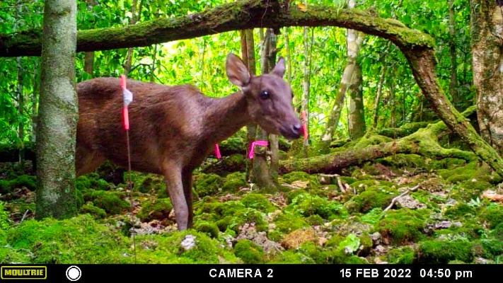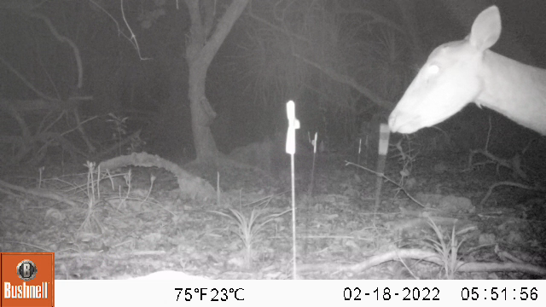

Supplementary material Appendix B Figure B1. Detections of deer at known locations during diurnal (left panel) and nocturnal (right panel) periods.

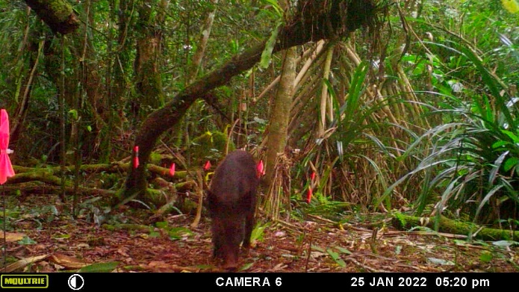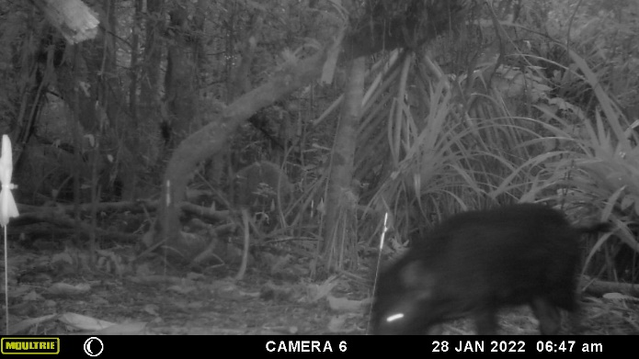

Supplementary material Appendix B Figure B2. Detections of pigs at known locations during diurnal (left panel) and nocturnal (right panel) detections.

## Supplementary material Appendix C: Detection function model selection

**Camp RJ 1, Bak TM 2, Burt M 3 and Vogt S 3** (Year) Using distance sampling with camera traps to estimate densities of ungulates on tropical, oceanic islands.

1 U.S. Geological Survey, Pacific Island Ecosystems Research Center, Kīlauea Field Station, P.O. Box 44, Hawai‘i National Park, HI 96718; [rcamp@usgs.gov](mailto:rcamp@usgs.gov)

2 Hawai‘i Cooperative Studies Unit, University of Hawai‘i at Hilo, P.O. Box 44, Hawai‘i National Park, HI 96718

3 Naval Facilities Marianas, Andersen Air Force Base, 36 Civil Engineering Squadron, Environmental Flight, Unit 14007, APO AP 96543

Any use of trade, firm, or product names is for descriptive purposes only and does not imply endorsement by the U.S. Government.

Detection function model selection accounting for overdispersion for deer detections (Supplementary material Appendix C Table C1) with model fitted to the deer detections (Supplementary material Appendix C Figure C1), and for pigs detections (Supplementary material Appendix C Table C2) with model fitted to the pigs detections (Supplementary material Appendix C Figure C2).

Supplementary material Appendix C Table C1. Detection function model selection statistics and parameter estimates for deer analyses of camera trap records collected in 2022 on the Naval Facilities Engineering System Command Marianas, Andersen Air Force Base, Guam. Key function with and without adjustment terms ranked by QAIC accounting for overdispersion ($\hat{c}$). Presented are the chi-square ($X^{2}$) goodness-of-fit statistic *p*-value, and the estimated average detection probability with standard error.

|  |  |  |  |  |  |
| --- | --- | --- | --- | --- | --- |
| Key function | $X^{2}$*p*-value | Average detectability | SE(Average detectability) | QAIC | $$\hat{c}$$ |
| Hazard-rate | <0.001 | 0.296 | 0.005 | 344.18 | 35.14 |
| Half-normal | <0.001 | 0.181 | 0.004 | 204.37 | 60.26 |

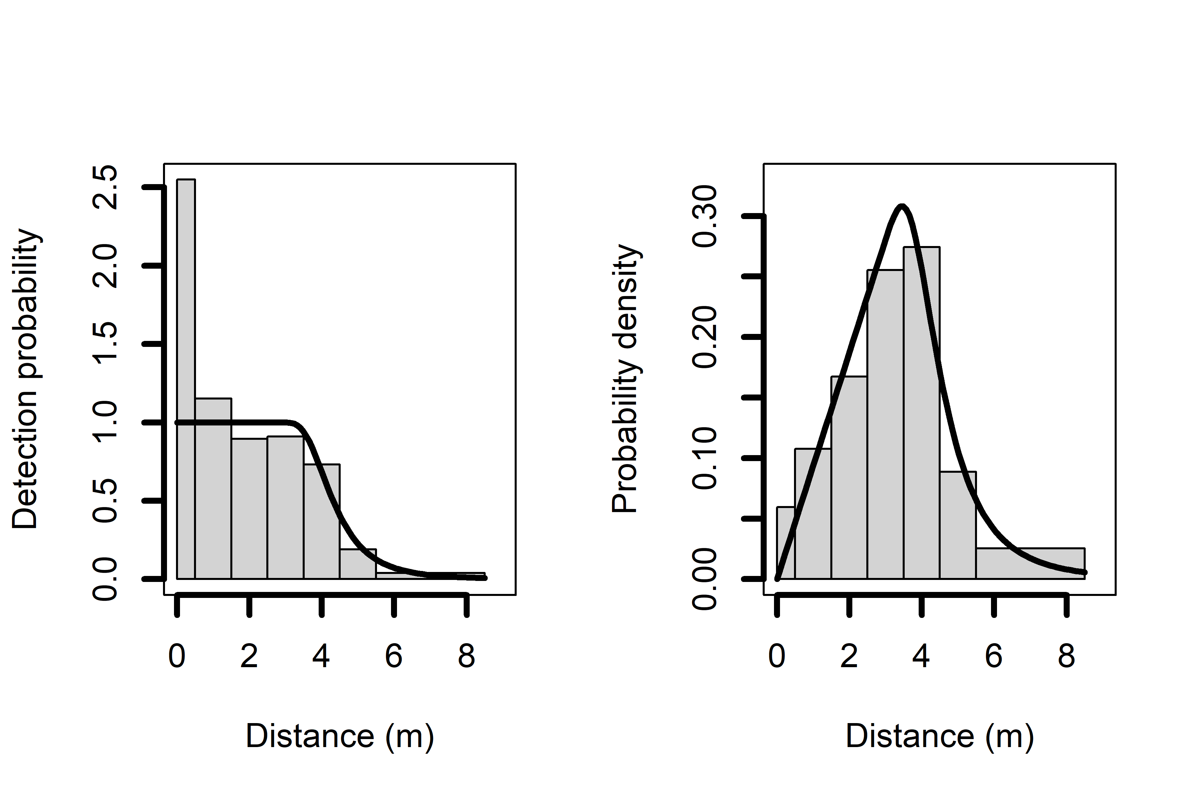

Supplementary material Appendix C Figure C1. Detection function plots for the hazard-rate model without series expansion fitted to the deer detections collected in 2022 on the Naval Facilities Engineering System Command Marianas, Andersen Air Force Base, Guam. Plots represent the average detection probability (left panel) and probability density (right panel). There is moderate deviation in the histogram in the probability plots, which provides evidence the function acceptably fits the data.

Supplementary material Appendix C Table C2. Detection function model selection statistics and parameter estimates for pigs detections of camera trap records collected in 2022 on the Naval Facilities Engineering System Command Marianas, Andersen Air Force Base, Guam. Key function with and without adjustment terms ranked by QAIC accounting for overdispersion ($\hat{c}$). Presented are the chi-square ($X^{2}$) goodness-of-fit statistic *p*-value, and the estimated detection probability with standard error.

|  |  |  |  |  |  |
| --- | --- | --- | --- | --- | --- |
| Key function | $X^{2}$*p*-value | Average detectability | SE(Average detectability) | QAIC | $$\hat{c}$$ |
| Hazard-rate | <0.001 | 0.270 | 0.005 | 254.08 | 61.39 |
|  |  |  |  |  |  |
| Half-normal | <0.001 | 0.188 | 0.003 | 114.88 | 140.75 |

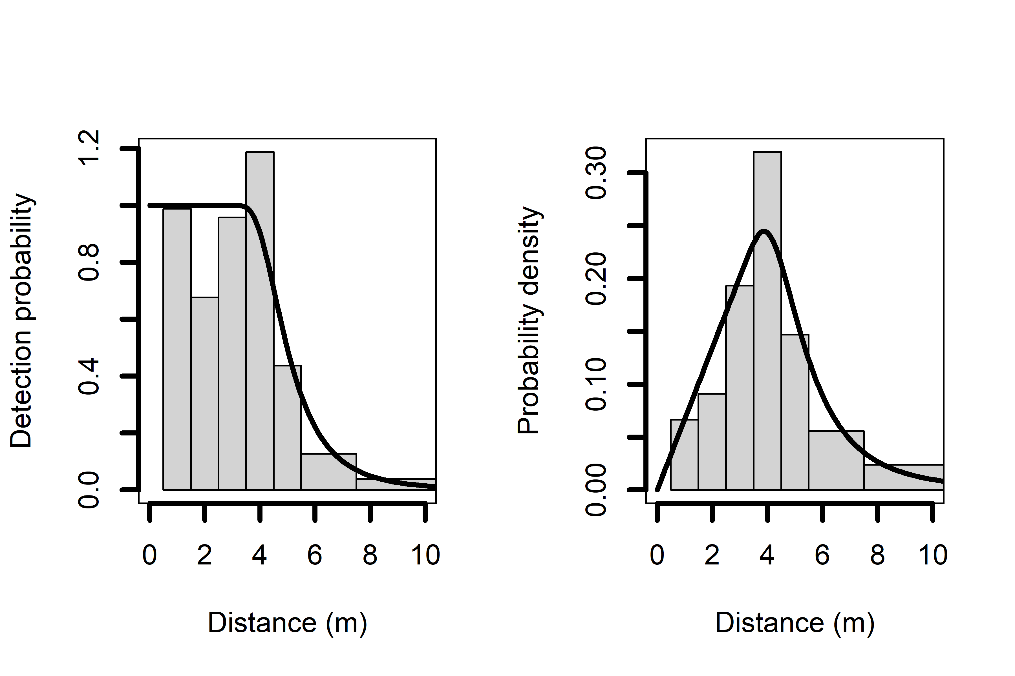

Supplementary material Appendix C Figure C3. Detection function plots for the hazard-rate model without series expansion fitted to the pig detections from data collected in 2022 on the Naval Facilities Engineering System Command Marianas, Andersen Air Force Base, Guam. Plots represent the average detection probability (left panel) and probability density (right panel). There is moderate deviation in the histogram in the probability plots, which provides evidence the function acceptably fits the data.

## Supplementary material Appendix D: Best practices

**Camp RJ 1, Bak TM 2, Burt M 3 and Vogt S 3** (Year) Using distance sampling with camera traps to estimate densities of ungulates on tropical, oceanic islands.

1 U.S. Geological Survey, Pacific Island Ecosystems Research Center, Kīlauea Field Station, P.O. Box 44, Hawai‘i National Park, HI 96718; [rcamp@usgs.gov](mailto:rcamp@usgs.gov)

2 Hawai‘i Cooperative Studies Unit, University of Hawai‘i at Hilo, P.O. Box 44, Hawai‘i National Park, HI 96718

3 Naval Facilities Marianas, Andersen Air Force Base, 36 Civil Engineering Squadron, Environmental Flight, Unit 14007, APO AP 96543

Any use of trade, firm, or product names is for descriptive purposes only and does not imply endorsement by the U.S. Government.

Conservation and management questions about monitoring animal populations define the focus and scope of possible objectives, which can be used to identify information needs. These objectives and information needs drive the sampling design, data collection methods, analytical methods, and conclusions. We provide here several points for consideration and best practices for establishing and conducting distance sampling with camera trap surveys for density estimation.

**Adequate Coverage**

* Pilot study data can be used to determine the sampling intensity and effort (i.e., number of camera traps and length of trapping) needed to reach desired levels of precision following methods described in this study.
* Different species home range sizes do not adversely affect CTDS, thus different trap spacing for different species is not needed. Also, double-counting is not a concern as an animal cannot be captured on separate cameras simultaneously. Therefore, optimize placement for any one species is discouraged. If optimizing is preferred, then a best practice would be to treat each species as a separate study.
* Trapping intensity may need to be adjusted as animal populations change, increasing the number of cameras if populations decline due to management activities like hunting or the number of cameras decreased as populations recovery due to conservation activities.

**Cameras and Camera Trap Placement**

* Cameras are needed that can withstand inclement weather including tropical rainy season, with camera makes and models chosen for the specific conditions.
* Cameras should have highly sensitive passive infrared motion sensors and take high-quality videos (1280 x 720 pixels per frame at 20 fps images).
* Howe *et al*. (2017) recommends recoding time-stamped video of >2*t* seconds, where *t* is the units of time between snapshot moments, and notes that practical considerations constrain *t* and video image length. Video recording length should be consistent among all cameras and the 15-second-long videos we used captured images of animals that rapidly moved through the field of view as well as those that lingered in the field of view for prolonged periods and provided enough detections to reliably estimate densities.
* Trigger times should be programmed to trigger immediately, and the delay between detections when an animal remains in range should be programmed to 0 seconds.
* Cameras should be installed at a low height between the sensor and ground to minimize violations that all animals immediately in front of the camera are detected to meet the certainty of detection at distance zero assumption (Howe *et al.* 2017, Palencia *et al.* 2021). For deer and pigs sampled in our study, cameras were secured to trees 30–50 cm above the ground and angled parallel to the slope of the ground to record animals throughout the field of view. Haucke *et al.* (2022) suggests attaching cameras tightly to stationary objects such as trees to minimize motion and that the bottom third of the field of view should be covered by the ground.
* Fonteyn *et al.* (2020) recommends cutting back grasses and vegetation within a 3-m radius of the camera to reduce false triggers and ensure detection is certain at zero distance. The undergrowth should, however, remain mostly unchanged. Modification within the field of view should be recorded.
* Kolowski & Forrester (2017) and Fonteyn *et al.* (2020) found sampling preferentially on game trails did not alter the detection probability or density estimates. Targeting habitat features that are preferentially used by animals violates the critical assumption that sampling locations are independent of animal locations (Buckland et al. 2015). Therefore, the best practice is to not sample game trails preferentially—low detection can be mitigated with longer sampling periods. Several factors other than game trails can affect detection probability (animal activity, terrain, vegetation, weather), which can be modeled during distance sampling analysis.

**Reference Distances**

* Until automated methods improve, reference distances should be collected to aid manual methods to estimate distances. These reference distances can also be used to test or validate distances estimated from automated methods.
* Placing survey flags from 1 to 15 m out, at 1-m intervals, and marking natural objects (trees and branches) at known distances from the camera allowed for quick distance references for animals close to cameras and near the centerline. Marking reference to greater distances may be needed if animals are detected further away from cameras.
* Recording a person showing a paper sheet depicting the distance to the camera (e.g., a 4 for 4 m out) and walking across the field of view from one side to the other between 1 and 11 m helped identify distances to cameras when animals were at the edges of the field of view. Again, marking at greater distances may be needed if animals are detected further away from cameras.

**Peak Activity**

* Use all videos collected to estimate densities rather than meeting the synchrony assumption by sub-setting the digital data to peak activity periods. Animal activity can be computed as the level of temporal activity with variance using the *fitact()* function of the *R* (R Core Team 2021) package *activity* (Rowcliffe 2021).
* If a peak activity interval is used, it should be estimated for each study rather than using the peak activity interval from previous studies or areas following methods described in Rowcliffe *et al*. (2014).

**Sampling Period**

* Density likely changes between dry and wet seasons in the tropics. Sampling during both seasons is beneficial. Given this, CTDS will provide an average density across the sampling period.

**Trapping Effort**

* Exclude detections that occurred on days of camera setup and teardown, as recommended by Howe *et al.* (2017). Based on this study, detections on the first day after setup should also be dropped, a procedure also recommended by Palencia *et al*. (2021).
* Plotting daily detection rates will provide the information needed to determine if detections on the first or subsequent days after setup should be dropped along with detections on the days of setup and teardown.

**Imagery Preprocessing**

* All images should be assigned a unique identifier or code, which may be gathered from standard camera metadata.
* Species and object identification should follow standard naming conventions, including genus and species.
* Total number of individuals in imagery should be recorded, particularly if multiple individuals are in a single image.
* Images should be coded for each species if multiple species occur in an image.
* Machine-learning methods have substantially reduced classification time and made classification methods repeatable. A best practice is to use software programs to gather camera metadata and management of data.

**Data Management**

* Summary statistics of camera trap days or nights can be calculated by summing the number of 24-h periods each camera per site was operating, and by recording the number of images taken per camera per site and number of images with objects, broken down by target and non-target objects, and blanks (empty images that do not contain visible objects).
* Input data include CSV file of a camera operation (or SD card) log with fields for camera identification, strata, start time and date, end time and date, and angle of the field of view. If data are collected from multiple orientations, the start and end information should be specific to each orientation. Sampling effort can be computed from the camera operation log, independently by orientation if needed.
* The file of detections with distances should also include fields for camera identification, video name, video time and date, snapshot moment, object, and distance.

References

**Buckland ST, Rextad EA, Marques TA and Oedekoven CS** (2015) Distance sampling: Methods and applications. Springer, London, UK.

**Corlatti L, Sivieri S, Sudolska B, Giacomelli S and Pedrotti L** (2020) A field test of unconventional camera trap distance sampling to estimate abundance of marmot populations. *Wildlife Biology* **4**, wlb.00652. https://doi.org/10.2981/wlb.00652

**Fonteyn D, Vermeulen C, Deflandre N, Cornelis D, Lhiest S Houngbegnon FGA, Doucet J-L and Fayolle A** (2020) Wildlife trail or systematic? Camera trap placement has little effect on estimates of mammal diversity in a tropical forest in Gabon. *Remote Sensing in Ecology and Conservation* DOI: 10.1002/rse2.191

**Haucke T, Kühl HS, Hoyer J and Steinhage V** (2022) Overcoming the distance estimation bottleneck in camera trap distance sampling. *ArXiv*, 2105.04244v1

**Howe, EJ, Buckland ST, Despres-Einspenner M-L and Kühl HS** (2017) Distance sampling with camera traps. *Methods in Ecology and Evolution* 8, 1558–1565. <https://doi.org/10.1111/2041-210X.12790>

**Kolowski JM and Forrester TD** (2017) Camera trap placement and the potential for bias due to trails and other features. *PLoS ONE* 12, e0186679. <https://doi.org/10.1371/journal.pone.0186679>

**Palencia P, Rowcliffe JM, Vicente J and Acevedo P** (2021) Assessing the camera trap methodologies used to estimate density of unmarked populations. *Journal of Applied Ecology* **58**, 1583-1592. DOI: 10.1111/1365-2664.13913

**R Core Team** (2021) R: a language and environment for statistical computing. Version 4.2.1. (R Foundation for Statistical Computing, Vienna, Austria)

**Rowcliffe JM** (2021) Activity: Animal activity statistics. R package version 1.3.1. The Comprehensive R Archive Network (CRAN).

**Rowcliffe JM, Kays R, Kranstauber B, Carbone C and Jansen PA** (2014) Quantifying levels of animal activity using camera trap data. *Methods in Ecology and Evolution* **5**, 1170–1179.