R. norvegicus

Supplemental Figure S5 presents boxplots demonstrating the distribution of environmental data and highlights the environmental variables identified by the model as influencing habitat suitability predictions for R. norvegicus. It shows how the species responds to different environmental factors.
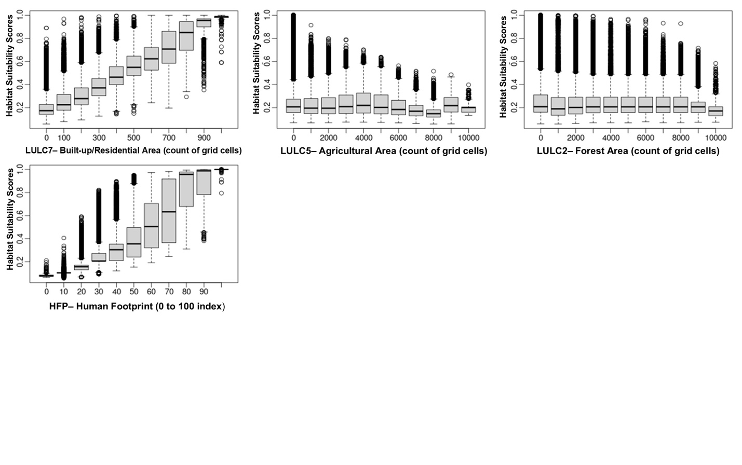
Supplemental Figure S5. Final environmental variables as predicted by the model to influence the habitat suitability of R. norvegicus.

R. norvegicus demonstrates significant adaptability to built-up/residential areas and environments impacted by human activities. It maintains consistent habitat suitability across agricultural landscapes and forests, although its suitability tends to decrease in areas of increased forest density.

