R. exulans

Supplemental Figure S3 presents boxplots demonstrating the distribution of environmental data and highlights the environmental variables identified by the model as influencing habitat suitability predictions for R. exulans. It shows how the species responds to different environmental factors.

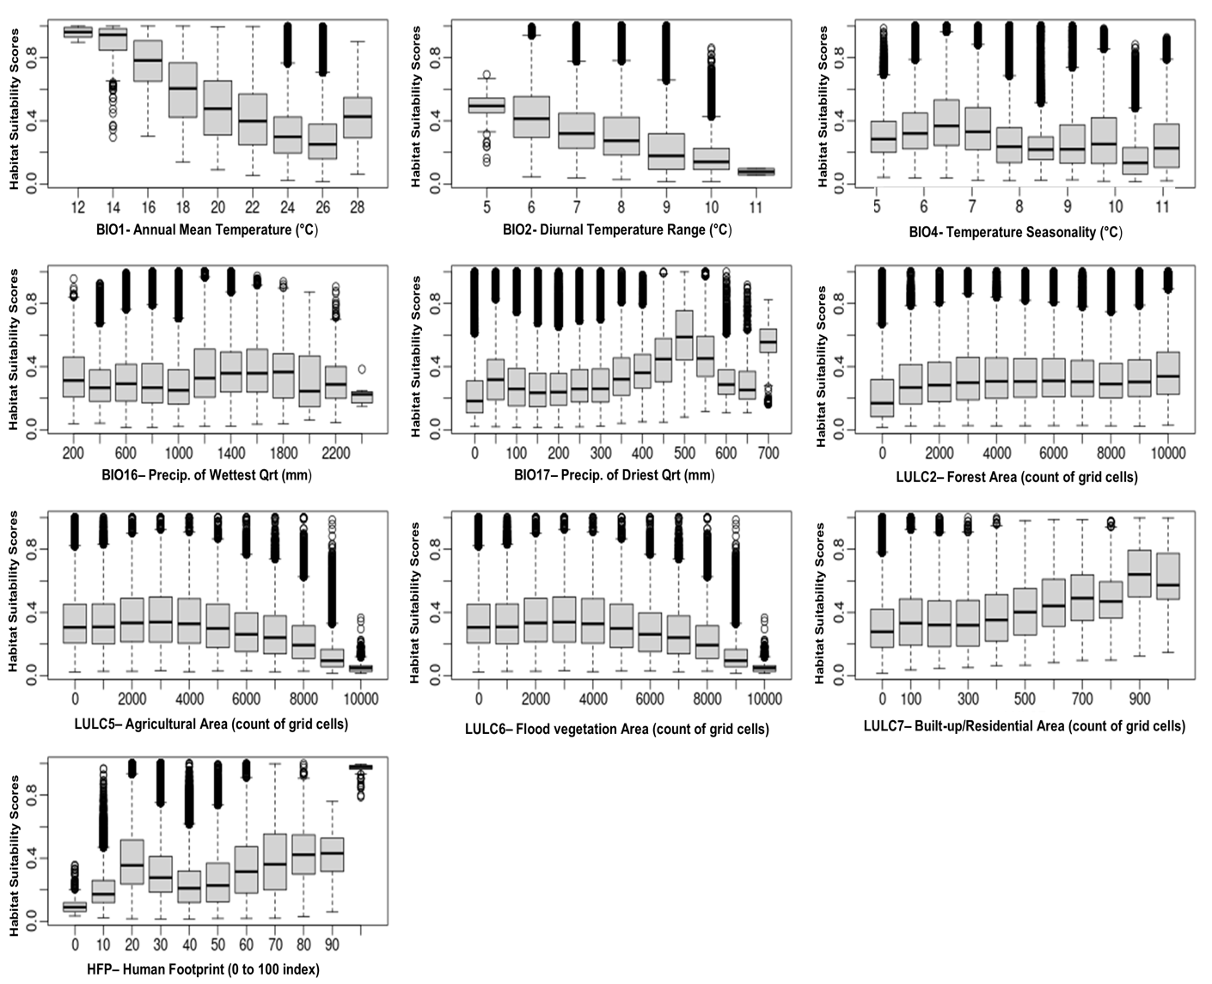

Supplemental Figure S3. Final environmental variables as predicted by the model to influence the habitat suitability of R. exulans.

R. exulans demonstrates a preference for cooler temperatures and moderate precipitation, favoring narrow diurnal temperature variations, yet exhibiting broad adaptability to seasonal temperature fluctuations. The species shows stable habitat suitability in moderately dense forests with increased suitability in denser forests. It prefers areas of low agricultural density and marginal flood vegetation plains, with suitability decreasing as agricultural density/flood vegetation plains increases. However, it displays adaptability to increasingly dense residential areas and a range of human activity levels.

