R. tanezumi

Supplemental Figure S2 presents boxplots demonstrating the distribution of environmental data and highlights the environmental variables identified by the model as influencing habitat suitability predictions for R. tanezumi. It shows how the species responds to different environmental factors.
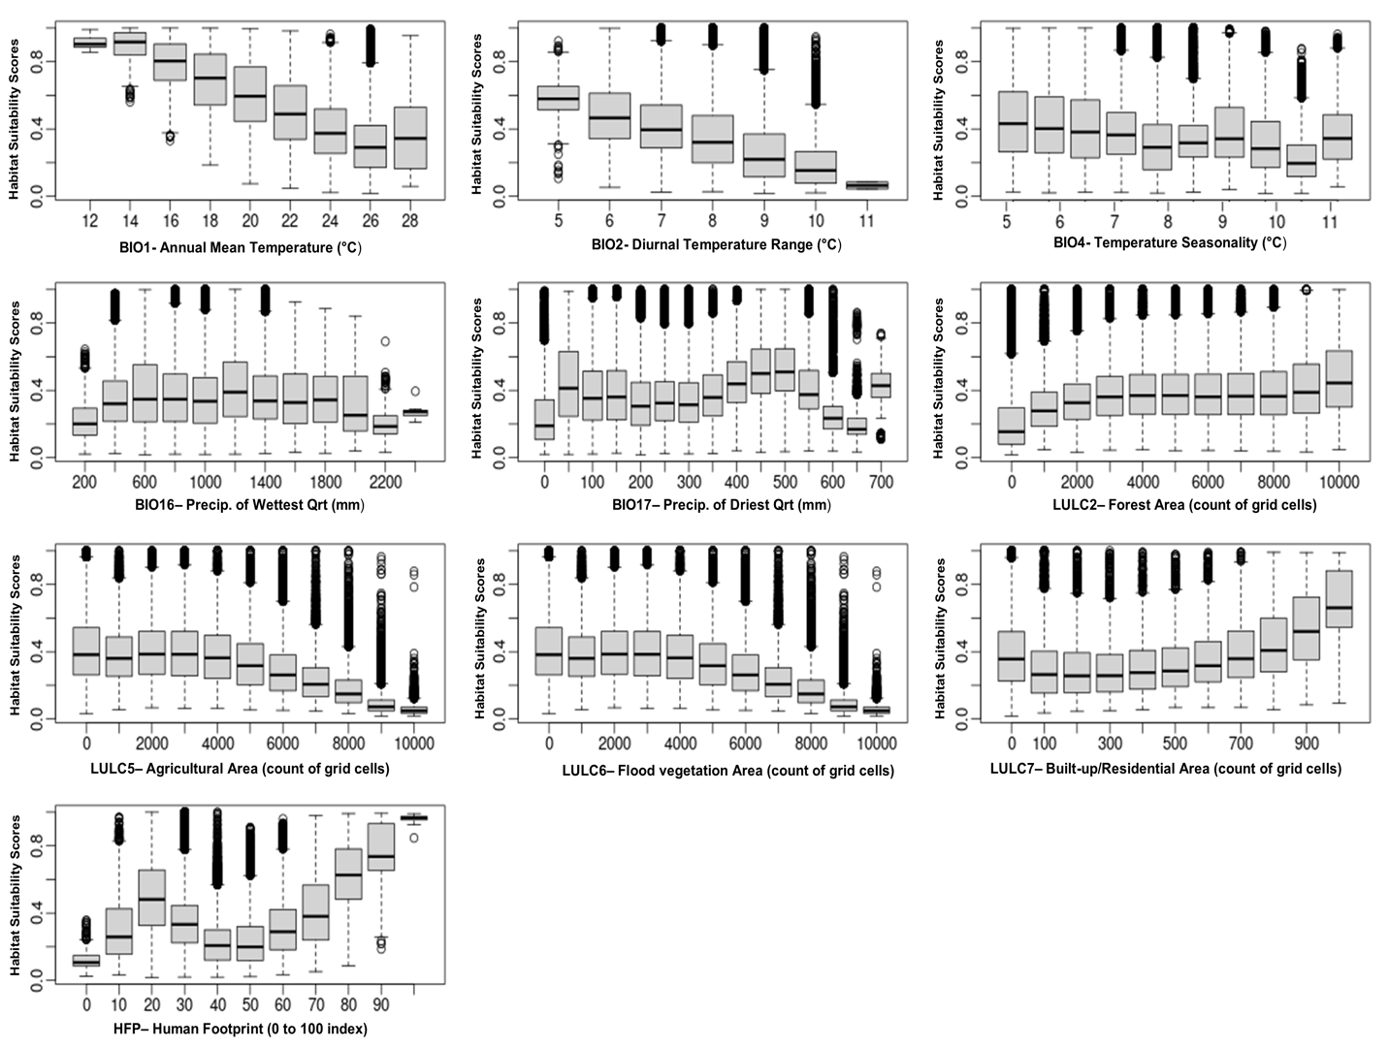

Supplemental Figure S2. Final Environmental variables as predicted by the model to influence the habitat suitability of R. tanezumi.

R. tanezumi exhibits a preference for cooler climates and moderate rainfall, favoring narrower diurnal temperature fluctuations while demonstrating adaptability to a wide range of seasonal temperature variations. The species is capable of inhabiting dense forests, areas of low agricultural density and marginal flood vegetation plains. Also it shows a broad spectrum of tolerance towards built-up/residential areas and human-induced disturbances.

