Analysis of species associations

Statistical analysis of species association indices

Supplementary material

S.1 A primer on Bayesian analysis
Bayesian analysis has become a powerful tool for an increasing number of scientific disciplines. Ecology is not an exception and the literature on Bayesian methods in Ecology is growing. Two examples are the books by McCarthy (2007) and King et al. (2010). In this section, we describe the general Bayesian inference mechanism; its application to the case of an association index is discussed in the main text.
In any statistical inference problem, the main source of information is a set of observed data x. These data are always assumed to be a random sample, in the sense that it was generated according to a probability distribution $p\left( x \right| θ )$. This model describes the variability that can be observed in the data given the value of the parameter $θ$. When its functional form of $p\left( x \right| θ )$ is known, the only quantity that must be studied to have a complete description of the underlying phenomena is precisely $θ$. Thus, in this parametric setting, we have a model that allows us to say what we can expect from the data given the (unknown) value of the parameter, and the goal of the researcher is to provide an answer to the inverse question. What can be said about the parameter given the data that have been observed? From a Bayesian point of view, the answer to this question is provided through another probability model, $p\left( θ \right| x )$, so that for any set $A$ (an interval, for example) the researcher can calculate $Pr\left( θ∈A \right| x )$, the probability that $θ$ belongs to $A$, given the observed data $x$. The main characteristic of this procedure is that $θ$ is treated as a random variable even though it is a fixed (but unknown) constant.
The Bayesian theory conceives the probability as a general measure of uncertainty, which can describe both the variability in the random sample and the lack of knowledge about the fixed value of the parameter. As for the specific mechanism to obtain this model, Bayes’ formula provides the solution:
$$p\left(θ \right| x )=\frac{p\left(x \right|θ)p(θ)}{p\left(x\right)} .$$
Since $p\left(x\right)$ does not depend on $θ$, it is quite common to write $p\left( θ \right| x ) ∝ p\left(θ\right)p\left( x \right| θ)$, where ∝ denotes “is proportional to”. The so-called posterior distribution $p\left( θ \right| x )$ describes what the researcher knows about $θ$ once the data $x$ are taken into account, and the calculation of $Pr\left( θ∈A \right| x )$ is then feasible for any set $A$. We stress that $θ$ is an unknown constant. In any case, to produce the posterior distribution we need $p\left( x \right| θ)$, the sampling model for the data, and $p\left(θ\right)$, known as the prior distribution of $θ$. This prior model describes the knowledge of the researcher about $θ$ before the data $x$ are available. The Bayes formula updates the prior distribution into the posterior distribution using the sampling model.
Sometimes, the researcher may have relevant knowledge about $θ$ before de data $x$ are collected. This knowledge can be incorporated into the study by tailoring the prior distribution to represent that information properly. However, in other situations, only a limited amount of prior information may be available, or a posterior distribution mostly based on the sample data $x$ may be required for some reason. Under such circumstances, the prior distribution is chosen to produce a posterior distribution mainly shaped by the sample. Prior distributions of this type are usually known as non-informative or reference priors and are commonly used in scientific research.

S.2 Some illustrative examples of frequency tables and their corresponding association indices

S.2.1 Synthetic data
Ecological indices measure a type of association that is not the same as stochastic dependence. In this section, we present four examples using synthetic data that illustrate how, for the same table of frequencies, some well-known ecological indices can suggest patterns that are different from those suggested by some popular statistical indices. The ecological indices considered are Ochiai, Dice, and Jaccard, whereas the statistical indices included for comparison are the Pearson correlation coefficient and the $H$ index.

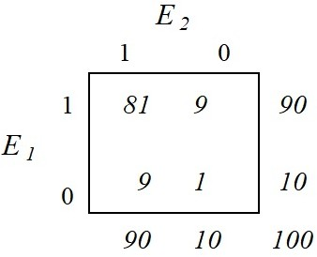
Table S1. Synthetic data for Example 1.

The first example is shown in Table S1, where the joint relative frequencies equal the product of the corresponding marginal relative frequencies. Consequently, these data strongly support the hypothesis of stochastic independence. In this case, the Pearson index is given by $R = 0$ while $H$ equals $0.64$.
On the other hand, the ecological indices take values that suggest a strong positive association. Specifically, $O = 0.9$ (Ochiai), $D = 0.9$ (Dice) and $J = 0.82$ (Jaccard).

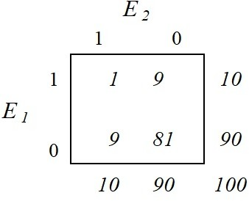
Table S2. Synthetic data for Example 2.

The second example (Table S2) also satisfies the product rule of stochastic independence, even though the frequencies $n_{00}$ and $n_{11}$ have been exchanged for each other. Here again $R = 0$ and $H = 0.64$, as expected. However, now we have $O=0.10$, $D=0.10$ and $J=0.05$. Permutation of the frequencies in the main diagonal of the table leads to ecological indices pointing towards no association.

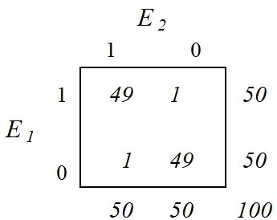
Table S3. Synthetic data for Example 3.

Example 3 (Table S3) concentrates almost all of the cases on the main diagonal, with both $n_{00}$ and $n_{11}$ large compared with the other frequencies. Here, from a statistical point of view, we have a strong positive association since $R=H=0.96$. On the other hand, the ecological indices take the following values: $O=0.98$, $D=0.98,$ and $J=0.96$. This is an instance of agreement between the two types of indices.

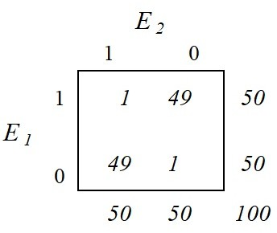
Table S4. Synthetic data for Example 4.

The last example (Table S4) is quite similar to the previous one, although the large frequencies are now located along the other diagonal of the table and thus suggest a strong negative statistical association. $R$ and $H$ confirm this since both take the value $-0.96$. In this case, $O=0.02$, $D=0.02,$ and $J=0.01$, strongly suggesting no association.

S.2.2 Real data examples
Here, we discuss two real data examples with a focus on the Ochiai and Pearson indices. These data come from Ludwig and Reynolds (1988, page 139), who study the presence-absence of eight species of trees at ten different locations (See Table S5). Note that we can get a $2 × 2$ array describing the association between any pair of species. Table S6 displays the Bur oak and Black oak data, whereas Table S7 shows the data for Red oak and American elm. The Ochiai index takes the same value for both tables, namely $O=0.82$. On the other hand, the Pearson index is $R=0.67$ for Table S6 and $R=-0.17$ for Table S7. These values were computed using the spaa R package (see Section S.1.4).

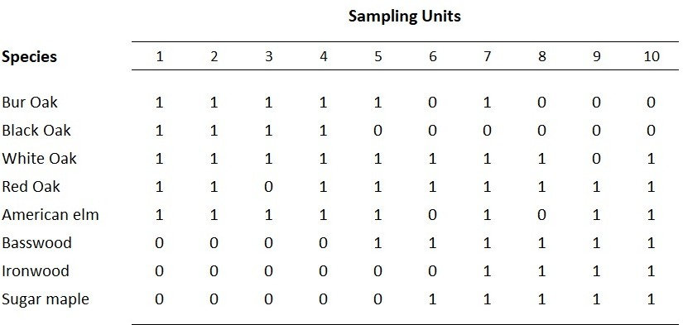
Table S5. Ecological data matrix of presence-absences for eight trees in 10 upland forest sampling units, southern Wisconsin. Source: Ludwig and Reynolds (1988, page 139).

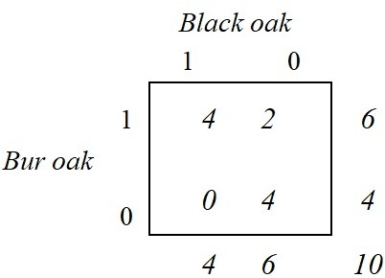
Table S6. Bur oak and Black oak, Wisconsin data (see Table S5).

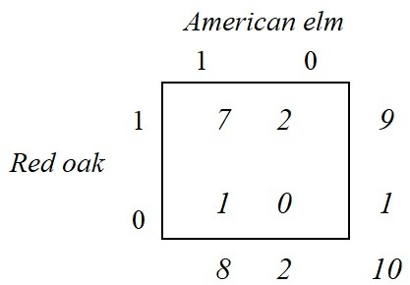
Table S7. Red oak and American elm, Wisconsin data (see Table S5).

The Bayesian analysis of these two cases yields the following results. For the data of Table S6, the point estimate of the Ochiai index is 0.75, with a 95% posterior probability interval given by (0.46, 0.94), while the point estimate of the Pearson index is 0.54 with a 95% posterior probability interval given by (0.09, 0.88). Now, for the data of Table S7, the point estimate of the Ochiai index is 0.78, with a 95% posterior probability interval given by (0.56, 0.94), while the point estimate of the Pearson index is 0 with a 95% posterior probability interval given by (-0.36, 0.55). These values were computed using our basa R package (see Section S.1.3).

The main conclusion is that the Ochiai index does not distinguish these two different cases. In fact, when analyzing these data, Ludwig and Reynolds compare $n_{11}$ with its (estimated) expected value under the hypothesis of independence. As a result, they conclude that since $n_{11}>E(n_{11})$ in the first case, the association may be positive between Burk oak and Black oak.
In the second case, given the opposite inequality, they report that the association between Red oak and American elm may be negative. Furthermore, these authors perform a Chi-square test of independence which, incidentally, may not be adequate given the small sample size and the occurrence of zeroes in the tables. They reject the independence hypothesis in the first case but not in the second case. For the sake of comparison, for each of these cases we carried out a Bayesian test of independence based on the mutual information (MI) as described in Gutiérrez-Peña and Mendoza (2017, Sect. 4.2). The results of these Bayesian tests are consistent with those reported by Ludwig and Reynolds (1988). The main point of these examples is to stress that the ecological indices measure some types of association between species that are different from the stochastic dependence described by the statistical indices.
Before closing this section, we note that the mutual information is defined as the Kullback-Leibler divergence between the joint density function and the product of the corresponding marginal density functions of two random variables (Cover and Thomas, 1991). It is always non-negative and is zero if and only if the two variables are stochastically independent. These properties make the MI a suitable statistical measure of association, and a good alternative to the Pearson correlation coefficient. We have implemented the MI in our R package basa.

S.2.3 A short tutorial on the use of the basa R package
Here we illustrate the use of the accompanying software, basa, using the Wisconsin tree data shown in Table S5 of this supplementary material. In particular, we show how to reproduce the results (including Figure 3) that support the discussion of Section 3.2 of the article. All the relevant files are available from the website https://lacb-inirena.mx/bayesian-analysis-of-species-associations/

Data formatting
We first load the basa package
> library(basa)

The file “trees.txt” contains the data shown in Table S5. We load this data into R
> pre.abs.data <- matrix(scan(file="trees.txt"),nrow=8,ncol=10,byrow=T)

and create a data frame
> pre.abs.df <-
data.frame(BurOak=pre.abs.data[1,],
BlackOak=pre.abs.data[2,],
WhiteOak=pre.abs.data[3,],
RedOak=pre.abs.data[4,],
AmericanElm=pre.abs.data[5,],
Basswood=pre.abs.data[6,],
Ironwood=pre.abs.data[7,],
SugarMaple=pre.abs.data[8,])

We can then display the data frame
> pre.abs.df
BurOak BlackOak WhiteOak RedOak AmericanElm Basswood Ironwood SugarMaple
1 1 1 1 1 1 0 0 0
2 1 1 1 1 1 0 0 0
3 1 1 1 0 1 0 0 0
4 1 1 1 1 1 0 0 0
5 1 0 1 1 1 1 0 0
6 0 0 1 1 0 1 0 1
7 1 0 1 1 1 1 1 1
8 0 0 1 1 0 1 1 1
9 0 0 0 1 1 1 1 1
10 0 0 1 1 1 1 1 1
Analysis of all of the available indices for the Bur Oak and Black Oak data
The following command will create a $2 × 2$ contingency table containing the frequencies corresponding to the Bur Oak and Black Oak species (see Table S6)

> BurOak.BlackOak.data <- con.tab(pre.abs.df["BurOak"],pre.abs.df["BlackOak"])
> BurOak.BlackOak.data
[1] 4 2 0 4

and similarly for the Red Oak and American Elm species (see Table S7).

> RedOak.AmericanElmOak.data <- con.tab(pre.abs.df["RedOak"],pre.abs.df["AmericanElm"])
> RedOak.AmericanElmOak.data
[1] 7 2 1 0

We then define the set of indices we wish to work with

> Indices <- c("dice","hamann","jaccard","mi","ochiai","pearson")

The following command display the posterior summary statistics than be used for the purposes of statistical inference on the association between Bur Oak and Black Oak

> results.table(BurOak.BlackOak.data,Indices)
Posterior summary statistics for each index:
mean median sd mad 2.5% 97.5%
dice 0.734 0.755 0.141 0.139 0.413 0.942
hamann 0.501 0.532 0.241 0.242 -0.040 0.880
jaccard 0.600 0.607 0.167 0.178 0.260 0.890
mi 0.192 0.177 0.121 0.129 0.006 0.457
ochiai 0.752 0.770 0.126 0.123 0.459 0.942
pearson 0.541 0.557 0.202 0.198 0.089 0.875

and similarly for Red Oak and American Elm

> results.table(RedOak.AmericanElm.data,Indices)
Posterior summary statistics for each index:
mean median sd mad 2.5% 97.5%
dice 0.780 0.795 0.104 0.100 0.539 0.939
hamann 0.334 0.359 0.261 0.270 -0.211 0.781
jaccard 0.651 0.659 0.135 0.143 0.369 0.884
mi 0.029 0.014 0.043 0.018 0.000 0.146
ochiai 0.787 0.801 0.100 0.097 0.558 0.938
pearson 0.005 -0.044 0.235 0.205 -0.360 0.552

In what follows, we will only illustrate the use of basa using the pair Bur Oak and Black Oak. Similar command can produce the corresponding results for the pair Red Oak and American Elm.

The following command displays the Pearson correlation matrix for pairs of indices

> corrmat.pearson(BurOak.BlackOak.data,Indices)
Pearson correlation matrix:
dice hamann jaccard mi ochiai
hamann 0.866 NA NA NA NA
jaccard 0.991 0.874 NA NA NA
mi 0.801 0.880 0.839 NA NA
ochiai 0.994 0.867 0.986 0.823 NA
pearson 0.853 0.947 0.853 0.941 0.875

and the corresponding (more robust) Spearman correlation matrix

> corrmat.spearman(BurOak.BlackOak.data,Indices)
Spearman correlation matrix:
dice hamann jaccard mi ochiai
hamann 0.883 NA NA NA NA
jaccard 1.000 0.885 NA NA NA
mi 0.848 0.923 0.840 NA NA
ochiai 0.997 0.879 0.997 0.859 NA
pearson 0.873 0.963 0.863 0.990 0.877

Analysis of all pairs of species with Ochiai index
basa is also able to provide summary statistics that allow one to carry our simultaneous inferences for all the species of interest for a given index. In the following example, we use the Ochiai index.

Posterior means and standard deviations of the Ochiai index for all species.

> posterior.means(pre.abs.df,"ochiai")
Posterior means for all species:
BurOak BlackOak WhiteOak RedOak AmericanElm Basswood Ironwood
BlackOak 0.755 NA NA NA NA NA NA
WhiteOak 0.770 0.626 NA NA NA NA NA
RedOak 0.651 0.484 0.846 NA NA NA NA
AmericanElm 0.813 0.662 0.786 0.786 NA NA NA
Basswood 0.348 0.082 0.650 0.771 0.559 NA NA
Ironwood 0.246 0.097 0.486 0.627 0.510 0.752 NA
SugarMaple 0.226 0.088 0.570 0.703 0.472 0.844 0.816

> posterior.sds(pre.abs.df,"ochiai")
Posterior standard deviations for all species:
BurOak BlackOak WhiteOak RedOak AmericanElm Basswood Ironwood
BlackOak 0.127 NA NA NA NA NA NA
WhiteOak 0.104 0.127 NA NA NA NA NA
RedOak 0.126 0.145 0.085 NA NA NA NA
AmericanElm 0.099 0.128 0.100 0.100 NA NA NA
Basswood 0.153 0.098 0.126 0.102 0.141 NA NA
Ironwood 0.151 0.110 0.143 0.127 0.148 0.128 NA
SugarMaple 0.140 0.106 0.136 0.117 0.147 0.104 0.120

Posterior medians and median absolute deviations of the Ochiai index for all species. These provide robust versions of the means and standard deviations displayed above.

> posterior.medians(pre.abs.df,"ochiai")
Posterior medians for all species:
BurOak BlackOak WhiteOak RedOak AmericanElm Basswood Ironwood
BlackOak 0.770 NA NA NA NA NA NA
WhiteOak 0.784 0.639 NA NA NA NA NA
RedOak 0.661 0.491 0.861 NA NA NA NA
AmericanElm 0.829 0.676 0.800 0.800 NA NA NA
Basswood 0.340 0.043 0.663 0.783 0.568 NA NA
Ironwood 0.225 0.054 0.490 0.637 0.520 0.771 NA
SugarMaple 0.202 0.048 0.585 0.714 0.471 0.866 0.838

> posterior.mads(pre.abs.df,"ochiai")
Posterior median absolute deviations for all species:
BurOak BlackOak WhiteOak RedOak AmericanElm Basswood Ironwood
BlackOak 0.1245 NA NA NA NA NA NA
WhiteOak 0.0983 0.129 NA NA NA NA NA
RedOak 0.1287 0.152 0.079 NA NA NA NA
AmericanElm 0.0939 0.132 0.097 0.095 NA NA NA
Basswood 0.1620 0.059 0.127 0.100 0.146 NA NA
Ironwood 0.1602 0.071 0.152 0.126 0.153 0.126 NA
SugarMaple 0.1473 0.064 0.143 0.117 0.160 0.094 0.111

Joint analysis of the Ochiai and Pearson indices for the BurOak vs BlackOak data
Finally, we show how to carry out the joint analysis of the Ochiai and Pearson indices using the basa function psai2.

The following command will compute and display marginal summary statistics (mean, standard deviation, median, median absolute deviation, credible intervals for each of the Ochiai and Pearson indices. In addition, it will display both Pearson and Spearman correlation coefficients between those indices and produce a graph that includes the histograms of the marginal posterior distributions of each index and a scatter plot representing the joint posterior distribution of both indices.

> psai2(ochiai,pearson,BurOak.BlackOak.data)
$Index1
$Index1$name
[1] "ochiai"

$Index1$mean
[1] 0.750

$Index1$median
[1] 0.768

$Index1$sd
[1] 0.128

$Index1$mad
[1] 0.127

$Index1$interval
2.5% 97.5%
0.455 0.943

$Index2
$Index2$name
[1] "pearson"

$Index2$mean
[1] 0.537

$Index2$median
[1] 0.554

$Index2$sd
[1] 0.202

$Index2$mad
[1] 0.201

$Index2$interval
2.5% 97.5%
0.0829 0.8652

$Correlation
$Correlation$pearson
[1] 0.871

$Correlation$spearman
[1] 0.880

Further details of these and all available functions can be found the basa manual, available at https://lacb-inirena.mx/bayesian-analysis-of-species-associations/.

S.2.4 Comparison with a frequentist analysis using the spaa R package
In this section, we re-analyze the Wisconsin tree data (shown in Table S5 of this supplementary material) using the spaa package (Zhang and Ma 2014).

The following command computes frequentist point estimates of various associations indices between each pair of species, including the V ratio, Jaccard, Ochiai, Dice and Pearson indices, among others. For the sake of comparison with the results of Section S.1.3, here we only display the results for the Ochiai and Pearson indices.

> sp.pair(pre.abs.df)
$Ochiai
BurOak BlackOak WhiteOak RedOak AmericanElm Basswood Ironwood SugarMaple
BurOak 1.000 0.816 0.816 0.680 0.866 0.333 0.204 0.183
BlackOak 0.816 1.000 0.667 0.500 0.707 0.000 0.000 0.000
WhiteOak 0.816 0.667 1.000 0.889 0.825 0.680 0.500 0.596
RedOak 0.680 0.500 0.889 1.000 0.825 0.816 0.667 0.745
AmericanElm 0.866 0.707 0.825 0.825 1.000 0.577 0.530 0.474
Basswood 0.333 0.000 0.680 0.816 0.577 1.000 0.816 0.913
Ironwood 0.204 0.000 0.500 0.667 0.530 0.816 1.000 0.894
SugarMaple 0.183 0.000 0.596 0.745 0.474 0.913 0.894 1.000

$Pearson
BurOak BlackOak WhiteOak RedOak AmericanElm Basswood Ironwood SugarMaple
BurOak 1.000 0.667 0.408 -0.272 0.612 -0.667 -0.583 -0.816
BlackOak 0.667 1.000 0.272 -0.408 0.408 -1.000 -0.667 -0.816
WhiteOak 0.408 0.272 1.000 -0.111 -0.167 -0.272 -0.408 -0.333
RedOak -0.272 -0.408 -0.111 1.000 -0.167 0.408 0.272 0.333
AmericanElm 0.612 0.408 -0.167 -0.167 1.000 -0.408 -0.102 -0.500
Basswood -0.667 -1.000 -0.272 0.408 -0.408 1.000 0.667 0.816
Ironwood -0.583 -0.667 -0.408 0.272 -0.102 0.667 1.000 0.816
SugarMaple -0.816 -0.816 -0.333 0.333 -0.500 0.816 0.816 1.000

It must be pointed out that spaa only provides point estimates of the association indices. No assessment of the variability of these values (standard deviations or confidence intervals) is provided by the software.

References
Cover TM and Thomas JA (1991). Elements of Information Theory. Wiley, New York.
Gutiérrez-Peña E and Mendoza M (2017). Bayesian Methods for Categorical Data. In Wiley StatsRef: Statistics Reference Online. DOI:10.1002/9781118445112.stat06134.pub2.
King R, Morgan BJT, Gimenez O and Brooks SP (2010). Bayesian Analysis for Population Ecology. Chapman & Hall, Boca Raton.
Ludwig JA and Reynolds JF (1988). Statistical Ecology. A Primer on Methods and Computing. Wiley, New York
McCarthy MA (2007). Bayesian Methods for Ecology. Cambridge University Press, Cambridge.
R Core Team (2020). R: A language and environment for statistical computing. R Foundation for Statistical Computing, Vienna, Austria. URL https://www.R-project.org/.
Zhang JL and Ma KP (2014) spaa: An R package for computing species association and niche overlap. Research Progress of Biodiversity Conservation in China X, 165–174 (in Chinese)

