**Appendix 1 Concept map of the IHTAM framework**

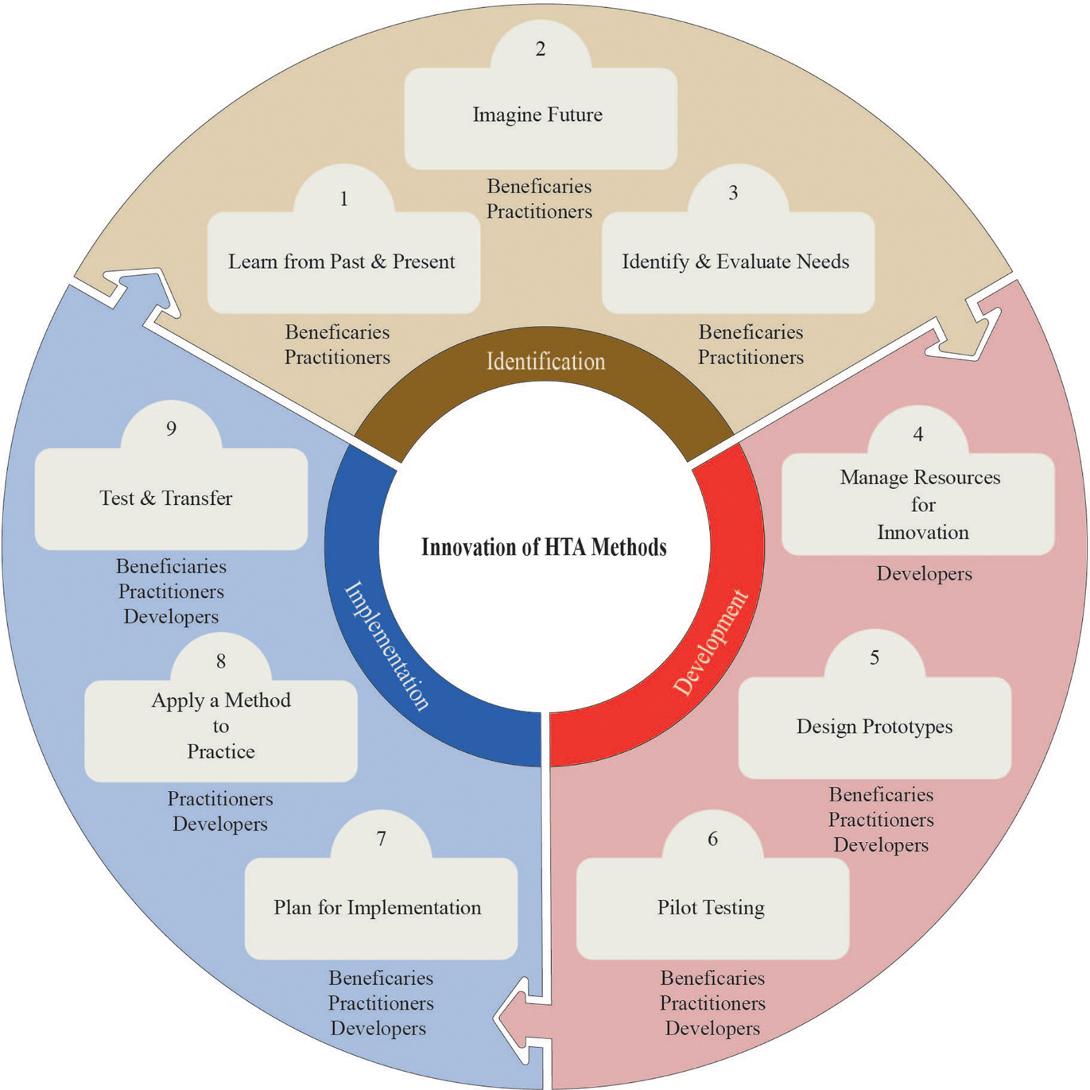

**Appendix 2 Examples on how HTA stakeholders participates in the three cases**

|  |  |  |  |
| --- | --- | --- | --- |
| **Who** | **HTA stakeholder group** | **Role** | **Example tasks** |
| **Case 1** | Researcher (n=3) | Developer | * Presentation * Technical assistance |
| Patient and clinician (NR) | Practitioner | * Application of the NTCP model using data from various countries for patient selection |
| HTA agency (n=1) | Beneficiary | * Application of the health economics models using data from various countries for HTA/reimbursement decision making |
| **Case 2** | Researcher (n=2) | Developer | * Identification of needs to implement patient subgroups and risk prediction models in a decision support tool |
| HTA agency (n=4) | Beneficiary | * Identification of outcomes of interest * Requirements about open source software * Explainability of methods * Interest of application to specific subgroups |
| HTA researcher (n=3) | Practitioner | * Expressed their needs for case study methods * Input in modelling (reviewed confounders / covariate lists) |
| Patient association (n=1) | Beneficiary | * Attended our presentations * Provided feedback * Expressed needs for case study methods * Evaluated how to tailor the methods to local contexts and whether the tailored method could be adopted. |
| **Case 3** | HTA researcher (n=3) | Developer | * Learned about limitations of current HTA processes * Identified available methods * Conducted literature reviews * Assessed what needs to be done for existing methods to be widely used in HTA. * Identified needs of stakeholders by presenting work and seeking help in constructing models |
| Clinician (n=4) | Developer | * Expressed their needs for case study methods * Input in modelling (reviewed confounders / covariate lists) |
| HTA researchers, Patients and HTA agencies (NR) | Practitioner and Beneficiary | * Attended presentations * Provided feedback during presentations * Expressed needs for case study methods * Evaluated how to tailor the methods to local contexts and whether the tailored method could be adopted |

*Note* NR indicate the number of stakeholders are not reported.

**Appendix 3 Flow diagram illustrating the use of the IHTAM roadmap**

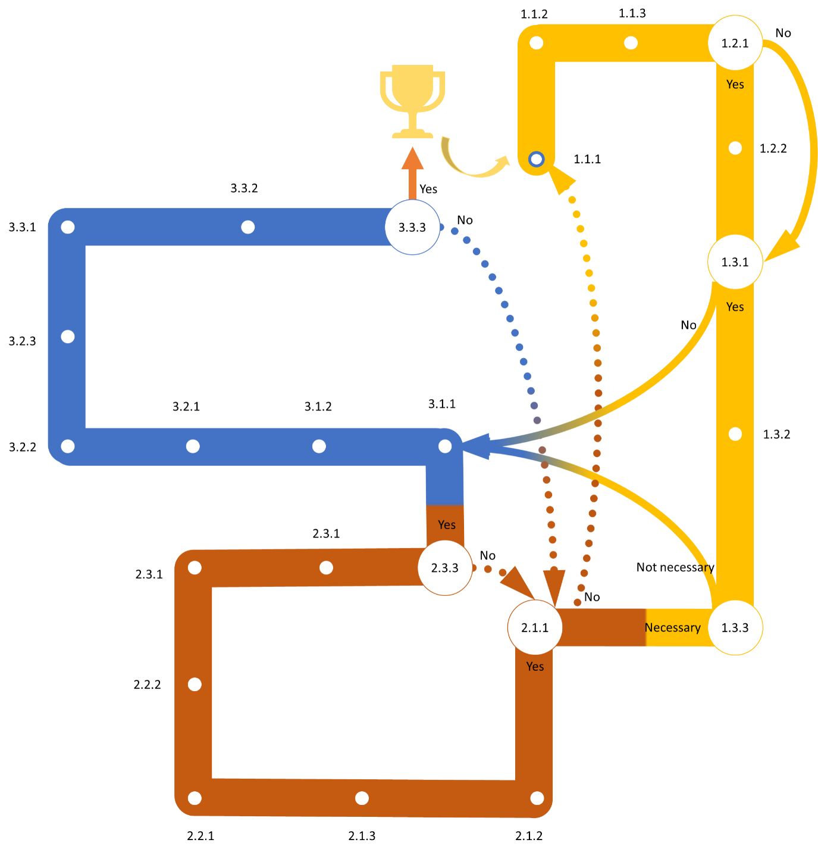

*Note*The three-digit numbers indicate the roadmap items: the first digit indicates the three innovation phases (i.e. “Identification”, “Development”, “Implementation”), which are colored in yellow, red, and blue, respectively; the second digit, the nine subphases (e.g. “Learn from past & present” and “Imagine future”); the third digit, the specific items of a (sub)phase. The hollow circles indicate the items linked to the loop structure: e.g., if needs for a novel HTA method is identified (Item 1.3.1), users may manage resources needed for method development (Item 1.3.2); otherwise, user may jump to Item 3.1.1, to plan for implementation of an existing method. The arrows indicate the loop structure: solid arrows, going forward; dashed arrows, going back.