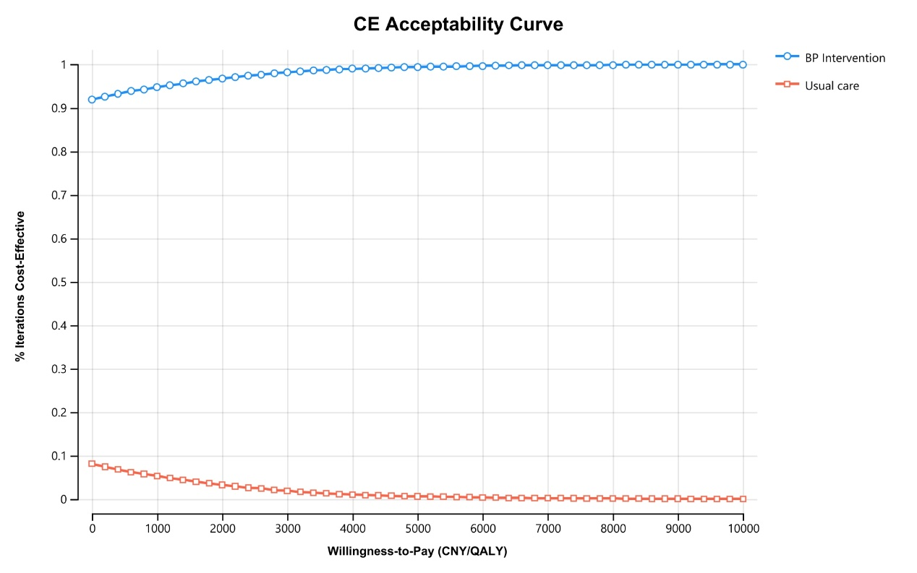

**Supplementary Figure 1. Cost-effectiveness acceptability curve.** It is evident that whatever the WTP threshold is, BP intervention always has higher acceptability. CE, cost effectiveness; CNY, Chinese Yuan; QALY, quality-adjusted life year; BP, blood pressure.

**Supplementary Table 1**: Comparison of cardiovascular event rates between cohort study and Markov simulation.

|  |  |  |  |  |
| --- | --- | --- | --- | --- |
|  | Control | | BP intervention | |
| 3-year CV event rate | CRHCP trial1, 2 | Markov simulation | CRHCP trial | Markov simulation |
| All cause death | 4.7% | 4.7% | 4.0% | 4.0% |
| MI | 0.8% | 0.7% | 0.6% | 0.6% |
| HF | 0.4% | 0.4% | 0.3% | 0.3% |
| Stroke | 5.4% | 5.2% | 3.7% | 3.6% |
| 10-year CV event rate | Kailuan cohort3 | Markov simulation |  | |
| All cause death | 12.7% | 14.8% |
| MI | 1.9% | 2% |
| HF | / | 1.2% |
| Stroke | / | 14.4% |

CV, Cardiovascular; CRHCP, China Rural Hypertension Control Project; BP, Blood pressure; MI, Myocardial infarction; HF, Heart failure.

1. Sun Y, Mu J, Wang DW, et al. A village doctor-led multifaceted intervention for blood pressure control in rural China: an open, cluster randomised trial. *Lancet* 2022; 399: 1964-1975. 2022/05/03. DOI: 10.1016/s0140-6736(22)00325-7.

2. He J, Ouyang N, Guo X, et al. Effectiveness of a non-physician community health-care provider-led intensive blood pressure intervention versus usual care on cardiovascular disease (CRHCP): an open-label, blinded-endpoint, cluster-randomised trial. *Lancet* 2023 2023/03/06. DOI: 10.1016/s0140-6736(22)02603-4.

3. Peng X, Jin C, Song Q, et al. Stage 1 Hypertension and the 10-Year and Lifetime Risk of Cardiovascular Disease: A Prospective Real-World Study. *Journal of the American Heart Association* 2023; 12: e028762. 20230328. DOI: 10.1161/jaha.122.028762.