Supplementary material for:
Jones, B., Ryan, M., Cook, N.S. and Gutzwiller, F.S. (2023)
Development of a Disease-Specific Health Utility Score for Chronic Obstructive Pulmonary Disease from a Discrete Choice Experiment Patient Preference Study.
Submitted to International Journal of Technology Assessment in Health Care.

Supplementary Table S1: Example of a DCE choice set
Attribute | Patient A |  | Patient B
Shortness of breath.  On a typical day: | You experience shortness of breath when washing (e.g., taking a shower) or dressing |  | You experience shortness of breath when sitting or lying down
Cough.  On a typical day: | Your cough does not interrupt/disturb any of your usual activities |  | Your cough interrupts/disturbs most of your usual activities
Incontinence.  On a typical day: | Your COPD symptoms are causing a few drops of urine leakage |  | Your COPD symptoms are causing a few drops of urine leakage
Mucus.  On a typical morning: | It is not at all difficult to bring up mucus |  | It is a little difficult to bring up mucus
Sleep quality.  When waking up on a typical morning: | You feel rested |  | You do not feel rested at all
Exacerbations.  During a typical year: | You never experience any COPD flare-ups/ exacerbations |  | You experience one or more COPD flare-ups/exacerbations that require a hospital stay or visit

COPD indicates Chronic Obstructive Pulmonary Disease; DCE, Discrete Choice Experiment

Supplementary Table S2. Relative importance (%) of each attribute in each country
 | Country
Attribute | Australia | France | Japan | UK | USA
Shortness of breath | 20.44 | 25.07 | 15.82 | 18.69 | 16.42
Cough | 12.33 | 11.21 | 5.46 | 4.79 | 9.22
Urinary incontinence | 14.88 | 17.80 | 17.58 | 22.40 | 13.68
Mucus clearance | 13.43 | 10.69 | 11.34 | 12.69 | 12.71
Sleep quality | 18.84 | 16.32 | 24.42 | 14.07 | 24.25
Exacerbations | 20.08 | 18.91 | 25.38 | 27.37 | 23.71

Supplementary Table S3: Comorbidities of patients in COPD self-perceived severity subgroups

Condition | Mild | Moderate | Severe | Very Severe
Anemia (%) | 9 | 5 | 7 | 5
Mini-stroke (%) | 5 | 4 | 4 | 3
Congestive Heart Failure (%) | 10 | 6 | 7 | 12
Gastroesophageal reflux disease (%) | 29 | 19 | 23 | 22
Malnutrition (%) | 4 | 1 | 0 | 5
Osteoporosis (%) | 14 | 13 | 20 | 19
Peptic Ulcer (%) | 5 | 1 | 1 | 0
Vascular disease (%) | 8 | 3 | 3 | 4
Rheumatological disease (%) | 16 | 14 | 17 | 12
Mean EQ-5D-3L score | 0.69 | 0.68 | 0.56 | 0.38
Mean COPD utility score | 0.74 | 0.68 | 0.54 | 0.46
Sample size | 116 | 563 | 297 | 74
Supplementary Table S4: Mean EQ-5D-3L score and mean COPD health utility score within each comorbidity subgroup

Comorbidity | Present | Sample size | Mean EQ-5D-3L | Mean COPD utility
Anemia | Yes | 66 | 0.42 | 0.55
 | No | 984 | 0.64 | 0.64
Malnutrition | Yes | 15 | 0.10 | 0.46
 | No | 1035 | 0.63 | 0.63
Congestive Heart Failure | Yes | 75 | 0.41 | 0.53
 | No | 975 | 0.64 | 0.64
Gastroesophageal reflux disease | Yes | 823 | 0.56 | 0.59
 | No | 227 | 0.65 | 0.64
Mini stroke | Yes | 45 | 0.44 | 0.59
 | No | 1005 | 0.64 | 0.63
Osteoporosis | Yes | 164 | 0.52 | 0.58
 | No | 886 | 0.65 | 0.64
Peptic Ulcer | Yes | 15 | 0.15 | 0.46
 | No | 1035 | 0.63 | 0.63
Vascular disease | Yes | 41 | 0.33 | 0.53
 | No | 1009 | 0.64 | 0.63
Rheumatological disease | Yes | 157 | 0.49 | 0.58
 | No | 893 | 0.65 | 0.64
COPD indicates Chronic Obstructive Pulmonary Disease

Supplementary Table S5: Multinomial logistic regression (MNL) solution
Attribute | Level and level definition | MNL Estimate | Std Error | 95% confidence interval | COPD utility weight
Shortness of breath | 1. Shortness of breath experienced during strenuous activity (e.g., walking uphill / upstairs). | 0.510 | 0.035 | (0.442, 0.578) | 0.192
 | 2. Shortness of breath experienced during light activity (e.g., a short walk on level ground). | 0.432 | 0.035 | (0.363, 0.500) | 0.163
 | 3. Shortness of breath experience when washing (e.g., taking a shower) or dressing. | 0.255 | 0.035 | (0.187, 0.323) | 0.096
 | 4*. Shortness of breath experienced at rest (e.g., when sitting or lying down). | 0 | - | - | 0
Cough | 1. Cough does not interrupt/disturb any of your usual activities. | 0.216 | 0.028 | (0.161, 0.272) | 0.082
 | 2. Cough interrupts/disturbs some usual activities. | 0.119 | 0.028 | (0.063, 0.174) | 0.045
 | 3*. Cough interrupts/disturbs most usual activities. | 0 | - | - | 0
Incontinence | 1. COPD symptoms do not cause any urine leakage. | 0.424 | 0.029 | (0.368, 0.480) | 0.160
 | 2. COPD symptoms are causing a few drops of urine leakage. | 0.328 | 0.028 | (0.272, 0.383) | 0.123
 | 3*. COPD symptoms are causing urine leakage which makes underwear wet. | 0 | - | - | 0
Mucus  clearance | 1. It is not at all difficult to bring up mucus. | 0.354 | 0.028 | (0.298, 0.410) | 0.133
 | 2. It is a little difficult to bring up mucus. | 0.262 | 0.028 | (0.206, 0.318) | 0.099
 | 3*. It is very difficult to bring up mucus. | 0 | - | - | 0
Sleep disturbance | 1. On waking feel rested. | 0.532 | 0.028 | (0.477, 0.588) | 0.201
 | 2. On waking feel somewhat rested. | 0.389 | 0.028 | (0.333 0.444) | 0.146
 | 3*. On waking do not feel rested at all. | 0 | - | - | 0
Exacerbations | 1. Never experience any COPD flare-ups/exacerbations. | 0.617 | 0.029 | (0.560, 0.673) | 0.232
 | 2. Experience one or more COPD flare-ups/exacerbations that require antibiotics/steroids. | 0.435 | 0.028 | (0.379, 0.490) | 0.164
 | 3*. Experience one or more COPD flare-ups/exacerbations that require a hospital stay or visit. | 0 | 0 | - | 0

Supplementary Figure S1: Relative importance of attributes based on RPL model

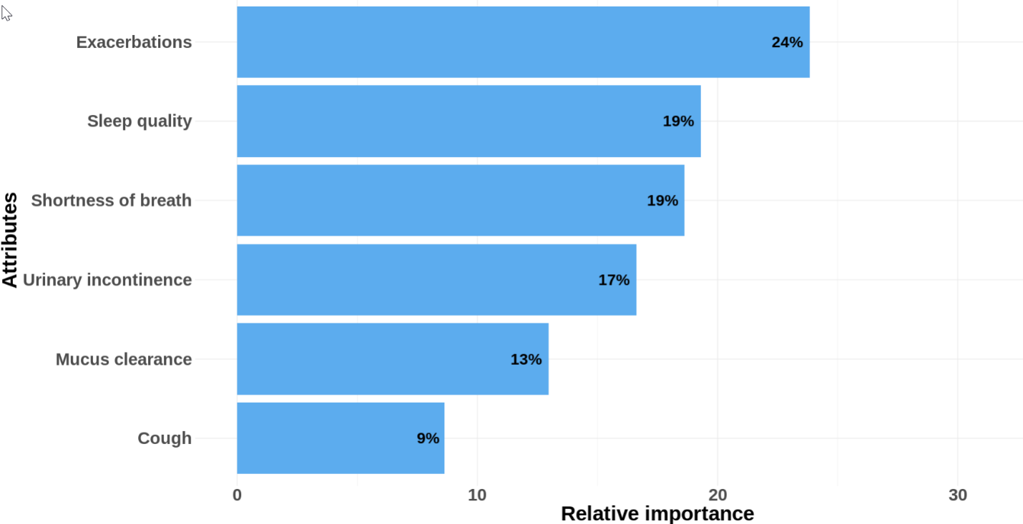

Supplementary Figure S2: Density plots for EQ-5D (3L) and COPD health utility scores for patient with negative EQ-5D (3L) scores

