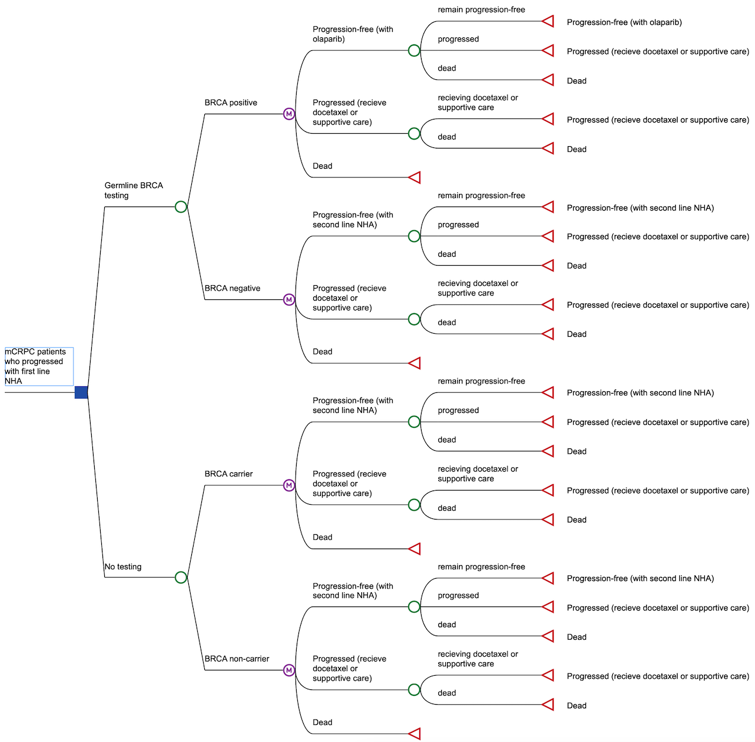

Figure S1. Detailed schematic of the model

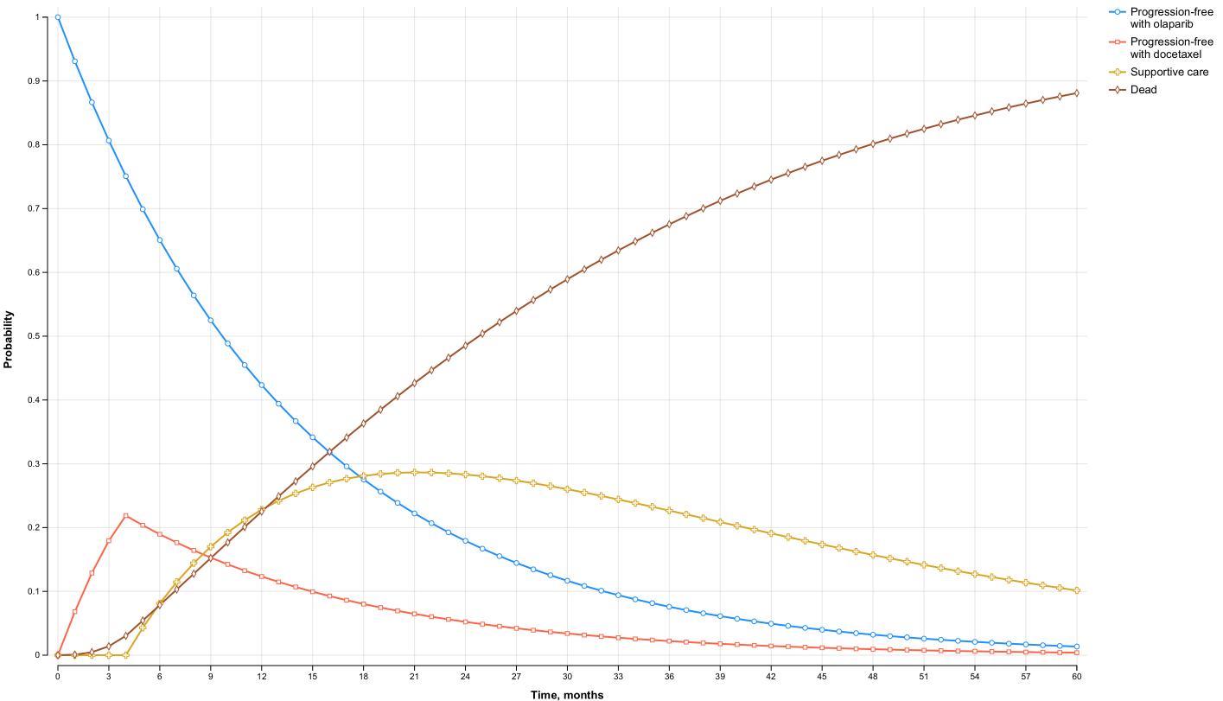

Figure S2. Markov traces for BRCA positive patients receiving olaparib treatment

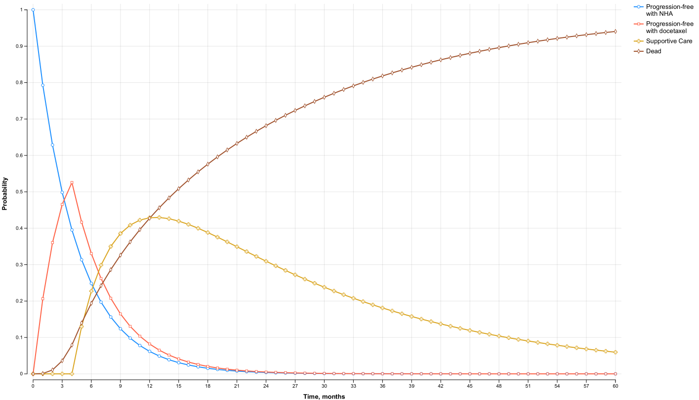

Figure S3. Markov traces for BRCA carriers receiving NHA treatment

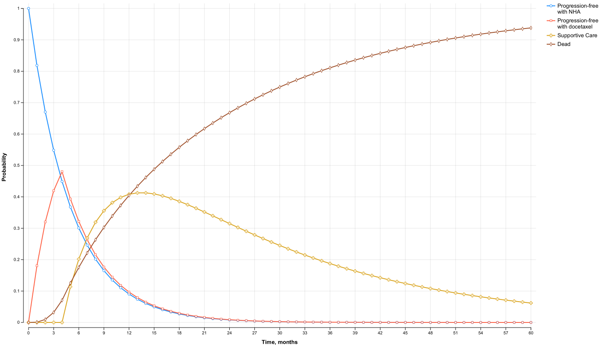

Figure S4. Markov traces for BRCA negative/non-carriers receiving NHA treatment

Figure S5. Change in incremental cost-effectiveness ratio (ICER) with reduction in olaparib cost.

