Supplementary material

## **S1. Clay samples**

Table S1 gives a short description of the raw material samples collected for this study. Figure S1 presents the plot of the clay samples when projected onto the PCA biplot carried out in this analysis. Note that the clay samples are only supplementary individuals and therefore do not impact the PCA analysis.

|  |  |  |  |
| --- | --- | --- | --- |
|  | **Location** | **Island** | **Type of raw material** |
| DLA.A | Kalanka, Delimara | Malta | Red soil, erosion of Globigerina limestone |
| FC.A | Fort Chambray, Għajnsielem | Gozo | Blue Clay, sample from slope |
| GH.A | Gelmus Hill, Rabat | Gozo | Blue Clay, sample from hill (elevation: 85m) |
| GH.B | Gelmus Hill, Rabat | Gozo | Blue Clay, sample from hill, mid-slope [(Asciak 2019, 54, sample 1)](https://www.zotero.org/google-docs/?7esWv9) |
| GH.C | Gelmus Hill, Rabat | Gozo | Blue Clay, sample from hill (elevation: 100m), close to the Greensand layer [(Asciak 2019, 54, sample 2)](https://www.zotero.org/google-docs/?tg0RSn) |
| GNB.B | Ġnejna Bay, Mġarr | Malta | Marly interbed from slope, within Globerigina limestone |
| GNB.D | Ġnejna Bay, Mġarr | Malta | Blue Clay from slope |
| GNB.E | Ġnejna Bay, Mġarr | Malta | Marly interbed within Globigerina limestone |
| GT.A | Għajn Tuffieħa, Mġarr | Malta | Blue Clay (elevation: 31m) from densely vegetated area |
| GT.B | Għajn Tuffieħa, Mġarr | Malta | Blue Clay (elevation: 28 m) |
| LP.A | Ta' Lippija, Mġarr | Malta | Terra Rossa, Upper Coralline Limestone |
| LP.E | Ta' Lippija, Mġarr | Malta | Terra Rossa, Upper Coralline Limestone |
| MG.A | Imġiebaħ, Selmun | Malta | Blue Clay? Clayey deposit, both Globigerina marl and Blue Clay present |
| MG.B | Imġiebaħ, Selmun | Malta | Blue Clay? Clayey deposit, both Globigerina marl and Blue Clay present |
| MX.A | Marsaxlokk | Malta | Soil eroded from Middle Globigerina marl |
| MX.D | Marsaxlokk | Malta | Soil eroded from Middle Globigerina marl, waterlogged |
| NF.A | In-Nuffara, Nadur | Gozo | Blue Clay, sample from hill (elevation: 27m) |
| NF.B | In-Nuffara, Nadur | Gozo | Blue Clay, sample from hill (elevation: 27m) |
| QL.A | Il-Qolla, Rabat | Malta | Blue Clay, sample from hill (elevation: 189m) |
| QL.B | Il-Qolla, Rabat | Malta | Blue Clay, sample from hill (elevation: 187 m) |
| QR.A | Il-Qarraba, Mġarr | Malta | Blue Clay, from the sea bed |
| QR.C | Il-Qarraba, Mġarr | Malta | Blue Clay from slope, rich in iron inclusions |
| QR.D | Il-Qarraba, Mġarr | Malta | Blue Clay from slope, below posidonia banquette |
| RIH.A | Ras il-Ħamrija, Qrendi | Malta | Blue Clay |
| RIH.B | Ras il-Ħamrija, Qrendi | Malta | Blue Clay, from the top of RIH, top of slope |
| RIH.D | Ras il-Ħamrija, Qrendi | Malta | Blue Clay, bottom of slope, within fault |
| RML.B | Ramla Bay, Xagħra | Gozo | Blue Clay, eastern part of Ramla Bay, bottom slope |
| RML.D | Ramla Bay, Xagħra | Gozo | Blue Clay, eastern part of Ramla Bay, bottom slope |
| RML.E | Ramla Bay, Xagħra | Gozo | Blue Clay from slope, clay running of from the slope after a storm, mixed with sand |
| SLF.A | Fort Leonard, Żabbar | Malta | Clay from ditch surrounding the fort, San Leonardo Beds |
| SLF.B | Fort Leonard, Żabbar | Malta | Clay from ditch surrounding the fort, San Leonardo Beds |
| TL.A | Ta' Leveċa, Għasri | Gozo | Blue Clay, sample from hill (elevation: 40m) |
| TL.B | Ta' Leveċa, Għasri | Gozo | Blue Clay, sample from hill (elevation: 30m) |

**Table S1.** Geological samples for this study; codes referred to in Figure 8*.*

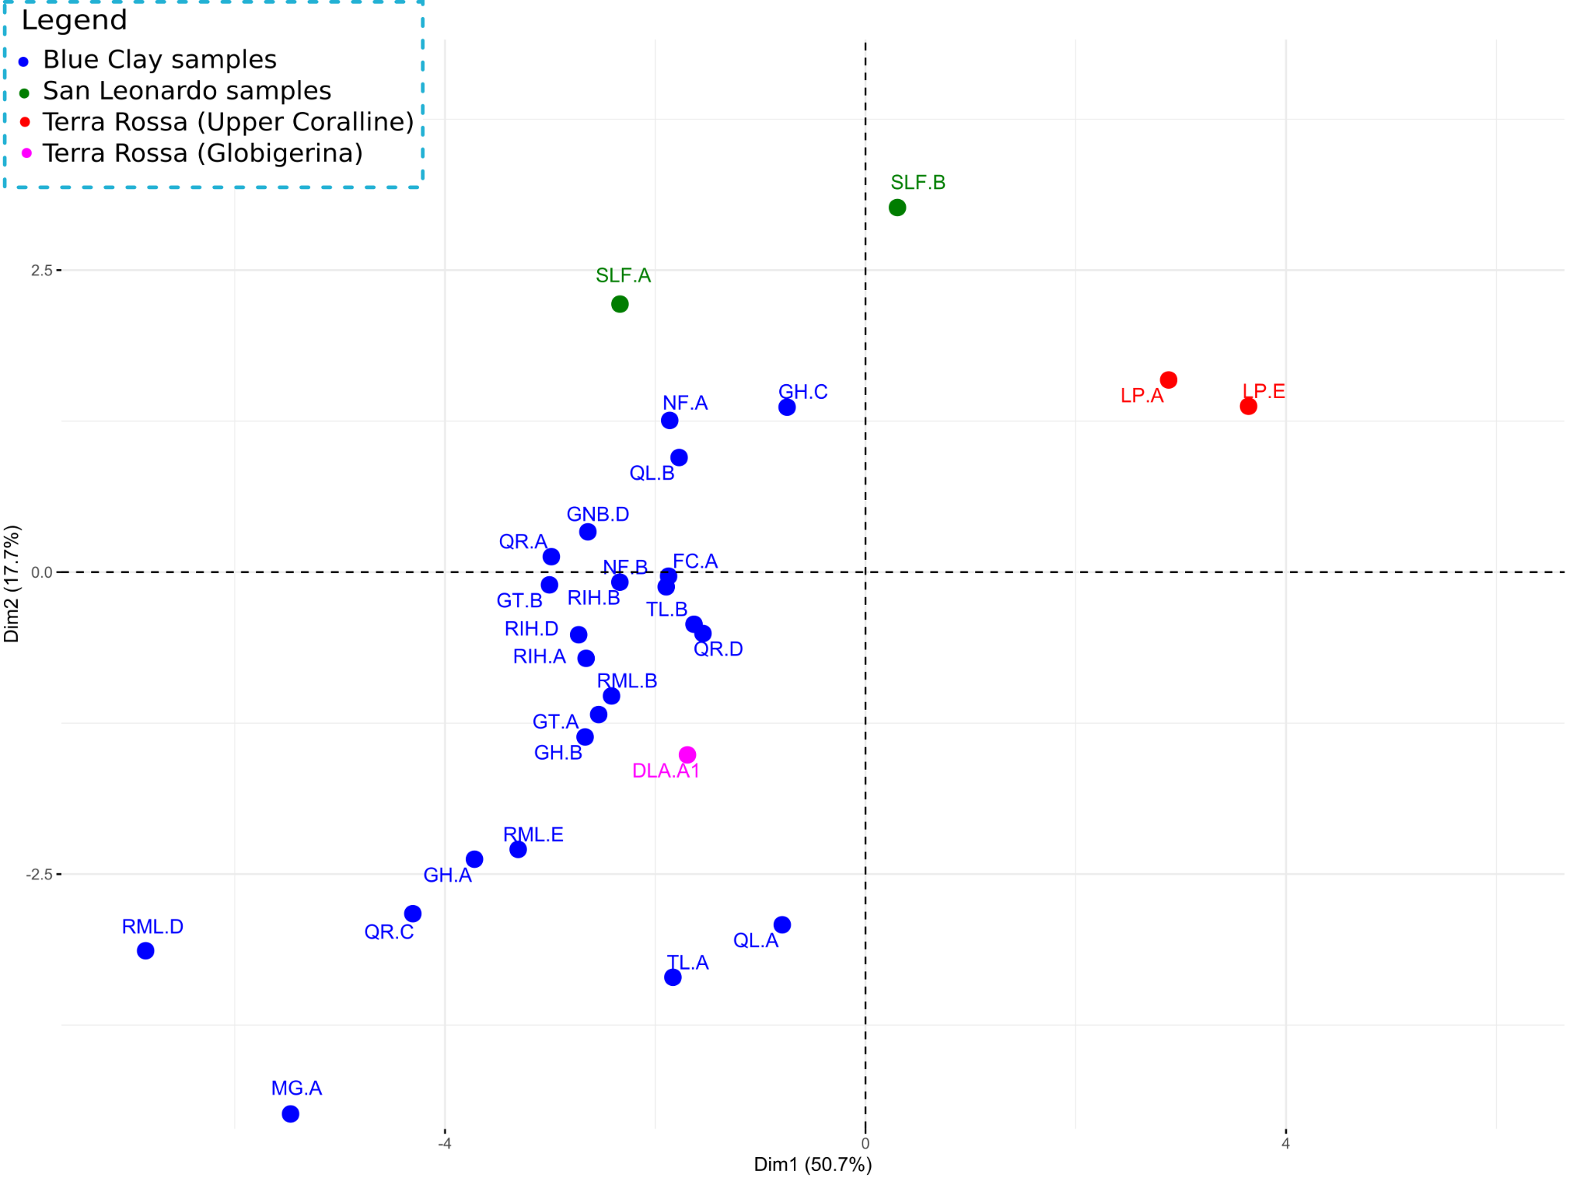

**Figure S1.** Biplot with only supplementary individuals (clays) plotted*.*

## **S2. Terra Rossa briquettes**

Briquettes of the two samples from Ta’ Lippija (LP.A and LP.E) were manufactured for petrographic analysis. The samples did not need crushing. The soil was gradually mixed with water, with weights recorded to assess *water of plasticity*. When the material was plastic enough to be shaped, it was inserted into a slab mould, pressed, taken off the mould and indented to create four briquettes [(Vella](https://www.zotero.org/google-docs/?hJXJkg) *[et al](https://www.zotero.org/google-docs/?hJXJkg)*[. 2021; Xuereb 2021 for procedure)](https://www.zotero.org/google-docs/?hJXJkg). Two additional indents 10 cm apart were created to measure linear shrinkage. The slabs were left to dry for a week, dried in an oven at 100°C for one hour and then weighed and measured again. The briquettes were then separated, and two for each geological sample were fired in an electric furnace at 500°C and 120 mins soaking time. The heating rate was 200°C/hour. Table S2 records the metrics of both slabs before separation and firing; Figure **S3** shows briquettes after firing.

|  |  |  |  |
| --- | --- | --- | --- |
|  | | LP.E1 | LP.A1 |
| Water of plasticity (%) | | 40 | 34 |
| Manufacture | Weight (g) slab | 64.59 | 62.12 |
| Indents (cm) | 10 | 10 |
| Post drying | Weight (g) slab | 46.65 | 43.82 |
| Indents (cm) | 8.91 | 8.84 |
| Loss weight of slab (g) | | 17.94 | 18.3 |
| Shrinkage (%) | | 10.9 | 11.6 |

**Table S2.** Data on the making and firing of Terra Rossa briquettes.

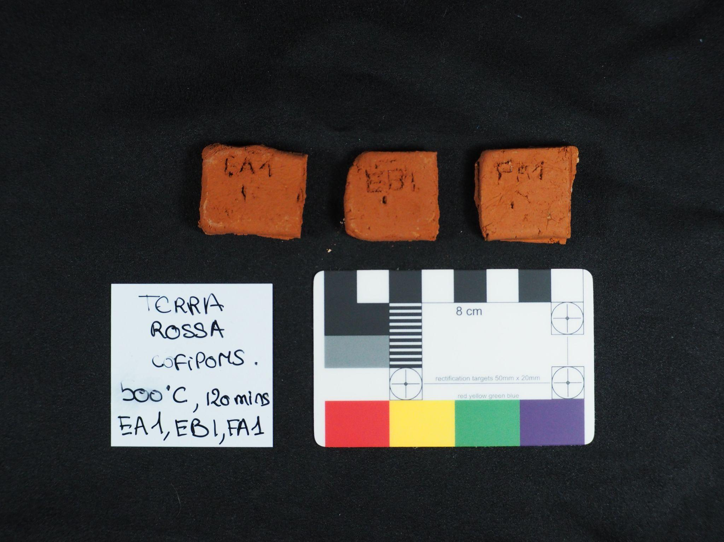

**Figure S2.** Photographs of fired briquettes.

## **S3. Validation**

Repeated analyses (Table S3) were performed on sample 21 (sherd) 14 times and clay sample QL.A (Il-Qolla, Rabat)12 times to assess the reliability of the obtained results.

|  |  |  |  |  |  |  |
| --- | --- | --- | --- | --- | --- | --- |
|  | QL.B, n=12 | | | Sample 21, n=14 | | |
|  | Mean (%) | σ (%) | Relative σ (%) | Mean (%) | σ (%) | Relative σ (%) |
| Al2O3 | 13.3 | 0.9 | 6.5 | 14.9 | 0.7 | 5.03 |
| CaO | 15.2 | 0.2 | 1.3 | 13.7 | 0.2 | 1.11 |
| Fe2O3 | 6.75 | 0.09 | 1.31 | 7.3 | 0.09 | 1.23 |
| Ga2O3 | 0.0032 | 0.0004 | 13.14 | 0.0024 | 0.0006 | 27.09 |
| K2O | 2.39 | 0.06 | 2.6 | 2.64 | 0.04 | 1.63 |
| Nb2O5 | 0.003 | 0.0009 | 28.85 | 0.0033 | 0.0003 | 7.58 |
| Rb2O3 | 0.0156 | 0.0007 | 4.77 | 0.0175 | 0.0004 | 2.16 |
| SiO2 | 45.01 | 1.29 | 2.87 | 47.05 | 3.34 | 7.1 |
| SrO | 0.0578 | 0.0008 | 1.41 | 0.0572 | 0.001 | 1.69 |
| TiO2 | 0.82 | 0.02 | 2.62 | 0.88 | 0.02 | 2.24 |
| Y2O3 | 0.0031 | 0.0008 | 24.2 | 0.005 | 0.0003 | 5.47 |
| ZnO | 0.0129 | 0.0005 | 4.14 | 0.0134 | 0.0005 | 3.51 |
| ZrO2 | 0.0319 | 0.0061 | 19.14 | 0.0486 | 0.0016 | 3.3 |

**Table S3.** repeatability of readings for the chosen variable for a sample of clay (QL.B) and a sherd (sample 21).

## 

## **S4. Multivariate analysis**

Table S4.1 presents the results of the PCA analysis carried out using the R package FactoMineR [(Lê](https://www.zotero.org/google-docs/?zf041R) *[et al](https://www.zotero.org/google-docs/?zf041R)*[. 2008)](https://www.zotero.org/google-docs/?zf041R), including eingenvalues and percentage of variance for each principal component. The correlation between the variables and the five principal components can be found in Table S4.2. For definitions of eigenvalues and loadings, see Carlson [(2017, 266)](https://www.zotero.org/google-docs/?Fmd2Fm).

|  |  |  |  |
| --- | --- | --- | --- |
|  | Eigenvalue | Percentage of variance | Cumulative percentage of variance |
| PC 1 | **7.1029** | 50.7347 | 50.7347 |
| PC 2 | **2.4767** | 17.6908 | 68.4255 |
| PC 3 | **1.6702** | 11.9297 | 80.3552 |
| PC 4 | 0.9122 | 6.5154 | 86.8706 |
| PC 5 | 0.7475 | 5.3396 | 92.2102 |
| PC 6 | 0.3443 | 2.459 | 94.6693 |
| PC 7 | 0.247 | 1.7646 | 96.4339 |
| PC 8 | 0.1778 | 1.2703 | 97.7042 |
| PC 9 | 0.1122 | 0.8017 | 98.5059 |
| PC 10 | 0.0851 | 0.6078 | 99.1138 |
| PC 11 | 0.0494 | 0.3525 | 99.4663 |
| PC 12 | 0.0429 | 0.3064 | 99.7726 |
| PC 13 | 0.0188 | 0.1341 | 99.9067 |
| PC 14 | 0.0131 | 0.0933 | 100 |

**Table S4.1.** Results of the PCA analysis, including eigenvalues and cumulative percentage of variance.

|  |  |  |  |  |  |
| --- | --- | --- | --- | --- | --- |
|  | Dim.1 | Dim.2 | Dim.3 | Dim.4 | Dim.5 |
| Al2O3 | 0.3253 | 0.5284 | 0.464 | -0.4415 | 0.3138 |
| CaO | -0.9483 | 0.0744 | 0.073 | 0.0679 | 0.2067 |
| Fe2O3 | 0.5021 | 0.5513 | 0.3455 | -0.3916 | -0.2404 |
| Ga | 0.0466 | 0.7247 | 0.1387 | 0.5964 | -0.1761 |
| K2O | -0.1266 | 0.7485 | -0.5555 | 0.056 | 0.1433 |
| Mn | 0.9105 | -0.1342 | 0.137 | 0.0314 | -0.1194 |
| Nb | 0.8746 | 0.0986 | 0.1566 | 0.1408 | 0.279 |
| Rb | 0.2475 | 0.7335 | -0.5004 | -0.0953 | 0.1329 |
| SiO2 | 0.8815 | 0.0283 | -0.3844 | 0.0813 | -0.166 |
| Sr | -0.9277 | 0.0836 | 0.0825 | 0.0094 | 0.2833 |
| TiO2 | 0.9579 | 0.0218 | 9e-04 | -0.0758 | -0.1118 |
| Y | 0.6799 | -0.0572 | 0.4383 | 0.3466 | 0.3777 |
| Zn | -0.5212 | 0.4427 | 0.6001 | 0.1553 | -0.298 |
| Zr | 0.9397 | -0.1717 | -0.0432 | 0.1178 | 0.1883 |

**Table S4.2.** Correlation between the first five dimensions and the different variables.

## **S5. Datasets**

Some pottery samples and clay samples were removed from the analysis, but the data is given below. Samples 47, 74, 1 and 67 were removed from the study because they were outlying samples which had not been analysed petrographically. It was, therefore, not possible to assess if the sherds were outlying because of a different fabric group or analytical error. These are not included in the 53 samples analysed in the paper. The clay samples removed from the multivariate analysis are GNB.B, GNB.E, MX.A, MX.D, MG.B. MX.A, D and GNB.B, E.

|  |  |  |  |  |  |  |  |  |  |  |  |  |  |  |
| --- | --- | --- | --- | --- | --- | --- | --- | --- | --- | --- | --- | --- | --- | --- |
|  | Major and minor oxides (%) | | | | | | Trace elements (ppm) | | | | | | | |
| Sample | Al2O3 | CaO | Fe2O3 | K2O | SiO2 | TiO2 | Ga | Mn | Nb | Rb | Sr | Y | Zn | Zr |
| 1 | 14.72 | 16.75 | 7.43 | 2.93 | 51.62 | 0.91 | 48 | 596 | 34 | 176 | 617 | 47 | 152 | 425 |
| 2 | 13.52 | 12.85 | 7.36 | 2.71 | 59.58 | 0.92 | 23 | 603 | 21 | 167 | 466 | 36 | 110 | 370 |
| 4 | 14.62 | 13.11 | 8.02 | 3.08 | 55.36 | 0.94 | 26 | 622 | 26 | 169 | 507 | 39 | 127 | 349 |
| 5 | 13.44 | 3.20 | 7.65 | 1.83 | 68.89 | 1.23 | 20 | 1893 | 30 | 136 | 166 | 41 | 98 | 833 |
| 7 | 15.66 | 17.99 | 7.87 | 2.82 | 48.02 | 0.92 | 16 | 369 | 24 | 171 | 672 | 29 | 113 | 292 |
| 8 | 16.19 | 16.91 | 8.10 | 3.05 | 49.13 | 0.95 | 25 | 619 | 27 | 185 | 588 | 43 | 124 | 390 |
| 9 | 15.28 | 11.91 | 8.41 | 3.29 | 54.53 | 0.94 | 38 | 744 | 32 | 198 | 386 | 50 | 145 | 425 |
| 10 | 15.47 | 13.81 | 7.50 | 2.73 | 53.69 | 0.94 | 21 | 495 | 27 | 176 | 534 | 39 | 114 | 397 |
| 11 | 13.91 | 20.09 | 6.90 | 2.97 | 48.70 | 0.86 | 18 | 638 | 21 | 134 | 692 | 35 | 113 | 366 |
| 12 | 12.02 | 22.56 | 6.38 | 2.11 | 49.46 | 0.75 | 20 | 341 | 18 | 97 | 588 | 37 | 110 | 376 |
| 13 | 14.28 | 9.14 | 8.27 | 2.94 | 59.68 | 1.09 | 21 | 1530 | 28 | 152 | 374 | 37 | 106 | 463 |
| 15 | 13.19 | 15.60 | 7.36 | 2.54 | 54.76 | 0.92 | 21 | 957 | 23 | 126 | 477 | 37 | 108 | 421 |
| 17 | 15.05 | 13.75 | 7.57 | 2.90 | 54.46 | 0.95 | 28 | 543 | 27 | 174 | 537 | 38 | 124 | 395 |
| 18 | 14.56 | 6.05 | 7.84 | 3.07 | 62.42 | 1.14 | 26 | 863 | 34 | 133 | 261 | 42 | 105 | 532 |
| 19 | 14.10 | 11.75 | 7.97 | 3.89 | 56.72 | 0.91 | 28 | 621 | 22 | 148 | 351 | 36 | 143 | 345 |
| 21 | 16.26 | 15.05 | 8.02 | 2.90 | 51.77 | 0.96 | 24 | 640 | 26 | 176 | 532 | 43 | 119 | 395 |
| 22 | 14.49 | 18.81 | 7.26 | 2.84 | 49.78 | 0.84 | 19 | 395 | 22 | 161 | 582 | 29 | 111 | 285 |
| 23 | 12.51 | 28.30 | 7.22 | 0.98 | 44.15 | 0.75 | 19 | 405 | 26 | 68 | 769 | 40 | 128 | 245 |
| 24 | 14.99 | 27.97 | 7.28 | 1.66 | 36.71 | 0.78 | 22 | 481 | 17 | 89 | 702 | 39 | 166 | 222 |
| 25 | 13.48 | 12.03 | 7.37 | 2.76 | 59.94 | 0.94 | 30 | 596 | 25 | 161 | 475 | 40 | 118 | 369 |
| 26 | 17.63 | 17.97 | 7.83 | 2.64 | 46.57 | 0.94 | 23 | 491 | 26 | 145 | 673 | 39 | 118 | 346 |
| 27 | 13.64 | 21.45 | 7.65 | 1.85 | 49.29 | 0.85 | 20 | 432 | 26 | 90 | 586 | 39 | 116 | 266 |
| 28 | 11.84 | 20.99 | 7.46 | 2.82 | 50.04 | 0.74 | 26 | 609 | 20 | 174 | 494 | 34 | 138 | 215 |
| 30 | 12.78 | 20.70 | 7.65 | 2.86 | 48.53 | 0.95 | 29 | 423 | 20 | 155 | 540 | 30 | 139 | 239 |
| 32 | 15.71 | 3.47 | 8.12 | 3.06 | 63.79 | 1.15 | 26 | 744 | 33 | 170 | 187 | 40 | 105 | 543 |
| 33 | 16.03 | 8.92 | 8.99 | 3.55 | 56.16 | 0.98 | 29 | 477 | 23 | 210 | 358 | 30 | 149 | 270 |
| 35 | 12.75 | 4.13 | 7.92 | 2.79 | 67.59 | 1.16 | 21 | 1267 | 33 | 150 | 226 | 41 | 97 | 555 |
| 36 | 15.29 | 3.98 | 8.35 | 2.02 | 64.40 | 1.37 | 30 | 2235 | 35 | 134 | 198 | 46 | 138 | 617 |
| 37 | 9.66 | 28.23 | 6.84 | 2.83 | 49.32 | 0.84 | 20 | 447 | 22 | 148 | 639 | 34 | 115 | 273 |
| 39 | 14.90 | 3.37 | 8.11 | 1.81 | 66.46 | 1.28 | 21 | 2731 | 31 | 140 | 161 | 48 | 114 | 713 |
| 40 | 14.30 | 28.15 | 7.80 | 1.22 | 40.97 | 0.86 | 18 | 428 | 21 | 67 | 828 | 35 | 147 | 220 |
| 42 | 16.24 | 14.35 | 7.80 | 3.39 | 51.05 | 0.96 | 29 | 598 | 33 | 164 | 520 | 46 | 132 | 431 |
| 43 | 14.35 | 5.12 | 7.96 | 2.98 | 64.17 | 1.14 | 25 | 892 | 33 | 159 | 233 | 39 | 97 | 559 |
| 46 | 14.28 | 3.74 | 8.15 | 2.97 | 65.04 | 1.18 | 29 | 1205 | 32 | 155 | 182 | 41 | 98 | 555 |
| 47 | 15.33 | 15.77 | 8.91 | 3.41 | 49.73 | 0.94 | 34 | 608 | 36 | 216 | 522 | 44 | 150 | 353 |
| 48 | 12.88 | 13.30 | 7.66 | 2.77 | 58.60 | 0.93 | 19 | 604 | 24 | 158 | 451 | 38 | 107 | 403 |
| 50 | 12.17 | 20.17 | 6.84 | 2.80 | 52.08 | 0.83 | 26 | 315 | 19 | 150 | 537 | 27 | 130 | 222 |
| 52 | 12.90 | 26.14 | 6.77 | 2.22 | 46.48 | 0.86 | 27 | 434 | 20 | 69 | 768 | 30 | 134 | 307 |
| 53 | 13.99 | 3.14 | 7.95 | 2.42 | 69.44 | 1.27 | 19 | 1486 | 31 | 149 | 177 | 43 | 92 | 732 |
| 54 | 13.10 | 10.48 | 7.31 | 2.79 | 61.89 | 1.06 | 22 | 766 | 29 | 140 | 254 | 39 | 92 | 493 |
| 58 | 13.38 | 12.73 | 6.65 | 2.90 | 58.85 | 0.97 | 30 | 397 | 28 | 158 | 434 | 39 | 112 | 470 |
| 60 | 15.01 | 15.43 | 7.24 | 2.83 | 53.59 | 0.91 | 45 | 695 | 32 | 168 | 622 | 48 | 137 | 441 |
| 61 | 15.42 | 1.29 | 8.40 | 1.60 | 68.61 | 1.30 | 18 | 2211 | 34 | 138 | 97 | 47 | 102 | 890 |
| 62 | 14.99 | 8.33 | 8.90 | 3.34 | 58.50 | 0.97 | 27 | 501 | 21 | 177 | 315 | 26 | 134 | 235 |
| 64 | 13.92 | 16.66 | 6.86 | 2.78 | 52.04 | 0.91 | 19 | 320 | 24 | 167 | 571 | 32 | 107 | 358 |
| 65 | 13.10 | 18.76 | 6.93 | 2.55 | 52.29 | 0.90 | 20 | 481 | 21 | 160 | 858 | 31 | 109 | 302 |
| 66 | 14.33 | 19.21 | 7.20 | 2.54 | 49.31 | 0.87 | 23 | 397 | 19 | 146 | 633 | 25 | 116 | 271 |
| 67 | 15.50 | 24.42 | 7.90 | 0.50 | 43.68 | 0.86 | 18 | 395 | 21 | 45 | 893 | 37 | 120 | 263 |
| 68 | 13.02 | 0.86 | 6.65 | 1.36 | 73.80 | 1.32 | 18 | 2079 | 32 | 122 | 83 | 45 | 87 | 1031 |
| 69 | 14.10 | 19.89 | 7.09 | 2.71 | 49.50 | 0.81 | 24 | 407 | 21 | 153 | 638 | 27 | 114 | 267 |
| 70 | 15.84 | 2.12 | 9.23 | 1.80 | 65.79 | 1.37 | 32 | 1799 | 35 | 156 | 124 | 50 | 126 | 682 |
| 71 | 14.09 | 17.14 | 7.41 | 2.63 | 51.86 | 0.89 | 24 | 661 | 24 | 142 | 579 | 34 | 93 | 419 |
| 72 | 13.87 | 14.83 | 7.85 | 2.85 | 54.62 | 0.88 | 25 | 351 | 22 | 158 | 454 | 25 | 104 | 259 |
| 73 | 12.02 | 15.96 | 7.12 | 3.67 | 55.86 | 0.87 | 24 | 363 | 19 | 153 | 483 | 27 | 109 | 282 |
| 74 | 14.37 | 12.27 | 8.71 | 3.91 | 53.83 | 0.98 | 15 | 409 | 18 | 143 | 719 | 30 | 93 | 246 |
| TL.B | 11.50 | 12.42 | 7.77 | 2.41 | 57.56 | 0.88 | 23 | 258 | 16 | 169 | 355 | 22 | 99 | 247 |
| NF.B | 12.80 | 16.19 | 7.50 | 2.74 | 55.77 | 0.92 | 24 | 419 | 17 | 137 | 655 | 23 | 97 | 242 |
| GH.B | 13.62 | 22.77 | 7.80 | 2.53 | 46.87 | 0.80 | 20 | 402 | 20 | 144 | 615 | 26 | 101 | 242 |
| FC.A | 13.90 | 9.68 | 7.08 | 2.91 | 60.00 | 0.98 | 23 | 370 | 16 | 152 | 614 | 20 | 101 | 234 |
| GH.A | 10.24 | 18.98 | 6.21 | 2.27 | 55.64 | 0.71 | 39 | 466 | 26 | 93 | 994 | 43 | 99 | 341 |
| GT.A | 12.08 | 21.14 | 7.27 | 2.51 | 50.88 | 0.89 | 29 | 373 | 17 | 176 | 397 | 25 | 120 | 228 |
| GT.B | 14.24 | 16.35 | 7.33 | 2.61 | 50.18 | 0.87 | 14 | 350 | 31 | 151 | 443 | 38 | 78 | 294 |
| MX.A | 6.39 | 50.36 | 3.04 | 1.93 | 30.40 | 0.47 | 24 | 476 | 17 | 152 | 530 | 25 | 117 | 290 |
| NF.A | 12.69 | 9.74 | 8.35 | 2.81 | 57.97 | 0.86 | 19 | 415 | 24 | 151 | 488 | 31 | 98 | 292 |
| QL.A | 10.66 | 25.82 | 7.67 | 2.09 | 48.42 | 0.90 | 18 | 439 | 25 | 165 | 640 | 26 | 99 | 242 |
| RIH.D | 12.61 | 17.79 | 7.02 | 2.50 | 53.90 | 0.82 | 29 | 326 | 24 | 164 | 429 | 25 | 118 | 328 |
| DLA.A | 11.67 | 21.67 | 7.33 | 2.30 | 51.25 | 0.86 | 21 | 359 | 13 | 77 | 1458 | 31 | 76 | 238 |
| QR.D | 13.09 | 16.39 | 7.43 | 2.86 | 55.97 | 0.92 | 30 | 317 | 22 | 151 | 598 | 22 | 105 | 225 |
| GH.C | 15.52 | 9.87 | 7.56 | 2.84 | 56.20 | 1.04 | 46 | 420 | 31 | 113 | 1085 | 41 | 140 | 330 |
| GNB.B | 7.58 | 59.22 | 3.52 | 1.76 | 19.12 | 0.51 | 42 | 384 | 27 | 103 | 972 | 39 | 109 | 331 |
| GNB.D | 14.45 | 16.77 | 6.70 | 2.64 | 51.20 | 0.91 | 20 | 290 | 10 | 81 | 1097 | 30 | 94 | 185 |
| GNB.F | 9.78 | 42.77 | 4.57 | 2.07 | 32.37 | 0.60 | 23 | 415 | 18 | 147 | 678 | 23 | 106 | 257 |
| MG.A | 7.92 | 39.16 | 4.01 | 1.94 | 38.02 | 0.58 | 19 | 399 | 17 | 120 | 396 | 19 | 81 | 181 |
| MX.D | 6.80 | 48.33 | 3.33 | 1.84 | 31.11 | 0.48 | 24 | 338 | 24 | 149 | 601 | 25 | 108 | 236 |
| QR.A | 14.88 | 20.23 | 7.27 | 2.93 | 44.76 | 0.88 | 25 | 263 | 21 | 156 | 522 | 24 | 103 | 248 |
| QR.C | 11.62 | 32.58 | 6.39 | 2.43 | 38.50 | 0.84 | 21 | 361 | 24 | 149 | 634 | 27 | 104 | 249 |
| RIH.A | 12.28 | 18.15 | 6.63 | 2.63 | 52.16 | 0.86 | 22 | 240 | 18 | 115 | 942 | 21 | 119 | 191 |
| RIH.B | 14.35 | 15.34 | 6.57 | 2.80 | 53.90 | 0.93 | 16 | 339 | 19 | 138 | 586 | 24 | 87 | 247 |
| RML.B | 12.77 | 19.43 | 6.56 | 2.70 | 51.62 | 0.89 | 28 | 275 | 23 | 203 | 154 | 21 | 126 | 326 |
| RML.D | 12.41 | 33.44 | 4.80 | 1.86 | 38.84 | 0.57 | 31 | 279 | 21 | 192 | 281 | 18 | 121 | 224 |
| RML.E | 13.18 | 22.41 | 6.49 | 2.42 | 47.46 | 0.74 | 22 | 209 | 15 | 113 | 1016 | 24 | 102 | 183 |
| SLF.B | 16.13 | 5.80 | 8.75 | 3.77 | 59.49 | 1.11 | 28 | 791 | 28 | 174 | 124 | 43 | 104 | 514 |
| SLF.A | 15.00 | 21.87 | 8.34 | 2.66 | 46.00 | 0.96 | 30 | 993 | 27 | 179 | 105 | 44 | 110 | 498 |
| GNB.A | 11.53 | 36.86 | 4.68 | 1.84 | 36.28 | 0.56 | 27 | 374 | 23 | 160 | 549 | 27 | 117 | 262 |
| LP.A | 15.31 | 4.72 | 8.82 | 3.27 | 61.76 | 1.00 | 29 | 371 | 21 | 158 | 553 | 25 | 121 | 236 |
| LP.E | 14.42 | 1.27 | 8.84 | 2.92 | 67.00 | 0.98 | 22 | 391 | 21 | 166 | 529 | 24 | 117 | 239 |
| QL.B | 14.76 | 17.09 | 7.56 | 2.68 | 50.74 | 0.92 | 29 | 334 | 20 | 144 | 525 | 26 | 125 | 251 |

**Table S5.1.** Normalised dataset*.*

|  |  |  |  |  |  |  |  |  |  |  |  |  |  |  |  |
| --- | --- | --- | --- | --- | --- | --- | --- | --- | --- | --- | --- | --- | --- | --- | --- |
|  |  | Major/minor oxides (%) | | | | | | Trace elements (ppm) | | | | | | | |
| HCA |  | Al2O3 | CaO | Fe2O3 | K2O | SiO2 | TiO2 | Ga | Mn | Nb | Rb | Sr | Y | Zn | Zr |
| A.1 | x̄ | 13.39 | 25.76 | 7.18 | 1.67 | 44.51 | 0.98 | 21 | 420 | 21 | 80 | 707 | 40 | 119 | 443 |
| σ | 1.13 | 3.03 | 0.54 | 0.49 | 5.00 | 0.12 | 3 | 46 | 4 | 14 | 101 | 7 | 16 | 196 |
| RSD (%) | 8.41 | 11.78 | 7.46 | 29.33 | 11.22 | 12.58 | 15 | 11 | 17 | 17 | 14 | 18 | 13 | 44 |
| B-A.2 | x̄ | 13.28 | 19.24 | 7.23 | 2.83 | 50.85 | 0.91 | 23 | 421 | 21 | 156 | 604 | 38 | 120 | 368 |
| σ | 1.49 | 3.18 | 0.37 | 0.27 | 2.35 | 0.11 | 4 | 97 | 2 | 11 | 95 | 3 | 17 | 81 |
| RSD (%) | 11.24 | 16.51 | 5.05 | 9.52 | 4.62 | 12.38 | 19 | 23 | 8 | 7 | 16 | 9 | 14 | 22 |
| C | x̄ | 14.82 | 12.83 | 7.80 | 2.95 | 55.67 | 1.02 | 27 | 672 | 26 | 166 | 466 | 38 | 119 | 423 |
| σ | 1.34 | 3.41 | 0.58 | 0.45 | 4.91 | 0.18 | 6 | 328 | 4 | 21 | 120 | 6 | 20 | 177 |
| RSD (%) | 9.04 | 26.58 | 7.37 | 15.25 | 8.82 | 17.92 | 24 | 49 | 14 | 12 | 26 | 16 | 17 | 42 |
| D.2 | x̄ | 14.46 | 4.98 | 8.11 | 2.60 | 64.61 | 0.89 | 25 | 1411 | 32 | 149 | 216 | 27 | 107 | 289 |
| σ | 0.97 | 2.62 | 0.46 | 0.50 | 2.73 | 0.14 | 4 | 639 | 2 | 11 | 67 | 9 | 14 | 114 |
| RSD (%) | 6.71 | 52.55 | 5.71 | 19.31 | 4.23 | 16.14 | 18 | 45 | 8 | 8 | 31 | 34 | 13 | 40 |
| D.1 | x̄ | 14.22 | 1.07 | 7.53 | 1.48 | 71.21 | 0.73 | 18 | 2145 | 33 | 130 | 90 | 31 | 107 | 294 |
| Blue Clay | x̄ | 12.81 | 19.30 | 7.02 | 2.58 | 51.14 | 0.93 | 24 | 369 | 21 | 151 | 551 | 30 | 108 | 353 |
| σ | 1.98 | 7.52 | 1.03 | 0.38 | 6.20 | 0.16 | 6 | 84 | 4 | 21 | 176 | 9 | 14 | 207 |
| RSD (%) | 15.46 | 38.96 | 14.64 | 14.57 | 12.12 | 17.32 | 25 | 23 | 18 | 14 | 32 | 29 | 13 | 59 |
| Terra Rossa | x̄ | 14.87 | 3.00 | 8.83 | 3.10 | 64.38 | 0.98 | 29 | 892 | 27 | 176 | 114 | 26 | 108 | 285 |

**Table S5.2.** Descriptive statistics (mean, standard deviation and relative standard deviation) per HCA cluster (not accounting for mismatches) on the normalised dataset. Groups with only two samples have only the mean.

## Bibliography

[Asciak, G. 2019.](https://www.zotero.org/google-docs/?rtBKtM) *[Characterisation and Identification of Fossil and Mineral Inclusions in Roman Pottery from One Site in Victoria, Gozo.](https://www.zotero.org/google-docs/?rtBKtM)* [MA dissertation (taught). University of Malta:](https://www.zotero.org/google-docs/?rtBKtM) Malta.

[Carlson, D.L. 2017.](https://www.zotero.org/google-docs/?rtBKtM) *[Quantitative Methods in Archaeology Using R](https://www.zotero.org/google-docs/?rtBKtM)*[. Cambridge University Press:](https://www.zotero.org/google-docs/?rtBKtM) Cambridge.

[Lê, S., Josse, J. and Husson, F. 2008. FactoMineR: an R package for multivariate analysis.](https://www.zotero.org/google-docs/?rtBKtM) *[Journal of Statistical Software](https://www.zotero.org/google-docs/?rtBKtM)* [25: 1–18.](https://www.zotero.org/google-docs/?rtBKtM)

[Richard-Trémeau, E. 2023.](https://www.zotero.org/google-docs/?rtBKtM) *[PotteryFabrics from Malta: Characterising Late Punic/Early Roman Fabrics from the Żejtun Villa and the Sanctuary at Tas-Silġ.](https://www.zotero.org/google-docs/?rtBKtM)* [Research MA dissertation. University of Malta: Malta. Available at: https://www.um.edu.mt/library/oar/handle/123456789/109715 (accessed June 26, 2023).](https://www.zotero.org/google-docs/?rtBKtM)

[Vella, M. and Richard-Trémeau, E. 2021.](https://www.zotero.org/google-docs/?rtBKtM) *[Operating Procedures for the Manufacturing of Clay Briquettes](https://www.zotero.org/google-docs/?rtBKtM)*[. University of Malta: Malta. Available at: https://www.um.edu.mt/operatingprocedures/doc/CAR-017-01 (accessed October 27, 2021).](https://www.zotero.org/google-docs/?rtBKtM)

[Xuereb, L. 2021. *A Study on the Firing of Sourced Maltese Clay into a Usable Product*. B. Eng. dissertation. University of Malta: Malta. Available at: https://www.um.edu.mt/library/oar/handle/123456789/103123 (accessed June 26, 2023).](https://www.zotero.org/google-docs/?rtBKtM)