Supplementary materials

Part I Control system of the physical prototype in the wind tunnel experiment
The wind tunnel experiment (as shown in Figure 1) is the most fundamental experimental method used in the design and aerodynamic performance testing of aircraft. This method allows the measurement of aerodynamic forces generated by airflow over the wings, the flow state of the airflow, and aerodynamic derivatives under steady inflow conditions using a six-axis force sensor or PIV (Particle Image Velocimetry). In this paper, we used the wind tunnel to test the aerodynamic forces and moments of different tail configurations under steady inflow and under the wake generated by flapping wings.
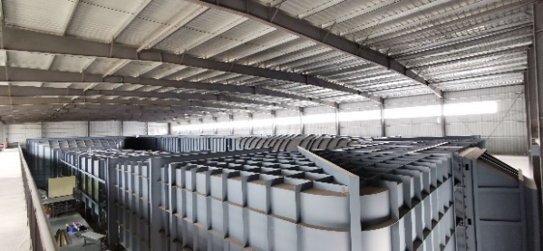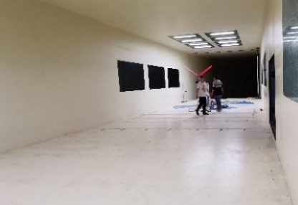
Figure 1．The return-flow wind tunnel used in the wind tunnel experiment: external view (left) and test section (right)
The wind tunnel used in this study to test the bionic flapping-wing flying robot prototype is a return-flow wind tunnel at the Harbin Institute of Technology (Shenzhen) campus. The test section of this wind tunnel is 24 m long, 6 m wide, and 3.6 m high, with a maximum controllable wind speed of 35 m/s. The velocity field in the test section has excellent uniformity, with a turbulence intensity below 1% and an axial static pressure gradient below 0.01 m, making it very suitable for testing the bionic flapping-wing flying robot prototype with a wingspan of 1.8 m designed in this project.
The control system of the physical prototype in this study consists of two parts: the control system of the flapping-wing robot prototype and the control system of the measurement platform.
(1) Control system of the physical prototype of the flapping-wing robot
The overall control system hardware connections of the flapping-wing robot are shown in Figure 2(A) and Figure 2(B), and mainly consist of power supply, switches, control unit, and actuation devices. The flight control system is powered through the signal line of the electronic speed controller (ESC). After receiving control commands, it outputs three channels of control signals. One channel is the control signal for the 20A ESC; the ESC outputs a PWM wave to adjust the motor speed according to the control signal, thereby controlling the wing flapping frequency. Another channel outputs the control signal for the pitch servo, controlling the raising and lowering of the tail to adjust the pitch attitude of the fuselage. The third channel outputs the control signal for the roll servo, controlling the left-right swing of the tail to adjust the yaw and roll attitudes of the fuselage. For the flapping-wing robot, the control of fuselage roll attitude and yaw attitude is achieved solely by the roll servo, i.e., controlled by a single PWM wave signal; therefore, the control input to the roll servo should be a multivariate function of the roll angle and the yaw angle. The schematic diagram of the control system of the flapping-wing robot is shown in Figure 2(C).

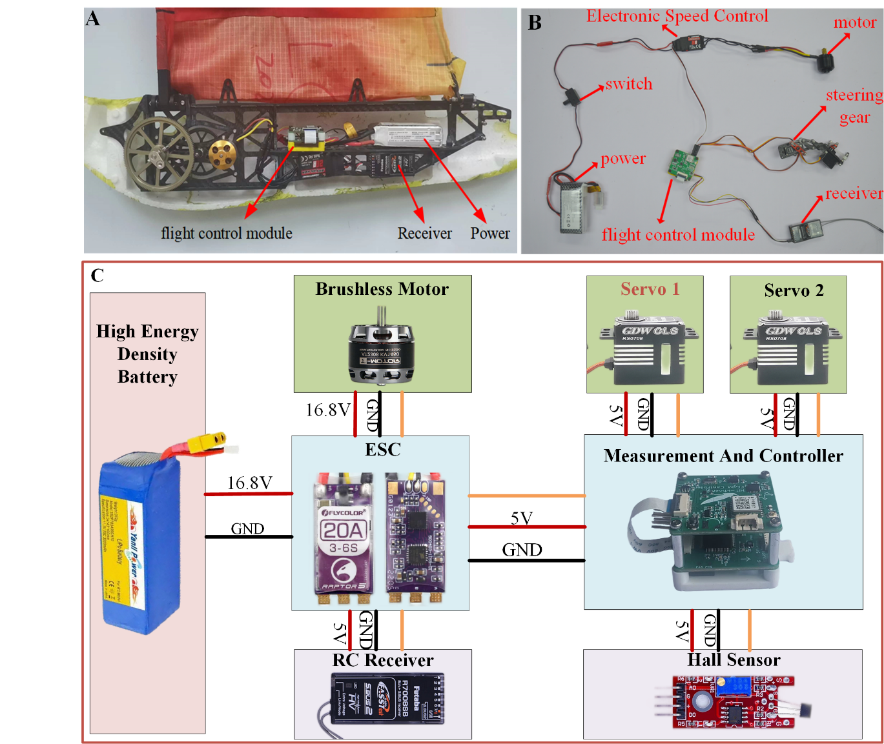
Figure 2. Control system diagram of the flapping-wing robot prototype. (A) Physical view of the control system of the flapping-wing robot prototype. (B) Physical view of the hardware connections of the control system of the flapping-wing robot prototype. (C) Schematic diagram of the control system of the flapping-wing robot prototype.
(2) Control system of the wind tunnel test platform
The main content of the wind tunnel tests is the performance evaluation of tails. Tail performance includes the following aspects: the aerodynamic forces and moments generated by the tail relative to the fuselage under different actuation states with inflow, and the relationship between the generated aerodynamic forces/moments and the actuation amount. The measurement setup consists of two main parts: the support platform at the bottom and the test device on top. A detailed schematic of the test device is shown in Figure 3(C).
The test device also consists of two parts: the wing measurement module (shown within the orange dashed box in the figure) at the front and the tail measurement module (shown within the red dashed box in the figure) at the rear. The aerodynamic forces and moments generated by the flapping wings are measured by six-axis force sensor #1 in the wing measurement module. The aerodynamic forces and moments experienced by the tail under the combined effect of the inflow and the wake generated by the flapping wings are measured by six-axis force sensor #2 in the tail measurement module. The research focus of this paper is the tail measurement module.
The tail measurement module is mainly used to measure the aerodynamic forces and moments generated by different tails at various positions relative to the bionic flapping-wing flying robot in the longitudinal and vertical directions. The movement of the tail assembly in the longitudinal and vertical directions is controlled by two lead screw-driven linear stages actuated by two stepper motors (stepper motor #1 and stepper motor #2 in Figure 3(C)). On the sides of the two stepper motors, there are sensors (linear position sensors #1 and #2 in Figure 3(C)) that measure the position of six-axis force sensor #2 in the longitudinal and vertical directions. Using these two linear position sensors and the relative positional relationships between the coordinate systems, the position of the tail relative to the bionic flapping-wing flying robot at different times can be obtained. The wind tunnel test setup and the actual test scene are shown in Figure 3(A) and Figure 3(B), respectively.
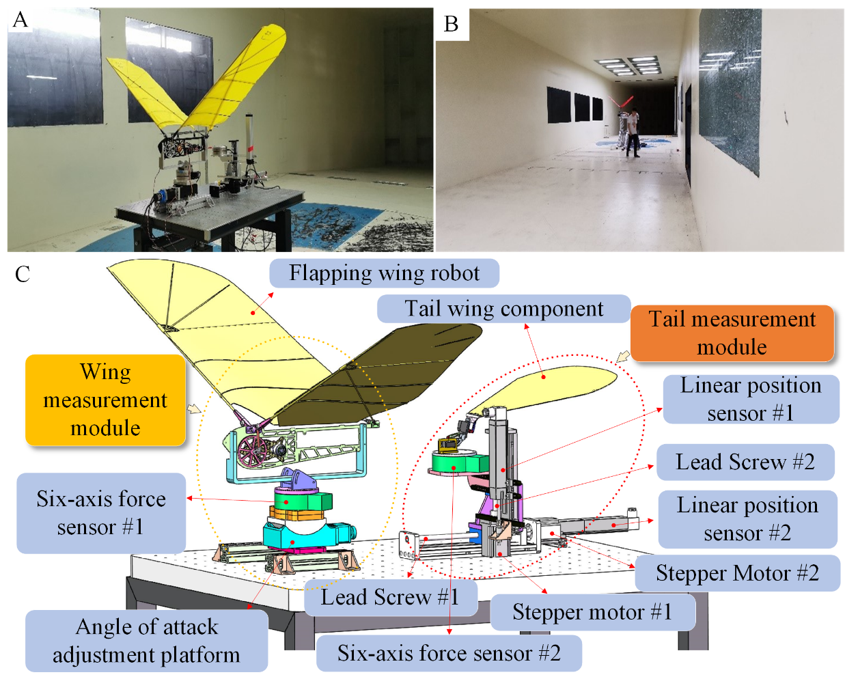
Figure 3. Control system diagram of the wind tunnel test platform. (A) Physical view of the wind tunnel test experimental setup. (B) Physical view of the wind tunnel test scene. (C) Wing and tail measurement system constituting the test setup.
To acquire data from the various sensors in the wind tunnel test measurement scheme designed in this paper, and to control the speed and position of the motors, a dedicated signal acquisition and motion control system was designed (its functional and structural block diagram is shown in Figure 4). This system is used to acquire data from the sensors under several experimental schemes, control the flapping frequency of the bionic flapping-wing flying robot, control the angle of attack in the wind tunnel test platform, and adjust the angular position of the motors, among other information.
This system is essentially a hierarchical control system with "host computer command + slave computer real-time execution + sensor closed-loop feedback + independent data acquisition and recording". Its core control link is located in the middle and right parts: the LabVIEW acquisition platform on the PC serves as the host computer, responsible for parameter setting, human-computer interaction, experiment monitoring, and data management; the STM32 control circuit serves as the slave computer, responsible for converting the desired values sent by the host computer into real-time control signals for each actuator. In other words, LabVIEW mainly addresses "what target to achieve", such as setting the flapping frequency, angle of attack, tail position, etc.; STM32 mainly addresses "how to drive the motors and mechanisms to achieve those targets", completing low-level execution through high-speed sampling and rapid adjustment.
The system first receives desired values from the host computer and sends them to the STM32 control circuit. Based on these target values, the STM32 outputs control signals to multiple actuators: first, to adjust the flapping frequency of the bionic flapping-wing flying robot; second, to control the motors related to the angle of attack, tail longitudinal position, and tail vertical position on the wind tunnel test platform. After the actuators operate, the current system state is measured in real time by various feedback sensors, and the actual state is sent back to the STM32. Specifically, the flapping frequency is detected by a Hall sensor and fed back as the "actual frequency"; position-related quantities are fed back as "actual positions" by encoders and displacement sensors; attitude or angle quantities are fed back as "actual angles" by angle sensors. The STM32 continuously compares these feedback values with the desired values given by the host computer, calculates the deviations, and then corrects the output control signals, thus forming a typical closed-loop control mechanism. The significance of closed-loop control is that even in the presence of factors such as motor hysteresis, mechanical backlash, aerodynamic disturbances, and load variations, the system can continuously approach the target values through feedback, improving the stability and accuracy of frequency control, position control, and angle control.
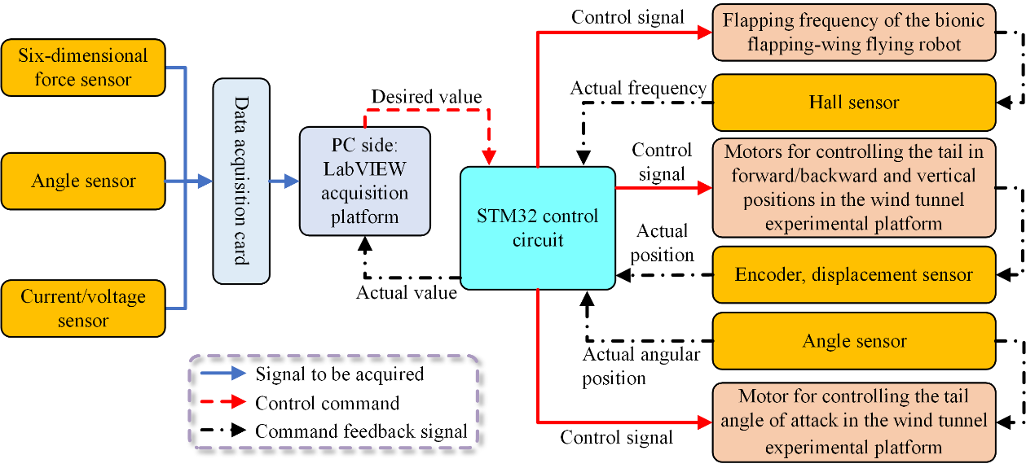
Figure 4. Block diagram of the signal acquisition and control system of the wind tunnel experimental platform
In this research, a NI data acquisition card with high sampling accuracy and sampling frequency was selected according to the requirements. At the same time, a supporting host computer acquisition platform based on LabVIEW was developed. To control the motion of multiple motors for position and angular speed control used in various schemes, a slave computer control circuit based on an STM32 chip was also designed. The STM32, as the control board, communicates with the host computer, controls actuators such as motors, and pre-processes feedback signals before transmitting them to the host computer. The functional and structural block diagram of this signal acquisition and control system is shown in Figure 4.
To better configure the hardware, pre-process, display, and store the acquired signals, and communicate with the slave computer, a host computer software program based on LabVIEW was developed. This host computer software program mainly includes a block diagram and a front panel. The block diagram is used for programming, while the front panel is used for graphical display and operation. The logic flow chart of the signal acquisition and processing program of the LabVIEW-based host computer platform is shown in Figure 5.
The designed host computer front panel mainly includes the following three parts:
(1) System setting area: used to configure channels, serial port numbers, set sampling frequency and sampling time, configure save information, etc. Its interface is shown in Figure 6.
(2) Signal display area: after pre-processing the acquired sensor signals, they are directly displayed as time-domain graphs in this area. Its interface is shown in the left area of Figure 7.
(3) Control area: used to start or stop the acquisition card from acquiring sensor information, communicate with the STM32F4 development board to control the flapping frequency of the bionic flapping-wing flying robot, control the rotational speed and position of each motor, and control data saving. Its interface is shown in the right area of Figure 7.
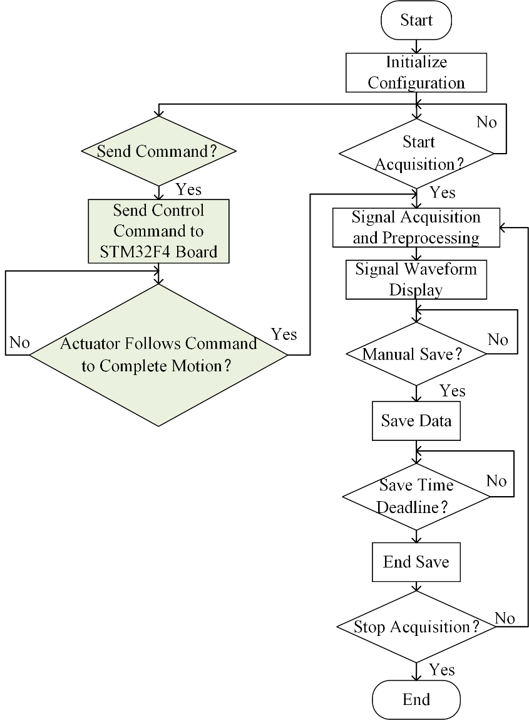
Figure 5. Logic block diagram of the host computer program
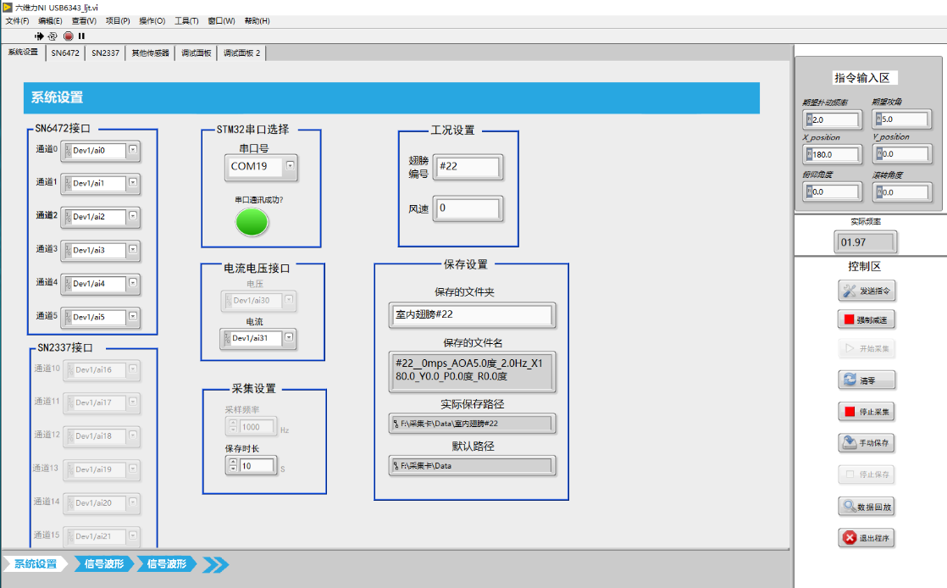
Figure 6. System setting area of the front panel
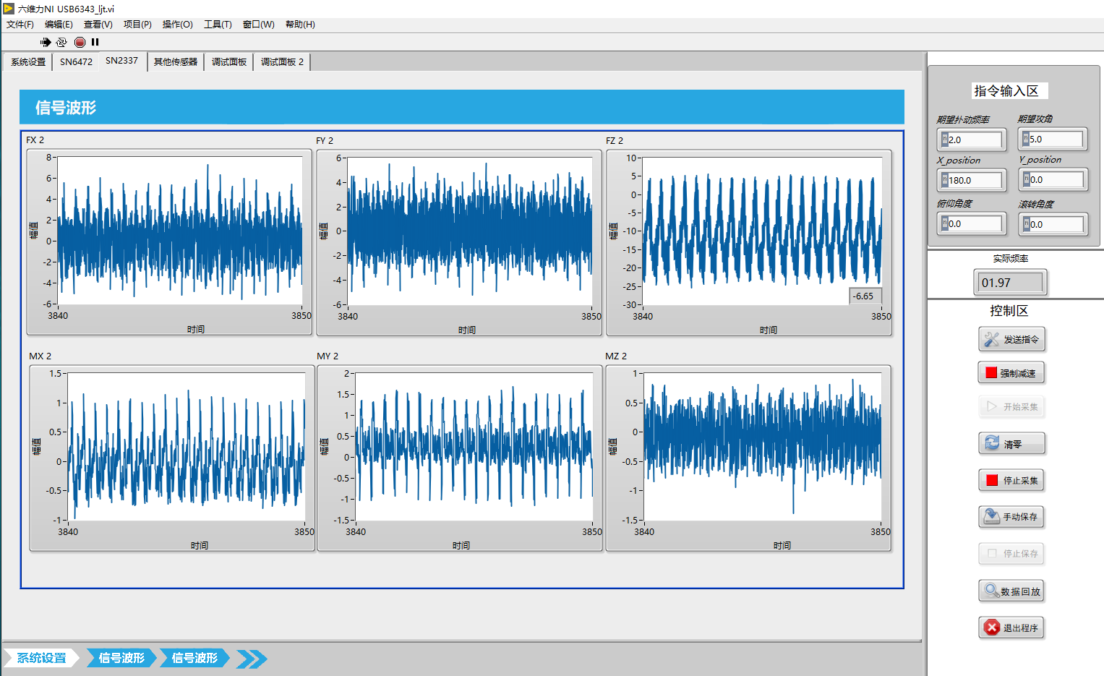
Figure 7. Signal display area and control area of the front panel
As the slave computer platform in this acquisition system, the STM32 control board is mainly responsible for receiving control commands from the host computer LabVIEW platform, converting these commands into control signals for each motor and servo in the experimental platform, and outputting the control signals to the actuators. It also performs feedback control of the wing flapping frequency (using a Hall switch located at the wing shaft) and voltage conversion. The system structure and functional block diagram of the designed slave computer are shown in Figure 8.

The main control objects of the STM32 control board during operation include:
(1) The rotation of the brushless DC motor that drives the wings – adjusting the flapping frequency by controlling the speed of the brushless DC motor;
(2) The servos that control the tail motion – controlling the tail to move in different ways;
(3) The stepper motor on the wind tunnel test platform that adjusts the angle of attack – adjusting the angle of attack of the prototype body during flapping;
(4) The stepper motors on the wind tunnel test platform that adjust the tail position – verifying the different aerodynamic characteristics of the tail at different positions during the experiment.
Figure 8. Hardware schematic diagram of the control system of the bionic flapping-wing flying robot wind tunnel test platform.
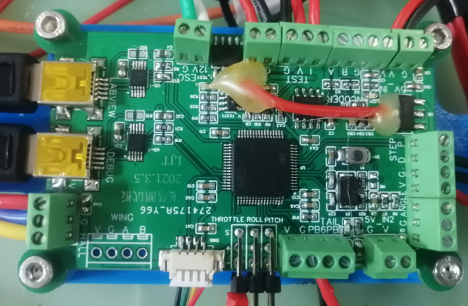
Figure 9. Physical view of the STM32 control board (slave computer)
The slave computer designed in this paper uses an STM32F405 as the MCU of the control board, with a main frequency of 168 MHz and ample resources (including serial ports, timers, external interrupts, and other peripherals). The physical view of the designed slave computer is shown in Figure 9. The control board program is designed based on the real-time operating system FreeRTOS, which fully meets the real-time control requirements of the experiments.

