Supplementary Information

Lessons learned from shallow subglacial bedrock drilling campaigns in Antarctica

Scott Braddock¹, Ryan A. Venturelli², Keir Nichols³, Elliot Moravec⁴, Grant V. Boeckmann⁵, Seth Campbell¹, Greg Balco⁶, Robert Ackert⁷, David Small⁸, Joanne S. Johnson⁹, Nelia Dunbar¹⁰, John Woodward¹¹, Sujoy Mukhopadhyay¹², Brent Goehring¹³

¹ School of Earth and Climate Sciences and the Climate Change Institute, University of Maine, Orono, ME, USA
² Geology and Geological Engineering, Colorado School of Mines, Golden, CO, USA,
³ Earth Science and Engineering, Imperial College London, London, SW7 2BX, UK,
⁴ U.S. Ice Drilling Program, University of Wisconsin-Madison, Madison, WI, USA
⁵ Niels Bohr Institute, University of Copenhagen, Copenhagen, Denmark,
⁶ Berkeley Geochronology Center, Berkeley, CA, USA,
⁷ Climate Change Institute, University of Maine, Orono, ME, USA,
⁸ Department of Geography, Durham University, Durham, DH1 3LE, UK,
⁹ British Antarctic Survey, Cambridge, UK,
¹⁰ New Mexico Bureau of Geology and Mineral Resources, Socorro, NM, USA,
¹¹ Geography and Environmental Science, Northumbria University, Newcastle-upon-Tyne, NE1 8ST, UK
¹² Department of Earth and Planetary Sciences, University of California – Davis, Davis, CA 95616, USA
¹³ Los Alamos National Laboratory, Los Alamos, NM, USA

1. Drilling Technology
The Winkie Drill system uses jointed pipes, driven from the surface, to collect samples using traditional diamond coring bits. The drill produces a 48.1 mm borehole and 33.5 mm core with a continuous core length of 1.52 m. The drill can be equipped with four bit designs to be used for a variety of ice-bed conditions (Fig. S1). The three main components of the system are 1) powerhead and frame, 2) drill string and core barrel, and 3) circulation system. The circulation system for the subglacial drill included modifications for cold operation and fluid recovery. Isopar K, a paraffin-like, relatively non-toxic hydrocarbon solvent used in industrial cleaning applications and with a density of 760 kg m^{–3}, was selected for the circulation fluid after several studies noted its advantages for use in polar environments (Talalay, 2011; Sheldon and others, 2014; Liu and others, 2016). The “used” Isopar K must be contained, filtered, and recycled. For this, a tank with several filtration socks is assembled to capture the Isopar K and a light-weight piston pump is used to circulate the fluid through the borehole. When first developed, the Winkie Drill used standard commercial components for every subsystem except for the circulation system. Since the drill system was field tested in 2016/17, parts of the equipment have changed to meet the demands and challenges associated with collecting subglacial bedrock cores. We document the evolution of the Winkie Drill in section 3 of the main text.
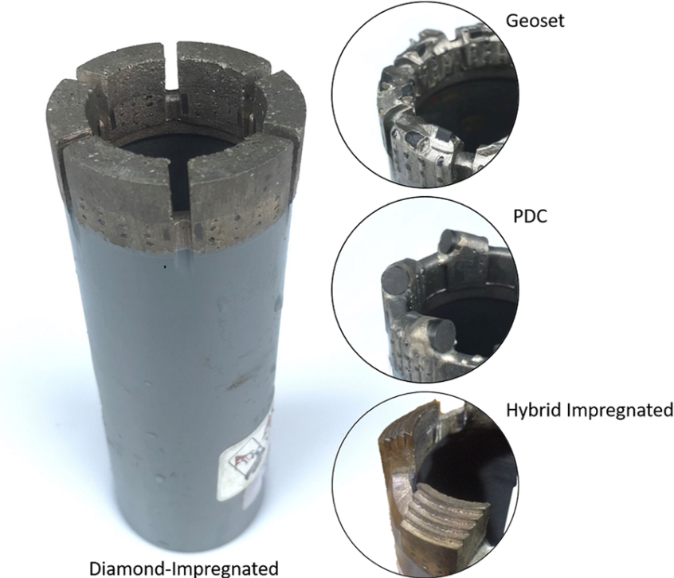
Fig. S1. Winkie Drill is equipped with four bit designs. The #10 diamond-impregnated bit is used in hard bedrock formations. The geoset bit is used in soft rock formations or when sediments are entrained in the ice. The polycrystalline diamond compact (PDC) bit can be used in similarly soft rock formations but has had limited success when ice is present in the kerf. The hybrid impregnated bit is made from the same material as the standard #10 diamond-impregnated bit but includes a relief angle behind the leading edge. This bit can cut ice and transition into bedrock. Figure reproduced from Boeckmann and others, 2020; Fig. 4.

The weight of the required drilling system for a field campaign is driven by the targeted depth at which a team intends to drill and surface conditions at the drill site. This is because a large portion of the total weight is from the drill rods and drill fluid. Additionally, drill sites that contain firn or fractured blue ice require a pilot drill and casing to contain the drill fluid. See Table S1 to calculate the approximate weight of equipment based on targeted drill depths and glaciological conditions.

Table S1. Estimated weight for required drilling equipment. The weight of necessary equipment will scale to the intended depth of drilling.
Equipment | Weight (kg) | Notes
Drill Rig & Equipment | 1000 | Modified IDP Winkie Drill system
Drill Generators | 200 | Weight for two Honda 5 kW Generators
Drill Rod | 40 | Weight per 15 m of rod section
Drill Fluid | 45 | Weight required per 15 m depth drilled
Fuel | 340 | Weight for two 200 L drums
Pilot Drill* | 590 | IDP Badger-Eclipse Drill
Casing* | 83 | Weight per 15 m section of casing
Packer Equipment* | 90 | Inflatable packer and compressor
* A pilot drill and associated equipment are necessary for drilling at sites with firn or fractured blue ice.

2. Radar Technology
The choice of GPR system and antennas depends upon the target drill depths, with deeper targets requiring lower frequency radar systems. Low-frequency antennas (5-100 MHz) have the capability to image hundreds-to-thousands of meters depth, primarily depending on frequency choice, transmitter power, and sample rates. Higher-frequency antennas (200-900 MHz) can image tens-to-hundreds of meters of depth and are often used for imaging near-surface features or shallow ice thicknesses. Often, shallow radar surveys are carried out over small areas (~100-500 m²) using a grid system. Grids are created using stakes spaced at set intervals (usually every 10, 25, or 50 m) and located for post processing using GPS systems. The grid system allows for distance normalization of radar profiles, a post-processing method that enables the user to more accurately geolocate subglacial features of interest. Targeted ice thickness depths for grid surveys range from 10 to 150 m. See Table S2 for a summary of the GPR hardware and basic settings used at each field site.

Table S2. Summary of ground-penetrating radar (GPR) hardware and basic settings used for data collection at five sites in Antarctica. GSSI - Geophysical Survey Systems Incorporated. S&S - Sensors and Software. Two GPR surveys were conducted in the Hudson Mountains. Data for the 2019/20 survey is given in brackets.
Drill site | Ohio Range | Mt. Murphy | Hudson Mountains | Enterprise Hills | Mt. Waesche
Season | 2015-2016 | 2019-2020 | (2019/20)  2022-2023 | 2022-2023 | 2018-2019
GPR Make | GSSI | GSSI | (S&S)  GSSI | S&S | GSSI
GPR Model | 3207, 50400S | 3207, 50400S | (PulseEKKO)  50200HS, 50400S | PulseEKKO | 3207, 50400S
GPR Antenna (MHz) | 100, 400 | 100, 400 | (100, 200)  200, 400 | 100 | 100, 400
GPR Receiver | SIR-4000 | SIR-4000 | (Digital Video Logger)  Panasonic® Toughpad G2 | Digital Video Logger | SIR-4000
Scan Rates (scans/second) | 12-90 | 12-90 | 12-110 | 12 | 12-90
Sampling Rates (samples/scan) | 1024-4096 | 1024-4096 | (4,000ns/300m)  1024-4096 | 1440 | 1024-4096
Bandpass Filter (MHz) | 25-350, 100-800 | 25-350, 100-800 | (40-80, 120-240)  65-800,100-800 | 20-200 | 25-350, 100-800

3. Study Sites
For each site, we provide the scientific justification for drilling and an overview of the drilling and radar campaigns (if applicable). See main text for a site description and the key takeaways from radar and drilling efforts.

3.1 Ohio Range
Scientific justification
The Ohio Range is part of the Transantarctic Mountains that divides the WAIS and East Antarctic Ice Sheet (EAIS). This location was selected for subglacial bedrock recovery drilling because ice sheet models indicated the potential of the site to record evidence of low stand glacial ice during the Plio-Pleistocene (Pollard and Deconto 2009, 2012). The Pliocene is of interest because it is the most recent period in which global temperatures were warmer than present and atmospheric CO2 concentrations may have been slightly higher than current levels (e.g. Haywood and others, 2000; Jiang and others, 2005), potentially providing an analog for future WAIS behavior. Therefore, cosmogenic nuclide inventories in subglacial bedrock cores recovered from this site provide evidence of ice-free conditions at periods of interest in the past. Simple two stage models of the observed cosmogenic nuclide concentrations in the recovered cores provide constraints on minimum exposure and cover. Similar to the adjacent exposed bedrock on the Bennet nunataks, the cosmogenic nuclide concentrations of the recovered subglacial samples indicate a complex exposure history with at least several hundred thousand years of integrated exposure and cover. Bedrock exposure ranges from 300 ka (thousands of years) to 2000 ka and ice cover from 150 to 200 ka (Mason, 2018; Middleton and others, 2018).

Radar survey
In preparation for subglacial drilling, extensive 400MHz and 100 MHz GPR surveys were conducted in 2015/16 and 2016/17 to map subglacial topography and englacial stratigraphy surrounding Tuning and Bennett Nunataks (Fig. S2). These data were collected to locate subglacial ridge crests or rises with minimal entrained debris in the ice above to assure success of drilling shallow (<30-50 m) ice cores to extract subglacial bedrock samples. In addition, data was used to interpret local flow dynamics during advance and retreat of ice elevation in the Ohio Range and provide ice depth information for constraining numerical ice models. GPR data was supplemented with ice ablation and velocity measurements obtained from stakes installed during 2015/16 to better characterize local glaciological conditions using methods similar to those by Campbell and others, (2013).

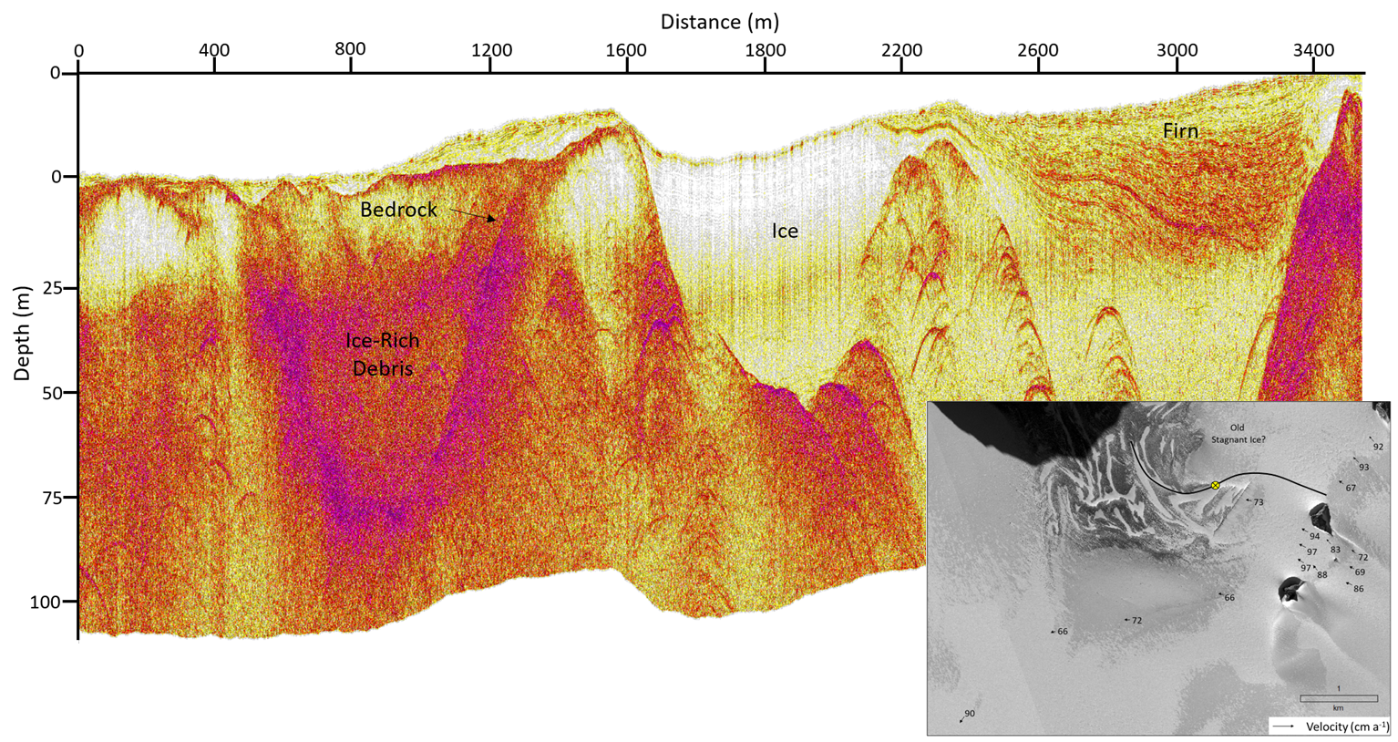
Fig. S2. Example 100 MHz radar profile collected in 2015/16 that crosses a complex area of ice, firn, and bedrock (see inset). For depth estimates, a relative permittivity of 3.1 was assumed. The profile has been distance and surface normalized and stacked to improve signal to noise ratios. The values in the inset map indicate velocity measurements and ice flow direction. Imagery © 2023 Maxar

Drilling efforts
The 2016/17 season was the first deployment of the Winkie drill system in Antarctica to attempt to extract a bedrock core. The drilling goal was to collect 50+ cm subglacial bedrock samples from six discrete boreholes ranging in depth from 10 m to 30 m beneath the ice surface. If the drill performed well, the team would attempt a borehole to 50 m depth. All drilling operations were carried out through blue ice, which simplified the drill fluid circulation system because non-fractured blue ice can contain the drilling fluid. The drill was first tested by using air circulation to clear ice chips but this proved to be ineffective and the team switched to Kovacs augers to create access boreholes to the underlying bedrock. The team successfully drilled for 12 days following a planned procedure: 1) drilling an access hole to the bedrock surface using Kovacs augers driven by the Winkie Drill, 2) configuring the Winkie Drill for wet drilling, using a geoset bit (Fig.S1) for the first coring run, 3) drilling with the geoset bit until penetration was no longer possible due to bit dulling then collecting the core, 4) replacing the geoset bit with a diamond impregnated bit and coring to the desired depth, 5) moving the Winkie Drill to the next drill site. This resulted in the extraction of five bedrock cores that varied in length from 28 cm to 67 cm. The successful boreholes were drilled through ice at depths between 12.1 and 28.3 m (Table 1). One additional core of sediment was collected (rather than bedrock) from 27.0 m when attempting to reach bedrock.
The project was successful, and a list of recommendations were made during post-season discussions that included using a remote power source and an electric motor for the drill and a drill enclosure. Enclosing the drill would prevent weather interruptions and issues from blowing snow entering parts of the drill system. Moving to a remote power source would alleviate the noise and exhaust generated by the engine mounted to the Winkie Drill. In addition, the team found that drill system upgrades could be made to address the process known as rod tripping. Rod tripping entails removing or replacing drill rod from the borehole to access the coring assembly or drill bit. Rod tripping is necessary to clear the drill bit if it becomes clogged with ice or mud, or to recover a drilled core. This is especially relevant for deeper boreholes (>30 m) where rod tripping speed is a main driver of drilling production rate. The team suggested that a mechanism should be added to the system to make rod tripping less physically demanding and more efficient for the operators given the targeted drilling depths.

3.2 Mt Murphy
Scientific justification
Mt. Murphy is located between the Thwaites and Pope Glaciers in the Amundsen Sea region of West Antarctica, an area of rapid glacier thinning in recent decades that has been a focus of studies of the Antarctic contribution to present and future sea-level rise (Scambos and others, 2017). These and other Amundsen Sea glaciers overlie over deepened subglacial basins, so that present-day grounding line retreat has the potential to initiate a positive feedback response in which retreat into the basin increases the water depth at the calving face, which increases the calving rate and spurs further retreat. This so-called marine ice sheet instability is hypothesized to be a potential trigger for irreversible ice loss from a substantial portion of West Antarctica in the coming decades to centuries, with possibly significant impacts on global sea level (Thomas and others, 1979; Bamber and others, 2009).
Subglacial bedrock drilling at Mt. Murphy (and also in the Hudson Mountains and Enterprise Hills described in section 3.3 and 3.4) was motivated by the observation that cosmogenic-nuclide exposure age datasets in many regions of Antarctica including the Amundsen Sea indicate rapid thinning to the present ice surface elevation between 8 - 4 ka ago, but provide no evidence of thicker ice after that time (see Johnson and others, 2022). Thus, either the ice thickness has been perfectly stable in this region for over 4 ka – which is unlikely given dynamic late Holocene boundary conditions, including changing relative sea level and oceanographic conditions – or the ice sheet thinned to a configuration smaller than present, with grounding lines inboard of present positions, and then thickened to the present configuration. The possibility that thinning and grounding line retreat inboard of present positions took place earlier in the Holocene and did not lead to irreversible retreat is important in understanding the significance of present thinning in this region, so the drilling project was intended to determine whether a late Holocene retreat-advance cycle did or did not take place.

Radar survey
A radar survey for the selection of the first drill site was conducted in the one day immediately prior to drilling. A radar line collected with a ski-towed 100 MHz antenna (Fig. S3) that crossed the subglacial extension of the ridge several times was used to select an initial drill site so that drill assembly and site preparation could begin at the same time as a more detailed radar survey was conducted. The area available for site survey was limited by a prominent bergschrund 100-200 m from the ice margin that separated a crevasse-free area below the bergschrund from an extensively crevassed area between the bergschrund and the ice margin. As the ice thickness at the bergschrund was ~30 m, this precluded drilling at any sites shallower than that depth. Further radar surveying, mainly including a 70 by 100 m grid survey with 10-meter line spacing (see Fig. S3) established that the subglacial ridge dropped away from the nunatak fairly steeply, leaving approximately a 70-meter long section of subglacial ridge between the bergschrund and the maximum ice thickness deemed efficient for drilling operations at approximately 60 m. Thus, the grid survey was used to select several drill sites along this ridge segment with ice thicknesses interpreted from the radar between 35-60 m.
An important element of the radar survey at this site was that radar survey and drill deployment were taking place simultaneously – drilling commenced less than one day after the beginning of the radar survey – and under deep field conditions, so it was not possible to apply advanced processing techniques to the radar data to optimize bedrock depth estimates. As such, only rapid and low-overhead processing techniques such as stacking (which improves signal-to-noise ratio) and a simple migration algorithm based on bedrock hyperbolae (which corrects incorrect bedrock slopes influenced by side reflections) were used. Regardless, four out of six drill holes successfully recovered bedrock core.

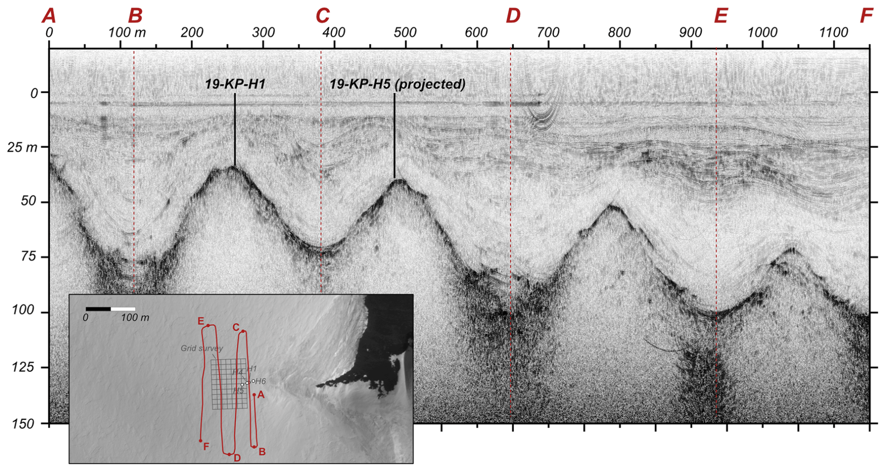
Fig. S3. Example 100 MHz radar profile collected prior to drilling in 2019/20 that crosses the subglacial portion of Kay Peak Ridge four times (see inset map). The profile has been distance normalized (RADAN, 2017), and a Kirchhoff migration (Schneider, 1978, Özdemir and others, 2014) was applied to improve bedrock depth estimates. Core 19-KP-H1 lies on the radar line, as shown, and the nearest projected location of 19-KP-H5 is also shown. The location of the grid survey that was also used for drill site selection is shown in gray. This figure is reproduced from Balco and others, 2023.

Drilling efforts
The primary difference between the Winkie drill deployment at this site and previous deployment in the Ohio Range was the addition of casing and pilot drill equipment needed for drilling through firn. Blue ice without fractures is impermeable, so drilling fluid can circulate to the surface without sealing the borehole walls. In contrast, firn is permeable and incapable of containing pressurized drill fluid, so achieving fluid circulation for rock coring requires the use of borehole casing and a packer system, as well as a separate drill for creating the borehole to place the casing. For the Mt. Murphy project, this was achieved by using the IDP Badger-Eclipse cable-suspended ice coring drill (henceforth Eclipse drill). This drill produces an oversized borehole that accommodates casing large enough to pass the Winkie Drill rods and rock coring tooling. Thus, the Eclipse drill was used to create an access hole deep enough to reach ice of sufficiently high density (> 870 kg m⁻³) to form a seal with an inflatable packer. The use of two drill systems had significant advantages in that 1) rock coring at one site could take place at the same time as access hole drilling at a second site, which greatly improved efficiency, and 2) high-quality ice core could be collected without delaying rock coring operations. However, the addition of the Eclipse drill, borehole casing pipe, and packer system increased the total drill system weight. For example, the Winkie Drill equipment for a 60 m blue ice site weighs approximately 2600 kg; the additional Eclipse drill and casing weighs approximately 1000 kg. Other Winkie upgrades for this field season included replacing the 2-stroke gasoline powerhead engine with an electric motor and controls, adding a tripod and capstan winch for easier rod tripping, and improved fluid tank and mud pumps for drill fluid circulation and handling.
The drilling objective was to collect six 1.5 m bedrock core samples ranging in depth 10 m to 60 m from the ridgeline extending from Kay Peak. The team of six arrived onsite after a 2-week logistics delay. Drilling proceeded at a rapid pace for 16 days following the general procedure: 1) drill the access hole as deep as possible with the Eclipse drill until dirty ice or bedrock prevents further ice coring; 2) move the Eclipse drill to the next site and install the Winkie Drill, casing, and packer system; 3) use the geoset bit to penetrate through dirty ice, clay and overburden; 4) after penetrating into competent rock, replace the geoset bit with impregnated bit to retrieve bedrock core. Unexpectedly, the most time-consuming part of this process proved to be penetrating the relatively thin (70-120 cm) dirty ice and sediment layer overlying bedrock, which required repeated rod tripping for bit cleaning and maintenance of fluid circulation. Six access holes were drilled to depths between 31-58 m. One was abandoned because of the presence of liquid meltwater, apparently sourced from runoff from the adjacent exposed bedrock ridge. A second was abandoned because the bed was not encountered at the maximum practical depth for rock coring - the borehole missed the subglacial ridge. Rock cores with a minimum length of 1.2 m were collected from three of the other holes, and a 10-cm bedrock surface sample from the final hole.
Finally, although the ability to simultaneously operate both access and coring drills permitted high productivity in a very short field season, it also demanded long workdays and continuous effort by field personnel: a minimum of 10 hours were spent in active work at the drill site each day, with only one weather break. Although safety issues were fortunately not experienced during this field season, the resulting fatigue risked contributing to mistakes and/or poor decision-making practices. This level of effort should not be considered sustainable for planning future field seasons.

3.3 Hudson Mountains
Scientific justification
The Hudson Mountains are situated adjacent to Pine Island Glacier and are in the same sector of Antarctica (the Amundsen Sea sector) as Mt. Murphy (Section 3.2). The apparent lack of late-Holocene exposure ages from currently exposed sites in the Hudson Mountains (Johnson and others, 2014 and Nichols and others, 2023) indicates either ice sheet stability since the mid-Holocene or a phase of ice sheet thinning below present followed by thickening (with associated grounding line retreat and readvance) in the Amundsen Sea sector. A relative sea level record reconstructed from islands located in the Amundsen Sea suggests that no broad spatial scale, major readvance of the grounding line occurred during the last 5 ka (Braddock and others, 2022). Cosmogenic nuclide concentrations in subglacial bedrock cores collected from nearby Mt. Murphy (see Section 3.2) suggest that tens of kilometers of grounding line retreat inland of its present position likely accompanied upstream ice sheet thinning of at least 30 to 35 meters of ice in the previous 5 ka (Balco and others, 2023). Subsequent readvance and ice thickening must have occurred at Mt. Murphy for the adjacent glaciers such as Thwaites to expand to their modern-day limits. To determine if the thinning of glaciers near Mt. Murphy was a unique, local event or a broader, regional ice volume loss in the region, a second site was selected for subglacial drilling efforts because of its proximity to the neighboring Pine Island Glacier.

Radar survey
In the 2019/20 season, a team of two scientists and two field guides visited the Hudson Mountains with the goals of 1) undertaking radar surveys to identify suitable site(s) for subglacial bedrock recovery drilling and 2) collecting surficial bedrock samples to determine if the mineral composition of the rocks is appropriate for cosmogenic dating and to constrain the above-ice deglacial history. Upon completion of the initial surveys, the site near the shear margin of Pine Island Glacier at Winkie Nunatak ( -74.8595°, -99.7833°) was selected. It is in an area with snow and firn cover. This site was intended to be drilled the following year, however, due to delays caused by the Covid-19 pandemic, the second (drilling) field season was carried out in 2022/23. Because of the two-year delay in returning to the site, and the consequent likelihood of significant change in near-surface ice conditions as this the drill site is located close to the active shear margin of the rapidly retreating Pine Island Glacier, a GPR technician joined the drill team to resurvey the site. First, the team carried out a survey on foot in search of visible signs of crevassing at the surface but found no obvious signs of slumping or collapsed snow bridges. Following this initial inspection, the team conducted a repeat survey of the same area near Winkie Nunatak surveyed in 2019/20 by establishing a gridded flag system over an area of 150 m by 300 m (Fig. S4) using two GPR antenna systems. One antenna was better suited to detect near-surface crevasses in greater resolution (400 MHz antenna) while the other system could image ice thickness at greater depths (200 MHz Hyperstacking antenna). The GPR systems were hand-towed across the survey area at approximately 1 m s⁻¹. Nearest to the nunatak, where ice was thinnest (<30 m), the radar surveys revealed multiple large extensional crevasses that ran over the targeted subglacial ridge top at oblique angles. These crevasses were covered by snow bridges that were probed and found to be only 0.5 m thick. Crevassing had been detected in the 2019/20 season, but it was difficult to discern from the resulting radargrams if there was one large crevasse or multiple that were closely packed in the shallow ice region nearest to the nunatak because the antenna used was intended for penetrating to greater depths but in lower resolution. More extensive probing and additional GPR surveys revealed that it would not be advisable for the team to drill over the ridge crest because of crevasse safety concerns. It was decided that the team would therefore drill on the flank of the ridge, to a GPR-estimated depth of ~45 m (Fig. S4). Additional GPR surveys would be carried out simultaneously with drilling efforts in order to locate a second, shallower drill site that would provide further constraints on the degree of past ice sheet thinning.

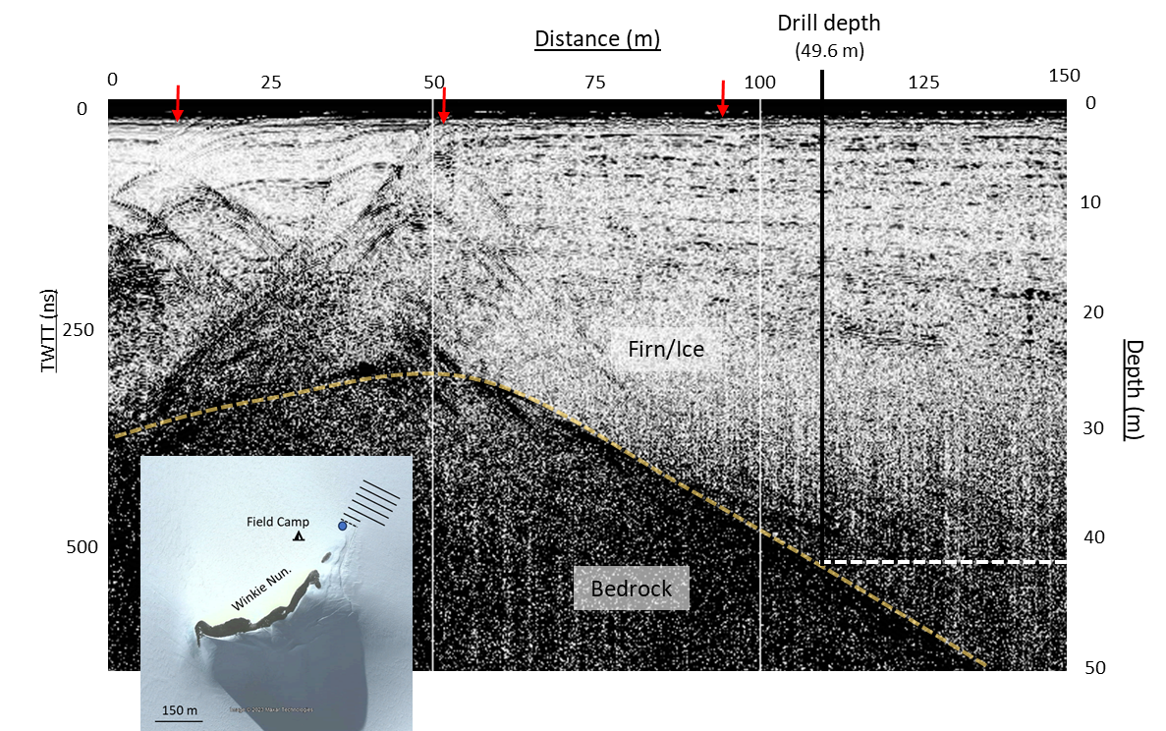
Fig. S4. Example 200 MHz Hyperstack radar profile collected prior to drilling in 2022/23 that crosses the subglacial ridge top of Winkie Nunatak (see inset map). The profile has been stacked and distance normalized. White vertical lines at 50 and 100 m indicate the location of flagged survey points spaced at 50 m intervals. The red arrows on the horizontal axis indicate the location of crevasses. The location of the drill site is shown with a black line with the corresponding estimated depth shown by the dashed horizontal white line. In the inset map, the location of the grid survey that was also used for drill site selection is shown by the black lines. The red line shows the location of the radargram in this profile and the direction the GPR was towed is indicated by the red arrow direction. Inset image: Imagery © 2023 MAXAR.

Drilling efforts
In the 2022/23 season, the IDP deployed its modified Winkie and Eclipse drills to the Hudson Mountains with the objective of collecting three subglacial bedrock cores of varying depths (<30 m, 30 - 50 m, > 50 m). The drilling techniques and equipment deployed at Winkie Nunatak closely followed the strategy previously used at Mt. Murphy but with several upgrades focused on improving system efficiency. To improve the drill fluid circulation system, an insulated settling tank paired with an air-to-liquid process chiller was implemented. The focus of these upgrades was to settle fine clay contaminants and maintain subfreezing drill fluid during coring operations as the team expected similar ice-bedrock conditions to Mt. Murphy given the sites proximity to the coast. Throughout the season, the process chiller performed well and reduced the risk of freezing the drill string downhole. Additional upgrades were also made to the Winkie rod handling system including a powered capstan winch and custom foot clamp to improve operator safety while reducing rod tripping cycle time in deeper boreholes. To reduce logistics burden, drilling equipment was cached at a field depot following the Mt. Murphy season for two years prior to being deployed at Winkie Nunatak. Although this reduced the logistics burden of drill camp input, over-wintering was harsh on drill equipment, meaning that it required several days of additional field diagnostics and troubleshooting prior to use.

Due to delays traveling to the field site and safety concerns arising from the crevasse field described above, the team decided mid-season to focus on drilling a single borehole at ~45 m below the ice surface. Since the subglacial ridge was covered by firn, not blue ice, the Eclipse drill was again used to drill a 48 m access hole for the inflatable packer and casing system. This access method using a field-proven coring drill continued to be reliable and efficient for firn-covered sites. After access drilling was complete, the Winkie Drill was assembled at the drill site. A total of nine coring attempts were executed over four days of drilling, yielding only 1.6 m of ice and debris-rich ice core. Coring runs were typically cut short after only 5 - 10 cm due to loss of penetration or fluid circulation. Upon inspection at the surface, coring bits were normally glazed with fine clay which effectively plugged core bit waterways. A variety of different bits, penetration rates, and drill fluid circulation rates were tried without any noted improvement. Despite maintaining clean, cold drill fluid, no improvements in coring frozen clay were noted as compared to the Mt. Murphy season. Fluid circulation blockages at the bit and core barrel caused by fine clay created substantial drilling delays and was a contributing factor in not recovering a bedrock core at this site. After 28 days on site, including 11 days of drilling activity, one borehole through 49.6 m depth of ice was drilled, yielding 1.6 m of clay rich mixed media core. Ultimately, a bedrock core was not recovered from the borehole due to a combination of drilling challenges caused by clay rich overburden and time constraints that prevented an attempt at drilling at a second site.

3.4 Enterprise Hills
Scientific justification
As outlined above, the Holocene evolution of WAIS has been widely discussed with increasing focus on the potential for significant retreat beyond present day grounding lines in several sectors of the Antarctic ice sheet, with direct geological evidence of such behavior documented in the Ross Sea and Amundsen Sea sectors. The Weddell Sea is another sector where retreat-readvance behavior has been postulated, but direct glacial-geological evidence does not yet exist. A zone of grounding line retreat inland of its present position was hypothesized by Kingslake and others (2018) based on modeling. This zone encompasses a 1500 m deep sedimentary basin with a retrograde bed slope that underlies major ice streams draining into the southern part of the Weddell Sea embayment (Ross and others, 2012).

Radar results
A localized GPR survey was undertaken focused on the area around the small patch of exposed bedrock ~350 m northeast of Plummer Nunatak. The area around this exposure was predominantly blue ice with patches of wind-blown snow up to 2 m thick. Because the drill site is on blue ice, where crevasses are clearly visible and easily avoided, there were no concerns about crevassing at Enterprise Hills. To characterize the sub-ice topography, a PulseEkko Pro GPR system with 100 MHz antennas was used to survey the identified drill site(s). Due to loss of some components during transit, it was not possible to connect any GPS system to the digital video logger, meaning that survey lines had to be marked out by hand prior to collecting GPR. This greatly increased the effort involved and limited time dedicated for additional radar surveying. As a result, only two potential drill sites were surveyed (Fig. S5). The antennas, transmitter, and receiver were attached to a plastic sledge and hand-towed across the survey area at approximately 1 m s⁻¹.
The GPR survey clearly identified the ice-bedrock transition at depths of interest. A subglacial bedrock ridge was identified extending away from the small rock outcrop near Plummer Nunatak. Unfortunately, the crest of this ridge remained at a near constant depth (~10 m) for the entirety of its length before it passed below a steeper blue ice slope on which set-up of the drill rig would have been problematic. To increase the range of depths to be sampled, a decision was made to drill away from the ridge crest. In doing so, it was difficult to accurately assess the true depth to bedrock, likely due to the steep nature of the local sub-ice topography introducing off-nadir reflectors giving a negative bias to the estimated ice thicknesses (e.g. Lapazaran and others, 2016). Interpretation of the profiles was also hampered by the absence of a specialist with GPR knowledge within the field team.
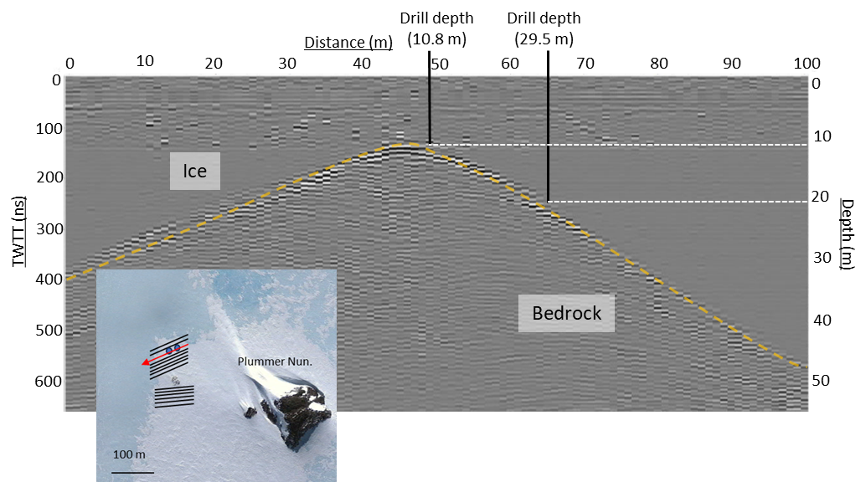
Fig. S5. Example 100 MHz radar profile collected prior to drilling in 2022/23 that is located near Plummer Nunatak (see inset map). The profile has been distance normalized to survey flags spaced at 25 m intervals. Location of the drill sites are shown with black lines with the corresponding estimated depth shown by the dashed horizontal white line. In the inset map, the location of the grid survey that was also used for drill site selection is shown by the black lines with and a red line shows the location of the radargram in this profile and the direction the GPR was towed is indicated by the red arrow direction. Blue dots in the inset map indicate drill site locations from radar profile. Inset map created from Google Earth: Imagery © 2023 Maxar.

Drilling efforts
Two sites, bracketing this zone, were selected for sub-glacial drilling to test for Holocene retreat-readvance in the Weddell Sea. The first of these sites, in the Enterprise Hills (-79.9439°, -81.4314°), was visited in the austral summer of 2022/23 and the second site at the Pensacola Mountains will be visited in 2023/24. Drilling was undertaken with a Winkie Drill system purchased by Durham University. Modifications follow Boeckmann and others. (2020) but are less extensive than the systems used at Mt. Murphy (section 3.2) and Hudson Mountains (3.3 section). In practice the system is most like that used at the Ohio Range in 2016/17. As such it requires ice that is frozen to the bed and, as it cannot core where firn is present, it can only be deployed at sites with blue ice at the surface. These logistical limitations strongly influence site selection. A total of six access holes (7 – 29.5 m) were produced using modified Kovacs ice augers during 11 days of drilling activity by a team of four. For most access hole locations, a pit was excavated in the snow cover to allow the drill rig to be set up directly on blue ice. Of the six access holes, four attempts were made at rock coring. At one site, fluid circulation could not be established which is thought to be the result of fluid draining into a bedrock crack and another site was deemed to be too shallow to justify the effort to core given time constraints. A total of four rock cores (5 – 47 cm) were collected, consisting of medium-fine grained quartzites. These cores spanned depths of 9.5 – 29.5 m below present-day ice levels. In all holes we encountered a practically clean bedrock interface with the small amount of loose material encountered interpreted as being in situ pieces of weathered bedrock. No clasts or debris were observed in the ice column.
Several issues were encountered that impacted and/or disrupted drilling activities with the most significant of these being related to fluid circulation and the mud pump. Specifically, there was a persistent issue with liquid water being present in the fluid circulation loop that were attributed to either: 1) small ice chippings, either left over from augering or produced during coring activities enter the loop. These are subsequently melted due to frictional heating (in the pump or downhole) or within warm drill fluid, and/or 2) direct production of liquid water due to frictional heating at the drill head and/or melting of the borehole wall due to warm drill fluid. Regardless of the source of the water it had several noticeable impacts. Firstly, it could refreeze within the pump when not in use, this would prevent the pump from starting unless it was heated sufficiently to melt any ice present. Secondly, if water was not quickly and efficiently flushed from the borehole it can accumulate and re-freeze at the bottom of the borehole (drill fluid being less dense than water). This occurred at one site where the resulting ‘ice plug’ was unknowingly re-cored in the subsequent core run. Finally, when rod tripping at another drill site after completion of an initial short (~5 cm) coring run, liquid water refroze on the outside core barrel and froze the drill string to the borehole wall. This required considerable time and effort to free.
We also noted the presence of fine rock particles within the drill fluid which could impact on its effectiveness either through clogging of fluid pathways on the drill bit or by contributing to accumulation of clay and/or ice agglomerations in the fluid. Other issues encountered included the loss of a core barrel at the first site due to “pack off”. This is where fluid circulation is not maintained for a sufficient duration to clear chippings from the hole. The chippings settle around the drill string causing it to become stuck in the borehole. There was also an issue with the inverter drive, used to control the mud pump, malfunctioning. This required that the pump be connected directly to the generator. Finally, the starter mechanism for the two-stroke gas engine failed due to a broken plastic component, presumably made brittle by the cold temperatures.

Despite these issues, there were considerable periods when the drill rig was performing well and producing core. Our modified ice augers worked without issue to 30 m depth and the intention is to test them deeper in the coming field season. The main modifications for the 2023/24 field campaign relate to a simplified pump design and improvements to the fluid management system including improved monitoring of fluid temperature, a settling tank, and a baffled circulation tank. These modifications should reduce the presence of cuttings as well as ice/water in the drill fluid during and after downhole circulation.

3.5 Mt. Waesche
Scientific justification
Mt. Waesche lies near a dome of WAIS in central Marie Byrd Land. Changes in ice elevation there reflect past changes in WAIS extent and volume (Ackert and others, 1999, 2013). The timing and occurrence of lower ice elevations at interior sites in West Antarctica have implications for the WAIS contribution to past and future sea level changes but is generally unconstrained. The presence of cosmogenic nuclides in subglacial bedrock is clear evidence for past exposure and thus, lower ice elevation than at present. In addition, the direct dating by ⁴⁰Ar/³⁹Ar of lava flows that extend beneath the ice margin provide independent evidence for lower ice elevations at the time of eruption. The ages, lithologies, and physical settings of young volcanic rocks at Mt. Waesche provides a unique opportunity to determine WAIS elevation during the last interglacial. A set of Eemian interglacial-age lava flows, examined and sampled during the 2018/19 field season, extend below the present ice surface. Previous work at Mt. Waesche demonstrated that the local volcanic rocks are suitable for cosmogenic nuclide dating (Ackert and others,1999, 2013). Successful sampling of young lava flows below the current ice sheet level, and analysis of the cosmogenic nuclide profile, will allow us to determine if WAIS volume was significantly smaller during the last interglacial period.

Radar survey
In the 2018/19 season, a reconnaissance team conducted a geophysical survey to map subglacial topography over the blue ice zone on the southern flank of Mt. Waesche. At Mt. Waesche, GPR is critically important in order to produce maps of the subglacial lava flow topography to guide drilling, as well as to trace tephra horizons in englacial stratigraphy over the kilometer to tens-of-kilometers scale. Collected radar data were processed in the field and throughout 2019 in preparation for the drilling season. The GPR data served several purposes: 1) the aim was to locate suitable sites, such as subglacial ridge crests or knobs, for drilling shallow ice cores (< 120 m depth below surface) to extract rock samples from below the ice-bed interface, 2) the data provide valuable insights into potential changes in local flow dynamics during periods of decreased ice thickness in the region by mapping the distribution of tephra layers and ice stratigraphy. 3) the GPR data provides information on regional ice depth to constrain numerical ice flow models. Finally, they enable identification of subglacial landforms, including ponded lava that is indicative of ice-lava interaction at depths up to 700 m below the current ice elevation.

Over 14 days of GPR data collection, the team of six located two potential drilling locations at the targeted depths (Fig. 6b). The collected radar profiles allowed for the creation of 3-D radargrams of the sites. The advantage of 3-D imaging for drill site selection is to map out potential near-surface hazards, to better reduce ice thickness estimates in areas with complex subglacial topography, and to preselect multiple target drill sites. To do this, a 100 m by 100 m grid system was established with radar profiles collected at 10 m intervals using a 100 MHz antenna towed by hand. The density of GPR data collected, along with sufficient time allotted for processing the data before drilling in an upcoming season, allowed for the creation of 3-D radargrams (example in Fig. 7). Additionally, lower frequency antennas (5, 10 MHz) were towed by snowmobile to image englacial stratigraphy at greater depths and over a larger spatial area (dashed black lines in Fig 6b).

References
Ackert Jr RP and 6 others (1999) Measurements of past ice sheet elevations in interior West Antarctica. Science 286(5438):276-80. https://doi.org/10.1126/science.286.5438.276

Ackert, Jr RP and 6 others (2013) Controls on interior West Antarctic Ice Sheet Elevations: inferences from geologic constraints and ice sheet modeling. Quaternary Science Reviews 65:26-38. http://doi.org/10.1016/j.quascirev.2012.12.017

Balco, G and 12 others (2023) Reversible ice sheet thinning in the Amundsen Sea Embayment during the Late Holocene, The Cryosphere, 17, 1787–1801, https://doi.org/10.5194/tc-17-1787-2023.

Bamber J L, Riva REM, Vermeersen LAB, Lebroco AM (2009) Reassessment of the Potential Sea-Level Rise from a Collapse of the West Antarctic Ice Sheet. Science 324,901-903. https://doi.org/10.1126/science.1169335

Boeckmann GV and 6 others (2021) Adaptation of the Winkie Drill for subglacial bedrock sampling. Annals of Glaciology 62(84):109-17. https://doi.org/10.1017/aog.2020.73

Braddock S, and 9 others (2022) Relative sea-level data preclude major late Holocene ice-mass change in Pine Island Bay. Nature Geoscience 15(7):568-72. doi.org/10.1038/s41561-022-00961-y

Campbell S and 6 others (2013) Radar-detected englacial stratigraphy in the Pensacola Mountains, Antarctica: implications for recent changes in ice flow and accumulation. Annals of Glaciology 54(63):91-100. https://doi.org/10.3189/2013AoG63A371

RADAN 7 Manual Geophysical Survey Systems (GSSI) (2017), Nashua, NH.

Haywood AM, Sellwood BW and Valdes PJ (2000) Regional warming: Pliocene (3 Ma) paleoclimate of Europe and the Mediterranean. Geology 28(12):1063-6. https://doi.org/10.1130/0091-7613(2000)28%3C1063:RWPMPO%3E2.0.CO;2

Jiang D, Wang H, Ding Z, Lang X, and Drange H (2005) Modeling the middle Pliocene climate with a global atmospheric general circulation model. Journal of Geophysical Research: Atmospheres 110(D14). https://doi.org/10.1029/2004JD005639

Johnson, JS and 8 others. (2014). Rapid thinning of Pine Island Glacier in the early Holocene: Science, v. 343, p. 999–1001, https://doi.org/10.1126/science.1247385.

Johnson, JS and 12 others (2022) Review article: Existing and potential evidence for Holocene grounding line retreat and readvance in Antarctica, The Cryosphere, 16, 1543–1562, https://doi.org/10.5194/tc-16-1543-2022

Kingslake J and 9 others (2018) Extensive retreat and re-advance of the West Antarctic Ice Sheet during the Holocene. Nature 558(7710):430-4. https://doi.org/10.1038/s41586-018-0208-x

Lapazaran JJ, Otero J, Martín-Español A and Navarro FJ (2016) On the errors involved in ice-thickness estimates I: ground-penetrating radar measurement errors. Journal of Glaciology 62(236):1008-20. https://doi.org/10.1017/jog.2016.93

Liu N, Xu H, Yang Y, Han L, Wang L and Talalay P (2016) Physicochemical properties of potential low-temperature drilling fluids for deep ice core drilling. Cold Regions Science and Technology 129:45-50. http://doi.org/10.1016/j.coldregions.2016.06.004

Mason ZE, (2018) Subglacial Cosmogenic Exposure Constraints On The History Of The West Antarctic Ice Sheet. University of California, Davis.

Middleton JL, Mason Z, Mukhopadhyay S, Putnam A., Ackert RP. and Campbell SW, (2018) December. Cosmogenic nuclides suggest long-term Pleistocene exposure of subglacial bedrock at the Ohio Range in the West Antarctic Ice Sheet. In AGU Fall Meeting Abstracts (Vol. 2018, pp. C22B-05)

Nichols, KA and 11 others (2023) Offshore-onshore record of Last Glacial Maximum–to–present grounding line retreat at Pine Island Glacier, Antarctica. Geology, 51, (11): 1033–1037. https://doi.org/10.1130/G51326.1

Özdemir C, Demirci Ş, Yiğit E and Yilmaz B (2014) A review on migration methods in b-scan ground penetrating radar imaging. Mathematical Problems in Engineering 2014, 280738. doi: 10.1155/2014/280738

Pollard D and DeConto RM (2009) Modelling West Antarctic ice sheet growth and collapse through the past five million years. Nature 458(7236):329-32. https://doi.org/10.1038/nature07809

Pollard D and DeConto RM (2012) Description of a hybrid ice sheet-shelf model, and application to Antarctica. Geoscientific Model Development 5(5):1273-95. https://doi.org/10.5194/gmd-5-1273-2012

Ross N and 9 others (2012) Steep reverse bed slope at the grounding line of the Weddell Sea sector in West Antarctica. Nature Geoscience 5(6):393-6. https://doi.org/10.1038/ngeo1468

Scambos TA and 10 others (2017) How much, how fast?: A science review and outlook for research on the instability of Antarctica's Thwaites Glacier in the 21st century. Global and Planetary Change;153:16-34. http://doi.org/10.1016/j.gloplacha.2017.04.008

Schneider WA (1978) Integral formulation for migration in two and three dimensions. Geophysics. 43(1):49-76.

Sheldon, S, Popp, T, Hansen, S and Steffensen, J (2014) Promising new borehole liquids for ice-core drilling on the East Antarctic high plateau. Annals of Glaciology 55(68), 260–270. doi: 10.3189/2014AoG68A043

Talalay, PG (2011) Drilling Fluids for Deep Coring in Central Antarctica. Technical Report PRC 12-01. China: Polar Research Center, Jilin University, 1–73

Thomas R, Sanderson T and Rose K (1979) Effect of climatic warming on the West Antarctic ice sheet. Nature 277, 355–358 https://doi.org/10.1038/277355a0

