Weathering alteration in Antarctica environment as seen in the MIL 090030 Martian Nakhlite
Leire Coloma*, Julene Aramendia, Jennifer Huidobro, Iratxe Población, Cristina García-Florentino, Kepa Castro, Gorka Arana and Juan Manuel Madariaga
Department of Analytical Chemistry, University of the Basque Country UPV/EHU, P.O. Box 644, E-48080 Bilbao, Spain (*correspondence: leire.coloma@ehu.eus )
SUPPLEMENTARY MATERIAL
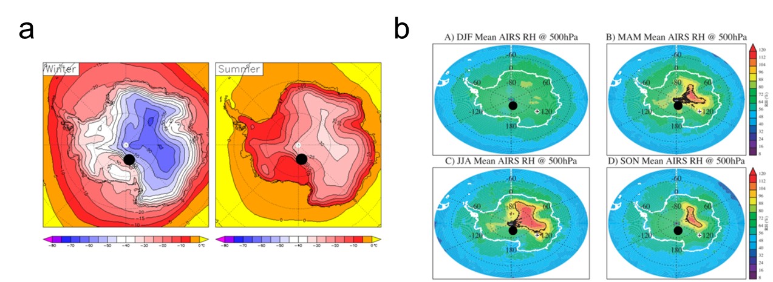
Fig. S1. a) Antarctica’s average temperature in winter and summer (Razin, 2005); b) Antarctica’s average relative humidity from A) December-January-February, B) March-April-May, C) June-July-August and D) September-October-November (Gettelman and others, 2006). In both cases Miller Range region is indicated with a black spot.

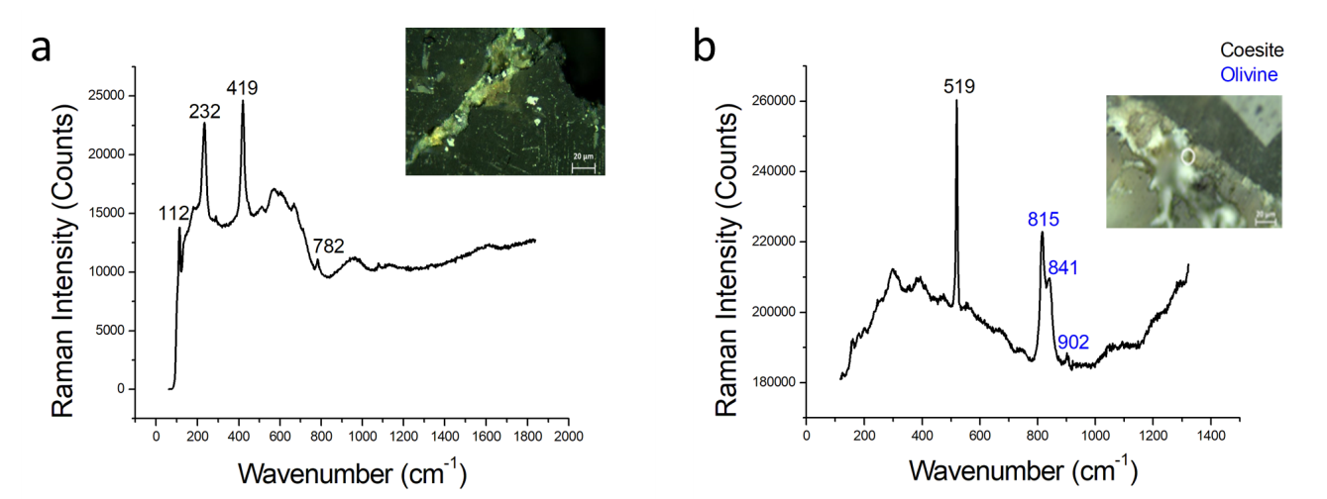
Fig. S2. a) Raman spectrum of cristobalite; b) Raman spectrum of coesite (black) with olivine (blue). Olivine is a primary Martian mineral.

