Supplementary

Glacier thickness and volume estimation in the Upper Indus Basin using modelling and ground penetrating radar measurements

Shakil Ahmad Romshoo, Tariq Abdullah, Ummer Ameen and Mustafa Hameed Bhat
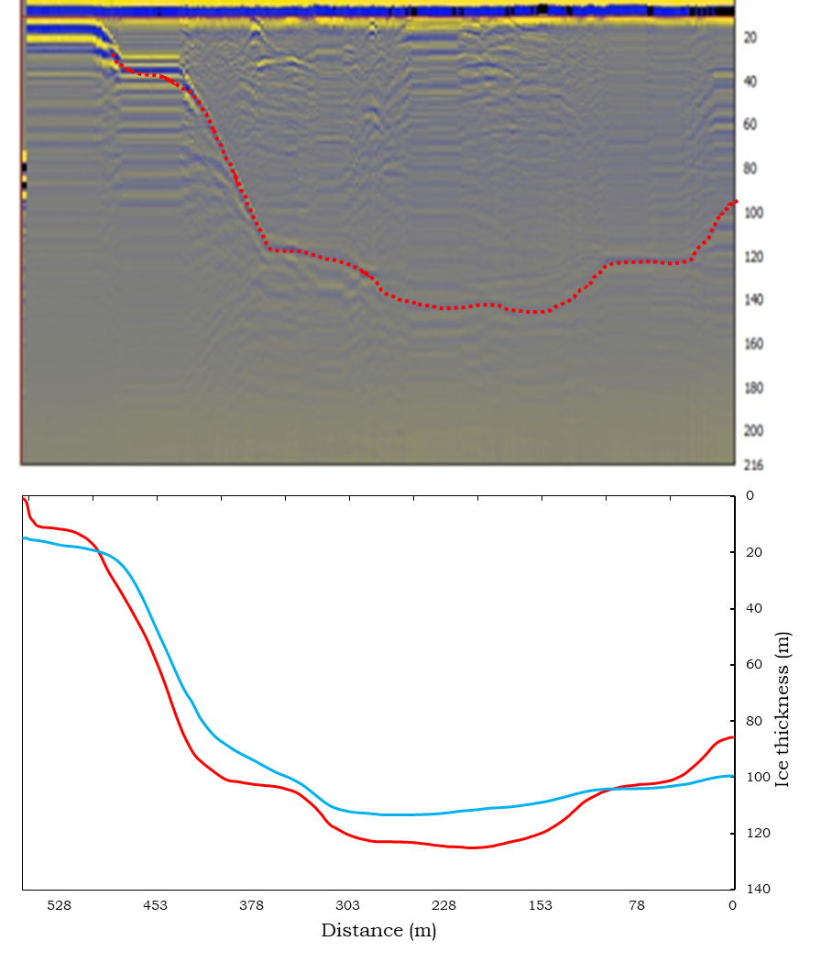
Fig S1: Radargrams of various GPR profile 1 (KP1) of the Kolahoi Glacier surveyed in August, 2018.
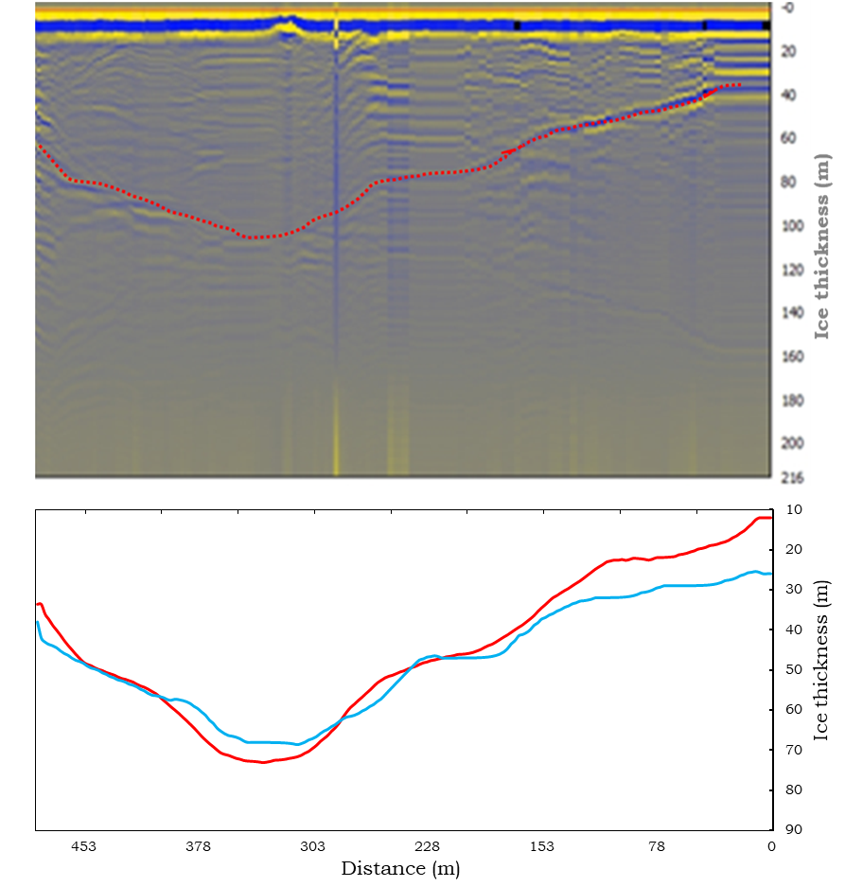
Fig S2: Radargrams of various GPR profile 2 (MP2) of the Machoi Glacier surveyed in August, 2018.
Fig S3: Comparison of the glacier volume estimates from the present study with previous studies over the study region.
*The volume estimates are only available for the Drass sub-basin.
**The volume estimates based on volume-areas scaling (V-A scaling) have been calculated based on the volume-area scaling approach by Bahr and others, (1997).

